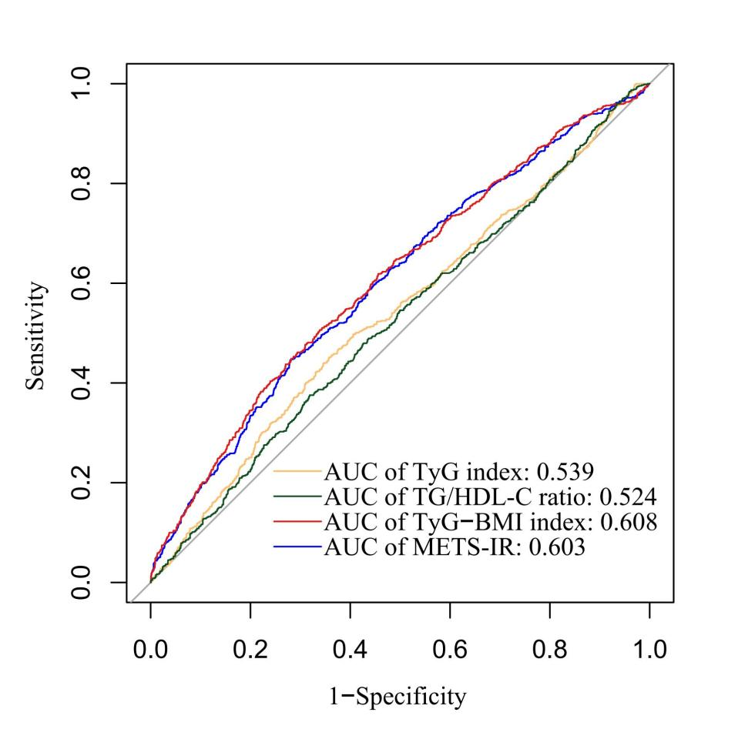
Figure. S1 Receiver operating curve for the use of four insulin resistance indexes in the detection of AF recurrence following ablation. AUC, area under curve; METS-IR, metabolic score for insulin resistance; TyG, triglyceride and glucose; TyG-BMI, triglyceride glucose-body mass index; TG/HDL-C, triglyceride to high-density lipoprotein cholesterol

Fig. S2 Kaplan–Meier estimated event rates of AF recurrence following ablation according to tertiles of insulin resistance indexes. AF, atrial fibrillation; METS-IR, metabolic score for insulin resistance; TyG, triglyceride and glucose; TyG-BMI, triglyceride glucose-body mass index; TG/HDL-C, triglyceride to high-density lipoprotein cholesterol

Figure. S3 Kapla-Meier estimated event rates of AF recurrence following ablation according to cut-off values of ROC curves for insulin resistance indexes. METS-IR, metabolic score for insulin resistance; ROC, receiver operating curve; TyG, triglyceride and glucose; TyG-BMI, triglyceride glucose-body mass index; TG/HDL-C, triglyceride to high-density lipoprotein cholesterol

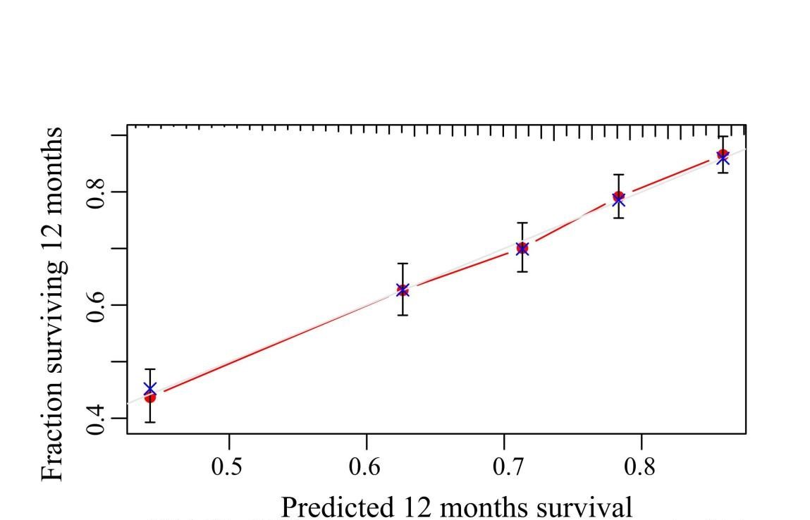
Fig. S4 The calibration plots for the adjusted model predicting AF recurrence. The x-axis represents the predicted AF recurrence risk. The y-axis represents the actual AF recurrence rate. The gray line indicates a perfect prediction by an ideal model. The red solid line indicates the performance of the predicting model, of which a closer fit to the gray line suggests better prediction. The adjusted model refers to the established basic risk model. Established basic risk model included age, sex, body mass index, current drinking, diabetes mellitus, hyperlipidemia, coronary heart disease, duration of AF (≥24 months), AF type, fasting blood glucose, HbA1c, left atrial diameter, platelets, CHA₂DS₂-VASc score. AF, atrial fibrillation;

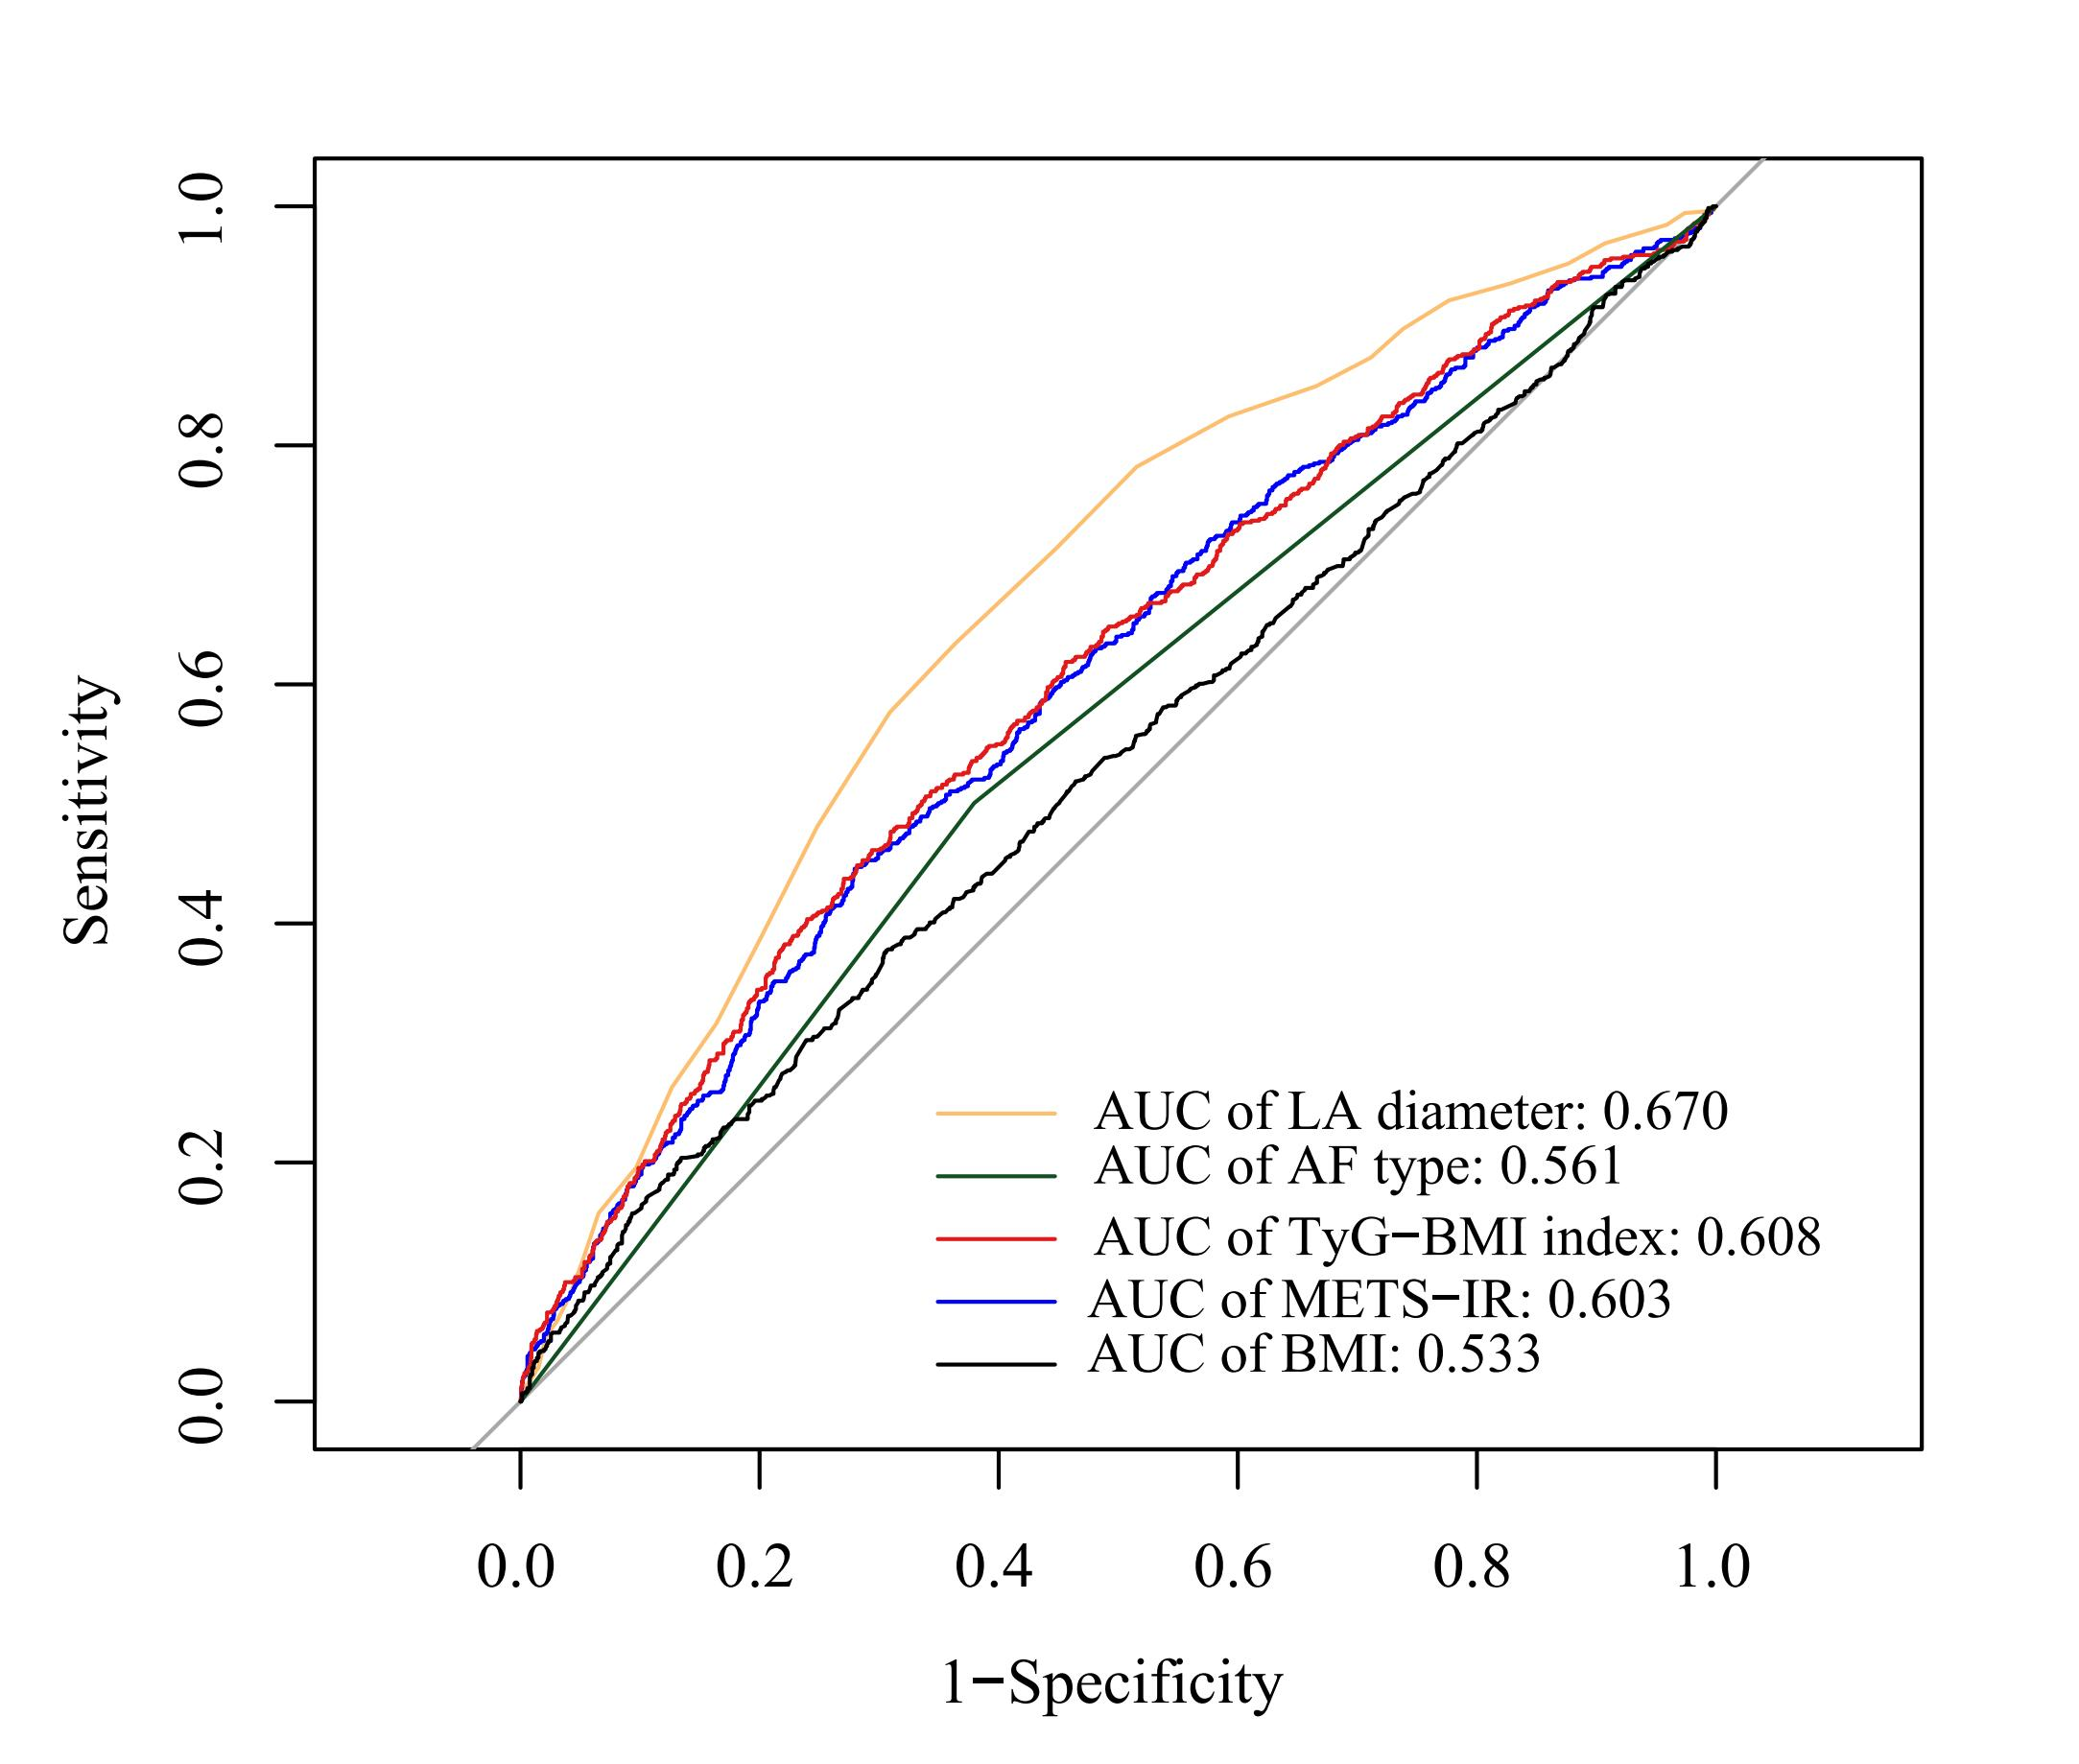
Figure. S5 Receiver operating curve for risk factors in the detection of AF recurrence following ablation. AUC, area under curve; BMI, body mass index; METS-IR, metabolic score for insulin resistance; LA, left atrial; TyG-BMI, triglyceride glucose-body mass index

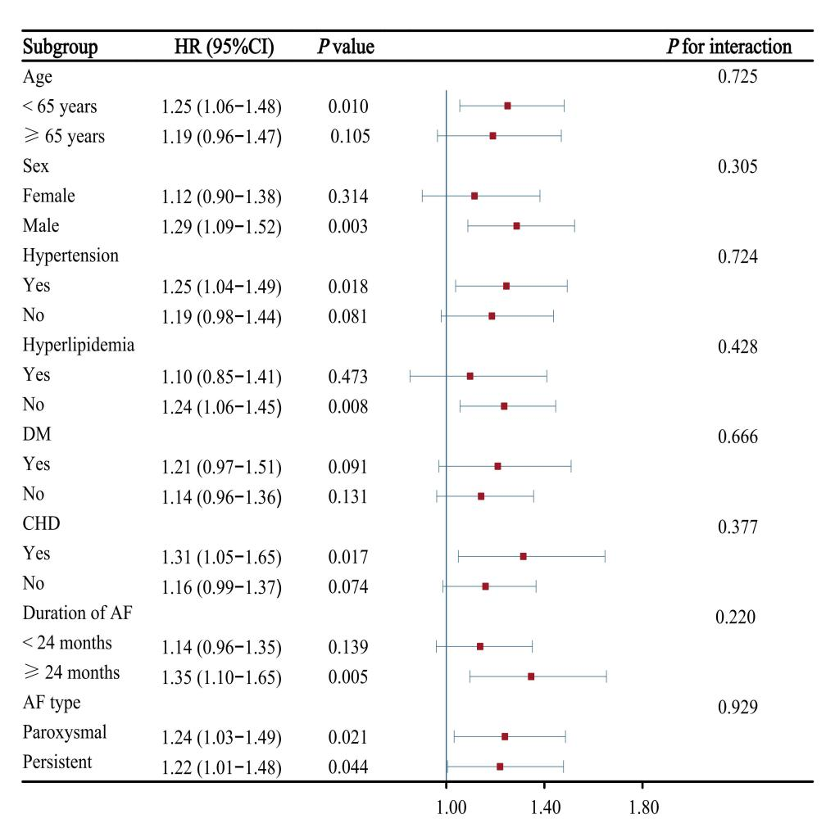
Fig. S6 Association between TyG index (per 1 unit increase) and AF recurrence following ablation in different subgroups. AF, atrial fibrillation; CHD, coronary heart disease; DM, diabetes mellitus; TyG, triglyceride and glucose

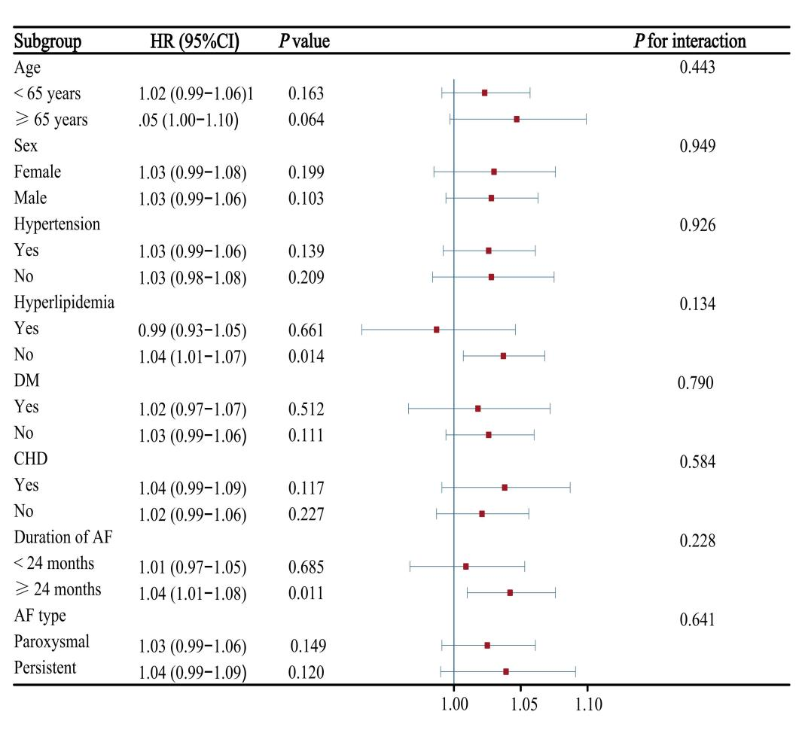
Fig. S7 Association between TG/HDL-C ratio (per 1 unit increase) and AF recurrence following ablation in different subgroups. AF, atrial fibrillation; CHD, coronary heart disease; DM, diabetes mellitus; TG/HDL-C, triglyceride to high-density lipoprotein cholesterol

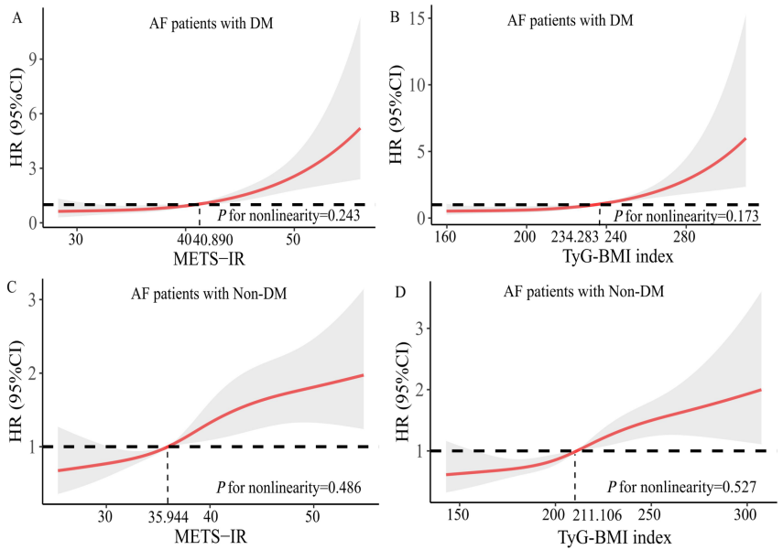
Fig. S8 Restricted cubic spline curves for AF recurrence by METS-IR and TyG-BMI index after covariate adjustment in DM and non-DM patients. The risk factors adjusted for in this analysis included age, sex, current drinking, hyperlipidemia, coronary heart disease, duration of AF (≥ 24 months), AF type, HbA1c, left atrial diameter, platelet, CHA₂DS₂-VASc. AF, atrial fibrillation; CI, confidence interval; HR, hazard ratio; METS-IR, metabolic score for insulin resistance; TyG-BMI, triglyceride glucose-body mass index

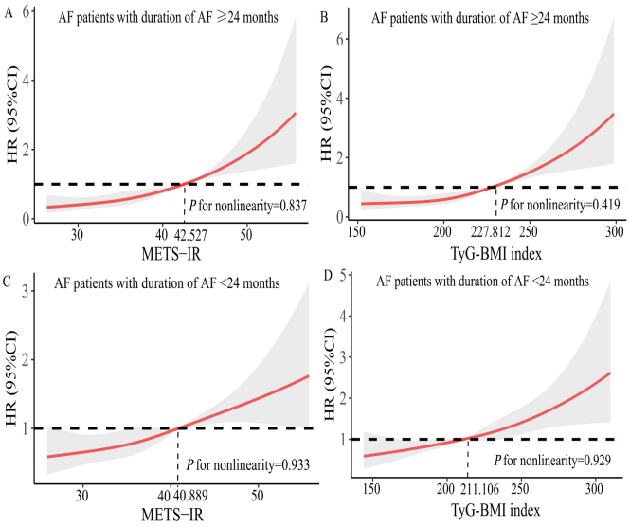
Fig. S9 Restricted cubic spline curves for AF recurrence by METS-IR ans TyG-BMI index after covariates adjustment in duration of AF ≥ 24 and < 24 months patients. The risk factors adjusted for in this analysis included age, sex, current drinking, hyperlipidemia, coronary heart disease, diabetes mellitus, AF type, HbA1c, left atrial diameter, platelet, CHA₂DS₂-VASc. AF, atrial fibrillation; CI, confidence interval; HR, hazard ratio; METS-IR, metabolic score for insulin resistance; TyG-BMI, triglyceride glucose-body mass index

Table S1 Association between non-insulin-based IR indexes and AF recurrence after ablation stratified by the statins medication at admission.
 | HR (95%CI) | P value | P for interaction
TyG index (per 1 unit increase) |  |  | 0.239
Statins | 1.09 (0.87-1.37) | 0.456
Non-statins | 1.29 (1.10-1.52) | 0.002
METS-IR (per 1 unit increase) |  |  | 0.974
Statins | 1.04 (1.03-1.06) | <0.001
Non-statins | 1.04 (1.03-1.06) | <0.001
TyG-BMI index (per 10 unit increase) |  |  | 0.998
Statins | 1.10 (1.06-1.14) | <0.001
Non-statins | 1.10 (1.07-1.12) | <0.001
TG/HDL-C ratio (per 1 unit increase) |  |  | 0.231
Statins | 1.00 (0.94-1.06) | 0.893
Non-statins | 1.04 (1.01-1.07) | 0.014
CI, confidence interval; HR, hazard ratio; IR, insulin resistance; METS-IR, metabolic score for insulin resistance; TyG, triglyceride and glucose; TyG-BMI, triglyceride glucose-body mass index; TG/HDL-C, triglyceride to high-density lipoprotein cholesterol

Table S2 Association between METS-IR or TyG-BMI index with DM or non-DM and AF recurrence after ablation.
Variables | HR (95%CI) | P value
METS-IR <40.899 without DM | Reference
METS-IR <40.899 with DM | 0.99 (0.75-1.32) | 0.962
METS-IR ≥40.899 without DM | 1.42 (1.17-1.73) | <0.001
METS-IR ≥40.899 with DM | 2.06 (1.57-2.70) | <0.001
TyG-BMI index <225.501 without DM | Reference
TyG-BMI index <225.501 with DM | 0.99 (0.74-1.31) | 0.922
TyG-BMI index ≥225.501 without DM | 1.37 (1.13-1.66) | 0.001
TyG-BMI index ≥225.501 with DM | 1.94 (1.48-2.53) | <0.001

DM, diabetes mellitus; HR, hazard ratio; CI, confidence interval; METS-IR, metabolic score for insulin resistance; TyG-BMI, triglyceride glucose-body mass index

Table S3 Added predictive ability and reclassification statistics of METS-IR and TyG-BMI index in DM and non-DM patients.
 | C-statistic  (95% CI) | P value | IDI (95% CI) | P value | Continuous  NRI (95% CI) | P value
AF patients with DM
Baseline risk model | 0.680 (0.637-0.723) | Reference | Reference |  | Reference
+METS-IR | 0.709 (0.667-0.752) | 0.042 | 0.061 (0.029-0.095) | 0.002 | 0.213 (0.099-0.292) | 0.002
+TyG-BMI index | 0.711 (0668-0.753) | 0.041 | 0.071 (0.036-0.111) | <0.001 | 0.242 (0.156-0.312) | <0.001
AF patients with non-DM
Baseline risk model | 0.695 (0.666-0.723) | Reference | Reference |  | Reference
+METS-IR | 0.702 (0.674-0.730) | 0.120 | 0.004 (-0.007-0.015) | 0.380 | 0.053 (-0.037-0.120) | 0.202
+TyG-BMI index | 0.703 (0.675-0.731) | 0.111 | 0.006 (-0.005-0.018) | 0.264 | 0.094 (-0.003-0.147) | 0.060
AF, atrial fibrillation; CI, confidence interval; DM, diabetes mellitus; IDI, integrated discrimination improvement; METS-IR, metabolic score for insulin resistance; NRI, net reclassification improvement; TyG-BMI, triglyceride glucose-body mass index
Baseline risk model: age, sex, body mass index, current drinking, hyperlipidemia, coronary heart disease, duration of AF (≥ 24 months), AF type, fasting blood glucose, HbA1c, left atrial diameter, platelet, CHA₂DS₂-VASc score

Table S4 Association between METS-IR or TyG-BMI index with duration of AF ≥ 24
or < 24months and AF recurrence after ablation.
Variables | HR (95%CI) | P value
METS-IR <40.899 with D1 | Reference
METS-IR <40.899 with D2 | 1.59 (1.29-1.96) | <0.001
METS-IR ≥40.899 with D1 | 2.02 (1.59-2.56) | <0.001
METS-IR ≥40.899 with D2 | 2.18 (1.74-2.74) | <0.001
TyG-BMI index <225.501 with D1 | Reference
TyG-BMI index <225.501 with D2 | 1.56 (1.27-1.93) | <0.001
TyG-BMI index ≥225.501 with D1 | 1.88 (1.49-2.38) | <0.001
TyG-BMI index ≥225.501 with D2 | 2.10 (1.68-2.63) | <0.001

HR, hazard ratio; CI, confidence interval; METS-IR, metabolic score for insulin resistance; TyG-BMI, triglyceride glucose-body mass index. D1, duration of AF <24 months; D2, duration of AF ≥24 months

Table S5 Added predictive ability and reclassification statistics of METS-IR and TyG-BMI index in duration of AF ≥ 24 and <24 months patients.
 | C-statistic  (95% CI) | P value | IDI (95% CI) | P value | Continuous  NRI (95% CI) | P value
AF patients with duration of AF ≥ 24 months
Baseline risk model | 0.699 (0.664-0.733) | Reference | Reference |  | Reference
+METS-IR | 0.723 (0.689-0.757) | 0.024 | 0.048 (0.023-0.072) | 0.002 | 0.191 (0.108-0.253) | 0.002
+TyG-BMI index | 0.722 (0687-0.756) | 0.038 | 0.053 (0.028-0.081) | <0.001 | 0.212 (0.122-0.274) | <0.001
AF patients with duration of AF < 24 months
Baseline risk model | 0.681 (0.649-0.714) | Reference | Reference |  | Reference
+METS-IR | 0.684 (0.651-0.717) | 0.525 | 0.004 (-0.010-0.018) | 0.669 | 0.068 (-0.049-0.134) | 0.244
+TyG-BMI index | 0.686 (0.653-0.719) | 0.392 | 0.007 (-0.007-0.023) | 0.300 | 0.094 (-0.006-0.161) | 0.068
AF,atrial fibrillation; CI, confidence interval; IDI, integrated discrimination improvement; METS-IR, metabolic score for insulin resistance; NRI, net reclassification improvement; TyG-BMI, triglyceride glucose-body mass index
Baseline risk model: age, sex, body mass index, current drinking, hyperlipidemia, coronary heart disease, diabetes mellitus, AF type, fasting blood glucose, HbA1c, left atrial diameter, platelet, CHA₂DS₂-VASc score

