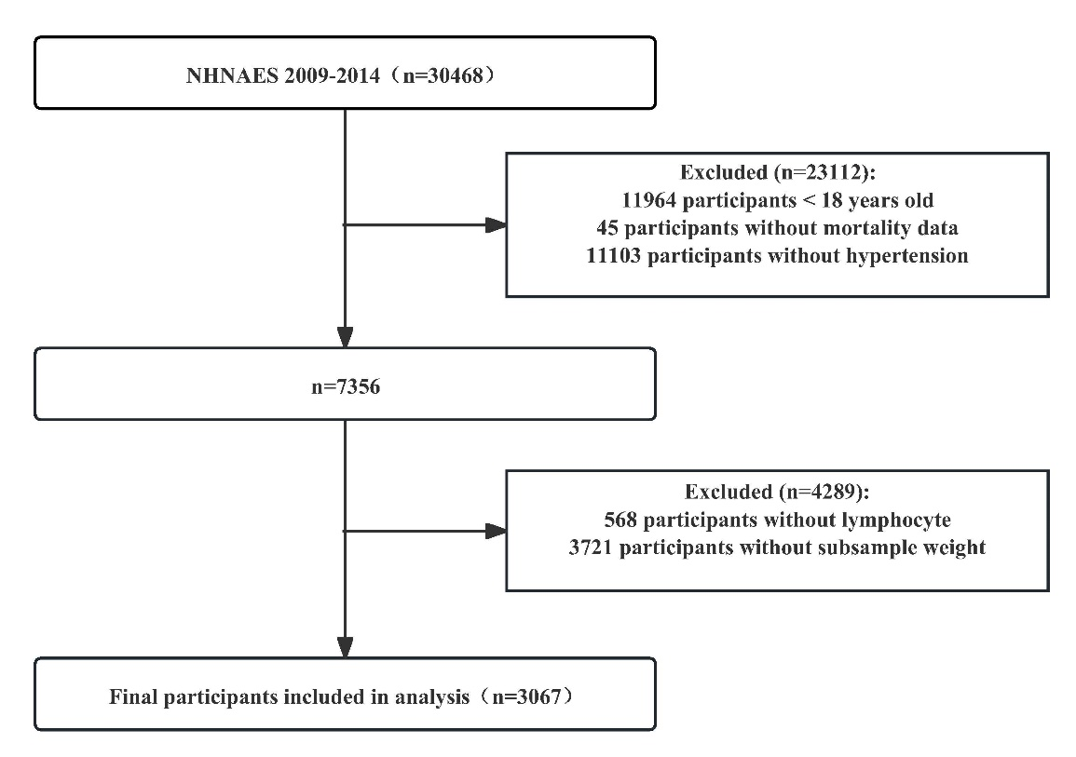
Figure S1. The flow chart of participants in the current study

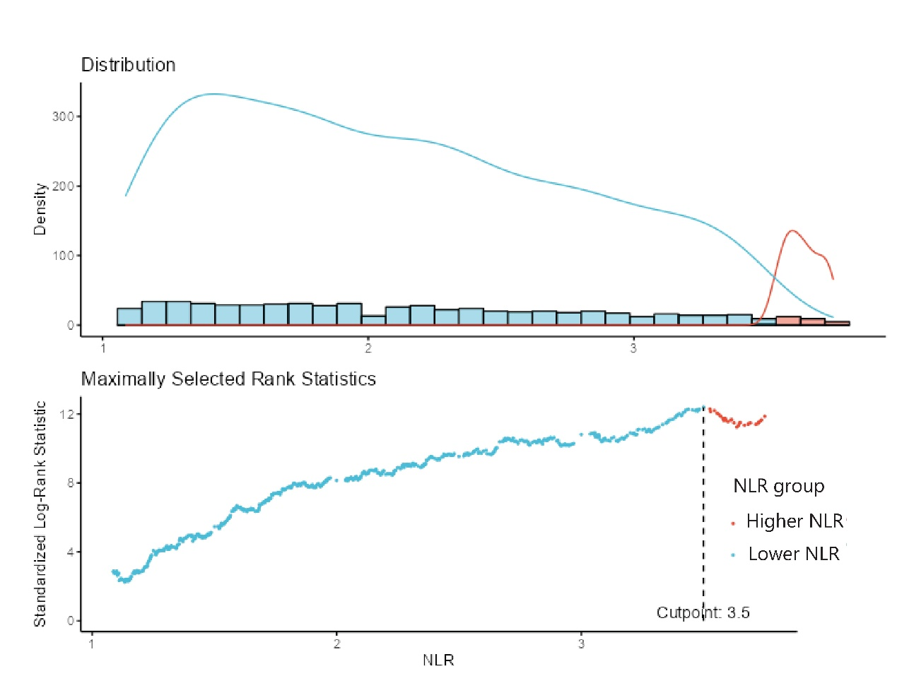
Figure S2. The cutoff point was calculated using the maximally selected rank statistics based on the ‘maxstat’ package.

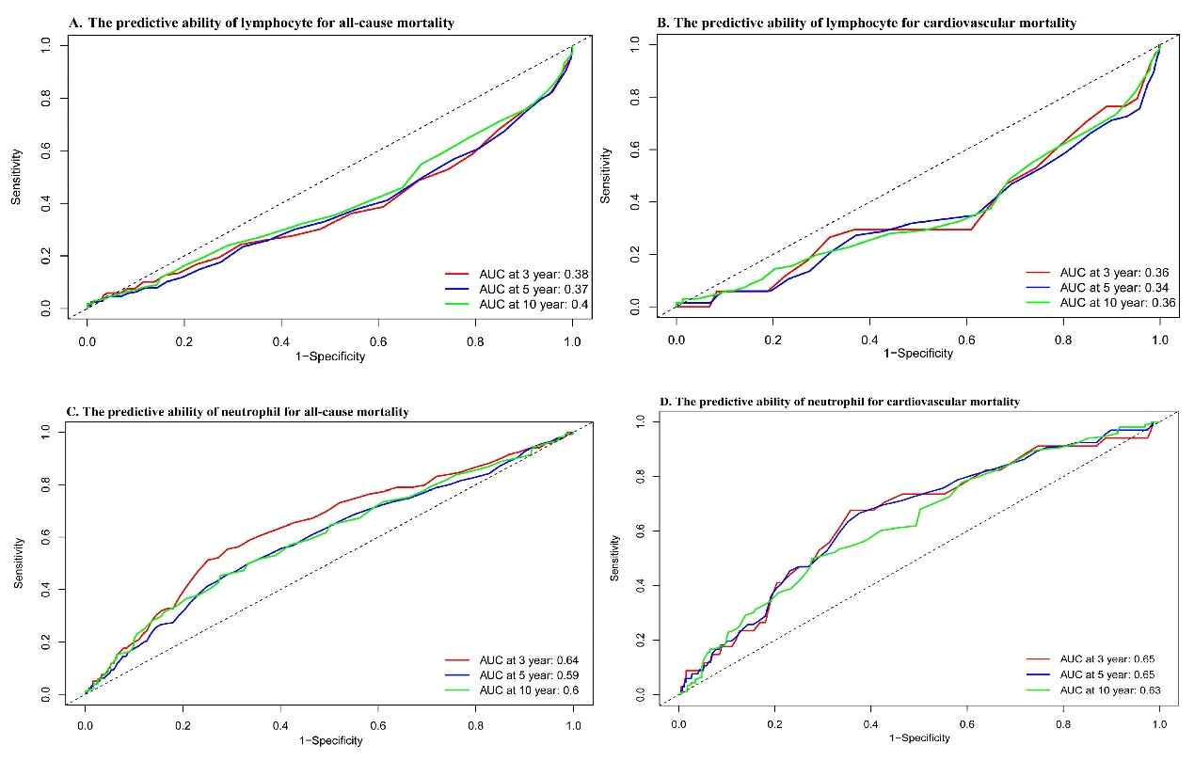
Figure S3. The predictive ability of neutrophil and lymphocyte alone for all‑cause and cardiovascular mortality in patients with hypertension

Table S1. Effect of NLR level on cardiovascular mortality: adjusted hazard ratios from segmented cox regression analysis
Inflection point | Adjusted HR (95% CI) | P-value
<2.3 | 2.1(1.09, 4.05) | 0.027
≥2.3 | 1.12(1.06, 1.18) | <0.001
Log-likelihood ratio | <0.001
HR was adjusted for age, sex, race, BMI, smoking status, education level, diabetes, history of CVD, HDL, LDL, TG, TC, HbA1c, and the eGFR.

