Supplemental Materials
Supplemental Table 1. Cox proportional hazard ratios for ACM at ICU and in-hospital.
Categories | Model 1 |  |  | Model 2 |  |  | Model 3
Categories | HR (95%CI) | P-value | P for trend | HR (95%CI) | P-value | P for trend | HR (95%CI) | P-value | P for trend
ICU mortality
Continues variable Per unit | 1.22(0.92-1.61) | 0.167 |  | 1.32(0.98-1.77) | 0.063 |  | 1.31(0.96-1.79) | 0.092
Quartile |  |  | 0.470 |  |  | 0.247 |  |  | 0.394
Q1(N=369) | Reference |  |  | Reference |  |  | Reference
Q2(N=367) | 0.89(0.48-1.63) | 0.698 |  | 0.88(0.48-1.62) | 0.681 |  | 0.92(0.50-1.71) | 0.797
Q3(N=369) | 0.87(0.48-1.57) | 0.641 |  | 0.91(0.50-1.67) | 0.769 |  | 0.95(0.52-1.76) | 0.871
Q4(N=370) | 1.24(0.72-2.12) | 0.435 |  | 1.39(0.80-2.42) | 0.246 |  | 1.40(0.77-2.54) | 0.273
In-hospital mortality
Continues variable Per unit | 1.21(0.97-1.51) | 0.085 |  | 1.32(1.05-1.66) | 0.016 |  | 1.29(1.01-1.64) | 0.042
Quartile |  |  | 0.261 |  |  | 0.153 |  |  | 0.250
Q1(N=369) | Reference |  |  | Reference |  |  | Reference
Q2(N=367) | 1.15(0.73-1.84) | 0.546 |  | 1.17(0.73-1.85) | 0.517 |  | 1.18(0.74-1.89) | 0.483
Q3(N=369) | 0.86(0.52-1.41) | 0.544 |  | 0.95(0.57-1.59) | 0.853 |  | 0.93(0.55-1.57) | 0.773
Q4(N=370) | 1.32(0.84-2.06) | 0.232 |  | 1.50(0.94-2.37) | 0.09 |  | 1.40(0.87-2.26) | 0.165
HR: hazard ratio; CI: confidence interval; ACM: all-cause mortality; ICU: intensive care unit. Model 1: Unadjusted; Model 2: Adjusted age, sex, and ethnicity; Model 3: adjusted age, sex, ethnicity, hypertension, diabetes, RF, liver disease, and IVH.

Supplemental Figure 1. Kaplan-Meier survival analysis curves for (A) ICU and (B) in-hospital ACM.
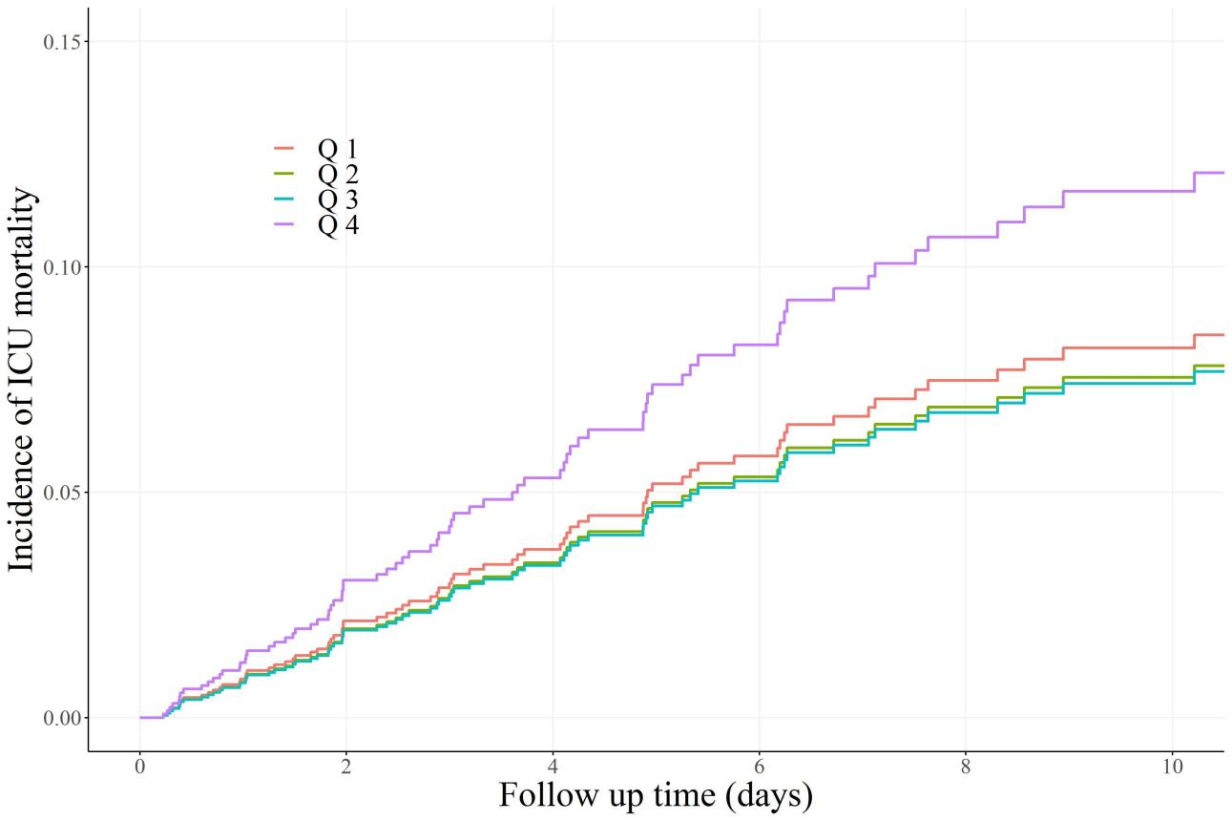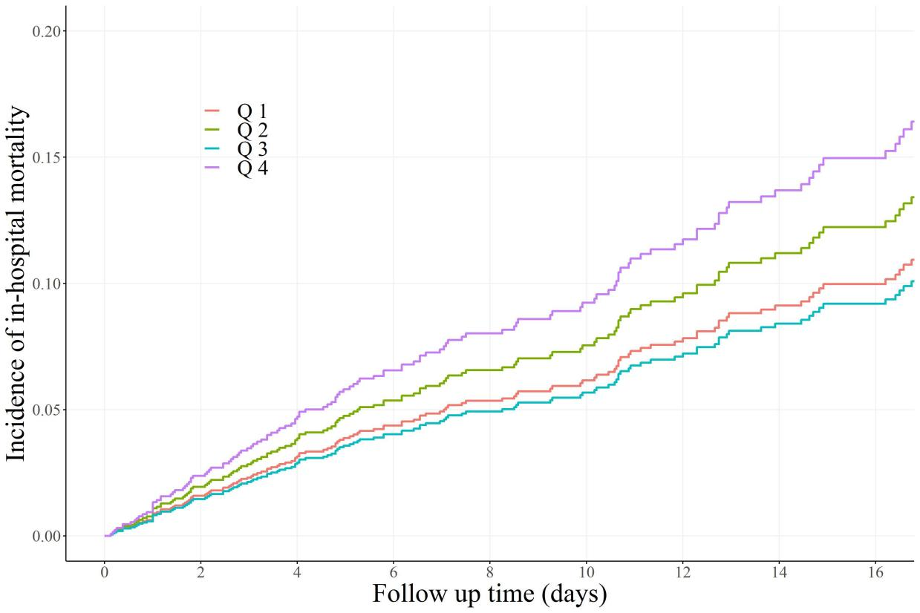
- (B)
ACM: all-cause mortality; ICU: intensive care unit.

Supplemental Figure 2. Restricted cubic spline curve for (A) ICU and (B) in-hospital ACM.
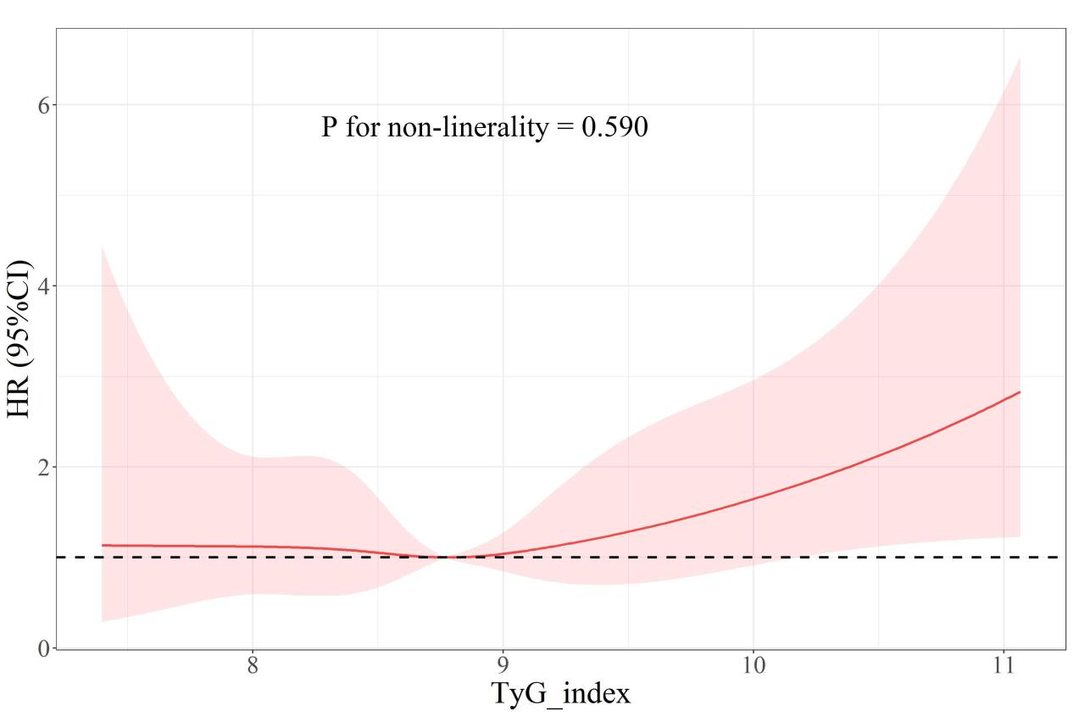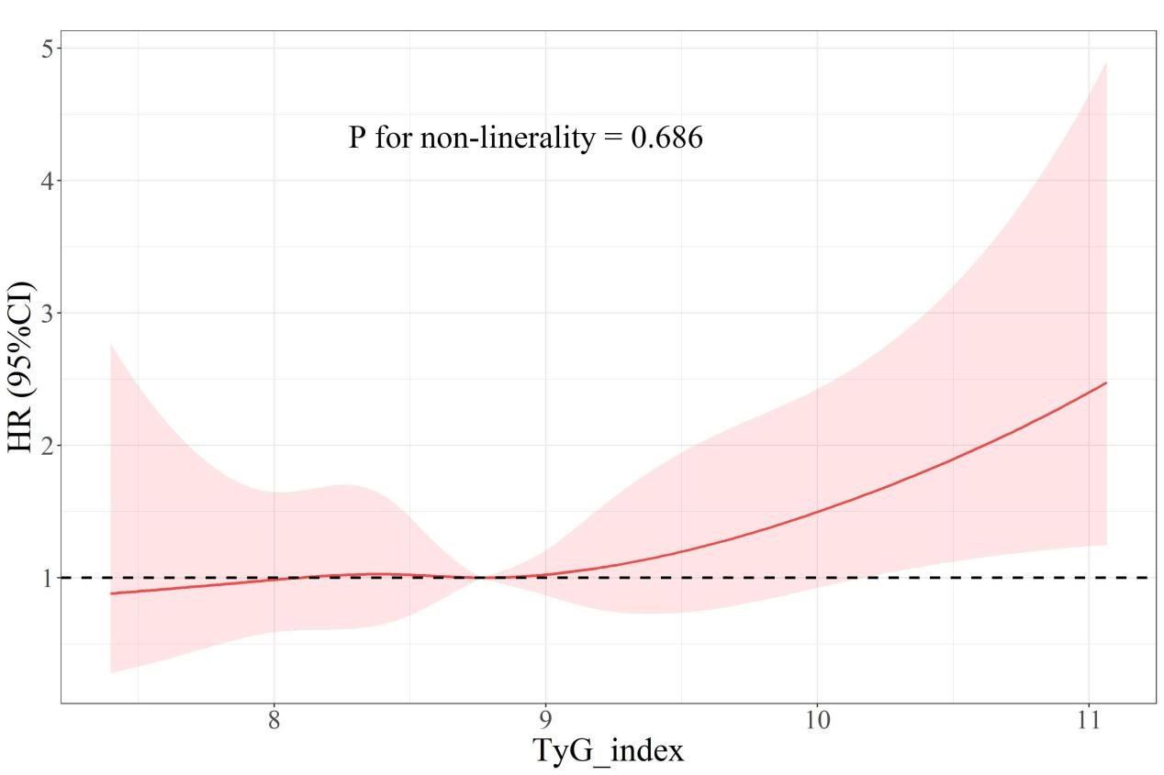
- (B)
HR, hazard ratio; CI, confidence interval; TyG index, triglyceride-glucose index; ACM: all-cause mortality; ICU: intensive care unit.

Supplemental Figure 3. Forest plots of hazard ratios for (A) ICU and (B) in-hospital ACM in different subgroups.
- (B)
HR, hazard ratio; CI, confidence interval; ACM: all-cause mortality. HRs were adjusted for age, sex, ethnicity, hypertension, diabetes, RF, liver disease, and IVH.

