Additional files
Table S1 Baseline characteristics of all participants according to the TyG index
Characteristic | Overall | Q1 (n = 2084) | Q2 (n = 2084) | Q3 (n = 2083) | Q4(n = 2084) | P-value
 | (n = 8335) | (6.79-8.36) | (8.37-8.75) | (8.76-9.18) | (9.19-13.40)
Age, years | 57 (12) | 54 (12) | 57 (12) | 58 (12) | 58 (12) | <0.001
Sex |  |  |  |  |  | <0.001
male | 4,170 (48%) | 892 (38%) | 1,046 (49%) | 1,057 (49%) | 1,175 (57%)
female | 4,165 (52%) | 1,192 (62%) | 1,038 (51%) | 1,026 (51%) | 909 (43%)
Race |  |  |  |  |  | <0.001
Mexican American | 1,325 (5.3%) | 200 (3.4%) | 293 (4.9%) | 349 (5.7%) | 483 (7.8%)
Other Hispanic | 553 (3.4%) | 105 (2.5%) | 127 (2.8%) | 176 (4.9%) | 145 (3.5%)
Non-Hispanic White | 4,431 (76%) | 1,064 (75%) | 1,120 (76%) | 1,143 (76%) | 1,104 (77%)
Non-Hispanic Black | 1,562 (9.8%) | 602 (15%) | 421 (10%) | 297 (7.3%) | 242 (5.5%)
Other race | 464 (5.4%) | 113 (4.1%) | 123 (5.8%) | 118 (5.8%) | 110 (6.1%)
Education |  |  |  |  |  | <0.001
Under high school | 1,250 (7.4%) | 213 (5.1%) | 290 (6.9%) | 315 (8.1%) | 432 (10%)
High school or equivalent | 3,178 (35%) | 708 (29%) | 782 (35%) | 818 (37%) | 870 (42%)
Above high school | 3,907 (57%) | 1,163 (66%) | 1,012 (58%) | 950 (55%) | 782 (48%)
Family PIR | 3.22 (1.59) | 3.40 (1.58) | 3.27 (1.59) | 3.11 (1.58) | 3.05 (1.60) | <0.001
BMI, kg/m² | 29 (6) | 27 (6) | 29 (7) | 30 (6) | 31 (6) | <0.001
Smoking status |  |  |  |  |  | <0.001
Current smoker | 1,595 (19%) | 373 (17%) | 390 (18%) | 390 (21%) | 442 (22%)
Former smoker | 2,722 (32%) | 607 (29%) | 644 (30%) | 711 (33%) | 760 (36%)
Never smoker | 4,018 (49%) | 1,104 (54%) | 1,050 (51%) | 982 (47%) | 882 (42%)
Total cholesterol, mg/dL | 204 (42) | 193 (36) | 200 (36) | 207 (41) | 219 (50) | <0.001
Triglyceride, mg/dL | 148 (136) | 68 (15) | 105 (16) | 150 (27) | 288 (226) | <0.001
HbA1C, % | 5.70 (0.92) | 5.41 (0.47) | 5.54 (0.53) | 5.68 (0.67) | 6.25 (1.49) | <0.001
Fasting Glucose, mg/dL | 108 (31) | 95 (11) | 102 (14) | 107 (19) | 130 (52) | <0.001
Insulin, uU/mL | 12 (12) | 8 (7) | 11 (7) | 13 (14) | 18 (15) | <0.001
TyG index | 8.78 (0.64) | 8.06 (0.24) | 8.56 (0.11) | 8.96 (0.12) | 9.66 (0.49) | <0.001
CVD | 1,339 (13%) | 254 (9.0%) | 310 (11%) | 351 (14%) | 424 (17%) | <0.001
Heart failure | 380 (3.5%) | 63 (2.3%) | 83 (2.6%) | 92 (3.7%) | 142 (5.6%) | <0.001
CHD | 529 (5.4%) | 93 (3.8%) | 119 (4.7%) | 145 (6.3%) | 172 (7.2%) | <0.001
angina | 363 (4.0%) | 52 (2.3%) | 89 (3.7%) | 102 (4.4%) | 120 (5.6%) | <0.001
Heart attack | 550 (5.4%) | 100 (3.5%) | 131 (5.3%) | 135 (5.4%) | 184 (7.5%) | <0.001
Stroke | 439 (4.0%) | 98 (3.3%) | 102 (3.6%) | 114 (4.4%) | 125 (4.8%) | 0.12
Hypertension | 1,669 (16%) | 337 (12%) | 388 (14%) | 424 (18%) | 520 (21%) | <0.001
Diabetes mellitus | 1,899 (17%) | 153 (5.7%) | 283 (8.8%) | 485 (18%) | 978 (37%) | <0.001
Antihyperlipidemic agents | 55 (0.5%) | 4 (<0.1%) | 16 (0.8%) | 12 (0.6%) | 23 (0.6%) | 0.022
Antidiabetic agents | 193 (1.7%) | 14 (0.4%) | 27 (1.0%) | 48 (1.6%) | 104 (4.1%) | <0.001
Pain | 2,344 (28%) | 535 (24%) | 558 (26%) | 575 (27%) | 676 (33%) | <0.001
All values are presented as mean±SD, or counts (weighted, proportion)
PIR: poverty income ratio; HbA1C: hemoglobin type A1C; CVD: cardiovascular disease; CHD: coronary heart disease
Table S2 Baseline characteristics of participants with chest pain, according to the TyG index
Characteristic | Overall | Q1 (n = 535) | Q2 (n = 558) | Q3 (n = 575) | Q4 (n = 676) | P-value
 | (n = 2334) | (6.79-8.36) | (8.37-8.75) | (8.76-9.18) | (9.19-13.40)
Age, years | 57 (12) | 55 (12) | 57 (12) | 59 (11) | 58 (12) | <0.001
Sex |  |  |  |  |  | <0.001
male | 1,169 (48%) | 228 (39%) | 285 (50%) | 283 (46%) | 373 (56%)
female | 1,175 (52%) | 307 (61%) | 273 (50%) | 292 (54%) | 303 (44%)
Race |  |  |  |  |  | <0.001
Mexican American | 330 (4.7%) | 39 (2.6%) | 71 (4.0%) | 87 (5.3%) | 133 (6.6%)
Other Hispanic | 131 (3.6%) | 19 (2.9%) | 30 (3.0%) | 46 (5.2%) | 36 (3.1%)
Non-Hispanic White | 1,306 (76%) | 260 (69%) | 316 (78%) | 327 (77%) | 403 (78%)
Non-Hispanic Black | 460 (11%) | 195 (22%) | 105 (9.4%) | 87 (7.9%) | 73 (6.0%)
Other race | 117 (5.1%) | 22 (3.2%) | 36 (6.0%) | 28 (4.9%) | 31 (6.2%)
Education |  |  |  |  |  | <0.001
Under high school | 374 (9.2%) | 64 (7.4%) | 87 (9.0%) | 73 (9.1%) | 150 (11%)
High school or equivalent | 914 (38%) | 167 (29%) | 213 (36%) | 239 (42%) | 295 (45%)
Above high school | 1,056 (53%) | 304 (64%) | 258 (55%) | 263 (49%) | 231 (45%)
Family PIR | 3.00 (1.63) | 3.14 (1.66) | 3.02 (1.59) | 2.97 (1.62) | 2.88 (1.64) | 0.071
BMI, kg/m² | 30 (6) | 27 (6) | 29 (6) | 30 (6) | 32 (6) | <0.001
Smoking status |  |  |  |  |  | 0.015
Current smoker | 541 (24%) | 122 (21%) | 125 (26%) | 127 (24%) | 167 (24%)
Former smoker | 812 (34%) | 158 (31%) | 174 (30%) | 211 (36%) | 269 (41%)
Never smoker | 991 (42%) | 255 (48%) | 259 (45%) | 237 (41%) | 240 (35%)
Total cholesterol, mg/dL | 201 (44) | 187 (40) | 193 (36) | 202 (40) | 218 (51) | <0.001
Triglyceride, mg/dL | 158 (124) | 70 (15) | 106 (16) | 149 (29) | 288 (170) | <0.001
HbA1C, % | 5.77 (1.05) | 5.46 (0.52) | 5.53 (0.51) | 5.71 (0.73) | 6.32 (1.62) | <0.001
Fasting Glucose, mg/dL | 110 (35) | 95 (11) | 102 (14) | 108 (22) | 132 (56) | <0.001
Insulin, uU/mL | 13 (15) | 9 (8) | 11 (8) | 14 (24) | 17 (13) | <0.001
TyG index | 8.85 (0.66) | 8.08 (0.24) | 8.57 (0.11) | 8.95 (0.12) | 9.68 (0.50) | <0.001
CVD | 751 (27%) | 143 (23%) | 167 (24%) | 190 (29%) | 251 (32%) | 0.005
Heart failure | 237 (8.1%) | 39 (6.4%) | 49 (5.8%) | 62 (9.3%) | 87 (10%) | 0.030
CHD | 328 (13%) | 60 (11%) | 70 (10%) | 88 (15%) | 110 (14%) | 0.060
angina | 287 (11%) | 43 (8.4%) | 68 (10%) | 81 (14%) | 95 (13%) | 0.071
Heart attack | 377 (14%) | 71 (11%) | 87 (13%) | 88 (13%) | 131 (17%) | 0.2
Stroke | 197 (6.5%) | 41 (6.4%) | 46 (6.4%) | 50 (6.0%) | 60 (7.1%) | >0.9
Hypertension | 461 (16%) | 97 (13%) | 98 (14%) | 103 (16%) | 163 (20%) | 0.061
Diabetes mellitus | 610 (19%) | 55 (9.1%) | 88 (9.7%) | 144 (19%) | 323 (37%) | <0.001
Antihyperlipidemic agents | 23 (0.7%) | 1 (<0.1%) | 7 (0.8%) | 5 (1.1%) | 10 (0.8%) | 0.2
Antidiabetic agents | 61 (1.7%) | 4 (0.5%) | 5 (0.5%) | 17 (1.3%) | 35 (4.2%) | <0.001
All values are presented as mean±SD, or counts (weighted, proportion)
PIR: poverty income ratio; HbA1C: hemoglobin type A1C; CVD: cardiovascular disease; CHD: coronary heart disease

Table S3 Baseline characteristics of participants without chest pain, according to the TyG index
Characteristic | Overall | Q1 (n= 1549) | Q2 (n = 1526) | Q3 (n = 1508) | Q4 (n = 1408) | P-value
 | (n = 5991) | (6.79-8.36) | (8.37-8.75) | (8.76-9.18) | (9.19-13.40)
Age, years | 57 (12) | 54 (12) | 57 (12) | 58 (12) | 58 (12) | <0.001
Sex |  |  |  |  |  | <0.001
male | 3,001 (48%) | 664 (38%) | 761 (48%) | 774 (50%) | 802 (58%)
female | 2,990 (52%) | 885 (62%) | 765 (52%) | 734 (50%) | 606 (42%)
Race |  |  |  |  |  | <0.001
Mexican American | 995 (5.6%) | 161 (3.6%) | 222 (5.2%) | 262 (5.8%) | 350 (8.4%)
Other Hispanic | 422 (3.3%) | 86 (2.4%) | 97 (2.8%) | 130 (4.7%) | 109 (3.7%)
Non-Hispanic White | 3,125 (76%) | 804 (76%) | 804 (76%) | 816 (76%) | 701 (77%)
Non-Hispanic Black | 1,102 (9.3%) | 407 (13%) | 316 (10%) | 210 (7.1%) | 169 (5.3%)
Other race | 347 (5.5%) | 91 (4.4%) | 87 (5.7%) | 90 (6.2%) | 79 (6.0%)
Education |  |  |  |  |  | <0.001
Under high school | 876 (6.7%) | 149 (4.3%) | 203 (6.1%) | 242 (7.7%) | 282 (9.6%)
High school or equivalent | 2,264 (34%) | 541 (29%) | 569 (34%) | 579 (35%) | 575 (41%)
Above high school | 2,851 (59%) | 859 (67%) | 754 (60%) | 687 (57%) | 551 (49%)
Family PIR | 3.30 (1.57) | 3.49 (1.54) | 3.36 (1.58) | 3.17 (1.57) | 3.14 (1.58) | <0.001
BMI, kg/m² | 28.8 (6.4) | 26.4 (5.7) | 28.5 (6.6) | 29.7 (6.0) | 31.2 (6.2) | <0.001
Smoking status |  |  |  |  |  | 0.003
Current smoker | 1,054 (18%) | 251 (16%) | 265 (16%) | 263 (19%) | 275 (20%)
Former smoker | 1,910 (31%) | 449 (29%) | 470 (30%) | 500 (31%) | 491 (34%)
Never smoker | 3,027 (51%) | 849 (55%) | 791 (54%) | 745 (49%) | 642 (46%)
Total cholesterol, mg/dL | 205 (41) | 195 (35) | 202 (36) | 209 (42) | 219 (50) | <0.001
Triglyceride, mg/dL | 145 (141) | 68 (15) | 105 (16) | 150 (26) | 288 (248) | <0.001
HbA1C, % | 5.68 (0.87) | 5.39 (0.45) | 5.54 (0.54) | 5.67 (0.65) | 6.22 (1.42) | <0.001
Fasting Glucose, mg/dL | 107 (29) | 95 (11) | 102 (14) | 107 (18) | 129 (50) | <0.001
Insulin, uU/mL | 12 (10) | 8 (6) | 10 (7) | 13 (9) | 18 (15) | <0.001
TyG index | 8.75 (0.63) | 8.05 (0.24) | 8.56 (0.11) | 8.96 (0.12) | 9.64 (0.49) | <0.001
CVD | 588 (7.4%) | 111 (4.6%) | 143 (7.0%) | 161 (9.0%) | 173 (9.9%) | <0.001
Heart failure | 143 (1.8%) | 24 (0.9%) | 34 (1.5%) | 30 (1.6%) | 55 (3.3%) | <0.001
CHD | 201 (2.7%) | 33 (1.5%) | 49 (2.7%) | 57 (3.1%) | 62 (3.7%) | 0.004
angina | 76 (1.1%) | 9 (0.3%) | 21 (1.4%) | 21 (1.0%) | 25 (2.0%) | 0.002
Heart attack | 173 (2.2%) | 29 (1.1%) | 44 (2.6%) | 47 (2.6%) | 53 (3.0%) | 0.003
Stroke | 242 (3.0%) | 57 (2.3%) | 56 (2.6%) | 64 (3.8%) | 65 (3.6%) | 0.059
Hypertension | 1,208 (16%) | 240 (12%) | 290 (15%) | 321 (18%) | 357 (21%) | <0.001
Diabetes mellitus | 1,289 (15%) | 98 (4.6%) | 195 (8.5%) | 341 (17%) | 655 (36%) | <0.001
Antihyperlipidemic agents | 32 (0.4%) | 3 (<0.1%) | 9 (0.8%) | 7 (0.4%) | 13 (0.5%) | 0.11
Antidiabetic agents | 132 (1.7%) | 10 (0.4%) | 22 (1.2%) | 31 (1.7%) | 69 (4.0%) | <0.001
All values are presented as mean±SD, or counts (weighted, proportion)
PIR: poverty income ratio; HbA1C: hemoglobin type A1C; CVD: cardiovascular disease; CHD: coronary heart disease

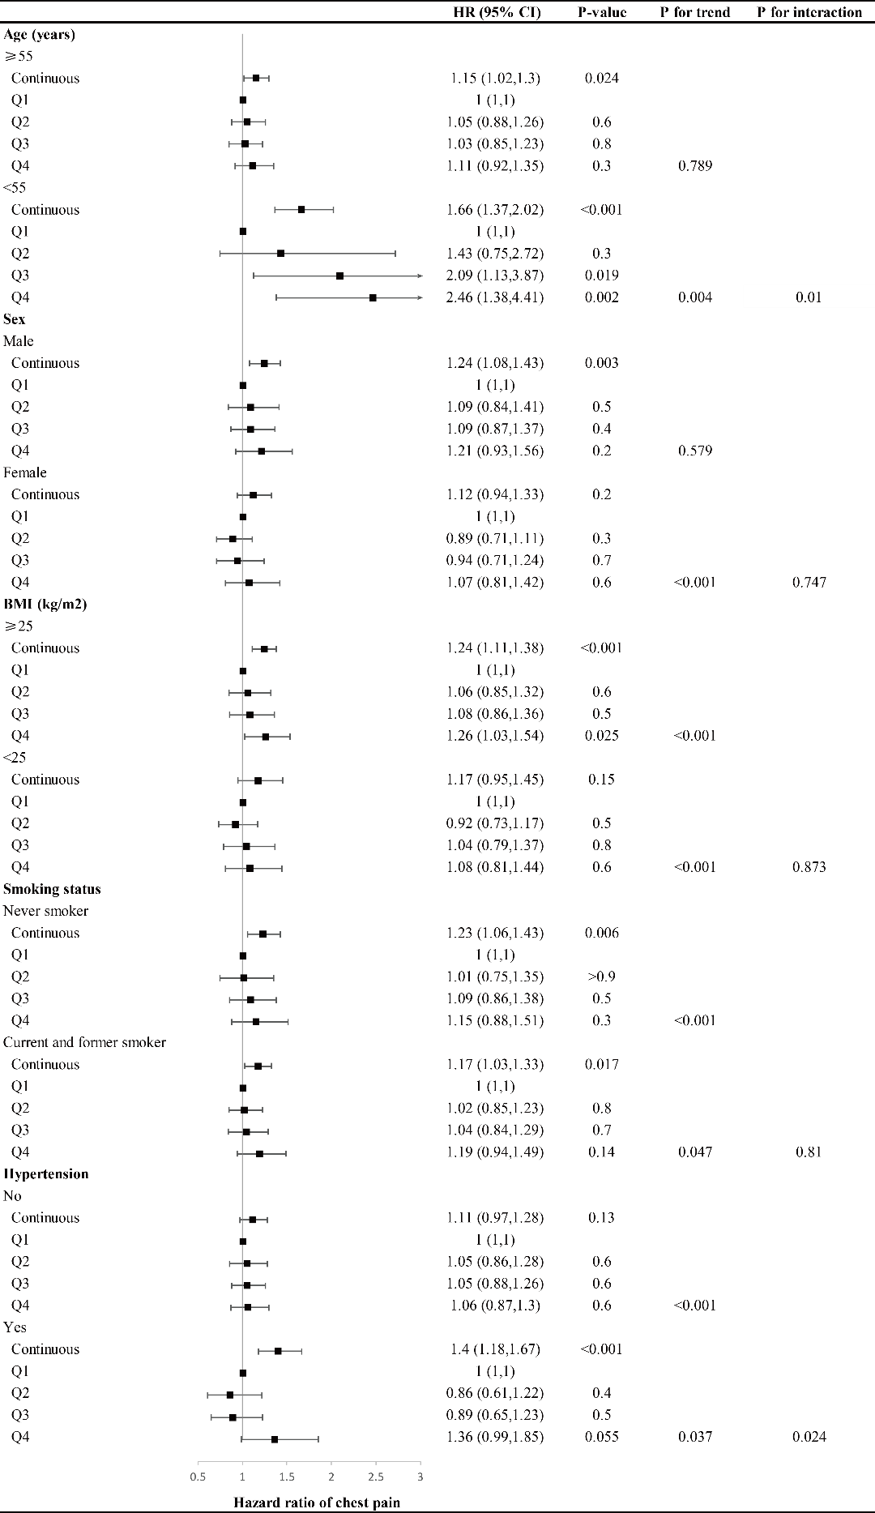
Fig. S1 Subgroup analysis of association between the TyG index and all-cause mortality in all the participants. Adjusted for age, sex, BMI, races, education, smoking status, total cholesterol, and hypertension, heart failure, coronary heart disease, angina, heart attack, stroke, antihyperlipidemic agents, and antidiabetic agents. HR: Hazard ratio, CI: confidence interval.
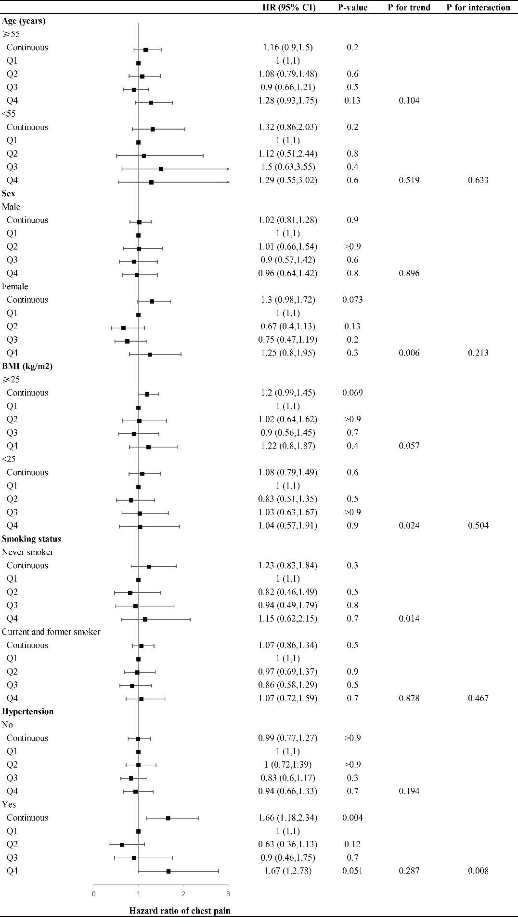
Fig. S2 Subgroup analysis of association between the TyG index and all-cause mortality in participants with chest pain. Adjusted for age, sex, BMI, races, education, smoking status, total cholesterol, and hypertension, heart failure, coronary heart disease, angina, heart attack, stroke, antihyperlipidemic agents, and antidiabetic agents. HR: Hazard ratio, CI: confidence interval.
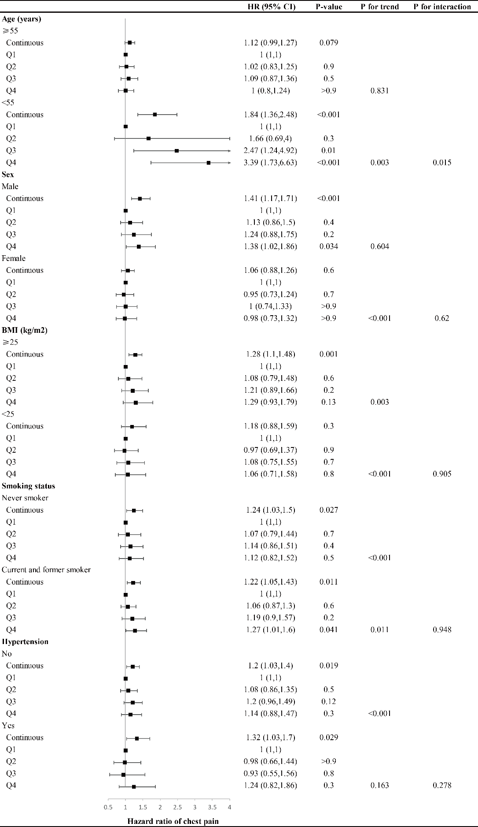
Fig. S3 Subgroup analysis of association between the TyG index and all-cause mortality in participants without chest pain. Adjusted for age, sex, BMI, races, education, smoking status, total cholesterol, and hypertension, heart failure, coronary heart disease, angina, heart attack, stroke, antihyperlipidemic agents, and antidiabetic agents. HR: Hazard ratio, CI: confidence interval.

