Supplementary Information

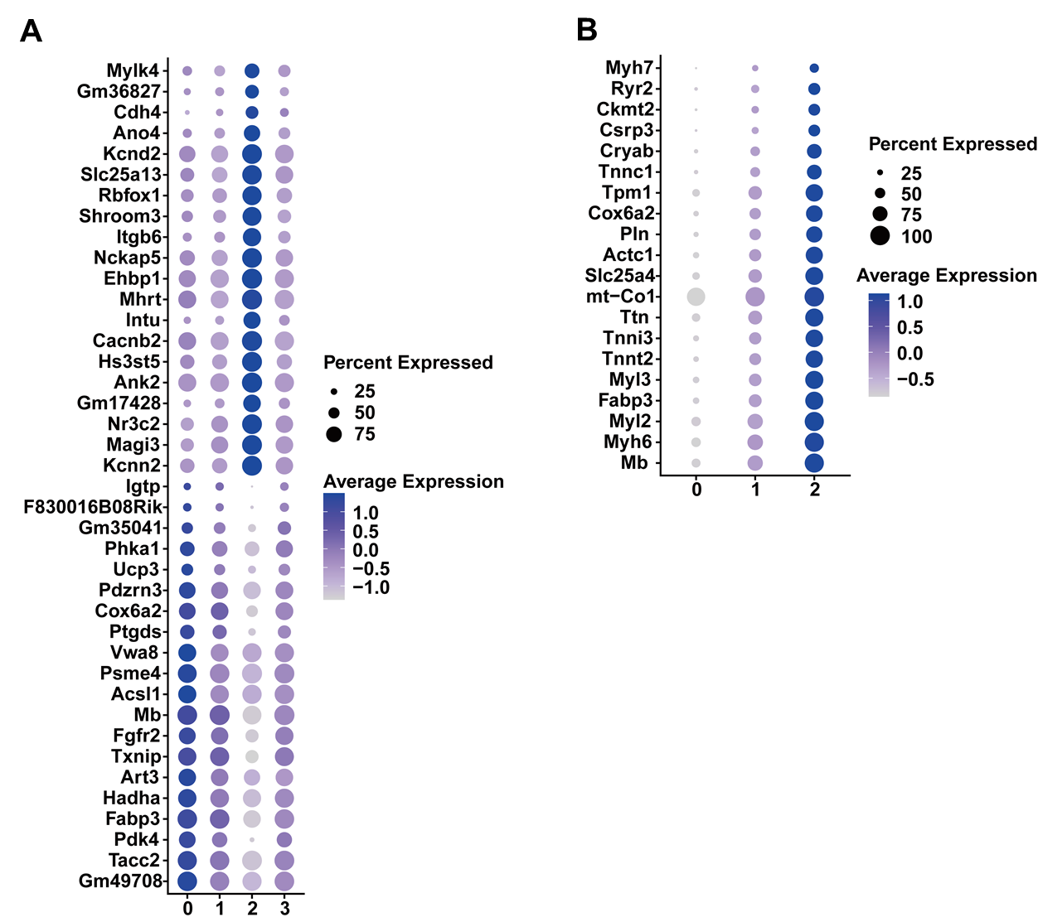
Supplementary Figure 1. Cluster-specific marker genes of cardiomyocytes and fibroblasts.
- Bubble plot of cluster-specific marker genes of cardiomyocytes. The diameter of the dot represents the proportion of cells that express the corresponding gene and the density of the dot represents the average gene expression level among all subpopulations.
B. Bubble plot of cluster-specific marker genes of fibroblasts. The diameter of the dot represents the proportion of cells that express the corresponding gene and the density of the dot represents the average gene expression level among all subpopulations.

Supplementary Figure 2. Bubble plot of cluster-specific marker genes in endothelial cells. The diameter of the dot represents the proportion of cells that express the corresponding gene, and the density of the dot represents the average gene expression level among all subpopulations.

