Additional file:
Insulin sensitivity estimates and their association with coronary artery disease in type 1 diabetes. Does it matter?
Stefan Mutter, PhD^{1,2,3}, Erika B Parente, PhD^{1,2,3}, Andrzej S Januszewski, PhD^{4,5}, Johan R Simonsen, DMSc^{1,2,3}, Valma Harjutsalo, PhD^{1,2,3}, Per-Henrik Groop, DMSc, FRCPE^{1,2,3,6,7}, Alicia J Jenkins, MD, FRACP*^{5,7}, Lena M Thorn*, DMSc^{1,3,8}, on behalf of the FinnDiane Study Group
*equal contributions
¹Folkhälsan Institute of Genetics, Folkhälsan Research Center, Biomedicum Helsinki, Haartmaninkatu 8, 00290 Helsinki, Finland
²Department of Nephrology, University of Helsinki and Helsinki University Hospital, Haartmaninkatu 4, 00290 Helsinki, Finland
³Research Program for Clinical and Molecular Metabolism, Faculty of Medicine, University of Helsinki, Haartmaninkatu 8, 00290 Helsinki, Finland
⁴Sydney Pharmacy School, University of Sydney, A15, Science Rd, Camperdown NSW 2050, Australia
⁵NHMRC Clinical Trials Centre, University of Sydney, K25, Parramatta Rd, Camperdown NSW 2050, Australia
⁶Department of Diabetes, Central Clinical School, Monash University, The Alfred Centre
99 Commercial Rd, Melbourne VIC 3004, Australia
⁷Baker Heart and Diabetes Institute, 75 Commercial Rd, Melbourne VIC 3004, Australia
⁸Department of General Practice and Primary Health Care, University of Helsinki and Helsinki University Hospital, Biomedicum 2, Tukholmankatu 8, 00290 Helsinki, Finland

Table of Contents
Table S1. Physicians and nurses at each of the FinnDiane centres participating in patient recruitment and characterisation. 4
Table S2. Baseline clinical characteristics at according to the Kidney Disease Improving Global Outcomes (KDIGO) risk categories. 6
Table S3. C-indexes and 95% confidence intervals (CI) with regards to coronary artery disease (CAD) for three estimated glucose disposal rate (eGDR) formulae, the metabolic syndrome and their components for the full cohort. 7
Table S4. C-indexes and 95% confidence intervals (CI) with regards to coronary artery disease (CAD) for three estimated glucose disposal rate (eGDR) formulae, the metabolic syndrome and their components for individuals in Kidney Disease Improving Global Outcomes (KDIGO) category low. 8
Table S5. C-indexes and 95% confidence intervals (CI) with regards to coronary artery disease (CAD) for three estimated glucose disposal rate (eGDR) formulae, the metabolic syndrome and their components for individuals in Kidney Disease Improving Global Outcomes (KDIGO) category moderate. 9
Table S6. C-indexes and 95% confidence intervals (CI) with regards to coronary artery disease (CAD) for three estimated glucose disposal rate (eGDR) formulae, the metabolic syndrome and their components for individuals in Kidney Disease Improving Global Outcomes (KDIGO) categories high and very high. 10
Table S7. Comparison of the FinnDiane study participants to those in the clamp studies 11
Figure S1. A Venn diagram for insulin resistance defined as those individuals that were ranked in the lowest quartile of each estimated glucose disposal rate (eGDR) score. 12
Figure S2. Kaplan-Meier curves for subsequent coronary artery disease (CAD) based on baseline estimated glucose disposal rete (eGDR) quartiles for (A) eGDR by Williams; (B) eGDR by Duca, and (C) eGDR by Januszewski 13
Figure S3. Kaplan-Meier curves for subsequent coronary artery disease (CAD) based on metabolic syndrome (yes vs. no). 14
Figure S4. Hazard ratio plot for coronary artery disease according to different eGDR formulae in individuals at KDIGO category low. 15
Figure S5. Hazard ratio plot for coronary artery disease according to different eGDR formulae in individuals at KDIGO category moderate 16
Figure S6. Hazard ratio plot for coronary artery disease according to different eGDR formulae in individuals at KDIGO category high & very high. 17

Table S1. Physicians and nurses at each of the FinnDiane centres participating in patient recruitment and characterisation.
The Finnish Diabetic Nephropathy Study Center | Physicians and nurses
Anjalankoski Health Center | S.Koivula, T.Uggeldahl
Central Finland Central Hospital, Jyväskylä | T.Forslund, A.Halonen, A.Koistinen, P.Koskiaho, M.Laukkanen, J.Saltevo, M.Tiihonen
Central Hospital of Åland Islands, Mariehamn | M.Forsen, H.Granlund, A.-C.Jonsson, B.Nyroos
Central Hospital of Kanta-Häme, Hämeenlinna | P.Kinnunen, A.Orvola, T.Salonen, A.Vähänen
Central Hospital of Kymenlaakso, Kotka | R.Paldanius, M.Riihelä, L.Ryysy
Central Hospital of Länsi-Pohja, Kemi | H.Laukkanen, P.Nyländen, A.Sademies
Central Ostrobothnian Hospital District, Kokkola | S.Anderson, B.Asplund, U.Byskata, P.Liedes, M.Kuusela, T.Virkkala
City of Espoo Health Centers | A.Lyytinen, A.Nikkola, M.Niska, E.Oukko-Ruponen, E.Ritola, H.Saarinen, T.Virtanen
City of Helsinki Health Centers | J.Haaga, A.Kaprio, H.Kari, J.Kärkkäinen, P.Kääriäinen, A-L.Pietiläinen, B.Rantaeskola, T.Simonen
City of Hyvinkää Health Center | S.Klemetti, T.Nyandoto, E.Rontu, S.Satuli-Autere
City of Vantaa Health Centers | R.Ahonen, A.Airas, M.Erola, M.Ivaska-Suomela, E.Jatkola, A.Jauhiainen, J.Laakso, M.Laine, R.Lönnblad, A.Malm, J.Mäkelä, T.Pellonpää, R.Puranen, E.Rautamo, K.Rautavaara, R.Toivonen, H.Virtanen
Heinola Health Center | P.Hentunen, J.Lagerstam
Helsinki University Central Hospital, Department of Medicine, Division of Nephrology | A. Dufva, M.Feodoroff, D.Gordin, O.Heikkilä, K.Hietala, J.Fagerudd, M.Korolainen, L.Kyllönen, J.Kytö, S.Lindh, K.Pettersson-Fernholm, M.Rosengård-Bärlund, A.Sandelin, L.Thorn, J.Tuomikangas, K. Uljala, T.Vesisenaho, J.Wadén
Herttoniemi Hospital, Helsinki | V.Sipilä
Hospital of Lounais-Häme, Forssa | T.Kalliomäki, J.Koskelainen, R.Nikkanen, N.Savolainen, H.Sulonen, E.Valtonen
Hyvinkää Hospital | L. Norvio, A.Hämäläinen
Iisalmi Hospital | E.Toivanen
Jokilaakso Hospital, Jämsä | A.Parta, I.Pirttiniemi
Jorvi Hospital, Helsinki University Central Hospital | S.Aranko, S.Ervasti, R.Kauppinen-Mäkelin, A.Kuusisto, T.Leppälä, K.Nikkilä, L.Pekkonen
Jyväskylä Health Center, Kyllö | K.Nuorva, M.Tiihonen
Kainuu Central Hospital, Kajaani | S.Jokelainen, K.Kananen, M.Karjalainen, P.Kemppainen, A-M.Mankinen, A.Reponen, M.Sankari
Kerava Health Center | H.Stuckey, P.Suominen
Kirkkonummi Health Center | A.Lappalainen, M.Liimatainen, J.Santaholma
Kivelä Hospital, Helsinki | A.Aimolahti, E.Huovinen
Koskela Hospital, Helsinki | V.Ilkka, M.Lehtimäki
Kotka Health Center | E.Pälikkö-Kontinen, A.Vanhanen
Kouvola Health Center | E.Koskinen, T.Siitonen
Kuopio University Hospital | E.Huttunen, R.Ikäheimo, P.Karhapää, P.Kekäläinen, M.Laakso, T.Lakka, E.Lampainen, L.Moilanen, S. Tanskanen, L.Niskanen, U.Tuovinen, I.Vauhkonen, E.Voutilainen
Kuusamo Health Center | T.Kääriäinen, E.Isopoussu
Kuusankoski Hospital | E.Kilkki, I.Koskinen, L.Riihelä
Laakso Hospital, Helsinki | T.Meriläinen, P.Poukka, R.Savolainen, N.Uhlenius
Lahti City Hospital | A.Mäkelä, M.Tanner
Lapland Central Hospital, Rovaniemi | L.Hyvärinen, K.Lampela, S.Pöykkö, T.Rompasaari, S.Severinkangas, T.Tulokas
Lappeenranta Health Center | P. Erola, L.Härkönen, P.Linkola, T.Pekkanen, I.Pulli, E.Repo
Lohja Hospital | T.Granlund, K.Hietanen, M.Porrassalmi, M.Saari, T.Salonen, M.Tiikkainen
Länsi-Uusimaa Hospital, Tammisaari | I.-M.Jousmaa, J.Rinne
Loimaa Health Center | A.Mäkelä, P.Eloranta
Malmi Hospital, Helsinki | H.Lanki, S.Moilanen, M.Tilly-Kiesi
Mikkeli Central Hospital | A.Gynther, R.Manninen, P.Nironen, M.Salminen, T.Vänttinen
Mänttä Regional Hospital | I.Pirttiniemi, A-M.Hänninen
North Karelian Hospital, Joensuu | U-M.Henttula, P.Kekäläinen, M.Pietarinen, A.Rissanen, M.Voutilainen
Nurmijärvi Health Center | A.Burgos, K.Urtamo
Oulaskangas Hospital, Oulainen | E.Jokelainen, P-L.Jylkkä, E.Kaarlela, J.Vuolaspuro
Oulu Health Center | L.Hiltunen, R.Häkkinen, S.Keinänen-Kiukaanniemi
Oulu University Hospital | R.Ikäheimo
Päijät-Häme Central Hospital | H.Haapamäki, A.Helanterä, S.Hämäläinen, V.Ilvesmäki, H.Miettinen
Palokka Health Center | P.Sopanen, L.Welling
Pieksämäki Hospital | V.Sevtsenko, M.Tamminen
Pietarsaari Hospital | M-L.Holmbäck, B.Isomaa, L.Sarelin
Pori City Hospital | P.Ahonen, P.Merisalo, E.Muurinen, K.Sävelä
Porvoo Hospital | M.Kallio, B.Rask, S.Rämö
Raahe Hospital | A.Holma, M.Honkala, A.Tuomivaara, R.Vainionpää
Rauma Hospital | K.Laine, K.Saarinen, T.Salminen
Riihimäki Hospital | P.Aalto, E.Immonen, L.Juurinen
Salo Hospital | A.Alanko, J.Lapinleimu, P.Rautio, M.Virtanen
Satakunta Central Hospital, Pori | M.Asola, M.Juhola, P.Kunelius, M.-L.Lahdenmäki, P.Pääkkönen, M.Rautavirta
Savonlinna Central Hospital | T.Pulli, P.Sallinen, M.Taskinen, E.Tolvanen, T.Tuominen, H.Valtonen, A.Vartia, S-L. Viitanen
Seinäjoki Central Hospital | O.Antila, E.Korpi-Hyövälti, T.Latvala, E.Leijala, T.Leikkari, M.Punkari, N.Rantamäki, H.Vähävuori
South Karelia Central Hospital, Lappeenranta | T.Ensala, E.Hussi, R.Härkönen, U.Nyholm, J.Toivanen
Tampere Health Center | A.Vaden, P.Alarotu, E.Kujansuu, H.Kirkkopelto-Jokinen, M.Helin, S.Gummerus, L.Calonius, T.Niskanen, T.Kaitala, T.Vatanen
Tampere University Hospital | P. Hannula, I.Ala-Houhala, R.Kannisto, T.Kuningas, P.Lampinen, M.Määttä, H.Oksala, T.Oksanen, A.Putila, H.Saha, K.Salonen, H.Tauriainen, S.Tulokas
Tiirismaa Health Center, Hollola | T.Kivelä, L.Petlin, L.Savolainen
Turku Health Center | A.Artukka, I.Hämäläinen, L.Lehtinen, E.Pyysalo, H.Virtamo, M.Viinikkala, M.Vähätalo
Turku University Central Hospital | K.Breitholz, R.Eskola, K.Metsärinne, U.Pietilä, P.Saarinen, R.Tuominen, S.Äyräpää
Vaajakoski Health Center | K.Mäkinen, P.Sopanen
Valkeakoski Regional Hospital | S.Ojanen, E.Valtonen, H.Ylönen, M.Rautiainen,T.Immonen
Vammala Regional Hospital | I.Isomäki, R.Kroneld, L.Mustaniemi, M.Tapiolinna-Mäkelä
Vaasa Central Hospital | S.Bergkulla, U.Hautamäki, V-A.Myllyniemi, I.Rusk

Table S2. Baseline clinical characteristics at according to the Kidney Disease Improving Global Outcomes (KDIGO) risk categories.
 | KDIGO low  N = 2,513 | KDIGO moderate  N = 516 | KDIGO high & very high  N = 488 | p-value
Incident CAD (%) | 9.71 | 19.96 | 39.34 | <0.001
Men (%) | 46.44 | 55.23 | 54.92 | <0.001
Age (years) | 35.46 (11.31) | 38.67 (11.74) | 40.56 (10.17) | <0.001
Diabetes duration (years) | 18.07 (11.45) | 25.39 (11.00) | 28.27 (8.29) | <0.001
Onset age (years) | 17.4 (9.42) | 13.28 (8.56) | 12.29 (7.39) | <0.001
Onset before 10 years of age (%) | 23.48 | 40.50 | 44.88 | <0.001
Onset before 5 years of age (%) | 7.96 | 16.28 | 13.73 | <0.001
HbA1c (%) | 8.22 (1.40) | 8.73 (1.41) | 8.99 (1.56) | <0.001
HbA1c (mmol/mol) | 66.35 (15.32) | 71.88 (15.38) | 74.77 (17.10) | <0.001
HbA1c below 7% (%) | 16.83 | 8.14 | 6.56 | <0.001
Insulin dose (IU/kg) | 0.68 (0.55, 0.84) | 0.71 (0.57, 0.90) | 0.65 (0.54, 0.79) | <0.001
Pump use (%) | 5.97 | 6.20 | 4.92 | 0.622
Systolic BP (mmHg) | 129 (15) | 136 (18) | 142 (19) | <0.001
Diastolic BP (mmHg) | 78 (9) | 80 (10) | 82 (11) | <0.001
Pulse pressure (mmHg) | 51 (13) | 56 (16) | 60 (17) | <0.001
Antihypertensive medication (%) | 12.90 | 60.78 | 94.24 | <0.001
BMI (kg/m²) | 24.95 (3.52) | 25.62 (3.62) | 26.02 (3.98) | <0.001
Waist-Height ratio | 0.49 (0.06) | 0.51 (0.06) | 0.53 (0.07) | <0.001
Waist-Hip ratio | 0.85 (0.08) | 0.88 (0.08) | 0.89 (0.09) | <0.001
Waist (cm) | 84.24 (10.61) | 87.25 (11.56) | 89.19 (12.38) | <0.001
Total cholesterol (mmol/L) | 4.77 (0.88) | 4.99 (0.91) | 5.42 (1.06) | <0.001
LDL cholesterol (mmol/L) | 2.87 (0.81) | 3.05 (0.84) | 3.40 (0.93) | <0.001
HDL cholesterol (mmol/L) | 1.40 (0.39) | 1.37 (0.41) | 1.26 (0.39) | <0.001
Non-HDL cholesterol (mmol/L) | 3.37 (0.91) | 3.62 (0.96) | 4.15 (1.13) | <0.001
Triglycerides (mmol/L) | 0.93 (0.71, 1.28) | 1.05 (0.82, 1.51) | 1.35 (0.95, 1.90) | <0.001
Lipid-lowering medication (%) | 5.86 | 11.07 | 20.58 | <0.001
Metabolic syndrome (%) | 30.20 | 48.16 | 65.98 | <0.001
History of smoking (%) | 40.62 | 49.90 | 57.17 | <0.001
eGDR
Williams (mg/kg/min) | 8.01 (1.83) | 5.83 (2.29) | 4.31 (1.74) | <0.001
Duca (mg/kg/min) | 3.93 (1.46) | 3.44 (1.38) | 3.20 (1.31) | <0.001
Januszewski (mg/kg/min) | 6.83 (4.35, 9.48) | 6.02 (3.07, 8.55) | 0.89 (-4.26, 5.45) | <0.001

Data are mean (SD), median (IQR), or percentages. CAD=coronary artery disease; BP=blood pressure; KDIGO= Kidney Disease Improving Global Outcomes risk categories; eGDR=estimated glucose disposal rate

Table S3. C-indexes and 95% confidence intervals (CI) with regards to coronary artery disease (CAD) for three estimated glucose disposal rate (eGDR) formulae, the metabolic syndrome and their components for the full cohort.
 | C-index [95% CI]
Duration | 0.75 [0.73, 0.77]
Age | 0.74 [0.72, 0.76]
Williams eGDR | 0.69 [0.67, 0.72]
Systolic blood pressure | 0.67 [0.64, 0.69]
Pulse pressure | 0.67 [0.64, 0.69]
Antihypertensive treatment | 0.65 [0.63, 0.67]
Waist-height ratio | 0.63 [0.60, 0.65]
Januszewski eGDR | 0.62 [0.60, 0.65]
Diabetic kidney disease | 0.62 [0.60, 0.64]
Total cholesterol | 0.62 [0.59, 0.64]
LDL cholesterol | 0.61 [0.59, 0.64]
Metabolic syndrome | 0.61 [0.59, 0.63]
Waist-hip ratio | 0.60 [0.57, 0.62]
HbA1c | 0.59 [0.57, 0.62]
Triglycerides | 0.59 [0.57, 0.62]
Waist | 0.58 [0.56, 0.61]
BMI | 0.56 [0.54, 0.59]
Smoking | 0.54 [0.52, 0.56]
HDL cholesterol | 0.54 [0.52, 0.56]
Duca eGDR | 0.53 [0.51, 0.56]
Diastolic blood pressure | 0.53 [0.50, 0.55]
Age of onset | 0.52 [0.49, 0.54]
Male sex | 0.51 [0.49, 0.53]

Table S4. C-indexes and 95% confidence intervals (CI) with regards to coronary artery disease (CAD) for three estimated glucose disposal rate (eGDR) formulae, the metabolic syndrome and their components for individuals in Kidney Disease Improving Global Outcomes (KDIGO) category low.
 | C-index [95% CI]
Age | 0.75 [0.72, 0.78]
Duration | 0.73 [0.70, 0.77]
Pulse pressure | 0.65 [0.62, 0.69]
Systolic blood pressure | 0.65 [0.61, 0.68]
Williams eGDR | 0.63 [0.59, 0.67]
Waist-height ratio | 0.61 [0.58, 0.65]
Total cholesterol | 0.58 [0.55, 0.62]
LDL cholesterol | 0.58 [0.55, 0.62]
Metabolic syndrome | 0.58 [0.54, 0.61]
Antihypertensive treatment | 0.57 [0.55, 0.60]
HbA1c | 0.57 [0.54, 0.61]
Waist | 0.57 [0.53, 0.61]
BMI | 0.57 [0.53, 0.60]
Waist-hip ratio | 0.56 [0.53, 0.60]
Januszewski eGDR | 0.54 [0.50, 0.58]
Triglycerides | 0.54 [0.50, 0.57]
Diastolic blood pressure | 0.52 [0.48, 0.55]
HDL cholesterol | 0.52 [0.48, 0.55]
Male sex | 0.51 [0.48, 0.54]
Age of onset | 0.51 [0.47, 0.54]
Smoking | 0.51 [0.48, 0.54]
Duca eGDR | 0.50 [0.46, 0.54]

Table S5. C-indexes and 95% confidence intervals (CI) with regards to coronary artery disease (CAD) for three estimated glucose disposal rate (eGDR) formulae, the metabolic syndrome and their components for individuals in Kidney Disease Improving Global Outcomes (KDIGO) category moderate.
 | C-index [95% CI]
Age | 0.75 [0.71, 0.79]
Duration | 0.72 [0.68, 0.77]
Pulse pressure | 0.64 [0.59, 0.70]
Systolic blood pressure | 0.63 [0.58, 0.69]
LDL cholesterol | 0.62 [0.56, 0.67]
Waist-height ratio | 0.61 [0.56, 0.67]
Total cholesterol | 0.60 [0.54, 0.65]
Waist-hip ratio | 0.59 [0.53, 0.65]
Williams eGDR | 0.59 [0.53, 0.65]
Metabolic syndrome | 0.57 [0.52, 0.62]
Waist | 0.57 [0.51, 0.63]
HbA1c | 0.56 [0.51, 0.62]
Age of onset | 0.56 [0.50, 0.62]
Januszewski eGDR | 0.55 [0.50, 0.61]
Triglycerides | 0.55 [0.50, 0.60]
BMI | 0.55 [0.49, 0.60]
Antihypertensive treatment | 0.53 [0.48, 0.58]
Duca eGDR | 0.52 [0.47, 0.58]
Smoking | 0.52 [0.47, 0.57]
Male sex | 0.51 [0.46, 0.56]
Diastolic blood pressure | 0.50 [0.45, 0.56]
HDL cholesterol | 0.50 [0.45, 0.56]

Table S6. C-indexes and 95% confidence intervals (CI) with regards to coronary artery disease (CAD) for three estimated glucose disposal rate (eGDR) formulae, the metabolic syndrome and their components for individuals in Kidney Disease Improving Global Outcomes (KDIGO) categories high and very high.
 | C-index [95% CI]
Age | 0.68 [0.64, 0.71]
Duration | 0.65 [0.61, 0.69]
Pulse pressure | 0.61 [0.57, 0.65]
Systolic blood pressure | 0.60 [0.55, 0.64]
Januszewski eGDR | 0.58 [0.54, 0.63]
Age of onset | 0.57 [0.53, 0.61]
Triglycerides | 0.57 [0.52, 0.61]
Williams eGDR | 0.57 [0.52, 0.61]
Waist-hip ratio | 0.56 [0.51, 0.60]
Total cholesterol | 0.55 [0.51, 0.59]
Smoking | 0.55 [0.51, 0.58]
Metabolic syndrome | 0.55 [0.51, 0.58]
Waist-height ratio | 0.54 [0.50, 0.59]
LDL cholesterol | 0.54 [0.49, 0.58]
HDL cholesterol | 0.53 [0.49, 0.58]
Diastolic blood pressure | 0.53 [0.49, 0.58]
Waist | 0.53 [0.49, 0.57]
HbA1c | 0.53 [0.48, 0.57]
Duca eGDR | 0.52 [0.47, 0.56]
Male sex | 0.52 [0.48, 0.55]
Antihypertensive treatment | 0.51 [0.49, 0.53]
BMI | 0.50 [0.45, 0.54]

Table S7. Comparison of the FinnDiane study participants to those in the clamp studies
 | FinnDiane | Williams | Duca | Januszewski
Men (%) | 49 | 50 | 53 | 54
Age (years) | 36.64 | 35.89 | 45.64 | 40.00
HbA1c (%) | 8.4 | 9.5 | 7.6 | 7.7
Systolic blood pressure (mmHg) | 132 | 119 | 116 | 125
Diastolic blood pressure (mmHg) | 79 | 75 | 74 | 71
BMI (kg/m²) | 25.20 | 26.73 | 26.68 | 25.20
Waist hip ratio | 0.86 | 0.86 | 0.86 | 0.86
Waist (cm) | 85.37 | 92.12 | 88.68 | 86.95
Total cholesterol (mmol/L) | 4.89 | 4.39 | 3.59 | 4.80
LDL cholesterol (mmol/L) | 2.97 | 2.66 | 1.74 | 2.90
HDL cholesterol (mmol/L) | 1.38 | 1.11 | 1.48 | 1.5
Triglycerides (mmol/L) | 0.98 | 3.04 | 0.81 | 0.9

Figure S1. A Venn diagram for insulin resistance defined as those individuals that were ranked in the lowest quartile of each estimated glucose disposal rate (eGDR) score.
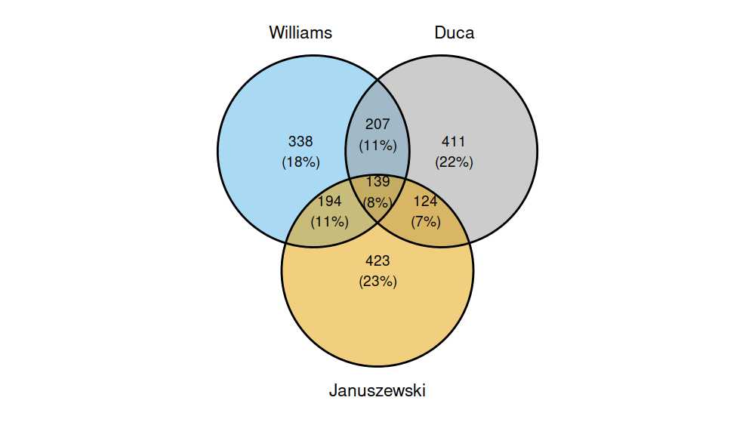

Figure S2. Kaplan-Meier curves for subsequent coronary artery disease (CAD) based on baseline estimated glucose disposal rete (eGDR) quartiles for (A) eGDR by Williams; (B) eGDR by Duca, and (C) eGDR by Januszewski
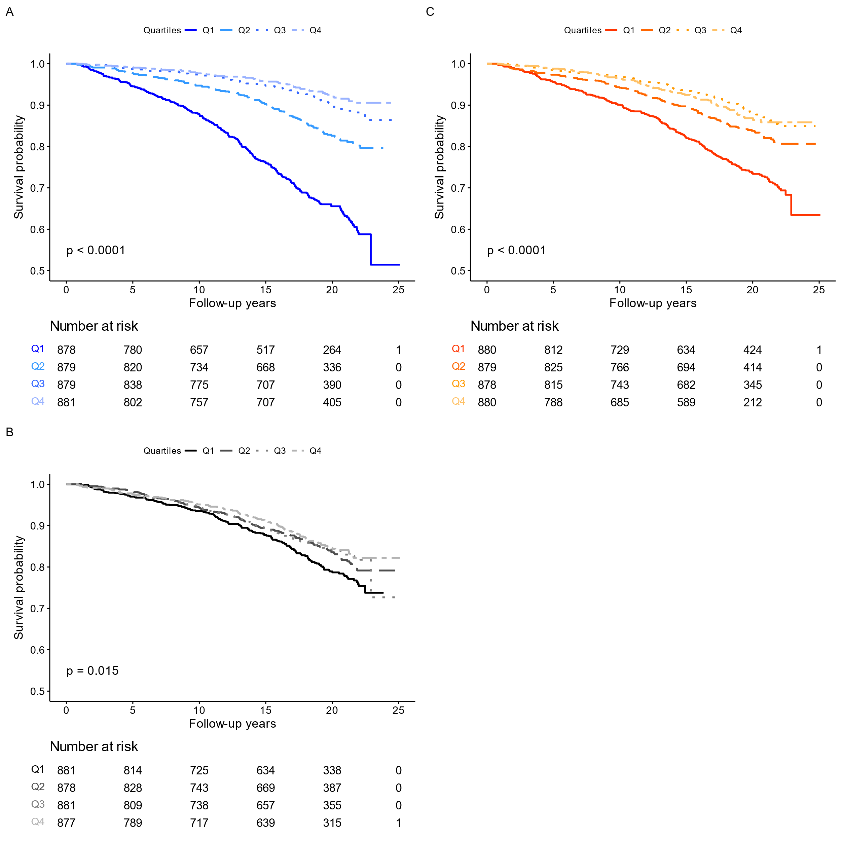

Figure S3. Kaplan-Meier curves for subsequent coronary artery disease (CAD) based on metabolic syndrome (yes vs. no).
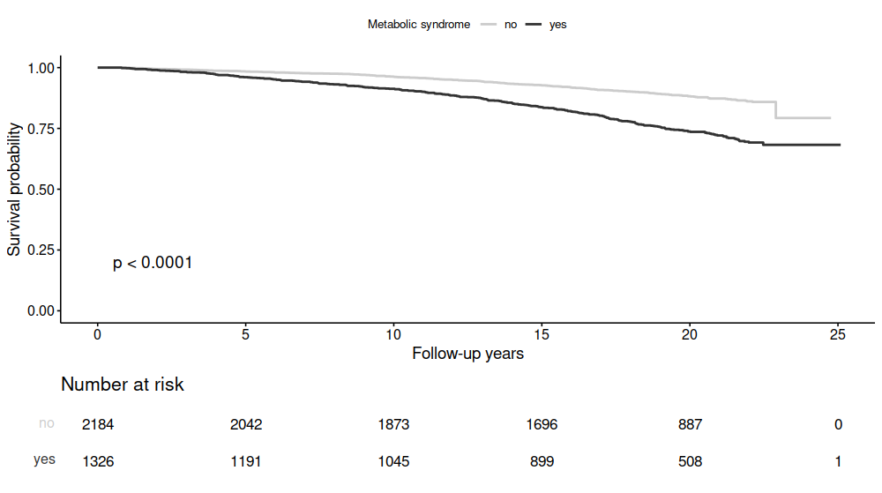

Figure S4. Hazard ratio plot for coronary artery disease according to different eGDR formulae in individuals at KDIGO category low.
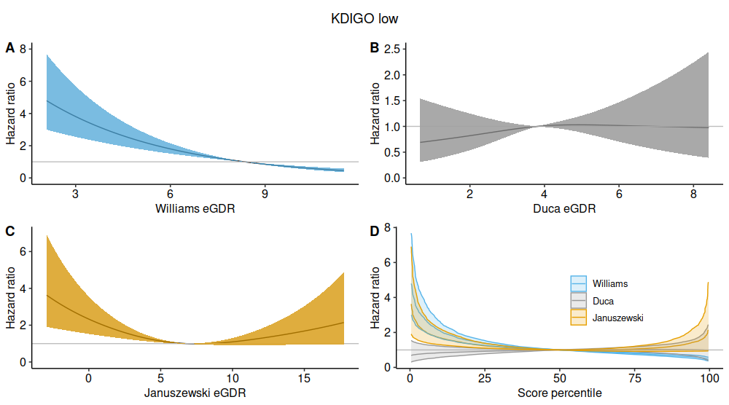

Figure S5. Hazard ratio plot for coronary artery disease according to different eGDR formulae in individuals at KDIGO category moderate.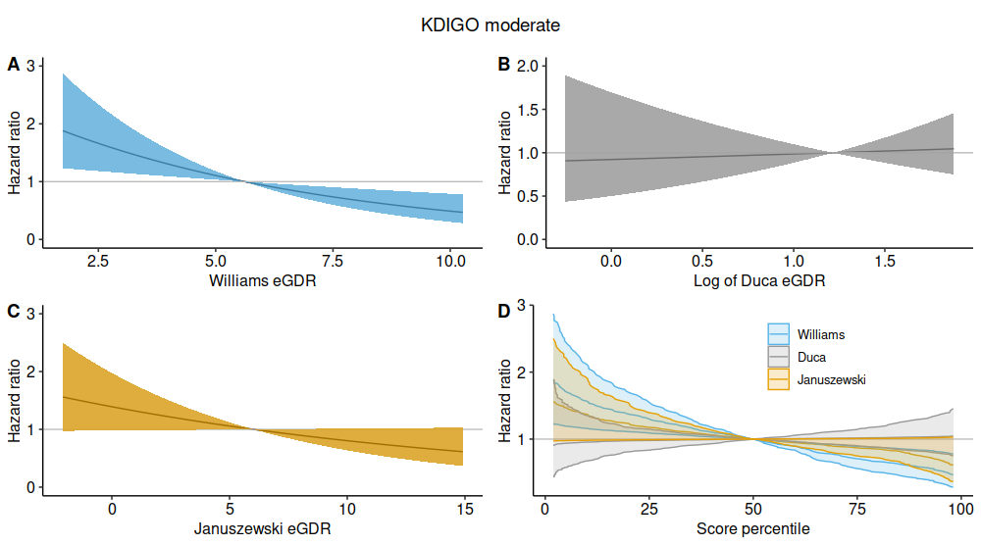

Figure S6. Hazard ratio plot for coronary artery disease according to different eGDR formulae in individuals at KDIGO category high & very high.
