Additional file 1

Table S1. Definition of insulin resistance indexes.
Variables | Formulas
TyG index | TyG index = Ln (TG × FPG / 2)
TyG-BMI index | TyG-BMI index = Ln (TG × FPG / 2) × BMI
TG/HDL-C ratio | TG/HDL-C ratio = TG / HDL-C
METS-IR | METS-IR = Ln (2 × FPG + TG) × BMI / Ln (HDL-C)
BMI (kg/m2), FBG (mg/dl), TG (mg/dl), and HDL (mg/dl) are used to in the formulas above.
Abbreviations: BMI, body mass index; FPG, fasting plasma glucose; HDL-C, high-density lipoprotein cholesterol; METS-IR, metabolic score for insulin resistance; TG, triglycerides; TG/HDH-C, triglyceride to high-density lipoprotein cholesterol ratio; TyG, Triglyceride and glucose; TyG-BMI, triglyceride glucose-body mass index.

Table S2. Variables and cut-off values used for four-strata European Society of Cardiology risk score.
Determinants of prognosis | Low risk | Intermediate-low risk | Intermediate-high risk | High risk
Points assigned | 1 | 2 | 3 | 4
WHO-FC | I or II | - | III | IV
6MWD, m | > 440 | 320-440 | 165-319 | < 165
BNP, ng/L or  NT-proBNP, ng/L | < 50  < 300 | 50-199  300–649 | 200-800  650-1100 | > 800  > 1100
Risk is calculated by dividing the sum of all grades by the number of variables and rounding to the next integer.
Abbreviations: 6MWD, 6-minute walking distance; BNP, brain natriuretic peptide; NT-proBNP, N-terminal pro-brain natriuretic peptide; WHO-FC, World Health Organization functional class.
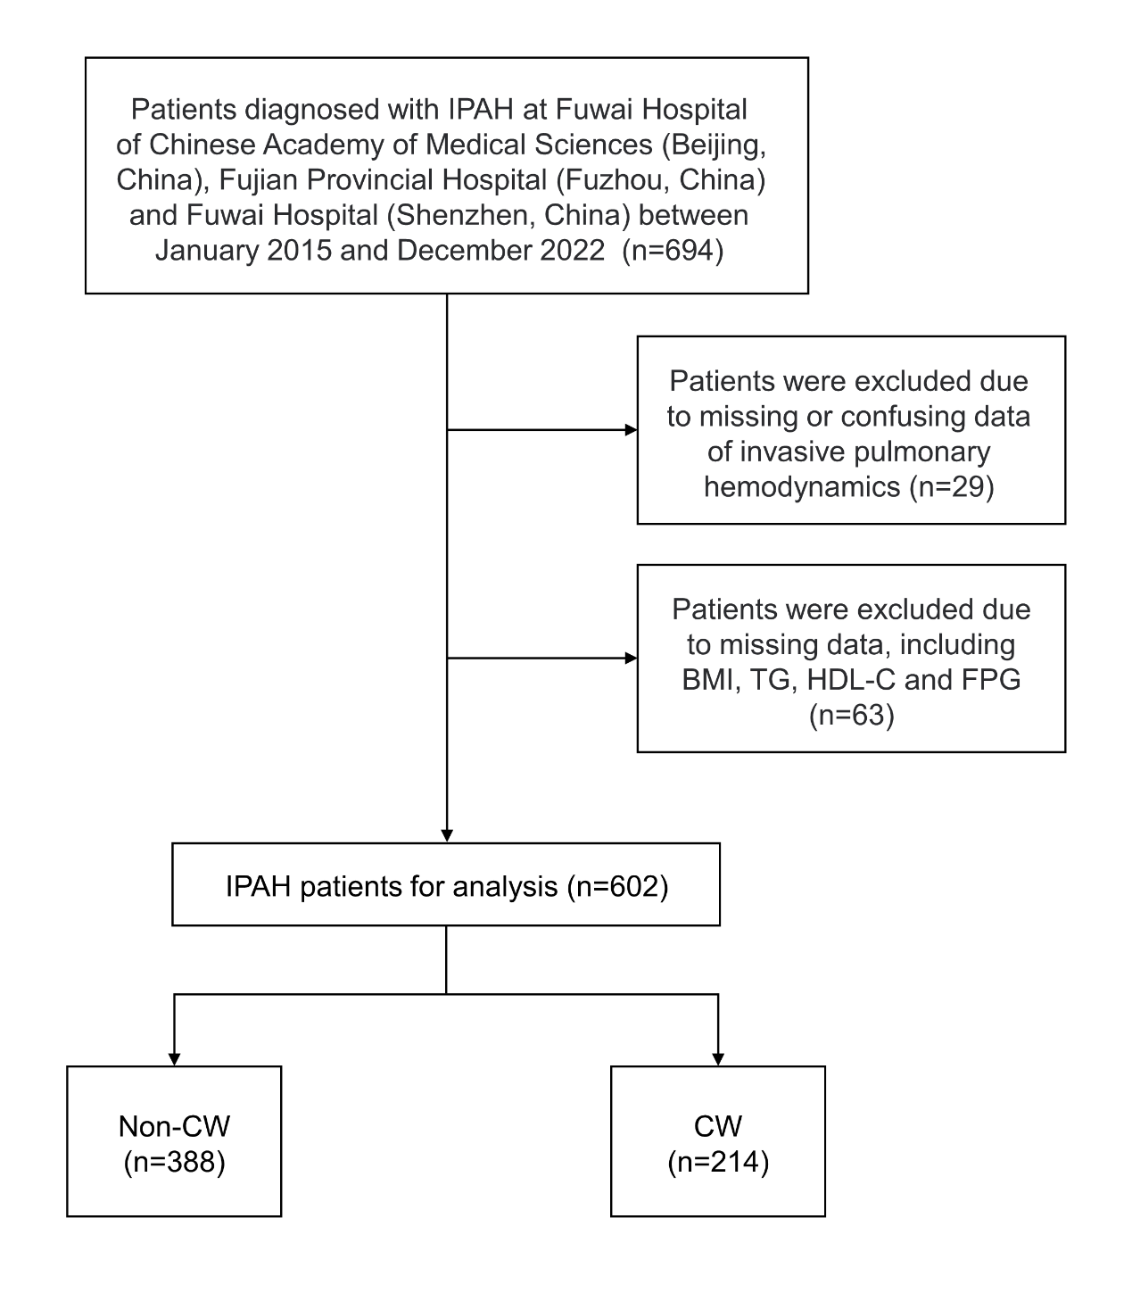
Figure S1. The flowchart of study participants.
Abbreviations: BMI, body mass index; CW, clinical worsening; FPG, fasting plasma glucose; HDL-C, high-density lipoprotein cholesterol; IPAH, Idiopathic pulmonary arterial hypertension; TG, triglycerides.

