Figure S1 Comparison of GLS between high TyG index group and control group in three heart failure types groups
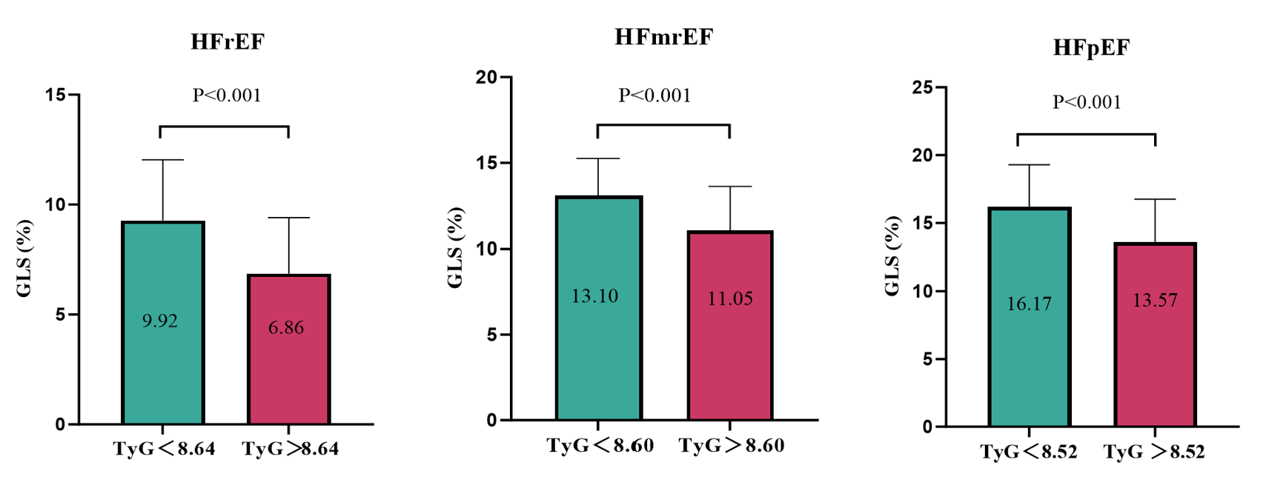
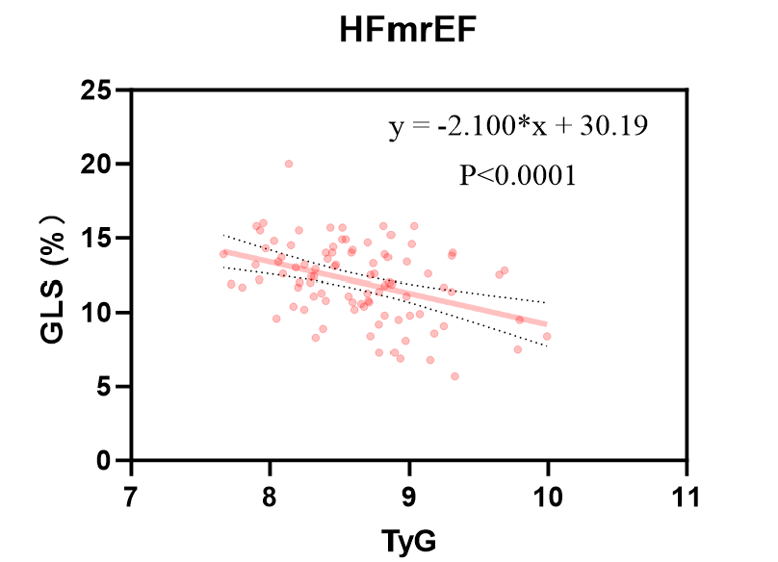
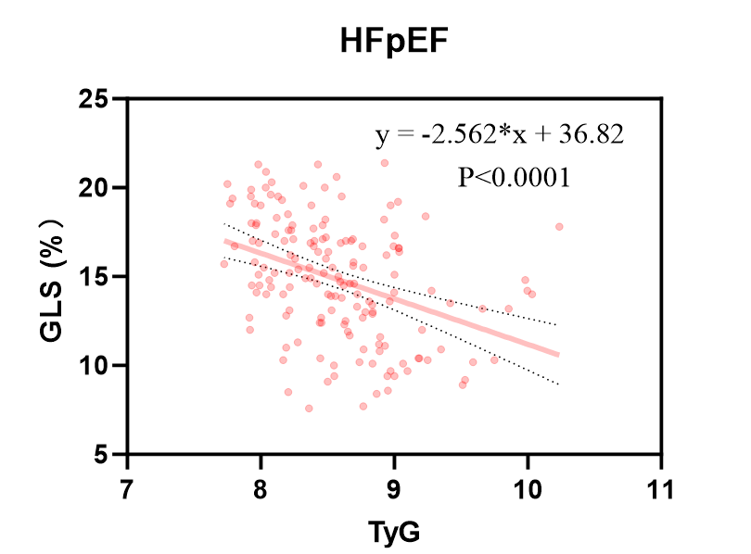
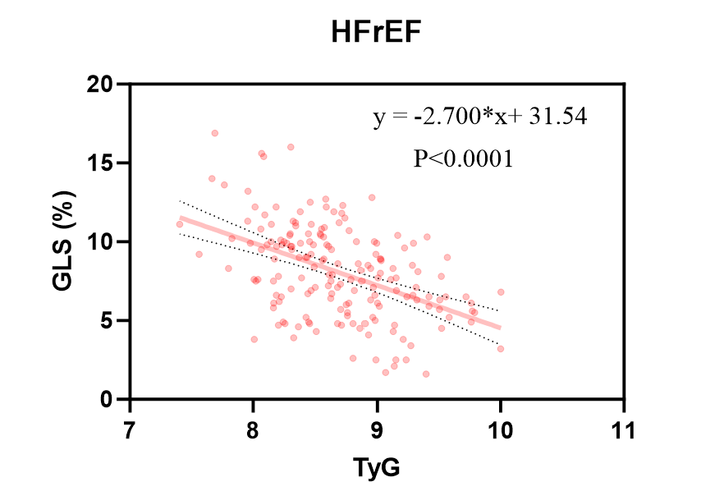
Figure S2 Scatterplot of GLS versus TyG index for three heart failure types

Figure S3 Restricted cubic spline plot between the TyG index level and reduced GLS for three heart failure types 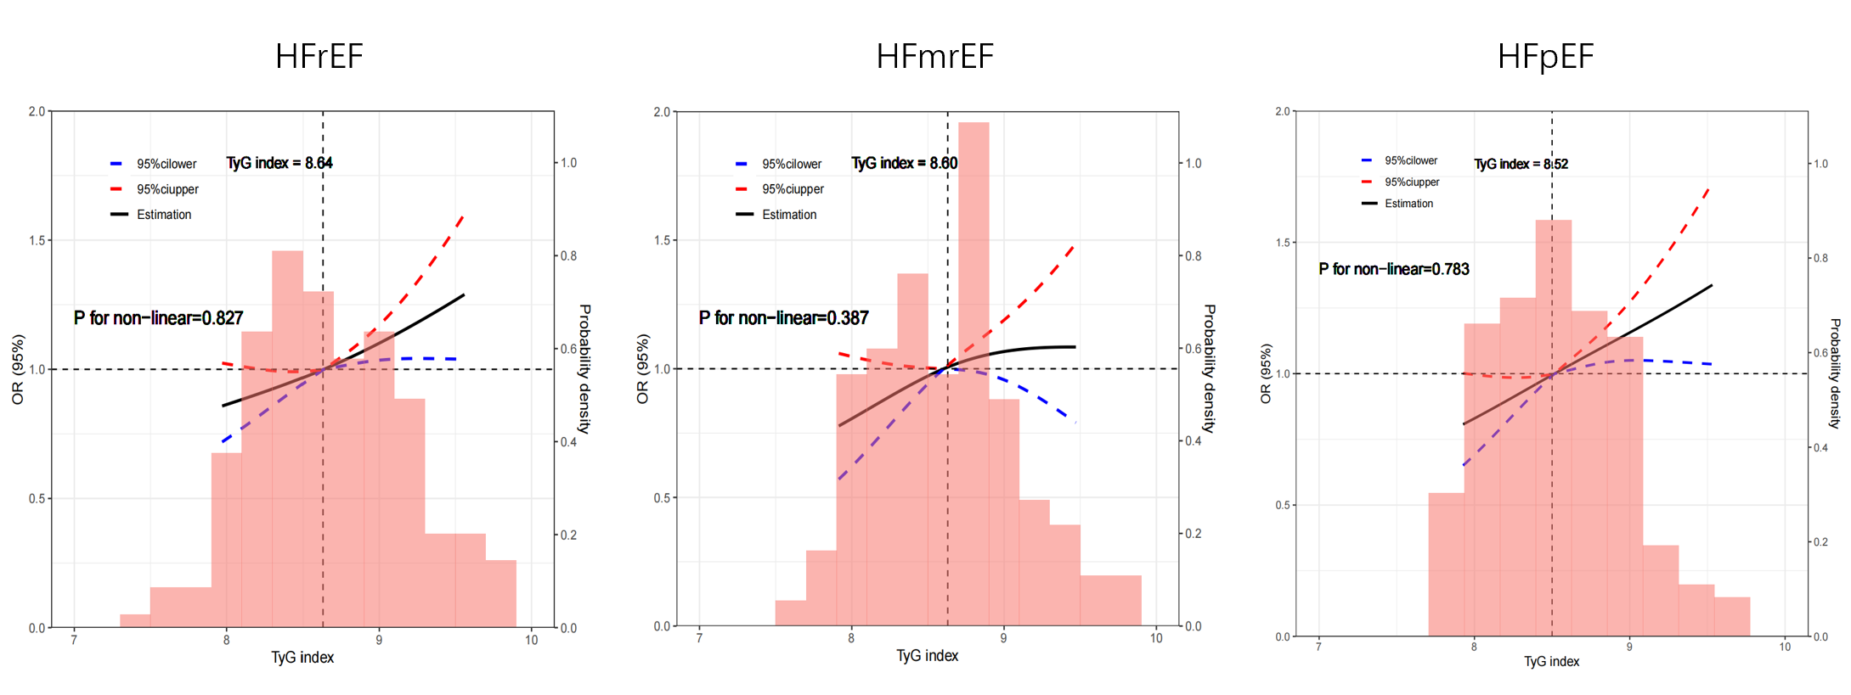
Adjusted for age, gender, BMI, hypertension, CAD, DM, hyperlipidemia, OSA, smoking, drinking, LVEF, NT-proBNP, TC, LDL-C, HDL-C, eGFR, E/e’, and LVMi
Reduced GLS in HFpEF: GLS＜7.9%；Reduced GLS in HFmrEF: GLS＜12.2%；Reduced GLS in HFpEF: GLS＜14.9%；

Table S1 Co-linearity analysis between covariates
Covariates | Tolerance | VIF
Age | 0.654 | 1.530
Gender | 0.560 | 1.787
BMI | 0.810 | 1.235
Hypertension | 0.769 | 1.301
DM | 0.821 | 1.219
Hyperlipidemia | 0.816 | 1.225
CAD | 0.742 | 1.348
Smoking | 0.549 | 1.820
Drinking | 0.535 | 1.870
LVEF | 0.875 | 1.142
TC | 0.495 | 2.019
LDL-C | 0.492 | 2.031
HDL-C | 0.944 | 1.059
NT-proBNP | 0.815 | 1.227
E/e’ | 0.797 | 1.255
LVMi | 0.869 | 1.151

Table S2 Baseline characteristics of the study population according to the heart failure group
Variables | HFrEF(N=175) | HFmrEF (N=92) | HFpEF (N=160) | P-value
TyG index | 8.68±0.51 | 8.63±0.49 | 8.58±0.50 | 0.139
General conditions
Age (years) | 48.23±13.82 | 47.54±14.58 | 49.00±15.00 | 0.736
Male, n (%) | 119 (68.0) | 56 (60.9) | 96 (60.0) | 0.312
BMI (kg/m²) | 26.92±6.36 | 26.66±6.30 | 28.06±6.46 | 0.116
smoking, n (%) | 83 (47.7) | 40 (43.5) | 58 (38.3) | 0.231
drinking, n (%) | 84 (48.3) | 45 (48.9) | 64 (41.6) | 0.387
Medical history, n (%)
Hypertension | 62 (35.4) | 36 (39.1) | 58 (37.7) | 0.822
DM | 27 (15.5) | 17 (18.5) | 24 (15.6) | 0.789
Hyperlipidemia | 70 (40.0) | 32 (34.8) | 62 (38.8) | 0.702
CAD | 28 (16.0) | 22 (23.9) | 39 (25.3) | 0.090
Pervious PCI | 16 (9.1) | 12 (13.0) | 16 (10.4) | 0.612
Pervious CABG | 1 (0.6) | 5 (5.4) | 7 (4.5) | 0.039
OSA | 19 (10.9) | 9 (9.8) | 15 (9.7) | 0.935
Echocardiographic
LVEF (%) | 31.00 (25.00-36.00) | 45.00 (44.00-47.00) | 56.00 (53.00-62.00) | < 0.001
GLS (%) | 8.08±2.92 | 12.08±2.57 | 14.87±3.40 | < 0.001
LVEDV (ml) | 190 (148-235) | 122 (104-155) | 111 (91-134) | < 0.001
LVSDV (ml) | 90 (57-130) | 65 (54-82) | 54 (44-68) | < 0.001
E (cm/s) | 77.00 (55.50-97.50) | 65.00 (52.00-78.00) | 73.00 (55.00-85.50) | 0.012
E/e’ | 11.84 (9.60-16.13) | 8.20 (7.09-11.06) | 9.73 (8.77-13.35) | < 0.001
LVM (g) | 156.74 (91.76-264.69) | 176.33 (109.37-236.88) | 154.19 (106.46-207.09) | 0.521
LVMi (g/m²) | 80.06 (48.81-145.48) | 89.20 (57.70-123.11) | 89.12 (59.67-124.12) | 0.605
Laboratory text
FBG (mmol/L) | 5.40 (4.94-5.89) | 5.25 (4.90-5.89) | 5.51 (4.91-5.75) | 0.256
TC (mmol/L) | 4.19 (3.48-4.97) | 3.88 (3.25-4.62) | 4.18 (3.45-4.98) | 0.066
LDL-C (mmol/L) | 2.53±0.81 | 2.26±0.70 | 2.49±0.99 | 0.052
HDL-C (mmol/L) | 1.08 (0.95-1.31) | 1.09 (0.91-1.49) | 1.13 (1.01-1.43) | 0.042
TG (mmol/L) | 1.29 (1.01-1.78) | 1.30 (0.95-1.67) | 1.19 (0.89-1.51) | 0.086
eGFR(ml/min/1.73m²) | 90.02±32.12 | 96.56±32.20 | 97.32±27.34 | 0.064
NT-proBNP (pg/ml) | 1006 (422-2003) | 392 (102-928) | 261 (92-644) | < 0.001
Cardiovascular medications, n (%)
Hypoglycemic drugs | 26 (14.9) | 18 (19.6) | 24 (15.0) | 0.559
Statins | 51 (29.1) | 23 (25.0) | 38 (23.8) | 0.510
Beta-blockers | 161 (92.0) | 84 (91.3) | 119 (74.4) | < 0.001
ACEI/ARB/ANRI | 157 (89.7) | 69 (75.0) | 105 (65.6) | < 0.001
MRA | 151 (86.3) | 67 (75.0) | 88 (55.0) | < 0.001
SGLT-2i | 112 (64.0) | 43 (46.7) | 54 (33.8) | < 0.001
P values in bold are＜0.05

Table S3 Correlation between TyG index and cardiovascular risk factors in three heart failure types
Variables | Correlation coefficient (r) | P-value
HFrEF
Age（years) | -0.191& | 0.011
BMI（kg/m²) | 0.233& | 0.002
TC (mmol/L) | 0.286* | ＜0.001
LDL-C (mmol/L) | 0.298& | ＜0.001
HDL-C (mmol/L) | -0.299* | 0.003
eGFR (ml/min/1.73m²) | 0.028& | 0.710
NT-proBNP (pg/ml) | -0.210* | 0.006
LVEF (%) | -0.204* | 0.007
GLS (%) | -0.471& | ＜0.001
HFmrEF
Age（years) | 0.092& | 0.382
BMI（kg/m²) | -0.090& | 0.384
TC (mmol/L) | -0.002* | 0.985
LDL-C (mmol/L) | -0.048& | 0.651
HDL-C (mmol/L) | -0.163* | 0.133
eGFR (ml/min/1.73m²) | -0.155& | 0.140
NT-proBNP (pg/ml) | -0.197* | 0.060
LVEF (%) | -0.061* | 0.561
GLS (%) | -0.398& | ＜0.001
HFpEF
Age（years) | 0.058 | 0.464
BMI（kg/m²) | 0.014 | 0.864
TC (mmol/L) | 0.267 | 0.001
LDL-C (mmol/L) | 0.137 | 0.085
HDL-C (mmol/L) | -0.310 | ＜0.001
eGFR (ml/min/1.73m²) | -0.071 | 0.374
NT-proBNP (pg/ml) | 0.085 | 0.297
LVEF (%) | -0.033 | 0.679
GLS (%) | -0.379 | ＜0.001
&Person
* Spearman
P values in bold are＜0.05

Table S4 multivariate linear regression in three heart failure types
 | β | 95% CI | P-value
HFrEF
Model 1 | -2.65 | -3.43 to -1.86 | < 0.001
Model 2 | -2.75 | -3.57 to -1.94 | < 0.001
Model 3 | -2.22 | -2.99 to -1.44 | < 0.001
HFmrEF
Model 1 | -2.00 | -3.01 to -1.01 | < 0.001
Model 2 | -2.00 | -3.12 to -0.89 | 0.001
Model 3 | -2.10 | -3.27 to -0.93 | 0.001
HFpEF
Model 1 | -2.35 | -3.32 to –1.38 | < 0.001
Model 2 | -2.34 | -3.39 to -1.29 | < 0.001
Model 3 | -2.46 | -3.58 to -1.35 | < 0.001
Model 1: adjusted for age and gender
Model 2: adjusted for variables :model 1 covariates + BMI, hypertension, CAD, DM, hyperlipidemia, OSA, smoking, drinking
Model 3: adjusted for variables :model 2 covariates+ LVEF, NT-proBNP, TC, LDL-C, HDL-C, eGFR, E/e’, and LVMi
P values in bold are＜0.05

Table S5 Multivariate logistic regression analysis in three heart failure types
TyG | OR (95% CI)
TyG | Model 1 | Model 2 | Model 3
HFrEF
Per 1 Unit increase | 5.08 (2.44-10.56)*** | 6.00 (2.69-13.39) *** | 5.30 (1.86-15.10) **
Tertile 1 | Ref. | Ref. | Ref.
Tertile 2 | 2.03 (0.94-4.39) | 1.95 (0.87-4.38) | 1.81 (0.62-5.31)
Tertile 3 | 4.35 (1.94-9.76) *** | 4.74 (2.01-11.17)*** | 4.27 (1.34-13.62)*
P for trend | 0.002 | 0.002 | 0.045
HFmrEF
Per 1 Unit increase | 2.61 (1.03-6.64) | 3.29 (0.93-5.26) | 3.51 (0.86-8.38)
Tertile 1 | Ref. | Ref. | Ref.
Tertile 2 | 1.38 (0.50-3.82) | 1.82 (0.54-4.06) | 3.52 (0.72-6.78)
Tertile 3 | 2.57 (0.87-7.59) | 5.01 (1.19-9.56)** | 8.57 1.50-15.67)*
P for trend | 0.224 | 0.086 | 0.054
HFpEF
Per 1 Unit increase | 5.16 (2.33-11.45)*** | 5.99 (2.40-14.97) *** | 6.36 (2.12-19.14) **
Tertile 1 | Ref. | Ref. | Ref.
Tertile 2 | 2.05 (0.90-4.65) | 1.64 (0.68-3.97) | 2.21 (0.75-6.47)
Tertile 3 | 5.50 (2.31-13.13) *** | 6.69 (2.42-18.47)*** | 7.13 (2.03-25.19)**
P for trend | 0.001 | 0.001 | 0.009
Model 1: adjusted for age and gender
Model 2: adjusted for variables :model 1 covariates + BMI, hypertension, CAD, DM, hyperlipidemia, OSA, smoking, drinking
Model 3: adjusted for variables :model 2 covariates+ LVEF, NT-proBNP, TC, LDL-C, HDL-C, eGFR, E/e’, and LVMi
*P＜0.05
**P＜0.01
***P＜0.001
P values in bold are＜0.05

Table S6 Sensitivity analysis: exclusion of patient with DM, hypoglycemic or lipid-lowering drug use and SGLT-2i use in three heart failure types
 | β | 95% CI | P-value
Group 1
HFrEF | -2.65 | -3.43 to -1.87 | ＜0.001
HFmrEF | -1.84 | -3.23 to -0.45 | 0.010
HFpEF | -2.36 | -3.60 to -1.11 | ＜0.001
Group 2
HFrEF | -2.64 | -3.64 to –1.64 | ＜0.001
HFmrEF | -2.02 | -3.61 to -0.43 | 0.014
HFpEF | -1.72 | -3.15 to -0.29 | 0.019
Group 3
HFrEF | -1.75 | -3.11 to -0.38 | 0.014
HFmrEF | -2.43 | -4.69 to -0.17 | 0.036
HFpEF | -2.53 | -4.06 to -0.99 | 0.002
Adjusted for age, gender, BMI, hypertension, CAD, hyperlipidemia, OSA, smoking, drinking, LVEF, NT-proBNP, TC, LDL-C, HDL-C, eGFR, E/e’, and LVMi
Group 1:patients without DM
Group 2: patients without hypoglycemic or lipid-lowering drug use
Group 3: patients without SGLT-2i use
P values in bold are < 0.05

Table S7 Subgroup analysis in three heart failure types
 | HFrEF |  | HFmrEF |  |  | HFpEF
 | β (95% CI) | P for interaction | β (95% CI) |  | P for interaction | β (95% CI) |  | P for interaction
Gender |  | 0.781 |  |  | 0.994 |  |  | 0.083
Female | -2.68 (-4.24 to -1.12)** |  | -2.34 (-5.81 to 1.12) |  |  | -2.89 (-4.48 to -1.30)**
Male | -2.82 (-3.84 to -1.81)*** |  | -2.08 (-3.34 to -0.81)** |  |  | -1.81 (-3.14 to -0.49)**
DM |  | 0.222 |  |  | 0.149 |  |  | 0.487
No | -2.70 (-3.69 to -1.71)*** |  | -1.82 (-3.05 to -0.60)** |  |  | -2.08 (-3.24 to -0.93)**
Yes | -2.33 (-4.40 to -0.68)** |  | -4.40 (-8.49 to 0.64) |  |  | -3.38 (-7.34 to 0.58)
HTN |  | 0.834 |  |  | 0.917 |  |  | 0.963
No | -2.32 (-3.19 to -1.47)*** |  | -1.82 (-3.41 to -0.21)* |  |  | -2.41 (-3.78 to -1.04)**
Yes | -0.83 (-2.53 to -0.87) |  | -1.69 (-3.79 to 0.42) |  |  | -2.41 (-4.28 to -0.55)*
Hyperlipidaemia |  | 0.429 |  |  | 0.867 |  |  | 0.122
No | -3.17 (-4.30 to -2.01)*** |  | -2.31 (-3.81 to -0.82)* |  |  | -2.58 (-3.77 to -1.38 )***
Yes | -2.20 (-3.42 to -0.97)** |  | -1.48 (-3.43 to -0.47) |  |  | -1.58 (-3.79 to 0.64)
CAD |  | 0.306 |  |  | 0.871 |  |  | 0.661
No | -2.52 (-3.43 to -1.64)*** |  | -2.03 (-3.28 to -0.78)* |  | 0 | -2.42 (-3.70 to -1.13)***
Yes | -3.93 (-6.63 to -1.22) |  | -3.82 (-7.83 to 0.19) |  |  | -1.49 (-3.56 to 0.59)
OSA |  | 0.046 |  |  | 0.748 |  |  | 0.714
No | -3.00 (-3.83 to -2.71)*** |  | -2.02 (-3.28 to -0.75)* |  |  | -2.40 (-3.49 to -1.31)***
Yes | 1.34 (-2.73 to 4.10) |  | -3.18 (-5.12 to 1.34) |  |  | -1.64 (-9.20 to 5.92)
BMI |  | 0.293 |  |  | 0.134 |  |  | 0.363
＜30 | -2.74 (-1.55 to -1.81)*** |  | -2.11 (-3.40 to -0.81)* |  |  | -2.28 (-3.47 to -1.08)***
≥30 | -1.19 (-7.56 to 2.54) |  | -1.06 (-4.09 to 1.96) |  |  | -2.66 (-8.00 to 2.68)
Adjusted for age, gender, BMI, HTN,CAD, DM, hyperlipidemia, OSA, smoking, and drinking
* P < 0.05
** P < 0.01
*** P < 0.001
P values in bold are < 0.05

