Supplemental Online Content

eFigure. Mean Cumulative Function Curves for Total Number Of Events For A Myocardial Infarction, B Main Coronary Outcome, C Expanded Coronary Outcome, D Coronary Revascularization, E Hospitalization for Unstable Angina

eFigure. Mean Cumulative Function Curves for Total Number Of Events For A Myocardial Infarction, B Main Coronary Outcome, C Expanded Coronary Outcome, D Coronary Revascularization, E Hospitalization for Unstable Angina
We plotted the occurrence of total events over time using mean cumulative function plots that show the cumulative average number of events per patient. Rate ratios based on a negative binomial model including age as a linear covariate and treatment, sex, baseline BMI category, baseline HbA1c category, baseline eGFR category and geographical region as fixed effects with log (observation) time as offset. Abbreviations: BMI, body mass index; CI, confidence interval; eGFR, estimated glomerular filtration rate; HbA1c, glycated hemoglobin.

A Myocardial infarction
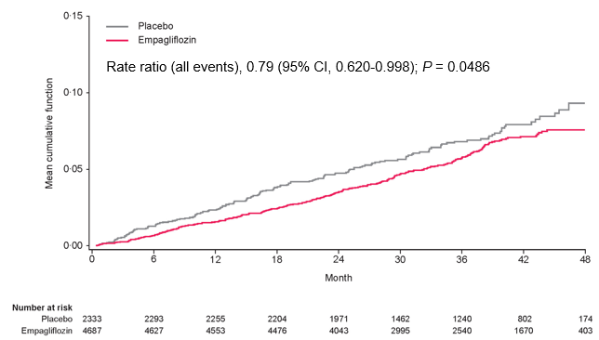

B Main coronary outcome (myocardial infarction and/or coronary revascularization)
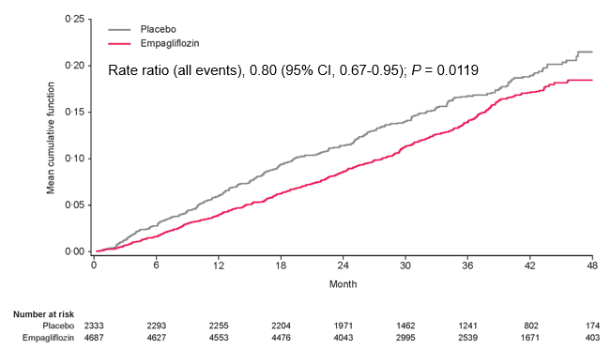

C Expanded coronary outcome (myocardial infarction and/or coronary revascularization and/or hospitalization for unstable angina)
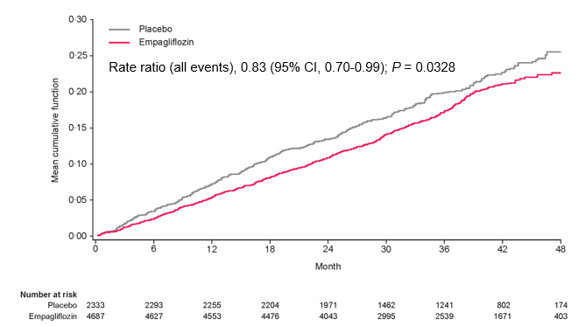

D Coronary revascularization
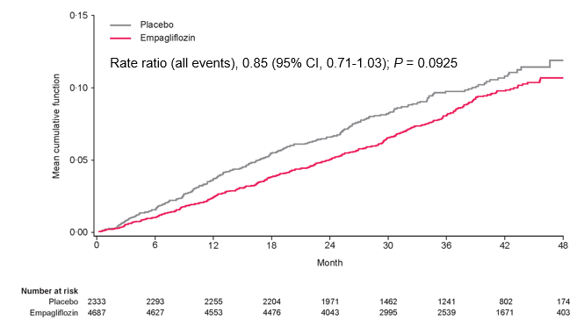

E Hospitalization for unstable angina
