Additional File 1:

Table S1. Ethnic differences in cardiac, inflammation, adipokine, and insulin sensitivity markers by glucose tolerance status
Different |  | Normal glucose tolerance |  | Prediabetes/diabetes
Markers |  | South Asian | Nordic | South Asian | Nordic
 |  | n=48 [30%] | n=57 [53%] | n=114 [70%] | n=50 [47%]
Cardiac | NT-proBNP | 29 (17-38) | 40 (22-58)* | 22 (14-40) | 44 (21-74)***
 | Troponin T | 1.5 (1.5-1.5) | 1.5 (1.5-1.5) | 1.5 (1.5-1.5) | 1.5 (1.5-1.5)
Inflammation | CRP | 1.7 (0.8-3.2) | 0.8 (0.3-2.3)** | 2.7 (1.3-4.6) | 2.2 (0.9-5.7)
 | Interleukin 6 | 2.2 (1.5-3.2) | 1.5 (1.5-2.1)*** | 2.3 (1.5-3.5) | 1.9 (1.5-3.1)
Adipokines | Leptin | 1620 (1136-2198) | 1036 (573-1430)** | 1669 (1199-2602) | 1824 (1038-2906)
 | Adiponectin | 7.4 (5.6-9.5) | 10.9 (8.2-13.5)*** | 6.8 (5.1-9.4) | 8.7 (6.3-13.6)**
Insulin sensitivity | HOMA2-S | 61 (44-87) | 102 (70-138)*** | 44 (32-69) | 63 (46-87)**
 | Matsuda-ISI | 3.1 (2.4-4.2) | 5.6 (3.5-7.2)*** | 2.2 (1.6-3.3) | 3.2 (2.1-4.2)***
Data presented as median (IQR) or number [n].
HOMA2-S: HOMA2-sensitivity, ISI: insulin sensitivity index, NT-pro BNP: N-terminal pro B-type natriuretic peptide
*p ≤ 0.05, **p ≤ 0.01, ***p ≤ 0.001 for South Asian vs. Nordic women

Table S2. Correlation between NT-proBNP and metabolic markers in South Asian and Nordic women
 |  |  | South Asian | Nordic | All
 |  |  | n=162 [31%] | n=107 [53%] | n=269
BMI (kg/m²⁾ |  |  | -0.086 (0.274) | -0.006 (0.954) | -0.065 (0.287)
Waist-to-height ratio |  |  | -0.111 (0.163) | -0.096 (0.325) | -0.153 (0.012)
Systolic blood pressure (mmHg) |  |  | 0.037 (0.641) | 0.130 (0.181) | 0.093 (0.128)  (0
eGFR (mL/min/1.73m²) |  |  | -0.200 (0.011) | -0.050 (0.611) | -0.206 (<0.001)
Fasting plasma glucose (mmol/L) |  |  | -0.068 (0.390) | -0.092 (0.345) | -0.083 (0.177)
2-h OGTT glucose (mmol/L) |  |  | -0.081 (0.306) | 0.057 (0.561) | -0.071 (0.247)
HbA_{1c} (mmol/mol) |  |  | -0.108 (0.171) | -0.083 (0.397) | -0.169 (0.005)
Fasting insulin (pmol/L) |  |  | -0.255 (0.001) | -0.288 (0.003) | -0.361 (<0.001)
Fasting c-peptide (pmol/L) |  |  | -0.202 (0.011) | -0.254 (0.008) | -0.304 (<0.001)
C-reactive protein (mg/L) |  |  | -0.047 (0.554) | 0.079 (0.416) | -0.061 (0.316)
Interleukin 6‡ (pg/ml) |  |  | -0.113 (0.153) | -0.134 (0.170) | -0.194 (0.001)
Leptin (pmol/L) |  |  | -0.156 (0.065) | -0.043 (0.666) | -0.146 (0.022)
Adiponectin (mg/L) |  |  | 0.232 (0.006) | 0.168 (0.087) | 0.293 (<0.001)
HOMA2-S |  |  | 0.255 (0.001) | 0.280 (0.004) | 0.355 (<0.001)
Matsuda ISI |  |  | 0.291 (<0.001) | 0.243 (0.013) | 0.369 (<0.001)
Data presented as r-spearman correlation (p-value).
HOMA-S: HOMA2-sensitivity, Matsuda ISI: Matsuda insulin sensitivity index, NT-proBNP: N-terminal pro B-type natriuretic peptide
For all analyses p-values < 0.001 were considered significant to reduce the number of sporadic findings due to multiple testing.

Table S3. Predictors of NT-proBNP (ng/L) concentrations (log transformed) in unadjusted and adjusted linear regression analyses
 | Unadjusted |  | Model 1 |  | Model 2 |  | Model 3 |  | Model 4 |  | Model 5
 | Crude B | P | Std B | p | Std B | p | Std B | p | Std B | p | Std B | P
Ethnicity | -0.201 | <0.001 | -0.155 | 0.015 | -0.161 | 0.011 | -0.133 | 0.037 | -0.066 | 0.333 | 0.029 | 0.701
Age (years) | 0.116 | 0.057 | 0.032 | 0.632 | 0.041 | 0.532 | 0.048 | 0.473 | 0.052 | 0.435 | 0.032 | 0.636
Systolic blood pressure (mmHg) | 0.105 | 0.085 | 0.065 | 0.286 | 0.093 | 0.124 | 0.110 | 0.079 | 0.095 | 0.125 | 0.098 | 0.129
eGFR (mL/min/1.73m²) | -0.171 | 0.005 | -0.117 | 0.084 | -0.116 | 0.085 | -0.122 | 0.071 | -0.106 | 0.115 | -0.097 | 0.156
Interleukin-6 (pg/mL) | -0.064 | 0.294 |  |  | -0.022 | 0.711 | -0.042 | 0.525 | -0.023 | 0.732 | -0.019 | 0.774
Body mass index | -0.012 | 0.844 |  |  |  |  | -0.059 | 0.386 | 0.031 | 0.655 | 0.144 | 0.057
Adiponectin (mg/L) | 0.238 | <0.001 |  |  |  |  |  |  | 0.197 | 0.003 | 0.145 | 0.036
Matsuda ISI | 0.265 | <0.001 |  |  |  |  |  |  |  |  | 0.264 | 0.001
Model 1 (ethnicity, age, systolic blood pressure, eGFR), model 2 (model 1 + interleukin -6), model 3 (model 2 + body mass index), model 4 (model 3 + adiponectin) and model 5 (model 4 + Matsuda ISI (insulin sensitivity index)).
For all analyses p-values <0.05 were considered significant

Table S4. Predictors of NT-proBNP (ng/L) concentrations (log transformed) in South Asian and Nordic women
South Asian | logNT-proBNP
 | Standardized B | p | 95% C.I.
Age (years) | 0.145 | 0.114 | -0.003 to 0.031
Systolic blood pressure (mmHg) | 0.061 | 0.469 | -0.005 to 0.010
GFR (mL/min/1.73m²) | -0.135 | 0.141 | -0.013 to 0.002
Interleukin-6 (pg/mL) | 0.185 | 0.047 | 0.001 to 0.096
Leptin (pmol/L) | -0.255 | 0.009 | 0.000 to 0.000
Adiponectin (mg/L) | 0.103 | 0.241 | -0.009 to 0.034
Matsuda ISI | 0.214 | 0.030 | 0.005 to 0.106

Nordic | logNT-proBNP
 | Standardized B | p | 95% C.I.
Age (years) | -0.099 | 0.353 | -0.025 to 0.009
Systolic blood pressure (mmHg) | 0.144 | 0.184 | -0.002 to 0.013
GFR (mL/min/1.73m²) | -0.068 | 0.526 | -0.010 to 0.005
Interleukin-6 (pg/mL) | -0.041 | 0.687 | -0.061 to 0.040
Leptin (pmol/L) | -0.076 | 0.514 | 0.000 to 0.000
Adiponectin (mg/L) | 0.116 | 0.318 | -0.009 to 0.027
Matsuda ISI | 0.277 | 0.020 | 0.007 to 0.080
Linear regression analyses adjusted for ethnicity, age, BMI, systolic blood pressure, eGFR, interleukin-6, leptin, adiponectin and Matsuda ISI (Model 5).
ISI: insulin sensitivity index, NT-pro BNP: N-terminal pro B-type natriuretic peptide
For all analyses p-values <0.05 were considered significant.

Table S5. Predictors of NT-proBNP (ng/L) concentrations (log transformed) in women with normal glucose tolerance and prediabetes/diabetes
Normal glucose toleranse | logNT-proBNP
 | Standardized B | p | 95% C.I.
Ethnicity | -0.129 | 0.315 | -0.294 to 0.096
Age (years) | -0.252 | 0.038 | -0.039 to -0.001
Systolic blood pressure (mmHg) | 0.149 | 0.172 | -0.003 to 0.015
GFR (mL/min/1.73m²) | -0.150 | 0.264 | -0.016 to 0.004
Interleukin-6 (pg/mL) | 0.103 | 0.339 | -0.028 to 0.081
Leptin (pmol/L) | -0.268 | 0.030 | 0.000 to 0.000
Adiponectin (mg/L) | -0.115 | 0.369 | -0.027 to 0.010
Matsuda ISI | 0.093 | 0.480 | -0.024 to 0.050
Prediabetes or diabetes | logNT-proBNP
 | Standardized B | p | 95% C.I.
Ethnicity | -0.002 | 0.980 | -0.158 to 0.154
Age (years) | 0.141 | 0.091 | -0.002 to 0.030
Systolic blood pressure (mmHg) | 0.118 | 0.152 | -0.002 to 0.011
GFR (mL/min/1.73m²) | -0.138 | 0.103 | -0.011 to 0.001
Interleukin-6 (pg/mL) | 0.036 | 0.666 | -0.034 to 0.053
Leptin (pmol/L) | 0.001 | 0.987 | 0.000 to 0.000
Adiponectin (mg/L) | 0.167 | 0.057 | -0.001 to 0.038
Matsuda ISI | 0.324 | <0.001 | 0.036 to 0.138
Linear regression analyses adjusted for ethnicity, age, BMI, systolic blood pressure, eGFR, interleukin-6, leptin, adiponectin and Matsuda ISI (Model 5).
ISI: insulin sensitivity index, NT-pro BNP: N-terminal pro B-type natriuretic peptide
For all analyses p-values <0.05 were considered significant.

Table S6. Mediation analyses of ethnic differences in logNT-proBNP
Ethnicity | Beta | Beta change (%) | Odds Ratio | p-value | 95% C.I.
LogNT-proBNP | -1.091 | - | 0.336 | 0.001 | 0.173 to 0.654
+ Age | -1.038 | 4.9 | 0.354 | 0.003 | 0.179 to 0.703
+ BMI | -1.091 | 0.0 | 0.336 | 0.001 | 0.173 to 0.654
+ Systolic blood pressure | -1.047 | 4.0 | 0.351 | 0.002 | 0.179 to 0.687
+eGFR | -0.928 | 14.9 | 0.395 | 0.008 | 0.199 to 0.786
+ IL-6 | -1.098 | 0.6 | 0.334 | 0.001 | 0.170 to 0.655
+ Leptin | -1.104 | 1.2 | 0.331 | 0.002 | 0.165 to 0.667
+ Adiponectin | -0.648 | 40.6 | 0.523 | 0.076 | 0.256 to 1.070
+ Matsuda ISI | -0.515 | 52.8 | 0.598 | 0.159 | 0.292 to 1.223
Mediation analyses of ethnic differences in logNT-proBNP, adjusted separately for age (years), BMI (kg/m²), systolic blood pressure (mmHg), eGFR (ml/min/1.73m²), interleukin-6 (pg/mL), leptin (pmol/L), adiponectin (mg/L) and insulin sensitivity (by Matsuda insulin sensitivity index, ISI). Insulin sensitivity, adiponectin and eGFR mediated 56.4%, 40.6% and 14.9% of the ethnic difference in logNT-proBNP, respectively. Data are log β-coefficients for logNT-proBNP with 95% CI.

Fig. S1. NT-proBNP distribution across ethnicities
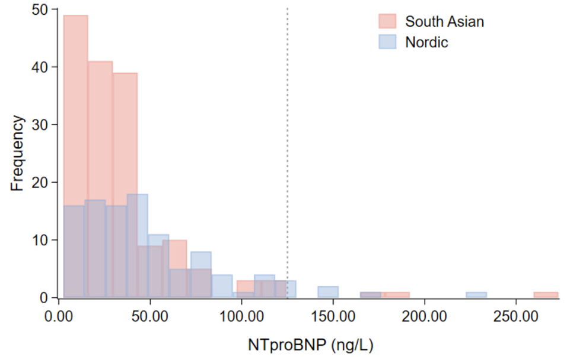
Supplementary Fig. 1. NT-proBNP (ng/L) distribution for South Asian (red) and Nordic (blue) women. In total, 1.9% (n = 3) of the South Asian and 5.6% (n =6) of the Nordic women had NT-proBNP levels ≥ 125 ng/L (vertical dotted line).

