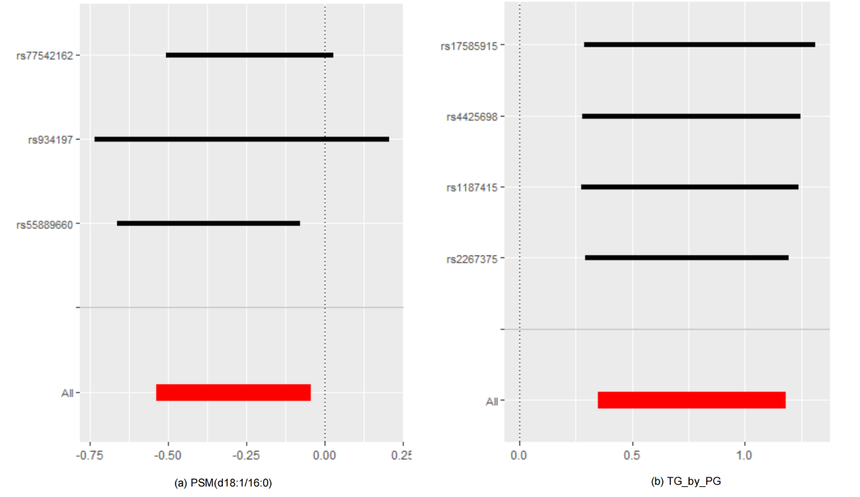
Fig. S1 Leave-one-out results of TG_by_PG and PSM (d18:1/16:0).
Abbreviations: PSM (d18:1/16:0) = palmitoyl sphingomyelin (d18:1/16:0); TG_by_PG = ratio of triglycerides to phosphoglycerides.

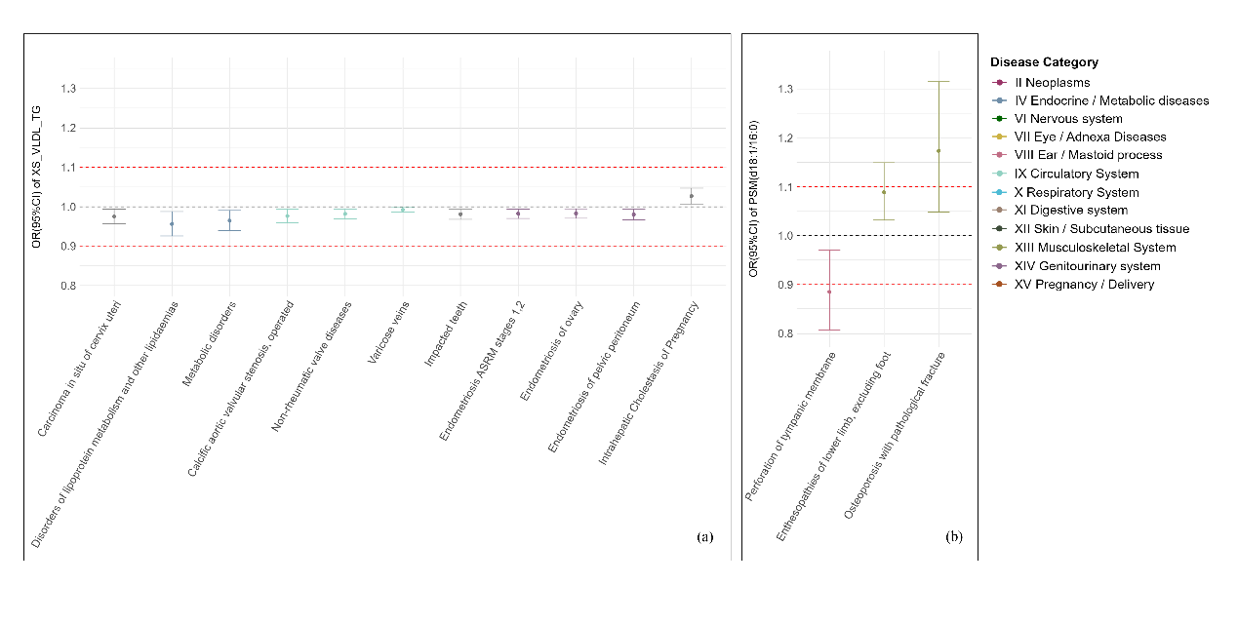
Fig. S2 Potential on-target side effects associated with XS_VLDL_TG and PSM (d18:1/16:0) intervention revealed by phenome–wide Mendelian randomization analysis.
Notes: Odds ratios with their 95% confidence intervals represent the effect estimates on the risk of various non-GDM diseases of per 10% reduction in GDM risk by targeting (a) XS_VLDL_TG and (b) PSM (d18:1/16:0), respectively. Associations that are above the horizontal line with a black dash indicate deleterious side effects, while those below represent beneficial side effects. Th2 upper red dashed horizontal line (odds ratio = 1.10) represents the point at which decreased GDM risk is counterbalanced by an equal increase in disease risk.
Abbreviations: OR = odds ratio, CI=confidence interval, PSM (d18:1/16:0) = palmitoyl sphingomyelin (d18:1/16:0), XS_VLDL_TG = triglycerides in very small VLDL.

