Table S1. Displays the basic characteristics and clinical data between TyG index < 9.06 and TyG index ≥ 9.06 groups.

 | TyG index < 9.06  (n = 112) | TyG index ≥ 9.06  (n = 114) | P value
Baseline characteristics
Age(y) | 57.6±11.7 | 55.9±11.8 | 0.275
Female, ﻿n (%) | 56(50.0%) | 51(44.7%） | 0.255
Body mass index (kg/m²) | 23.8±3.01 | 24.49±3.06 | 0.108
Rest heart rate (b.p.m.) | 74±11 | 75±12 | 0.655
Smoking history, ﻿n (%) | 32(28.6%) | 27(23.7%) | 0.247
Systolic blood pressure (mm Hg) | 130±16 | 132±17 | 0.416
Diastolic blood pressure (mm Hg) | 79±11 | 80±11 | 0.284
Blood biochemistry
Triglycerides (mmol/L) | 1.07±0.39 | 2.43±1.87 | <0.001
Total cholesterol (mmol/L) | 4.15±0.98 | 4.55±1.14 | 0.008
HDL-C (mmol/L) | 1.42±0.46 | 1.13±0.31 | <0.001
LDL-C (mmol/L) | 2.26±0.79 | 2.64±0.88 | 0.019
Fasting blood glucose (mmol/L) | 6.48±1.91 | 10.10±4.72 | <0.001
HbA1c (%) | 6.73±1.52 | 8.03±2.15 | <0.001
TyG index | 8.51±0.36 | 9.64±0.54 | <0.001
eGFR, mL/min/1.73m² | 92.33±13.52 | 92.03±16.89 | 0.913
Medication history
Biguanides, ﻿n (%) | 53(47.3%) | 63(55.3%) | 0.144
Sulfonylureas, ﻿n (%) | 17(15.2%) | 11(9.6%) | 0.145
α-Glucosidase inhibitor, ﻿n (%) | 40(35.7%) | 64(56.1%) | 0.002
﻿SGLT-2 inhibitors, ﻿n (%) | 13(11.6%) | 20(17.5%) | 0.141
Thiazolidinediones, ﻿n (%) | 10(8.9%) | 14(12.3%) | 0.274
GLP-1/DPP-4 inhibitor, ﻿n (%) | 9(8.0%) | 11(9.6%) | 0.424
Insulin, ﻿n (%) | 28(25.0%) | 23(20.2%) | 0.239
Statins, ﻿n (%) | 62(55.4%) | 55(48.2%) | 0.255
HDL-C, high density lipoprotein cholesterol; LDL-C, low density lipoprotein cholesterol; HbA1c, glycated hemoglobin, TyG index, triglyceride glucose index; eGFR estimated glomerular filtration rate; SGLT-2, Sodium-glucose cotransporter-2; GLP-1/DPP-4 inhibitor, glucagon-like peptide-1/dipeptidyl peptidase 4 inhibitor.

Table S2. Intra-observer and inter-observer variability.

 | Intra-observer |  |  | Inter-observer
 | ICC | 95% CI |  | ICC | 95% CI
LV remodeling index | 0.989 | 0.971-0.997 |  | 0.957 | 0.923-0.989
LV GFI | 0.971 | 0.943-0.991 |  | 0.932 | 0.907-0.961
Perfusion index | 0.969 | 0.933-0.986 |  | 0.949 | 0.922-0.978
Upslope | 0.972 | 0.938-0.991 |  | 0.952 | 0.931-0.987
MaxSI | 0.966 | 0.937-0.989 |  | 0.953 | 0.928-0.989
TTM | 0.948 | 0.913-0.988 |  | 0.921 | 0.809-0.970

ICC, intraclass correlation coefficients. LV, left ventricular; GFI, global function index; MaxSI, max signal intensity; TTM, time to maximum signal intensity.

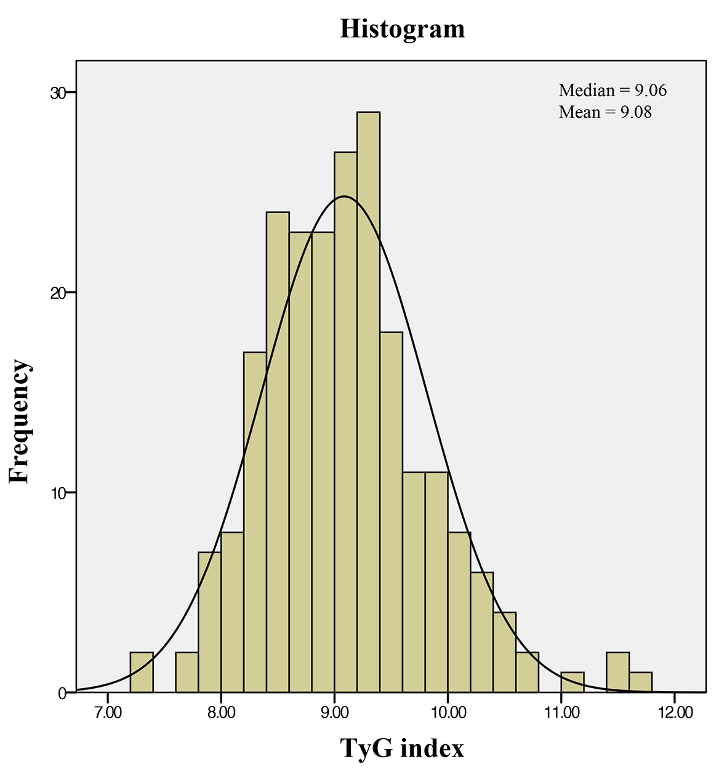Figure S1. The histogram of TyG index distribution.
TyG index, triglyceride glucose index.

