Supplemental material

Supplemental Table 1. Power analyses according to the Monte Carlo methods.
Dependent variable | Mediator | Estimate power
HF | EAT | 0.98
SDNN | EAT | 1
SDANN | EAT | 1
SDNN index | EAT | 0.96
rMSSD | EAT | 0.96
pNN50 | EAT | 0.87
EAT, epicardial adipose tissue; HF, high frequency; SDNN, SD of all normal to normal intervals; SDANN, SD deviation of sequential 5-minute normal to normal interval; SDNN index, the mean value of the SD of all the normal to normal intervals in every 5-minute interval within 24 hours; rMSSD, the root mean square of successive differences; pNN50, the number of pairs of adjacent normal to normal intervals differing by >50 ms in the entire recording divided by the total number of normal to normal intervals.

Supplemental Table 2. Structural validity of confirmatory factor analysis.
 | Latent variable constructed by all HRV indices | Latent variable constructed by four HRV indices
χ² | 828 | 45
df | 20 | 2
GFI | 0.687 | 0.940
CFI | 0.571 | 0.958
SRMR | 0.152 | 0.036
RMR | 0.150 | 0.035
AIC | 6855 | 3314
BIC | 6917 | 3346

χ², chi-square; df, degree of freedom; GFI, goodness of fit index; CFI, comparative fit index; SRMR, standardized root mean square residual; RMR, root mean square residual; AIC, akaike information criterion; BIC, bayesian information criterion.

Supplemental Table 3. Reliability of confirmatory factor analysis.
Latent variable | Path | Factor loading | AVE | CR
Constructed by all HRV indices | LF ← HRV burden | 0.50 | 0.419 | 0.817
Constructed by all HRV indices | HF ← HRV burden | 0.46 | 0.419 | 0.817
Constructed by all HRV indices | LF/HF ← HRV burden | -0.06 | 0.419 | 0.817
Constructed by all HRV indices | SDNN ← HRV burden | 0.73 | 0.419 | 0.817
Constructed by all HRV indices | SDANN ← HRV burden | 0.34 | 0.419 | 0.817
Constructed by all HRV indices | SDNN index ← HRV burden | 0.91 | 0.419 | 0.817
Constructed by all HRV indices | rMSSD ← HRV burden | 0.84 | 0.419 | 0.817
Constructed by all HRV indices | pNN50 ← HRV burden | 0.84 | 0.419 | 0.817
Constructed by four HRV indices | SDNN ← HRV burden | 0.67 | 0.698 | 0.902
Constructed by four HRV indices | SDNN index ← HRV burden | 0.92 | 0.698 | 0.902
Constructed by four HRV indices | rMSSD ← HRV burden | 0.87 | 0.698 | 0.902
Constructed by four HRV indices | pNN50 ← HRV burden | 0.86 | 0.698 | 0.902
SDNN, SD of all normal to normal intervals; SDNN index, the mean value of the SD of all the normal normal to normal intervals in every 5-minute interval within 24 hours; rMSSD, the root mean square of successive differences; pNN50, the number of pairs of adjacent normal to normal intervals differing by >50 ms in the entire recording divided by the total number of normal to normal intervals; AVE, average variance extracted; CR, composite reliability.

Supplemental Table 4. Sensitivity analyses for adjusted direct and indirect effects of T2DM with HRV burden via epicardial adipose tissue.
Treatment | β | 95% CI | Proportion mediated, %
Male
Total effect | -0.332 | (-0.763, 0.112)
Direct effect | -0.225 | (-0.640, 0.222) | -
Indirect effect | -0.107 | (-0.271, 0.008) | -
Female
Total effect | -0.814 | (-1.201, -0.427)
Direct effect | -0.650 | (-1.035, -0.264) | 79.85
Indirect effect | -0.164 | (-0.306, -0.023) | 20.15
Protopathic bias
Total effect | -0.654 | (-0.955, -0.340)
Direct effect | -0.552 | (-0.847, -0.259) | 84.40
Indirect effect | -0.102 | (-0.214, -0.018) | 15.60
Without CAD
Total effect | -0.374 | (-0.722, -0.037)
Direct effect | -0.188 | (-0.548, 0.125) | 50.27
Indirect effect | -0.186 | (-0.329, -0.058) | 49.73
Without hypertension
Total effect | -0.525 | (-0.971, -0.068)
Direct effect | -0.281 | (-0.779, 0.132) | 53.52
Indirect effect | -0.244 | (-0.445, -0.048) | 46.48
Adjusted for age, gender, HbA1c, FPG, BMI, TG, TC, smoke, alcohol, hypoglycemic therapy (OAD, Insulin, OAD+insulin), medications (ACEI/ARB, statin, antiplatelet), hypertension, CAD, diabetic peripheral neuropathy), duration of diabetes mellitus. T2DM, type 2 diabetes mellitus; HRV burden, heart rate variability burden; HbA1c, glycosylated hemoglobin; FPG, fasting plasma glucose; BMI, body mass index; TG, triglyceride; TC, total cholesterol; OHA, oral antidiabetic drug; ACEI, angiotensin-converting enzyme inhibitors; ARB, angiotension receptor blocker; CAD, coronary artery disease. CI, confidence interval.

Supplemental Figure 1. Confirmatory factor analysis model.
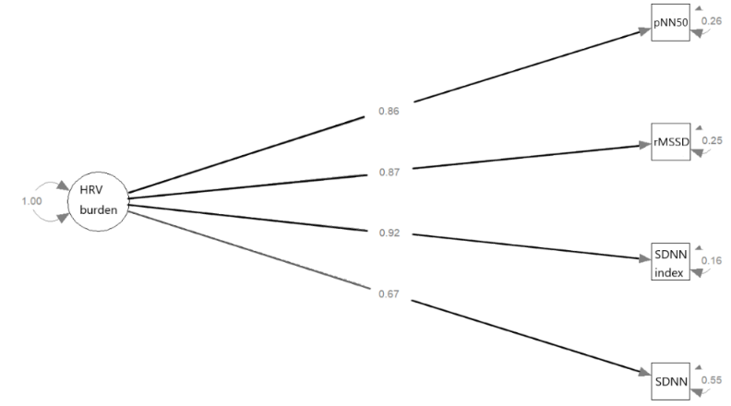
HRV, heart rate variability; SDNN, SD of all normal to normal intervals; SDNN index, the mean value of the SD of all the normal normal to normal intervals in every 5-minute interval within 24 hours; rMSSD, the root mean square of successive differences; pNN50, the number of pairs of adjacent normal to normal intervals differing by >50 ms in the entire recording divided by the total number of normal to normal intervals.

