Supplementary data

Supplemental Figure 1. Overview of Nested Case-Control Design
Supplemental Table 1. Diagnosis Codes Used to Define Exclusion Criteria and NAFLD-Related Risk Factors
Supplemental Table 2. WHO ATC Codes Used to Define Class of Glucose-Lowering Agents and Comedications
Supplemental Table 3. Baseline Characteristics of Patients in Case and Control Groups Measured from Year Before/at Cohort Entry Date and Index Date
Supplemental Figure 2. Impact of Unmeasured Confounders Assessed Using Rule-Out Method

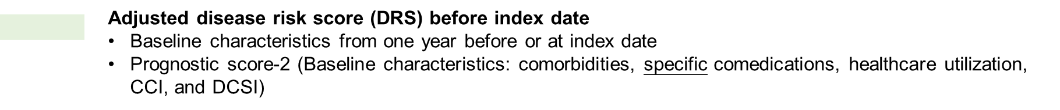
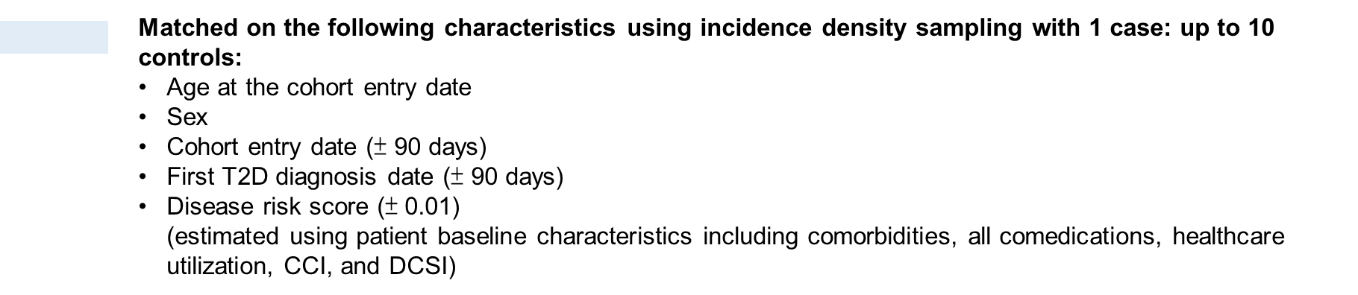
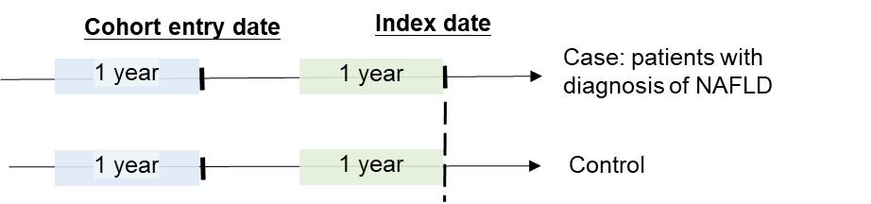
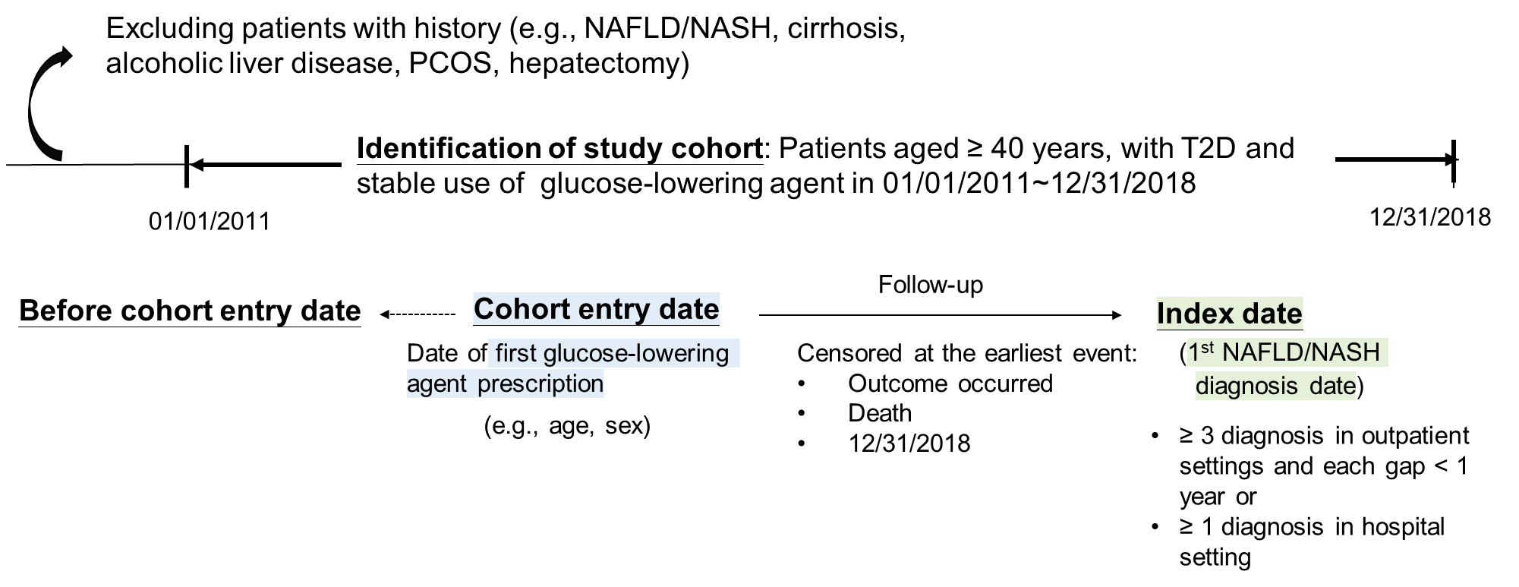
Supplemental Figure 1. Overview for nested case-control design

Abbreviations: T2D, type 2 diabetes; DCSI, Diabetes Complications Severity Index; CCI, Charlson Comorbidity Index.

Supplemental Table 1. Diagnosis codes used to define exclusion criteria and NAFLD-related the risk factors

Definition variable | ICD-9-CM & ICD-10-CM codes | Taiwan National Health Insurance code
Exclusion criteria
Hepatocellular carcinoma (HCC) | 155.0, C22.0, C22.9 | -
Non-alcoholic fatty liver disease (NAFLD) | 571.8, K75.81 | -
Cirrhosis | 456.0, 456.2, 571.5, 572.2, 572.4, 789.5, I85.0, I85.1, K72.90, K72.91, R18.8, K74.0−K74.2, K74.60, K74.69 | -
Biliary cirrhosis | 571.6, K74.3−K74.5 | -
Alcoholic liver disease  and alcohol dependence | 571.0−571.3, 303.9, V11.3, V79.1, K70 | -
Polycystic ovary syndrome (PCOS) | 256.4, E28.2 | -
Gestational diabetes | 648.0, O24 | -
Toxic liver disease | 573.3, K71 | -
Other infection cause hepatitis | 573.2, K77 | -
Autoimmune hepatitis | 571.42, K75.4 | -
Human immunodeficiency virus (HIV) infection | 042, V08, 079.53, B20, Z21, Z22.6, B97.35 | -
Hemochromatosis | 275, E83.11 | -
Wilson’s disease | 275.1, E83.01 | -
α1-antitrypsin deficiency | 277.6, E88.01 | -
Budd-Chiari syndrome | 453.0, I82.0 | -
Hepatectomy  or liver transplantation |  | 75002B, 75003B, 75004B, 75005B, 75020A, 75020B, 75015B, 75016B, 75017B, 75018B, N26021, N26018, N26019, 75025B, 75026B, 75027B, 75028B, 75030B, 75031B, 75032B, 75033B
Risk factors
Diabetic nephropathy | 250.4, 249.4, 580, 581, 582, 583, 585, 586, 593.9, E08.3, E11.2, E13.2, N00, N04, N03, N05, N18, N19 | -
Diabetic neuropathy | 250.6, 249.6, 337.0, 337.1, 354, 355, 356.9, 357.2, 358.1, 458.0, 536.3, 564.5, 596.54, 713.5, 951.0, 951.1, 951.3, E08.4, E11.4, E13.4, G90.09, G90.8, G90.9, G99.0, G56, G57, G60.9, G73.3, G90.01, H49, I95.1, K31.84, K59.1, N31.9, M14.6, S04 | -
Peripheral vascular disease | 250.7, 249.7, 442.3, 440.21, 443.81, 443.9, 892.1, 040.0, 444.22, 707.1, 785.4, E08.5, E11.5, E13.5, I96, E08.621, E11.621, E13.621, I72.4, I70.21, I73.89, I73.9, S91.3, A48.0, I74.3, L97 | -
Diabetic retinopathy | 250.5, 361, 362, 369, 379.23, E08.3, E11.3, E13.3, H35.0, H35.35, H35.6, H35.8, H35.9, H33, H54, H43.1 | -
Hepatitis B virus (HBV) infection | 070.22, 070.23, 070.32, 070.33, 070.20, 070.30, B18.0, B18.1, B19.10, B19.11 | -
Hepatitis C virus (HCV) infection | 070.41, 070.51, 070.44, 070.54, B18.2, B19.20, B19.21 | -
HBV carrier | V02.61, B17.0, Z22.51 | -
Dyslipidemia | 272.0−272.5, 272.8−272.9,  E78.0−E78.6, E78.70, E78.79, E78.81, E78.89, E78.9 | -
Hypothyroidism | 243, 244, E00, E01.8, E02, E03.0, E03.1, E03.2, E03.3, E03.8, E03.9, E89.0 | -
Obstructive sleep apnea | 780.51, 780.53, 780.57, G47.33 | -
Psoriasis | 696.0, 696.1, L40 | -
Gout | 274, M10.0 | -
Obesity | 278.00–278.02, 278.1, E65, E66.01, E66.09, E66.1, E66.2, E66.8, E66.9 | -
Hypertension | 401–405, I10, I11, I12, I13, I15, I16 | -
Myocardial infarction | 410, 411, 412, I21, I22, I23, I24, I25.2 | -
Cardiac arrhythmia | 426, 427, I44, I45, I47-I49 | -
Heart failure | 428, I50 | -
Ischemic stroke | 433, 434, 437.1, I63, I65, I66, I67.81, I67.82, I67.89 | -
Hemorrhagic stroke | 430, 431, 432, I60, I61, I62 | -
Chronic obstructive pulmonary disease (COPD) | 491, 492, 496, J41, J42, J43, J44 | -
Depression | 296.2, 300.4, 311, F32, F34.1 | -
Peptic ulcer disease | 533, K27 | -
Hyperthyroidism | 242, E05 | -
HbA1c tests |  | 09006B, 09006C
LDL tests |  | 09044C

Supplemental Table 2. WHO ATC code used to define the class of glucose-lowering agents and comedications

Definition drugs | WHO ATC code
Amiodarone | C01BD01
Methotrexate | L01BA01
Systemic corticosteroids | H02
Valproate | N03AG01
Carbamazepine | N03AF01
Tamoxifen | L02BA01
Metformin | A10BA02, A10BD02, A10BD03, 10BD05, A10BD07, A10BD08, 10BD10, A10BD11, A10BD13, 10BD14, A10BD15, A10BD20
Sulfonylureas | A10BB, A10BD02
Thiazolidinediones | A10BG, A10BD03, A10BD05, A10BD09
Dipeptidyl peptidase-4 (DPP-4) inhibitors | A10BH, A10BD07, A10BD08, A10BD09, A10BD10, A10BD11, A10BD13, A10BD19, A10BD21, A10BD24
Glucagon-like peptide-1 receptor agonists (GLP-1RAs) | A10BJ, A10AE54, A10AE56
sodium-glucose cotransporter 2 (SGLT-2) inhibitors | A10BK, A10BD15, A10BD19, A10BD20, A10BD21, A10BD24
α glucosidase inhibitors | A10BF
Glinides | A10BX02, A10BX03, A10BX08,  A10BD14
Long acting insulin | A10AD, A10AE
Statins | C10AA, C10BA01, C10BA02, C10BA03, C10BA05, C10BX03
Fibrates | C10AB, C10BA03
Ezetimibe | C10AX09, C10BA02, C10BA05
Angiotensin-converting enzyme inhibitors (ACEIs) | C09AA, C09BB, C09BA
Angiotensin receptor blockers (ARBs) | C09CA, C09DB, C09DA, C09DX
Beta blockers | C07AA, C07AB, C07AG
Calcium Channel Blockers (CCBs) | C08D, C08CA, C09BB, C09DB, C09DX01, C09DX03, C10BX03
Loop diuretics | C03BA, C03CA, C09BA04, C09DA09
Thiazide diuretics | C03AA, C09BA01, C09BA02, C09DA01, C09DA03, C09DA04, C09DA06, C09DA07, C09DA08, C09DX01, C09DX03
Aldosterone antagonists | C03DA
Aspirin (low dose) | B01AC06
Aspirin (high dose) | N02BA01
non-steroidal anti-inflammatory drugs (NSAIDs) | M01A
Lactulose | A06AD11
Tocopherol (vitamin E) | A11HA03
Direct antivirals agents (DAAs) | J05AP
Antivirals for treatment of HBV infections | J05AF05, J05AF08, J05AF10, J05AF11, J05AF13, J05AF07

Supplemental Table 3. Baseline Characteristics of Patients in Case and Control Groups Measured from Year Before/at Cohort Entry Date and Index Date
 | At cohort entry date |  |  |  |  | At index dateª
Characteristics | Cases  (n=5,730) |  | Controls  (n=45,070) |  | SMD^{b} | Cases  (n=5,730) |  | Controls  (n=45,070) |  | SMD^{b}
Age, years, mean (SD) | 57.60 | (10.46) | 57.77 | (10.44) | -0.016 | 59.28 | (10.58) | 59.41 | (10.57) | -0.012
Male, No. (%) | 3,047 | (53.18) | 23,753 | (52.70) | 0.009 | 3,047 | (53.18) | 23,753 | (52.70) | 0.009
Diabetes-related comorbidities, No. (%)
Diabetic nephropathy | 414 | (7.23) | 3,225 | (7.16) | 0.003 | 909 | (15.86) | 6,168 | (13.69) | 0.061
Diabetic neuropathy | 322 | (5.62) | 2,587 | (5.74) | -0.005 | 499 | (8.71) | 3,449 | (7.65) | 0.039
Peripheral vascular disease | 169 | (2.95) | 1,360 | (3.02) | -0.004 | 250 | (4.36) | 1,667 | (3.70) | 0.034
Diabetic retinopathy | 210 | (3.66) | 1,884 | (4.18) | -0.027 | 479 | (8.36) | 3,659 | (8.12) | 0.009
Liver-related diseases, No. (%)
HBV infection | 258 | (4.50) | 1,657 | (3.68) | 0.042 | 422 | (7.36) | 1,682 | (3.73) | 0.159
HCV infection | 98 | (1.71) | 700 | (1.55) | 0.012 | 181 | (3.16) | 824 | (1.83) | 0.085
HBV carrier | 40 | (0.70) | 188 | (0.42) | 0.038 | 69 | (1.20) | 198 | (0.44) | 0.085
Other risk factors associated with NAFLD, No. (%)
Dyslipidemia | 2,960 | (51.66) | 22,568 | (50.07) | 0.032 | 3,744 | (65.34) | 26,076 | (57.86) | 0.154
Hypertension | 3,090 | (53.93) | 25,356 | (56.26) | -0.047 | 3,355 | (58.55) | 26,647 | (59.12) | -0.012
Hypothyroidism | 60 | (1.05) | 413 | (0.92) | 0.013 | 78 | (1.36) | 436 | (0.97) | 0.037
Obstructive sleep apnea | 53 | (0.92) | 359 | (0.80) | 0.014 | 59 | (1.03) | 294 | (0.65) | 0.041
Psoriasis | 37 | (0.65) | 281 | (0.62) | 0.003 | 45 | (0.79) | 291 | (0.65) | 0.017
Gout | 632 | (11.03) | 4,938 | (10.96) | 0.002 | 545 | (9.51) | 3,929 | (8.72) | 0.028
Obesity | 120 | (2.09) | 765 | (1.70) | 0.029 | 154 | (2.69) | 563 | (1.25) | 0.104
CVD-related comorbidities, No. (%)
Coronary heart disease
Myocardial infarction | 101 | (1.76) | 901 | (2.00) | -0.017 | 125 | (2.18) | 914 | (2.03) | 0.011
Cardiac arrhythmia | 292 | (5.10) | 2,366 | (5.25) | -0.007 | 320 | (5.58) | 2,320 | (5.15) | 0.019
Heart failure | 143 | (2.50) | 1,221 | (2.71) | -0.013 | 174 | (3.04) | 1,328 | (2.95) | 0.005
Stroke
Ischemic stroke | 168 | (2.93) | 1,784 | (3.96) | -0.056 | 268 | (4.68) | 2,017 | (4.48) | 0.010
Hemorrhagic stroke | 59 | (1.03) | 487 | (1.08) | -0.005 | 63 | (1.10) | 523 | (1.16) | -0.006
Other comorbidities, No. (%)
COPD | 373 | (6.51) | 2,625 | (5.82) | 0.028 | 443 | (7.73) | 2,575 | (5.71) | 0.081
Depression | 269 | (4.69) | 1,777 | (3.94) | 0.037 | 290 | (5.06) | 1,821 | (4.04) | 0.049
Peptic ulcer disease | 619 | (10.80) | 4,442 | (9.86) | 0.031 | 831 | (14.50) | 4,081 | (9.05) | 0.170
Hyperthyroidism | 83 | (1.45) | 755 | (1.68) | -0.018 | 79 | (1.38) | 710 | (1.58) | -0.016
DCSI, mean (SD) | 0.50 | (0.88) | 0.53 | (0.92) | -0.031 | 0.78 | (1.10) | 0.69 | (1.05) | 0.086
CCI, mean (SD) | 1.50 | (1.91) | 1.37 | (1.94) | 0.065 | 2.12 | (2.17) | 1.78 | (2.19) | 0.158
Healthcare service utilization, No. (%)
HbA1c test
0 | 1,347 | (23.51) | 11,172 | (24.79) | 0.020 | 343 | (5.99) | 6,508 | (14.44) | 0.309
1 | 2,936 | (51.24) | 22,470 | (49.86) | 0.020 | 1,037 | (18.10) | 9,656 | (21.42) | 0.309
2 | 838 | (14.62) | 6,942 | (15.40) | 0.020 | 1,079 | (18.83) | 8,930 | (19.81) | 0.309
≥ 3 | 609 | (10.63) | 4,486 | (9.95) | 0.020 | 3,271 | (57.09) | 19,976 | (44.32) | 0.309
LDL test
0 | 2,883 | (50.31) | 23,364 | (51.84) | 0.034 | 1,309 | (22.84) | 14,569 | (32.33) | 0.238
1 | 1,710 | (29.84) | 13,237 | (29.37) | 0.034 | 1,387 | (24.21) | 10,849 | (24.07) | 0.238
2 | 608 | (10.61) | 4,650 | (10.32) | 0.034 | 1,111 | (19.39) | 8,459 | (18.77) | 0.238
≥ 3 | 529 | (9.23) | 3,819 | (8.47) | 0.034 | 1,923 | (33.56) | 11,193 | (24.83) | 0.238
Inpatient visits
0 | 4,587 | (80.05) | 35,981 | (79.83) | -0.003 | 4,590 | (80.10) | 36,880 | (81.83) | 0.045
1 | 840 | (14.66) | 6,866 | (15.23) | -0.003 | 756 | (13.19) | 5,539 | (12.29) | 0.045
2 | 203 | (3.54) | 1,488 | (3.30) | -0.003 | 207 | (3.61) | 1,500 | (3.33) | 0.045
≥ 3 | 100 | (1.75) | 735 | (1.63) | -0.003 | 177 | (3.09) | 1,151 | (2.55) | 0.045
Co-medications, No. (%)
Drugs inducing steatohepatitis
Amiodarone | 26 | (0.45) | 285 | (0.63) | -0.024 | 37 | (0.65) | 349 | (0.77) | -0.015
Methotrexate | 20 | (0.35) | 145 | (0.32) | 0.005 | 22 | (0.38) | 179 | (0.40) | -0.002
Systemic corticosteroids | 1,628 | (28.41) | 12,100 | (26.85) | 0.035 | 1,640 | (28.62) | 11,829 | (26.25) | 0.053
Valproate | 65 | (1.13) | 409 | (0.91) | 0.023 | 85 | (1.48) | 471 | (1.05) | 0.039
Carbamazepine | 27 | (0.47) | 192 | (0.43) | 0.007 | 22 | (0.38) | 167 | (0.37) | 0.002
Tamoxifen | 26 | (0.45) | 164 | (0.36) | 0.014 | 34 | (0.59) | 177 | (0.39) | 0.029
Glucose-lowering agents
Metformin | 4,530 | (79.06) | 35,536 | (78.85) | 0.005 | 4,776 | (83.35) | 35,695 | (79.20) | 0.107
Sulfonylureas | 1,858 | (32.43) | 15,187 | (33.70) | -0.027 | 2,627 | (45.85) | 18,929 | (42.00) | 0.078
Thiazolidinediones | 90 | (1.57) | 863 | (1.91) | -0.026 | 284 | (4.96) | 2,213 | (4.91) | 0.002
DPP-4 inhibitors | 374 | (6.53) | 2,779 | (6.17) | 0.015 | 1,323 | (23.09) | 8,410 | (18.66) | 0.109
GLP-1RAs | NA^{c} | (NA) | NA^{c} | (NA) | 0.003 | 15 | (0.26) | 73 | (0.16) | 0.022
SGLT-2 inhibitors | 4 | (0.07) | 35 | (0.08) | -0.003 | 59 | (1.03) | 440 | (0.98) | 0.005
α glucosidase inhibitors | 231 | (4.03) | 2,035 | (4.52) | -0.024 | 469 | (8.18) | 3,448 | (7.65) | 0.020
Glinides | 177 | (3.09) | 1,455 | (3.23) | -0.008 | 295 | (5.15) | 2,132 | (4.73) | 0.019
Long-acting insulin | 107 | (1.87) | 926 | (2.05) | -0.014 | 236 | (4.12) | 1,605 | (3.56) | 0.029
CVD-related medications
Statins | 1,982 | (34.59) | 15,760 | (34.97) | -0.008 | 2,853 | (49.79) | 22,304 | (49.49) | 0.006
Fibrates | 648 | (11.31) | 4,844 | (10.75) | 0.018 | 781 | (13.63) | 5,440 | (12.07) | 0.047
Ezetimibe | 106 | (1.85) | 850 | (1.89) | -0.003 | 207 | (3.61) | 1,417 | (3.14) | 0.026
ACEIs | 562 | (9.81) | 5,050 | (11.20) | -0.046 | 549 | (9.58) | 4,379 | (9.72) | -0.005
ARBs | 1,662 | (29.01) | 13,458 | (29.86) | -0.019 | 2,165 | (37.78) | 17,321 | (38.43) | -0.013
Beta-blockers | 1,627 | (28.39) | 12,788 | (28.37) | 0.000 | 1,650 | (28.80) | 12,827 | (28.46) | 0.007
CCBs | 2,228 | (38.88) | 18,191 | (40.36) | -0.030 | 2,389 | (41.69) | 19,116 | (42.41) | -0.015
Loop diuretics | 575 | (10.03) | 4,692 | (10.41) | -0.012 | 599 | (10.45) | 4,738 | (10.51) | -0.002
Thiazide diuretics | 677 | (11.82) | 5,538 | (12.29) | -0.015 | 722 | (12.60) | 5,793 | (12.85) | -0.008
Aldosterone antagonists | 78 | (1.36) | 798 | (1.77) | -0.033 | 146 | (2.55) | 1,000 | (2.22) | 0.022
Other medications
Aspirin (low dose) | 950 | (16.58) | 7,924 | (17.58) | -0.027 | 1,112 | (19.41) | 8,960 | (19.88) | -0.012
Aspirin (high dose) | 224 | (3.91) | 1,744 | (3.87) | 0.002 | 236 | (4.12) | 1,374 | (3.05) | 0.058
NSAIDs | 4,369 | (76.25) | 32,649 | (72.44) | 0.087 | 4,388 | (76.58) | 31,893 | (70.76) | 0.132
Lactulose | 25 | (0.44) | 142 | (0.32) | 0.020 | 53 | (0.92) | 266 | (0.59) | 0.039
Tocopherol (vitamin E) | 25 | (0.44) | 158 | (0.35) | 0.014 | 29 | (0.51) | 142 | (0.32) | 0.030
DAA | 11 | (0.19) | 66 | (0.15) | 0.011 | 16 | (0.28) | 99 | (0.22) | 0.012
HBV-related medications | 10 | (0.17) | 104 | (0.23) | -0.013 | 32 | (0.56) | 236 | (0.52) | 0.005
Abbreviations: HBV, hepatitis B virus; HCV, hepatitis C virus; CVD, cardiovascular disease; COPD, chronic obstructive pulmonary disease; CCI, Charlson Comorbidity index; DCSI, diabetes complications severity index; LDL, low-density lipoprotein; DPP-4 inhibitors, dipeptidyl peptidase-4 inhibitors; GLP-1 RAs, glucagon-like peptide-1 receptor agonists; SGLT-2 inhibitors, sodium-glucose cotransporter-2 inhibitors; ACEI, angiotensin-converting enzyme inhibitor; ARB, angiotensin II receptor blocker; CCB, calcium channel blockers; NSAID, non-steroidal anti-inflammatory drugs; DAA, direct-acting antiviral
Notes:
ª The index date refers to the date of first NAFLD/NASH diagnosis.
^{b} An absolute SMD of >0.1 indicates a statistically significant difference between-group difference in patient characteristics.
^{c} Use of GLP-1RAs was also measured and adjusted for in the matching procedures. However, a very low prescription of GLP-1RAs (e.g., less than 3 prescriptions) in our study period could not be shown in the table to comply with the utilization policy of Taiwan’s National Health Insurance database.
Supplemental Figure 2. Impact of unmeasured confounders assessed using the array method (rule-in)
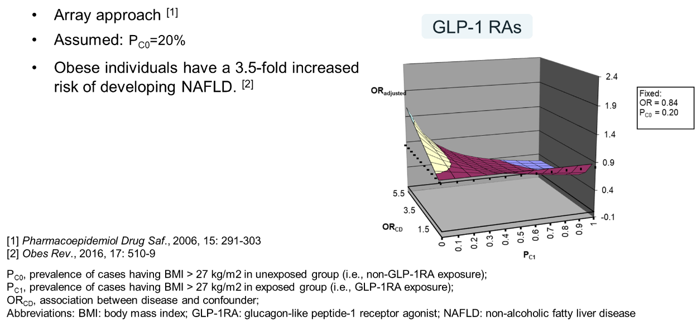

Length: Surface under the curve represents the “true” or fully adjusted odds ratio (OR) where an OR of non-alcoholic fatty liver diseases (NAFLDs)/non-alcoholic steatohepatitis (NASH) of 0.84 and a prevalence of body mass index (BMI) > 27 kg/m² (as an unmeasured confounder of interest) (P_{C0}) of 20% in the non-GLP-1RA group were assumed. According to reported data¹, GLP-1RAs have a weight-loss effect. We thus assumed that the prevalence of BMI > 27 kg/m² (P_{c1}) in the GLP-1RA group was higher than 20% (P_{C0}). Finally, the predicted unbiased OR (OR_{adjusted}) was away from null (OR = 1).

Reference
1. Chang KC, Shao SC, Kuo S, et al. Comparative effectiveness of dulaglutide versus liraglutide in Asian type 2 diabetes patients: a multi-institutional cohort study and meta-analysis. Cardiovasc Diabetol. Oct 9 2020;19(1):172. doi:10.1186/s12933-020-01148-8

