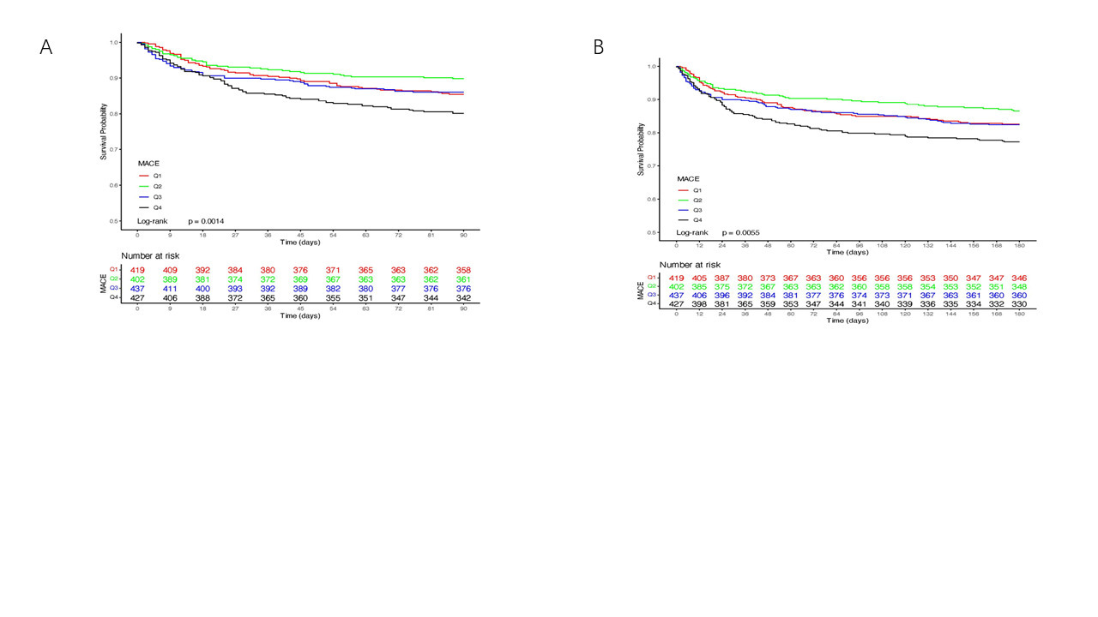
Figure.S1 Kaplan-Meier survival analysis curves for all-cause mortality
Kaplan-Meier curves and cumulative incidence of 90-day (A) and 180-day (B) all-cause mortality stratified by SHR index

