Fig.S3 Forest plots of stratified analyses of SHR index and 90-day all-cause mortality
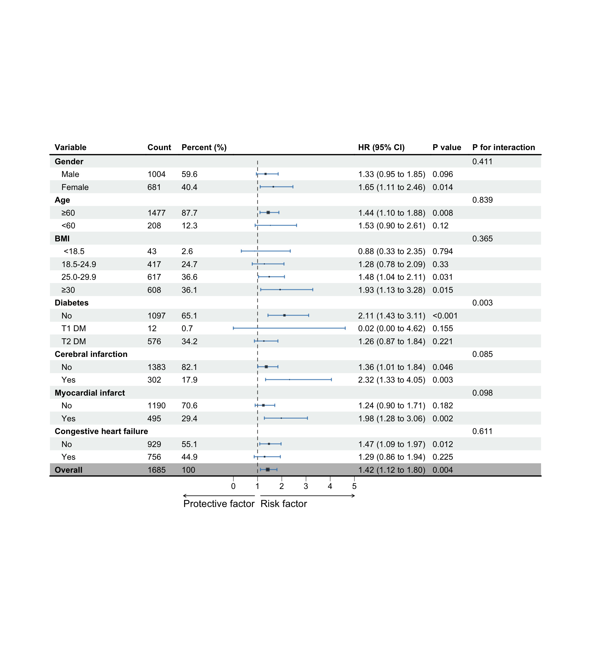
BMI, body mass index; T1 DM, type1 diabetes mellitus; T2 DM, type2 diabetes mellitus

