Supplementary Table 1. Association between glucose-insulin homeostasis biomarkers and incident type 2 diabetes (218 events) in the VITAL trial
 | Q1 | Q2 | Q3 | Q4 | P_{trend} | OR (95% CI) per SD increment
Insulin (pmol/L)
Median (IQR) | 17.39 (10.42-20.84) | 48.62 (41.67-49.61) | 75.40 (65.98-83.34) | 165.63 (118.07-284.75)
Range | <34.73 | 34.73-55.56 | 55.57-90.29 | >90.29
Cases/controls | 31/60 | 36/53 | 48/55 | 103 /50
Model 1¹ | 1.00 (ref.) | 1.38 (0.70, 2.69) | 1.72 (0.91, 3.28) | 4.69 (2.46, 8.95) | 8.67 x 10⁻⁷ | 1.86 (1.32, 2.62)
Model 2² | 1.00 (ref.) | 0.81 (0.36, 1.80) | 1.27 (0.60, 2.67) | 3.20 (1.52, 6.75) | 0.0003 | 1.63 (1.14, 2.34)
Model 3³ | 1.00 (ref.) | 0.68 (0.28, 1.62) | 1.00 (0.44, 2.26) | 2.51 (1.11, 5.69) | 0.004 | 1.46 (1.03, 2.06)
Model 4⁴ | 1.00 (ref.) | 1.20 (0.36, 4.00) | 1.07 (0.35, 3.30) | 2.73 (0.80, 9.33) | 0.11 | 1.16 (0.76, 1.78)
C-peptide (pmol/L)
Median (IQR) | 218.26 (141.53-262.28) | 392.07 (357.14-426.24) | 554.45 (509.20-614.60) | 1027.92 (799.20-1358.64)
Range | <306.36 | 306.36-465.87 | 466.20-662.39 | >662.39
Cases/controls | 24/55 | 36/54 | 40/54 | 118/55
Model 1¹ | 1.00 (ref.) | 1.56 (0.80, 3.07) | 1.51 (0.74, 3.08) | 6.27 (3.16, 12.44) | 4.33 x 10⁻⁸ | 2.58 (1.82, 3.67)
Model 2² | 1.00 (ref.) | 1.53 (0.68, 3.42) | 1.47 (0.68, 3.19) | 6.56 (2.72, 15.83) | 1.49 x 10⁻⁵ | 2.45 (1.63, 3.69)
Model 3³ | 1.00 (ref.) | 1.35 (0.57, 3.21) | 1.16 (0.50, 2.69) | 4.58 (1.80, 11.65) | 0.001 | 2.04 (1.35, 3.09)
Model 4⁴ | 1.00 (ref.) | 2.37 (0.69, 8.12) | 1.94 (0.54, 6.95) | 6.04 (1.48, 24.62) | 0.02 | 1.61 (0.97, 2.65)
Insulin resistance score
Median (IQR) | 4.83 (3.03-6.76) | 16.21 (13.48-19.61) | 44.64 (33.64-54.86) | 97.35 (81.84-99.94)
Range | <10.64 | 10.64-25.25 | 25.53-64.12 | >64.12
Cases/controls | 27/55 | 34/54 | 41/54 | 116/55
Model 1¹ | 1.00 (ref.) | 1.33 (0.67, 2.63) | 1.44 (0.75, 2.80) | 4.63 (2.46, 8.70) | 3.6 x 10⁻⁷ | 1.98 (1.56, 2.52)
Model 2² | 1.00 (ref.) | 0.84 (0.37, 1.90) | 1.12 (0.52, 2.41) | 3.26 (1.50, 7.09) | 0.0003 | 1.90 (1.44, 2.52)
Model 3³ | 1.00 (ref.) | 0.64 (0.26, 1.56) | 0.91 (0.40, 2.10) | 2.19 (0.94, 5.07) | 0.01 | 1.72 (1.28, 2.31)
Model 4⁴ | 1.00 (ref.) | 1.13 (0.32, 4.05) | 1.56 (0.48, 5.07) | 1.90 (0.58, 6.15) | 0.21 | 1.41 (0.93, 2.12)
HbA1c (%)
Median (IQR) | 5.3 (5.2-5.4) | 5.6 (5.5-5.60) | 5.8 (5.7-5.8) | 6.1 (6.0-6.3)
Range | <5.5 | 5.5-5.6 | 5.6-5.8 | >5.8
Cases/controls | 11/79 | 12/60 | 32/42 | 163/37
Model 1¹ | 1.00 (ref.) | 2.45 (0.69, 8.73) | 10.33 (3.05, 35.02) | 48.43 (14.82, 158.34) | 5.74 x 10⁻¹⁴ | 6.70 (4.08, 10.99)
Model 2² | 1.00 (ref.) | 2.18 (0.50, 9.51) | 8.58 (2.28, 32.30) | 44.96 (11.93, 169.47) | 1.47 x 10⁻¹¹ | 6.58 (3.82, 11.36)
Model 3³ | 1.00 (ref.) | 2.38 (0.50, 11.19) | 9.89 (2.36, 41.36) | 47.98 (11.38, 202.4) | 4.09 x 10⁻¹⁰ | 7.00 (3.76, 13.02)
Model 4⁵ | 1.00 (ref.) | 2.77 (0.57, 13.54) | 9.78 (2.20, 43.55) | 46.41 (10.55, 204.23) | 1.61 x 10⁻⁹ | 6.53 (3.53, 12.10)
Notes:
[1] Model 1 includes the matching factors age, sex, and fasting status
[2] Model 2 is additionally adjusted for race/ethnicity, smoking status, alcohol consumption, systolic blood pressure, HDL cholesterol, family history of T2D, use of antihypertensives, use of lipid-lowering agents, and randomized treatment arm (omega-3, vitamin D, or placebo)
[3] Model 3 is additionally adjusted for BMI.
[4] Model 4 is additionally adjusted for HbA1c.
[5] Model 4 is additionally adjusted for insulin and C-peptide.

Supplementary Table 2. Association between glucose-insulin homeostasis biomarkers and incident cardiovascular disease or coronary heart disease in the VITAL trial
 | Q1 | Q2 | Q3 | Q4 | P_{trend} | OR (95% CI) per SD increment
CVD (715 events)¹
Insulin (pmol/L)
Median (IQR) | 17.39 (10.42-20.84) | 41.67 (36.72-48.62) | 75.40 (62.51-83.34) | 173.63 (126.96-256.97)
Range | <27.78 | 27.79-49.61 | 49.62-97.23 | >97.23
Cases/controls | 197/216 | 125/150 | 186/173 | 207/176
Model 1² | 1.00 (ref.) | 0.89 (0.64, 1.25) | 1.25 (0.93, 1.69) | 1.38 (1.01, 1.88) | 0.02 | 1.06 (0.94, 1.19)
Model 2³ | 1.00 (ref.) | 0.78 (0.55, 1.10) | 1.03 (0.75, 1.42) | 1.11 (0.79, 1.56) | 0.41 | 0.99 (0.88, 1.12)
Model 3⁴ | 1.00 (ref.) | 0.78 (0.55, 1.10) | 1.12 (0.74, 1.40) | 1.07 (0.76, 1.51) | 0.55 | 0.98 (0.87, 1.11)
Model 4⁵ | 1.00 (ref.) | 0.76 (0.53, 1.08) | 1.00 (0.73, 1.39) | 1.03 (0.73, 1.46) | 0.68 | 0.98 (0.87, 1.10)
C-peptide (pmol/L)
Median (IQR) | 96.57 (59.08-143.19) | 286.38 (246.42-329.67) | 469.53 (415.88-519.48) | 852.48 (685.98-1208.79)
Range | <199.80 | 199.81-369.63 | 369.64-566.10 | >566.11
Cases/controls | 188/179 | 173/181 | 139/177 | 215/178
Model 1² | 1.00 (ref.) | 0.97 (0.66, 1.42) | 0.81 (0.55, 1.21) | 1.26 (0.83, 1.90) | 0.33 | 0.99 (0.86, 1.14)
Model 2³ | 1.00 (ref.) | 0.98 (0.65, 1.48) | 0.69 (0.46, 1.06) | 1.01 (0.64, 1.59) | 0.67 | 0.89 (0.76, 1.04)
Model 3⁴ | 1.00 (ref.) | 0.99 (0.65, 1.48) | 0.69 (0.45, 1.04) | 0.97 (0.61, 1.54) | 0.52 | 0.87 (0.75, 1.02)
Model 4⁵ | 1.00 (ref.) | 0.97 (0.67, 1.46) | 0.67 (0.44, 1.02) | 0.94 (0.59, 1.50) | 0.44 | 0.87 (0.75, 1.02)
Insulin resistance score
Median (IQR) | 3.72 (2.85-4.82) | 10.52 (7.92-14.18) | 32.39 (24.45-44.00) | 96.63 (82.95-99.89)
Range | <6.06 | 6.07-17.66 | 17.67-59.67 | >59.67
Cases/controls | 168/179 | 148/179 | 183/178 | 216/179
Model 1² | 1.00 (ref.) | 0.86 (0.62, 1.19) | 1.16 (0.84, 1.60) | 1.36 (0.97, 1.90) | 0.02 | 1.18 (1.04, 1.33)
Model 2³ | 1.00 (ref.) | 0.80 (0.57, 1.13) | 0.92 (0.65, 1.30) | 1.10 (0.76, 1.58) | 0.49 | 1.09 (0.95, 1.25)
Model 3⁴ | 1.00 (ref.) | 0.80 (0.57, 1.12) | 0.90 (0.64, 1.28) | 1.06 (0.73, 1.54) | 0.66 | 1.07 (0.94, 1.23)
Model 4⁵ | 1.00 (ref.) | 0.78 (0.56, 1.10) | 0.88 (0.62, 1.25) | 1.00 (0.69, 1.47) | 0.85 | 1.06 (0.92, 1.22)
HbA1c (%)
Median (IQR) | 5.3 (5.2-5.4) | 5.5 (5.5-5.6) | 5.8 (5.7-5.9) | 6.4 (6.1-7.1)
Range | <5.4 | 5.4-5.6 | 5.6-5.9 | >5.9
Cases/controls | 170/220 | 164/153 | 171/177 | 205/165
Model 1² | 1.00 (ref.) | 1.40 (1.02, 1.92) | 1.27 (0.94, 1.73) | 1.82 (1.30, 2.55) | 0.002 | 1.29 (1.12, 1.48)
Model 2³ | 1.00 (ref.) | 1.37 (0.99, 1.90) | 1.14 (0.83, 1.58) | 1.38 (0.94, 2.04) | 0.19 | 1.20 (1.02, 1.40)
Model 3⁴ | 1.00 (ref.) | 1.37 (0.99, 1.90) | 1.14 (0.82, 1.58) | 1.34 (0.90, 1.99) | 0.24 | 1.19 (1.02, 1.39)
Model 4⁶ | 1.00 (ref.) | 1.39 (1.00, 1.92) | 1.15 (0.83, 1.60) | 1.39 (0.93, 2.05) | 0.19 | 1.19 (1.01, 1.39)
CHD (423 events)⁷
Insulin (pmol/L)
Median (IQR) | 17.39 (10.42-20.84) | 41.67 (36.72-48.62) | 69.45 (62.51-83.34) | 173.63 (126.96-256.69)
Range | <27.78 | 27.79-48.62 | 48.63-97.23 | >97.23
Cases/controls | 132/107 | 82/66 | 111/122 | 98/132
Model 1² | 1.00 (ref.) | 0.95 (0.61, 1.49) | 1.39 (0.96, 2.01) | 1.69 (1.14, 2.50) | 0.004 | 1.16 (0.98, 1.38)
Model 2³ | 1.00 (ref.) | 0.89 (0.55, 1.42) | 1.14 (0.76, 1.71) | 1.45 (0.94, 2.24) | 0.08 | 1.10 (0.92, 1.31)
Model 3⁴ | 1.00 (ref.) | 0.88 (0.55, 1.42) | 1.13 (0.75, 1.70) | 1.43 (0.92, 2.23) | 0.10 | 1.09 (0.92, 1.30)
Model 4⁵ | 1.00 (ref.) | 0.86 (0.54, 1.39) | 1.11 (0.74, 1.67) | 1.37 (0.88, 2.14) | 0.14 | 1.07 (0.91, 1.28)
C-peptide (pmol/L)
Median (IQR) | 86.58 (59.08-129.87) | 276.39 (237.91-316.52) | 461.94 (402.93-519.48) | 849.15 (682.65-1138.86)
Range | <186.48 | 186.49-356.31 | 356.32-571.99 | >571.99
Cases/controls | 102/107 | 103/106 | 91/106 | 127/106
Model 1² | 1.00 (ref.) | 1.06 (0.63, 1.79) | 1.01 (0.59, 1.75) | 1.52 (0.86, 2.70) | 0.13 | 1.06 (0.88, 1.28)
Model 2³ | 1.00 (ref.) | 1.04 (0.59, 1.86) | 0.85 (0.46, 1.54) | 1.22 (0.64, 2.33) | 0.67 | 0.96 (0.78, 1.18)
Model 3⁴ | 1.00 (ref.) | 1.05 (0.59, 1.87) | 0.84 (0.46, 1.54) | 1.20 (0.62, 2.30) | 0.75 | 0.95 (0.77, 1.17)
Model 4⁵ | 1.00 (ref.) | 1.04 (0.58, 1.85) | 0.84 (0.46, 1.55) | 1.15 (0.60, 2.23) | 0.82 | 0.95 (0.76, 1.17)
Insulin resistance score
Median (IQR) | 3.63 (2.77-4.60) | 9.97 (7.29-13.04) | 30.23 (22.46-39.26) | 95.58 (79.49-99.84)
Range | <5.63 | 5.63-16.37 | 16.38-55.38 | >55.38
Cases/controls | 82/107 | 89/106 | 109/106 | 145/106
Model 1² | 1.00 (ref.) | 1.11 (0.74, 1.67) | 1.42 (0.95, 2.14) | 2.07 (1.34, 3.21) | 0.001 | 1.31 (1.11, 1.53)
Model 2³ | 1.00 (ref.) | 1.01 (0.65, 1.56) | 1.15 (0.73, 1.80) | 1.75 (1.08, 2.84) | 0.02 | 1.25 (1.05, 1.50)
Model 3⁴ | 1.00 (ref.) | 1.00 (0.65, 1.56) | 1.15 (0.73, 1.80) | 1.74 (1.06, 2.85) | 0.03 | 1.25 (1.04, 1.50)
Model 4⁵ | 1.00 (ref.) | 1.01 (0.65, 1.56) | 1.14 (0.72, 1.80) | 1.66 (1.01, 2.73) | 0.05 | 1.22 (1.02, 1.48)
HbA1c (%)
Median (IQR) | 5.3 (5.2-5.4) | 5.5 (5.5-5.6) | 5.8 (5.7-5.9) | 6.5 (6.1-7.2)
Range | <5.4 | 5.4-5.6 | 5.6-5.9 | >5.9
Cases/controls | 87/133 | 104/81 | 104/111 | 124/100
Model 1² | 1.00 (ref.) | 2.12 (1.39, 3.25) | 1.52 (1.01, 2.29) | 2.13 (1.36, 3.35) | 0.006 | 1.29 (1.08, 1.55)
Model 2³ | 1.00 (ref.) | 2.02 (1.29, 3.15) | 1.20 (0.77, 1.87) | 1.66 (0.96, 2.89) | 0.21 | 1.22 (0.99, 1.52)
Model 3⁴ | 1.00 (ref.) | 2.03 (1.30, 3.17) | 1.21 (0.78, 1.88) | 1.64 (0.94, 2.85) | 0.23 | 1.23 (0.99, 1.52)
Model 4⁶ | 1.00 (ref.) | 2.03 (1.29, 3.18) | 1.21 (0.77, 1.88) | 1.63 (0.94, 2.85) | 0.23 | 1.21 (0.97, 1.51)
CVD: cardiovascular disease; CHD: coronary heart disease; HbA1c: glycated hemoglobin; IQR: interquartile range
[1] Cardiovascular disease is defined as the composite of non-fatal myocardial infarction, non-fatal stroke, and cardiovascular death
[2] Model 1 includes the matching factors age, sex, and fasting status
[3] Model 2 is additionally adjusted for race/ethnicity, smoking status, alcohol consumption, baseline diabetes status, systolic blood pressure, LDL cholesterol, HDL cholesterol, family history of cardiovascular disease, use of antihypertensives, use of lipid-lowering agents, and randomized treatment arm (omega-3, vitamin D, or placebo)
[4] Model 3 is additionally adjusted for BMI
[5] Model 4 is additionally adjusted for HbA1c
[6] Model 4 is additionally adjusted for insulin, and C-peptide
[7] Coronary heart disease is defined as the composite of non-fatal myocardial infarction, coronary revascularization, and coronary deaths

Supplementary Table 3. Association between glucose-insulin homeostasis biomarkers and incident type 2 diabetes (218 events) in the VITAL trial, using single imputation
 | Q1 | Q2 | Q3 | Q4 | P_{trend} | OR (95% CI) per SD increment
Insulin (pmol/L)
Median (IQR) | 17.39 (10.42-20.84) | 48.62 (41.67-49.61) | 75.40 (65.98-83.34) | 165.63 (118.07-284.75)
Range | <34.73 | 34.73-55.56 | 55.57-90.29 | >90.29
Cases/controls | 31/60 | 36/53 | 48/55 | 103 /50
Model 1¹ | 1.00 (ref.) | 1.41 (0.72, 2.77) | 1.76 (0.92, 3.34) | 4.83 (2.52, 9.25) | 6.80 x 10⁻⁷ | 1.80 (1.41, 2.28)
Model 2² | 1.00 (ref.) | 0.81 (0.37, 1.78) | 1.15 (0.56, 1.38) | 3.07 (1.47, 6.39) | 0.0004 | 1.67 (1.15, 2.44)
Model 3³ | 1.00 (ref.) | 0.64 (0.27, 1.51) | 0.82 (0.37, 1.81) | 2.28 (1.02, 5.11) | 0.01 | 1.49 (1.04, 2.15)
Model 4⁴ | 1.00 (ref.) | 1.17 (0.35, 3.93) | 0.95 (0.31, 2.88) | 2.87 (0.82, 10.11) | 0.11 | 1.24 (0.80, 1.93)
C-peptide (pmol/L)
Median (IQR) | 218.26 (141.53-262.28) | 392.07 (357.14-426.24) | 554.45 (509.20-614.60) | 1027.92 (799.20-1358.64)
Range | <306.36 | 306.36-465.87 | 466.20-662.39 | >662.39
Cases/controls | 24/55 | 36/54 | 40/54 | 118/55
Model 1¹ | 1.00 (ref.) | 1.61 (0.82, 3.17) | 1.54 (0.75, 3.13) | 6.78 (3.37, 13.65) | 2.69 x 10⁻⁸ | 2.74 (1.89, 3.95)
Model 2² | 1.00 (ref.) | 1.38 (0.63, 3.01) | 1.29 (0.61, 2.74) | 5.43 (2.33, 12.65) | 5.27 x 10⁻⁵ | 2.36 (1.58, 3.54)
Model 3³ | 1.00 (ref.) | 1.09 (0.47, 2.54) | 0.93 (0.41, 2.14) | 3.44 (1.38, 8.59) | 0.004 | 1.92 (1.27, 2.90)
Model 4⁴ | 1.00 (ref.) | 2.04 (0.49, 6.53) | 1.65 (0.50, 5.49) | 4.87 (1.30, 18.18) | 0.02 | 1.59 (0.99, 2.55)
Insulin resistance score
Median (IQR) | 4.83 (3.03-6.76) | 16.21 (13.48-19.61) | 44.64 (33.64-54.86) | 97.35 (81.84-99.94)
Range | <10.64 | 10.64-25.25 | 25.53-64.12 | >64.12
Cases/controls | 27/55 | 34/54 | 41/54 | 116/55
Model 1¹ | 1.00 (ref.) | 1.36 (0.68, 2.71) | 1.48 (0.76, 2.88) | 4.82 (2.54, 9.11) | 2.51 x 10⁻⁷ | 2.02 (1.59, 2.57)
Model 2² | 1.00 (ref.) | 0.83 (0.37, 1.84) | 1.00 (0.47, 2.11) | 3.04 (1.42, 6.50) | 0.0006 | 1.84 (1.40, 2.42)
Model 3³ | 1.00 (ref.) | 0.59 (0.25, 1.43) | 0.75 (0.34, 1.69) | 1.92 (0.84, 4.40) | 0.02 | 1.64 (1.22, 2.20)
Model 4⁴ | 1.00 (ref.) | 1.05 (0.30, 3.67) | 1.35 (0.43, 4.27) | 1.88 (0.58, 6.14) | 0.21 | 1.43 (0.95, 2.17)
HbA1c (%)
Median (IQR) | 5.3 (5.2-5.4) | 5.6 (5.5-5.60) | 5.8 (5.7-5.8) | 6.1 (6.0-6.3)
Range | <5.5 | 5.5-5.6 | 5.6-5.8 | >5.8
Cases/controls | 11/79 | 12/60 | 32/42 | 163/37
Model 1¹ | 1.00 (ref.) | 2.48 (0.69, 8.90) | 10.39 (3.06, 35.23) | 48.55 (14.84, 158.77) | 5.87 x 10⁻¹⁴ | 6.67 (4.07, 10.94)
Model 2² | 1.00 (ref.) | 2.10 (0.49, 8.94) | 8.33 (2.25, 30.82) | 43.68 (11.78, 161.97) | 9.00 x 10⁻¹² | 6.44 (3.79, 10.94)
Model 3³ | 1.00 (ref.) | 2.31 (0.50, 10.59) | 9.63 (2.34, 39.61) | 45.92 (11.09, 190.15) | 2.78 x 10⁻¹⁰ | 6.78 (3.72, 12.38)
Model 4⁵ | 1.00 (ref.) | 2.58 (0.54, 12.26) | 9.53 (2.19, 41.50) | 45.00 (10.47, 193.45) | 9.97 x 10⁻¹⁰ | 6.45 (3.53, 11.78)
Notes:
[1] Model 1 includes the matching factors age, sex, and fasting status
[2] Model 2 is additionally adjusted for race/ethnicity, smoking status, alcohol consumption, systolic blood pressure, HDL cholesterol, family history of T2D, use of antihypertensives, use of lipid-lowering agents, and randomized treatment arm (omega-3, vitamin D, or placebo)
[3] Model 3 is additionally adjusted for BMI.
[4] Model 4 is additionally adjusted for HbA1c.
[5] Model 4 is additionally adjusted for insulin and C-peptide.

Supplementary Table 4. Association between glucose-insulin homeostasis biomarkers and incident cardiovascular disease or coronary heart disease in the VITAL trial, using single imputation
 | Q1 | Q2 | Q3 | Q4 | P_{trend} | OR (95% CI) per SD increment
CVD (715 events)¹
Insulin (pmol/L)
Median (IQR) | 17.39 (10.42-20.84) | 41.67 (36.72-48.62) | 75.40 (62.51-83.34) | 173.63 (126.96-256.97)
Range | <27.78 | 27.78-49.61 | 49.62-97.22 | ≥97.22
Cases/controls | 197/216 | 125/150 | 186/173 | 207/176
Model 1² | 1.00 (ref.) | 0.89 (0.64, 1.25) | 1.25 (0.93, 1.69) | 1.38 (1.01, 1.88) | 0.02 | 1.06 (0.94, 1.20)
Model 2³ | 1.00 (ref.) | 0.77 (0.54, 1.08) | 1.02 (0.74, 1.40) | 1.09 (0.77, 1.52) | 0.49 | 0.99 (0.87, 1.11)
Model 3⁴ | 1.00 (ref.) | 0.76 (0.54, 1.08) | 1.00 (0.73, 1.38) | 1.05 (0.75, 1.49) | 0.62 | 0.98 (0.87, 1.11)
Model 4⁵ | 1.00 (ref.) | 0.75 (0.53, 1.06) | 0.99 (0.72, 1.37) | 1.02 (0.72, 1.44) | 0.75 | 0.98 (0.86, 1.10)
C-peptide (pmol/L)
Median (IQR) | 96.57 (59.08-143.19) | 286.38 (246.42-329.67) | 469.53 (415.88-519.48) | 852.48 (685.98-1208.79)
Range | <201.17 | 201.17-369.63 | 369.64-566.10 | ≥566.10
Cases/controls | 188/179 | 173/181 | 139/177 | 215/178
Model 1² | 1.00 (ref.) | 0.97 (0.66, 1.42) | 0.81 (0.55, 1.20) | 1.26 (0.83, 1.91) | 0.33 | 0.99 (0.86, 1.14)
Model 2³ | 1.00 (ref.) | 0.96 (0.64, 1.45) | 0.68 (0.44, 1.03) | 0.97 (0.62, 1.54) | 0.56 | 0.88 (0.76, 1.03)
Model 3⁴ | 1.00 (ref.) | 0.96 (0.64, 1.45) | 0.66 (0.44, 1.02) | 0.94 (0.59, 1.49) | 0.43 | 0.87 (0.74, 1.01)
Model 4⁵ | 1.00 (ref.) | 0.94 (0.63, 1.43) | 0.65 (0.43, 1.00) | 0.91 (0.57, 1.45) | 0.36 | 0.87 (0.74, 1.01)
Insulin resistance score
Median (IQR) | 3.72 (2.85-4.82) | 10.52 (7.92-14.18) | 32.39 (24.45-44.00) | 96.63 (82.95-99.89)
Range | <6.08 | 6.08-17.66 | 17.67-59.97 | ≥59.97
Cases/controls | 168/179 | 148/179 | 183/178 | 216/179
Model 1² | 1.00 (ref.) | 0.86 (0.62, 1.19) | 1.15 (0.84, 1.59) | 1.36 (0.98, 1.91) | 0.02 | 1.18 (1.04, 1.33)
Model 2³ | 1.00 (ref.) | 0.78 (0.56, 1.11) | 0.91 (0.64, 1.28) | 1.06 (0.74, 1.53) | 0.58 | 1.08 (0.94, 1.23)
Model 3⁴ | 1.00 (ref.) | 0.78 (0.56, 1.10) | 0.89 (0.63, 1.26) | 1.03 (0.70, 1.49) | 0.75 | 1.06 (0.93, 1.22)
Model 4⁵ | 1.00 (ref.) | 0.77 (0.54, 1.09) | 0.87 (0.61, 1.23) | 0.98 (0.67, 1.43) | 0.94 | 1.05 (0.91, 1.20)
HbA1c (%)
Median (IQR) | 5.3 (5.2-5.4) | 5.5 (5.5-5.6) | 5.8 (5.7-5.9) | 6.8 (6.1-7.1)
Range | <5.4 | 5.4-5.6 | 5.6-5.9 | >5.9
Cases/controls | 170/220 | 164/153 | 171/177 | 205/165
Model 1² | 1.00 (ref.) | 1.40 (1.02, 1.92) | 1.27 (0.93, 1.73) | 1.82 (1.30, 2.56) | 0.001 | 1.29 (1.12, 1.48)
Model 2³ | 1.00 (ref.) | 1.38 (1.00, 1.91) | 1.13 (0.82, 1.56) | 1.35 (0.92, 2.00) | 0.23 | 1.19 (1.01, 1.39)
Model 3⁴ | 1.00 (ref.) | 1.37 (0.99, 1.91) | 1.13 (0.81, 1.56) | 1.32 (0.89, 1.96) | 0.28 | 1.17 (1.01, 1.38)
Model 4⁶ | 1.00 (ref.) | 1.39 (1.00, 1.93) | 1.14 (0.83, 1.59) | 1.36 (0.91, 2.02) | 0.23 | 1.18 (1.00, 1.38)
CHD (423 events)⁷
Insulin (pmol/L)
Median (IQR) | 17.39 (10.42-20.84) | 41.67 (36.72-48.62) | 69.45 (62.51-83.34) | 173.63 (126.96-256.69)
Range | <27.78 | 27.78-49.62 | 49.63-97.22 | ≥97.22
Cases/controls | 132/107 | 82/66 | 111/122 | 98/132
Model 1² | 1.00 (ref.) | 0.95 (0.61, 1.48) | 1.39 (0.96, 2.00) | 1.68 (1.14, 2.50) | 0.004 | 1.17 (0.99, 1.38)
Model 2³ | 1.00 (ref.) | 0.84 (0.52, 1.35) | 1.12 (0.75, 1.67) | 1.36 (0.89, 2.10) | 0.12 | 1.10 (0.92, 1.31)
Model 3⁴ | 1.00 (ref.) | 0.84 (0.52, 1.35) | 1.12 (0.75, 1.68) | 1.36 (0.88, 2.11) | 0.14 | 1.09 (0.92, 1.30)
Model 4⁵ | 1.00 (ref.) | 0.82 (0.51, 1.33) | 1.10 (0.73, 1.65) | 1.31 (0.84, 2.04) | 0.19 | 1.08 (0.91, 1.28)
C-peptide (pmol/L)
Median (IQR) | 86.58 (59.08-129.87) | 276.39 (237.91-316.52) | 461.84 (402.93-519.48) | 849.15 (682.65-1138.86)
Range | <186.48 | 186.49-356.31 | 356.32-571.99 | ≥571.99
Cases/controls | 102/107 | 103/106 | 91/106 | 127/106
Model 1² | 1.00 (ref.) | 1.06 (0.63, 1.79) | 1.02 (0.59, 1.75) | 1.52 (0.86, 2.70) | 0.13 | 1.07 (0.88, 1.29)
Model 2³ | 1.00 (ref.) | 1.04 (0.59, 1.85) | 0.82 (0.45, 1.50) | 1.12 (0.59, 2.13) | 0.89 | 0.94 (0.76, 1.15)
Model 3⁴ | 1.00 (ref.) | 1.04 (0.59, 1.85) | 0.82 (0.45, 1.50) | 1.11 (0.58, 2.12) | 0.95 | 0.93 (0.75, 1.14)
Model 4⁵ | 1.00 (ref.) | 1.03 (0.58, 1.83) | 0.82 (0.45, 1.50) | 1.07 (0.56, 2.06) | 0.97 | 0.92 (0.75, 1.14)
Insulin resistance score
Median (IQR) | 3.63 (2.77-4.60) | 9.97 (7.29-13.04) | 30.23 (22.46-39.26) | 95.58 (79.49-99.84)
Range | <5.63 | 5.63-16.37 | 16.38-55.38 | ≥55.38
Cases/controls | 82/107 | 89/106 | 109/106 | 145/106
Model 1² | 1.00 (ref.) | 1.11 (0.73, 1.67) | 1.41 (0.93, 2.12) | 2.07 (1.34, 3.21) | 0.001 | 1.31 (1.11, 1.54)
Model 2³ | 1.00 (ref.) | 0.98 (0.64, 1.52) | 1.13 (0.72, 1.75) | 1.61 (1.00, 2.58) | 0.04 | 1.21 (1.02, 1.44)
Model 3⁴ | 1.00 (ref.) | 0.98 (0.64, 1.53) | 1.13 (0.72, 1.77) | 1.62 (1.00, 2.65) | 0.04 | 1.22 (1.01, 1.46)
Model 4⁵ | 1.00 (ref.) | 0.99 (0.64, 1.53) | 1.13 (0.72, 1.77) | 1.56 (0.95, 2.56) | 0.07 | 1.19 (0.99, 1.43)
HbA1c (%)
Median (IQR) | 5.3 (5.2-5.4) | 5.5 (5.5-5.6) | 5.8 (5.7-5.9) | 6.5 (6.1-7.2)
Range | <5.4 | 5.4-5.6 | 5.6-5.9 | >5.9
Cases/controls | 87/133 | 104/81 | 104/111 | 124/100
Model 1² | 1.00 (ref.) | 2.12 (1.39, 3.24) | 1.51 (1.00, 2.26) | 2.15 (1.37, 3.37) | 0.006 | 1.30 (1.09, 1.56)
Model 2³ | 1.00 (ref.) | 2.03 (1.30, 3.18) | 1.15 (0.74, 1.79) | 1.49 (0.86, 2.58) | 0.39 | 1.20 (0.97, 1.48)
Model 3⁴ | 1.00 (ref.) | 2.03 (1.30, 3.18) | 1.16 (0.74, 1.79) | 1.48 (0.85, 2.57) | 0.41 | 1.20 (0.97, 1.48)
Model 4⁶ | 1.00 (ref.) | 2.03 (1.29, 3.20) | 1.16 (0.75, 1.81) | 1.49 (0.86, 2.59) | 0.40 | 1.18 (0.95, 1.47)
CVD: cardiovascular disease; CHD: coronary heart disease; HbA1c: glycated hemoglobin; IQR: interquartile range
[1] Cardiovascular disease is defined as the composite of non-fatal myocardial infarction, non-fatal stroke, and cardiovascular death
[2] Model 1 includes the matching factors age, sex, and fasting status
[3] Model 2 is additionally adjusted for race/ethnicity, smoking status, alcohol consumption, baseline diabetes status, systolic blood pressure, LDL cholesterol, HDL cholesterol, family history of cardiovascular disease, use of antihypertensives, use of lipid-lowering agents, and randomized treatment arm (omega-3, vitamin D, or placebo)
[4] Model 3 is additionally adjusted for BMI
[5] Model 4 is additionally adjusted for HbA1c
[6] Model 4 is additionally adjusted for insulin, and C-peptide
[7] Coronary heart disease is defined as the composite of non-fatal myocardial infarction, coronary revascularization, and coronary deaths

Supplementary Table 5. Association between glucose-insulin homeostasis biomarkers and incident type 2 diabetes (154 events) in the VITAL trial, using complete case analysis
 | Q1 | Q2 | Q3 | Q4 | P_{trend} | OR (95% CI) per SD increment
Insulin (pmol/L)
Median (IQR) | 17.39 (10.42-20.84) | 48.62 (41.67-49.61) | 75.40 (65.98-83.34) | 152.79 (116.07-239.60)
Range | <27.78 | 27.79-55.56 | 55.57-88.29 | >88.29
Cases/controls | 22/42 | 29/41 | 36/35 | 67/36
Model 1¹ | 1.00 (ref.) | 1.35 (0.62, 2.94) | 2.15 (1.00, 4.62) | 4.20 (1.97, 8.96) | 5.93 x 10⁻⁵ | 2.05 (1.25, 3.36)
Model 2² | 1.00 (ref.) | 0.80 (0.32, 2.01) | 1.49 (0.63, 3.55) | 3.01 (1.26, 7.23) | 0.003 | 1.86 (1.07, 3.23)
Model 3³ | 1.00 (ref.) | 0.70 (0.26, 1.85) | 1.23 (0.49, 3.06) | 2.47 (0.95, 6.40) | 0.02 | 1.58 (0.92, 2.72)
Model 4⁴ | 1.00 (ref.) | 1.51 (0.33, 7.00) | 2.06 (0.47, 9.15) | 2.60 (0.49, 13.68) | 0.29 | 1.01 (0.56, 1.85)
C-peptide (pmol/L)
Median (IQR) | 216.45 (139.86-249.73) | 372.96 (334.67-412.81) | 529.47 (488.68-596.07) | 952.81 (756.74-1296.20)
Range | <283.05 | 283.06-436.23 | 436.24-639.36 | >639.36
Cases/controls | 16/39 | 25/38 | 30/38 | 83/39
Model 1¹ | 1.00 (ref.) | 1.91 (0.85, 4.27) | 2.43 (0.98, 6.07) | 8.97 (3.62, 22.23) | 7.85 x 10⁻⁷ | 3.58 (2.12, 6.04)
Model 2² | 1.00 (ref.) | 1.57 (0.60, 4.11) | 2.10 (0.74, 5.97) | 9.52 (2.95, 30.76) | 4.16 x 10⁻⁵ | 3.67 (1.95, 6.90)
Model 3³ | 1.00 (ref.) | 1.21 (0.44, 3.33) | 1.56 (0.51, 4.71) | 6.14 (1.75, 21.55) | 0.001 | 3.03 (1.60, 5.74)
Model 4⁴ | 1.00 (ref.) | 5.76 (0.94, 34.39) | 6.62 (1.10, 39.70) | 21.79 (2.13, 222.62) | 0.01 | 2.17 (0.83, 5.69)
Insulin resistance score
Median (IQR) | 4.73 (2.85-6.42) | 15.49 (13.10-19.11) | 40.73 (32.14-49.40) | 94.86 (78.10-99.90)
Range | <9.73 | 9.74-23.11 | 23.12-60.06 | >60.06
Cases/controls | 18/39 | 27/38 | 28/38 | 81/39
Model 1¹ | 1.00 (ref.) | 1.64 (0.74, 3.64) | 1.94 (0.85, 4.44) | 5.46 (2.46, 12.13) | 8.7 x 10⁻⁶ | 2.08 (1.55, 2.81)
Model 2² | 1.00 (ref.) | 1.19 (0.47, 3.01) | 1.54 (0.60, 3.94) | 64.30 (1.58,11.69) | 0.001 | 2.10 (1.45, 3.05)
Model 3³ | 1.00 (ref.) | 0.74 (0.27, 2.07) | 1.11 (0.40, 3.07) | 62.63 (0.87, 7.88) | 0.01 | 1.92 (1.30, 2.82)
Model 4⁴ | 1.00 (ref.) | 1.93 (0.34, 10.86) | 2.87 (0.50, 16.32) | 4.68 (0.69, 31.88) | 0.10 | 1.76 (0.88, 3.52)
HbA1c (%)
Median (IQR) | 5.2 (5.1-5.3) | 5.5 (5.4-5.6) | 5.7 (5.7-5.7) | 6.1 (5.9-6.2)
Range | <5.3 | 5.4-5.6 | 5.7-5.7 | >5.7
Cases/controls | 3/40 | 13/59 | 10/17 | 128/38
Model 1¹ | 1.00 (ref.) | 5.40 (0.64, 45.43) | 38.86 (3.17,475.85) | 190.01 (17.67, 2043.25) | 9.11 x 10⁻⁹ | 13.94 (5.80-33.46)
Model 2² | 1.00 (ref.) | 4.94 (0.39, 62.61) | 32.61 (1.81, 587.25) | 182.40 (11.33, 2936.56) | 1.52 x 10⁻⁷ | 13.01 (5.07, 33.37)
Model 3³ | 1.00 (ref.) | 5.05 (0.38, 67.62) | 35.66 (1.87, 680.03) | 184.85 (10.99, 3110.17) | 4.32 x 10⁻⁷ | 14.54 (5.05, 41.85)
Model 4⁴ | 1.00 (ref.) | 6.51 (0.49, 87.21) | 34.52 (1.68, 709.97) | 165.69 (9.81, 2798.76) | 1.85 x 10⁻⁶ | 12.59 (4.29, 36.94)
Notes:
[1] Model 1 includes the matching factors age, sex, and fasting status
[2] Model 2 is additionally adjusted for race/ethnicity, smoking status, alcohol consumption, systolic blood pressure, HDL cholesterol, family history of T2D, use of antihypertensives, use of lipid-lowering agents, and randomized treatment arm (omega-3, vitamin D, or placebo)
[3] Model 3 is additionally adjusted for BMI.
[4] Model 4 is additionally adjusted for HbA1c.
[5] Model 4 is additionally adjusted for insulin and C-peptide.

Supplementary Table 6. Association between glucose-insulin homeostasis biomarkers and incident cardiovascular disease or coronary heart disease in the VITAL trial, using complete case analysis
 | Q1 | Q2 | Q3 | Q4 | P_{trend} | OR (95% CI) per SD increment
CVD (459 events)¹
Insulin (pmol/L)
Median (IQR) | 17.39 (10.42-20.84) | 41.67 (36.72-48.62) | 75.40 (62.51-83.34) | 173.63 (126.96-255.86)
Range | <27.78 | 27.79-49.61 | 49.62-97.23 | >97.23
Cases/controls | 136/141 | 82/102 | 122/114 | 119/102
Model 1 | 1.00 (ref.) | 0.80 (0.54, 1.18) | 1.13 (0.79, 1.62) | 1.27 (0.88, 1.85) | 0.15 | 1.03 (0.90, 1.19)
C-peptide (pmol/L)
Median (IQR) | 92.49 (59.08-139.86) | 286.38 (249.75-328.31) | 459.54 (404.62-504.00) | 819.18 (659.34-1138.86)
Range | <199.80 | 199.81-362.97 | 362.98-546.12 | >546.12
Cases/controls | 118/117 | 112/113 | 93/114 | 134/115
Model 1 | 1.00 (ref.) | 0.99 (0.61, 1.59) | 0.85 (0.53, 1.36) | 1.27 (0.76, 2.12) | 0.45 | 1.07 (0.90, 1.28)
Insulin resistance score
Median (IQR) | 3.78 (2.85-4.73) | 9.80 (7.29-13.20) | 30.17 (22.33-39.88) | 95.10 (74.76-99.81)
Range | <5.82 | 5.83-16.21 | 16.22-51.08 | >51.08
Cases/controls | 109/115 | 97/115 | 112/114 | 141/115
Model 1 | 1.00 (ref.) | 0.90 (0.61, 1.33) | 1.06 (0.71, 1.57) | 1.41 (0.94, 2.11) | 0.07 | 1.19 (1.02, 1.39)
HbA1c (%)
Median (IQR) | 5.3 (5.2-5.4) | 5.5 (5.5-5.6) | 5.8 (5.7-5.9) | 6.4 (6.1-7.0)
Range | <5.4 | 5.5-5.6 | 5.7-5.9 | >5.9
Cases/controls | 102/144 | 99/100 | 114/115 | 138/100
Model 1 | 1.00 (ref.) | 1.48 (1.00, 2.18) | 1.49 (1.02, 2.18) | 2.34 (1.54, 3.56) | 0.0002 | 1.39 (1.17, 1.66)
CHD (276 events)⁷
Insulin (pmol/L)
Median (IQR) | 17.39 (10.42-20.84) | 41.67 (36.72-48.62) | 69.45 (62.51-76.40) | 152.79 (114.06-242.97)
Range | <27.78 | 27.79-48.62 | 48.63-90.29 | >90.29
Cases/controls | 76/87 | 43/57 | 70/64 | 86/67
Model 1 | 1.00 (ref.) | 0.78 (0.45, 1.33) | 1.20 (0.76, 1.90) | 1.56 (0.98, 2.49) | 0.05 | 1.17 (0.95, 1.45)
C-peptide (pmol/L)
Median (IQR) | 86.58 (59.08-121.55) | 266.40 (236.43-299.70) | 430.03 (376.29-490.34) | 799.28 (652.68-1097.24)
Range | <183.15 | 183.16-340.10 | 340.11-540.55 | >540.55
Cases/controls | 62/69 | 56/69 | 68/68 | 87/69
Model 1 | 1.00 (ref.) | 1.01 (0.51, 1.99) | 1.44 (0.72, 2.89) | 2.15 (1.00, 4.63) | 0.009 | 1.29 (1.00, 1.65)
Insulin resistance score
Median (IQR) | 3.78 (2.79-4.60) | 9.25 (6.77-12.08) | 27.31 (19.80-35.56) | 92.77 (71.03-99.76)
Range | <5.59 | 5.60-15.63 | 15.64-44.13 | >44.13
Cases/controls | 56/70 | 57/68 | 63/68 | 99/69
Model 1 | 1.00 (ref.) | 1.11 (0.68, 1.79) | 1.29 (0.77, 2.18) | 2.26 (1.32, 3.88) | 0.003 | 1.42 (1.15, 1.76)
HbA1c (%)
Median (IQR) | 5.3 (5.2-5.4) | 5.6 (5.5-5.6) | 5.8 (5.7-5.9) | 6.5 (6.1-6.9)
Range | <5.4 | 5.5-5.6 | 5.7-5.9 | >5.9
Cases/controls | 50/86 | 65/54 | 71/78 | 84/57
Model 1 | 1.00 (ref.) | 2.55 (1.48, 4.41) | 1.85 (1.09, 3.14) | 3.38 (1.89, 6.04) | 0.0004 | 1.47 (1.15, 1.89)
CVD: cardiovascular disease; CHD: coronary heart disease; HbA1c: glycated hemoglobin; IQR: interquartile range
[1] Cardiovascular disease is defined as the composite of non-fatal myocardial infarction, non-fatal stroke, and cardiovascular death
[2] Coronary heart disease is defined as the composite of non-fatal myocardial infarction, coronary revascularization, and coronary deaths

Supplementary Figure 1a. Flow diagram of participant selection for the analysis of the association between glucose-insulin homeostatic biomarkers and incident type 2 diabetes in the Vitamin D and Omega-3 Trial
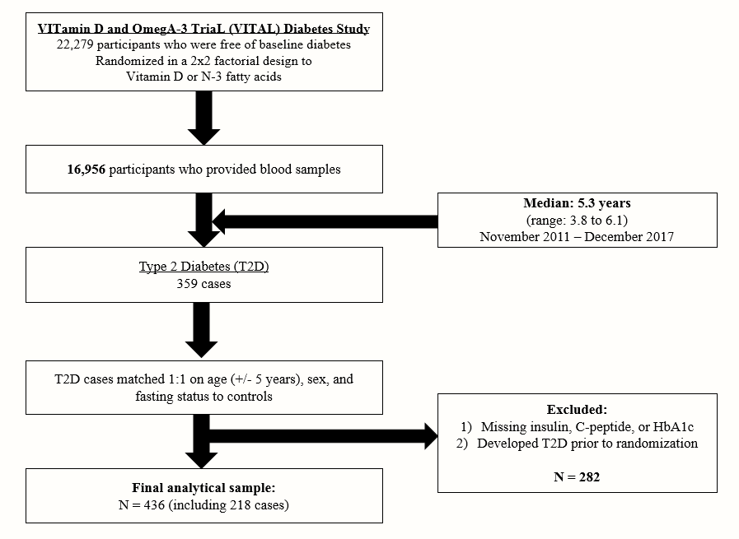

Supplementary Figure 1b. Flow diagram of participant selection for the analysis of the association between glucose-insulin homeostatic biomarkers and incident cardiovascular disease and coronary heart disease in the Vitamin D and Omega-3 Trial

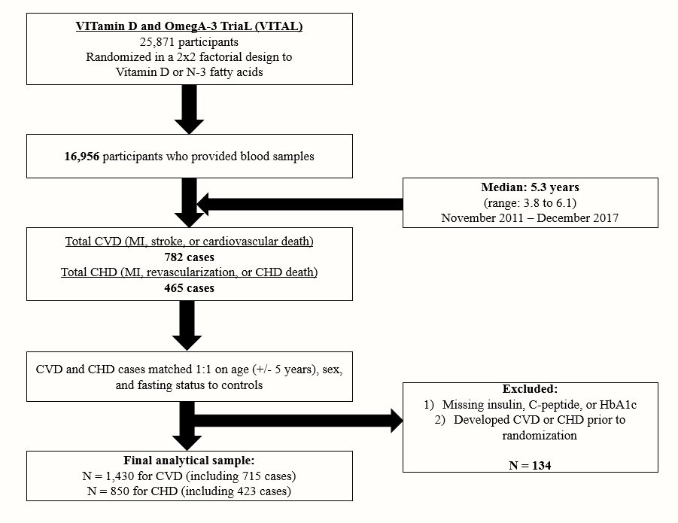

Supplementary Figure 2a. Spearman’s correlation coefficients between biomarkers of glucose-insulin homeostasis with each other and with body mass index, among individuals free of CVD (N = 715). * P<0.05; **P<0.01; ***P<0.001
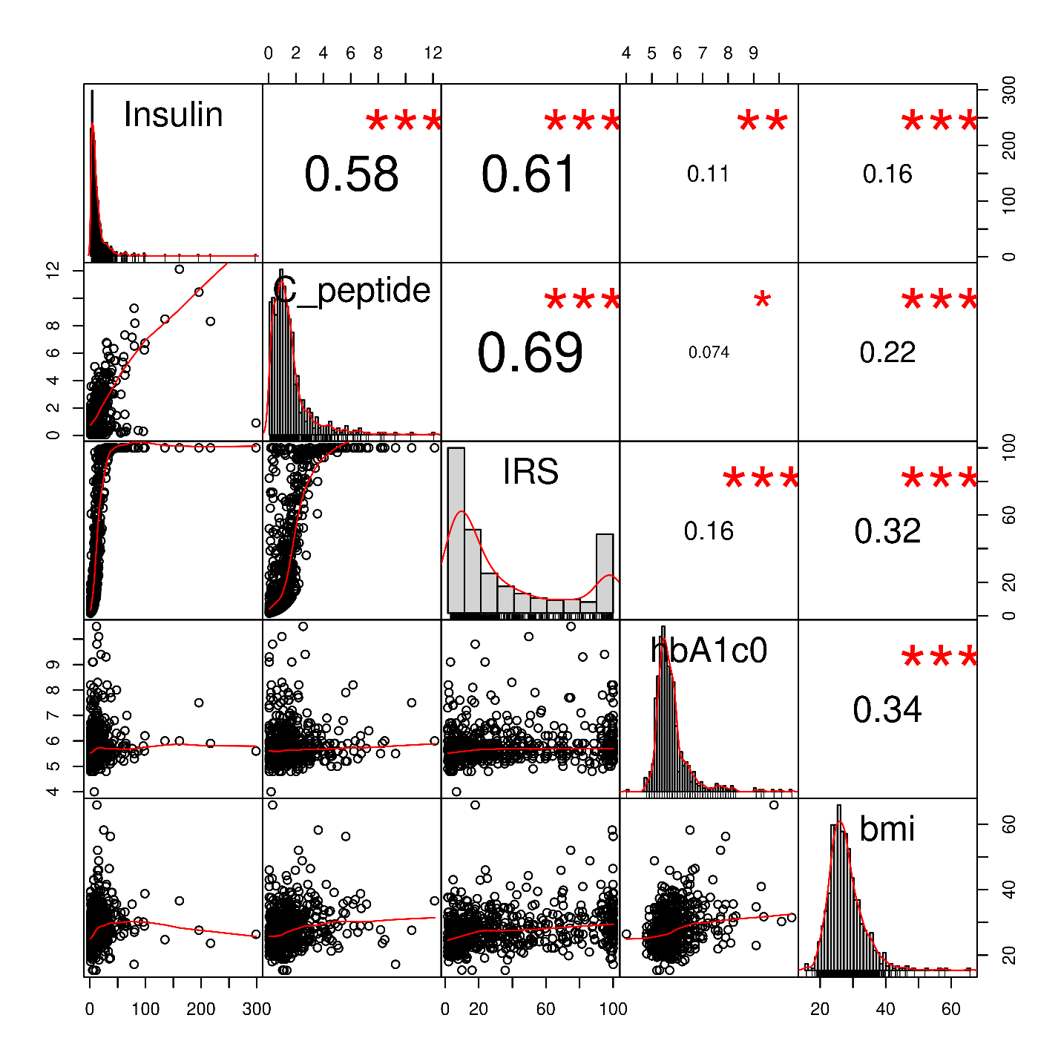

Supplementary Figure 2b. Spearman’s correlation coefficients between biomarkers of glucose-insulin homeostasis and body mass index, among individuals free of T2D (N = 218). * P<0.05; **P<0.01; ***P<0.001
