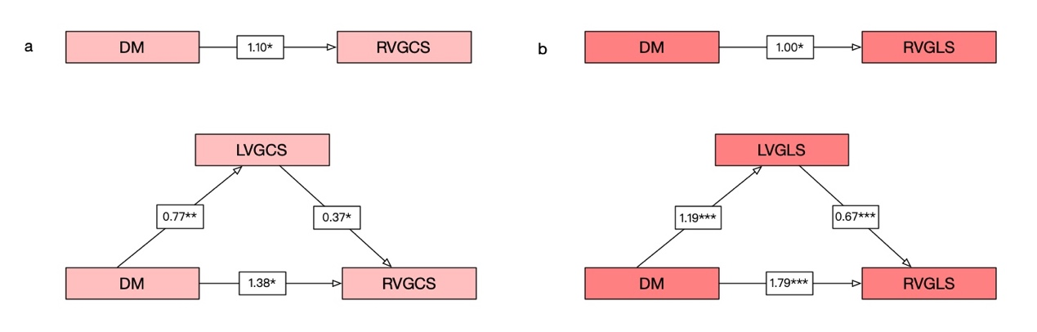
Additional file 2: Output models of LV strain (a: LVGCS, b: LVGLS) mediation. *** represents P less than 0.001, ** represents P less than 0.01, * represents P less than 0.05. DM: diabetes mellitus; GRS: global radial strain; GCS: global circumferential strain; GLS: global longitudinal strain.

