Supplemental materials

Sodium-Glucose Cotransporter 2 Inhibitors and Cardiovascular Events Among Patients with Type 2 Diabetes and Low-to-Normal Body Mass Index: A Nationwide Cohort Study

Supplemental Tables
Table S1. Comparison of target trial and the emulated trial
Table S2: The STROBE checklist
Table S3: Demographic characteristics by BMI category in patients with low-to-normal BMI
Table S4: Demographic characteristics by BMI category in patients with high BMI

Supplemental Figures
Figure S1. Flow of study sample selection
Figure S2. Distribution of demographic characteristics before and after matching.
Figure S3. Survival curve for secondary outcomes (all-cause death, stroke, myocardial infarction, and heart failure)
Table S1: Comparison of target trial and the emulated trial
Component | Target trial | Emulated trial
Eligibility criteria | Patients with type 2 diabetes without prior prescription of SGLT2 inhibitors and histories of cancer or severe chronic kidney disease. | Patients with diabetes and previous health screening records without prior prescription of SGLT2 inhibitors and histories of cancer, type 1 diabetes, or severe chronic kidney disease. Exclusion criteria also include lack of obvious treatment indication for diabetes (e.g., no use of any glucose-lowering agents or insulin, fasting blood glucose ≤ 126 mg/dL, and hemoglobin A1c ≤ 6.4%)
Treatment strategies | Initiation of SGLT2 inhibitors vs. placebo | Among DPP4 inhibitors naïve patients: Initiation of SGLT2 inhibitors vs. Initiation of DPP4 inhibitors  Among DPP4 inhibitor prevalent users: Initiation of SGLT2 inhibitors vs. No initiation of SGLT2 inhibitors
Assignment procedure | Random assignment at baseline with stratification for BMI (< 20.0, 20.0–22.4, 22.5–24.9, 25.0–29.9, 30.0–34.9, and 35.0 ≤ kg/m²); participants will be aware of their assigned strategy | Month-by-month propensity score matching with stratification for BMI (< 20.0, 20.0–22.4, 22.5–24.9, 25.0–29.9, 30.0–34.9, and 35.0 ≤ kg/m²); participants are aware of their treatment strategy
Follow-up period | Starts at randomization and ends at the occurrence of outcomes, loss to follow-up, or March 2022, whichever occurs first | Starts at treatment assignment and ends at the occurrence of outcomes, lost to follow-up, or March 2022, whichever occurs first
Outcome | Cardiovascular death, acute myocardial infarction, stroke, or heart failure | All-cause death and hospitalizations due to acute myocardial infarction, stroke, or heart failure
Causal contrast of interest | Intention-to-treat effect | Intention-to-treat effect
Analysis plan | The intention-to-treat effect will be estimated via Cox proportional hazard regression among individuals assigned to each treatment strategy. The analyses will be conducted for the whole population and subgroups of each BMI category. | The intention-to-treat effect will be estimated via Cox proportional hazard regression among individuals assigned to each treatment strategy. The analyses will be adjusted for relevant pre-baseline variables and will be conducted for the whole population and subgroups of each BMI category.
BMI, body mass index; DPP4, dipeptidyl peptidase 4; SGLT2, sodium-glucose cotransporter 2

Table S2: The STROBE checklist
STROBE 2007 (v4) Statement—Checklist of items that should be included in reports of cohort studies

Title: Sodium-Glucose Cotransporter 2 Inhibitors and Cardiovascular Events Among Patients with Type 2 Diabetes and Low-to-Normal Body Mass Index: A Nationwide Cohort Study

Section/Topic | Item # | Recommendation | Reported on page #
Title and abstract | 1 | (a) Indicate the study’s design with a commonly used term in the title or the abstract | 1
Title and abstract | 1 | (b) Provide in the abstract an informative and balanced summary of what was done and what was found | 4-5
Introduction
Background/rationale | 2 | Explain the scientific background and rationale for the investigation being reported | 6-7
Objectives | 3 | State specific objectives, including any prespecified hypotheses | 6-7
Methods
Study design | 4 | Present key elements of study design early in the paper | 7
Setting | 5 | Describe the setting, locations, and relevant dates, including periods of recruitment, exposure, follow-up, and data collection | 7
Participants | 6 | (a) Give the eligibility criteria, and the sources and methods of selection of participants. Describe methods of follow-up | 8
Participants | 6 | (b) For matched studies, give matching criteria and number of exposed and unexposed | 9-10
Variables | 7 | Clearly define all outcomes, exposures, predictors, potential confounders, and effect modifiers. Give diagnostic criteria, if applicable | 9
Data sources/ measurement | 8* | For each variable of interest, give sources of data and details of methods of assessment (measurement). Describe comparability of assessment methods if there is more than one group | 8-9
Bias | 9 | Describe any efforts to address potential sources of bias | 10
Study size | 10 | Explain how the study size was arrived at | NA
Quantitative variables | 11 | Explain how quantitative variables were handled in the analyses. If applicable, describe which groupings were chosen and why | 9
Statistical methods | 12 | (a) Describe all statistical methods, including those used to control for confounding | 10
Statistical methods | 12 | (b) Describe any methods used to examine subgroups and interactions | 10
Statistical methods | 12 | (c) Explain how missing data were addressed | 8
Statistical methods | 12 | (d) If applicable, explain how loss to follow-up was addressed | 9
Statistical methods | 12 | (e) Describe any sensitivity analyses | NA
Results
Participants | 13* | (a) Report numbers of individuals at each stage of study—eg numbers potentially eligible, examined for eligibility, confirmed eligible, included in the study, completing follow-up, and analysed | 11
 |  | (b) Give reasons for non-participation at each stage | Figure 1
 |  | (c) Consider use of a flow diagram | Figure 1
Descriptive data | 14* | (a) Give characteristics of study participants (eg demographic, clinical, social) and information on exposures and potential confounders | Table 1
 |  | (b) Indicate number of participants with missing data for each variable of interest | NA
 |  | (c) Summarise follow-up time (eg, average and total amount) | 12
Outcome data | 15* | Report numbers of outcome events or summary measures over time | 12
Main results | 16 | (a) Give unadjusted estimates and, if applicable, confounder-adjusted estimates and their precision (eg, 95% confidence interval). Make clear which confounders were adjusted for and why they were included | NA
 |  | (b) Report category boundaries when continuous variables were categorized | 12
 |  | (c) If relevant, consider translating estimates of relative risk into absolute risk for a meaningful time period | NA
Other analyses | 17 | Report other analyses done—eg analyses of subgroups and interactions, and sensitivity analyses | 11-12
Discussion
Key results | 18 | Summarise key results with reference to study objectives | 12
Limitations
Interpretation | 20 | Give a cautious overall interpretation of results considering objectives, limitations, multiplicity of analyses, results from similar studies, and other relevant evidence | 14
Generalisability | 21 | Discuss the generalisability (external validity) of the study results | 14
Other information
Funding | 22 | Give the source of funding and the role of the funders for the present study and, if applicable, for the original study on which the present article is based | 16

Table S3: Demographic characteristics by BMI category in patients with low-to-normal BMI
BMI, kg/m2 | < 20.0 |  | 20.0–22.4 |  | 22.5–24.9
 | DPP4 inhibitors | SGLT2 inhibitors | DPP4 inhibitors | SGLT2 inhibitors | DPP4 inhibitors | SGLT2 inhibitors
Variables | n = 2,675 | n = 2,675 | n = 11,909 | n = 11,909 | n = 28,684 | n = 28,684
Age, years | 58.4 (8.2) | 59.6 (7.8) | 58.7 (8.1) | 59.4 (8.0) | 58.3 (8.2) | 58.5 (8.1)
Female | 715 (26.7) | 606 (22.7) | 1,996 (16.8) | 1,941 (16.3) | 4,041 (14.1) | 4,235 (14.8)
Smoking | 1,524 (57.0) | 1,401 (52.4) | 6,833 (57.4) | 6,742 (56.6) | 17,373 (60.6) | 17,397 (60.7)
Statins | 783 (29.3) | 804 (30.1) | 4,406 (37.0) | 4,522 (38.0) | 11,765 (41.0) | 12,092 (42.2)
Insulin | 492 (18.4) | 426 (15.9) | 1,571 (13.2) | 1,362 (11.4) | 3,071 (10.7) | 2,709 (9.4)
Other glucose-lowering agents | 1,978 (73.9) | 2,078 (77.7) | 8,808 (74.0) | 9,086 (76.3) | 20,699 (72.2) | 21,213 (74.0)
History of CVD | 41 (1.5) | 61 (2.3) | 272 (2.3) | 296 (2.5) | 624 (2.2) | 718 (2.5)
Fasting blood glucose, mg/dL | 161.9 (58.5) | 170.9 (62.1) | 160.8 (53.3) | 165.6 (51.8) | 159.1 (48.4) | 161.5 (46.6)
Missing | 239 (8.9) | 253 (9.5) | 1,077 (9.0) | 1,007 (8.5) | 2,602 (9.1) | 2,469 (8.6)
HbA1c (%) | 7.8 (1.9) | 8 (1.9) | 7.7 (1.7) | 7.9 (1.6) | 7.6 (1.5) | 7.8 (1.4)
Missing | 1,778 (66.5) | 1,778 (66.5) | 7,692 (64.6) | 7,692 (64.6) | 18,367 (64.0) | 18,367 (64.0)
eGFR, ml/min/1.73m²
30–44 | 24 (0.9) | 53 (2.0) | 198 (1.7) | 268 (2.3) | 554 (1.9) | 612 (2.1)
45–59 | 180 (6.7) | 192 (7.2) | 1,005 (8.4) | 1,111 (9.3) | 3,069 (10.7) | 3,361 (11.7)
60–89 | 1,641 (61.3) | 1,505 (56.3) | 7,494 (62.9) | 7,336 (61.6) | 18,559 (64.7) | 18,019 (62.8)
≥ 90 | 830 (31.0) | 925 (34.6) | 3,212 (27.0) | 3,194 (26.8) | 6,502 (22.7) | 6,692 (23.3)
Systolic blood pressure, mmHg
< 110 | 584 (21.8) | 596 (22.3) | 1,558 (13.1) | 1,611 (13.5) | 2,627 (9.2) | 2,676 (9.3)
110–139 | 1,570 (58.7) | 1,538 (57.5) | 7,505 (63.0) | 7,393 (62.1) | 18,242 (63.6) | 18,053 (62.9)
≥ 140 | 521 (19.5) | 541 (20.2) | 2,846 (23.9) | 2,905 (24.4) | 7,815 (27.2) | 7,955 (27.7)
BMI, body mass index; CVD, cardiovascular disease; DPP4, dipeptidyl peptidase 4; eGFR, estimated glomerular filtration rate; HbA1c. hemoglobin A1c; SGLT2, sodium-glucose cotransporter 2
Table S4: Demographic characteristics by BMI category in patients with high BMI
BMI, kg/m2 | 25.0–29.9 |  | 30.0–34.9 |  | ≥ 35.0
 | DPP4 inhibitors | SGLT2 inhibitors | DPP4 inhibitors | SGLT2 inhibitors | DPP4 inhibitors | SGLT2 inhibitors
Variables | n = 64,794 | n = 64,794 | n = 24,743 | n = 24,743 | n = 6,978 | n = 6,978
Age, years | 55.8 (8.6) | 56.0 (8.5) | 52.3 (8.5) | 52.5 (8.4) | 48.6 (7.8) | 48.9 (7 .7)
Female | 10,264 (15.8) | 10,432 (16.1) | 5,279 (21.3) | 5,184 (21.0) | 1,879 (26.9) | 1,805 (25.9)
Smoking | 39,942 (61.6) | 40,813 (63.0) | 15,463 (62.5) | 15,897 (64.2) | 4,416 (63.3) | 4,493 (64.4)
Statins | 26,905 (41.5) | 27,510 (42.5) | 9,690 (39.2) | 9,847 (39.8) | 2,471 (35.4) | 2,430 (34.8)
Insulin | 5,991 (9.2) | 5,817 (9.0) | 1,886 (7.6) | 1,801 (7.3) | 465 (6.7) | 473 (6.8)
Other glucose-lowering agents | 45,368 (70.0) | 46,694 (72.1) | 16,432 (66.4) | 17,247 (69.7) | 4,699 (67.3) | 4,927 (70.6)
History of CVD | 1,327 (2.0) | 1,418 (2.2) | 472 (1.9) | 521 (2.1) | 102 (1.5) | 133 (1.9)
Fasting blood glucose, mg/dL | 159.6 (48.1) | 159.9 (45.2) | 156.7 (46.1) | 156.0 (42.8) | 154.6 (45.9) | 153.9 (42.7)
Missing | 5,895 (9.1) | 5,593 (8.6) | 2,210 (8.9) | 2,090 (8.4) | 640 (9.2) | 615 (8.8)
HbA1c (%) | 7.7 (1.5) | 7.7 (1.4) | 7.7 (1.5) | 7.7 (1.3) | 7.7 (1.4) | 7.6 (1.3)
Missing | 41,569 (64.2) | 41,569 (64.2) | 16,137 (65.2) | 16,137 (65.2) | 4,644 (66.6) | 4,644 (66.6)
eGFR, ml/min/1.73m²
30–44 | 1,364 (2.1) | 1,368 (2.1) | 529 (2.1) | 459 (1.9) | 126 (1.8) | 111 (1.6)
45–59 | 7,018 (10.8) | 7,497 (11.6) | 2,458 (9.9) | 2,502 (10.1) | 485 (7.0) | 487 (7.0)
60–89 | 41,442 (64.0) | 41,007 (63.3) | 15,180 (61.4) | 15,199 (61.4) | 3,967 (56.9) | 3,965 (56.8)
≥ 90 | 14,970 (23.1) | 14,922 (23.0) | 6,576 (26.6) | 6,583 (26.6) | 2,400 (34.4) | 2,415 (34.6)
Systolic blood pressure, mmHg
< 110 | 3,711 (5.7) | 3,718 (5.7) | 809 (3.3) | 853 (3.4) | 137 (2.0) | 145 (2.1)
110–139 | 40,477 (62.5) | 40,650 (62.7) | 14,378 (58.1) | 14,531 (58.7) | 3,644 (52.2) | 3,592 (51.5)
≥ 140 | 20,606 (31.8) | 20,426 (31.5) | 9,556 (38.6) | 9,359 (37.8) | 3,197 (45.8) | 3,241 (46.4)
BMI, body mass index; CVD, cardiovascular disease; DPP4, dipeptidyl peptidase 4; eGFR, estimated glomerular filtration rate; HbA1c. hemoglobin A1c; SGLT2, sodium-glucose cotransporter 2
Figure S1. Flow of study sample selection
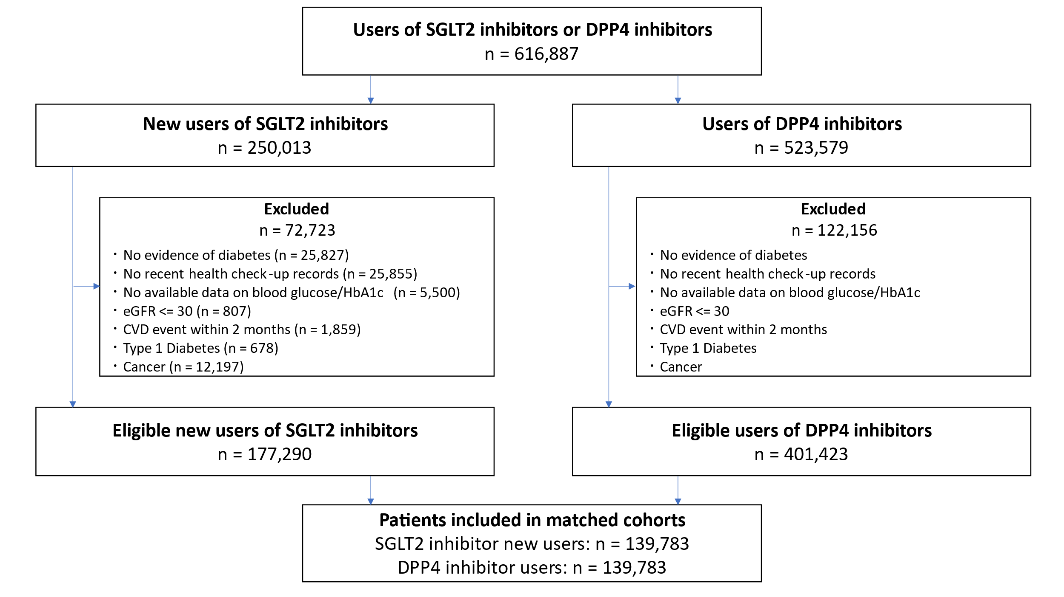

Numbers of new users of SGLT2 inhibitors and users of DPP4 inhibitors do not add up to the total number of the base cohort because some patients can be included for both arms.
The numbers for the reasons of exclusion were not presented individually for the users of DPP4 inhibitors because exclusion criteria were implemented separately for monthly exposure datasets and thus the same patient could be excluded with different reasons in different months.
CVD, cardiovascular disease; DPP4, dipeptidyl peptidase 4; eGFR, estimated glomerular filtration rate; HbA1c, hemoglobin A1c; SGLT2, sodium-glucose cotransporter 2
Figure S2. Distribution of demographic characteristics before and after matching.
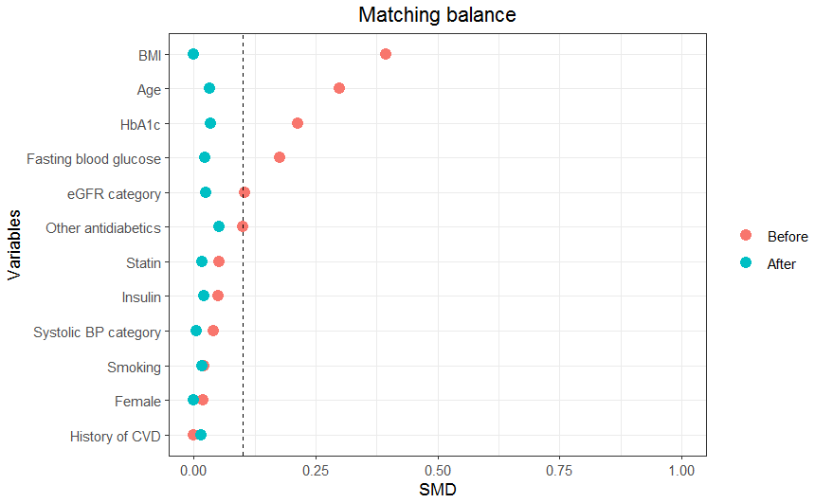
BMI, body mass index; BP, blood pressure; CVD, cardiovascular disease; eGFR, estimated glomerular filtration rate; HbA1c. hemoglobin A1c; SMD, standardized mean difference
Figure S3. Survival curve for secondary outcomes (all-cause death, stroke, myocardial infarction, and heart failure)
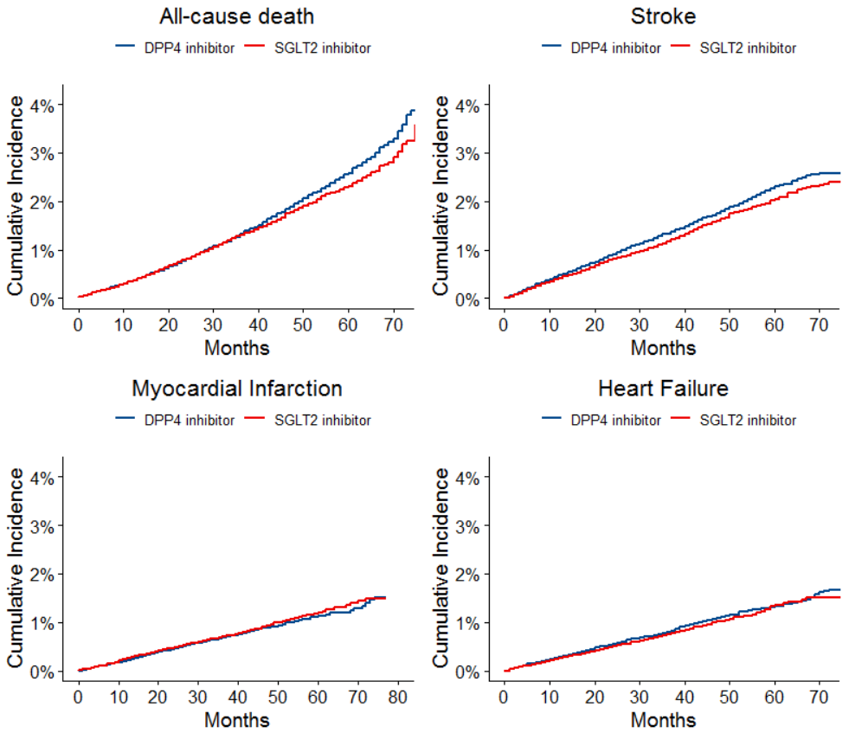
Log-rank p = 0.1 in all-cause death, < 0.05 in stroke, 0.3 in myocardial infarction, and 0.1 in heart failure
DPP4, dipeptidyl peptidase 4; SGLT2, sodium-glucose cotransporter 2

