SUPPLEMENTAL MATERIALS

Lipoxin A₄ improves cardiac remodeling and function in diabetes-associated cardiac dysfunction.

Authors

Ting Fu, Muthukumar Mohan, Madhura Bose, Eoin P. Brennan, Helen Kiriazis, Minh Deo, Cameron J. Nowell, Catherine Godson, Mark E. Cooper, Peishen Zhao, Barbara K. Kemp-Harper, Owen L Woodman, Rebecca H Ritchie, Phillip Kantharidis and Cheng Xue Qin.

1. Supplemental Figures
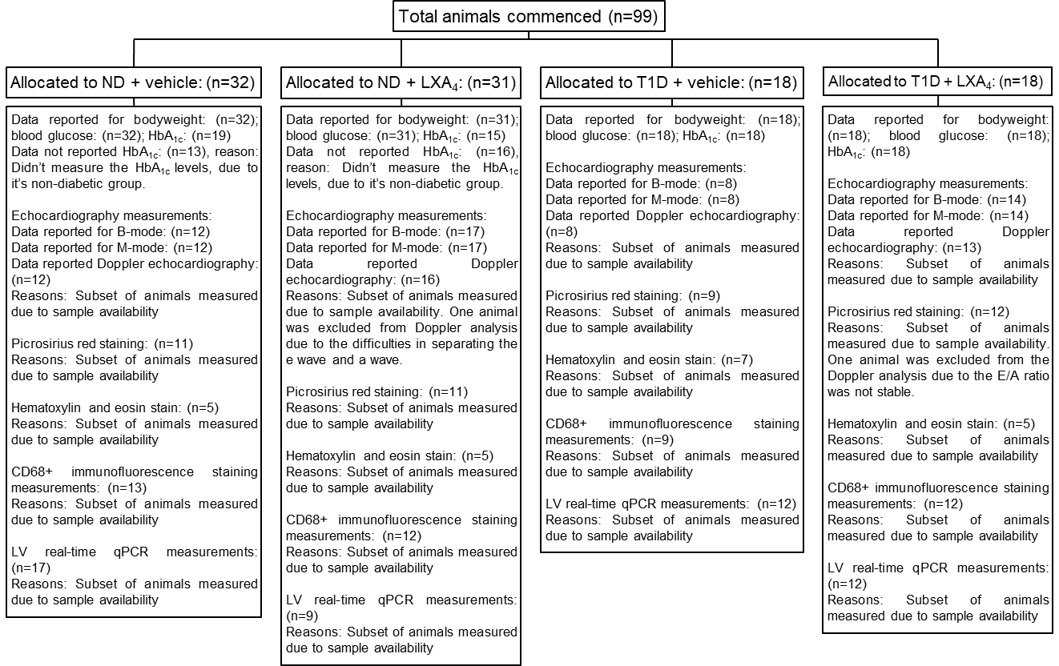
Figure S1. Flow chart of animal.

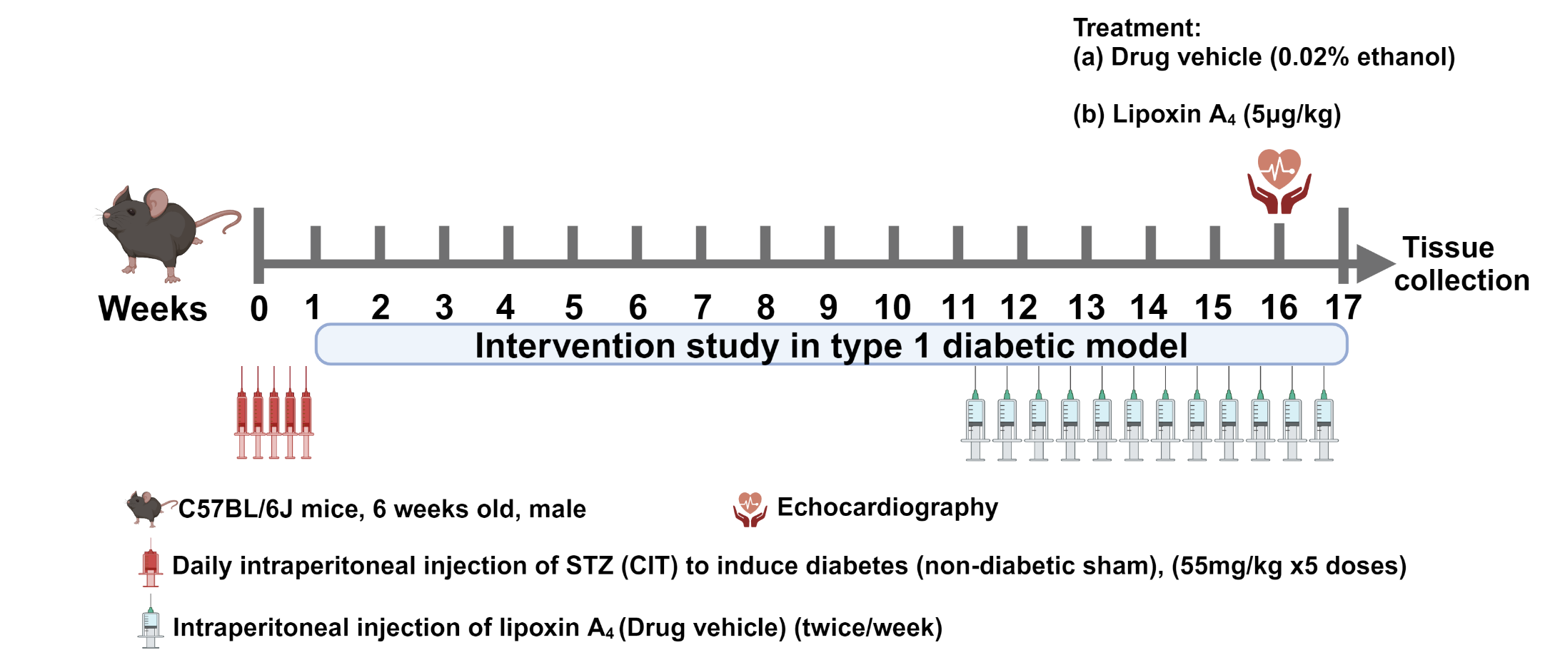
Figure S2. Experimental design.

Figure S2: The experimental timeline. Age-matched, 6-week-old ApoE^{-/-} male mice (C57BL/6 background) were randomly assigned to either the diabetic or non-diabetic cohort. The diabetic cohort received streptozotocin (STZ) for five consecutive days (i.p. 55 mg/kg/day in 0.1M citric acid vehicle). The non-diabetic cohort received citric acid vehicle by i.p. injection (200 μL of 0.5 M). Each cohort (diabetic and ND) was randomly divided into two groups, allocated to receive either drug vehicle (0.02% ethanol) or LXA₄ (5 μg/kg, in 0.02% ethanol) twice weekly by i.p. injection. After 10 weeks of vehicle-treated diabetes, mice received LXA₄ or vehicle from week 11 to week 16. A week before the endpoint, the echocardiography was performed. At the experimental endpoint, mouse was euthanized with an overdose of sodium pentobarbital (100 mg/kg i.p).

2. Supplemental Tables
Table S1 Genes and their respective primer sequences for analysis of RNA via qRT-PCR (mouse-specific sequence)
Gene | Gene | Forward primer (5’-3’) | Reverse primer (3’-5’)
Actin β | mCtβ | CATTGCTGACAGGATGCAGAAGG | TGCTGGAAGGTGGACAGTGAGG
Arginase-1 | mArg1 | TCAGAAGCTGTTCTTGGTCT | GTTCATGGGGATCCCAGTGA
Arachidonate 5-lipoxygenase | mAlox5 | ATTGCCATCCAGCTCAACCA | ACTGGAACGCACCCAGATTT
Arachidonate 12-lipoxygenase | mAlox12 | CAACCTAGTGCGTTTGTGGC | GGGACCACACTTGCCCC
Arachidonate 15-lipoxygenase | mAlox15 | GTGTCCCCCTGATGACTTGG | CATTCCCACCACGTACCGAT
Connective tissue growth factor | mCcn2 | TGACCCGGCGACCCACA | TACACCGACCCACCGAAGACACAG
Fibronectin | mFn | AAGACCATACCTGCCGAATG | CAACTGGTTGGCATGAAATG
Formyl peptide receptor 1 | mFpr1 | CCTTGGCTTTCTTCA | GCCCGTTCTTTACAT
Formyl peptide receptor 2 | mFpr2 | ACAGCAGTTGTGGCTTCCTT | CCTGGCCCATGAAAACATAG
Interleukin-1β | mIl-1β | TGCCACCTTTTGACAGTGATG | TGATGTGCTGCTGCGAGATT
Interleukin-6 | mIl-6 | CTGGACAACATACTGCTAACCG | GGGCATCACTTCTACCAGGTAA
Interleukin-18 | mIl-18 | GACTCTTGCGTCAACTTCAAGG | CAGGCTGTCTTTTGTCAACGA
Matrix metalloproteinase-2 | mMmp2 | GACAAGTTCTGGAGATACAATGAAGTG | CAGGTTATCAGGCATGGCATTC
Matrix metalloproteinase-9 | MMmp9 | AGACCAAGGGTACAGCCTGTTC | GGCACGCTGGAATGATCTAAG
Natriuretic peptide A | mNppa | TGGGACCCCTCCGATAGATC | AGCGAGCAGAGCCCTCAGT
Peroxisomal acyl-CoA oxidase type 2 | mCox2 | CCCCCACAGTCAAAGACACT | AGTTGCTCATCACCCCACTC
Serum amyloid A1 | mSaa1 | CACCAGCAGGATGAAGCTACT | CATGTCCCCAGCCCCTTG
S100 calcium-binding protein A9 | mS100a9 | TCATCGACACCTTCCATCAA | GTCCAGGTCCTCCATGATGT
Vascular endothelial growth factor | mVegf | AAACGAAAGCGCAAGAAATC | ATGCTTTCTCCGCTCTGAAC
α-myosin heavy chain | mMyh6 | GCTGGAAGATGAGTGCTCAGAG | CCAGCCATCTCCTCTGTTAGGT
β-myosin heavy chain | mMyh7 | CCTAGACTGCAACCGAGAGG | GCAGGCTCAAGTCATCTTCC

Table S2 Assessment of LV systolic function via B-mode echocardiography
 | Non-diabetic mice |  | Diabetic mice
 | Vehicle | LXA₄ | Vehicle | LXA₄
 | B-mode echocardiography
n | 12 | 17 | 8 | 14
Heart rate (bpm) | 459 ± 13 | 468 ± 7 | 429 ± 12 | 443 ± 10
LV volume, systole (μL) | 38.1 ± 3.0 | 39.2 ± 1.5 | 31.1 ± 2.7# | 28.6 ± 1.6$$$
LV volume, diastole (μL) | 71.4 ± 4.5 | 72.7 ± 2.1 | 60.0 ± 3.9# | 56.8 ± 2.9$$$
Stroke volume (μL) | 33.3 ± 1.8 | 33.5 ± 1.0 | 28.9 ± 1.7 | 28.1 ± 1.4$$
Ejection fraction (%) | 47.7 ± 1.7 | 46.1 ± 0.8 | 48.8 ± 1.7 | 49.4 ± 0.9$
Longitudinal fractional shortening (%) | 11.9 ± 0.4 | 11.5 ± 0.3 | 13.3 ± 0.5 | 13.5 ± 0.5$$$
Cardiac output (mL/min) | 15.4 ± 1.0 | 15.7 ± 0.5 | 12.4 ± 0.7# | 12.5 ± 0.7$$
LV area, systole (mm²) | 18.0 ± 1.0 | 18.5 ± 0.5 | 15.8 ± 0.7 # | 15.1 ± 0.5$$$
LV area, diastole (mm²) | 26.4 ± 1.1 | 26.8± 0.6 | 23.6 ± 0.8# | 22.7 ± 0.8$$$
Data presented as mean ± SEM. #P < 0.05 vs non-diabetic + vehicle; $P < 0.05, $$P< 0.01, $$$P< 0.001 vs non-diabetic + Lipoxin A₄; (2-way ANOVA, Fisher’s LSD post-hoc for multiple comparisons).

Table S3 Assessment of LV systolic function via M-mode echocardiography
 | Non-diabetic mice |  | Diabetic mice
 | Vehicle | LXA₄ | Vehicle | LXA4
 | M-mode echocardiography
n | 12 | 17 | 8 | 14
Heart rate (bpm) | 444 ± 14 | 445 ± 9 | 406 ± 11# | 436 ± 10
LVPW, diastole (mm) | 0.83 ± 0.03 | 0.84 ± 0.02 | 0.78 ± 0.04 | 0.73 ± 0.03$$
LVESD (mm) | 2.72 ± 0.12 | 2.88 ± 0.06 | 2.51 ± 0.09 | 2.42 ± 0.05$$$$
LVEDD (mm) | 3.96 ± 0.08 | 4.07 ± 0.05 | 3.86 ± 0.08 | 3.75 ± 0.06$$$
LVAW, diastole (mm) | 0.85 ± 0.03 | 0.82 ± 0.02 | 0.76 ± 0.03 | 0.74 ± 0.02
LV mass (mg) | 123 ± 3 | 128 ± 5 | 105 ± 7 | 94 ± 4$$$$
Fractional shortening (%) | 31.6 ± 1.9 | 29.1 ± 0.8 | 35.1 ± 1.3 | 35.3 ± 1.1$$$
Data presented as mean ± SEM. #P < 0.05 vs non-diabetic + vehicle; $$P< 0.01, $$$P< 0.001, $$$$P<0.0001 vs non-diabetic + Lipoxin A₄ (2-way ANOVA, Fisher’s LSD post-hoc for multiple comparisons).

