Supplementary Figure 1: Kaplan-Meier Estimated Curves for ASCVD Incidence by Glycemic Status for Women and Men
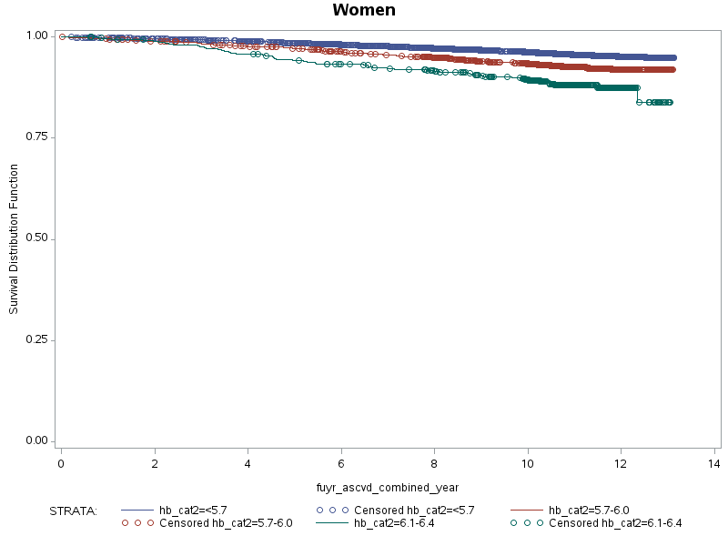
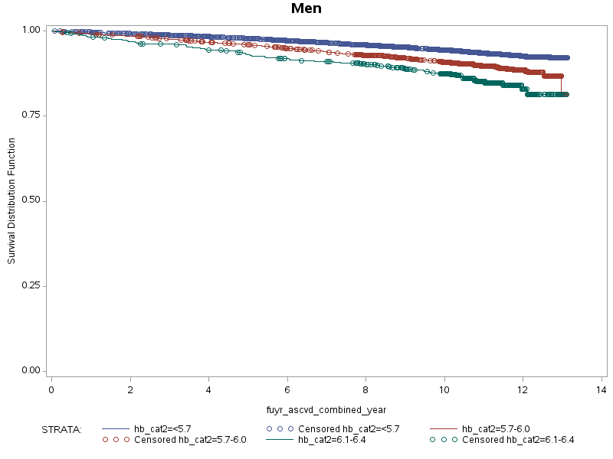

Supplementary Figure 2: Kaplan-Meier Estimated Curves for Diabetes Mellitus Incidence by Glycemic Status for Women and Men
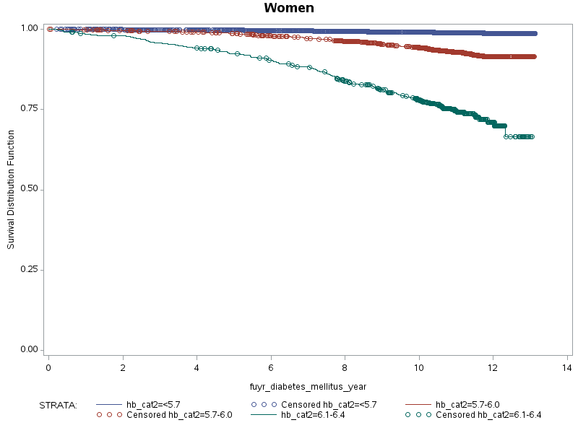
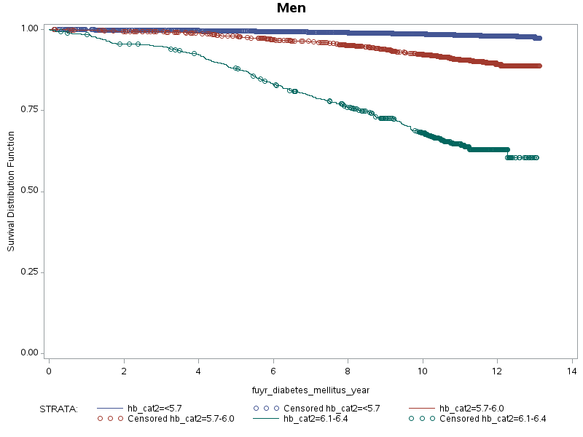

Supplementary Figure 3: Bar Graph of DM Incidence Rates by Glycemic Group and Quartiles of Waist to Hip Ratio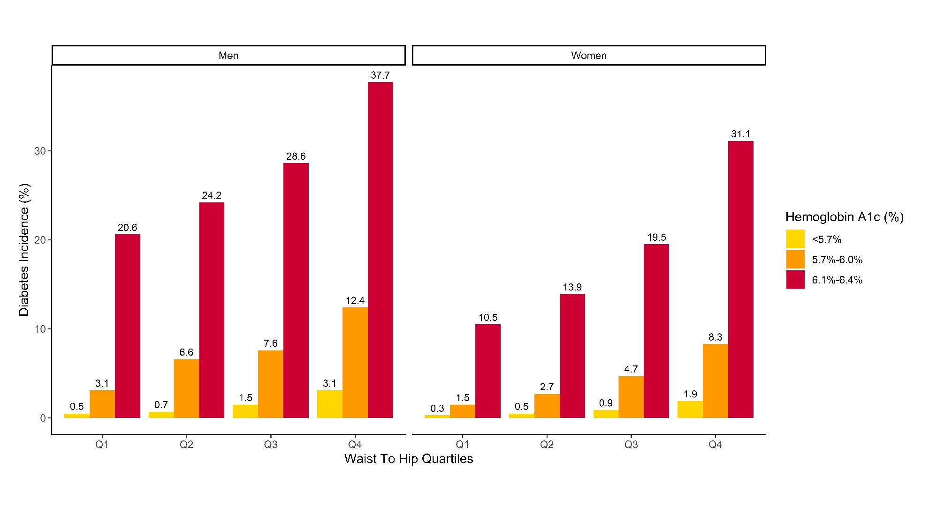

Supplementary Figure 4: Exclusion Criteria Flowchart

UK Biobank Cohort
N=502,406

Excluded participants with prevalent CVD or DM
N=39,166

N=463,240

Excluded participants with missing records for baseline factor covariates or HbA1c
N=124,453

N=338,787

Excluded participants who were on statins
N=42,317

Total Study Cohort
N=296,470

