Supplementary materials

Summary of Supplementary Content

- Supplemental Figure S1 Flowchart of study participants

- Supplemental Methods1 Revascularization Procedures

- Supplemental Methods2 Outcome Definitions

- Supplemental Table S1 Association of Remnant-C with AKI stage 2/3 in
Prediabetic and Diabetic Patients

- Supplemental Figure S2 Restricted cubic spline plot for AKI stage 2/3 by
remnant-C levels in Prediabetic and Diabetic Patients

- Supplemental Figure S3 Restricted cubic spline plot for MACCE by
remnant-C levels in Prediabetic and Diabetic Patients

- Supplemental Table S2 Association Between Quartiles of Remnant-C and the
Risk of AKI stage 2/3

- Supplemental Table S3 Association Between Quartiles of Remnant-C and the
Risk of MACCE

Supplemental Figure S1 Flowchart of study participants

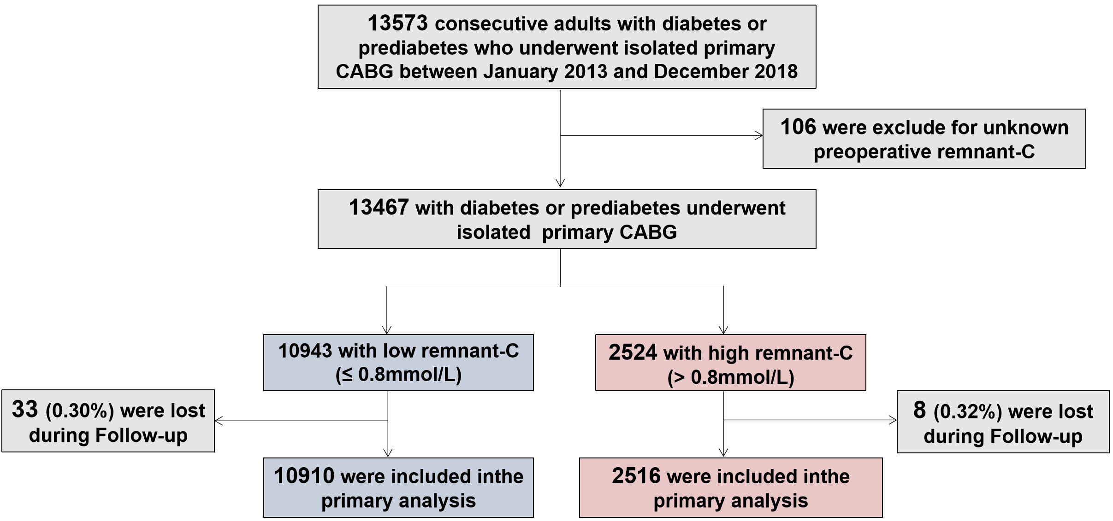

Supplemental Methods1

Revascularization Procedures
As part of standard institutional requirements, all surgeons had to have specialized in congenital or valve heart surgery for more than 3 years before undertaking any coronary artery bypass grafting (CABG) procedures. With respect to off-pump CABG, the surgeon had to perform at least 100 on-pump CABG procedures before being considered qualified to carry out the off-pump procedure. Once qualified, the choice of off-pump CABG or on-pump CABG for a particular patient was generally at the discretion of the individual surgeons.
Anesthesia was managed by inhalation of isoflurane with the addition of fentanyl or sufentanil, and propofol was administered continuously until the end of the procedure if necessary. Surgical revascularization was performed using standard bypass techniques. For on-pump CABG, a standard cardiopulmonary bypass was established, and moderate systemic hypothermia (28°C to 32°C) and perfusion with antegrade intermittent cold crystalloid cardioplegia were used. Heparin was given to achieve activated clotting times of 480 seconds or above before institution of cardiopulmonary bypass. For off-pump CABG, stabilization devices were used to provide a motionless anastomosis site, and heparin was administered before the start of the first distal anastomosis to achieve an activated clotting time of 300 to 350 seconds. On-pump CABG involved aortic cross-clamping and cardioplegic arrest, while off-pump CABG was performed with a partial occlusion clamp. Whenever possible, complete revascularization was attempted, and the internal thoracic artery was used preferentially for revascularization of the left anterior descending artery. The remaining vessels were to be bypassed either using another arterial conduit or the saphenous vein in the configuration decided by the surgeon. During reperfusion, the bypass grafting was completed with proximal anastomoses to the ascending aorta. The decision to switch to cardiopulmonary bypass during the procedure was based on significant hemodynamic instability or ventricular arrhythmia. After separation from cardiopulmonary bypass or on completion of all anastomoses, protamine was given to reverse the effects of heparin. All patients received tranexamic acid intraoperatively if not contraindicated. Postoperatively, starting within the first 24 hours, aspirin therapy (100 mg/day) is recommended and should be continued indefinitely. Routinely, re- exploration was performed if the bleeding exceeded 200 mL/hour in the first 3 hours or 300 mL/hour at any time, or in the presence of typical hemodynamic or echocardiographic features of cardiac tamponade.

Supplemental Methods2

Outcome Definitions

Perioperative time refers to the duration of hospitalization, from admission for surgery to discharge.

All-cause mortality was defined as death from any cause.

Myocardial infarction occurred when there were clinical signs and symptoms of ischemia that were distinct from the presenting ischemic event and met at least one of the following criteria:

- Spontaneous (before or without revascularization, >48 hours after CABG)

- New, significant Q waves in at least two contiguous leads of an electrocardiogram that were not present with the presenting ischemic event;

- Patients whose most recent cardiac markers measured before reinfarction, which were normal, required an increase in CK-MB or troponin that was above the 99th percentile upper limit of normal and at least ≥20% above the most recent value.

- Within 48 hours after CABG

A CABG-related myocardial infarction was defined by elevation of cardiac biomarker values >10 times the 99th percentile upper reference limit in patients with normal baseline cardiac troponin values (≤99th percentile upper reference limit) plus either new pathological Q waves; new left bundle-branch block, angiographically documented new graft, or native coronary artery occlusion; or imaging evidence of new loss of viable myocardium or new regional wall motion abnormality.

Cerebrovascular accident was confirmed by a neurologist on the basis of imaging studies and symptoms and was defined as follows:

- A focal neurologic deficit of central origin lasting >72 hours, or

- A focal neurologic deficit of central origin lasting >24 hours, with imaging evidence of cerebral infarction or intracerebral hemorrhage, or

- A non-focal encephalopathy lasting >24 hours with imaging evidence of cerebral infarction or hemorrhage adequate to account for the clinical state, or

- Transient ischemic attack, defined as the presence of acute focal neurological deficit thought to be of vascular origin with signs and symptoms lasting less than 24 hours.

Retinal arterial ischemia or hemorrhage was included in the definition of cerebrovascular accident.

Repeat revascularization was defined as any ischemia-driven repeat percutaneous coronary intervention or bypass surgery.

Cardiovascular death was defined as any death due to proximate cardiac cause (e.g.,
myocardial infarction, low-output failure, fatal arrhythmia), unwitnessed death, death of unknown cause, all procedure-related deaths (including those related to concomitant treatment), and death due to noncoronary vascular causes (e.g., cerebrovascular disease, ruptured aortic aneurysm, pulmonary embolism) or other vascular diseases.

Reoperation was defined as the excessive chest tube drainage and/or pericardial tamponade requiring reoperation.

Acute Kidney Injury (AKI) was adjudicated following the current KDIGO AKI guidelines based on the comprehensive records of perioperative SCr measurements during the hospital stay (from patient admission to day 7 after surgery). In summary, AKI stages were defined as follows: 1) stage-1: an absolute increase in SCr ≥0.3 mg/dL within 48 hours (the absolute criterion) or a relative increase in SCr ≥150% to 200% of the baseline (the ratio criterion); 2) stage-2: a relative increase in SCr ≥200% to 300% of the baseline; and 3) stage-3: a relative increase in SCr ≥300% of the baseline, or an increase in SCr to ≥4.0 mg/dL, or initiation of renal replacement therapy, respectively.

Supplemental Table S1 Association of Remnant-C with AKI stage 2/3 in Prediabetic and Diabetic Patients

Group  (n=13426) | Crude OR (95%CI) | P | Adjusted OR (95%CI) | P | Adjusted OR (95%CI)  Per SD increase | P for trend
Prediabetes  (n=5179) | 1.235 (1.009-1.466) | 0.041 | 1.361 (1.061-1.769) | 0.020 | 1.153(1.058-1.255) | 0.003
Diabetes  (n=8247) | 1.377 (1.018-1.768) | 0.025 | 1.441 (1.083-1.943) | 0.007 | 1.172 (1.070-1.298) | < 0.001
Adjusted covariates including age, sex, BMI, smoking, hypertension, hyperlipidemia, diabetes,insulin-treated diabetes, PAD, AF, COPD, CVE, CKD, NYHA class III/IV, LVEF, HbA1C, FPG, LDL-C, Hs-CRP, Serum creatinine, EuroSCORE, On pump, LM, TVD (Abbreviations as in Table 1). MI, myocardial infarction; AKI, acute kidney injury; CVA, cerebrovascular accident; OR, odds ratio; CI, confidence interval.
Supplemental Figure S2 Restricted cubic spline plot for AKI stage 2/3 by remnant-C
levels in Prediabetic and Diabetic Patients
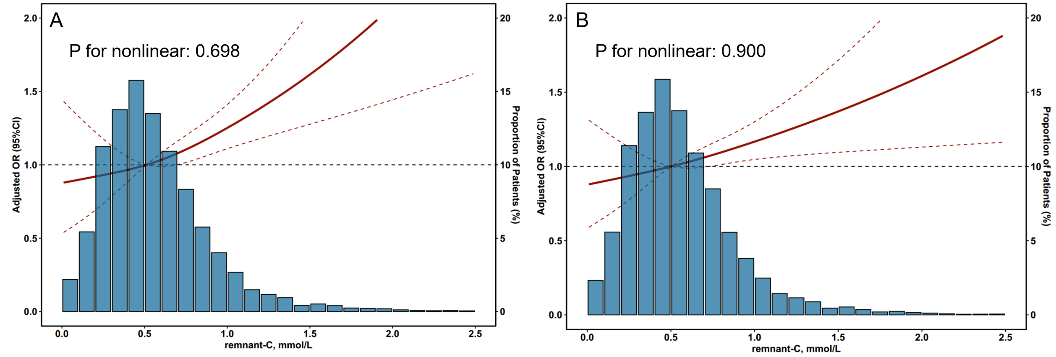
A: Diabetes Subgroup; B: Prediabetes Subgroup. The background histogram (blue) represents the proportion of the density distribution of remnant cholesterol in the study population. The solid red line indicates the estimated adjusted odds ratio, while the red dashed lines represent the 95% confidence interval. The horizontal gray dashed line indicates a odds ratio of 1.0. Adjusted covariates including age, sex, BMI, smoking, hypertension, hyperlipidemia, diabetes, insulin-treated diabetes, PAD, AF, COPD, CVE, CKD, NYHA class III/IV, LVEF, HbA1C, FPG, LDL-C, Hs-CRP, Serum creatinine, EuroSCORE, On pump, LM, TVD.
OR, odds ratio; CI, confidence interval; remnant-C, remnant cholesterol
Supplemental Figure S2 Restricted cubic spline plot for MACCE by remnant-C
levels in Prediabetic and Diabetic Patients
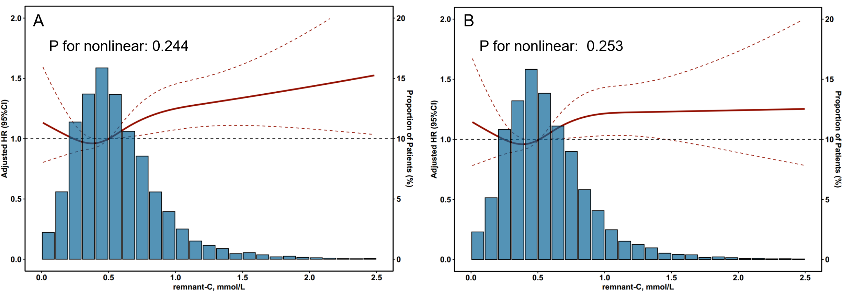

A: Diabetes Subgroup; B: Prediabetes Subgroup. The background histogram (blue) represents the proportion of the density distribution of remnant cholesterol in the study population. The solid red line indicates the estimated adjusted hazard ratio, while the red dashed lines represent the 95% confidence interval. The horizontal gray dashed line indicates a hazard ratio of 1.0. Adjusted covariates including age, sex, BMI, smoking, hypertension, hyperlipidemia, diabetes, insulin-treated diabetes, PAD, AF, COPD, CVE, CKD, NYHA class III/IV, LVEF, HbA1C, FPG, LDL-C, Hs-CRP, Serum creatinine, EuroSCORE, On pump, LM, TVD, and prescription of β-Blocker, aspirin, statin and ACEI/ARB at discharge.
HR, hazard ratio; CI, confidence interval; remnant-C, remnant cholesterol

Supplemental Table S2 Association Between Quartiles of Remnant-C and the Risk of AKI stage 2/3
Group | Crude OR(95% CI) | P | Adjusted OR | P
Q1 (Remnan-C≤0.34) | Reference
Q2 (0.34＜Remnan-C≤0.50) | 1.046 (0.764-1.432) | 0.779 | 1.073 (0.776-1.484) | 0.669
Q3 (0.50＜Remnan-C≤0.71) | 1.198 (0.884-1.629) | 0.244 | 1.236 (0.901-1.700) | 0.190
Q4 (Remnan-C＞0.71) | 1.293 (0.959-1.751) | 0.093 | 1.414 (1.034-1.940) | 0.030
Adjusted covariates including age, sex, BMI, smoking, hypertension, hyperlipidemia, diabetes, insulin-treated diabetes, PAD, AF, COPD, CVE, CKD, NYHA class III/IV, LVEF, HbA1C, FPG, LDL-C, Hs-CRP, Serum creatinine, EuroSCORE, On pump, LM, TVD. MI, myocardial infarction; AKI, acute kidney injury; CVA, cerebrovascular accident; OR, odds ratio; CI, confidence interval.

Supplemental Table S3 Association Between Quartiles of Remnant-C and the Risk of MACCE
Group | Crude HR(95% CI) | P | Adjusted HR | P
Q1 (Remnan-C≤0.34) | Reference
Q2 (0.34＜Remnan-C≤0.50) | 1.026 (0.877-1.201) | 0.748 | 1.051 (0.897-1.232) | 0.669
Q3 (0.50＜Remnan-C≤0.71) | 1.046 (0.894-1.224) | 0.575 | 1.052 (0.897-1.233) | 0.190
Q4 (Remnan-C＞0.71) | 1.123 (0.962-1.311) | 0.141 | 1.214 (1.037-1.421) | 0.016
Adjusted covariates including age, sex, BMI, smoking, hypertension, hyperlipidemia, diabetes, insulin-treated diabetes, PAD, AF, COPD, CVE, CKD, NYHA class III/IV, LVEF, HbA1C, FPG, LDL-C, Hs-CRP, Serum creatinine, EuroSCORE, On pump, LM, TVD, and prescription of β-Blocker, aspirin, statin and ACEI/ARB at discharge. MACCEs, major adverse cardiac and cerebrovascular events; MI, myocardial infarction; CVA, cerebrovascular accident; HR, hazard ratio; CI, confidence interval.

