Supplementary materials
Table S1 Baseline characteristics of study population stratified by quartiles of the TyG index
Figure S1 Sensitivity analyses of the associations between TyG-related indices and overall cardiovascular disease, coronary heart disease, and stroke in participants with MASLD after excluding those occurring outcomes within first 2 years
Figure S2 Sensitivity analyses of the associations between TyG-related indices and all-cause and cardiovascular mortality in participants with MASLD after excluding those occurring outcomes within first 2 years
Figure S3 Sensitivity analyses of the associations between TyG-related indices and overall cardiovascular disease, coronary heart disease, and stroke in participants with MASLD after imputing missing data on covariates using multiple chain imputation
Figure S4 Sensitivity analyses of the associations between TyG-related indices and all-cause and cardiovascular mortality in participants with MASLD after imputing missing data on covariates using multiple chain imputation
Figure S5 Sensitivity analyses of the associations between TyG-related indices and overall cardiovascular disease, coronary heart disease, stroke, and cardiovascular mortality in participants with MASLD: when considering the competing risk from other cause mortality
Figure S6 Sensitivity analyses of the associations between TyG-related indices and overall cardiovascular disease, coronary heart disease, stroke in participants with MASLD: only including those with diabetes at baseline (n=8,714)
Figure S7 Sensitivity analyses of the associations between TyG-related indices and all-cause death and cardiovascular death in participants with MASLD: only including those with diabetes at baseline (n=8,714)
Figure S8 Sensitivity analyses of the associations between TyG-related indices and overall cardiovascular disease, coronary heart disease, stroke in participants with MASLD: additionally adjusting for glycated haemoglobin (HbA1c)
Figure S9 Sensitivity analyses of the associations between TyG-related indices and all-cause death and cardiovascular death in participants with MASLD: additionally adjusting for glycated haemoglobin (HbA1c)
Figure S10 Subgroup analyses by age for the associations of TyG-related indices with study outcomes in participants with MASLD
Figure S11 Subgroup analyses by sex for the associations of TyG-related indices with study outcomes in participants with MASLD
Figure S12 Subgroup analyses by alcohol drinking for the associations of TyG-related indices with study outcomes in participants with MASLD

Table S1 Baseline characteristics of study population stratified by quartiles of the TyG index
Characteristics | Baseline TyG index |  |  |  | P value
Characteristics | Quartile 1  (n=24,333) | Quartile 2  (n=24,332) | Quartile 3  (n=24,333) | Quartile 4  (n=24,333) | P value
Age (years) | 57.0 (50.0, 63.0) | 58.0 (51.0, 63.0) | 58.0 (51.0, 63.0) | 57.0 (50.0, 63.0) | <0.001
Male | 14685 (60.4) | 15886 (65.3) | 16417 (67.5) | 17551 (72.1) | <0.001
White ethnicity | 22056 (90.6) | 22399 (92.1) | 22497 (92.5) | 22382 (92.0) | <0.001
College degree | 7505 (30.8) | 7593 (31.2) | 7625 (31.3) | 7341 (30.2) | 0.025
Household income |  |  |  |  | <0.001
Less than 18000 | 5450 (22.4) | 5322 (21.9) | 5557 (22.8) | 5752 (23.6)
18000 to 51999 | 12798 (52.6) | 12869 (52.9) | 12708 (52.2) | 12876 (52.9)
Greater than 52000 | 6085 (25.0) | 6141 (25.2) | 6068 (24.9) | 5705 (23.4)
Employed | 22652 (93.1) | 22889 (94.1) | 22736 (93.4) | 22488 (92.4) | <0.001
Townsend deprivation index | -2.0 (-3.5, 0.8) | -2.2 (-3.7, 0.4) | -2.2 (-3.7, 0.4) | -2.0 (-3.6, 0.7) | <0.001
Smoking status |  |  |  |  | <0.001
Never smoking | 12708 (52.2) | 12094 (49.7) | 12060 (49.6) | 11511 (47.3)
Ever smoking | 9363 (38.5) | 9762 (40.1) | 9573 (39.3) | 9565 (39.3)
Current smoking | 2262 (9.3) | 2476 (10.2) | 2700 (11.1) | 3257 (13.4)
Frequency of drinking |  |  |  |  | <0.001
Never or special occasions only | 4410 (18.1) | 3955 (16.3) | 4061 (16.7) | 4422 (18.2)
One to three times a moth | 2679 (11.0) | 2651 (10.9) | 2702 (11.1) | 2788 (11.5)
Once or twice a week | 6197 (25.5) | 6270 (25.8) | 6418 (26.4) | 6185 (25.4)
Three or four times a week | 5690 (23.4) | 5955 (24.5) | 5850 (24.0) | 5630 (23.1)
Daily or almost daily | 5357 (22.0) | 5501 (22.6) | 5302 (21.8) | 5308 (21.8)
Physical activity |  |  |  |  | 0.640
<150 min/week | 5362 (22.0) | 5289 (21.7) | 5368 (22.1) | 5405 (22.2)
≥ 150 min/week | 18971 (78.0) | 19043 (78.3) | 18965 (77.9) | 18928 (77.8)
Sleeping duration per day |  |  |  |  | <0.001
7-8 hours | 15884 (65.3) | 16383 (67.3) | 16305 (67.0) | 16021 (65.8)
<7 hours | 6714 (27.6) | 6208 (25.5) | 6124 (25.2) | 6229 (25.6)
>8 hours | 1735 (7.1) | 1741 (7.2) | 1904 (7.8) | 2083 (8.6)
Health diet score | 3.15 (1.32) | 3.11 (1.34) | 3.07 (1.35) | 2.99 (1.37) | <0.001
Hypertension | 19800 (81.4) | 20280 (83.3) | 20431 (84.0) | 20887 (85.8) | <0.001
Type 2 diabetes | 1294 (5.3) | 1370 (5.6) | 1809 (7.4) | 4241 (17.4) | <0.001
Family history of cardiometabolic disease | 18950 (77.9) | 18836 (77.4) | 18938 (77.8) | 19051 (78.3) | 0.139
Tyg-BMI index | 265.9 (247.6, 290.1) | 270.5 (252.4, 294.9) | 276.0 (257.0, 300.7) | 289.7 (267.5, 319.2) | <0.001
TyG-WC index | 866.6 (825.9, 914.7) | 897.1 (852.7, 950.1) | 920.1 (872.9, 979.6) | 972.6 (912.5, 1047.5) | <0.001
TyG-WHtR index | 5.1 (4.8, 5.4) | 5.2 (5.0, 5.6) | 5.4 (5.1, 5.7) | 5.7 (5.3, 6.1) | <0.001
Occurrence of study outcomes
Overall CVD | 2994 (12.3) | 3144 (12.9) | 3312 (13.6) | 3806 (15.6) | <0.001
CHD | 2431 (10.0) | 2603 (10.7) | 2750 (11.3) | 3196 (13.1) | <0.001
Stroke | 718 (3.0) | 695 (2.9) | 718 (3.0) | 795 (3.3) | 0.045
All-cause mortality | 2240 (9.2) | 2088 (8.6) | 2118 (8.7) | 2363 (9.7) | <0.001
Cardiovascular mortality | 460 (1.9) | 432 (1.8) | 410 (1.7) | 494 (2.0) | 0.030
Data are expressed as median (interquartile range) for non-normally distributed continue variables, mean (standard deviation) for continue variables with normal distribution, and n (%) for categorical variables.
Abbreviation: TyG, triglyceride-glucose; TyG-BMI, triglyceride glucose-body mass index; TyG-WC, triglyceride glucose-waist circumference; TyG-WHtR, triglyceride glucose-waist height ratio; CVD, cardiovascular disease; CHD, coronary heart disease.

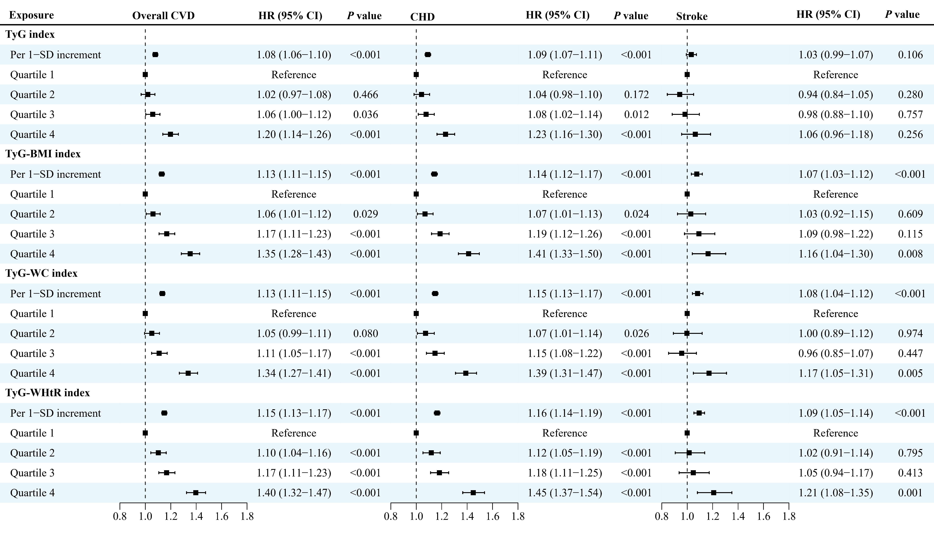
Figure S1 Sensitivity analyses of the associations between TyG-related indices and overall cardiovascular disease, coronary heart disease, and stroke in participants with MASLD after excluding those occurring outcomes within first 2 years
Models were adjusted for age, sex, ethnicity, employed status, Townsend deprivation index, family income, education, smoking status, alcohol drinking, sleep duration, physical activity, diet, and family history of cardiometabolic diseases. MASLD: metabolic-associated steatotic liver disease; CVD: cardiovascular disease; CHD: coronary heart disease; TyG: triglyceride glucose index; BMI: body mass index; WC waist circumference; WHtR waist-to-height ratio; HR: hazard ratio; CI: confidence interval.
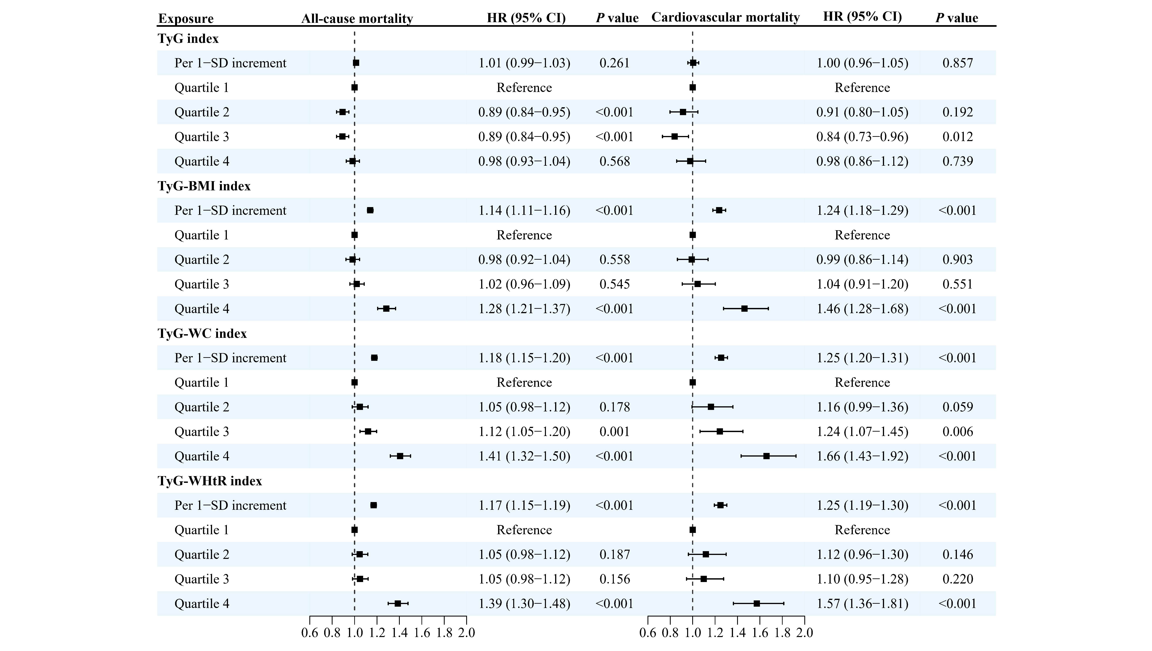
Figure S2 Sensitivity analyses of the associations between TyG-related indices and all-cause and cardiovascular mortality in participants with MASLD after excluding those occurring outcomes within first 2 years
Note: Models were adjusted for age, sex, ethnicity, employed status, Townsend deprivation index, family income, education, smoking status, alcohol drinking, sleep duration, physical activity, diet, and family history of cardiometabolic diseases. MASLD: metabolic-associated steatotic liver disease; CVD: cardiovascular disease; CHD: coronary heart disease; TyG: triglyceride glucose index; BMI: body mass index; WC waist circumference; WHtR waist-to-height ratio; HR: hazard ratio; CI: confidence interval.
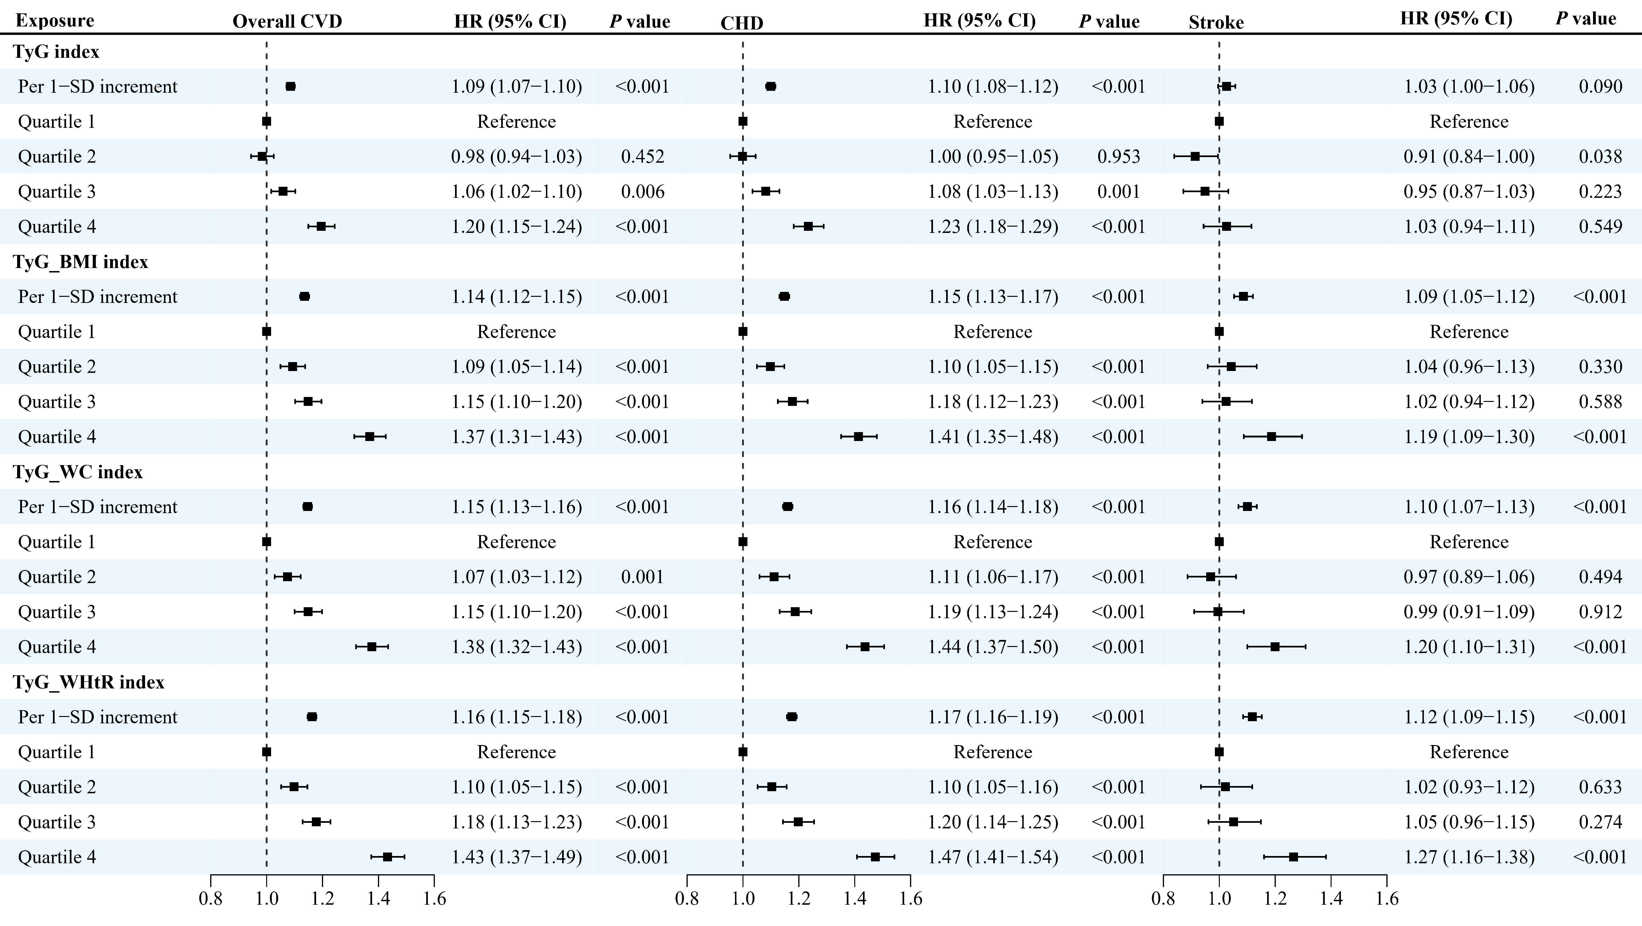
Figure S3 Sensitivity analyses of the associations between TyG-related indices and overall cardiovascular disease, coronary heart disease, and stroke in participants with MASLD after imputing missing data on covariates using multiple chain imputation
Note: Models were adjusted for age, sex, ethnicity, employed status, Townsend deprivation index, family income, smoking status, alcohol drinking, sleep duration, physical activity, and family history of cardiometabolic diseases. MASLD: metabolic-associated steatotic liver disease; CVD: cardiovascular disease; CHD: coronary heart disease; TyG: triglyceride glucose index; BMI: body mass index; WC waist circumference; WHtR waist-to-height ratio; HR: hazard ratio; CI: confidence interval.
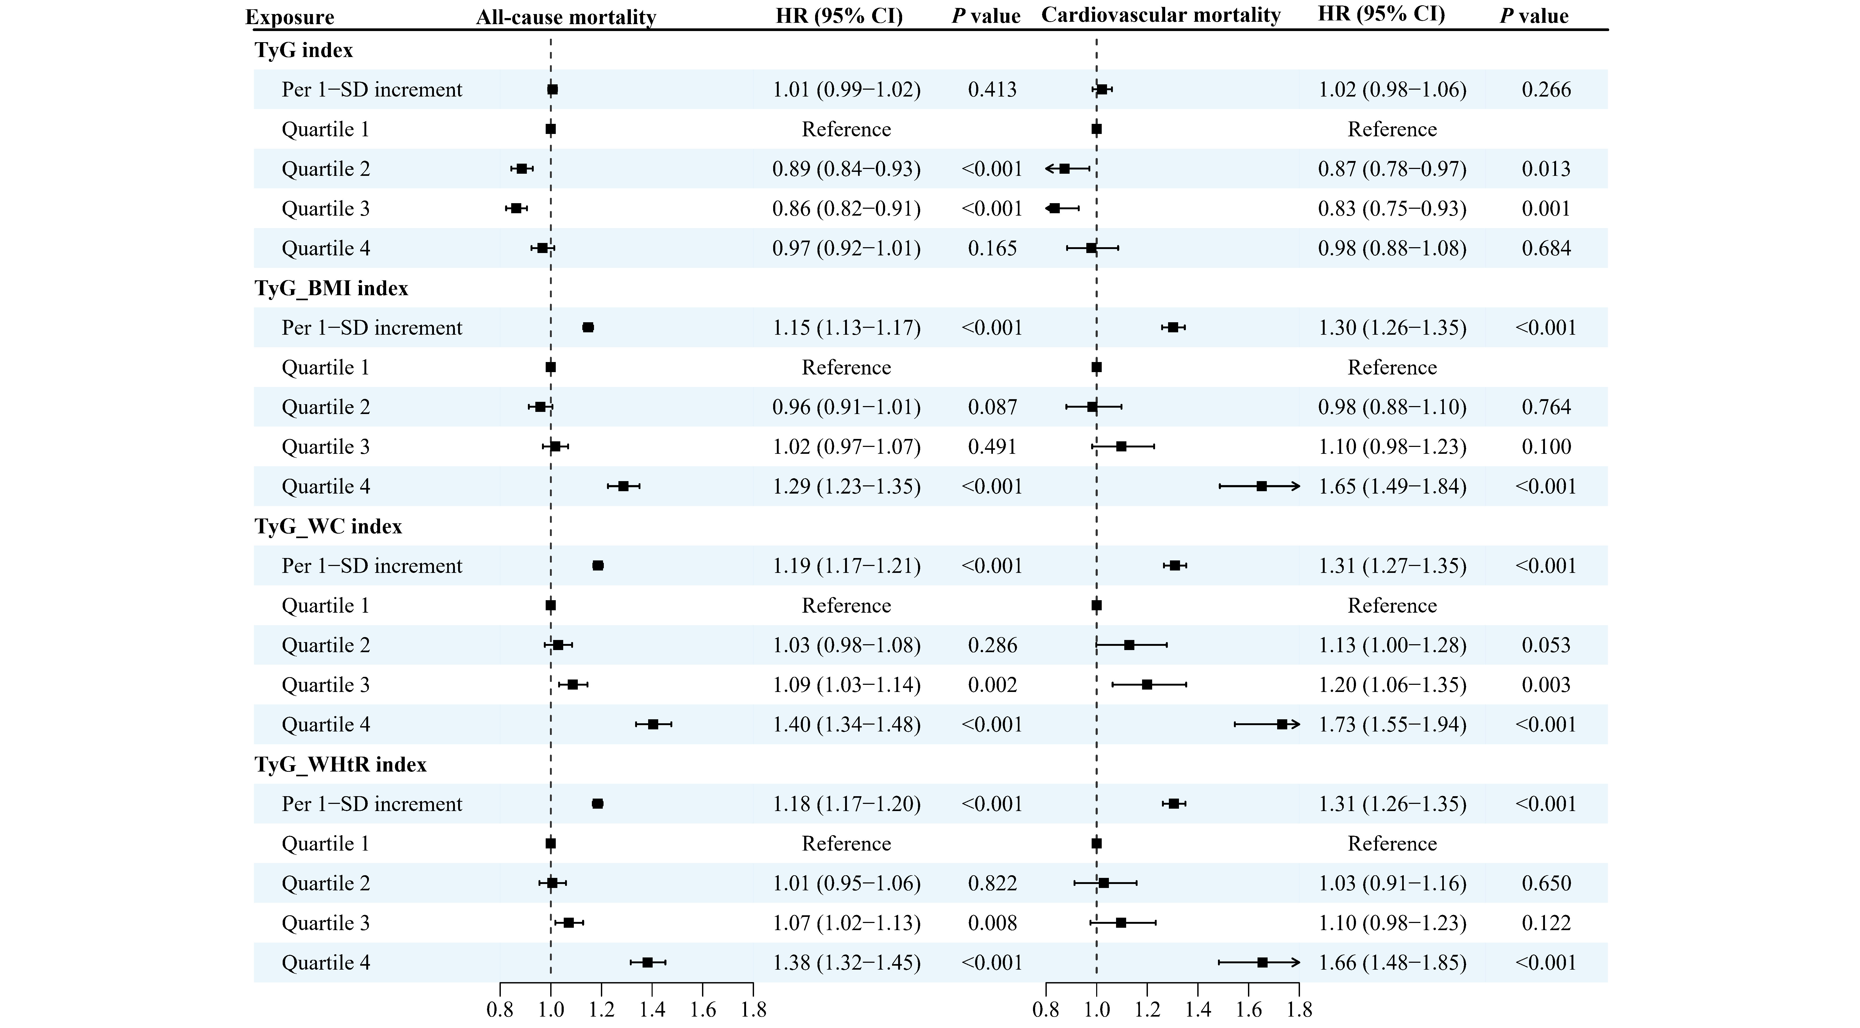
Figure S4 Sensitivity analyses of the associations between TyG-related indices and all-cause and cardiovascular mortality in participants with MASLD after imputing missing data on covariates using multiple chain imputation
Note: Models were adjusted for age, sex, ethnicity, employed status, Townsend deprivation index, family income, education, smoking status, alcohol drinking, sleep duration, physical activity, diet, and family history of cardiometabolic diseases. MASLD: metabolic-associated steatotic liver disease; CVD: cardiovascular disease; CHD: coronary heart disease; TyG: triglyceride glucose index; BMI: body mass index; WC waist circumference; WHtR waist-to-height ratio; HR: hazard ratio; CI: confidence interval.
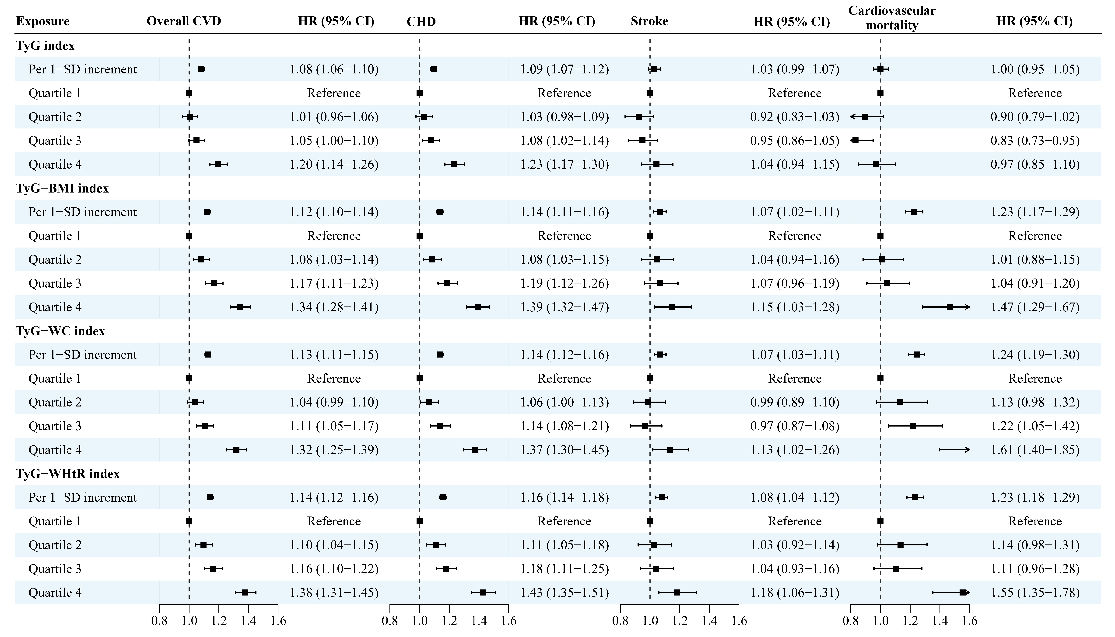
Figure S5 Sensitivity analyses of the associations between TyG-related indices and overall cardiovascular disease, coronary heart disease, stroke, and cardiovascular mortality in participants with MASLD: when considering the competing risk from other cause mortality
Note: Models were adjusted for age, sex, ethnicity, employed status, Townsend deprivation index, family income, education, smoking status, alcohol drinking, sleep duration, physical activity, diet, and family history of cardiometabolic diseases. MASLD: metabolic-associated steatotic liver disease; CVD: cardiovascular disease; CHD: coronary heart disease; TyG: triglyceride glucose index; BMI: body mass index; WC waist circumference; WHtR waist-to-height ratio; HR: hazard ratio; CI: confidence interval.
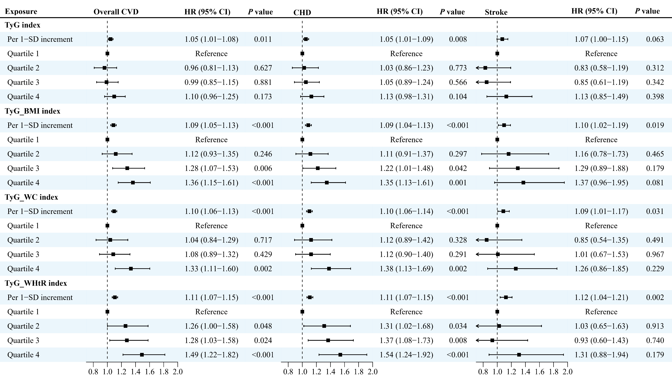
Figure S6 Sensitivity analyses of the associations between TyG-related indices and overall cardiovascular disease, coronary heart disease, stroke in participants with MASLD: only including those with diabetes at baseline (n=8,714)
Note: Models were adjusted for age, sex, ethnicity, employed status, Townsend deprivation index, family income, education, smoking status, alcohol drinking, sleep duration, physical activity, diet, and family history of cardiometabolic diseases. MASLD: metabolic-associated steatotic liver disease; CVD: cardiovascular disease; CHD: coronary heart disease; TyG: triglyceride glucose index; BMI: body mass index; WC waist circumference; WHtR waist-to-height ratio; HR: hazard ratio; CI: confidence interval.
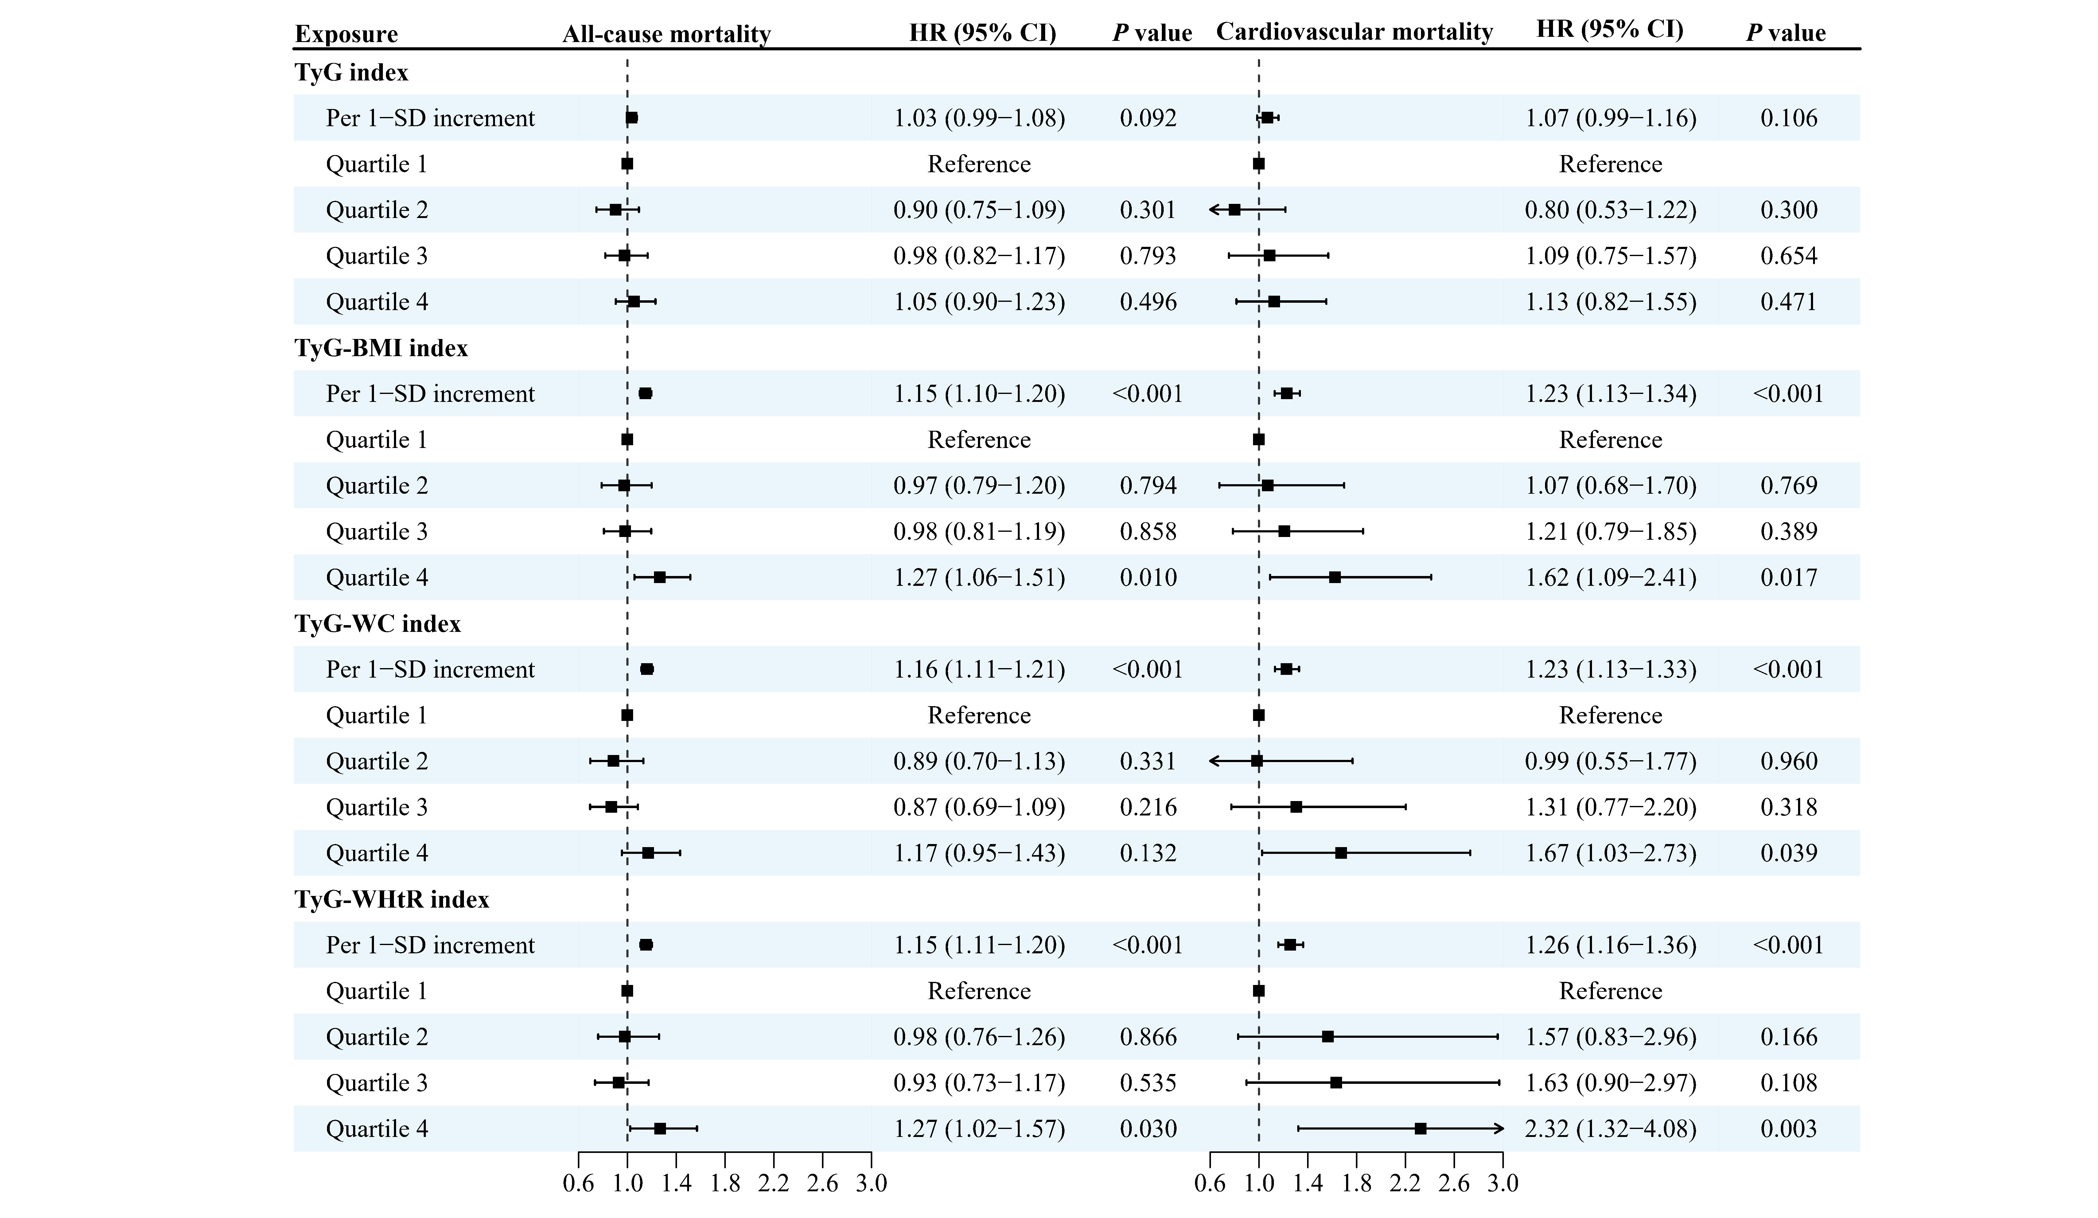
Figure S7 Sensitivity analyses of the associations between TyG-related indices and all-cause death and cardiovascular death in participants with MASLD: only including those with diabetes at baseline (n=8,714)
Note: Models were adjusted for age, sex, ethnicity, employed status, Townsend deprivation index, family income, education, smoking status, alcohol drinking, sleep duration, physical activity, diet, and family history of cardiometabolic diseases. MASLD: metabolic-associated steatotic liver disease; CVD: cardiovascular disease; CHD: coronary heart disease; TyG: triglyceride glucose index; BMI: body mass index; WC waist circumference; WHtR waist-to-height ratio; HR: hazard ratio; CI: confidence interval.
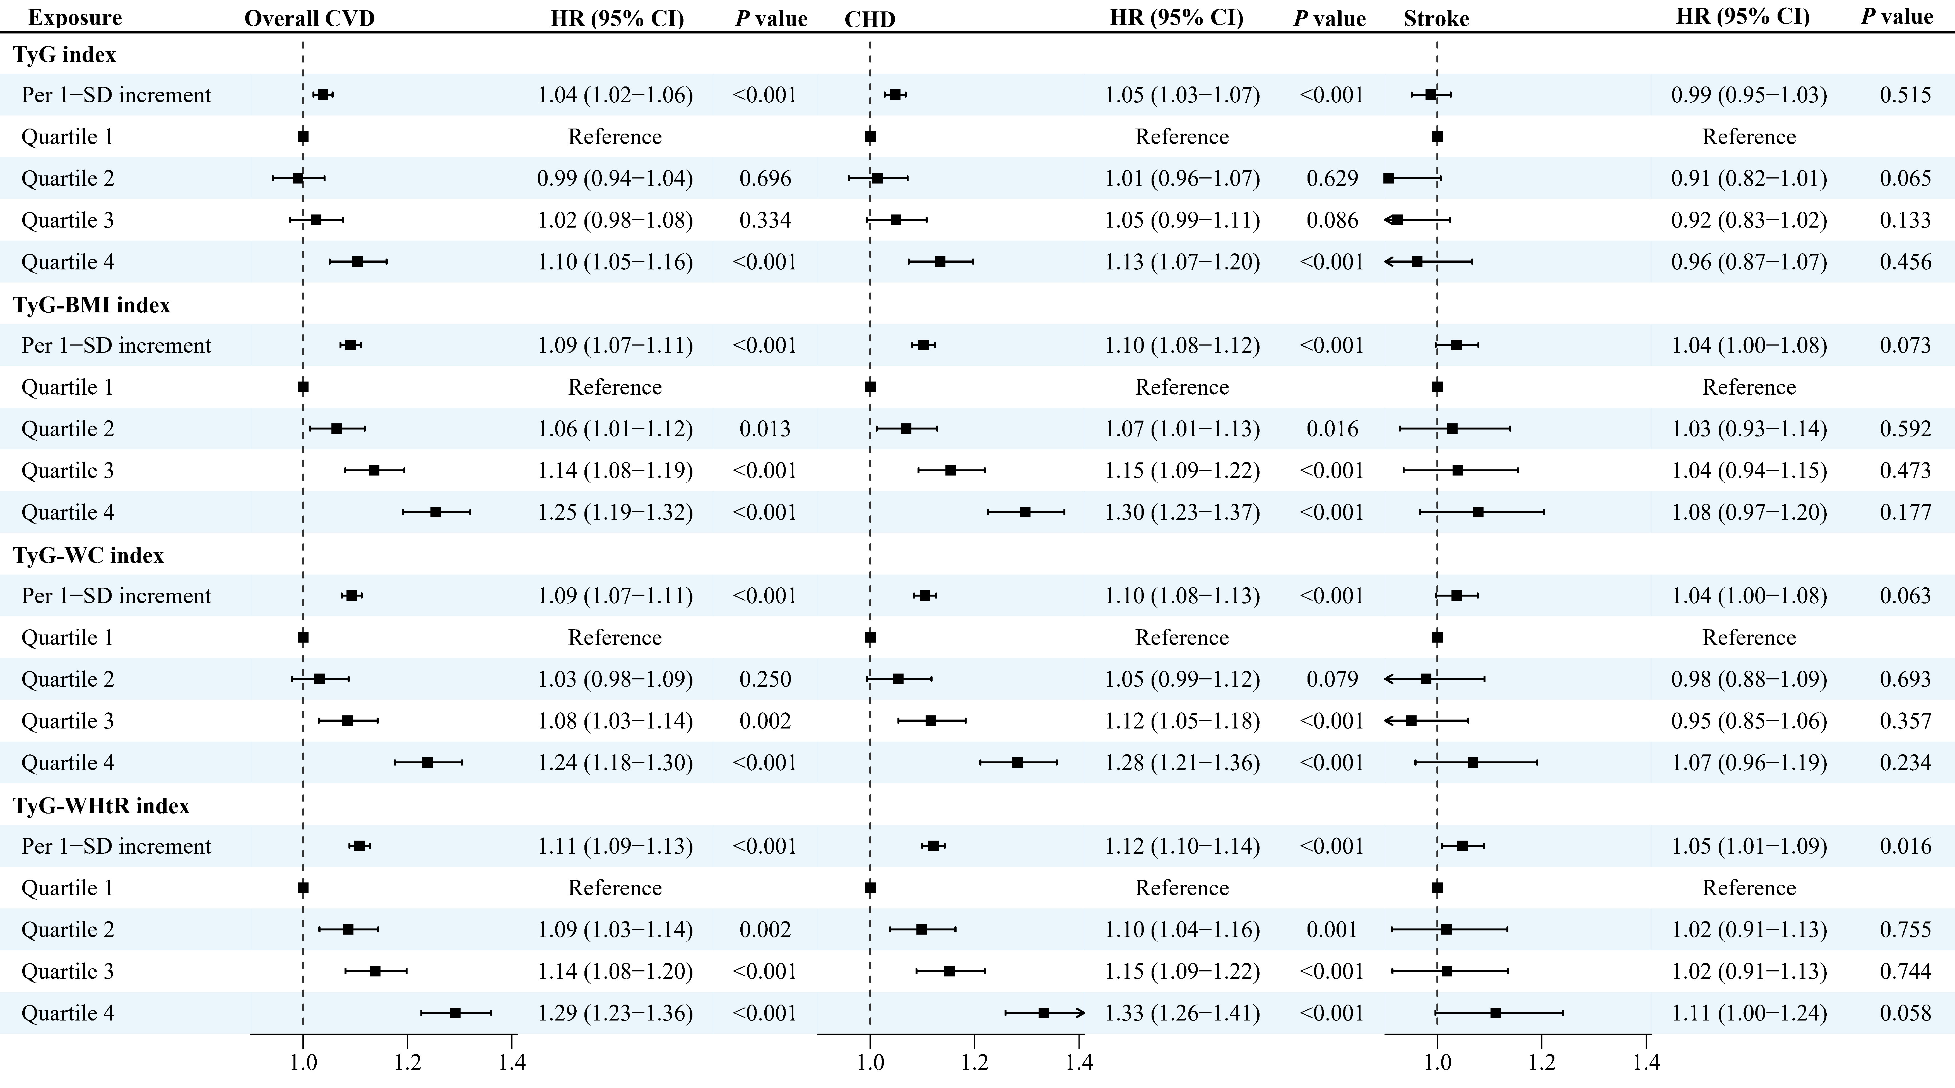
Figure S8 Sensitivity analyses of the associations between TyG-related indices and overall cardiovascular disease, coronary heart disease, stroke in participants with MASLD: additionally adjusting for glycated haemoglobin (HbA1c)
Note: Models were adjusted for age, sex, ethnicity, employed status, Townsend deprivation index, family income, education, smoking status, alcohol drinking, sleep duration, physical activity, diet, family history of cardiometabolic diseases, and glycated haemoglobin. MASLD: metabolic-associated steatotic liver disease; CVD: cardiovascular disease; CHD: coronary heart disease; TyG: triglyceride glucose index; BMI: body mass index; WC waist circumference; WHtR waist-to-height ratio; HR: hazard ratio; CI: confidence interval.
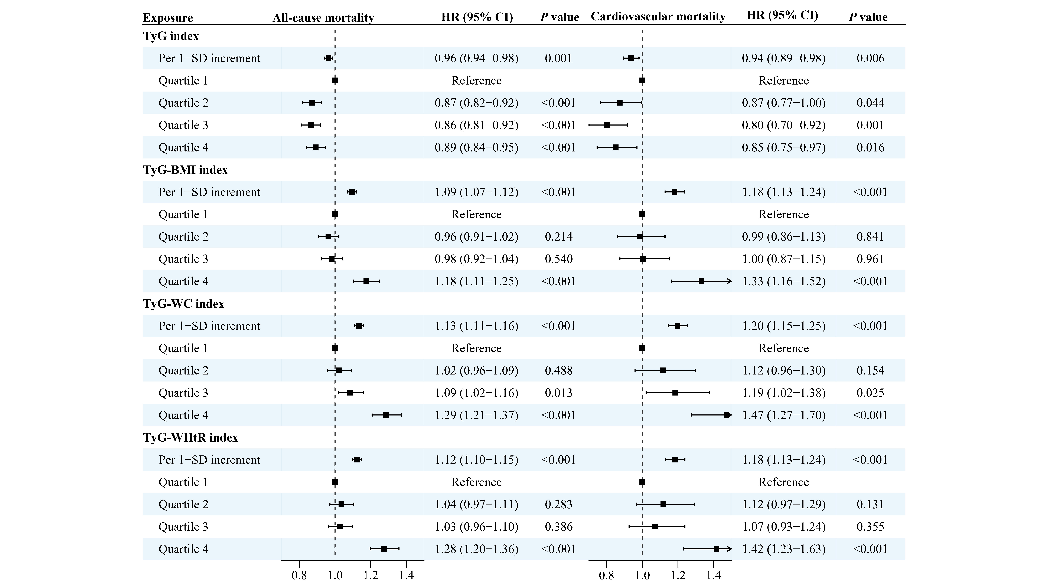
Figure S9 Sensitivity analyses of the associations between TyG-related indices and all-cause death and cardiovascular death in participants with MASLD: additionally adjusting for glycated haemoglobin (HbA1c)
Note: Models were adjusted for age, sex, ethnicity, employed status, Townsend deprivation index, family income, education, smoking status, alcohol drinking, sleep duration, physical activity, diet, family history of cardiometabolic diseases, and glycated haemoglobin. MASLD: metabolic-associated steatotic liver disease; CVD: cardiovascular disease; CHD: coronary heart disease; TyG: triglyceride glucose index; BMI: body mass index; WC waist circumference; WHtR waist-to-height ratio; HR: hazard ratio; CI: confidence interval.
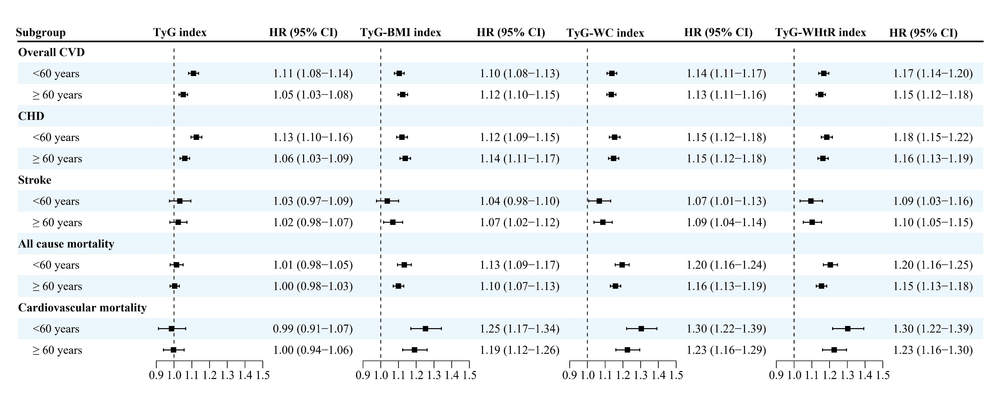
Figure S10 Subgroup analyses by age for the associations of TyG-related indices with study outcomes in participants with MASLD
Note: Data were presented as the hazard ratios for the association between per 1-standard deviation increment in TyG-related indices and risk of outcomes. Models were adjusted for age, sex, ethnicity, employed status, Townsend deprivation index, family income, education, smoking status, alcohol drinking, sleep duration, physical activity, diet, and family history of cardiometabolic diseases. MASLD: metabolic-associated steatotic liver disease; CVD: cardiovascular disease; CHD: coronary heart disease; TyG: triglyceride glucose index; BMI: body mass index; WC waist circumference; WHtR waist-to-height ratio; HR: hazard ratio; CI: confidence interval.
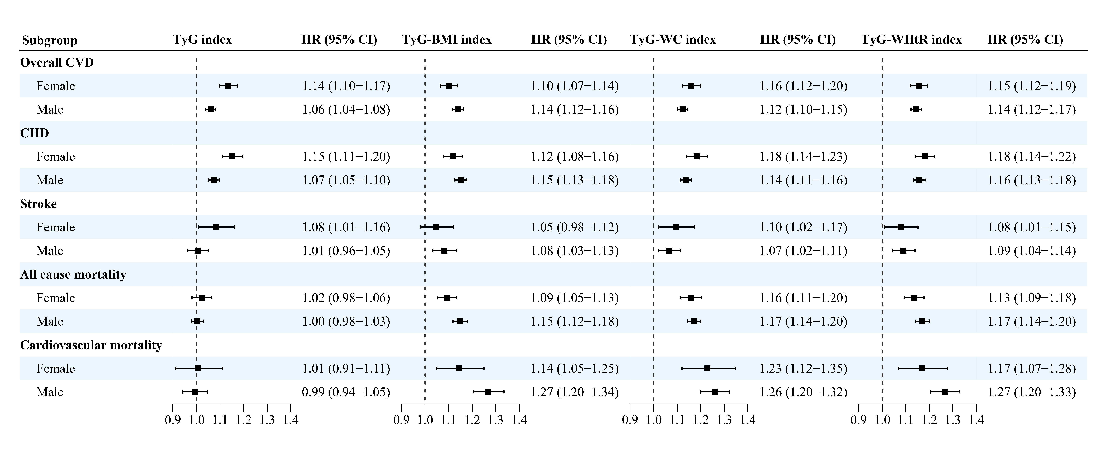
Figure S11 Subgroup analyses by sex for the associations of TyG-related indices with study outcomes in participants with MASLD
Note: Data were presented as the hazard ratios for the association between per 1-standard deviation increment in TyG-related indices and risk of outcomes. Models were adjusted for age, sex, ethnicity, employed status, Townsend deprivation index, family income, education, smoking status, alcohol drinking, sleep duration, physical activity, diet, and family history of cardiometabolic diseases. MASLD: metabolic-associated steatotic liver disease; CVD: cardiovascular disease; CHD: coronary heart disease; TyG: triglyceride glucose index; BMI: body mass index; WC waist circumference; WHtR waist-to-height ratio; HR: hazard ratio; CI: confidence interval.
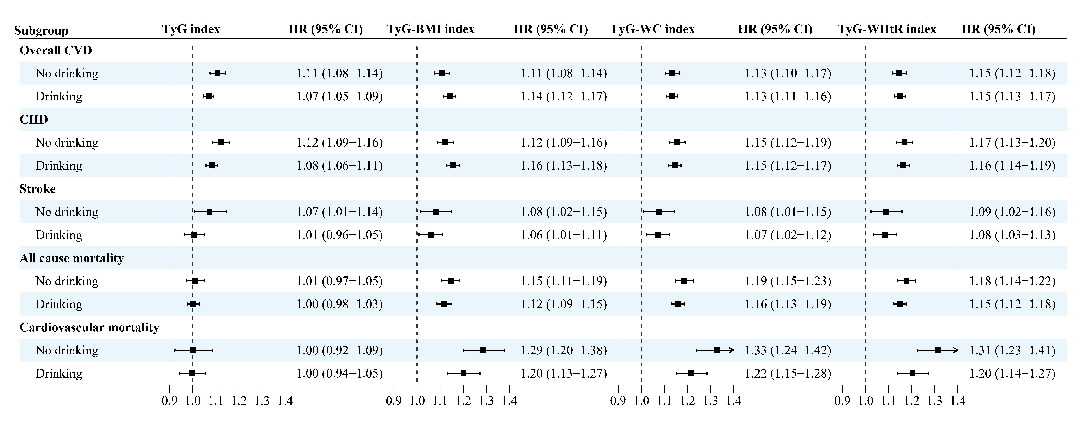
Figure S12 Subgroup analyses by alcohol drinking for the associations of TyG-related indices with study outcomes in participants with MASLD
Note: Data were presented as the hazard ratios for the association between per 1-standard deviation increment in TyG-related indices and risk of outcomes. The no drinking group was defined as drinking only special occasions or drinking one to three times a month, and the drinking group was defined as drinking once a week or more. Models were adjusted for age, sex, ethnicity, employed status, Townsend deprivation index, family income, education, smoking status, alcohol drinking, sleep duration, physical activity, diet, and family history of cardiometabolic diseases. MASLD: metabolic-associated steatotic liver disease; CVD: cardiovascular disease; CHD: coronary heart disease; TyG: triglyceride glucose index; BMI: body mass index; WC waist circumference; WHtR waist-to-height ratio; HR: hazard ratio; CI: confidence interval.

