Additional File 1

Cohort Design
China Health and Retirement Longitudinal Study (CHARLS)
The CHARLS is a nationally representative longitudinal survey of persons in China 45 years of age or older and their spouses [1], which conducted a national baseline survey (wave 1) in 2011-2012 with a comprehensive sample of 17708 individuals from 10257 households across 150 countries/districts and 450 villages/urban communities, and subsequently progressed with follow-up surveys in wave 2 (2013), wave 3 (2015), wave 4 (2018), and wave 5 (2020) [2]. The CHARLS survey collects participants’ information across multiple dimensions of demographics, health, and socioeconomic status through interviews. All participants underwent a computer-assisted, face-to-face personal interview using a structured questionnaire. The interviewers were trained by CHARLS staff members [1]. Data of the interview were collected and checked by the quality control team in CHARLS. Venous blood samples were obtained in both the national baseline wave in 2011-2012 (wave 1) and the follow-up wave (wave 3) [3].
Health and Retirement Study (HRS)
The HRS is a nationally representative longitudinal survey of more than 37000 individuals over age 50 in 23000 households in the USA [4]. The HRS sample is based on a multi-stage area probability design involving geographical stratification and clustering and oversampling of certain demographic groups [5]. The initial HRS cohort, recruited in 1992, consisted of persons born 1931–41 (then aged 51–61) and their spouses of any age. A second study, Asset and Health Dynamics Among the Oldest Old (AHEAD), was fielded the next year to capture the cohort born 1890–1923 (then aged 70 and above). In 1998, the two studies merged and, in order to make the sample fully representative of the USA population over age 50, two new cohorts were enrolled: the Children of the Depression (CODA), born 1924–30, and the War Babies, born 1942–47. HRS now employs a steady-state design, replenishing the sample every 6 years with younger cohorts not previously represented. In 2004, Early Baby Boomers (EBB, born 1948–53) were added, and in 2010, Mid Baby Boomers (MBB, born 1954–59) were added. The main survey occurs every 2 years, making 2012 the 11th follow-up of the 1992 cohort [4]. Most baseline interviews are conducted face-to-face (FTF). Prior to 2004, the primary mode for follow-up interviews was telephone, except for respondents over the age of 80 who are offered face-to-face (FTF) follow-up interviews. Since 2006, HRS has utilized a mixed-mode design for follow-up in which half of the sample is assigned an FTF interview with physical and biological measures and a psychosocial questionnaire, the enhanced FTF (EFTF) interview. The other half completes only the core interview, usually by telephone. The survey focused on four broad topics: income and wealth; health, cognition and use of healthcare services; work and retirement; and family connections. HRS data are also linked at the individual level to administrative records from Social Security and Medicare, Veteran’s Administration, the National Death Index and employer-provided pension plan information. Since 2006, data collection has expanded to include biomarkers and genetics as well as much greater depth in psychology and social context [4].

Fig.S1 Study Timelines and Design
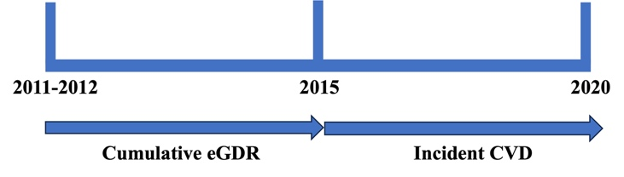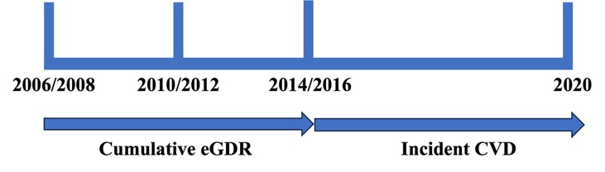
A (CHARLS) B (HRS)

Table S1 Baseline characteristics between inclusion and exclusion participants who provided blood samples in the CHARLS
Characteristics | Total  (n = 11847) | Include  (n = 2430) | Exclude  (n = 9417) | P
Age, years | 58.00 (51.00, 65.00) | 59.00 (55.00, 65.00) | 57.00 (49.00, 65.00) | <0.001
Gender, n(%) |  |  |  | <0.001
Male | 5503 (46.45) | 1205 (49.59) | 4298 (45.64)
Female | 6344 (53.55) | 1225 (50.41) | 5119 (54.36)
Marital status, n(%) |  |  |  | <0.001
Married | 9788 (82.62) | 2091 (86.05) | 7697 (81.74)
Others | 2059 (17.38) | 339 (13.95) | 1720 (18.26)
Residence type, n(%) |  |  |  | <0.001
Rural | 7530 (63.56) | 1715 (70.58) | 5815 (61.75)
Urban | 4317 (36.44) | 715 (29.42) | 3602 (38.25)
Educational level, n(%) |  |  |  | <0.001
Middle school or below | 10584 (89.35) | 2251 (92.63) | 8333 (88.51)
High school or vocational school | 1089 (9.19) | 166 (6.83) | 923 (9.80)
College or above | 172 (1.45) | 13 (0.53) | 159 (1.69)
Smoking status, n(%) |  |  |  | 0.007
Ever | 4613 (39.10) | 1008 (41.48) | 3605 (38.48)
Never | 7185 (60.90) | 1422 (58.52) | 5763 (61.52)
Alcohol drinking status, n(%) |  |  |  | 0.003
Ever | 4825 (40.93) | 1058 (43.54) | 3767 (40.25)
Never | 6964 (59.07) | 1372 (56.46) | 5592 (59.75)
Hypertension, n(%) | 4733 (40.28) | 814 (33.50) | 3919 (42.05) | <0.001
Dyslipidemia, n(%) | 5780 (49.51) | 996 (41.33) | 4784 (51.64) | <0.001
Lipid-lowering therapy, n (%) | 607 (5.26) | 61 (2.55) | 546 (5.98) | <0.001
Hypertension medications, n (%) | 2398 (20.46) | 293 (12.07) | 2105 (22.65) | <0.001
Waist circumference, cm | 84.50 (77.80, 92.00) | 83.00 (76.80, 90.00) | 85.00 (78.00, 92.60) | <0.001
Body mass index, kg/m² | 23.15 (20.86, 25.84) | 22.38 (20.43, 24.65) | 23.45 (21.05, 26.13) | <0.001
Systolic blood pressure, mm Hg | 126.50 (113.88, 141.50) | 124.00 (112.50, 138.50) | 127.00 (114.00, 142.50) | <0.001
Diastolic blood pressure, mm Hg | 74.50 (67.00, 83.00) | 73.00 (66.00, 81.00) | 75.00 (67.00, 83.50) | <0.001
Total cholesterol, mg/dL | 189.82 (166.62, 215.34) | 190.98 (167.40, 214.85) | 189.43 (166.24, 215.34) | 0.648
High-density lipoprotein cholesterol, mg/dL | 49.10 (39.82, 59.54) | 51.03 (42.53, 61.47) | 48.33 (39.43, 59.15) | <0.001
Glycosylated hemoglobin, % | 5.10 (4.90, 5.40) | 5.10 (4.80, 5.30) | 5.10 (4.90, 5.50) | <0.001

Table S2 Baseline characteristics between inclusion and exclusion participants who provided blood samples in the HRS
Characteristics | Total  (n = 13064) | Include  (n = 2008) | Exclude  (n = 11056) | P
Age, years | 68.00 (60.00, 75.00) | 64.00 (57.00, 70.00) | 69.00 (61.00, 76.00) | <0.001
Gender, n(%) |  |  |  | <0.001
Male | 5287 (40.47) | 705 (35.11) | 4582 (41.44)
Female | 7777 (59.53) | 1303 (64.89) | 6474 (58.56)
Marital status, n(%) |  |  |  | <0.001
Married | 8271 (63.32) | 1422 (70.82) | 6849 (61.95)
Others | 4792 (36.68) | 586 (29.18) | 4206 (38.05)
Residence type, n(%) |  |  |  | 0.590
Rural | 4241 (32.52) | 662 (33.03) | 3579 (32.42)
Urban | 8802 (67.48) | 1342 (66.97) | 7460 (67.58)
Educational level, n(%) |  |  |  | <0.001
Middle school or below | 2659 (20.36) | 228 (11.35) | 2431 (21.99)
High school or vocational school | 7628 (58.40) | 1165 (58.02) | 6463 (58.47)
College or above | 2775 (21.24) | 615 (30.63) | 2160 (19.54)
Smoking status, n(%) |  |  |  | <0.001
Ever | 7375 (56.86) | 982 (49.35) | 6393 (58.22)
Never | 5596 (43.14) | 1008 (50.65) | 4588 (41.78)
Alcohol drinking status, n(%) |  |  |  | <0.001
Ever | 6722 (51.46) | 1276 (63.55) | 5446 (49.26)
Never | 6341 (48.54) | 732 (36.45) | 5609 (50.74)
Hypertension, n(%) | 8920 (68.97) | 1061 (52.84) | 7859 (71.93) | <0.001
Dyslipidemia, n(%) | 9759 (95.14) | 1317 (94.21) | 8442 (95.29) | 0.079
Lipid-lowering therapy, n (%) | 5429 (41.69) | 535 (26.64) | 4894 (44.43) | <0.001
Hypertension medications, n (%) | 6834 (52.50) | 707 (35.23) | 6127 (55.64) | <0.001
Waist circumference, cm | 99.69 (90.17, 109.86) | 96.52 (86.36, 104.78) | 100.96 (91.44, 111.12) | <0.001
Body mass index, kg/m² | 28.47 (25.04, 32.53) | 27.70 (24.77, 31.33) | 28.62 (25.12, 32.81) | <0.001
Systolic blood pressure, mm Hg | 128.50 (117.00, 143.00) | 126.00 (114.50, 138.50) | 129.50 (117.50, 144.00) | <0.001
Diastolic blood pressure, mm Hg | 78.50 (71.00, 86.38) | 79.50 (72.50, 86.50) | 78.50 (71.00, 86.00) | <0.001
Total cholesterol, mg/dL | 196.33 (169.46, 228.13) | 207.71 (181.22, 235.81) | 194.65 (167.78, 226.44) | <0.001
High-density lipoprotein cholesterol, mg/dL | 52.16 (42.61, 64.48) | 56.64 (46.31, 70.77) | 51.96 (42.08, 63.25) | <0.001
Glycosylated hemoglobin, % | 5.69 (5.34, 6.14) | 5.46 (5.22, 5.70) | 5.69 (5.34, 6.25) | <0.001

Fig.S2 Flowchart of the study population
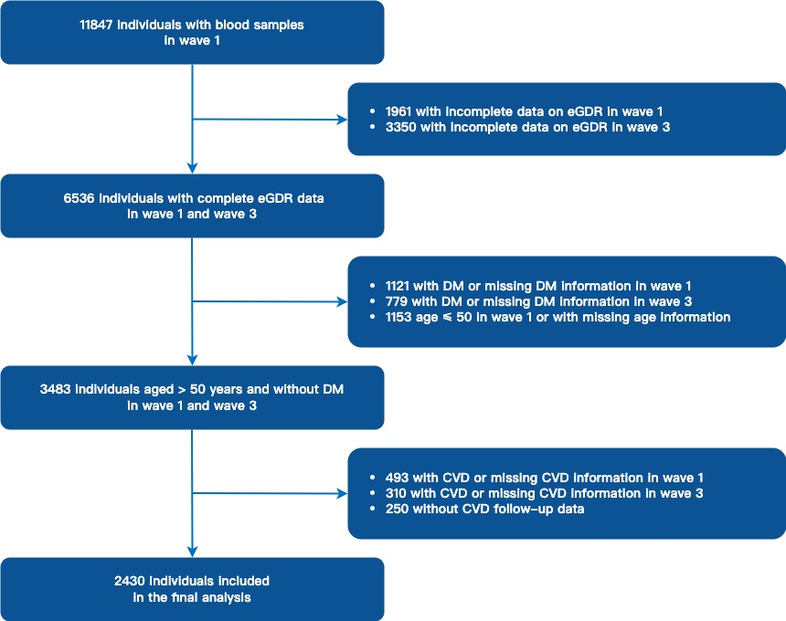
A (CHARLS)
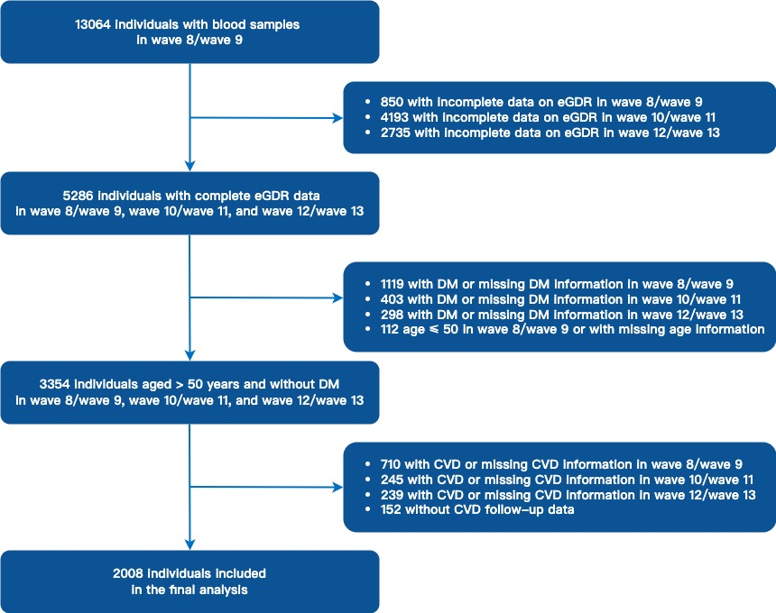
B (HRS)

Fig.S3 Kaplan–Meier curves according to cumulative eGDR quartiles for CVD
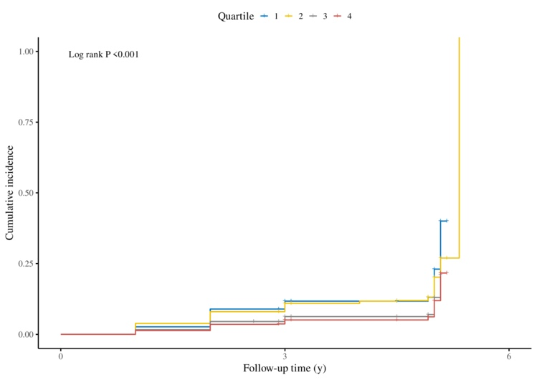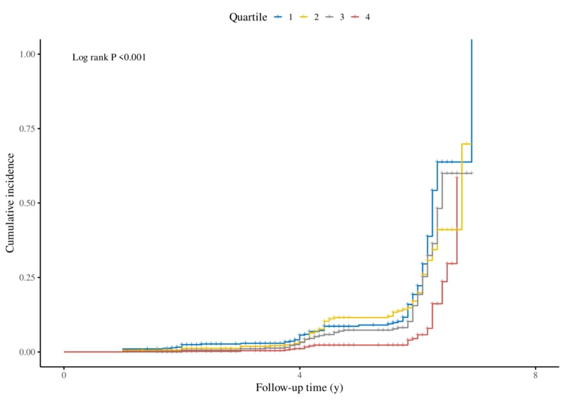
A (CHARLS) B (HRS)

Table S3 Subgroup analyses of the association between the cumulative eGDR and incident CVD
 | CHARLS |  |  |  |  | HRS
Subgroup | Quartile 1 | Quartile 2 | Quartile 3 | Quartile 4 | P for interaction | Quartile 1 | Quartile 2 | Quartile 3 | Quartile 4 | P for interaction
Gender |  |  |  |  | 0.235 |  |  |  |  | 0.098
Male | Reference | 0.733 (0.503-1.068) | 0.434 (0.277-0.682) | 0.411 (0.261-0.649) |  | Reference | 1.345 (0.781-2.316) | 1.370 (0.664-2.823) | 0.785 (0.327-1.885)
Female | Reference | 1.026 (0.692-1.521) | 0.866 (0.560-1.339) | 0.778 (0.496-1.220) |  | Reference | 0.653 (0.434-0.983) | 0.851 (0.548-1.320) | 0.363 (0.195-0.677)
Smoking status |  |  |  |  | 0.712 |  |  |  |  | 0.618
Never | Reference | 0.959 (0.669-1.375) | 0.759 (0.508-1.134) | 0.616 (0.403-0.942) |  | Reference | 0.736 (0.451-1.201) | 1.018 (0.590-1.756) | 0.541 (0.261-1.119)
Ever | Reference | 0.810 (0.533-1.232) | 0.482 (0.293-0.794) | 0.545 (0.337-0.880) |  | Reference | 1.030 (0.658-1.612) | 1.009 (0.596-1.709) | 0.418 (0.201-0.870)
Alcohol drinking status |  |  |  |  | 0.964 |  |  |  |  | 0.298
Never | Reference | 0.971 (0.674-1.401) | 0.694 (0.460-1.049) | 0.613 (0.399-0.941) |  | Reference | 0.618 (0.357-1.069) | 1.301 (0.717-2.361) | 0.389 (0.159-0.954)
Ever | Reference | 0.813 (0.539-1.226) | 0.568 (0.352-0.917) | 0.572 (0.357-0.918) |  | Reference | 1.002 (0.657-1.528) | 0.920 (0.563-1.505) | 0.539 (0.287-1.012)
Body mass index |  |  |  |  | 0.544 |  |  |  |  | 0.872
<28 | Reference | 0.856 (0.640-1.145) | 0.639 (0.462-0.886) | 0.600 (0.431-0.835) |  | Reference | 0.770 (0.389-1.524) | 0.980 (0.481-1.996) | 0.576 (0.248-1.334)
≥28 | Reference | 1.124 (0.513-2.463) | 0.651 (0.084-5.071) | - |  | Reference | 1.003 (0.661-1.523) | 1.015 (0.583-1.767) | 0.437 (0.149-1.286)
Body mass index |  |  |  |  | 0.430 |  |  |  |  | 0.244
<30 | Reference | 0.900 (0.683-1.185) | 0.623 (0.454-0.854) | 0.591 (0.428-0.815) |  | Reference | 1.257 (0.737-2.144) | 1.438 (0.802-2.578) | 0.626 (0.303-1.292)
≥30 | Reference | 0.305 (0.034-2.770) | 0.697 (0.038-12.950) | - |  | Reference | 0.706 (0.399-1.248) | 0.838 (0.412-1.704) | 1.003 (0.323-3.113)
The analyses adjusted age, gender, marital status, residence type, educational level, smoking status, alcohol drinking status, dyslipidemia, lipid-lowering therapy, and use of hypertension medications.

Fig.S4 Restricted cubic spline curves for incident CVD according to the cumulative eGDR_{BMI}
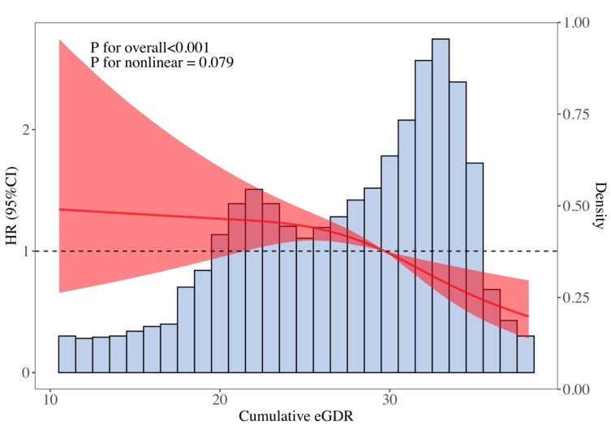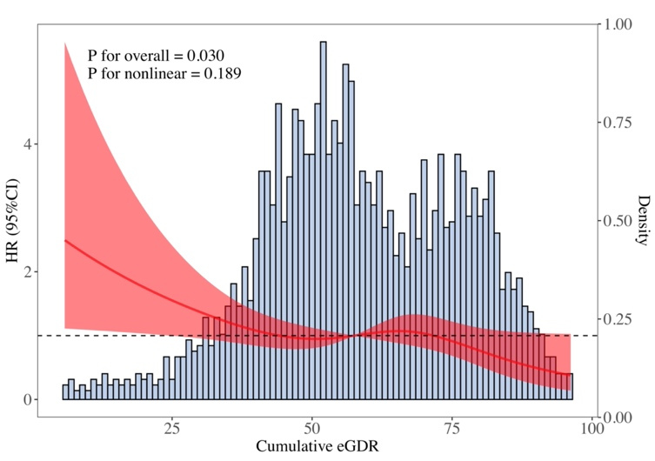
A (Adjusted-CHARLS) B (Adjusted-HRS)
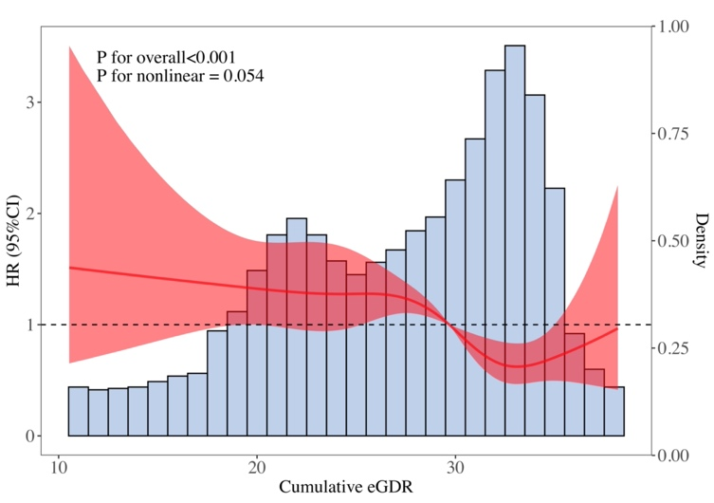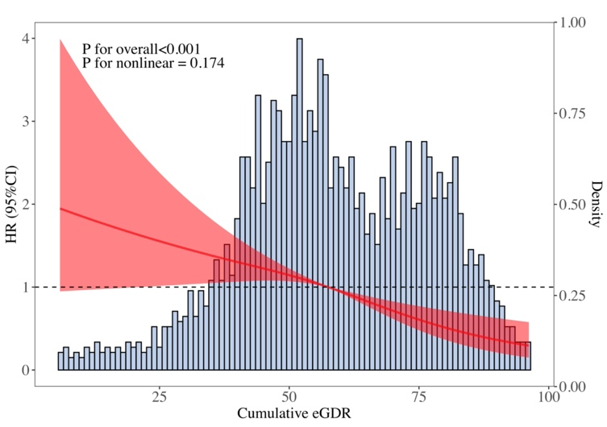
C (Unadjusted- CHARLS) D (Unadjusted- HRS)
The adjusted model adjusted age, gender, marital status, residence type, educational level, smoking status, alcohol drinking status, dyslipidemia, lipid-lowering therapy, and use of hypertension medications.

Table S4 Association between the cumulative eGDR_{BMI} and incident CVD
 | CHARLS |  |  |  |  |  | HRS |  |  |  |  |  | Pooled analysis
 | Model 1 |  | Model 2 |  | Model 3 |  | Model 1 |  | Model 2 |  | Model 3 |  | Model 1 |  |  |  | Model 2 |  |  |  | Model 3
 | HR 95%CI | P | HR 95%CI | P | HR 95%CI | P | HR 95%CI | P | HR 95%CI | P | HR 95%CI | P | HR 95%CI | P valueª | I², % | P value^{b} | HR 95%CI | P valueª | I², % | P value^{b} | HR 95%CI | P valueª | I², % | P value^{b}
Quartile 1 | Reference |  | Reference |  | Reference |  | Reference |  | Reference |  | Reference |  | Reference |  |  |  | Reference |  |  |  | Reference
Quartile 2 | 0.850 (0.663 - 1.089) | 0.199 | 0.851 (0.664 - 1.091) | 0.204 | 0.890 (0.679 - 1.166) | 0.397 | 0.778 (0.564 - 1.073) | 0.126 | 0.784 (0.568 - 1.084) | 0.141 | 0.826 (0.597 - 1.144) | 0.251 | 0.822 (0.676 - 1.001) | 0.051 | 0.0 | 0.669 | 0.825 (0.678 - 1.005) | 0.056 | 0.0 | 0.693 | 0.863 (0.701 - 1.063) | 0.166 | 0.0 | 0.729
Quartile 3 | 0.650 (0.495 - 0.854) | 0.002 | 0.645 (0.491 - 0.848) | 0.002 | 0.689 (0.508 - 0.935) | 0.017 | 0.743 (0.534 - 1.033) | 0.077 | 0.761 (0.545 - 1.061) | 0.107 | 1.027 (0.699 - 1.508) | 0.891 | 0.686 (0.556 - 0.847) | <0.001 | 0.0 | 0.540 | 0.689 (0.558 - 0.852) | 0.001 | 0.0 | 0.452 | 0.826 (0.560 - 1.220) | 0.337 | 60.6 | 0.111
Quartile 4 | 0.477 (0.356 - 0.639) | <0.001 | 0.472 (0.352 - 0.634) | <0.001 | 0.509 (0.367 - 0.706) | <0.001 | 0.410 (0.272 - 0.619) | <0.001 | 0.415 (0.275 - 0.627) | <0.001 | 0.610 (0.374 - 0.993) | 0.047 | 0.453 (0.357 - 0.575) | <0.001 | 0.0 | 0.557 | 0.452 (0.356 - 0.574) | <0.001 | 0.0 | 0.618 | 0.538 (0.410 - 0.706) | <0.001 | 0.0 | 0.546
Per SD change | 0.790 (0.719 - 0.867) | <0.001 | 0.786 (0.715 - 0.864) | <0.001 | 0.806 (0.721 - 0.901) | <0.001 | 0.729 (0.639 - 0.830) | <0.001 | 0.735 (0.645 - 0.838) | <0.001 | 0.824 (0.700 - 0.970) | 0.020 | 0.769 (0.712 - 0.830) | <0.001 | 0.0 | 0.327 | 0.768 (0.711 - 0.829) | <0.001 | 0.0 | 0.416 | 0.812 (0.740 - 0.890) | <0.001 | 0.0 | 0.827
Model 1 adjusted for age and gender; Model 2 adjusted for age, gender, marital status, residence type, educational level, smoking status, and alcohol drinking status; Model 3 adjusted for age, gender, marital status, residence type, educational level, smoking status, alcohol drinking status, dyslipidemia, lipid-lowering therapy, and use of hypertension medications.
P valueª For the pooled HR 95%CI.
P value^{b} For the I² statistic.

Table S5 Association between the cumulative eGDR and incident CVD, accounting for competing risk by all-cause mortality
 | CHARLS |  |  |  |  |  | HRS |  |  |  |  |  | Pooled analysis
 | Model 1 |  | Model 2 |  | Model 3 |  | Model 1 |  | Model 2 |  | Model 3 |  | Model 1 |  |  |  | Model 2 |  |  |  | Model 3
 | HR 95%CI | P | HR 95%CI | P | HR 95%CI | P | HR 95%CI | P | HR 95%CI | P | HR 95%CI | P | HR 95%CI | P valuea | I2, % | P valueb | HR 95%CI | P valuea | I2, % | P valueb | HR 95%CI | P valuea | I2, % | P valueb
Quartile 1 | Reference |  | Reference |  | Reference |  | Reference |  | Reference |  | Reference |  | Reference |  |  |  | Reference |  |  |  | Reference
Quartile 2 | 0.845 (0.663-1.078) | 0.180 | 0.844 (0.661-1.078) | 0.170 | 0.890 (0.687-1.151) | 0.370 | 0.789 (0.573-1.086) | 0.150 | 0.792 (0.574-1.093) | 0.160 | 0.859 (0.619-1.191) | 0.940 | 0.824 (0.679 - 1.000) | 0.050 | 0.0 | 0.738 | 0.825 (0.679 - 1.002) | 0.052 | 0.0 | 0.758 | 0.878 (0.717 - 1.075) | 0.208 | 0.0 | 0.868
Quartile 3 | 0.584 (0.445-0.768) | <0.001 | 0.581 (0.442-0.764) | <0.001 | 0.623 (0.462-0.841) | 0.002 | 0.761 (0.550-1.054) | 0.100 | 0.759 (0.546-1.054) | 0.100 | 0.986 (0.680-1.430) | 0.360 | 0.656 (0.507 - 0.849) | 0.001 | 33.1 | 0.222 | 0.653 (0.504 - 0.847) | 0.001 | 33.3 | 0.221 | 0.773 (0.493 - 1.211) | 0.261 | 71.9 | 0.059
Quartile 4 | 0.543 (0.413-0.714) | <0.001 | 0.536 (0.407-0.706) | <0.001 | 0.581 (0.429-0.786) | <0.001 | 0.330 (0.214-0.509) | <0.001 | 0.325 (0.211-0.503) | <0.001 | 0.466 (0.281-0.772) | 0.003 | 0.436 (0.269 - 0.708) | 0.001 | 72.4 | 0.057 | 0.430 (0.264 - 0.699) | 0.001 | 72.5 | 0.057 | 0.548 (0.423 - 0.711) | <0.001 | 0.0 | 0.463
Per SD change | 0.784 (0.716-0.859) | <0.001 | 0.780 (0.712-0.855) | <0.001 | 0.800 (0.719-0.890) | <0.001 | 0.698 (0.610-0.797) | <0.001 | 0.694 (0.606-0.794) | <0.001 | 0.785 (0.662-0.931) | 0.006 | 0.748 (0.669 - 0.836) | <0.001 | 49.5 | 0.159 | 0.744 (0.665 - 0.832) | <0.001 | 49.2 | 0.161 | 0.796 (0.727 - 0.871) | <0.001 | 0.0 | 0.854
Model 1 adjusted for age and gender; Model 2 adjusted for age, gender, marital status, residence type, educational level, smoking status, and alcohol drinking status; Model 3 adjusted for age, gender, marital status, residence type, educational level, smoking status, alcohol drinking status, dyslipidemia, lipid-lowering therapy, and use of hypertension medications.
P valueª For the pooled HR 95%CI.
P value^{b} For the I² statistic.

Table S6 Model performance when adding cumulative eGDR to the basic model
 | CHARLS |  |  | HRS
 | C-index (95%CI) | NRI (95%CI) | IDI (95%CI) | C-index (95%CI) | NRI (95%CI) | IDI (95%CI)
Basic model | 0.600 (0.572-0.629) | Reference | Reference | 0.667 (0.629-0.705) | Reference | Reference
Basic model + HTN | 0.602 (0.573-0.630) | 0.020 (-0.030-0.063) | 0.000 (-0.006-0.008) | 0.669 (0.631-0.707) | 0.018 (-0.037-0.063) | 0.003 (-0.005-0.022)
Basic model + eGDR at baseline | 0.603 (0.575-0.632) | 0.012 (-0.035-0.077) | 0.001 (-0.028-0.029) | 0.676 (0.638-0.713) | 0.012 (-0.046-0.084) | 0.002 (-0.002-0.013)
Basic model + cumulative eGDR | 0.613 (0.586-0.641) | 0.031 (-0.017-0.141) | 0.000 (-0.029-0.029) | 0.674 (0.637-0.712) | 0.043 (-0.049-0.064) | -0.001 (-0.006-0.008)
The basic model included age, gender, marital status, residence type, educational level, smoking status, alcohol drinking status, history of dyslipidemia, lipid-lowering therapy, use of hypertension medications, total cholesterol, and high-density lipoprotein cholesterol.

Table S7 Model performance when adding cumulative eGDR to the basic model
 | C-index (95%CI) | NRI (95%CI) | IDI (95%CI)
Basic model | 0.600 (0.572-0.629) | Reference | Reference
Basic model + cumulative TyG | 0.602 (0.573-0.630) | 0.003 (-0.029-0.065) | 0.000 (-0.125-0.087)
Basic model + cumulative TyG-BMI | 0.605 (0.577-0.633) | -0.002 (-0.029-0.073) | 0.000 (-0.044-0.044)
Basic model + cumulative TyG-WC | 0.603 (0.575-0.632) | -0.010 (-0.042-0.065) | 0.000 (-0.067-0.062)
Basic model + cumulative TyG-WHtR | 0.601 (0.572-0.630) | -0.014 (-0.043-0.058) | 0.000 (-0.059-0.042)
Basic model + cumulative eGDR | 0.613 (0.586-0.641) | 0.031 (-0.017-0.141) | 0.000 (-0.029-0.029)
The basic model included age, gender, marital status, residence type, educational level, smoking status, alcohol drinking status, history of dyslipidemia, lipid-lowering therapy, use of hypertension medications, total cholesterol, and high-density lipoprotein cholesterol.

References
1. Zhao Y, Hu Y, Smith JP, Strauss J, Yang G. Cohort profile: The China health and retirement longitudinal study (CHARLS). Int J Epidemiol. 2014;43:61–8.
2. Zhao Y, Strauss J, Yang G, Giles J, Hu PF (Perry), Hu Y, Lei X, Liu M, Park A, Smith JP, Wang Y. China Health and Retirement Longitudinal Study: 2011-2012 National Baseline User’s Guide. National School of Development, Peking University; 2013.
3. Chen X, Crimmins E, Hu P (Perry), Kim JK, Meng Q, Strauss J, et al. Venous blood-based biomarkers in the China health and retirement longitudinal study: Rationale, design, and results from the 2015 wave. Am J Epidemiol. 2019;188:1871–7.
4. Sonnega A, Faul JD, Ofstedal MB, Langa KM, Phillips JW, Weir DR. Cohort profile: The health and retirement study (HRS). Int J Epidemiol. 2014;43:576–85.
5. Heeringa SG, Connor JH. Technical description of the health and retirement survey sample design. University of Michigan, 1995. Available from: https://hrs.isr.umich.edu/publications/biblio/5310

