Table S1 Results of the proportional hazards assumption test in Cox regression.
 | All-cause mortality | Cardiovascular mortality
< 65 years
TyG | 0.718 | 0.478
TyG-WHtR | 0.706 | 0.681
METS-IR | 0.178 | 0.907
≥ 65 years
TyG | 0.372 | 0.602
TyG-WHtR | 0.104 | 0.269
METS-IR | 0.299 | 0.169
The method of Schoenfeld Residuals was used to assess whether the model met the assumption of proportional hazards. If P > 0.05, this assumption was met.
The results are expressed as P values.
TyG triglyceride glucose index; WHtR triglyceride glucose-waist to height ratio; METS-IR metabolic score for insulin resistance

Fig S1-1 Log-log plot of survival functions for three novel metabolic parameters in individuals aged < 65 years with MetS.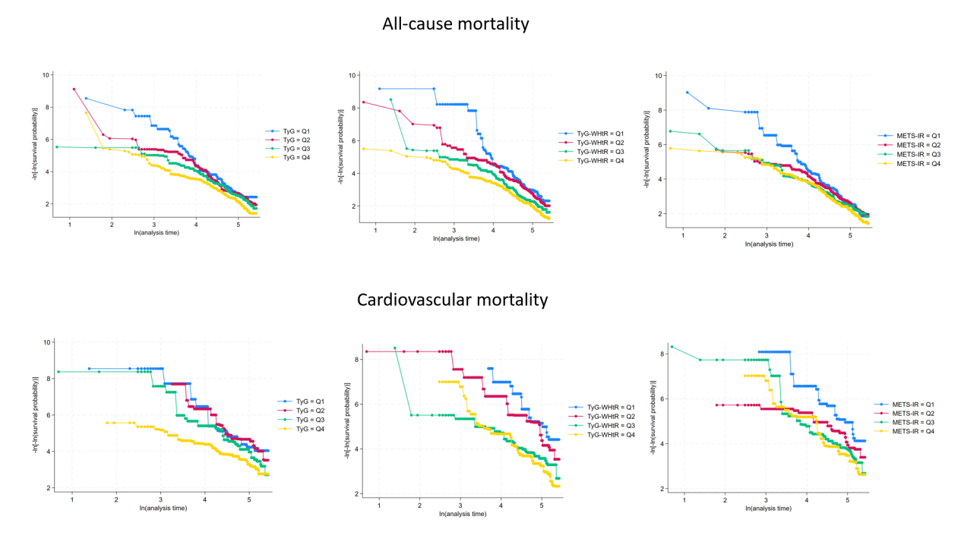
TyG triglyceride glucose index; WHtR triglyceride glucose-waist to height ratio; METS-IR metabolic score for insulin resistance; MetS metabolic syndrome.

Fig S1-2 Log-log plot of survival functions for three novel metabolic parameters in individuals aged ≥ 65 years with MetS. 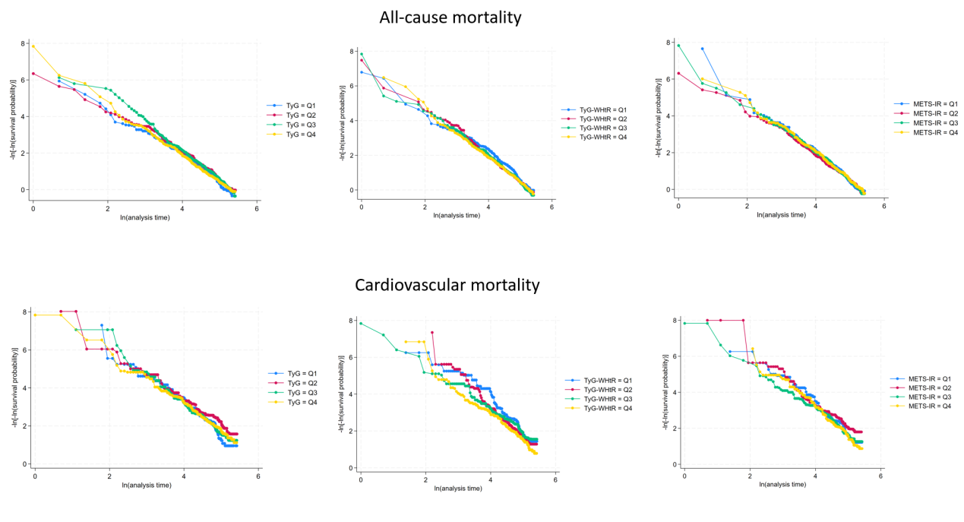
TyG triglyceride glucose index; WHtR triglyceride glucose-waist to height ratio; METS-IR metabolic score for insulin resistance; MetS metabolic syndrome.

Table S2 The association between three novel metabolic parameters with all-cause mortality and cardiovascular mortality in individuals < 65 years of age with MetS.
 | Model 1 | Model 2 | Model 3
All-cause mortality
TyG
Q2 vs. Q1 | 1.25 (0.84, 1.87)  P = 0.268 | 1.20 (0.81, 1.80)  P = 0.367 | 1.26 (0.84, 1.89)  P = 0.257
Q3 vs. Q1 | 1.42 (0.96, 2.10)  P = 0.080 | 1.36 (0.92, 2.01)  P = 0.126 | 1.40(0.94, 2.08)  P = 0.094
Q4 vs. Q1 | 2.18 (1.52, 3.12)  P＜0.001 | 1.88 (1.30, 2.71)  P = 0.001 | 1.63 (1.12, 2.39)  P = 0.011
TyG-WHtR
Q2 vs. Q1 | 1.29 (0.87, 1.90)  P = 0.208 | 1.17 (0.78, 1.75)  P = 0.457 | 1.14 (0.75, 1.74)  P = 0.546
Q3 vs. Q1 | 2.03 (1.39, 2.96)  P＜0.001 | 1.97 (1.32, 2.95)  P = 0.001 | 1.75 (1.13, 2.71)  P = 0.012
Q4 vs. Q1 | 2.87 (2.01, 4.11)  P＜0.001 | 3.47 (2.16, 5.57)  P＜0.001 | 2.78 (1.68, 4.61)  P＜0.001
METS-IR
Q2 vs. Q1 | 1.01 (0.71, 1.45)  P = 0.951 | 0.99 (0.68, 1.44)  P = 0.965 | 0.97 (0.66, 1.43)  P = 0.876
Q3 vs. Q1 | 1.17 (0.81, 1.68)  P = 0.403 | 1.25 (0.83, 1.86)  P = 0.283 | 1.08 (0.71, 1.64)  P = 0.728
Q4 vs. Q1 | 1.52 (1.08, 2.14)  P = 0.016 | 1.74 (1.03, 2.95)  P = 0.040 | 1.36 (1.12, 2.02)  P=0.026
Cardiovascular mortality
TyG
Q2 vs. Q1 | 1.00 (0.42, 2.36)  P = 0.999 | 0.92 (0.39, 2.16)  P = 0.842 | 0.90 (0.38, 2.13)  P = 0.809
Q3 vs. Q1 | 1.87 (0.81, 4.32)  P = 0.142 | 1.73 (0.75, 4.03)  P = 0.201 | 1.70 (0.73, 3.93)  P = 0.217
Q4 vs. Q1 | 3.19 (1.41, 7.19)  P = 0.005 | 2.58 (1.12, 5.92)  P = 0.025 | 2.04 (1.15, 4.90)  P = 0.019
TyG-WHtR
Q2 vs. Q1 | 1.83 (0.79, 4.23)  P = 0.160 | 1.52 (0.65, 3.54)  P = 0.336 | 1.46 (0.62, 3.44)  P = 0.388
Q3 vs. Q1 | 4.78 (2.15, 10.65)  P＜0.001 | 4.21 (1.78, 9.93)  P = 0.001 | 3.62 (1.42, 9.23)  P = 0.007
Q4 vs. Q1 | 7.15 (3.46, 14.78)  P＜0.001 | 7.22 (2.61, 19.96)  P＜0.001 | 4.99 (1.76, 14.11)  P = 0.002
METS-IR
Q2 vs. Q1 | 2.11 (0.92, 4.85)  P = 0.079 | 1.86 (0.81, 4.29)  P = 0.142 | 1.69 (0.72, 3.99)  P = 0.231
Q3 vs. Q1 | 3.43 (1.72, 6.86)  P＜0.001 | 3.12 (1.43, 6.82)  P = 0.004 | 2.59 (1.17, 5.72)  P = 0.019
Q4 vs. Q1 | 4.25 (2.11, 8.54)  P＜0.001 | 3.8 (1.2, 12.05)  P = 0.023 | 2.69 (1.89, 8.15)  P = 0.018
Weighted Cox proportional hazard models were used to estimate hazard ratio (HR) and 95% confidence interval (CI).
Model 1 was unadjusted.
Model 2 was adjusted for age, gender, ethnicity and educational level, BMI.
Model 3 was adjusted for age, gender, ethnicity, educational level, BMI, hypertension, hyperlipidemia, diabetes, smoking status and drinking status.
TyG triglyceride glucose index; WHtR triglyceride glucose-waist to height ratio; METS-IR metabolic score for insulin resistance; MetS metabolic syndrome.

Table S3 The association between three novel metabolic parameters with all-cause mortality and cardiovascular mortality in individuals ≥ 65 years of age with MetS.
 | Model 1 | Model 2 | Model 3
All-cause mortality
TyG
Q2 vs. Q1 | 0.83 (0.66, 1.04)  P = 0.103 | 0.86 (0.69, 1.08)  P = 0.195 | 0.81 (0.64, 1.03)  P = 0.082
Q3 vs. Q1 | 0.84 (0.68, 1.05)  P = 0.129 | 0.96 (0.77, 1.19)  P = 0.717 | 0.92 (0.73, 1.15)  P = 0.443
Q4 vs. Q1 | 0.97 (0.78, 1.21)  P = 0.779 | 1.04 (0.84, 1.30)  P = 0.714 | 0.94 (0.74, 1.19)  P = 0.590
TyG-WHtR
Q2 vs. Q1 | 1.21 (0.97, 1.52)  P = 0.091 | 1.19 (0.96, 1.48)  P = 0.119 | 1.16 (0.93, 1.46)  P = 0.192
Q3 vs. Q1 | 1.23 (0.99, 1.53)  P = 0.059 | 1.34 (1.06, 1.69)  P = 0.014 | 1.23 (0.96, 1.57)  P = 0.097
Q4 vs. Q1 | 1.22 (0.98, 1.53)  P = 0.079 | 1.57 (1.18, 2.09)  P = 0.002 | 1.45 (0.97, 1.96)  P = 0.059
METS-IR
Q2 vs. Q1 | 1.03 (0.83, 1.28)  P = 0.792 | 1.14 (0.91, 1.44)  P = 0.249 | 1.06 (0.84, 1.35)  P = 0.621
Q3 vs. Q1 | 1.01 (0.82, 1.25)  P = 0.900 | 1.16 (0.90, 1.49)  P = 0.240 | 1.04 (0.80, 1.36)  P = 0.744
Q4 vs. Q1 | 0.97 (0.78, 1.21)  P = 0.802 | 1.45 (1.02, 2.06)  P = 0.036 | 1.25 (0.86, 1.80)  P = 0.236
Cardiovascular mortality
TyG
Q2 vs. Q1 | 0.61 (0.39, 0.94)  P = 0.025 | 0.62 (0.40, 0.95)  P = 0.029 | 0.58 (0.37, 0.91)  P = 0.018
Q3 vs. Q1 | 0.88 (0.60, 1.29)  P = 0.511 | 1.00 (0.68, 1.47)  P = 0.994 | 0.95 (0.64, 1.41)  P = 0.806
Q4 vs. Q1 | 0.83 (0.56, 1.22)  P = 0.337 | 0.84 (0.57, 1.24)  P = 0.386 | 0.75 (0.50, 1.12)  P = 0.154
TyG-WHtR
Q2 vs. Q1 | 1.32 (0.88, 1.97)  P = 0.176 | 1.22 (0.81, 1.81)  P = 0.340 | 1.12 (0.74, 1.69)  P = 0.600
Q3 vs. Q1 | 1.10 (0.73, 1.66)  P = 0.647 | 1.04 (0.69, 1.58)  P = 0.840 | 1.00 (0.66, 1.54)  P = 0.983
Q4 vs. Q1 | 1.69 (1.14, 2.52)  P = 0.009 | 1.74 (0.93, 2.82)  P = 0.094 | 1.62 (0.99, 2.66)  P = 0.054
METS-IR
Q2 vs. Q1 | 0.72 (0.48, 1.08)  P = 0.111 | 0.72 (0.47, 1.09)  P = 0.122 | 0.66 (0.43, 1.02)  P = 0.062
Q3 vs. Q1 | 1.08 (0.74, 1.56)  P = 0.701 | 1.04 (0.68, 1.59)  P = 0.869 | 0.97 (0.63, 1.51)  P = 0.899
Q4 vs. Q1 | 1.20 (0.81, 1.76)  P = 0.363 | 1.29 (0.73, 2.30)  P = 0.382 | 1.13 (0.62, 2.06)  P = 0.680
Weighted Cox proportional hazard models were used to estimate hazard ratio (HR) and 95% confidence interval (CI).
Model 1 was unadjusted.
Model 2 was adjusted for age, gender, ethnicity and educational level, BMI.
Model 3 was adjusted for age, gender, ethnicity, educational level, BMI, hypertension, hyperlipidemia, diabetes, smoking status and drinking status.
TyG triglyceride glucose index; WHtR triglyceride glucose-waist to height ratio; METS-IR metabolic score for insulin resistance; MetS metabolic syndrome.

Fig 2-1 Survival (Kaplan–Meier) curves for mortality according to three novel metabolic parameters in individuals (< 65 years) with MetS.
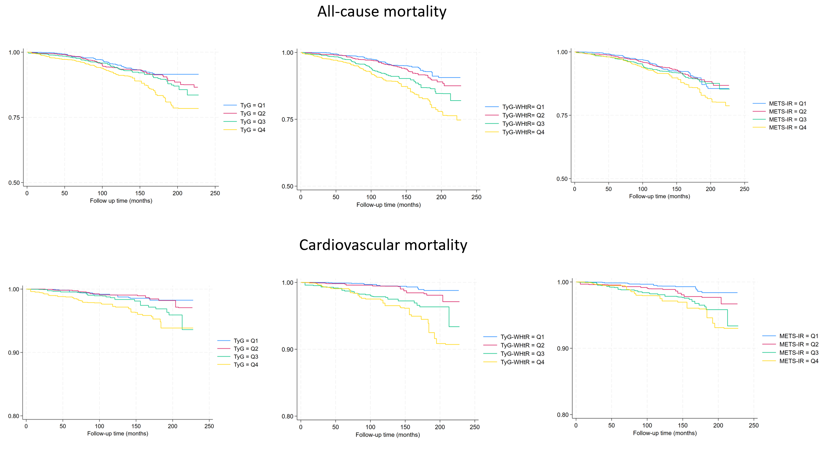
TyG triglyceride glucose index; WHtR triglyceride glucose-waist to height ratio; METS-IR metabolic score for insulin resistance; MetS metabolic syndrome.

Fig 2-2 Survival (Kaplan–Meier) curves for mortality according to three novel metabolic parameters in individuals (≥ 65 years) with MetS.
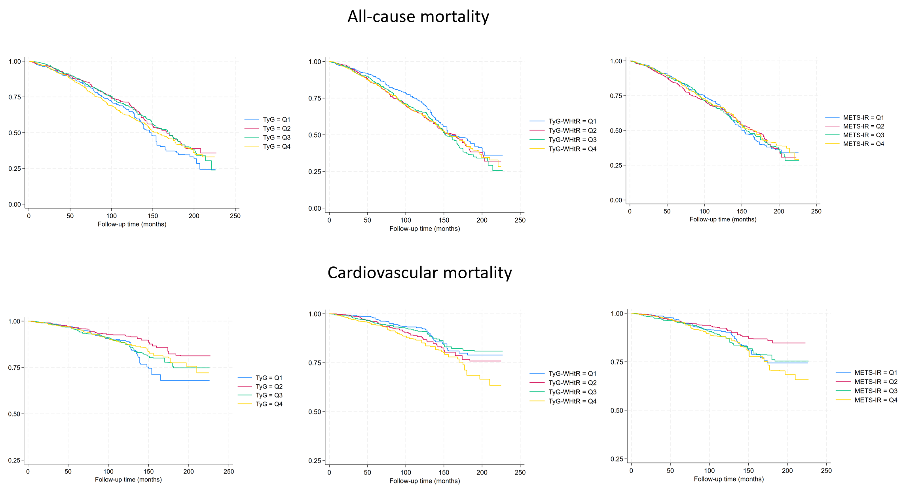
TyG triglyceride glucose index; WHtR triglyceride glucose-waist to height ratio; METS-IR metabolic score for insulin resistance; MetS metabolic syndrome.

Table S4 Linear relationships between three novel metabolic parameters and mortality
 | All-cause mortality | Cardiovascular mortality
< 65 years
TyG | 0.026 (0.012, 0.039)  P < 0.001 | 0.008 (0.001, 0.016)  P = 0.030
TyG-WHtR | 0.038 (0.022, 0.054)  P < 0.001 | 0.010 (0.001, 0.018)  P = 0.026
METS-IR | 0.003 (0.001, 0.004)  P = 0.003 | 0.002 (0.001, 0.004)  P = 0.004
≥ 65 years
TyG | 0.088 (0.051, 0.125)  P < 0.001 | 0.027 (0.003, 0.051)  P = 0.025
TyG-WHtR | 0.087 (0.046, 0.128)  P < 0.001 | 0.031 (0.004, 0.057)  P = 0.022
METS-IR | 0.007 (0.002, 0.012)  P = 0.007 | 0.004 (0.001, 0.007)  P = 0.042
Weighted linear models were used to assess the association between the three novel metabolic parameters and all-cause/cardiovascular mortality.
Results are expressed as correlation coefficients and 95% confidence intervals.
Model was adjusted for age, gender, ethnicity, educational level, BMI, hypertension, hyperlipidemia, diabetes, smoking status and drinking status.

Table S5 Time-dependent receiver operating characteristic (ROC) curve analysis of three novel metabolic parameters and mortality.
 | 3 years | 5 years | 10 years
All-cause mortality
TyG | 0.637 (0.577, 0.698) | 0.555 (0.492, 0.618) | 0.555 (0.516, 0.593)
TyG-WHtR | 0.653 (0.565, 0.741) | 0.577 (0.514, 0.640) | 0.560 (0.541, 0.680)
METS-IR | 0.609 (0.520, 0.698) | 0.542 (0.479, 0.606) | 0.532 (0.491, 0.573)
All-cause mortality
TyG | 0.681 (0.538, 0.823) | 0.642 (0.524, 0.760) | 0.565 (0.491, 0.639)
TyG-WHtR | 0.688 (0.542, 0.832) | 0.623 (0.497, 0.750) | 0.570 (0.494, 0.646)
METS-IR | 0.631 (0.470, 0.792) | 0.580 (0.461, 0.706) | 0.539 (0.464, 0.614)
Time-dependent ROC curves were used to evaluate the predictive ability of the three novel metabolic parameters for all-cause/cardiovascular mortality in people aged < 65 years with metabolic syndrome.
Time cutoffs were divided into 3, 5, and 10 years.
The results were expressed as the area under the curve (AUC) and the 95% confidence interval (CI).
All models were adjusted for age, gender, ethnicity, educational level, BMI, hypertension, hyperlipidemia, diabetes, smoking status and drinking status.
TyG triglyceride glucose index; WHtR triglyceride glucose-waist to height ratio; METS-IR metabolic score for insulin resistance.

Table S6 Subgroup analysis of TyG and all-cause mortality in individuals < 65 years of age with MetS.
 | Q1* | Q2 | Q3 | Q4
Participants(n) | 1,364 | 1,364 | 1,364 | 1,364
Age
< 45 | 1 | 3.78 (1.16, 12.26) | 1.69 (0.47, 6.07) | 3.02 (0.96, 9.53)
≥ 45 and < 65 | 1 | 1.03 (0.67, 1.60) | 1.38 (0.91, 2.10) | 1.56 (1.04, 2.34)
Gender
Male | 1 | 0.80 (0.45, 1.41) | 1.16 (0.68, 1.98) | 1.37 (0.82, 2.28)
Female | 1 | 2.13 (1.21, 3.73) | 1.81 (1.02, 3.19) | 2.31 (1.32, 4.05)
BMI
< 25 | 1 | 0.10 (0.01, 1.87) | 0.23 (0.02, 2.82) | 0.30 (0.03, 2.92)
≥ 25 and < 30 | 1 | 2.29 (1.03, 5.08) | 2.68 (1.28, 5.62) | 2.96 (1.44, 6.10)
≥ 30 | 1 | 1.04 (0.63, 1.72) | 1.11 (0.68, 1.82) | 1.11 (0.68, 1.82)
Ethnicity
Mexican American | 1 | 0.97 (0.34, 2.76) | 0.28 (0.08, 1.04) | 0.53 (0.20, 1.42)
Other Hispanic | 1 | ** | ** | **
Non-Hispanic White | 1 | 1.07 (0.63, 1.83) | 1.47 (0.89, 2.41) | 1.46 (0.89, 2.41)
Non-Hispanic Black | 1 | 1.64 (0.91, 2.95) | 1.24 (0.60, 2.60) | 2.37 (1.33, 4.24)
Other race | 1 | 10.88 (0.51, 233.55) | 5.14 (0.25, 106.2) | 16.38 (0.73, 367.21)
Education level
≤ High school | 1 | 0.93 (0.56, 1.54) | 1.01 (0.61, 1.68) | 1.2 (0.72, 1.99)
College | 1 | 1.82 (0.83, 3.99) | 1.96 (0.88, 4.37) | 3.11 (1.56, 6.20)
> College | 1 | 2.80 (0.94, 8.36) | 2.88 (1.09, 7.64) | 1.64 (0.51, 5.28)
Smoking
Never | 1 | 1.92 (0.91, 4.03) | 1.55 (0.75, 3.21) | 2.52 (1.20, 5.31)
Former | 1 | 0.93 (0.50, 1.74) | 0.95 (0.50, 1.81) | 1.28 (0.71, 2.28)
Current | 1 | 1.14 (0.53, 2.44) | 1.47 (0.74, 2.94) | 1.26 (0.66, 2.40)
Drinking
Never | 1 | 1.97 (0.91, 4.27) | 1.65 (0.73, 3.70) | 3.47 (1.58, 7.62)
Mild | 1 | 1.17 (0.73, 1.87) | 1.48 (0.93, 2.33) | 1.40 (0.90, 2.17)
Moderate or Heavy | 1 | ** | ** | 0.91 (0.10, 8.62)
Diabetes mellitus
Yes | 1 | 1.71 (0.85, 3.46) | 1.39 (0.71, 2.75) | 2.09 (1.15, 3.80)
No | 1 | 1.11 (0.67, 1.83) | 1.47 (0.90, 2.38) | 1.36 (0.78, 2.36)
Hypertension
Yes | 1 | 1.08 (0.68, 1.72) | 1.24 (0.79, 1.93) | 1.40 (0.92, 2.13)
No | 1 | 2.56 (1.12, 5.87) | 2.42 (1.02, 5.72) | 3.10 (1.29, 7.43)
Hyperlipidaemia
Yes | 1 | 1.25 (0.73, 2.14) | 1.42 (0.83, 2.46) | 1.56 (0.93, 2.61)
No | 1 | 1.31 (0.71, 2.41) | 1.36 (0.76, 2.45) | 1.80 (1.01, 3.19)
Weighted Cox proportional hazard models were used to estimate hazard ratio (HR) and 95% confidence interval (CI). *Reference; **The data included are too small for statistical analysis.
Model was adjusted for age, gender, ethnicity, educational level, BMI, hypertension, hyperlipidemia, diabetes, smoking status and drinking status. TyG triglyceride-glucose; MetS metabolic syndrome; BMI body mass index.
Table S7 Subgroup analysis of TyG-WHtR and all-cause mortality in individuals < 65 years of age with MetS.
 | Q1* | Q2 | Q3 | Q4
Participants(n) | 1,364 | 1,364 | 1,364 | 1,364
Age
< 45 | 1 | 0.96 (0.29, 3.18) | 1.36 (0.46, 4.04) | 1.85 (0.36, 9.43)
≥ 45 and＜65 | 1 | 1.18 (0.75, 1.86) | 1.93 (1.19, 3.14) | 3.12 (1.82, 5.36)
Gender
Male | 1 | 1.09 (0.60, 1.96) | 1.87 (0.98, 3.58) | 3.08 (1.49, 6.37)
Female | 1 | 1.30 (0.69, 2.44) | 1.81 (1.00, 3.24) | 2.78 (1.34, 5.76)
BMI
< 25 | 1 | 0.10 (0.01, 1.02) | 3.20 (0.16, 63.93) | **
≥ 25 and < 30 | 1 | 2.13 (1.14, 3.97) | 2.64 (1.17, 5.97) | 4.86 (1.23, 19.15)
≥ 30 | 1 | 0.93 (0.46, 1.88) | 1.93 (0.99, 3.75) | 2.69 (1.33, 5.46)
Ethnicity
Mexican American | 1 | 0.90 (0.32, 2.54) | 0.57 (0.19, 1.74) | 0.54 (0.17, 1.74)
Other Hispanic | 1 | 2.26 (0.37, 13.97) | 2.44 (0.30, 19.48) | 10.97 (0.60, 198.98)
Non-Hispanic White | 1 | 1.17 (0.68, 2.02) | 1.84 (1.04, 3.28) | 3.11 (1.60, 6.03)
Non-Hispanic Black | 1 | 0.97 (0.48, 1.93) | 1.87 (1.01, 3.46) | 2.34 (1.17, 4.67)
Other race | 1 | 1.57 (0.18, 13.92) | 3.19 (0.55, 18.56) | 2.37 (0.27, 21.04)
Education level
≤ High school | 1 | 0.71 (0.43, 1.18) | 1.42 (0.83, 2.44) | 1.72 (0.94, 3.13)
College | 1 | 1.44 (0.57, 3.67) | 3.29 (1.38, 7.80) | 8.26 (2.88, 23.74)
> College | 1 | 3.00 (0.86, 10.45) | 0.98 (0.21, 4.48) | 2.04 (0.40, 10.42)
Smoking
Never | 1 | 1.42 (0.66, 3.06) | 2.17 (0.93, 5.04) | 4.22 (1.68, 10.56)
Former | 1 | 0.63 (0.32, 1.22) | 1.38 (0.72, 2.65) | 2.15 (1.04, 4.45)
Current | 1 | 1.21 (0.57, 2.57) | 1.10 (0.51, 2.36) | 1.22 (0.47, 3.19)
Drinking
Never | 1 | 1.00 (0.42, 2.38) | 2.47 (1.11, 5.51) | 2.41 (0.83, 7.01)
Mild | 1 | 1.22 (0.75, 1.98) | 1.67 (0.99, 2.82) | 3.02 (1.70, 5.35)
Moderate or Heavy | 1 | ** | 0.30 (0.03, 3.61) | 1.47 (0.06, 38.07)
Diabetes mellitus
Yes | 1 | 0.95 (0.43, 2.08) | 1.61 (0.78, 3.31) | 2.49 (1.16, 5.35)
No | 1 | 1.23 (0.74, 2.06) | 1.88 (1.05, 3.36) | 3.04 (1.45, 6.36)
Hypertension
Yes | 1 | 1.21 (0.73, 1.99) | 1.85 (1.10, 3.12) | 2.88 (1.60, 5.20)
No | 1 | 0.96 (0.43, 2.13) | 1.46 (0.64, 3.33) | 2.53 (0.95, 6.74)
Hyperlipidaemia
Yes | 1 | 1.39 (0.80, 2.41) | 1.92 (1.07, 3.46) | 2.90 (1.57, 5.35)
No | 1 | 0.88 (0.46, 1.68) | 1.60 (0.81, 3.14) | 2.77 (1.12, 6.86)
Weighted Cox proportional hazard models were used to estimate hazard ratio (HR) and 95% confidence interval (CI). *Reference; **The data included are too small for statistical analysis.
Model was adjusted for age, gender, ethnicity, educational level, BMI, hypertension, hyperlipidemia, diabetes, smoking status and drinking status. TyG-WHtR triglyceride glucose-waist to height ratio; MetS metabolic syndrome.
Table S8 Subgroup analysis of METS-IR and all-cause mortality in individuals < 65 years of age with MetS.
 | Q1* | Q2 | Q3 | Q4
Participants(n) | 1,364 | 1,364 | 1,364 | 1,364
Age
＜45 | 1 | 0.29 (0.08, 1.09) | 1.06 (0.36, 3.10) | 0.57 (0.12, 2.78)
≥ 45 and＜65 | 1 | 1.09 (0.73, 1.65) | 1.06 (0.66, 1.70) | 1.65 (0.93, 2.92)
Gender
Male | 1 | 1.13 (0.62, 2.03) | 1.16 (0.63, 2.13) | 1.87 (0.92, 3.80)
Female | 1 | 0.91 (0.53, 1.56) | 1.20 (0.67, 2.18) | 1.09 (0.46, 2.56)
BMI
＜25 | 1 | ** | ** | **
≥ 25 and＜30 | 1 | 1.50 (0.79, 2.87) | 1.31 (0.47, 3.64) | 0.40 (0.04, 3.75)
≥ 30 | 1 | 1.55 (0.79, 3.07) | 1.85 (0.95, 3.60) | 2.10 (1.01, 4.35)
Ethnicity
Mexican American | 1 | 0.61 (0.23, 1.60) | 0.81 (0.33, 1.98) | 0.69 (0.21, 2.27)
Other Hispanic | 1 | 1.11 (0.24, 5.21) | 5.77 (0.90, 37.03) | 2.50 (0.25, 25.04)
Non-Hispanic White | 1 | 1.14 (0.70, 1.87) | 1.09 (0.63, 1.90) | 1.51 (0.76, 3.00)
Non-Hispanic Black | 1 | 0.69 (0.35, 1.36) | 1.19 (0.61, 2.30) | 1.46 (0.58, 3.68)
Other race | 1 | 0.30 (0.10, 0.96) | 0.15 (0.01, 2.57) | 0.53 (0.04, 6.33)
Education level
≤ High school | 1 | 0.85 (0.53, 1.37) | 0.85 (0.51, 1.40) | 0.86 (0.45, 1.66)
College | 1 | 1.31 (0.55, 3.11) | 2.19 (0.92, 5.21) | 4.02 (1.57, 10.31)
> College | 1 | 1.05 (0.32, 3.46) | 0.75 (0.17, 3.35) | 0.87 (0.13, 5.91)
Smoking
Never | 1 | 1.39 (0.65, 2.93) | 1.08 (0.49, 2.37) | 2.16 (0.87, 5.36)
Former | 1 | 0.58 (0.31, 1.08) | 0.91 (0.48, 1.73) | 0.81 (0.38, 1.74)
Current | 1 | 1.06 (0.54, 2.10) | 0.91 (0.39, 2.15) | 1.13 (0.35, 3.70)
Drinking
Never | 1 | 1.46 (0.64, 3.35) | 1.51 (0.56, 4.08) | 1.37 (0.35, 5.37)
Mild | 1 | 0.87 (0.55, 1.37) | 1.03 (0.64, 1.64) | 1.41 (0.81, 2.46)
Moderate or Heavy | 1 | ** | ** | **
Diabetes mellitus
Yes | 1 | 0.96 (0.48, 1.92) | 1.13 (0.55, 2.32) | 1.50 (0.67, 3.34)
No | 1 | 0.98 (0.60, 1.60) | 1.04 (0.61, 1.79) | 1.22 (0.55, 2.74)
Hypertension
Yes | 1 | 1.08 (0.68, 1.71) | 1.19 (0.73, 1.93) | 1.36 (0.73, 2.54)
No | 1 | 0.67 (0.32, 1.42) | 0.78 (0.34, 1.81) | 1.32 (0.48, 3.60)
Hyperlipidaemia
Yes | 1 | 1.15 (0.69, 1.93) | 1.15 (0.66, 2.02) | 1.96 (1.07, 3.59)
No | 1 | 0.74 (0.41, 1.35) | 0.87 (0.43, 1.76) | 0.65 (0.22, 1.93)
Weighted Cox proportional hazard models were used to estimate hazard ratio (HR) and 95% confidence interval (CI). *Reference; **The data included are too small for statistical analysis.
Model was adjusted for age, gender, ethnicity, educational level, BMI, hypertension, hyperlipidemia, diabetes, smoking status and drinking status. METS-IR metabolic score for insulin resistance; MetS metabolic syndrome.
Table S9 Subgroup analysis of TyG and cardiovascular mortality in individuals < 65 years of age with MetS.
 | Q1* | Q2 | Q3 | Q4
Participants(n) | 1,364 | 1,364 | 1,364 | 1,364
Age
＜45 | 1 | ** | ** | **
≥ 45 and＜65 | 1 | 0.69 (0.27, 1.74) | 1.57 (0.67, 3.66) | 1.75 (0.69, 4.44)
Gender
Male | 1 | 0.59 (0.17, 2.02) | 1.35 (0.42, 4.30) | 2.24 (0.72, 6.98)
Female | 1 | 1.52 (0.55, 4.21) | 2.24 (0.80, 6.22) | 1.42 (0.49, 4.09)
BMI
＜25 | 1 | ** | ** | **
≥ 25 and＜30 | 1 | 0.55 (0.07, 4.36) | 1.34 (0.26, 6.86) | 6.78 (1.56, 29.46)
≥ 30 | 1 | 0.89 (0.33, 2.39) | 1.60 (0.60, 4.26) | 1.54 (0.55, 4.33)
Ethnicity
Mexican American | 1 | 2.11 (0.19, 23.70) | 1.29 (0.08, 21.43) | 1.11 (0.08, 14.64)
Other Hispanic | 1 | ** | ** | **
Non-Hispanic White | 1 | 0.65 (0.17, 2.52) | 1.86 (0.55, 6.30) | 1.95 (0.54, 7.07)
Non-Hispanic Black | 1 | 2.42 (0.92, 6.39) | 1.55 (0.44, 5.51) | 3.22 (1.18, 8.78)
Other race | 1 | ** | ** | **
Education level
≤ High school | 1 | 0.66 (0.24, 1.83) | 0.82 (0.30, 2.22) | 1.19 (0.37, 3.82)
College | 1 | 4.30 (0.79, 23.39) | 4.83 (0.76, 30.60) | 14.39 (3.01, 68.86)
> College | 1 | 0.34 (0.02, 5.53) | 7.50 (0.68, 83.03) | 1.63 (0.11, 23.71)
Smoking
Never | 1 | 1.73 (0.53, 5.63) | 2.82 (0.73, 10.94) | 6.89 (1.51, 31.44)
Former | 1 | 0.41 (0.14, 1.26) | 0.43 (0.14, 1.36) | 0.46 (0.16, 1.33)
Current | 1 | 3.48 (0.45, 27.04) | 13.38 (2.45, 72.93) | 13.72 (2.45, 76.72)
Drinking
Never | 1 | 1.65 (0.48, 5.64) | 1.79 (0.52, 6.22) | 2.42 (0.61, 9.60)
Mild | 1 | 0.87 (0.29, 2.67) | 2.12 (0.72, 6.19) | 2.26 (0.75, 6.84)
Moderate or Heavy | 1 | ** | ** | **
Diabetes mellitus
Yes | 1 | 0.62 (0.18, 2.20) | 1.24 (0.40, 3.86) | 1.34 (0.47, 3.82)
No | 1 | 1.15 (0.35, 3.77) | 2.11 (0.64, 6.93) | 2.88 (0.76, 10.92)
Hypertension
Yes | 1 | 1.04 (0.36, 2.97) | 1.88 (0.68, 5.20) | 2.26 (0.78, 6.53)
No | 1 | 0.56 (0.11, 2.84) | 1.18 (0.24, 5.83) | 1.43 (0.28, 7.34)
Hyperlipidaemia
Yes | 1 | 0.86 (0.29, 2.60) | 1.99 (0.71, 5.60) | 1.90 (0.62, 5.83)
No | 1 | 1.15 (0.31, 4.26) | 1.15 (0.30, 4.42) | 2.79 (0.67, 11.65)
Weighted Cox proportional hazard models were used to estimate hazard ratio (HR) and 95% confidence interval (CI). *Reference; **The data included are too small for statistical analysis.
Model was adjusted for age, gender, ethnicity, educational level, BMI, hypertension, hyperlipidemia, diabetes, smoking status and drinking status. TyG triglyceride-glucose; MetS metabolic syndrome.
Table S10 Subgroup analysis of TyG-WHtR and cardiovascular mortality in individuals < 65 years of age with MetS.
 | Q1* | Q2 | Q3 | Q4
Participants(n) | 1,364 | 1,364 | 1,364 | 1,364
Age
＜45 | 1 | 0.09 (0.01, 1.03) | 3.91 (0.85, 18.1) | 3.72 (0.46, 30.06)
≥ 45 and＜65 | 1 | 1.73 (0.69, 4.37) | 3.65 (1.22, 10.89) | 5.35 (1.66, 17.27)
Gender
Male | 1 | 2.26 (0.63, 8.06) | 6.19 (1.56, 24.5) | 6.97 (1.42, 34.23)
Female | 1 | 0.86 (0.27, 2.78) | 1.72 (0.54, 5.54) | 3.76 (1.09, 12.93)
BMI
＜25 | 1 | ** | ** | **
≥ 25 and＜30 | 1 | 3.37 (1.06, 10.70) | 10.7 (2.35, 48.65) | **
≥ 30 | 1 | 1.13 (0.32, 3.95) | 2.89 (0.81, 10.36) | 3.51 (0.95, 12.96)
Ethnicity
Mexican American | 1 | 0.71 (0.07, 6.83) | 0.57 (0.06, 5.27) | 0.39 (0.02, 8.96)
Other Hispanic | 1 | 1.23 (0.03, 49.33) | 0.51 (0.14, 1.83) | 0.33 (0.02, 5.23)
Non-Hispanic White | 1 | 2.73 (0.69, 10.72) | 6.35 (1.44, 27.94) | 10.18 (2.05, 50.55)
Non-Hispanic Black | 1 | 1.27 (0.34, 4.74) | 4.09 (1.31, 12.72) | 5.79 (1.67, 20.08)
Other race | 1 | ** | 3.32 (1.01, 10.87) | 0.91 (0.06, 13.61)
Education level
≤ High school | 1 | 0.75 (0.26, 2.19) | 2.89 (0.89, 9.43) | 2.01 (0.59, 6.89)
College | 1 | 5.69 (0.93, 34.8) | 14.12 (2.23, 89.27) | 50.86 (6.90, 374.73)
> College | 1 | 3.94 (0.21, 73.77) | 0.56 (0.03, 11.2) | 9.70 (0.60, 156.74)
Smoking
Never | 1 | 1.12 (0.20, 6.24) | 14.83 (2.49, 88.28) | 23.93 (4.08, 140.48)
Former | 1 | 0.37 (0.11, 1.31) | 1.00 (0.26, 3.95) | 1.52 (0.42, 5.41)
Current | 1 | 3.98 (0.62, 25.61) | 2.95 (0.38, 22.81) | 2.42 (0.25, 23.26)
Drinking
Never | 1 | 1.16 (0.28, 4.83) | 1.53 (0.37, 6.40) | 0.97 (0.12, 8.21)
Mild | 1 | 2.59 (0.87, 7.76) | 8.13 (2.46, 26.87) | 13.63 (4.25, 43.76)
Moderate or Heavy | 1 | ** | ** | **
Diabetes mellitus
Yes | 1 | 0.60 (0.14, 2.53) | 0.86 (0.24, 3.13) | 1.55 (0.38, 6.27)
No | 1 | 2.34 (0.85, 6.45) | 8.03 (2.63, 24.52) | 11.42 (2.92, 44.63)
Hypertension
Yes | 1 | 1.58 (0.56, 4.41) | 4.72 (1.55, 14.36) | 5.66 (1.70, 18.88)
No | 1 | 1.16 (0.26, 5.10) | 1.53 (0.24, 9.68) | 4.21 (0.72, 24.71)
Hyperlipidaemia
Yes | 1 | 1.22 (0.39, 3.80) | 5.53 (1.72, 17.8) | 9.28 (2.92, 29.48)
No | 1 | 1.24 (0.31, 5.04) | 1.39 (0.31, 6.21) | 1.00 (0.12, 8.25)
Weighted Cox proportional hazard models were used to estimate hazard ratio (HR) and 95% confidence interval (CI). *Reference; **The data included are too small for statistical analysis.
Model was adjusted for age, gender, ethnicity, educational level, BMI, hypertension, hyperlipidemia, diabetes, smoking status and drinking status. TyG-WHtR triglyceride glucose-waist to height ratio; MetS metabolic syndrome.
Table S11 Subgroup analysis of METS-IR and cardiovascular mortality in individuals < 65 years of age with MetS.
 | Q1* | Q2 | Q3 | Q4
Participants(n) | 1,364 | 1,364 | 1,364 | 1,364
Age
＜45 | 1 | 0.14 (0.01, 1.89) | 2.29 (0.37, 14.12) | 4.04 (0.39, 41.62)
≥ 45 and＜65 | 1 | 1.89 (0.78, 4.61) | 2.61 (1.09, 6.22) | 2.28 (1.66, 7.92)
Gender
Male | 1 | 3.60 (0.91, 14.2) | 5.31 (1.54, 18.27) | 4.96 (1.05, 23.47)
Female | 1 | 0.98 (0.35, 2.76) | 1.73 (0.61, 4.91) | 2.29 (0.49, 10.61)
BMI
＜25 | 1 | ** | ** | **
≥ 25 and＜30 | 1 | 2.57 (0.78, 8.44) | 16.5 (2.71, 100.67) | **
≥ 30 | 1 | 2.94 (0.70, 12.42) | 3.73 (1.00, 13.95) | 3.84 (0.87, 16.99)
Ethnicity
Mexican American | 1 | 0.08 (0.01, 0.82) | 1.85 (0.32, 10.59) | 1.90 (0.15, 23.47)
Other Hispanic | 1 | ** | ** | **
Non-Hispanic White | 1 | 4.58 (1.30, 16.08) | 5.07 (1.45, 17.77) | 5.06 (1.05, 24.42)
Non-Hispanic Black | 1 | 0.67 (0.17, 2.60) | 2.33 (0.88, 6.18) | 2.08 (0.35, 12.34)
Other race | 1 | 2.95 (0.16, 56.17) | ** | 6.64 (0.40, 110.05)
Education level
≤ High school | 1 | 1.49 (0.56, 3.95) | 1.48 (0.65, 3.33) | 0.98 (0.28, 3.41)
College | 1 | 2.38 (0.31, 18.04) | 15.89 (2.88, 87.71) | 31.97 (4.73, 216.24)
> College | 1 | 1.91 (0.12, 30.26) | 1.77 (0.11, 27.66) | 2.00 (0.14, 29.28)
Smoking
Never | 1 | 5.14 (0.82, 32.32) | 6.92 (1.32, 36.35) | 14.92 (2.40, 92.63)
Former | 1 | 0.41 (0.12, 1.43) | 1.17 (0.44, 3.12) | 0.79 (0.21, 2.94)
Current | 1 | 3.67 (0.62, 21.69) | 2.76 (0.38, 20.10) | 2.30 (0.15, 34.17)
Drinking
Never | 1 | 1.28 (0.29, 5.76) | 1.22 (0.23, 6.42) | 0.49 (0.04, 5.50)
Mild | 1 | 1.86 (0.61, 5.71) | 3.33 (1.41, 7.89) | 4.34 (1.45, 12.99)
Moderate or Heavy | 1 | ** | ** | **
Diabetes mellitus
Yes | 1 | 0.65 (0.19, 2.26) | 0.97 (0.31, 2.96) | 1.06 (0.25, 4.49)
No | 1 | 2.83 (0.94, 8.50) | 4.69 (1.80, 12.21) | 5.54 (1.19, 25.83)
Hypertension
Yes | 1 | 1.73 (0.59, 5.06) | 2.93 (1.15, 7.44) | 2.46 (0.66, 9.11)
No | 1 | 1.43 (0.38, 5.36) | 1.45 (0.27, 7.65) | 3.77 (0.70, 20.23)
Hyperlipidaemia
Yes | 1 | 2.26 (0.72, 7.10) | 4.20 (1.61, 10.94) | 4.31 (1.35, 13.71)
No | 1 | 0.95 (0.28, 3.25) | 0.80 (0.20, 3.17) | 0.85 (0.07, 9.94)
Weighted Cox proportional hazard models were used to estimate hazard ratio (HR) and 95% confidence interval (CI). *Reference; **The data included are too small for statistical analysis.
Model was adjusted for age, gender, ethnicity, educational level, BMI, hypertension, hyperlipidemia, diabetes, smoking status and drinking status. METS-IR metabolic score for insulin resistance; MetS metabolic syndrome.
Table S12 Sensitive analysis shows the association between three novel metabolic parameters with all-cause and cardiovascular mortality in individuals < 65 years of age with MetS. (Excluding the participants with diabetes mellitus at baseline).
 | Model 1 | Model 2 | Model 3
All-cause mortality
TyG
Q2 vs. Q1 | 1.29 (0.77, 2.15) | 1.23 (0.73, 2.06) | 1.21 (0.71, 2.05)
Q3 vs. Q1 | 1.69 (1.00, 2.87) | 1.61 (0.95, 2.75) | 1.60 (0.92, 2.78)
Q4 vs. Q1 | 1.61 (1.08, 2.69) | 1.46 (1.15, 2.48) | 1.38 (1.03, 2.39)
TyG-WHtR
Q2 vs. Q1 | 1.07 (0.65, 1.74) | 0.97 (0.57, 1.65) | 0.99 (0.57, 1.72)
Q3 vs. Q1 | 1.39 (0.85, 2.29) | 1.33 (0.78, 2.28) | 1.35 (0.77, 2.37)
Q4 vs. Q1 | 1.60 (1.14, 2.61) | 1.79 (1.24, 3.41) | 1.72 (1.41, 3.38)
METS-IR
Q2 vs. Q1 | 0.89 (0.55, 1.45) | 0.89 (0.53, 1.49) | 0.95 (0.55, 1.62)
Q3 vs. Q1 | 1.07 (0.67, 1.69) | 1.19 (0.69, 2.04) | 1.24 (0.70, 2.18)
Q4 vs. Q1 | 0.98 (0.60, 1.60) | 1.36 (0.60, 3.10) | 1.36 (0.58, 3.20)
Cardiovascular mortality
TyG
Q2 vs. Q1 | 1.24 (0.33, 4.68) | 1.18 (0.31, 4.45) | 1.18 (0.31, 4.46)
Q3 vs. Q1 | 1.27 (0.31, 5.17) | 1.23 (0.30, 5.04) | 1.28 (0.31, 5.24)
Q4 vs. Q1 | 3.33 (0.90, 12.35) | 2.81 (1.75, 10.55) | 2.82 (1.73, 10.89)
TyG-WHtR
Q2 vs. Q1 | 1.78 (0.58, 5.43) | 1.42 (0.47, 4.30) | 1.48 (0.49, 4.48)
Q3 vs. Q1 | 5.21 (1.83, 14.86) | 4.55 (1.62, 12.80) | 4.49 (1.56, 12.92)
Q4 vs. Q1 | 5.42 (2.17, 13.55) | 5.58 (1.59, 19.65) | 5.34 (1.52, 18.81)
METS-IR
Q2 vs. Q1 | 2.37 (0.60, 9.42) | 2.24 (0.59, 8.58) | 2.36 (0.61, 9.17)
Q3 vs. Q1 | 4.97 (1.97, 12.58) | 5.59 (2.13, 14.65) | 5.67 (2.13, 15.11)
Q4 vs. Q1 | 4.23 (1.58, 11.32) | 7.45 (1.84, 30.18) | 7.79 (1.84, 32.93)
Weighted Cox proportional hazard models were used to estimate hazard ratio (HR) and 95% confidence interval (CI).
Model 1 was unadjusted.
Model 2 was adjusted for age, gender, ethnicity and educational level, BMI.
Model 3 was adjusted for age, gender, ethnicity, educational level, BMI, hypertension, hyperlipidemia, diabetes, smoking status and drinking status.
TyG triglyceride glucose index; WHtR triglyceride glucose-waist to height ratio; METS-IR metabolic score for insulin resistance; MetS metabolic syndrome.

Table S13 Sensitive analysis shows the association between three novel metabolic parameters with all-cause and cardiovascular mortality in individuals < 65 years of age with MetS. (Excluding the participants who died within 2 years).
 | Model 1 | Model 2 | Model 3
All-cause mortality
TyG
Q2 vs. Q1 | 1.10 (0.74, 1.65) | 1.07 (0.71, 1.61) | 1.13 (0.75, 1.71)
Q3 vs. Q1 | 1.25 (0.84, 1.85) | 1.18 (0.80, 1.76) | 1.20 (0.81, 1.80)
Q4 vs. Q1 | 1.84 (1.28, 2.64) | 1.59 (1.10, 2.31) | 1.36 (1.03, 1.99)
TyG-WHtR
Q2 vs. Q1 | 1.20 (0.80, 1.79) | 1.09 (0.72, 1.65) | 1.05 (0.68, 1.62)
Q3 vs. Q1 | 1.80 (1.23, 2.64) | 1.76 (1.17, 2.65) | 1.54 (0.99, 2.38)
Q4 vs. Q1 | 2.56 (1.78, 3.69) | 3.09 (1.87, 5.10) | 2.42 (1.42, 4.12)
METS-IR
Q2 vs. Q1 | 1.01 (0.70, 1.45) | 1.00 (0.69, 1.46) | 0.97 (0.66, 1.44)
Q3 vs. Q1 | 1.11 (0.76, 1.61) | 1.22 (0.81, 1.84) | 1.04 (0.67, 1.61)
Q4 vs. Q1 | 1.49 (1.05, 2.11) | 1.82 (1.04, 3.19) | 1.04 (0.80, 2.48)
Cardiovascular mortality
TyG
Q2 vs. Q1 | 0.80 (0.34, 1.89) | 0.75 (0.32, 1.76) | 0.72 (0.30, 1.72)
Q3 vs. Q1 | 1.66 (0.73, 3.78) | 1.53 (0.67, 3.54) | 1.46 (0.63, 3.34)
Q4 vs. Q1 | 2.36 (1.08, 5.13) | 1.94 (0.87, 4.36) | 1.45 (0.64, 3.31)
TyG-WHtR
Q2 vs. Q1 | 1.69 (0.71, 4.04) | 1.41 (0.59, 3.39) | 1.32 (0.55, 3.20)
Q3 vs. Q1 | 3.83 (1.75, 8.41) | 3.31 (1.44, 7.63) | 2.72 (1.12, 6.59)
Q4 vs. Q1 | 6.83 (3.27, 14.25) | 6.40 (2.21, 18.56) | 4.23 (1.46, 12.26)
METS-IR
Q2 vs. Q1 | 1.76 (0.80, 3.88) | 1.61 (0.72, 3.60) | 1.43 (0.63, 3.24)
Q3 vs. Q1 | 3.61 (1.78, 7.34) | 3.44 (1.53, 7.71) | 2.82 (1.25, 6.36)
Q4 vs. Q1 | 4.42 (2.16, 9.07) | 4.10 (1.21, 13.89) | 2.85 (0.90, 9.02)
Weighted Cox proportional hazard models were used to estimate hazard ratio (HR) and 95% confidence interval (CI).
Model 1 was unadjusted.
Model 2 was adjusted for age, gender, ethnicity and educational level, BMI.
Model 3 was adjusted for age, gender, ethnicity, educational level, BMI, hypertension, hyperlipidemia, diabetes, smoking status and drinking status.
TyG triglyceride glucose index; WHtR triglyceride glucose-waist to height ratio; METS-IR metabolic score for insulin resistance; MetS metabolic syndrome.

Table S14 The association between three novel metabolic parameters in individuals with MetS.
 | TyG | TyG-WHtR
< 65 years
TyG-WHtR | 0.407 (0.382, 0.433)  P＜0.001
METS-IR | 0.021 (0.019, 0.023)  P＜0.001 | 0.063 (0.061, 0.064)  P＜0.001
≥ 65 years
TyG-WHtR | 0.482 (0.451, 0.513)  P＜0.001
METS-IR | 0.029 (0.026, 0.032)  P＜0.001 | 0.066 (0.064, 0.069)  P＜0.001
Weighted linear regression analysis was used to assess the relationship between the three parameters.
Results are expressed as regression coefficients with 95% confidence intervals.
TyG triglyceride glucose index; WHtR triglyceride glucose-waist to height ratio; METS-IR metabolic score for insulin resistance; MetS metabolic syndrome.

Fig S3 Directed acyclic graph (DAG) of the proposed causal model between novel metabolic parameters and death.
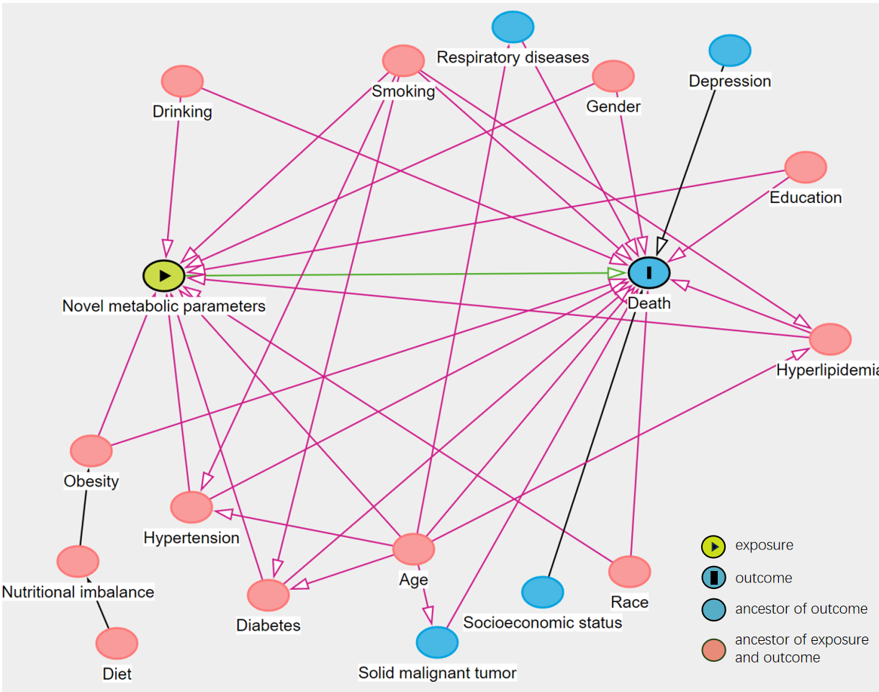
An interactive version of the DAG can be found here: https://www.dagitty.net/dags.html#.

Table S15 Results of unmeasured confounders in the weighted COX regression analysis.
 | All-cause mortality | Cardiovascular mortality
< 65 years
TyG
Q2 vs. Q1 | 1.83 (1.00, 3.19) | 1.46 (1.00, 4.70)
Q3 vs. Q1 | 2.15 (1.00, 3.58) | 2.79 (1.00, 7.32)
Q4 vs. Q1 | 2.64 (1.49, 4.21) | 3.50 (1.57, 9.27)
TyG-WHtR
Q2 vs. Q1 | 1.54 (1.00, 2.87) | 2.28 (1.00, 6.34)
Q3 vs. Q1 | 2.90 (1.51, 4.86) | 6.70 (2.19, 17.95)
Q4 vs. Q1 | 5.00 (2.75, 8.69) | 9.45 (2.92, 27.71)
METS-IR
Q2 vs. Q1 | 1.21 (1.00, 2.40) | 2.77 (1.00, 7.44)
Q3 vs. Q1 | 1.37 (1.00, 2.66) | 4.62 (1.62, 10.92)
Q4 vs. Q1 | 2.06 (1.49, 3.46) | 4.82 (3.19 15.78)
≥ 65 years
TyG
Q2 vs. Q1 | 1.77 (1.00, 2.50) | 2.84 (1.43, 4.85)
Q3 vs. Q1 | 1.39 (1.00, 2.08) | 1.29 (1.00, 2.50)
Q4 vs. Q1 | 1.32 (1.00, 2.04) | 2.00 (1.00, 3.41)
TyG-WHtR
Q2 vs. Q1 | 1.59 (1.00, 2.28) | 1.49 (1.00, 2.77)
Q3 vs. Q1 | 1.76 (1.00, 2.52) | 1.00 (1.00, 2.45)
Q4 vs. Q1 | 2.26 (1.00, 3.33) | 2.62 (1.00, 4.76)
METS-IR
Q2 vs. Q1 | 1.31 (1.00, 2.04) | 2.40 (1.00, 4.08)
Q3 vs. Q1 | 1.24 (1.00, 2.06) | 1.21 (1.00, 2.55)
Q4 vs. Q1 | 1.81 (1.00, 3.00) | 1.51 (1.00, 3.54)
The results of confounding factors were not measured in the weighted COX regression analysis model with adequate adjustment for covariates (Model 3).
Results are expressed as E-value and corresponding 95% confidence intervals.
TyG triglyceride glucose index; WHtR triglyceride glucose-waist to height ratio; METS-IR metabolic score for insulin resistance.

