TableS1.Distribution of variables with missing data
Variables | Number of Missing | Missing proportion
Education | 3 | 0.04%
LDL-C | 11 | 0.14%

TableS2.Collinearity Statistics.
Variables | VIF
AIP | 1.3
Age | 1.8
Gender | 2.5
Education | 1.2
BMI | 1.0
Diabetes | 1.7
Drinking | 1.4
Smoking | 2.0
eGFR | 1.7
Glucose | 1.7
TC | 3.7
UA | 1.6
LDL.C | 3.6
SBP | 2.6
DBP | 2.5

TableS3. Specific definitions of various diseases
Overweight/obesity | BMI ≥23 kg/m2
Abdominal obesity | Waist circumference≥80/90 cm in female/male
Prediabetes | Fasting blood glucose ≥ 100-124 mg/dL or HbA1c ≥ 5.7%-6.4% and  without self-reported diagnosis of diabetes, use of insulin, or oral  hypoglycemic agents
Diabetes | Fasting blood glucose ≥ 125 mg/dL or HbA1c ≥ 6.5% or self-reported diagnosis of diabetes, use of insulin, or oral hypoglycemic agents
Prediabetes | Fasting blood glucose ≥ 100-124 mg/dL or HbA1c ≥ 5.7%-6.4% and without self-reported diagnosis of diabetes, use of insulin, or oral  hypoglycemic agents
Hypertension | SBP ≥130 mm Hg or DBP ≥80 mm Hg or self-reported diagnosis of hypertension or use of antihypertensive medications
chronic kidney disease | Any of the two criteria is met：  - Self-reported history of chronic kidney disease  - eGFR < 60 ml/min/1.73m2
Hypertriglyceridemia | Triglycerides ≥ 135 mg/dL
metabolic syndrome | Meet any three or more of the five  ① Waist circumference ≥ 80/90 cm in female/male.  ②HDL cholesterol ≥50/40 mg/dL in female/male.  ③ Triglycerides ≥150 mg/dL.  ④ Elevated blood pressure (SBP ≥130 mm Hg or DBP ≥80 mm Hg and/or use of antihypertensive medications)  ⑤ Fasting blood glucose ≥100 mg/dL
Clinical CVD | Any of the two criteria is met：  ① Participants were asked "Have you been told by a doctor that you have been diagnosed with a heart disease, including angina, heart attack, congestive heart failure, and other heart problems?"  ②"Have you been told by a doctor that you have been diagnosed with a stroke?"
Subclinical CVD | Any of the two criteria is met：  - Very high-risk CKD in KDIGO classification: eGFR < 30 ml/min/1.73m2.  - Framingham risk score≥21.5/21.6 in female/male

TableS4.Framingham risk score for Men
Points | Age, years | HDL | TC | SBP Not Treated | SBP Treated | Smoker | Diabetic
-2 |  | 60+ |  | <120
-1 |  | 50–59
0 | 30–34 | 45–49 | <160 | 120–129 | <120 | No | No
1 |  | 35–44 | 160–199 | 130–139
2 | 35–39 | <35 | 200–239 | 140–159 | 120–129
3 |  |  | 240–279 | 160+ | 130–139 |  | Yes
4 |  |  | 280+ |  | 140–159 | Yes
5 | 40–44 |  |  |  | 160+
6 | 45–49
7
8 | 50–54
9
10 | 55–59
11 | 60–64
12 | 65–69
13
14 | 70–74
15 | 75+

TableS5.Framingham risk score for Women
Points | Age, years | HDL | TC | SBP Not Treated | SBP Treated | Smoker | Diabetic
-3 |  |  |  | <120
-2 |  | 60+
-1 |  | 50–59 |  |  | <120
0 | 30–34 | 45–49 | <160 | 120–129 |  | No | No
1 |  | 35–44 | 160–199 | 130–139
2 | 35–39 | <35 |  | 140–149 | 120–129
3 |  |  | 200–239 |  | 130–139 | Yes
4 | 40–44 |  | 240–279 | 150–159 |  |  | Yes
5 | 45–49 |  | 280+ | 160+ | 140–149
6 |  |  |  |  | 150–159
7 | 50–54 |  |  |  | 160+
8 | 55–59
9 | 60–64
10 | 65–69
11 | 70–74
12 | 75+

TableS6. Methods for evaluating CKM stages 0-3
CKM stages | Threshold for CKM conditions
Stages 0 | All criteria are met：  - BMI< 23 kg/m2  - Waist circumference <80/90 cm in female/male  - Fasting blood glucose < 100 mg/dL and HbA1c < 5.7% and without self-reported diagnosis of diabetes, use of insulin, or oral hypoglycemic agents.  - SBP <130 mm Hg and DBP <80 mm Hg without self-reported diagnosis of hypertension or use of antihypertensive medications.  - HDL-C <50/40 mg/dL in female/male  - TG < 150 mg/dL  - eGFR ≥ 60 ml/min/1.73m2 and without self-reported diagnosis of CKD  - No Subclinical CVD and clinical CVD
Stages 1 | Any of the three criteria is met:  - Overweight/obesity  - Abdominal obesity  - Prediabetes  All criteria are met：  （1）SBP <130 mmHg and DBP <80 mmHg without self-reported diagnosis of hypertension or use of antihypertensive medications.  （2）HDL-C <50/40 mg/dL in female/male  （3）TG < 150 mg/dL  （4）eGFR ≥ 60 ml/min/1.73m2 and without self-reported diagnosis of CKD  （5）No Subclinical CVD and clinical CVD
Stages 2 | Any of the five criteria is met:  - Hypertriglyceridemia  - Hypertension  - Diabetes  - metabolic syndrome  - eGFR：30-60 ml/min/1.73m2 and/or with self-reported diagnosis of CKD  All criteria are met：  - No Subclinical CVD and clinical CVD
Stages 3 | Any of the two criteria is met:  - eGFR<30 ml/min/1.73m2  - Subclinical CVD  Any of the eight criteria is met:  - Overweight/obesity  - Abdominal obesity  - Prediabetes  - Hypertriglyceridemia  - Hypertension  - diabetes  - metabolic syndrome  - eGFR：30-60 ml/min/1.73m2 and/or with self-reported diagnosis of CKD  The criterion is met：  - No clinical CVD

Thanks to reviewer 1 for their comments and interest, we further conducted an exploratory mediation analysis of CKD and diabetes (Tables S7 and S8).

TableS7 Mediation analysis of CKD in the association between AIP and CVD.
Independent variable | Mediator | Total effect |  | Indirect effect |  | Direct effect |  | Proportion mediated, %
Independent variable | Mediator | Coefficient (95% CI) | P value | Coefficient (95% CI) | P value | Coefficient (95% CI) | P value | Proportion mediated, %
AIP | CKD | -11.03 (-17.82, -4.64) | <0.001 | -0.04 (-0.33, 0.22) | 0.76 | -10.99 (-17.75, -4.57) | <0.001 | 0.3%
The model was adjusted for a number of variables, including gender, age, education, BMI, Diabetes, smoking, SBP, DBP, glucose, LDL-C and TC.

TableS8 Mediation analysis of Diabetes in the association between AIP and CVD.
Independent variable | Mediator | Total effect |  | Indirect effect |  | Direct effect |  | Proportion mediated, %
Independent variable | Mediator | Coefficient (95% CI) | P value | Coefficient (95% CI) | P value | Coefficient (95% CI) | P value | Proportion mediated, %
AIP | Diabetes | -11.97 (-18.776, -5.60) | <0.001 | -1.26 (-2.10, -0.50) | 0.002 | -10.63 (-17.37, -4.35) | <0.001 | 10.6%
The model was adjusted for a number of variables, including gender, age, education, BMI, smoking, SBP, DBP, LDL-C, TC and eGFR.

TableS9 Association between AIP and the occurrence of cardiovascular disease in the population with CKM syndrome stages 0–3
 | Events/Total | Model 1  HR (95%CI) | p-value | Model 2  HR (95%CI) | p-value | Model 3  HR (95%CI) | p-value
AIP (per1 units) | 1590/7708 | 1.36 (1.18, 1.57) | <0.001 | 1.39 (1.20, 1.60) | <0.001 | 1.29 (1.09, 1.53) | 0.003
Categories
Q1 | 447/2569 | 1.00 (ref) |  | 1.00 (ref) |  | 1.00 (ref)
Q2 | 558/2569 | 1.26 (1.11, 1.43) | <0.001 | 1.26 (1.11, 1.43) | <0.001 | 1.18 (1.04, 1.34) | 0.009
Q3 | 585/2570 | 1.34 (1.18, 1.51) | <0.001 | 1.35 (1.20, 1.53) | <0.001 | 1.22 (1.07, 1.38) | 0.003
P for trend |  | <0.001 |  | <0.001 |  | 0.004
Model 1：Unadjusted
Model 2：adjusted for gender, age.
Model 3：adjusted for model 2 covariates and education, BMI, Diabetes, smoking, SBP, DBP, glucose, LDL-C, TC and eGFR.

Table S10 Description of the distribution of the primary outcome
 | Cardiovascular Disease | Heart disease | Stroke
yes | 1590 (20.6%) | 1198 (15.5%) | 540 (7.0%)
no | 6118 (79.4%) | 6510 (84.5%) | 7168 (93.0%)

Table S11 Test of normality
Kolmogorov-Smirnov | Statistic | p-value
Age | 0.0651 | <0.0001
BMI | 0.2689 | <0.0001
Waist circumference | 0.705 | <0.0001
Creatinine | 0.0879 | <0.0001
eGFR | 0.0734 | <0.0001
Glucose | 0.2236 | <0.0001
HbA1c | 0.2055 | <0.0001
HDL-C | 0.0565 | <0.0001
LDL-C | 0.0377 | <0.0001
TC | 0.0428 | <0.0001
TG | 0.1767 | <0.0001
UA | 0.0533 | <0.0001
SBP | 0.0669 | <0.0001
DBP | 0.0409 | <0.0001

Table S12 The association of covariates with CVD was examined one by one
Covariates | N | term | beta | Se. | exp(beta) | 95%CI Low | 95%CI Upp | P-value
BMI | 7708 | BMI | 0.0033 | 0.0011 | 1.0033 | 1.0012 | 1.0054 | 0.0018
Education | 7705 | factor(Education)2 | 0.1849 | 0.0596 | 1.2031 | 1.0705 | 1.3521 | 0.0019
Diabetes | 7708 | factor(Diabetes)1 | 0.2496 | 0.0626 | 1.2835 | 1.1353 | 1.4510 | 0.0001
Smoking | 7708 | factor(Smoking)1 | 0.1728 | 0.0734 | 1.1886 | 1.0294 | 1.3724 | 0.0185
Drinking | 7703 | factor(Drinking)1 | -0.0411 | 0.0605 | 0.9597 | 0.8524 | 1.0806 | 0.4971
eGFR | 7708 | eGFR | -0.0048 | 0.0020 | 0.9952 | 0.9914 | 0.9991 | 0.0152
Glucose | 7708 | Glucose | 0.0018 | 0.0006 | 1.0018 | 1.0007 | 1.0030 | 0.0017
LDL-C | 7697 | LDL-C | 0.0019 | 0.0007 | 1.0019 | 1.0005 | 1.0033 | 0.0092
TC | 7708 | TC | 0.0016 | 0.0006 | 1.0016 | 1.0003 | 1.0029 | 0.0131
Uric acid | 7708 | Uric acid | 0.0256 | 0.0218 | 1.0260 | 0.9830 | 1.0708 | 0.2406
SBP | 7708 | SBP | 0.0082 | 0.0011 | 1.0083 | 1.0060 | 1.0105 | <0.0001
DBP | 7708 | DBP | 0.0144 | 0.0020 | 1.0145 | 1.0106 | 1.0185 | <0.0001

Table S13 The changes of the regression coefficients of AIP were observed by introducing the covariates in the basic model and removing the covariates in the full model
 |  | Basic model | Complete model
Covariates | +/- term | AIP | AIP | selection
 | Initial regression coefficient | 0.3456 | 0.2764
BMI | BMI | 0.3354 | 0.2879
Education | factor(Education) | 0.3358 | 0.2875
Diabetes | factor(Diabetes) | 0.2914 * | 0.2917 | Yes
Smoking | factor(Smoking) | 0.3443 | 0.2802
Drinking | factor(Drinking) | 0.3444 | 0.2817
eGFR | eGFR | 0.3326 | 0.2762
Glucose | Glucose | 0.3116 | 0.2754
LDL-C | LDL-C | 0.3732 | 0.1954 * | Yes
TC | TC | 0.3255 | 0.2330 * | Yes
Uric acid | Uric acid | 0.3420 | 0.2631
SBP | SBP | 0.2783 * | 0.2804 | Yes
DBP | DBP | 0.2764 * | 0.2866 | Yes
* Represents a change of more than 10% from the starting regression coefficient

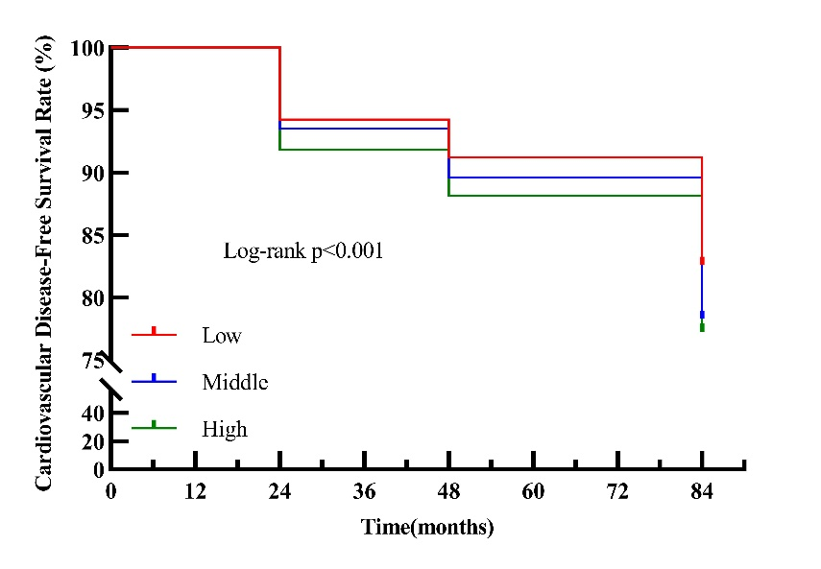
Figure S1: Kaplan-Meier survival curves showing the cardiovascular disease-free survival rates for the different AIP classification groups (low, medium, and high).

We thank reviewer 5 for their comments and interest. We applied RCS (Restricted Cubic Sample) analysis to explore the nonlinear relationship between AIP and CKM syndrome and its components. The results of the analysis showed significant nonlinear relationships (p < 0.001) between AIP and CKM syndrome, waist circumference, TG, fasting glucose, SBP and DBP. However, no significant nonlinear relationship was found with CKD（Figure S2-8）.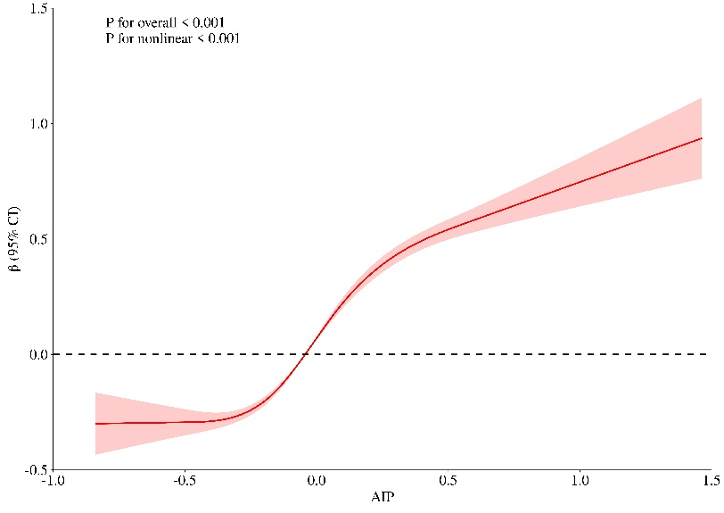
Figure S2: RCS analysis between AIP index and CKM syndrome stages 0-3.

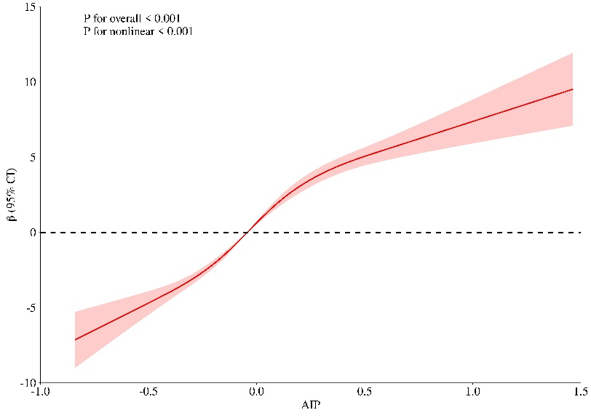
Figure S3: RCS analysis between AIP and waist circumference.

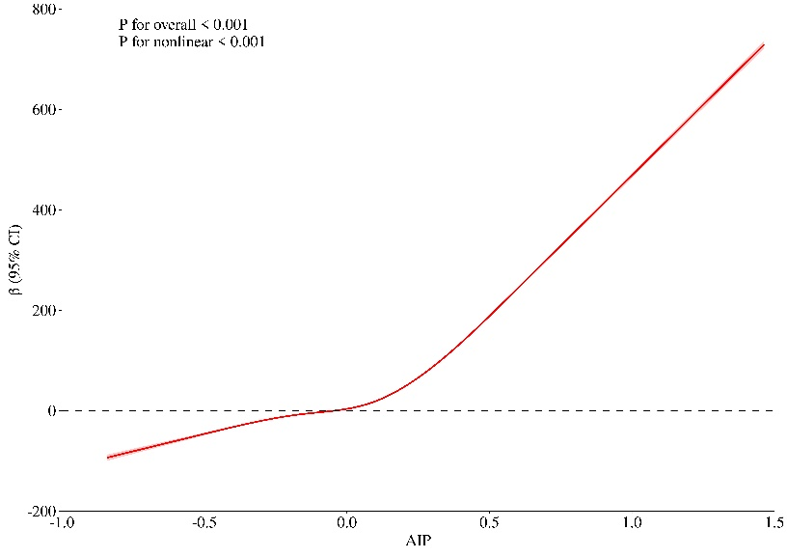
Figure S4: RCS analysis between AIP and triglycerides.

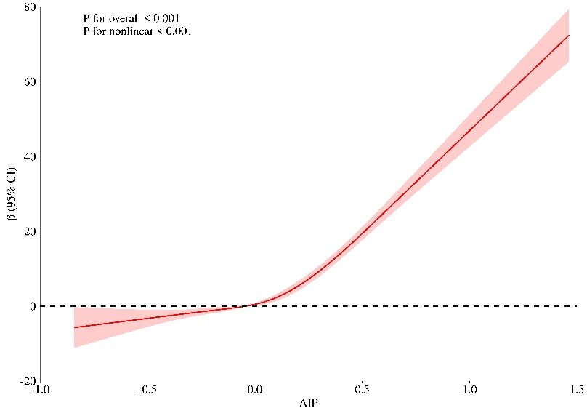
Figure S5: RCS analysis between AIP and fasting blood glucose.

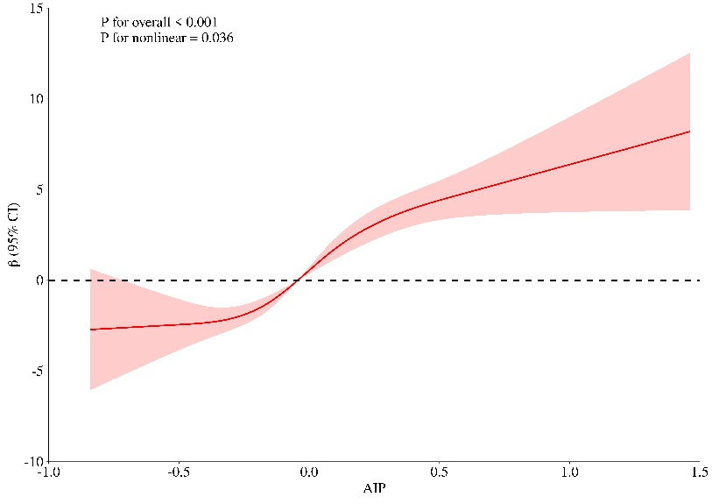
Figure S6: RCS analysis of AIP and SBP.

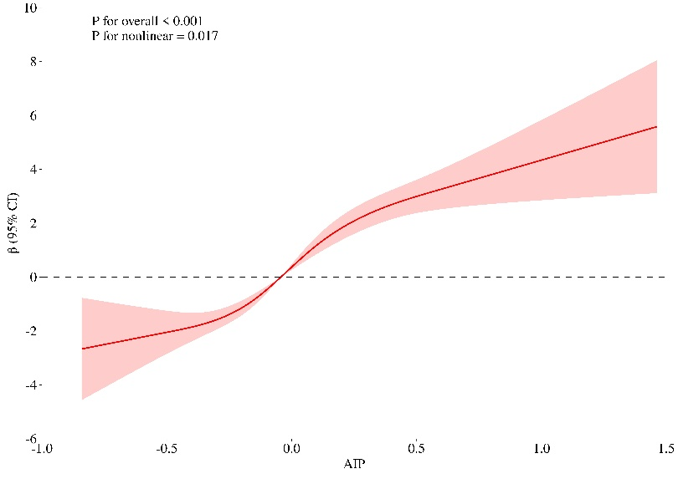
Figure S7: RCS analysis of AIP and DBP.

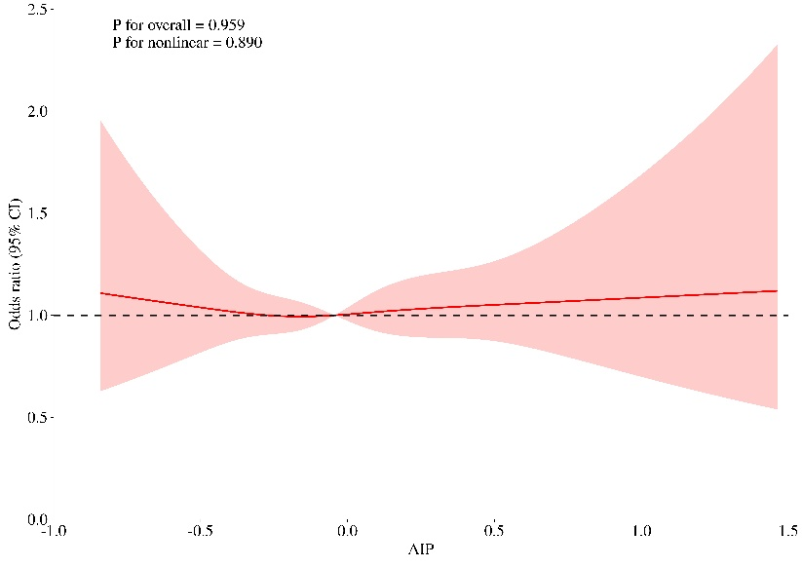
Figure S8: RCS analysis of AIP and CKD.

