Supplementary Materials

Tables
Supplementary table S1: Cox regression coefficient

Supplementary table S2 - Correlation between metformin use and Incidence of kidney disease progression and mortality, before PSM

Supplementary Table S3 – Sensitivity Analyses Using Inverse Probability Weighting:
Association Between Metformin Use and Primary Outcomes Before PSM

Supplementary table S4 - Correlation between metformin use and Incidence of kidney disease progression, all-cause mortality and safety outcomes after PSM

Supplementary Figure S1: Propensity Score Matching histograms

Supplementary Figure S2: Kaplan Meier curve for a) All-cause mortality B) Kidney-Disease progression C) Composite outcome including kidney disease progression and mortality D) All-cause Acidosis

Supplementary Figure S3: Assessment of eGFR changes over the study period

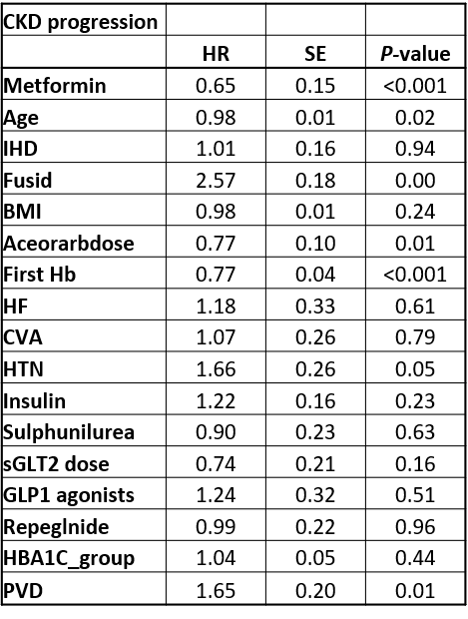
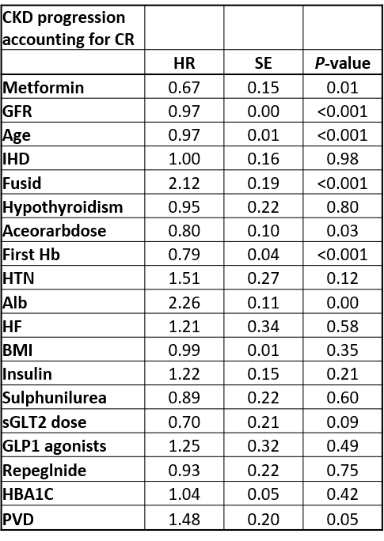
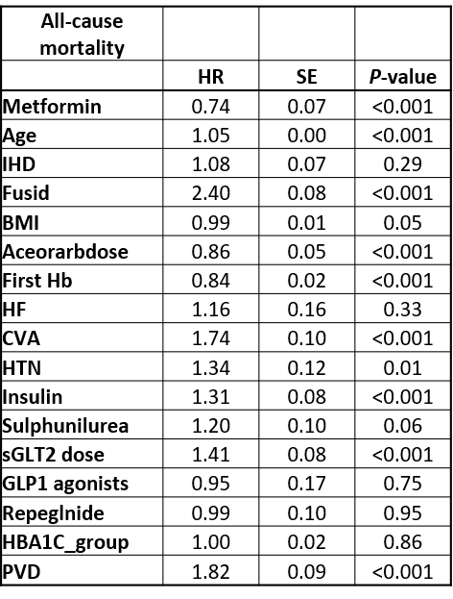
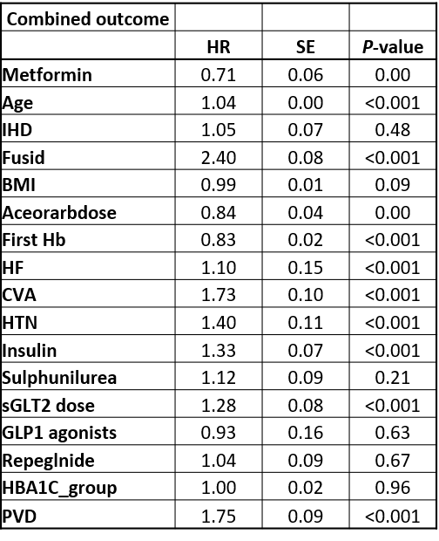
Supplementary Table S1: Cox regression coefficient

eGFR, estimated glomerular filtration rate; BMI, body mass index; IHD, ischemic heart disease; CVA, cerebrovascular disease; PVD, peripheral vascular disease; HTN, hypertension; SGLTi, sGLT2 inhibitor; HR, hazard ratio; CI, confidence interval

Supplementary Table S2 - Correlation between metformin use and Incidence of kidney disease progression and mortality, before PSM
Outcome | Univariate |  |  | Multivariate
Outcome | HR | 95% CI | p-value | HR | 95% CI | p-value
Composite kidney outcome | 0.76 | 0.62-0.94 | 0.009 | 0.79 | 0.64-0.97 | 0.025
Composite kidney outcome accounting for competing risk | 0.81 | 0.66-0.99 | 0.04 | 0.83 | 0.67-1.03 | 0.094
All-cause mortality | 0.67 | 0.62-0.73 | <0.001 | 0.73 | 0.67-0.8 | <0.001
Combined outcome of composite kidney and mortality | 0.66 | 0.61-0.72 | <0.001 | 0.73 | 0.67-0.8 | <0.001
# Sensitivity Analysis using IPW
Composite kidney outcome | 0.81 | 0.67-1 | 0.0512 | 0.8 | 0.65-0.98 | 0.031
Composite kidney outcome accounting for competing risk | 0.81 | 0.67-0.98 | 0.032 | 0.83 | 0.68-1.01 | 0.058
All-cause mortality | 0.76 | 0.68-0.84 | <0.001 | 0.74 | 0.67-0.82 | <0.001
Combined outcome of composite kidney and mortality | 0.78 | 0.71-0.86 | <0.001 | 0.76 | 0.69-0.83 | <0.001

Crude cohort n=45,545
The composite kidney outcome was defined as a 40% decline in eGFR from baseline value, or progression to ESRD, which was defined as an eGFR <15 mL/min/1.73m² or the need for RRT; Competing-risk model were used to account for the risk of death prior to occurrence of the composite kidney outcome HR, hazard ratio; CI, confidence interval
# Sensitivity analysis using Inverse Probability Weighting (IPW)

Supplementary Table S3 - Correlation between metformin use and Incidence of kidney disease progression, all-cause mortality and safety outcomes after PSM
Outcome | Univariate |  |  | Multivariate
Outcome | HR | 95% CI | p | HR | 95% CI | p
Composite kidney outcome | 0.674 | 0.51-0.9 | 0.007 | 0.650 | 0.48-0.87 | 0.004
Composite kidney outcome accounting for competing risk | 0.697 | 0.52-0.93 | 0.014 | 0.671 | 0.5-0.9 | 0.007
All-cause mortality | 0.763 | 0.67-0.87 | <0.001 | 0.736 | 0.64-0.84 | <0.001
Combined outcome of composite kidney and mortality | 0.739 | 0.65-0.84 | <0.001 | 0.712 | 0.63-0.81 | <0.001
Safety outcomes
Hospitalizations | 0.933 | 0.87-1 | 0.041 | 0.927 | 0.87-0.99 | 0.032
All-cause metabolic acidosis | 0.572 | 0.4-0.81 | 0.002 | 0.577 | 0.4-0.83 | 0.003
Ketoacidosis | 0.258 | 0.13-0.52 | <0.001 | 0.283 | 0.14-0.57 | <0.001
Non-ketotic metabolic acidosis | 0.853 | 0.56-1.3 | 0.853 | 0.834 | 0.54-1.28 | 0.404
AKI | 0.900 | 0.78-1.04 | 0.141 | 0.866 | 0.75-1 | 0.050
Severe AKI | 0.767 | 0.58-1.02 | 0.065 | 0.722 | 0.54-0.96 | 0.027
Anemia | 1.037 | 0.97-1.1 | 0.252 | 0.967 | 0.91-1.03 | 0.308
UTI events | 1.020 | 0.94-1.1 | 0.624 | 1.015 | 0.94-1.1 | 0.720
*Sensitivity Analyzes- BMI
Composite kidney outcome | 0.62 | 0.44-0.87 | 0.005 | 0.604 | 0.43-0.85 | 0.004
Composite kidney outcome accounting for competing risk | 0.59 | 0.49-0.69 | <0.001 | 0.58 | 0.49-0.69 | <0.001
All-cause mortality | 0.84 | 0.72-0.98 | 0.031 | 0.798 | 0.68-0.94 | 0.007
Combined outcome of composite kidney and mortality | 0.803 | 0.69-0.93 | 0.004 | 0.768 | 0.66-0.89 | <0.001
&Sensitivity Analyzes- no DM drugs
Composite kidney outcome | 0.684 | 0.43-1.1 | 0.116 | 0.626 | 0.38-1.02 | 0.062
Composite kidney outcome accounting for competing risk | 0.646 | 0.4-1.04 | 0.071 | 0.625 | 0.39-1 | 0.051
All-cause mortality | 0.704 | 0.57-0.86 | <0.001 | 0.694 | 0.56-0.86 | <0.001
Combined outcome of composite kidney and mortality | 0.687 | 0.57-0.84 | <0.001 | 0.665 | 0.54-0.81 | <0.001
#Sensitivity Analyzes- Complete dataset only
Composite kidney outcome | 0.74 | 0.55-1.0 | 0.049 | 0.71 | 0.52-0.96 | 0.028
Composite kidney outcome accounting for competing risk | 0.76 | 0.57-1.03 | 0.076 | 0.74 | 0.55-1 | 0.053
All-cause mortality | 0.77 | 0.67-0.88 | <0.001 | 0.74 | 0.64-0.85 | <0.001
Combined outcome of composite kidney and mortality | 0.75 | 0.66-0.85 | <0.001 | 0.72 | 0.63-0.82 | <0.001

The composite kidney outcome was defined as a 40% decline in eGFR from baseline value, or progression to ESRD, which was defined as an eGFR < 15 mL/min/1.73m² or the need for RRT; Competing-risk model were used to account for the risk of death prior to occurrence of the composite kidney HR, hazard ratio; CI, confidence interval; AKI, Acute Kidney Injury; UTI, Urinary Tract Infections
& Sensitivity analysis excluding patients from the matched cohort, who had a substantial difference in BMI (greater than 7 units), n= 9,742 patients.
* Sensitivity analysis including patients from the matched cohort, who were treated exclusively with either the combination of metformin and SGLT2i or SGLT2i monotherapy, without any other anti-glycemic treatment, n=8216
# Sensitivity analysis including patients from the matched cohort, with complete datasets, including all variables used in the propensity score calculation, n=12,249

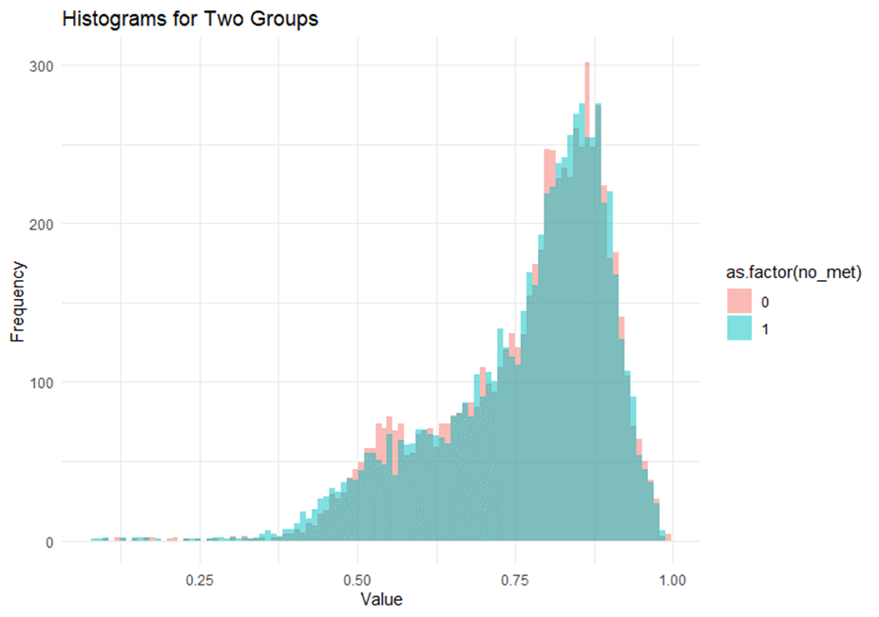
Supplementary Figure 1: Propensity Score Matching histograms

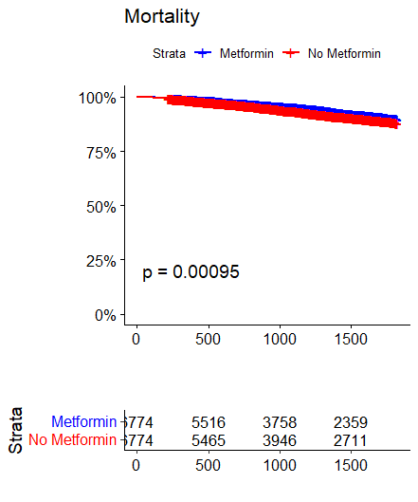
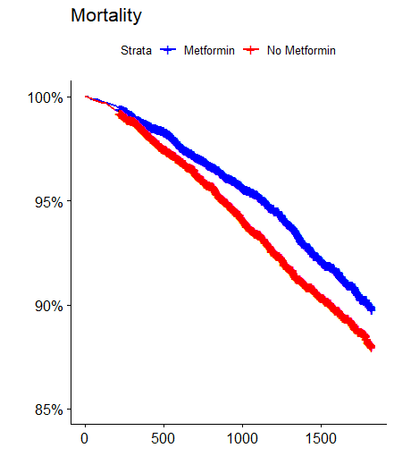
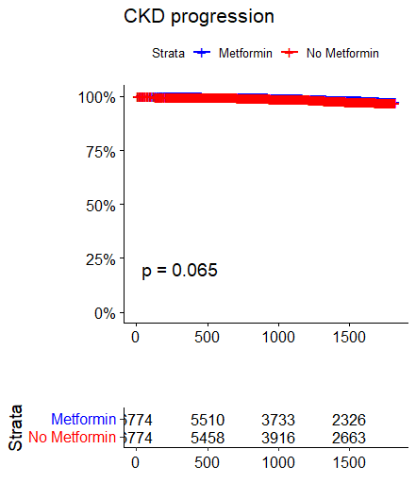
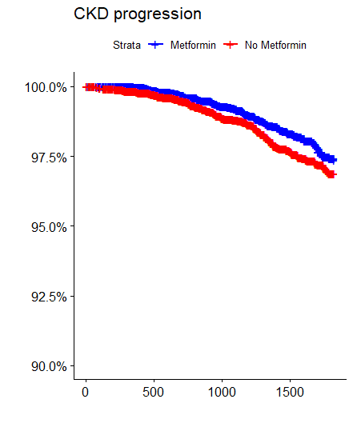
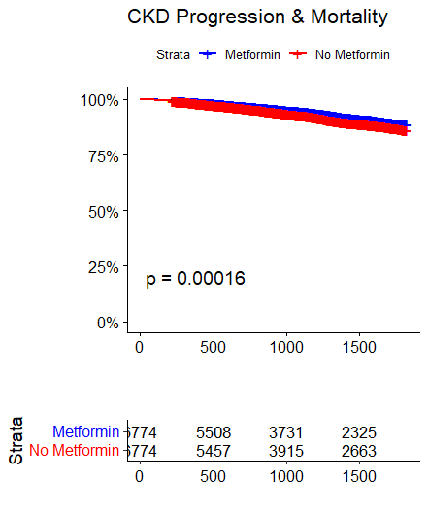
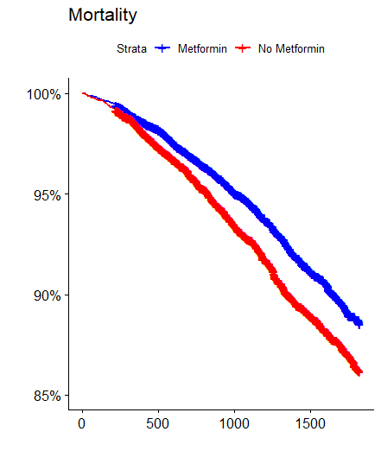
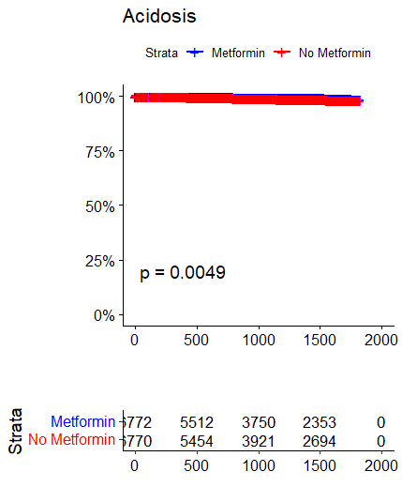
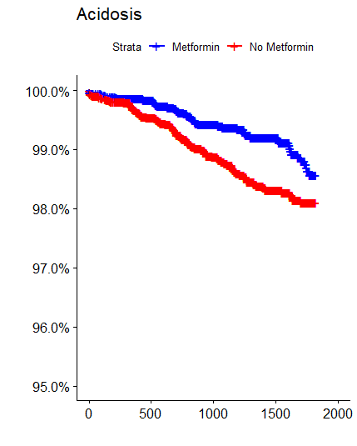
All- Cause Mortality
kidney Disease Progression
Composite Outcome
All- Cause Metabolic Acidosis
S2A
S2B
S2C
S2D
Supplementary Figure S2:
Kaplan Meier curve for a) All-cause mortality B) Kidney-Disease progression C) Composite outcome including kidney disease progression and mortality D) All-cause Acidosis
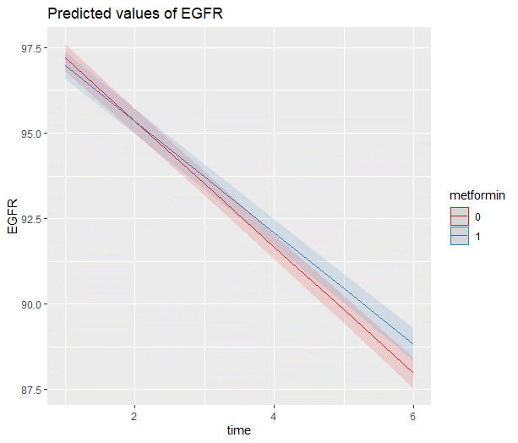
Supplementary Figure S3:
Assessment of eGFR changes over the study period was conducted using a multivariate mixed linear model with random slope and intercept to compare eGFR slopes between treatment groups. The analysis demonstrated that combination therapy with metformin and SGLT2i is associated with a significantly slower decline in eGFR, with a reduction of 0.21 (95% CI 0.13-0.29) ml/min/1.73 m² per year compared to SGLT2i monotherapy.
metformin
No metformin
eGFR
p<0.0001
Time

