Supplementary material

Fig.S1Dataset overview of the 8 tissues. 2
Fig.S2 Analysis of inter-tissue cell communication features. 4
Fig.S3 Analysis of cell communication among different cell types in various tissues. 5
Fig.S4 Analysis of cell communication among different cell types in various tissues. 6
Fig.S5 Inter-organ communication characteristics of ECs. 7
Fig.S6 Changes in intercellular communication in the heart and kidney under diabetes. 8
Fig.S7 Representative images of H&E pathological staining of heart/kidney 10

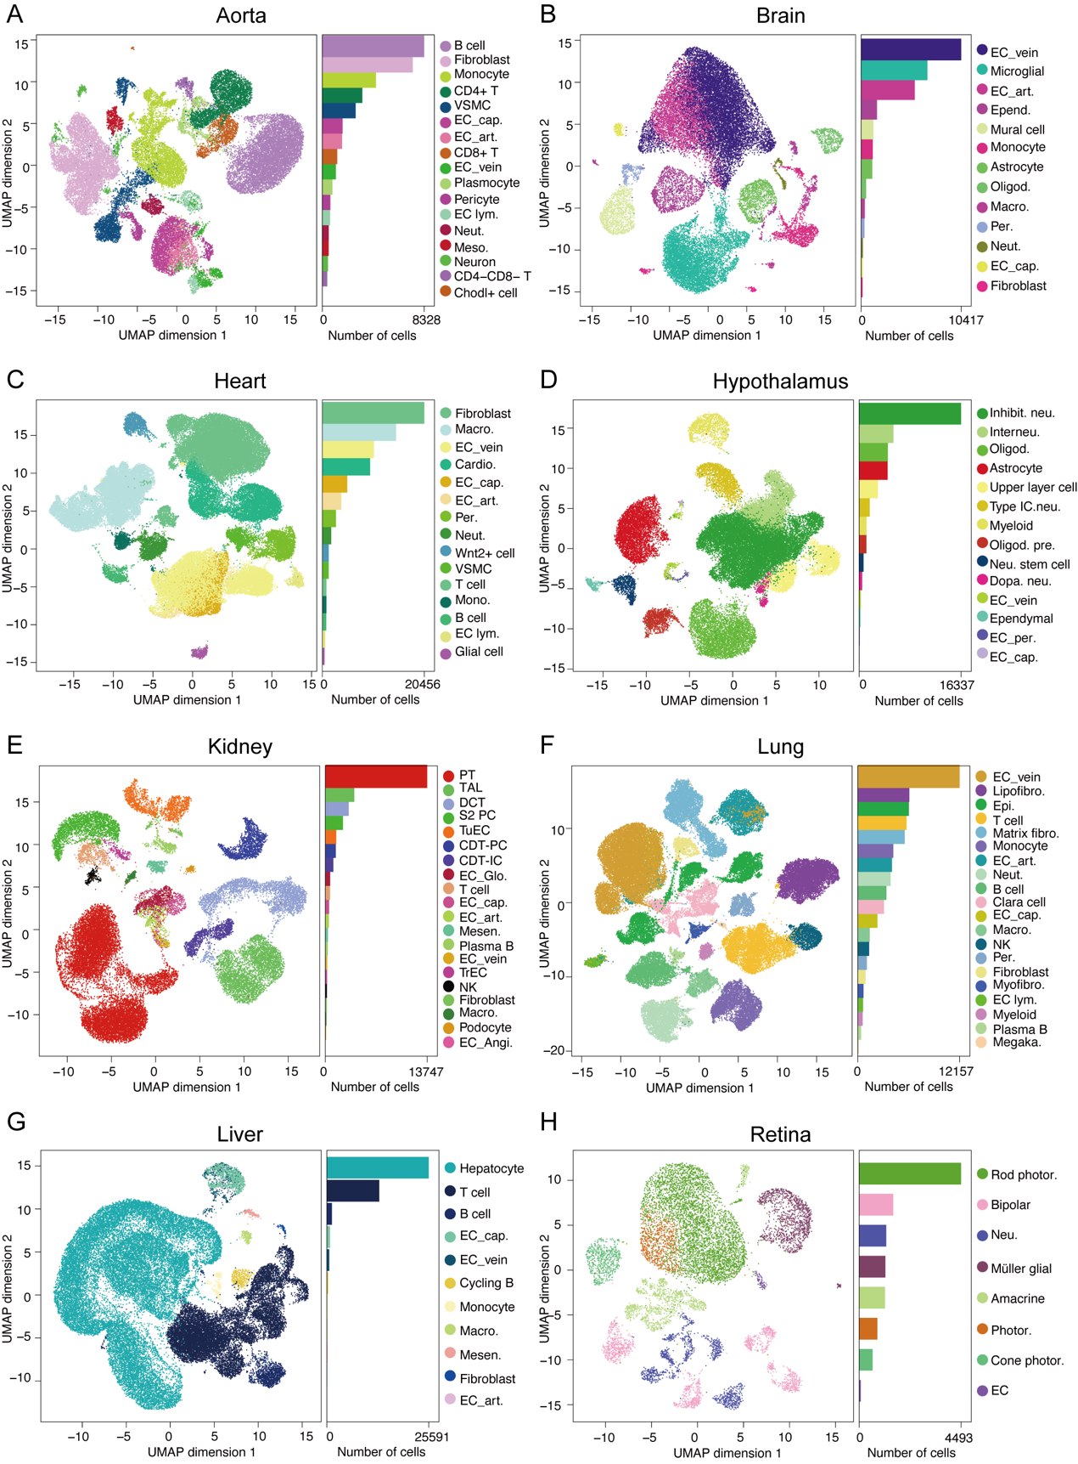
Fig.S1Dataset overview of the 8 tissues. A. Cell counts of different cell types in the aorta, UMAP dimensionality reduction clustering plot, and proportion of annotated cell numbers; B. Cell counts of different cell types in the brain, UMAP dimensionality reduction clustering plot, and proportion of annotated cell numbers; C. Cell counts of different cell types in the heart, UMAP dimensionality reduction clustering plot, and proportion of annotated cell numbers; D. Cell counts of different cell types in the hypothalamus, UMAP dimensionality reduction clustering plot, and proportion of annotated cell numbers; E. Cell counts of different cell types in the kidney, UMAP dimensionality reduction clustering plot, and proportion of annotated cell numbers; F. Cell counts of different cell types in the lung, UMAP dimensionality reduction clustering plot, and proportion of annotated cell numbers; G. Cell counts of different cell types in the liver, UMAP dimensionality reduction clustering plot, and proportion of annotated cell numbers; H. Cell counts of different cell types in the retina, UMAP dimensionality reduction clustering plot, and proportion of annotated cell numbers.

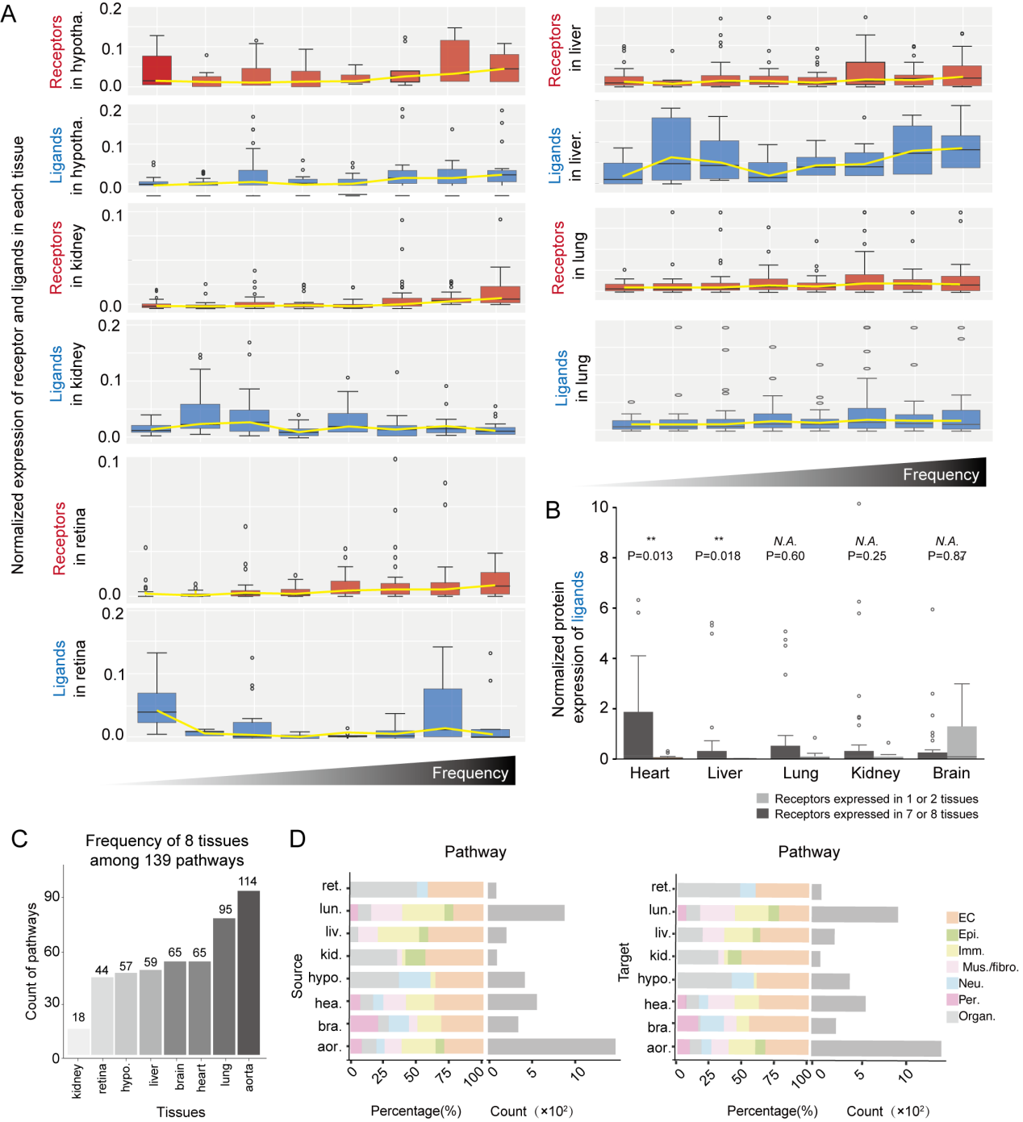
Fig.S2 Analysis of inter-tissue cell communication features. A. The shared frequencies of ligands across different tissues based on gene expression in the hypothalamus, kidney, retina, liver, and lung, displayed from left to right by frequencies 1 to 8; B. Box plots showing the expression levels of ligand proteins expressed in 1 or 2 tissues versus those expressed in 7 or 8 tissues across five organs, with a t-test performed to observe the differences in protein expression between the two groups; C. Frequency of all CCI pathways across the 8 tissues; D. Proportions (left) and counts (right) of each cell type participating in intercellular communication pathways as Source and Target across the 8 tissues.

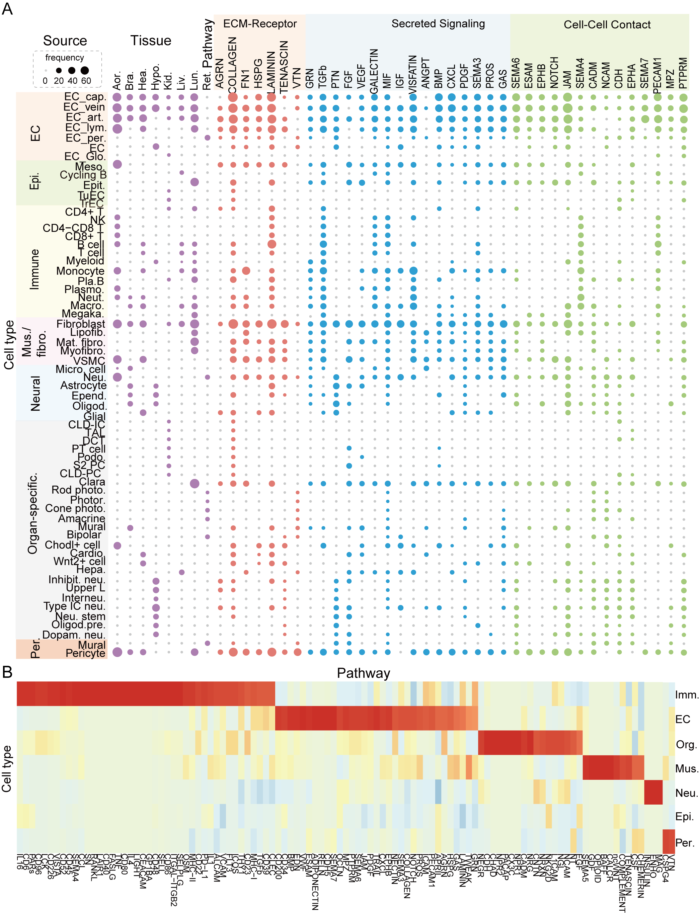

Fig.S3 Analysis of cell communication among different cell types in various tissues. A. Scatter plot visualizing the communication frequencies of all cell types as Sources across different pathways, with the size of the dots indicating the participation frequency; B. Heatmap displaying the specific intercellular communication pathways engaged by different major cell types, along with their communication strength.

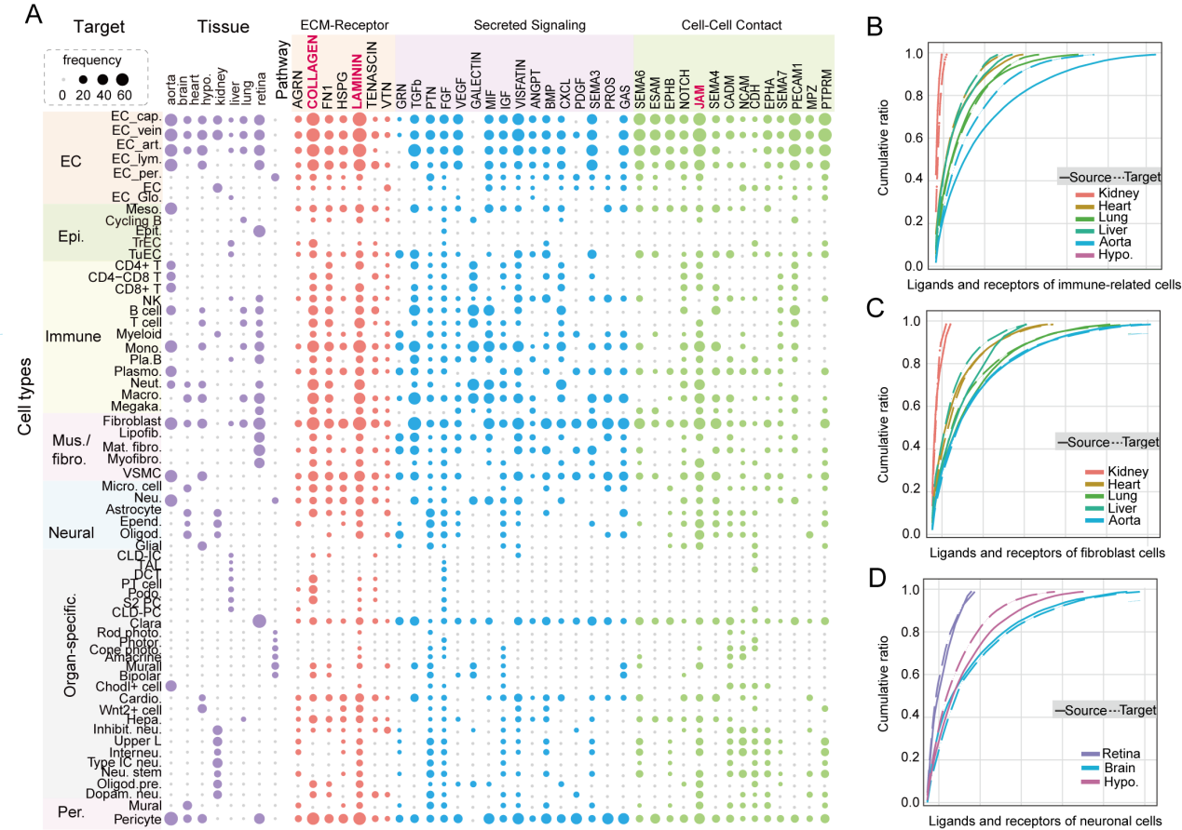
Fig.S4 Analysis of cell communication among different cell types in various tissues. A. Scatter plot visualizing the participation of all cell types as Targets in intercellular communication pathways, with the size of the dots indicating the participation frequency; B. Schematic representation of the cumulative percentage of receptors/ligands in various organs relative to the total number of immune-related cell ligands; C. Schematic representation of the cumulative percentage of receptors/ligands in various organs relative to the total number of fibroblast ligands; D. Schematic representation of the cumulative percentage of receptors/ligands in various organs relative to the total number of neuronal ligands.

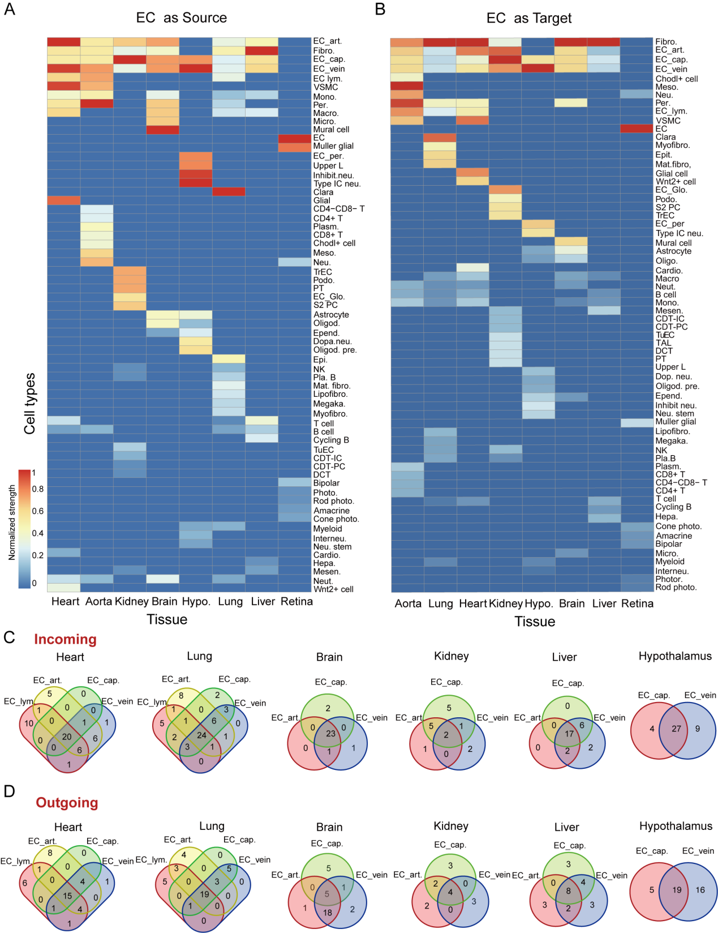
Fig.S5 Inter-organ communication characteristics of ECs. A. Heatmap showing the strength of CCI when ECs act as Sources in various tissues; B. Heatmap showing the strength of CCI when ECs act as Targets in various tissues; C. Venn diagram illustrating the overlap and specific pathways in the incoming signals of CCI for different EC subtypes in the aorta, lung, brain, kidney, liver, and hypothalamus; D. Venn diagram illustrating the overlap and specific pathways in the outgoing signals of CCI for different EC subtypes in the aorta, lung, brain, kidney, liver, and hypothalamus.

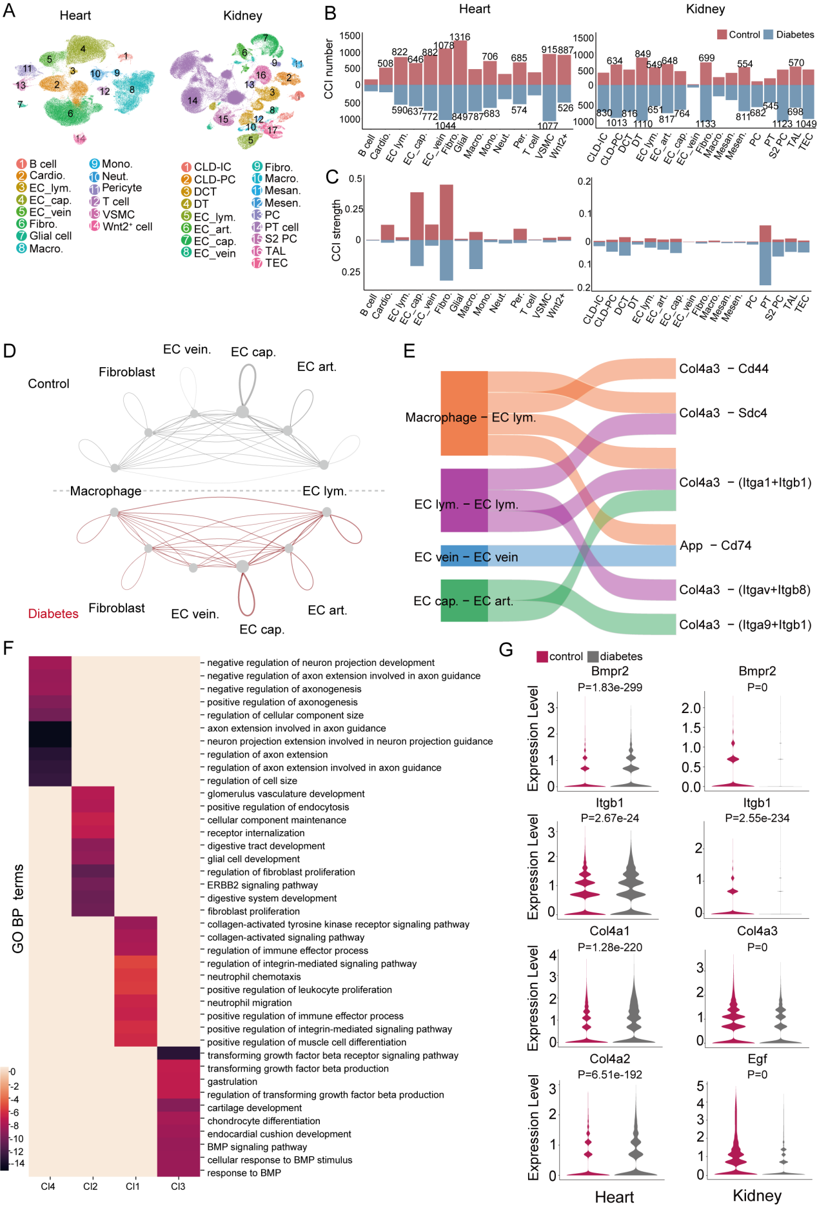
Fig.S6 Changes in intercellular communication in the heart and kidney under diabetes. A. UMAP dimensionality reduction clustering visualization showing cell annotation in the heart and kidney; B. The change in the number of intercellular communications among different cell types in the heart and kidney tissues under normal and diabetic conditions, with different colors distinguishing between disease and control statuses; C. The change in the intensity of intercellular communications among different cell types in the heart and kidney under normal and diabetic conditions, with different colors distinguishing between disease and control statuses; D. Pie chart showing the comparison of intercellular communication intensity among endothelial cells, macrophages, and fibroblasts in the kidneys under normal and diabetic conditions; E. Sankey diagram illustrating the specific types and receptor-ligand pairs involved in intercellular communication that showed significant changes in intensity under disease conditions as highlighted in panel D; F. Heatmap displaying the enriched pathways for the receptor-ligand pairs involved in intercellular communication common to both heart and kidney under diabetes; G. Violin plot showing the expression levels of representative genes in various modules in the heart and kidney under normal and DM conditions, as derived from integrated transcriptomic datasets.

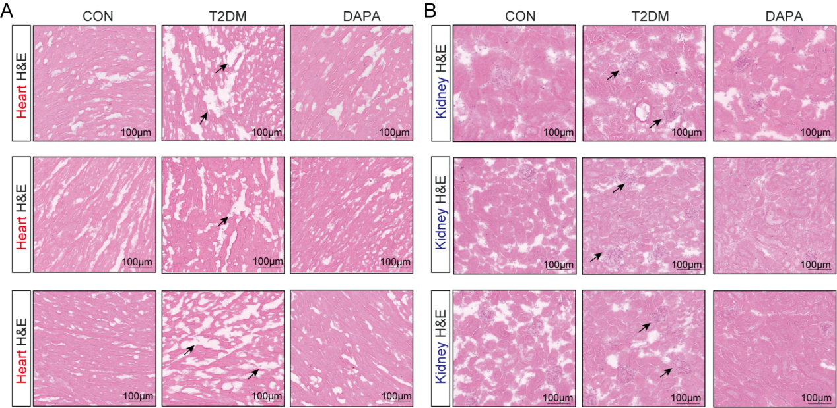
Fig.S7 Representative images of H&E pathological staining of heart/kidney. A.Representative images of H&E pathological staining of heart tissues in each group of mice (n = 3, 20×), arrows indicate the areas of myocardial fracture; B.Representative images of H&E pathological staining of kidney tissues in each group of mice (n = 3, 20×), arrows indicate the locations of enlarged glomerular units.

