Supplementary file

Supplementary Methods1
Revascularization Procedures
As part of standard institutional requirements, all surgeons had to have specialized in congenital or valve heart surgery for more than 3 years before undertaking any coronary artery bypass grafting (CABG) procedures. With respect to off-pump CABG, the surgeon had to perform at least 100 on-pump CABG procedures before being considered qualified to carry out the off-pump procedure. Once qualified, the choice of off-pump CABG or on-pump CABG for a particular patient was generally at the discretion of the individual surgeons.
Anesthesia was managed by inhalation of isoflurane with the addition of fentanyl or sufentanil, and propofol was administered continuously until the end of the procedure if necessary. Surgical revascularization was performed using standard bypass techniques. For on-pump CABG, a standard cardiopulmonary bypass was established, and moderate systemic hypothermia (28°C to 32°C) and perfusion with antegrade intermittent cold crystalloid cardioplegia were used. Heparin was given to achieve activated clotting times of 480 seconds or above before institution of cardiopulmonary bypass. For off-pump CABG, stabilization devices were used to provide a motionless anastomosis site, and heparin was administered before the start of the first distal anastomosis to achieve an activated clotting time of 300 to 350 seconds. On-pump CABG involved aortic cross-clamping and cardioplegic arrest, while off-pump CABG was performed with a partial occlusion clamp. Whenever possible, complete revascularization was attempted, and the internal thoracic artery was used preferentially for revascularization of the left anterior descending artery. The remaining vessels were to be bypassed either using another arterial conduit or the saphenous vein in the configuration decided by the surgeon. During reperfusion, the bypass grafting was completed with proximal anastomoses to the ascending aorta. The decision to switch to cardiopulmonary bypass during the procedure was based on significant hemodynamic instability or ventricular arrhythmia. After separation from cardiopulmonary bypass or on completion of all anastomoses, protamine was given to reverse the effects of heparin. All patients received tranexamic acid intraoperatively if not contraindicated. Postoperatively, starting within the first 24 hours, aspirin therapy (100 mg/day) is recommended and should be continued indefinitely. Routinely, re- exploration was performed if the bleeding exceeded 200 mL/hour in the first 3 hours or 300 mL/hour at any time, or in the presence of typical hemodynamic or echocardiographic features of cardiac tamponade.

Supplementary Methods2
Outcome Definitions
All-cause mortality was defined as death from any cause.

Myocardial infarction occurred when there were clinical signs and symptoms of ischemia that were distinct from the presenting ischemic event and met at least one of the following criteria:
1) Spontaneous (before or without revascularization, >48 hours after CABG)
A. New, significant Q waves in at least two contiguous leads of an electrocardiogram that were not present with the presenting ischemic event;
B. Patients whose most recent cardiac markers measured before reinfarction, which were normal, required an increase in CK-MB or troponin that was above the 99th percentile upper limit of normal and at least ≥20% above the most recent value.
- Within 48 hours after CABG
- CABG-related myocardial infarction was defined by elevation of cardiac biomarker values >10 times the 99th percentile upper reference limit in patients with normal baseline cardiac troponin values (≤99th percentile upper reference limit) plus either new pathological Q waves; new left bundle-branch block, angiographically documented new graft, or native coronary artery occlusion; or imaging evidence of new loss of viable myocardium or new regional wall motion abnormality.

Cerebrovascular accident was confirmed by a neurologist on the basis of imaging studies and symptoms and was defined as follows:
- A focal neurologic deficit of central origin lasting >72 hours, or
2) A focal neurologic deficit of central origin lasting >24 hours, with imaging evidence of cerebral infarction or intracerebral hemorrhage, or
3) A non-focal encephalopathy lasting >24 hours with imaging evidence of cerebral infarction or hemorrhage adequate to account for the clinical state, or
4) Transient ischemic attack, defined as the presence of acute focal neurological deficit thought to be of vascular origin with signs and symptoms lasting less than 24 hours.
Retinal arterial ischemia or hemorrhage was included in the definition of cerebrovascular accident.

Reoperation was defined as the excessive chest tube drainage and/or pericardial tamponade requiring reoperation.

Repeat revascularization was defined as any ischemia-driven repeat percutaneous coronary intervention or bypass surgery.

Figure S1 Study Flow Chart
CABG, coronary artery bypass grafting; eGFR, estimated glomerular filtration rate; SHR, stress hyperglycemia ratio.
Figure S2 Restricted cubic spline analysis of the association between SHR and perioperative outcomes in patients undergoing on-pump and off-pump CABG
Associations of SHR with perioperative MACCE in patients undergoing on-pump (A) and off-pump CABG (B). The solid red line represents the adjusted OR, and the yellow shaded area indicates the 95% CI. The horizontal dashed line represents the reference line (OR=1). P for overall indicates the significance of the whole curve, and P for nonlinear represents the significance of the nonlinear component. CABG, coronary artery bypass grafting; CI, confidence interval; MACCE, major adverse cardiovascular and cerebrovascular events; OR, odds ratio; SHR, stress hyperglycemia ratio.
Figure S3 Kaplan-Meier analyses for long-term MACCE in patients undergoing on-pump and off-pump CABG
Kaplan-Meier curves depict the cumulative incidence of events stratified by tertiles of stress hyperglycemia ratio: T1 (blue), T2 (yellow), and T3 (red). The results are shown for (A) on-pump CABG, (B) off-pump CABG. CABG, coronary artery bypass grafting; MACCE, major adverse cardiovascular and cerebrovascular events.
Figure S4 Restricted cubic spline analysis of the association between SHR and perioperative MACCE including previously excluded patients
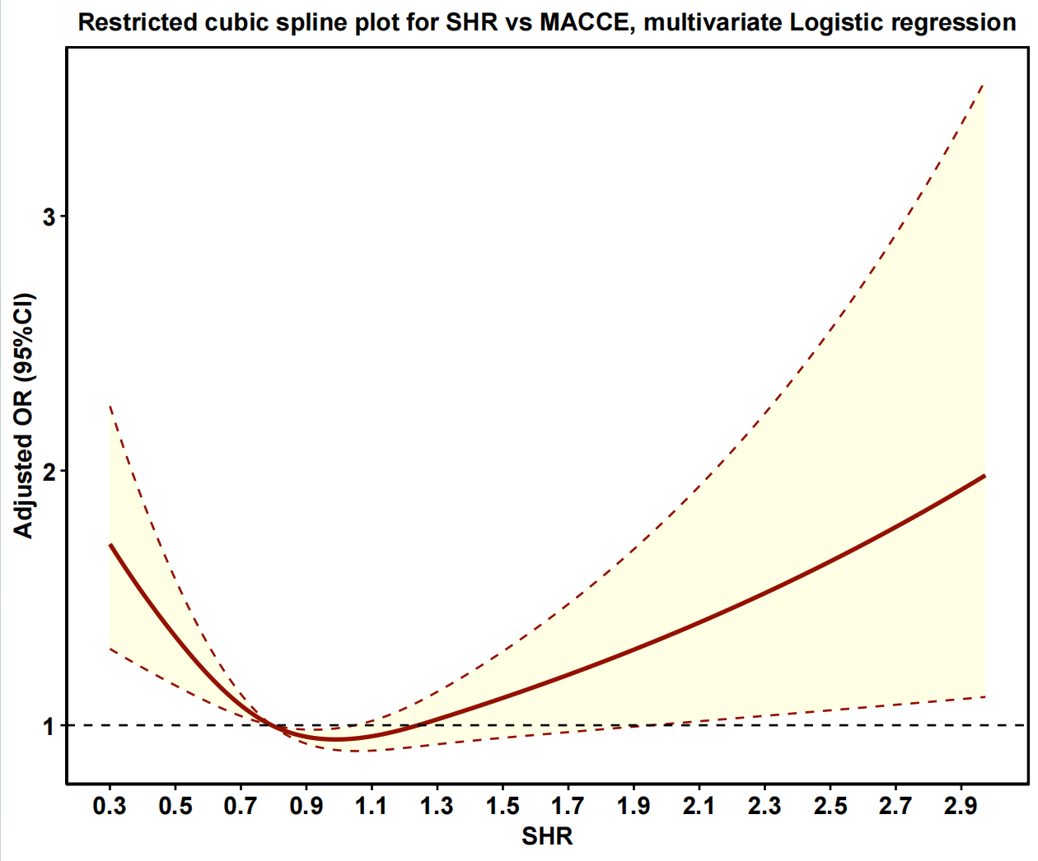
Associations of SHR with perioperative MACCE including previously excluded patients. The solid red line represents the adjusted OR, and the yellow shaded area indicates the 95% CI. The horizontal dashed line represents the reference line (OR=1). CI, confidence interval; MACCE, major adverse cardiovascular and cerebrovascular events; OR, odds ratio; SHR, stress hyperglycemia ratio.
Figure S5 Kaplan-Meier analyses for long-term MACCE including previously excluded patients
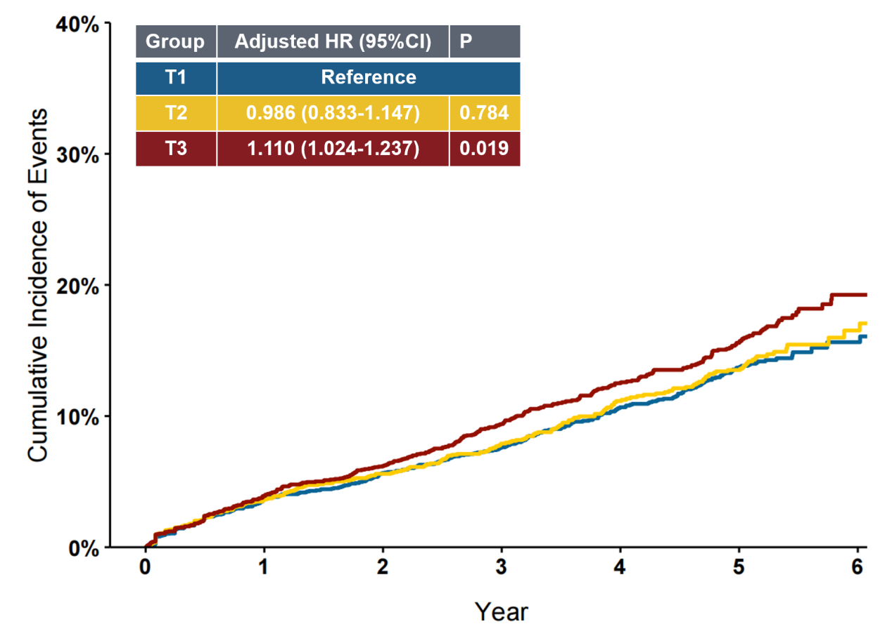
Kaplan-Meier curves depict the cumulative incidence of events stratified by tertiles of stress hyperglycemia ratio: T1 (blue), T2 (yellow), and T3 (red). Adjusted HRs with 95% CIs and corresponding P values for T2 and T3 (with T1 as the reference) are provided in the table. CI, confidence interval; HR, hazard ratio; MACCE, major adverse cardiovascular and cerebrovascular events.
Table S1 Improvement in discrimination and risk reclassification for perioperative outcomes after addition of SHR
Group | NRI (95% CI) | P | IDI (95% CI) | P
All patients
EuroSCORE II | Reference |  | Reference
EuroSCORE II + SHR | 0.036 (0.013-0.059) | 0.003 | 0.015 (0.010-0.021) | < 0.001
NGR
EuroSCORE II | Reference |  | Reference
EuroSCORE II + SHR | 0.063 (0.021-0.106) | 0.003 | 0.023 (0.011-0.035) | < 0.001
Pre-DM
EuroSCORE II | Reference |  | Reference
EuroSCORE II + SHR | 0.057 (0.019-0.095) | 0.003 | 0.020 (0.010-0.029) | < 0.001
DM
EuroSCORE II | Reference |  | Reference
EuroSCORE II + SHR | 0.026 (0.003-0.049) | 0.027 | 0.004 (0.002 - 0.005) | < 0.001
SHR, stress hyperglycemia ratio; NRI, net reclassification improvement; IDI, integrated discrimination improvement; CI, confidence interval; NGR, normal glucose regulation; Pre-DM, prediabetes mellitus; DM, diabetes mellitus; EuroSCORE II, European System for Cardiac Operative Risk Evaluation II.

