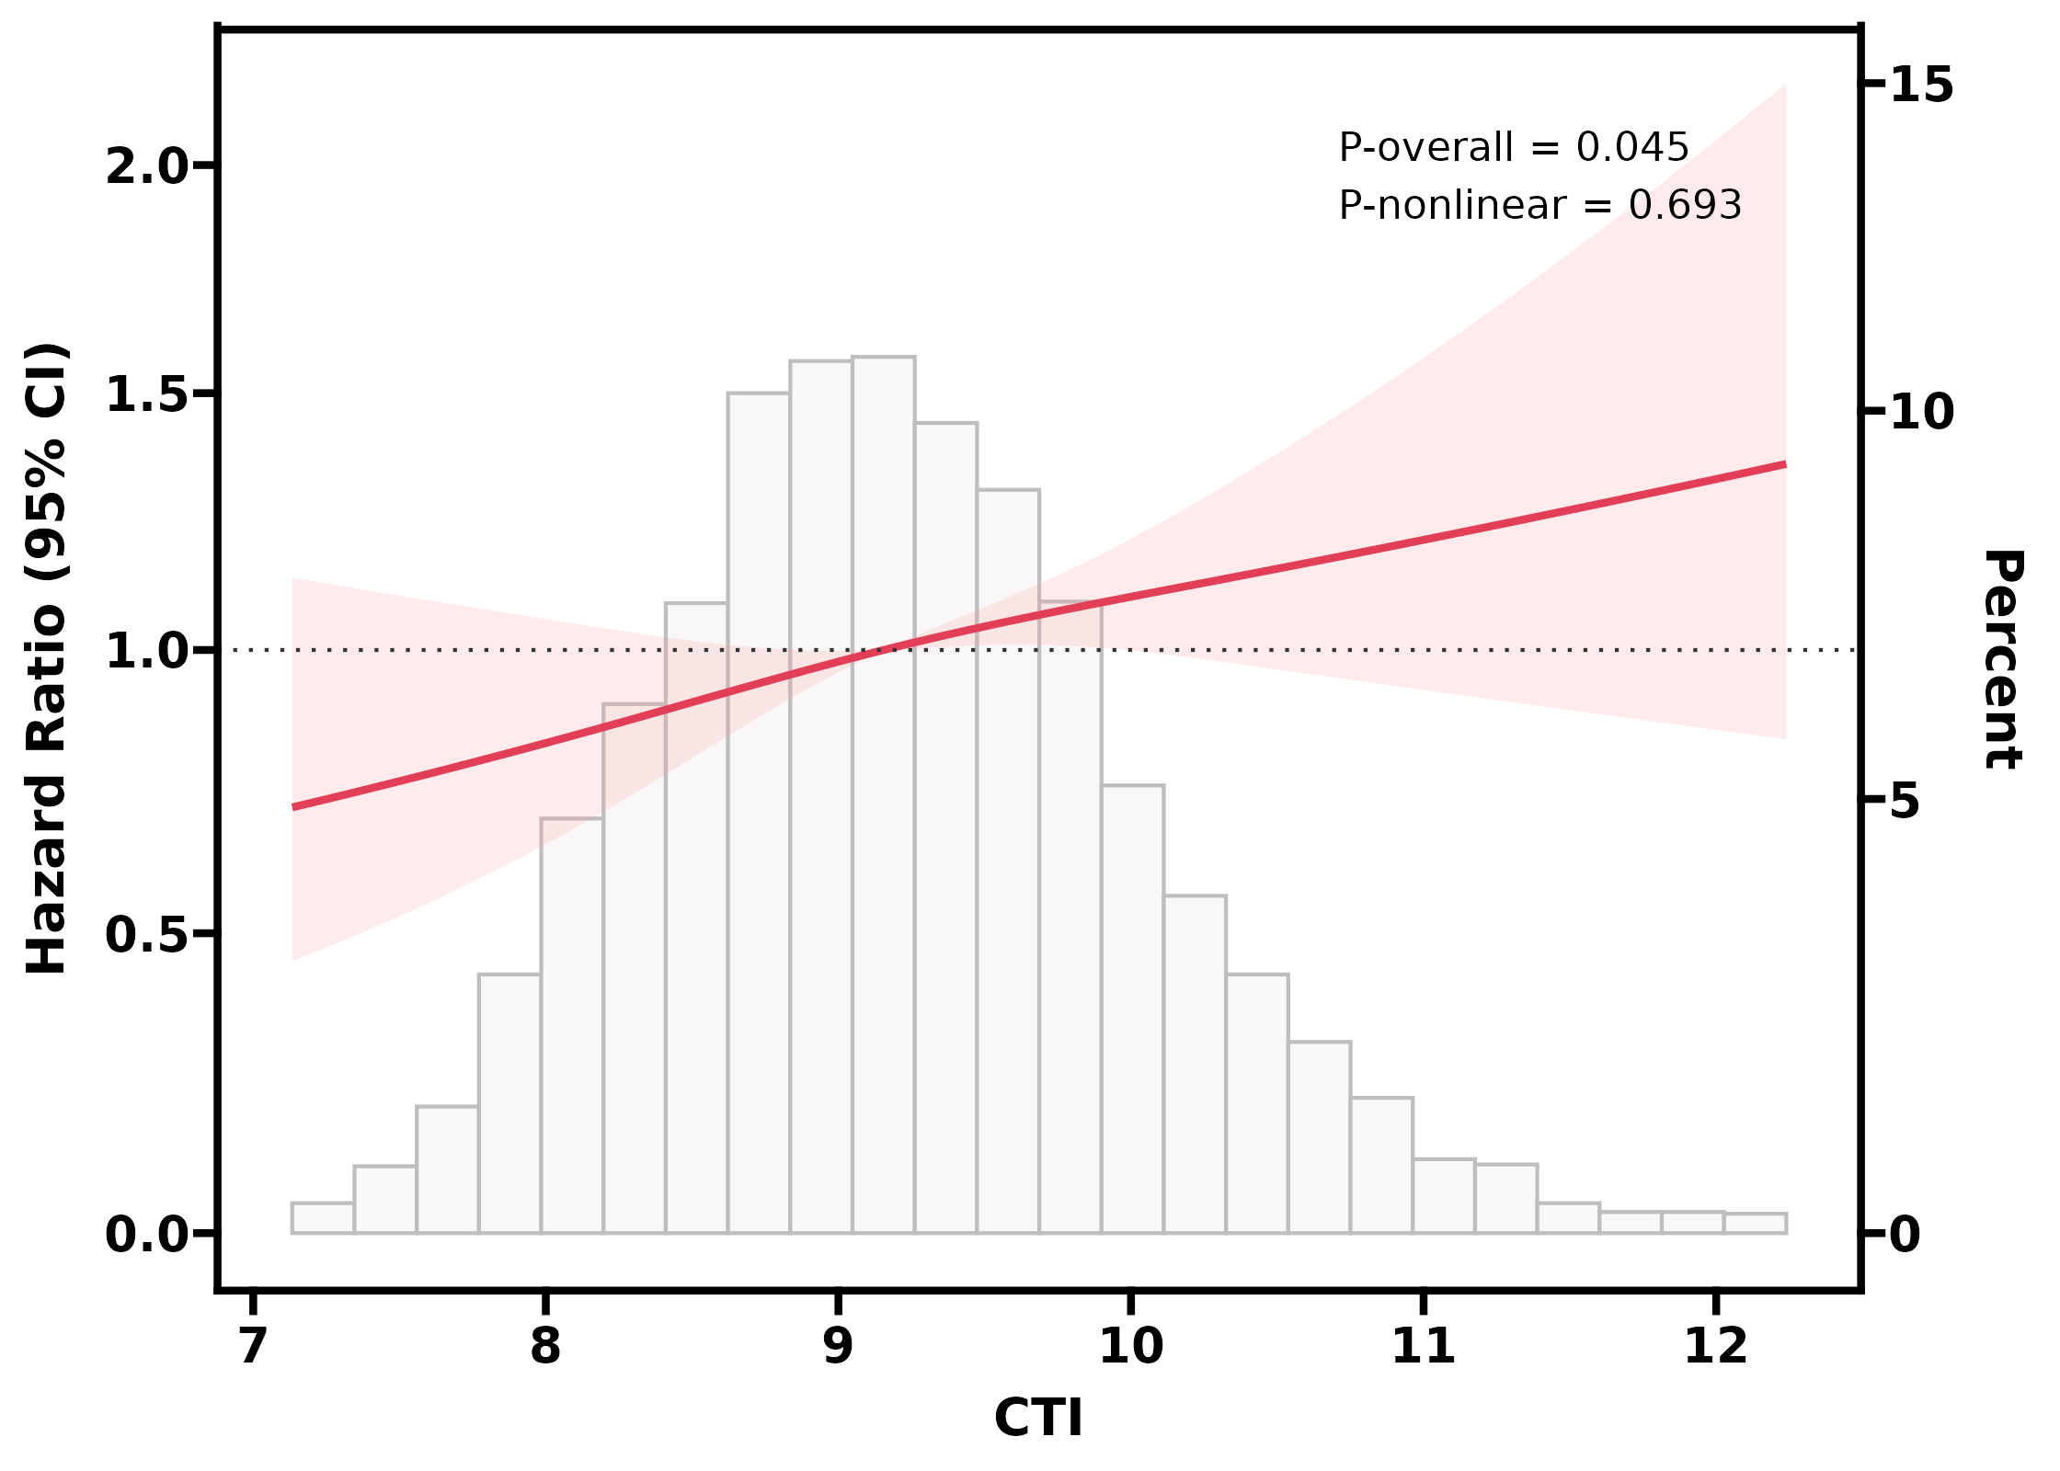
Fig. S3: Association of the CTI index and the risk of stroke in individuals with dyslipidemia. Adjusted for gender, age, residence, marital status, education level, smoking status, drinking status, hypertension, heart disease, hypertension medications, SBP, DBP, and BMI.

