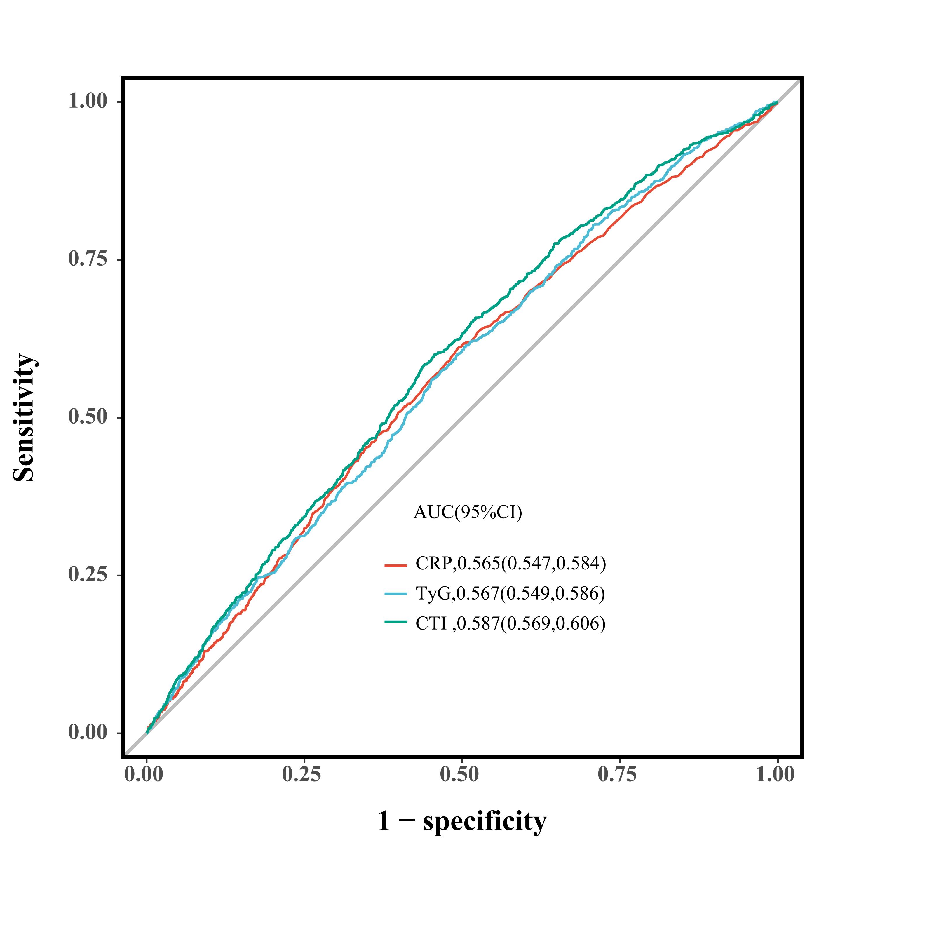
Fig. S1: Receiver operating characteristic curves for CRP, TyG index, and CTI predicting stroke incidence.

