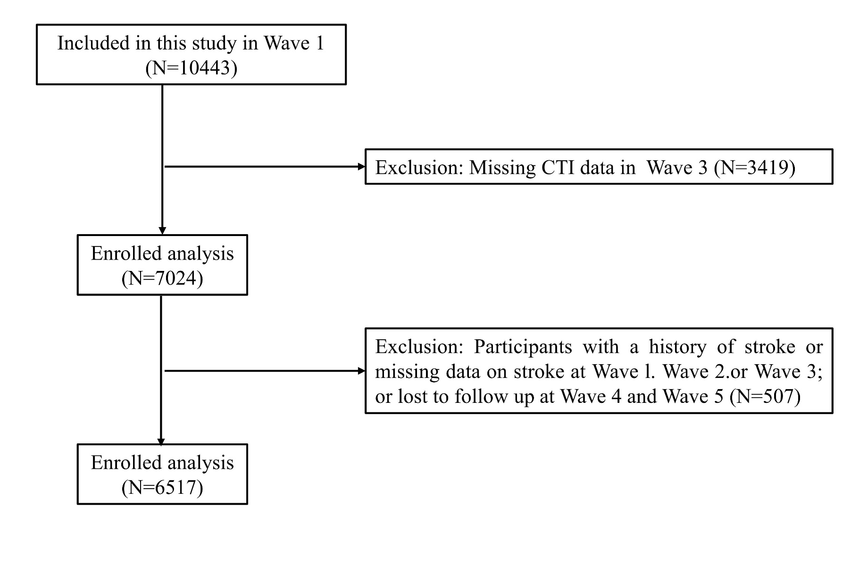
Fig S2: Flow chart of the participants with both W1 and W3 CTI data.

