Integrative metabolomics and genomics reveal molecular signatures for type 2 diabetes and its cardiovascular complications
Supplementary Material 2
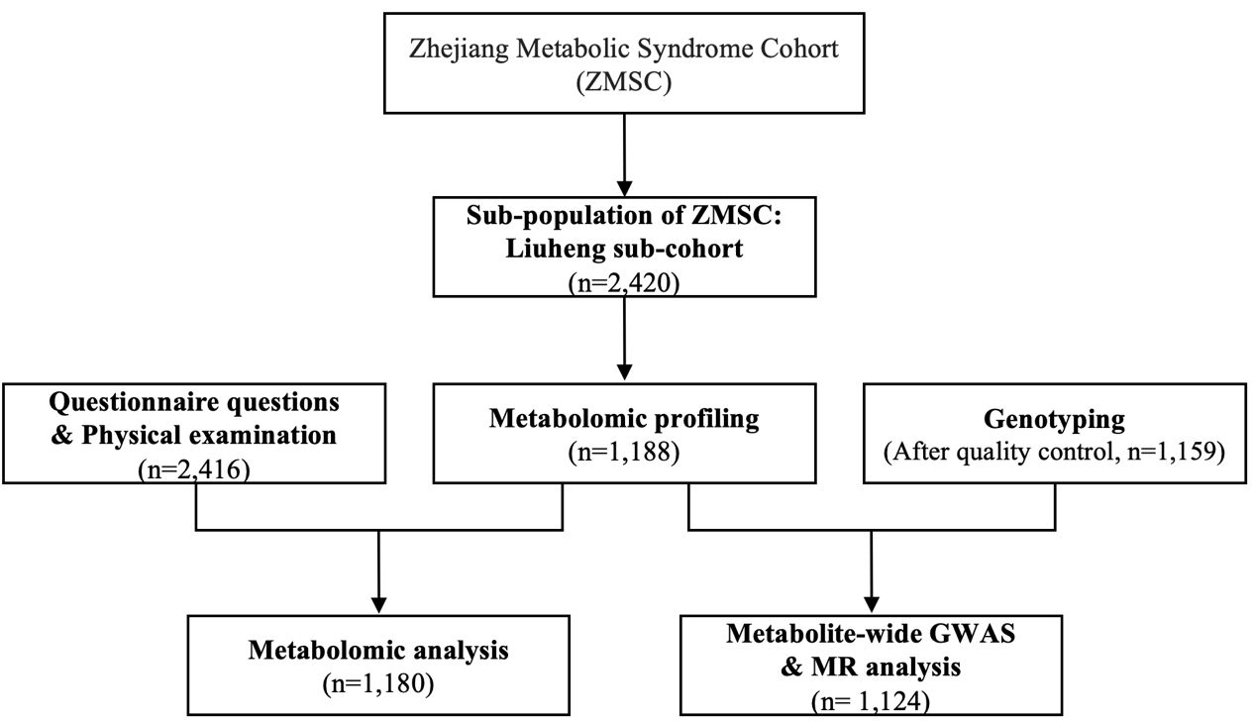
Figure S1. Flowchart of the participants selection in Zhejiang Metabolic Syndrome Cohort.
MR, Mendelian randomization; GWAS, genome wide association study.

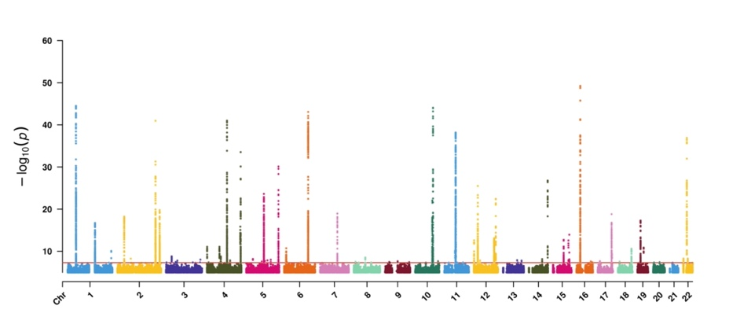
Figure S2. The Manhattan plot of GWAS for metabolites in ZMSC. The Manhattan plot displays the genetic associations (P ≤ 1.00×10⁻⁵) by pooling all the 1,912 metabolites in the ZMSC. The X-axis represents the chromosomal position, and the Y-axis represents -log10 (P). The red line shows the P value threshold at 5.00×10⁻⁸.

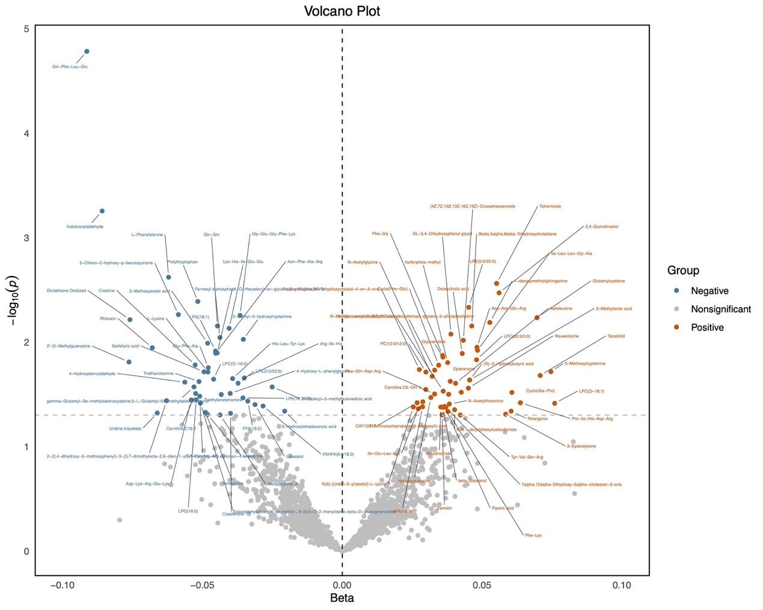
Figure S3. Volcano plot displaying results of serum metabolome-wide
Mendelian randomization (MR) in ZMSC. The metabolome-wide MR analysis
was performed based on GWAS summary statistics of 1,912 serum metabolites in ZMSC and T2D meta-GWAS summary statistics to explore the associations between serum metabolites and T2D. Metabolites with nominal significance (P_{IVW} < 0.05) are labeled. ZMSC, Zhejiang Metabolic Syndrome Cohort; T2D, type 2 diabetes; IVW, inverse-variance weighted.

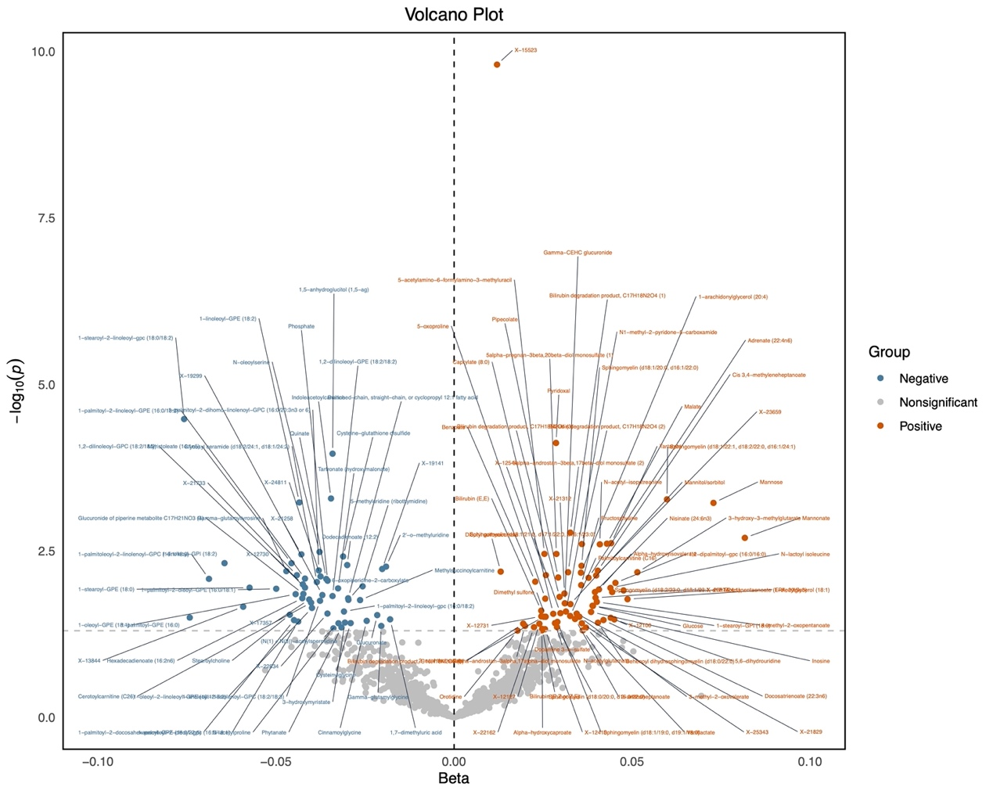
Figure S4. Volcano plot showing results from plasma metabolome-wide Mendelian randomization (MR) in CLSA. The metabolome-wide MR analysis was performed based on GWAS summary statistics of 1,391 serum metabolites in CLSA and T2D meta-GWAS summary statistics to explore the associations between serum metabolites and T2D. Metabolites with nominal significance (P_{IVW} < 0.05) are labeled. CLSA, the Canadian Longitudinal Study on Aging; T2D, type 2 diabetes; IVW, inverse-variance weighted.

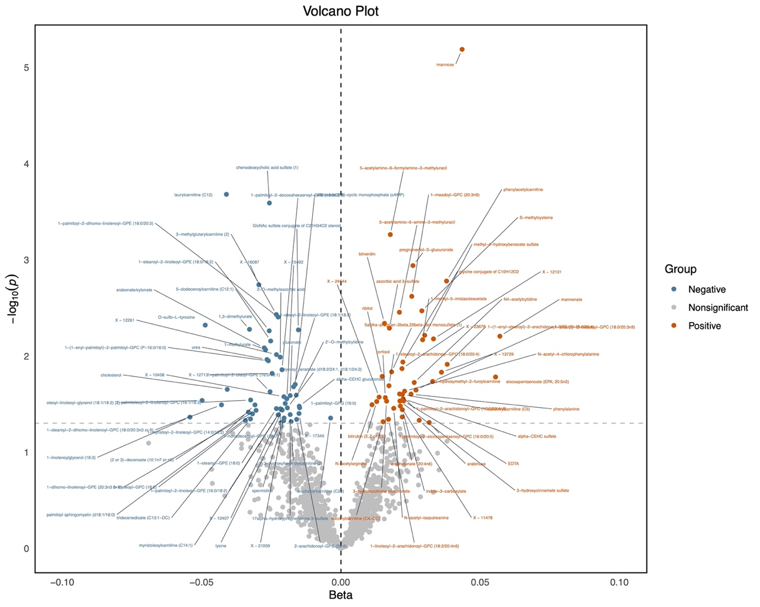
Figure S5. Volcano plot showing results from plasma metabolome-wide Mendelian randomization (MR) in METSIM. The metabolome-wide MR analysis was performed based on GWAS summary statistics of 1,091 serum metabolites in METSIM and T2D meta-GWAS summary statistics to explore the associations between serum metabolites and T2D. Metabolites with nominal significance (P_{IVW} < 0.05) are labeled. METSIM, the Metabolic Syndrome in Men (METSIM) study; T2D, type 2 diabetes; IVW, inverse-variance weighted.
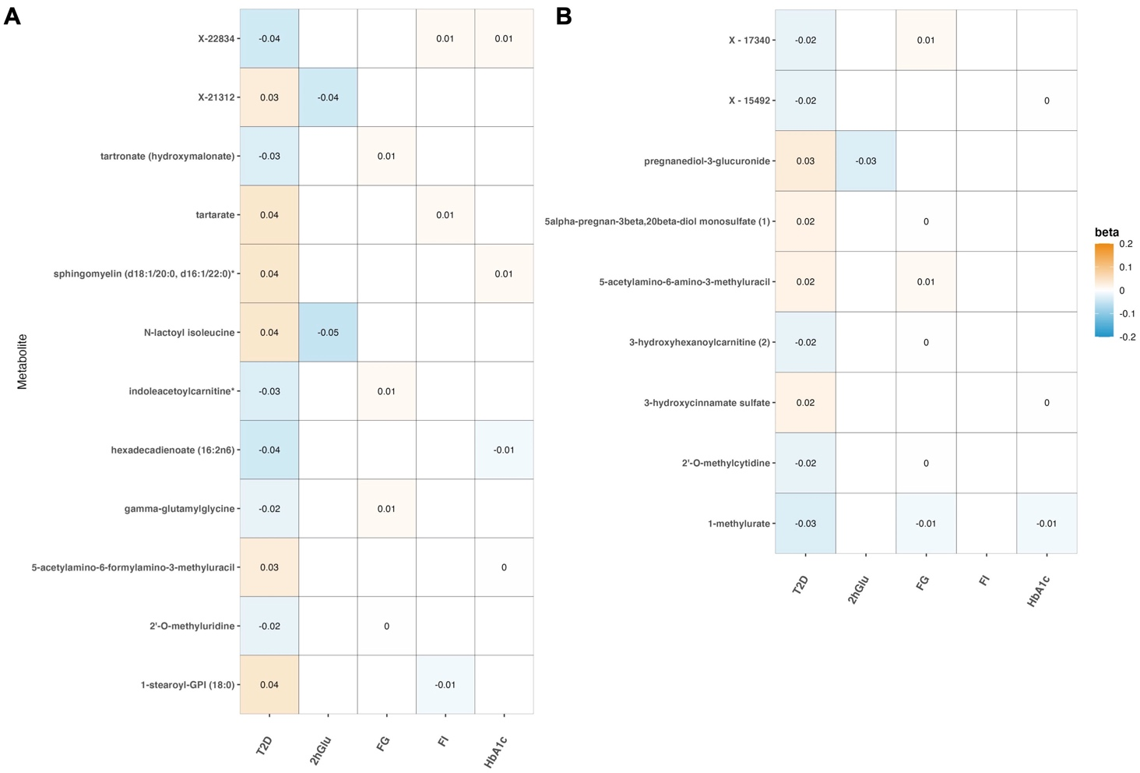

Figure S6. Mendelian randomization associations of plasma metabolites with T2D and four glycemic traits in Europeans. Beta was derived from the random-effect inverse-variance weighted analysis. A. Mendelian randomization associations for CLSA study. B. Mendelian randomization associations for METSIM study. CLSA, the Canadian Longitudinal Study on Aging; METSIM, the Metabolic Syndrome in Men study; T2D, type 2 diabetes; 2hGlu, 2-hour glucose after an oral glucose challenge; FG, fasting glucose; FI, fasting insulin; HbA1c, glycated hemoglobin.

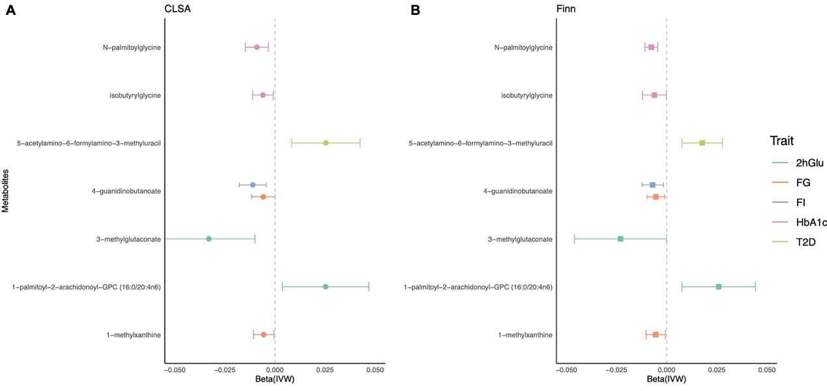
Figure S7. Validation of Mendelian randomization associations of metabolites with T2D and four glycemic traits in two EUR ancestry. The beta value derived from the random-effect IVW analysis of Mendelian randomization. IVW, inverse-variance weighted; CLSA, the Canadian Longitudinal Study on Aging; METSIM, the Metabolic Syndrome in Men study; T2D, type 2 diabetes; 2hGlu, 2-hour glucose after an oral glucose challenge; FG, fasting glucose; FI, fasting insulin; HbA1c, glycated hemoglobin.

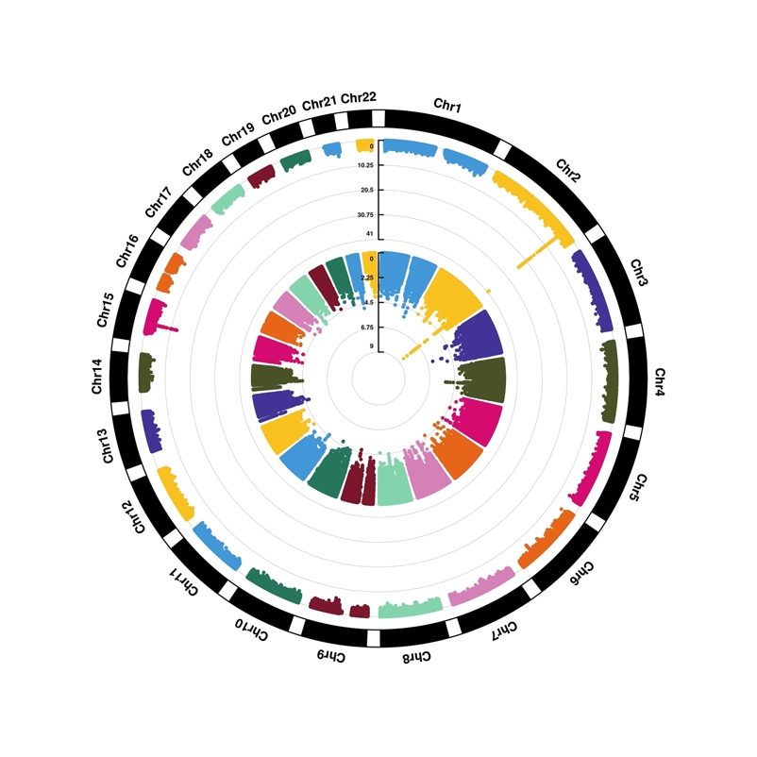
Figure S8. The circular Manhattan plot of replicable GWAS signals for creatine. From the outside to the inside are the signals from CLSA, and ZMSC.
CLSA, Canadian Longitudinal Study of Aging; ZMSC, Zhejiang metabolic syndrome cohort.

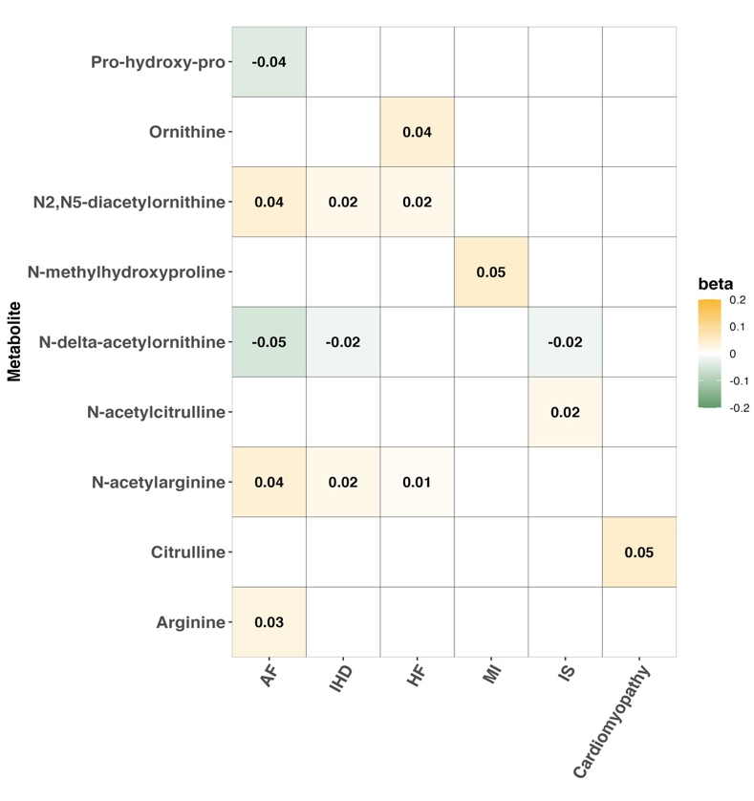
Figure S9. Mendelian randomization associations of serum urea cycle-related metabolites with diabetic cardiovascular complications. Beta was derived from the random-effect inverse-variance weighted analysis. AF, atrial flutter/fibrillation; IHD, ischemic heart disease; CHF, chronic heart failure; IS, ischemic stroke; MI, myocardial infarction.

