Supplemental Material

EXTENDED METHODS
Data collection and definition of diabetes mellitus
For each patient, demographic and baseline clinical data were collected, including age, sex, anthropometric data, cardiovascular risk factors, family history of cardiovascular disease, history of comorbidities, and admission and discharge therapy. Pre-existing type 2 diabetes mellitus (T2DM) was defined as known type 2 diabetes mellitus at the time of hospital admission for the TAVI procedure, irrespective of the therapeutic management (1).

Transthoracic echocardiography
Comprehensive transthoracic echocardiography (TTE) was performed by qualified cardiac imagers with >5 years of experience in cardiac imaging, as part of routine clinical practice using a high-quality ultrasound system (GE Vivid E9, E95 or S70, GE Healthcare Horten, Norway or Epiq 7C, Affiniti 70C, Philips Healthcare, Eindhoven, The Netherlands). Echocardiographic examinations were performed following the recommendations of the American Society of Echocardiography and the European Association of Cardiovascular Imaging (2). If patients were in sinus rhythm, 3 cardiac cycles were averaged for all measures, whereas for those in atrial fibrillation, 5 cardiac cycles were averaged.
Pulsed wave Doppler was used to measure the E- and A-wave peak velocities from the mitral inflow profile according to guidelines (3). The early diastolic velocity of the mitral annulus (e’) was obtained by Doppler tissue imaging at the lateral and septal aspects of the annulus and then averaged for each patient. The total E/e’ ratio was then calculated. Left atrial (LA) volume was measured using the biplane Simpson method and was indexed to body surface area (BSA) - left atrial volume indexed, LAVi (2). Left ventricular ejection fraction (LVEF) was estimated by the Simpson biplane method. Left ventricular (LV) mass was calculated with the corrected formula of the American Society of Echocardiography (ASE) and was indexed to BSA (2). LV diastolic dysfunction was assessed and graded according to American Society of Echocardiography guidelines (3). Systolic pulmonary arterial pressure (PASP) was derived from the peak velocity of the regurgitant jet of tricuspid regurgitation and the estimated right atrial pressure (4). The DTI-derived tricuspid lateral annular systolic velocity wave (S’) and tricuspid annular plane systolic excursion (TAPSE) were measured to assess the right ventricular (RV) longitudinal systolic function (2). The severity of aortic, mitral, and tricuspid regurgitation was determined using a multi-parametric approach, as recommended by the guidelines (4,5).
The hemodynamic parameters of aortic stenosis (AS) severity included peak aortic jet velocity (V_{peak}), mean transvalvular gradient obtained with the simplified Bernoulli equation, aortic valve area (AVA) calculated by the continuity equation and indexed to body surface area (AVAi) (6). The stroke volume was calculated by multiplying the area of the left ventricular outflow tract (LVOT) by the outflow tract time-velocity integral and indexed to the BSA (2). According to current guidelines, high gradient (HG) AS was defined as peak transvalvular velocity ≥4 m/s, transvalvular mean gradient (MG) ≥40 mmHg, and AVA ≤ 1 cm² in a regular flow state [LVEF>50% and stroke volume index (SVi) ≥35 ml/m²]. Low flow-low gradient (LF-LG) AS was defined as AVA≤1 cm², but transvalvular mean gradient (MG) <40 mmHg and peak transvalvular velocity <4 m/s in a low flow state (SVi<35 ml/m²). In patients with LF-LG AS, severity was confirmed with low-dose dobutamine stress echocardiography and/or cardiac computed tomography, as appropriate (7,8).
The extent of extra-valvular cardiac damage (EVCD) was categorized into 5 stages according to a model described by Genereux et al. (9). In detail, the EVCD was categorized into 5 stages, as follows: i) stage 0 - no cardiac damage; ii) stage 1 - left ventricular damage, as defined by left ventricular mass index (LVMi) > 115 g/m² (male) or > 95 g/m² (female), E/E’ > 14, LVEF <50%; iii) stage 2: left atrial or mitral damage, as defined by left atrial volume index > 34 ml/m², moderate to severe mitral regurgitation, atrial fibrillation; iv) stage 3: pulmonary vasculature or tricuspid damage, as defined by pulmonary artery systolic pressure (PASP) ≥ 60 mmHg, moderate to severe tricuspid regurgitation; v) stage 4: right ventricular damage, as defined by TAPSE <17 mm, S’ <9.5 cm/s, and fractional area change <35%. Patients were hierarchically classified in one given stage (the worst one) if at least one of the criteria of that stage was met. In this study EVCD was also dichotomized in Genereux stages 0-2 (isolated left heart dysfunction) and Genereux stages 3-4 (right heart involvement, advanced EVCD), as previously reported (10,11).

Clinical Outcomes
Pre-specified endpoints were all-cause mortality, cardiovascular deaths, heart failure, and the composite one (major adverse cardiovascular events, MACE). All-cause mortality included all causes of death for the population during the follow-up. Cardiovascular mortality consisted of deaths resulting from an AMI, sudden cardiac death, heart failure, stroke, and other cardiovascular causes. Heart failure, both with preserved and reduced ejection fraction, was diagnosed according to current ESC guidelines (12). Heart failure re-hospitalization was evaluated according to the ESC Guidelines and consisted of unscheduled hospital admission for a primary diagnosis of HF in which the patient presented typical signs, symptoms, and diagnostic testing consistent with the diagnosis of HF and consequently received HF-directed therapy (13). MACE was defined as a composite of cardiovascular mortality and non-fatal heart failure hospitalization (13). Clinical and procedural endpoints were defined following the Valve Academic Research Consortium 3 criteria (14).
REFERENCES
1. Marx N, Federici M, Schütt K et al. 2023 ESC Guidelines for the management of cardiovascular disease in patients with diabetes. Eur Heart J 2023;44:4043-4140.
2. Lang RM, Badano LP, Mor-Avi V et al. Recommendations for cardiac chamber quantification by echocardiography in adults: an update from the American Society of Echocardiography and the European Association of Cardiovascular Imaging. Eur Heart J Cardiovasc Imaging 2015;16:233-70.
3. Nagueh SF, Smiseth OA, Appleton CP et al. Recommendations for the Evaluation of Left Ventricular Diastolic Function by Echocardiography: An Update from the American Society of Echocardiography and the European Association of Cardiovascular Imaging. J Am Soc Echocardiogr 2016;29:277-314.
4. Lancellotti P, Tribouilloy C, Hagendorff A et al. Recommendations for the echocardiographic assessment of native valvular regurgitation: an executive summary from the European Association of Cardiovascular Imaging. Eur Heart J Cardiovasc Imaging 2013;14:611-644.
5. Zoghbi WA, Enriquez-Sarano M, Foster E et al. Recommendations for evaluation of the severity of native valvular regurgitation with two-dimensional and Doppler echocardiography. J Am Soc Echocardiogr 2003;16:777-802.
6. Baumgartner HC, Hung JC-C, Bermejo J et al. Recommendations on the echocardiographic assessment of aortic valve stenosis: a focused update from the European Association of Cardiovascular Imaging and the American Society of Echocardiography. Eur Heart J Cardiovasc Imaging 2017;18:254-275.
7. Vahanian A, Beyersdorf F, Praz F et al. 2021 ESC/EACTS Guidelines for the management of valvular heart disease. Eur Heart J 2022;43:561-632.
8. Dweck MR, Loganath K, Bing R et al. Multi-modality imaging in aortic stenosis: an EACVI clinical consensus document. Eur Heart J Cardiovasc Imaging 2023;24:1430-1443.
9. Généreux P, Pibarot P, Redfors B et al. Staging classification of aortic stenosis based on the extent of cardiac damage. Eur Heart J 2017;38:3351-3358.
10. Scarsini R, Gallinoro E, Ancona MB et al. Characterisation of coronary microvascular dysfunction in patients with severe aortic stenosis undergoing TAVI. EuroIntervention 2024;20:e289-e300.
11. Nakase M, Tomii D, Heg D et al. Long-Term Impact of Cardiac Damage Following Transcatheter Aortic Valve Replacement. JACC: Cardiovascular Interventions 2024;17:992-1003.
12. McDonagh TA, Metra M, Adamo M et al. 2021 ESC Guidelines for the diagnosis and treatment of acute and chronic heart failure: Developed by the Task Force for the diagnosis and treatment of acute and chronic heart failure of the European Society of Cardiology (ESC). With the special contribution of the Heart Failure Association (HFA) of the ESC. Eur J Heart Fail 2022;24:4-131.
13. Hicks KA, Mahaffey KW, Mehran R et al. 2017 Cardiovascular and Stroke Endpoint Definitions for Clinical Trials. Circulation 2018;137:961-972.
14. Généreux P, Piazza N, Alu MC et al. Valve Academic Research Consortium 3: Updated Endpoint Definitions for Aortic Valve Clinical Research. J Am Coll Cardiol 2021;77:2717-2746.

SUPPLEMENTARY TABLES
Supplementary Table 1. Medical therapy at hospital admission of SGLT2i users and no-SGLT2i users, according to the presence of CKD.

 | No CKD  N = 226 |  |  | CKD  N = 288
 | SGLT2i users  N = 43 | No-SGLT2i users  N = 183 | p-value | SGLT2i users  N = 71 | No-SGLT2i users  N = 217 | p-value
Antiplatelets, n (%) | 28 (65.1) | 125 (68.3) | 0.687 | 41 (57.7) | 151 (69.6) | 0.066
Anticoagulation, n (%) | 16 (37.2) | 65 (35.5) | 0.835 | 38 (53.5) | 92 (42.4) | 0.102
RAASi, n (%) | 23 (53.5) | 119 (65) | 0.159 | 35 (49.3) | 114 (52.5) | 0.635
ARNI, n (%) | 5 (11.6) | 11 (6) | 0.196 | 6 (8.5) | 7 (3.2) | 0.065
MRA, n (%) | 25 (58.1) | 57 (31.1) | <0.001 | 33 (46.5) | 74 (34.1) | 0.061
Diuretics, n (%) | 30 (69.8) | 120 (65.6) | 0.601 | 53 (74.6) | 168 (77.4) | 0.631
B-blockers, n (%) | 24 (55.8) | 93 (50.8) | 0.555 | 43 (60.6) | 133 (61.3) | 0.913
Statins, n (%) | 34 (79.1) | 139 (76) | 0.665 | 52 (73.2) | 172 (79.3) | 0.289
Glucose-lowering agents
Metformin, n (%) | 23 (53.5) | 110 (60.1) | 0.427 | 29 (40.8) | 99 (45.6) | 0.482
Sulfonylureas, n (%) | 6 (14) | 20 (10.9) | 0.576 | 4 (5.6) | 26 (12) | 0.129
DPP-4 Inhibitors, n (%) | 7 (16.3) | 31 (16.9) | 0.917 | 12 (16.9) | 32 (14.7) | 0.661
GLP-1 Agonist, n (%) | 3 (7) | 21 (11.5) | 0.389 | 5 (7) | 13 (6) | 0.751
Insulin sc., n (%) | 10 (23.3) | 37 (20.2) | 0.659 | 21 (29.6) | 81 (37.3) | 0.160

Categorical variables as number (%).
Abbreviations: CKD=chronic kidney disease; SGLT2i=sodium/glucose cotransporter 2 inhibitors; RAASi=renin-angiotensin-aldosterone system inhibitors; ARNI=angiotensin receptor/neprilysin inhibitor; MRA=mineralocorticoid receptor antagonists; DPP-4 = dipeptidyl peptidase-4; GLP-1 = glucagon-like peptide-1; sc. = subcutaneous.

Supplementary Table 2. Procedural characteristics of SGLT2i users and no-SGLT2i users, according to the presence of CKD.
 | No CKD  N = 226 |  |  | CKD  N = 288
 | SGLT2i users  N = 43 | No-SGLT2i users  N = 183 | p-value | SGLT2i users  N = 71 | No-SGLT2i users  N = 217 | p-value
Transfemoral vascular access, n (%) | 43 (100) | 177 (96.7) | 0.229 | 69 (97.2) | 213 (98.2) | 0.618
Valve-in-valve procedure, n (%) | 2 (4.7) | 6 (3.3) | 0.661 | 5 (7) | 9 (4.1) | 0.325
Valve type, n (%)  Balloon expandable, n (%)  Self-expanding, n (%) | 20 (46.5)  23 (53.5) | 58 (31.7)  125 (68.3) | 0.066 | 36 (50.7)  35 (49.3) | 88 (40.6)  129 (59.4) | 0.134
Procedural time, min | 100 [80 – 122] | 98 [70 – 120] | 0.125 | 91 [75 – 115] | 95 [75 – 120] | 0.996
Contrast dose, ml | 121 [95 – 175] | 120 [100 – 150] | 0.850 | 110 [90 – 120] | 110 [80 – 150] | 0.310
Significant PVL, n (%)• | 2 (4.7) | 3 (1.6) | 0.227 | 2 (2.8) | 4 (1.8) | 0.618
Permanent pacemaker implantation, n (%) | 7 (16.3) | 20 (10.9) | 0.330 | 7 (9.9) | 18 (8.3) | 0.684
Vascular complications, n (%)  Minor  Major | 5 (11.6)  1 (2.3) | 8 (4.4)  3 (1.6) | 0.172 | 1 (1.4)  1 (1.4) | 14 (6.5)  3 (1.4) | 0.252
Neurologic complications, n (%)  TIA  Stroke | 1 (2.3)  0 (0) | 2 (1.1)  4 (2.2) | 0.815 | 1 (1.4)  0 (0) | 4 (1.8)  1 (0.5) | 0.687
Bleeding type (VARC-3), n (%)  1  2  3 | 1 (2.3)  0 (0)  1 (2.3) | 3 (1.6)  3 (1.6)  2 (1.1) | 0.894 | 3 (4.2)  1 (1.4)  0 (0) | 7 (3.2)  7 (3.2)  3 (1.4) | 0.851
Acute kidney injury, n (%) | 3 (7) | 13 (7.1) | 0.977 | 6 (8.5) | 43 (19.8) | 0.027

Continuous variables are presented as mean±SD or as median [IQR]; while categorical variables as number (%). Abbreviations: CKD=chronic kidney disease; SGLT2i=sodium/glucose cotransporter 2 inhibitors; PVL=paravalvular leak; TIA=transient ischemic attack; VARC-3= Valve Academic Research Consortium 3.
• ≥ moderate PVL.

Supplementary Table 3. Long-term outcomes of SGLT2i users and no-SGLT2i users, according to the presence of CKD.

 | No CKD  N = 226 |  |  | CKD  N = 288
 | SGLT2i users  N = 43 | No-SGLT2i users  N = 183 | p-value | SGLT2i users  N = 71 | No-SGLT2i users  N = 217 | p-value
Primary Endpoint
MACE, n (%) | 7 (16.3) | 34 (18.6) | 0.725 | 14 (19.7) | 91 (41.9) | 0.001
Secondary Endpoints
All-cause deaths, n (%) | 4 (9.3) | 27 (14.8) | 0.350 | 9 (12.7) | 72 (33.2) | 0.001
Cardiovascular-death, n (%) | 3 (7) | 14 (7.7) | 0.880 | 5 (7) | 43 (19.8) | 0.012
HF hospitalization, n (%) | 4 (9.3) | 18 (9.8) | 0.915 | 8 (11.3) | 50 (23) | 0.032

Abbreviations: CKD=chronic kidney disease; SGLT2i=sodium/glucose cotransporter 2 inhibitors; MACE=major adverse cardiovascular events; HF=heart failure.

SUPPLEMENTARY FIGURE LEGEND
Supplementary Figure 1. Study flow chart.
Abbreviations: T2DM = type 2 diabetes mellitus; TAVI = transcatheter aortic valve interventions; SGLT2i = Sodium-glucose co-transporter 2 inhibitors. SCr= serum creatinine. CKD = chronic kidney disease.

Supplementary Figure 2. At the top, a line plot with error bars showing the changes of estimated glomerular filtration rate values across the 3-time points of the study (pre-TAVI, post-TAVI, and hospital discharge), in patients with and without CKD, comparing those treated with SGLT2i vs. no-SGLT2i users. Red lines represent the SGLT2i users; blue lines represent the no-SGLT2i users. At the bottom, the table summarizing eGFR values and statistical comparisons at each time point, including p-values and changes in eGFR (ΔeGFR).
Abbreviations: SGLT2i = sodium-glucose co-transporter 2 inhibitors; CKD = chronic kidney disease; TAVI = transcatheter aortic valve implantation; ΔSCr = changes in serum creatinine values.

Supplementary Figure 3. Kaplan-Meier survival curves in patients without AKI (green curve) and in those with AKI (orange curve).
Abbreviations: AKI = Contrast-induced Acute Kidney Injury; CKD = chronic kidney disease.

SUPPLEMENTARY FIGURES
Supplementary Figure 1.
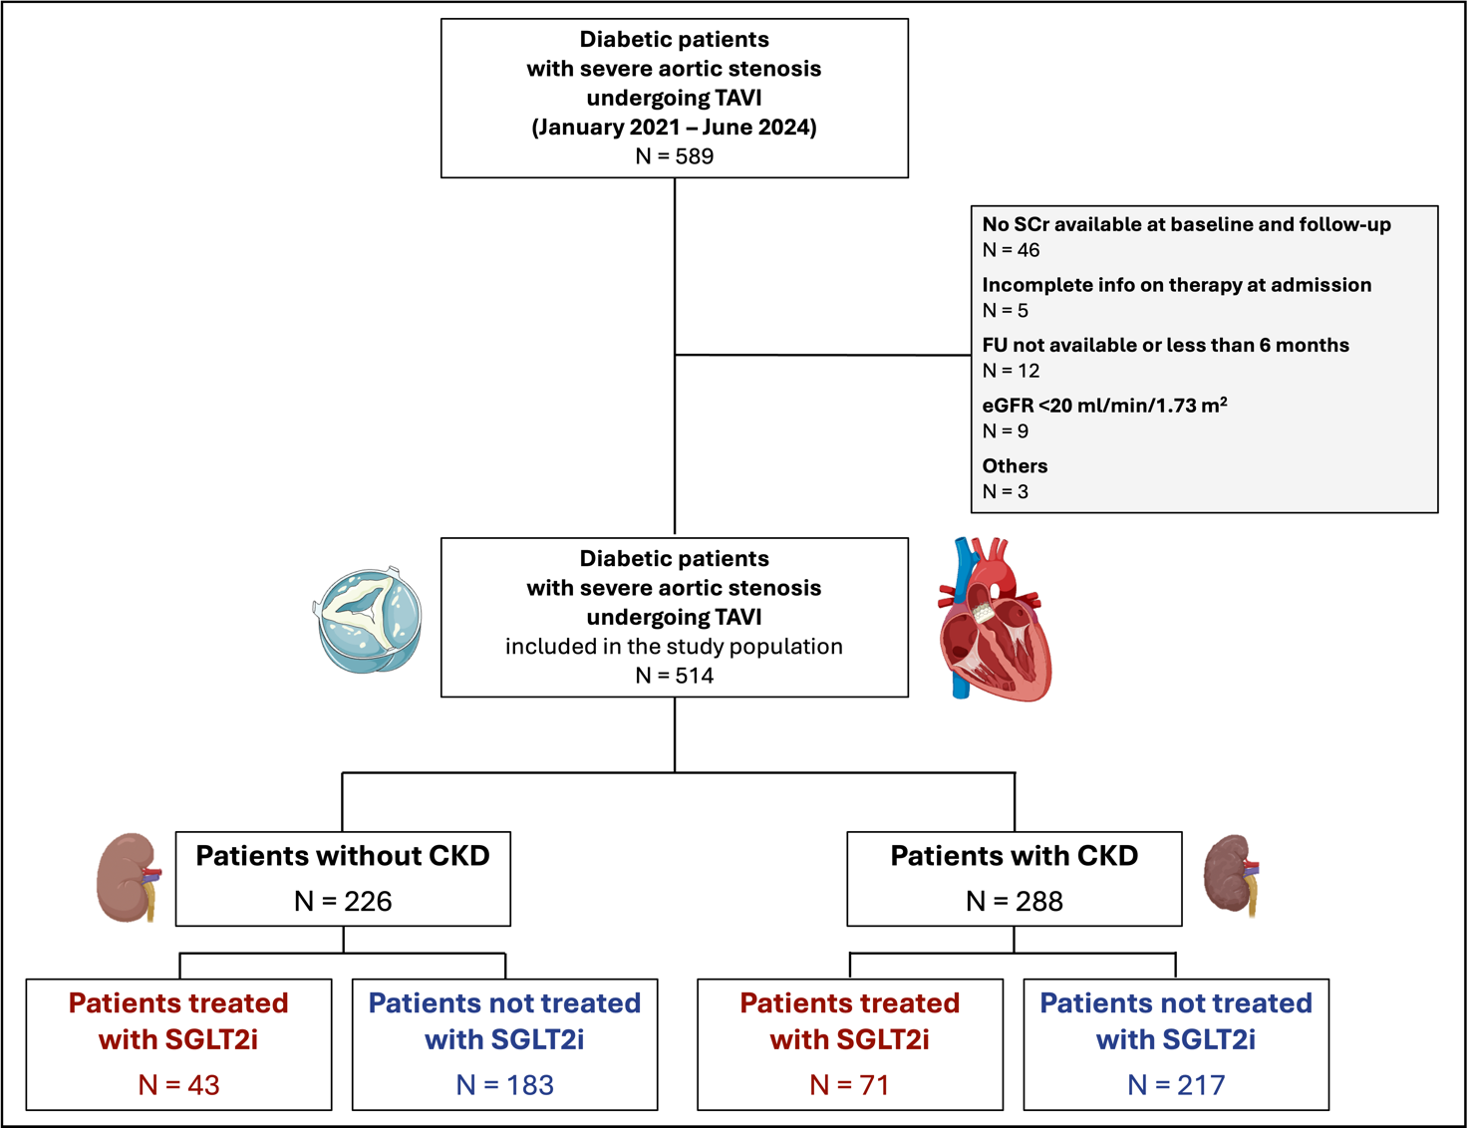

Supplementary Figure 2.

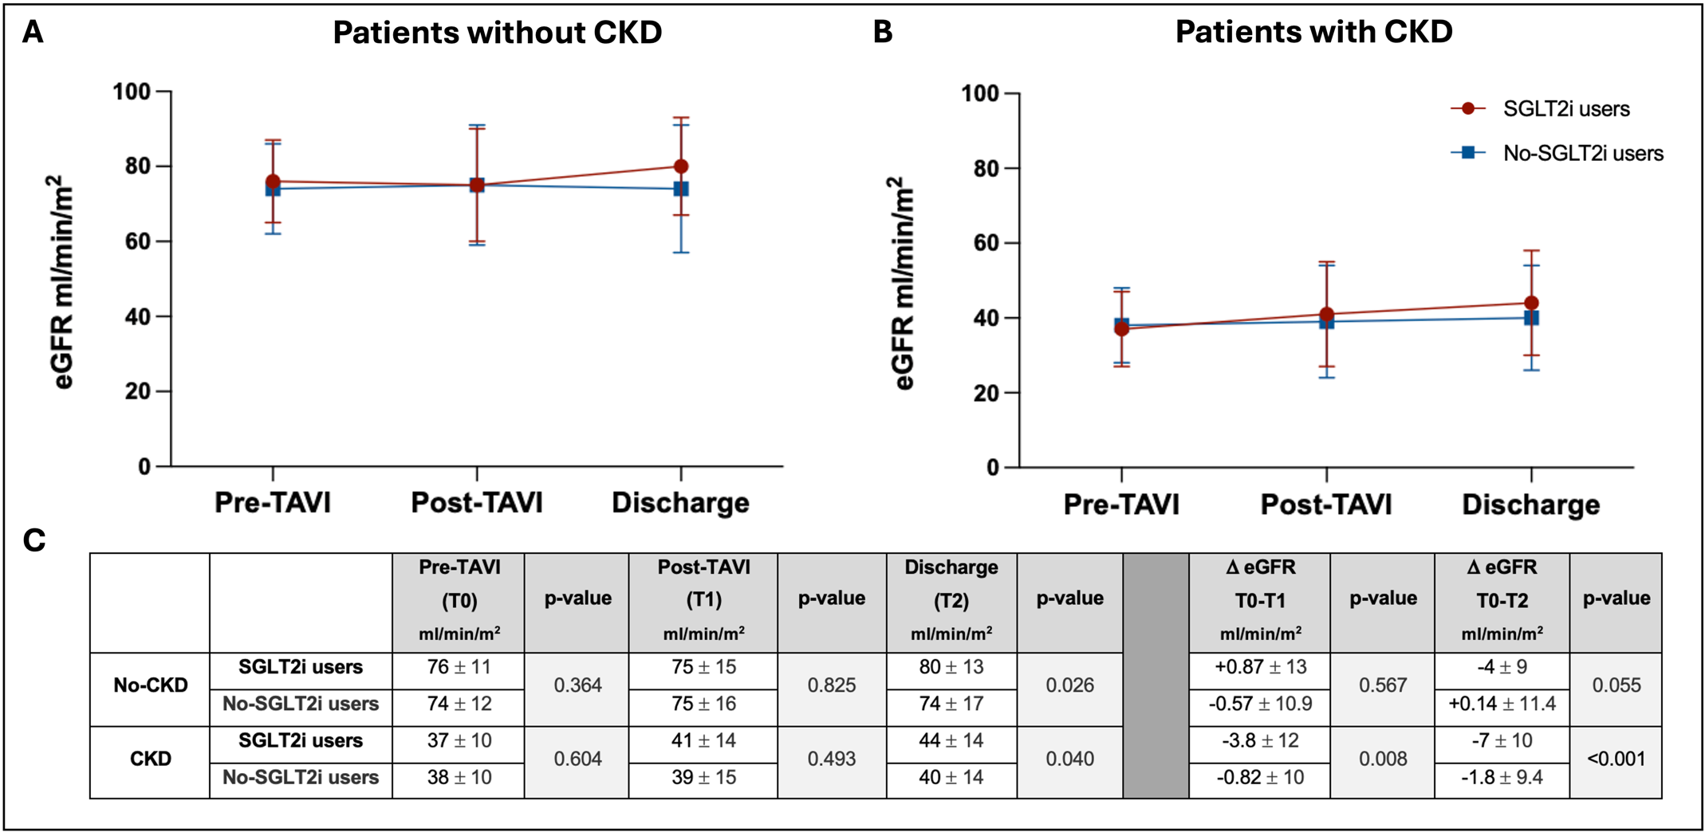

Supplementary Figure 3.

