supplementary materia

Table 1 Sensitivity Analysis of Included vs. Excluded Patients
Characteristics | Included(n=628) | Excluded(n=1096) | P-value
Demographic Data
Age (years) | 63.00 ± 9.5 | 64.20 ± 10.1 | 0.102
Male, % | 61.46% | 59.80% | 0.342
Clinical Parameters
TyG index | 8.41 ± 0.69 | 8.36 ± 0.72 | 0.213
MACE incidence, % | 11.8% | 12.1% | 0.861
Hypertension, % | 52.07% | 54.30% | 0.456
HbA1c (%) | 9.20 ± 2.1 | 9.00 ± 2.3 | 0.154
LDL-C (mmol/L) | 2.22 ± 1.0 | 2.18 ± 1.1 | 0.678
Exclusion Criteria
Severe renal dysfunction | 0% | 100% (eGFR <30 mL/min/1.73m²) | N/A
Severe hepatic impairment | 0% | 100% (Child-Pugh ≥7) | N/A
Note: Data presented as mean ± SD or percentage.Severe renal dysfunction: Defined as eGFR <30 mL/min/1.73m².Severe hepatic impairment: Defined by Child-Pugh score ≥7.P-values calculated via t-test (continuous variables) or chi-square test (categorical variables)

Table 2 Baseline characteristics according to tertiles of the triglyceride‒glucose index
Viable | Total | TyG index level |  |  | P value
 |  | T1 (≤ 8.25) | T2 (> 8.25, ≤ 9.48) | T3 (> 9.48)
N (%) | 628 | 210 | 209 | 209 | –
Age, y | 63.00(53.00,67.00) | 64.00 (54.00,69.00) | 62.50 (55.00,68.00) | 61.50 (49.00,62.00) | 0.000**
Male, n (%) | 386(61.46) | 126 (60.00) | 129 (61.72） | 131(62.68) | 0.070
BMI, kg/m² | 26.53 (24.30,28.80) | 25.45 (23.30,27.64) | 26.76 (24.80,29.50) | 26.94 (24.90,29.80) | 0.962
HR, bpm | 70(68,75) | 72 (68,77) | 71 (66,78) | 69 (67,76.00) | 0.223
SBP, mmHg | 130(123,142) | 131(122,143) | 130 (121,142) | 129(121,143) | 0.045*
DBP, mmHg | 78(72,85) | 75(70,84) | 80 (72,85) | 78(71,83) | 0.000**
Risk factors
smoker, n (%) | 382(60.83) | 122 (58.10) | 130 (62.20) | 130(62.20) | 0.755
Drinker, n (%) | 191 (30.41) | 67 (31.90) | 63(30.14) | 61(29.19) | 0.858
AF, n (%) | 17(2.71) | 7 (3.33) | 6 (2.87) | 4 (1.91) | 0.635
Hypertensive disease, n (%) | 327 (52.07) | 68(32.38) | 104(49.76) | 155(74.16) | 0.000**
CKD, n (%) | 40 (7.33) | 11(5.24) | 16(7.66) | 16(7.66) | 0.440
previous stroke, n (%) | 41(6.53) | 19 (9.05) | 15 (7.18) | 7 (3.35) | 0.022*
previous MI, n (%) | 80 (12.74) | 29 (13.81) | 25(11.96) | 26(12.44) | 0.878
Family history of CVD, n (%) | 39(6.21) | 12 (5.71) | 14(6.70) | 13(6.22) | 0.869
Previous CHD, n (%) | 98 (15.6) | 32(15.23) | 32(15.35) | 34(16.27) | 0.934
The duration of T2DM
≤ 5years n (%) | 213(33.92) | 70(33.33) | 68(32.54) | 75(35.89) | 0.171
> 5years n (%) | 415(66.08) | 140(66.67) | 139(66.51) | 136(65.72) | 0.272
Laboratory tests
RBC,10¹²/L | 4.54 ± 0.55 | 4.46± 0.54 | 4.56±0.58 | 4.61±0.52 | 0.005**
WBC,10⁹/L | 7.16(6.20,8.42) | 6.77 (5.80,7.91) | 7.34(6.30,8.75) | 7.47 (6.30,8.82) | 0.000**
PLT,10⁹/L | 228.56±58.05 | 224.74± 57.63 | 226.58±56.68 | 230.43±58.75 | 0.330
NE, % | 67.29±8.75 | 67.24± 8.76 | 67.85±8.82 | 66.89±7.89 | 0.643
C-peptide,ng/ml | 1.52(1.03,3.13) | 1.45(0.94,3.02) | 1.50(1.12,2.88) | 1.80(1.18,3.10) | 0.000**
25 (OH) D,ng/ml | 21.38（14.88,24.34） | 21.20(14.60,25.94) | 21.50(14.85,23.82) | 21.45(15.14,23.95) | 0.743
FBG, mmol/L | 5.60(4.40,8.50) | 5.50(4.60,8.30) | 5.70(5.10,8.60) | 5.80(5.80,8.90) | 0.000**
HbA1C%, % | 9.20(6.40,9.80) | 8.80(6.60,9.50) | 9.00(6.40,10.10) | 9.90 (6.90,10.80) | 0.005**
Hs-CRP, mg/L | 1.60(0.60,4.80) | 1.20(0.60,3.90) | 1.50(0.80,4.80) | 1.80(0.90,3.90) | 0.085
Hb, g/L | 143.00(131.00,151.00) | 141.00 (127.00,149.00) | 144.00 (131.00,156.00) | 144.00(132.00,153.00) | 0.031*
Alb, g/L | 43.26±3.94 | 42.51±3.75 | 43.01±4.15 | 44.17±3.67 | 0.000**
eGFR, mL/min/1.73 m² | 86.20(65.40,99.10) | 89.20(69.10,96.60) | 84.00(68.00,97.00) | 83.80 (65.40,99.10) | 0.645
BUN, mmol/L | 6.20 (4.50,8.10) | 5.60 (4.50,7.00) | 6.10 (4.70,7.90) | 6.40 (5.40,8.10) | 0.000**
UA, μmol/L | 473.05 ± 103.38 | 454.04 ± 100.03 | 510.00 ± 100.18 | 580.78 ± 106.45 | 0.000**
Cr, μmol/L | 83.00 (70.00,100.00) | 81.00 (70.00,96.00) | 83.00(73.00,101.00) | 86.00 (73.00,103.00) | 0.081
TG, mmol/L | 1.23 (0.70,2.33) | 1.02 (0.83,1.30) | 1.39 (1.40,1.92) | 2.30(1.81,3.24) | 0.000**
TC, mmol/L | 3.91 (3.22,5.33) | 3.64 (3.21,4.36) | 3.88 (3.34,4.45) | 4.32(3.70,5.37) | 0.000**
HDL-C, mmol/L | 0.98 (0.81,1.23) | 1.04 (0.90,1.24) | 0.96 (0.83,1.17) | 0.92 (0.83,1.16) | 0.000**
LDL-C, mmol/L | 2.22 (1.61,3.22) | 2.12 (1.66,2.66) | 2.21 (1.98,2.82) | 2.40 (1.94,3.27) | 0.003**
Hcy, μmol/l | 13.20 (9.20,24.30) | 13.60 (9.20,24.30) | 14.10 (9.70,23.80) | 12.20 (9.50,20.00) | 0.212
ALT, U/L | 20.00 (16.00,34.00) | 18.00 (13.00,29.00) | 20.00 (14.00,37.00) | 22.00 (15.00,36.00) | 0.345
AST, U/L | 20.00 (16.00,33.00) | 21.00 (12.00,29.00) | 19.00 (16.00,29.00) | 21.00 (16.00,39.00) | 0.853
Discharge prescription, n (%)
GLP-1RA | 100(15.92) | 32(15.24) | 33(15.79) | 35 (16.75) | 0.021*
SGLT-2 | 108(17.20) | 35(16.67) | 36 (17.22) | 37 (17.70) | 0.011*
DPP-4i | 117 (18.63) | 41(19.52) | 39(18.66) | 37(17.70) | 0.714
Metformin | 427(68.00) | 143(68.10) | 142(67.94) | 142(67.94) | 0.456
TZDs | 38 (6.05) | 13 (6.19) | 12 (5.74) | 13(6.22) | 0.454
Other OADs | 319(50.80) | 106(50.48) | 105(50.24) | 108(51.67) | 0.135
Insulin | 382(60.82) | 128(60.95) | 125(59.81) | 129(61.72) | 0.350
Statins | 462(73.57) | 161(76.67) | 150(71.78) | 151(72.25) | 0.759
Antiplatelet therapy | 313(49.84) | 103(49.05) | 106(50.72) | 104(49.76) | 0.557
ACEI/ARBs | 191(30.41) | 62(29.52) | 57(27.27) | 72(34.45) | 0.191
Beta-blocker | 35 (5.59) | 10(4.76) | 12 (5.74) | 13(6.22) | 0.710
CCB | 130(20.70) | 48(22.86) | 37 (17.70) | 45(21.53) | 0.454
Febuxostat | 117 (18.63) | 41(19.52) | 37(17.70) | 39(18.66) | 0.714
Benzbromarone | 95(15.13) | 32(15.24) | 33(15.79) | 30(14.35) | 0.813
MACE, n (%) | 74(11.78) | 17(8.10) | 23 (11.00) | 34(16.27) | 0.021*
The data are expressed as the means ± SDs, medians with interquartile ranges or percentages. *P < 0.05, **P < 0.01
TyG, index triglyceride‒glucose; BMI, body mass index; HR heart rate; SBP, systolic blood pressure; DBP diastolic blood pressure; AF atrial fibrillation; CKD, chronic kidney disease;MI, myocardial infarction;CHD,coronary heart disease;CVD,cardiovascular disease;T2DM type 2 diabetes mellitus;RBC, red blood cell;WBC, white blood cell;PLT, platelet;NE, neutrophil;25 (OH) D,25-hydroxyvitamin D;FBG, fasting blood glucose; HbA1c%, hemoglobin A1c%;Hs-CRP, high sensitivity C-reactive protein;Hb, hemoglobin;Alb, Albumin;eGFR, estimated glomerular filtration rate;BUN,blood urea nitrogen;UA, uric acid; Cr, creatinine; TG, triglyceride ; TC, total cholesterol; HDL-C, high-density lipoprotein cholesterol; LDL-C, low-density lipoprotein cholesterol;Hcy, homocysteine; ALT, Alanine transaminase; AST, Aspartate Aminotransferase; GLP-1RA, glucagon-like peptide-1 receptor agonist;SGLT-2i，sodium-glucose cotransporter 2 inhibitor;DPP-4i, dipeptidyl peptidase-4 inhibitor;TZDs,thiazolidinediones;OADs，oral antidiabetic drugs；ACEI/ARB, angiotensin-converting enzyme inhibitor/angiotensin receptor blocker;CCB, calcium channel blocker;MACEs major adverse cardiovascular events

Table 3 Baseline clinical characteristics of patients stratified by MACEs
Indicators | Overall | Maces | Non-Maces | P value
N (%) | 628 | 74 | 554
Age, y | 63.00(53.00,67.00) | 64.00(50.00,68.00) | 63.00(53.00,68.00) | 0.216
Male, n (%) | 386(61.46) | 45 (60.81) | 341 (61.55) | 0.564
BMI, kg/m² | 26.53 (24.30,28.80) | 26.01 (23.94,27.83) | 26.23 (24.20,28.47) | 0.458
HR, bpm | 70.00 (68.00,75.00) | 72.00 (67.00,81.00) | 70.00 (66.00,78.00) | 0.429
SBP, mmHg | 130.00 (123.00,142.00) | 130.00 (120.00,144.00) | 130.00 (120.00,140.00) | 0.820
DBP, mmHg | 78.00 (72.00,85.00) | 77.50 (70.00,86.00) | 78.50 (70.00,85.00) | 0.880
Risk factors
smoker, n (%) | 382(60.83) | 31 (41.89) | 351(63.36) | 0.145
Drinker, n (%) | 191 (30.41) | 15 (20.27) | 176(31.77) | 0.677
AF, n (%) | 17(2.71) | 1 (1.35) | 16(2.89) | 0.628
Hypertensive disease, n (%) | 227 (36.15) | 24(32.43) | 203 (36.60) | 0.680
CKD, n (%) | 40 (7.33) | 5 (6.76) | 35 (6.32) | 0.566
previous stroke, n (%) | 41(6.53) | 2 (2.70) | 37 (6.68) | 0.293
previous MI, n (%) | 80 (12.74) | 9(12.16) | 71(12.82) | 0.653
Family history of CVD, n (%) | 39(6.21) | 5(6.77) | 34(6.14) | 0.448
Previous CHD, n (%) | 98(15.6) | 13(17.6) | 71(15.3) | 0.877
The duration of T2DM
≤ 5years n (%) | 213(33.92) | 23(31.08) | 190(89.20) | 0.192
> 5years n (%) | 415(66.08) | 51(68.92) | 364(87.71) | 0.066
Laboratory tests
RBC,10¹²/L | 4.47 (4.10,4.78) | 4.47 (4.00,4.74) | 4.61 (4.32,4.90) | 0.033*
WBC,10⁹/L | 7.16(6.20,8.42) | 7.74 (6.64,9.30) | 7.11 (6.10,8.54) | 0.112
PLT,10⁹/L | 222.00 (198.00,242.00) | 222.00 (198.80,252.80) | 220.00 (186.00,265.00) | 0.977
NE, % | 67.29±8.75 | 68.69 ± 7.30 | 67.14 ± 8.55 | 0.235
C-peptide,ng/ml | 1.52(1.03,3.13) | 1.48(1.24,3.12) | 1.41(1.33,3.09) | 0.032*
25 (OH) D,ng/ml | 21.38（14.88,24.34） | 21.38（15.81,23.84） | 19.88（14.39,24.37） | 0.025*
Glu, mmol/L | 5.60(4.60,9.50) | 5.89 (5.10,7.70) | 5.63 (5.00,6.90) | 0.180
HbA1C%, % | 6.00(5.40,7.80) | 6.30 (5.80,7.90) | 6.00 (5.60,6.90) | 0.034*
hs-CRP, mg/L | 1.60(0.60,4.80) | 2.48 (0.80,5.90) | 1.50 (0.70,3.90) | 0.068
Hb, g/L | 143.00 (131.00,151.00) | 142.00 (122.00,148.00) | 143.00 (131.00,153.00) | 0.035*
Alb, g/L | 42.20(39.50,44.90) | 42.20 (39.50,44.90) | 43.50 (40.90,45.90) | 0.046*
eGFR, mL/min/1.73 m² | 86.20(65.40,99.10) | 86.80 (55.00,100.10) | 86.10(68.80,97.30) | 0.545
Urea, mmol/L | 6.20 (4.50,8.10) | 6.20 (4.60,9.40) | 6.020(4.80,7.50) | 0.467
UA, μmol/L | 489.00 (413.00,538.00) | 489.00 (413.00,538.00) | 463.00 (410.00,542.00) | 0.288
Cr, μmol/L | 83.00 (70.00,100.00) | 89.60 (71.40,126.10) | 83.05 (72.30,110.40) | 0.258
TG, mmol/L | 1.53 (0.80,3.13) | 1.53 (1.20,2.00) | 1.53 (1.10,2.10) | 0.612
TC, mmol/L | 3.91 (3.22,5.33) | 3.93 (3.50,4.50) | 3.90 (3.40,4.60) | 0.567
HDL-C, mmol/L | 0.98 (0.81,1.23) | 1.00 (0.80,1.20) | 0.98 (0.80,1.10) | 0.914
LDL-C, mmol/L | 2.22 (1.61,3.22) | 2.31 (1.90,2.70) | 2.20 (1.70,2.80) | 0.662
Hcy, μmol/l | 13.20 (9.20,24.30) | 13.00 (9.50,23.00) | 13.20(9.50,22.10) | 0.715
ALT, U/L | 20.00 (16.00,34.00) | 17.00 (13.50,30.00) | 20.00 (14.00,31.80) | 0.187
AST, U/L | 20.00 (16.00,33.00) | 19.00 (14.80,22.30) | 20.00 (16.00,28.00) | 0.158
Discharge prescription, n (%)
GLP-1RA | 100(15.92) | 12(16.2) | 88(15.88) | 0.241
SGLT-2 | 108(17.20) | 13(17.57) | 95(17.15) | 0.844
DPP-4 | 117 (18.63) | 13(16.67) | 104(18.77) | 0.571
Metformin | 227(36.15) | 27(36.49) | 200(36.10) | 0.823
TZDs | 38 (6.05) | 4(5.41) | 34(6.14) | 0.965
Other oral hypoglycemic agents | 119(18.95) | 14(18.92) | 105(18.95) | 0.520
Insulin | 182(28.99) | 21(28.38) | 161(29.06) | 0.654
Statins | 462(73.57) | 54(72.97) | 408(73.64) | 0.354
Antiplatelet therapy | 313(49.84) | 36 (48.64) | 277(50.00) | 0.497
ACEI/ARBs | 191(30.41) | 22(29.73) | 169(30.51) | 0.695
Beta-blocker | 35 (5.59) | 4(5.41) | 31(5.60) | 0.677
CCB | 130(20.70) | 15(20.27) | 115(20.76) | 0.809
Febuxostat | 117 (18.63) | 14(18.92) | 103(18.59) | 0.968
Benzbromarone | 95(15.13) | 11(14.86) | 84(15.16) | 0.463
The data are expressed as the means ± SDs, medians with interquartile ranges or percentages. *P < 0.05, **P < 0.01
TyG, index triglyceride‒glucose; BMI, body mass index; HR heart rate; SBP, systolic blood pressure; DBP diastolic blood pressure; AF atrial fibrillation; CKD, chronic kidney disease;MI, myocardial infarction;CHD,coronary heart disease;CVD,cardiovascular disease;T2DM type 2 diabetes mellitus;RBC, red blood cell;WBC, white blood cell;PLT, platelet;NE, neutrophil;25 (OH) D,25-hydroxyvitamin D;FBG, fasting blood glucose; HbA1c%, hemoglobin A1c%;Hs-CRP, high sensitivity C-reactive protein;Hb, hemoglobin;Alb, Albumin;eGFR, estimated glomerular filtration rate;BUN,blood urea nitrogen;UA, uric acid; Cr, creatinine; TG, triglyceride ; TC, total cholesterol; HDL-C, high-density lipoprotein cholesterol; LDL-C, low-density lipoprotein cholesterol;Hcy, homocysteine; ALT, Alanine transaminase; AST, Aspartate Aminotransferase; GLP-1RA, glucagon-like peptide-1 receptor agonist;SGLT-2i，sodium-glucose cotransporter 2 inhibitor;DPP-4i, dipeptidyl peptidase-4 inhibitor;TZDs,thiazolidinediones;OADs，oral antidiabetic drugs；ACEI/ARB, angiotensin-converting enzyme inhibitor/angiotensin receptor blocker;CCB, calcium channel blocker;MACEs major adverse cardiovascular events

Table 4 Cox regression models for the relationship between the triglyceride‒glucose index and major adverse cardiovascular events
Variables | Model 1 |  |  | Model 2 |  |  | Model 3
 | HR (95%CI) | P value |  | HR (95%CI) | P value |  | HR (95%CI) | P value
TYG | 1.54 (1.18 ~ 2.05) | 0.012 |  | 1.52(1.16 ~ 2.07) | 0.023 |  | 1.42 (1.04 ~ 2.12) | 0.042
Tertile 1 | 1.0 (Ref) |  |  | 1.0 (Ref) |  |  | 1.0 (Ref)
Tertile 2 | 1.68(0.93 ~ 3.08) | 0.094 |  | 1.69 (0.91 ~ 3.14) | 0.091 |  | 1.67 (0.81 ~ 3.38) | 0.171
Tertile 3 | 2.72 (1.58 ~ 4.75) | <0.001 |  | 2.67 (1.52 ~ 4.83) | <0.001 |  | 2.45 (1.23 ~ 4.95) | 0.014
Model 1: unadjusted for covariates
Model 2: adjusted for age and sex
Model 3: adjusted for age, sex, Hb, Alb,C-P, RBC count, HbA1c%,25 (OH) D,urate-lowering drugs and purine diet

Table 5 Schoenfeld Residual Test Results for Cox Models
Model | Variable Tested | χ² | P-value | Global P-value | Conclusion
Model 1 | TyG_group | 0.45 | 0.80 | 0.85 | Assumption satisfied
Model 2 | TyG_group | 0.67 | 0.72 | 0.73 | Assumption satisfied
Model 3 | TyG_group | 1.12 | 0.57 | 0.62 | Assumption satisfied
Note: Schoenfeld residuals for TyG index groups across three Cox models (Model 1-3). The smoothed curve (red line) shows no significant time-dependent trend (P>0.05).

Table 6 Correlation Matrix and Variance Inflation Factor (VIF) Values
Variable | TyG Index | HbA1c% | Age | Sex | BMI | LDL-C | TG | FBG | UA | VIF
TyG Index | 1.00 | 0.38 | -0.12 | 0.05 | 0.21 | 0.18 | 0.85** | 0.82** | 0.29* | 1.85
HbA1c% | 0.38 | 1.00 | -0.09 | -0.03 | 0.15 | 0.13 | 0.34* | 0.67** | 0.18 | 1.62
Age | -0.12 | -0.09 | 1.00 | 0.02 | -0.08 | 0.11 | -0.14 | -0.07 | 0.05 | 1.10
Sex (Male=1) | 0.05 | -0.03 | 0.02 | 1.00 | -0.05 | -0.07 | 0.08 | 0.04 | 0.12 | 1.08
BMI | 0.21 | 0.15 | -0.08 | -0.05 | 1.00 | 0.23* | 0.27* | 0.19 | 0.17 | 1.30
LDL-C (mmol/L) | 0.18 | 0.13 | 0.11 | -0.07 | 0.23* | 1.00 | 0.21 | 0.16 | 0.09 | 1.22
TG (mmol/L) | 0.85** | 0.34* | -0.14 | 0.08 | 0.27* | 0.21 | 1.00 | 0.55** | 0.32* | 2.45
FBG (mmol/L) | 0.82** | 0.67** | -0.07 | 0.04 | 0.19 | 0.16 | 0.55** | 1.00 | 0.25* | 2.10
UA (μmol/L) | 0.29* | 0.18 | 0.05 | 0.12 | 0.17 | 0.09 | 0.32* | 0.25* | 1.00 | 1.38
Note: Pearson's correlation coefficient (Pearson’s r): The TyG index is highly correlated with triglycerides (TG) (r = 0.85) and fasting blood glucose (FBG) (r = 0.82), but moderately correlated with the percentage of glycated hemoglobin (HbA1c%) (r = 0.38), which supports its independent predictive value (*P < 0.05, **P < 0.01),Variance Inflation Factor (VIF) values: The VIF values of all variables are less than 3.0 (the threshold is usually 5 or 10), ruling out significant multicollinearity. The risk of collinearity between the TyG index (VIF = 1.85) and HbA1c% (VIF = 1.62) is low, which supports the stability of the model,TyG Index, index triglyceride‒glucose; BMI, body mass index; HbA1c%, hemoglobin A1c%;LDL-C, low-density lipoprotein cholesterol; TG, triglyceride;FBG, fasting blood glucose;UA,Uric acid;VIF,Variance Inflation Factor
Table 7 Clinical characteristics of patients on both sides of the TyG index threshold (8.40)
Variables | TyG ≤8.40 (n=205) | TyG >8.40 (n=423) | P value
Age (years old) | 61.5±9.2 | 63.8±8.7 | 0.003
FBG (mmol/L) | 5.2±1.5 | 5.8±2.1 | <0.001
TG(mmol/L) | 1.3±0.4 | 2.2±0.7 | <0.001
UA(μmol/L) | 458±68 | 502±75 | <0.001
LDL-C (mmol/L) | 1.9±0.8 | 2.4±1.0 | <0.001
Hs-CRP(mg/L) | 1.2±0.8 | 2.7±1.5 | <0.001
Proportion of Hs-CRP ≥2.0 mg/L (%) | 18.70% | 43.10% | <0.001
Usage rate of statins (%) | 62.70% | 78.90% | <0.001
Usage rate of SGLT-2i (%) | 13.90% | 20.90% | <0.001
Usage rate of GLP-1RA(%) | 13.80% | 17.10% | <0.001
The data are expressed as the means ± SDs, medians with interquartile ranges or percentages.
FBG, fasting blood glucose;TG, triglycerides;UA,uric acid ;LDL-C, low-density lipoprotein cholesterol ;Hs-CRP, high-sensitivity c-reactive protein;SGLT-2i，sodium-glucose cotransporter 2 inhibitor;GLP-1RA, glucagon-like peptide-1 receptor agonist
Table 8 Uric acid level and TyG index
Variables | Low SUA (420-480 μmol/L)(n=216) | Moderate SUA (480-540 μmol/L)(n=287) | High SUA (≥540 μmol/L)(n=125) | P value
Age (years old) | 61.2±8.5 | 63.7±9.1 | 65.4±7.8 | 0.032
TyG index | 8.32±0.56 | 8.78±0.61 | 9.12±0.67 | <0.001
HbA1c（%） | 8.8 | 9.1 | 9.5 | <0.001
LDL-C (mmol/L) | 1.8±0.9 | 2.1±1.0 | 2.4±1.2 | <0.001
Mace（%） | 7.3 | 14.1 | 15.9 | <0.001
The data are expressed as the means ± SDs, medians with interquartile ranges or percentages.
SUA, serum uric acid,TyG, triglyceride‒glucose;HbA1c, hemoglobin A1c%;LDL-C, low-density lipoprotein cholesterol
Table 9 The interaction between the uric acid grouping and the TyG index
SUA Group | TyG Index HR (95% CI) | P-value
Low SUA (420-480 μmol/L) | 1.48 (1.12-1.95) | 0.006
Moderate SUA (480-540 μmol/L) | 1.72 (1.31-2.26) | <0.001
High SUA (≥540 μmol/L) | 1.98 (1.42-2.76) | <0.001
Note: All models were adjusted for age, HbA1c%, and LDL-C.

Table 10 Exploratory Analysis of ULT Types
ULT Agent | MACE Incidence (%) | Adjusted HR (95% CI) | P-value
Benzbromarone | 16.8% | 1.00 (Ref) | –
Febuxostat | 12.8% | 0.82 (0.68–1.01) | 0.076
Note: Patients receiving febuxostat (n=117) had a non-significant 18% lower MACE risk compared to benzbromarone users (n=95), though this difference requires validation in larger cohorts. ULT,Urate-lowering therapy

Table 11 Evaluation of predictive models of the TyG index for MACEs
 | C-statistic (95% CI) | P value | NRI (95% CI) | P value | IDI (95% CI) | P value
Baseline | 0.64(0.59–0.67) | 1.0(Ref) | 1.0(Ref) |  | 1.0(Ref)
+ TYG | 0.67(0.63–0.69) | 0.029 | 0.14(0.00–0.27) | 0.035 | 0.02 (0.00–0.03) | 0.043
CI, confidence interval; IDI, integrated discrimination improvement; NRI, net reclassification improvement

Graphical Abstract
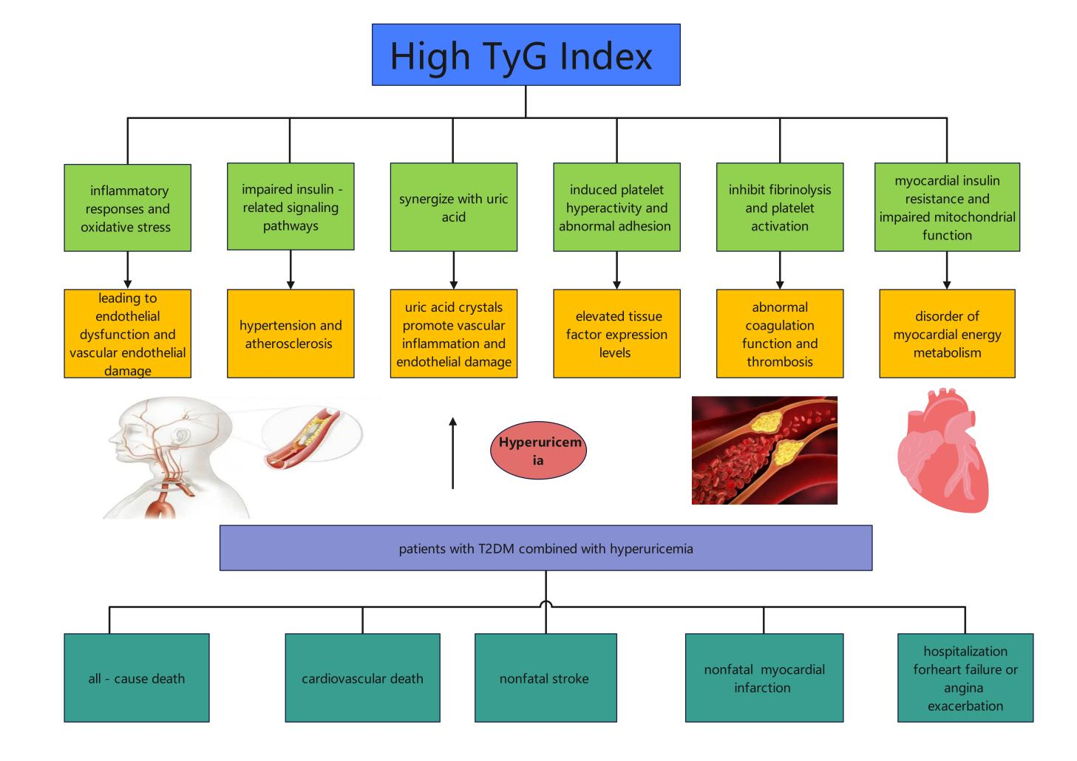
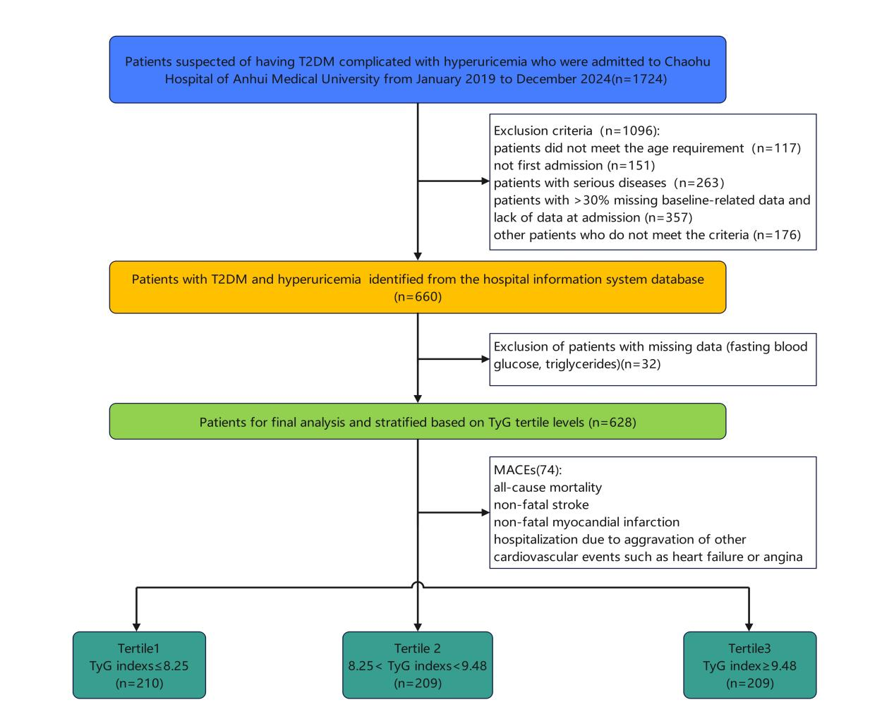
Fig. 1 Displays the flow chart depicting the patients that were included in the study
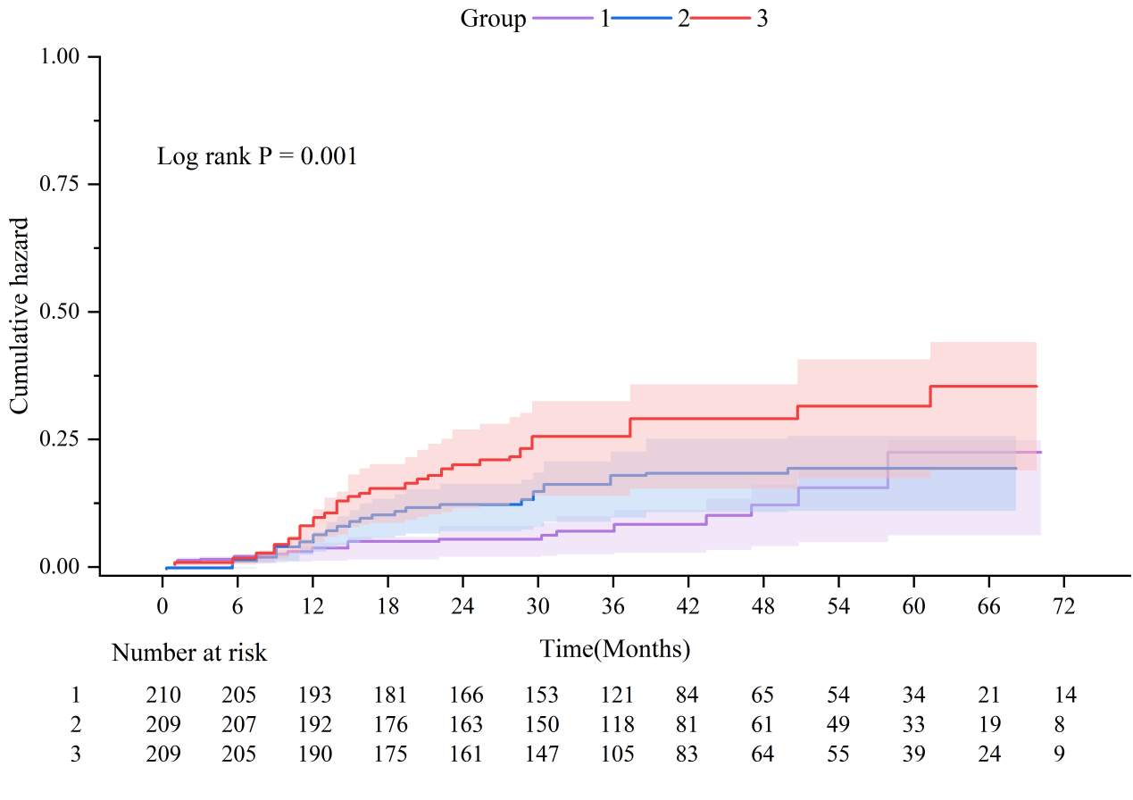
Fig. 2 The Kaplan–Meier curve shows the cumulative risk of cardiovascular events based on varying levels of the TyG index

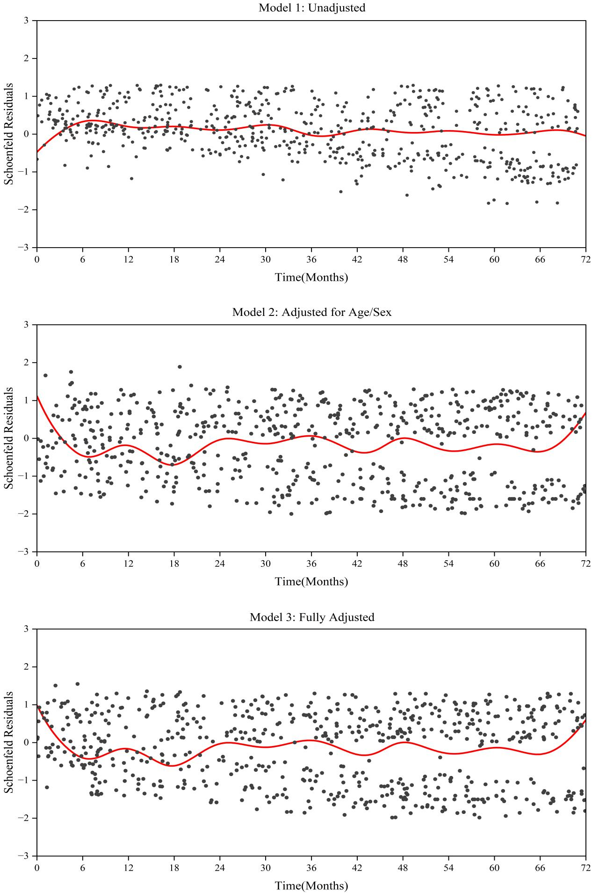
Fig. 3 The figure displays three models of Schoenfeld residuals plotted against time in months
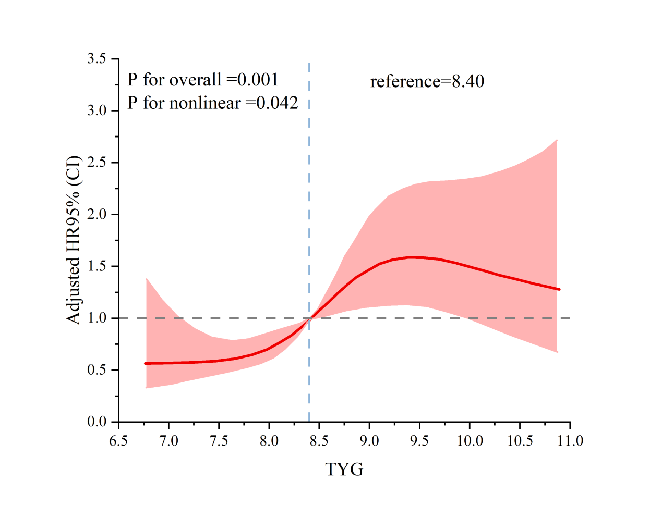Fig. 4 The The restricted cubic spline that represents the connection between MACEs and the TyG index.
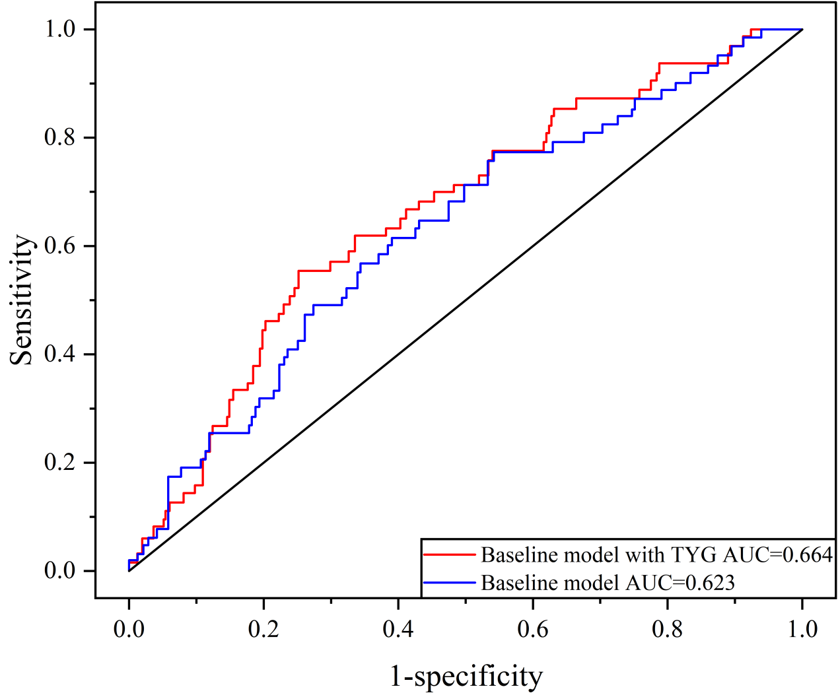Fig. 5 ROC curves that are time-dependent and applied to forecast MACEs

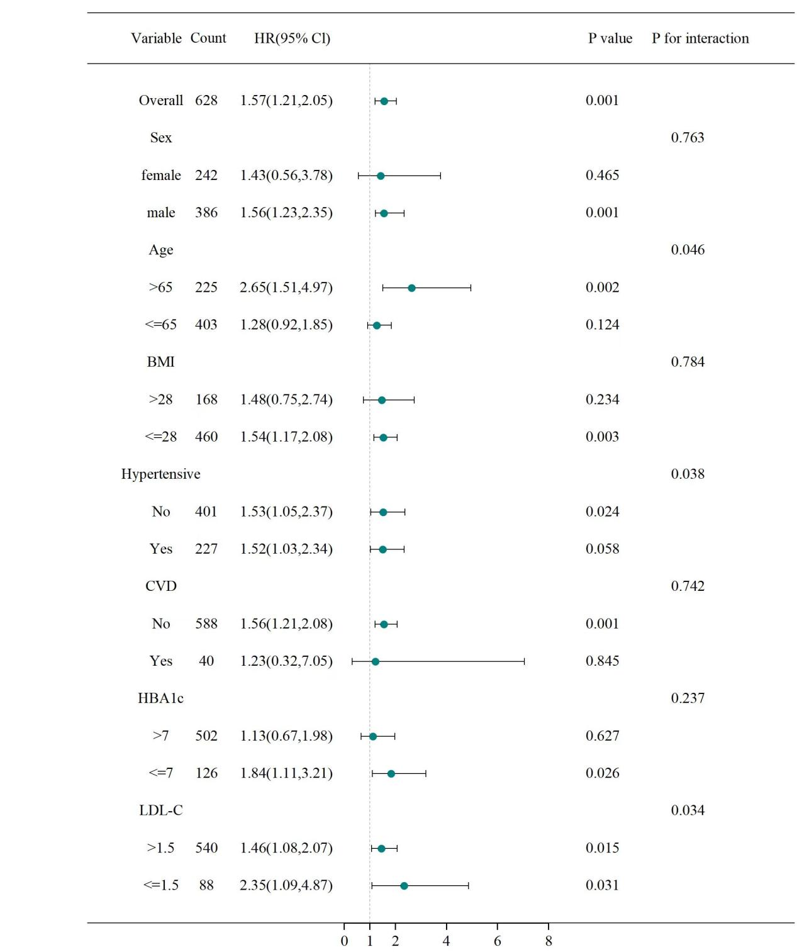Fig. 6 Subgroup and interaction analyses conducted to explore the association between the TyG index (per unit of standard deviation) and MACEs

