Supplementary material

Cumulative Blood Pressure Load as a Predictor of Arterial Stiffness Progression and Incident Diabetic Kidney Disease: A Multicenter Longitudinal Study

Table of Contents
Supplementary Methods 3
Measurement and definitions for modifiable factors 3
Figure S1: Flow chart and inclusion criteria for the arterial stiffness progression cohort and the diabetic kidney disease cohort 4
Figure S2: the Definition of Arterial Stiffness Progression Outcomes 5
Figure S3: Distributions of the number of BP measurements in arterial stiffness progression analysis (n=13,388) and incident diabetic kidney disease analysis (n=11,145) 6
Figure S4: Distributions of cumulative BP load in arterial stiffness progression analysis (n=13,388) 7
Figure S5: Distributions of cumulative BP load in diabetic kidney disease analysis (n=11,145) 8
Figure S6. Restricted cubic spline (RCS) curves for the associations of cumulative DBP load with the progression of arterial stiffness (A, B) and diabetic kidney disease (C, D). 9
Table S1. Completeness of recording for characteristics of the participants at baseline 10
Table S2. Criteria for Selecting Risk Factors for the Structural Equation Modeling 11
Table S3. Baseline Characteristics of Participants Included vs. Excluded from the Analysis 12
Table S4. Standardized path coefficients with bias-corrected bootstrap confidence intervals for the structural equation model in the arterial stiffness progression analysis (n = 13,388) 13
Table S5. Standardized path coefficients with bias-corrected bootstrap confidence intervals for the structural equation model in diabetic kidney disease analysis (n = 11,145) 14
Table S6. Associations of cumulative BP load with progression of arterial stiffness in patients without CVD (n = 11,515) 15
Table S7. Prognostic value of cumulative BP load compared with traditional risk factors in patients without CVD (n = 11,515) 16
Table S8. Associations of cumulative BP load with the progression of arterial stiffness (n = 5,869) and DKD (n = 3,851) in patients with a history of hypertension 17
Table S9. Prognostic value of cumulative BP load compared with traditional risk factors in patients with a history of hypertension 18
Table S10. Associations of cumulative BP load with the progression of arterial stiffness (n = 7,349) and DKD (n = 7,144) in patients without a history of hypertension 19
Table S11. Prognostic value of cumulative BP load compared with traditional risk factors in patients without a history of hypertension 20
Table S12. Associations of BP TITRE and BP variability with progression of arterial stiffness and diabetic kidney disease 21
Table S13. Prognostic Value of BP TITRE and BP Variability Compared with Traditional Risk Factors 22
Table S14. Associations of cumulative BP load with the progression of arterial stiffness (n = 2,012) and DKD (n = 1,968) in patients with four fixed BP measurements 23
Table S15. Prognostic value of cumulative BP load compared with traditional risk factors in patients with four fixed BP measurements 24
Table S16. Associations of cumulative BP load with the progression of arterial stiffness (n = 2,243) and DKD (n = 2,037) in patients whose BP was measured using the OMRON HBP-9031C device 25
Table S17. Prognostic value of cumulative BP load compared with traditional risk factors in patients whose BP was measured using the OMRON HBP-9031C device 26
Table S18. STROBE Statement—Checklist of items that should be included in reports of cohort studies 27
Reference 29

Supplementary Methods

Measurement and definitions for modifiable factors

Socioeconomic status was assessed using three indicators: education level, occupational status, and annual household income. Education level was classified as follows: less than high school (≤9 years) and high school or further (>9 years). Occupation was categorized into intermediate/low-grade (support staff, service workers, unemployed, or retired individuals) and high-grade (executive, administrative, or professional positions). Annual household income was categorized into <10, 10-30, 31-100, 101-300, and >300 thousand CNY. Dietary intake was assessed using a food questionnaire to capture habitual dietary patterns. A composite healthy diet score (range: 0-5) was calculated based on five components: daily vegetable/fruit intake (≥4.5 cups), weekly fish consumption (≥2 servings, ≥3.5-oz/serving), daily soy protein intake (≥25g), daily sodium intake (<1500mg), and weekly sugar-sweetened beverage consumption (≤450 kcal). Each component meeting the criteria contributed one point to the total score [1]. Physical activity was assessed using the short form of the International Physical Activity Questionnaire (IPAQ), based on self-reported frequency and average daily duration of vigorous- and moderate-intensity activities at leisure time. Participants were classified as meeting the physical activity goal if they engaged in ≥75 minutes of vigorous activity, ≥150 minutes of moderate activity, or an equivalent combination per week [2].

Figure S1: Flow chart and inclusion criteria for the arterial stiffness progression cohort and the diabetic kidney disease cohort

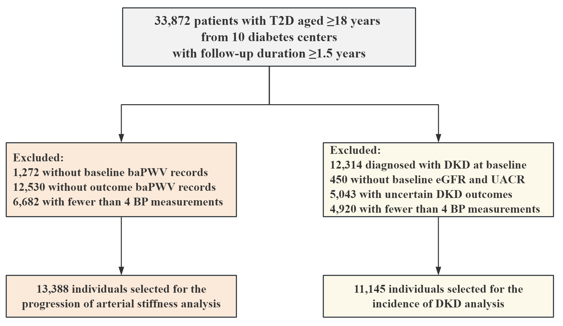

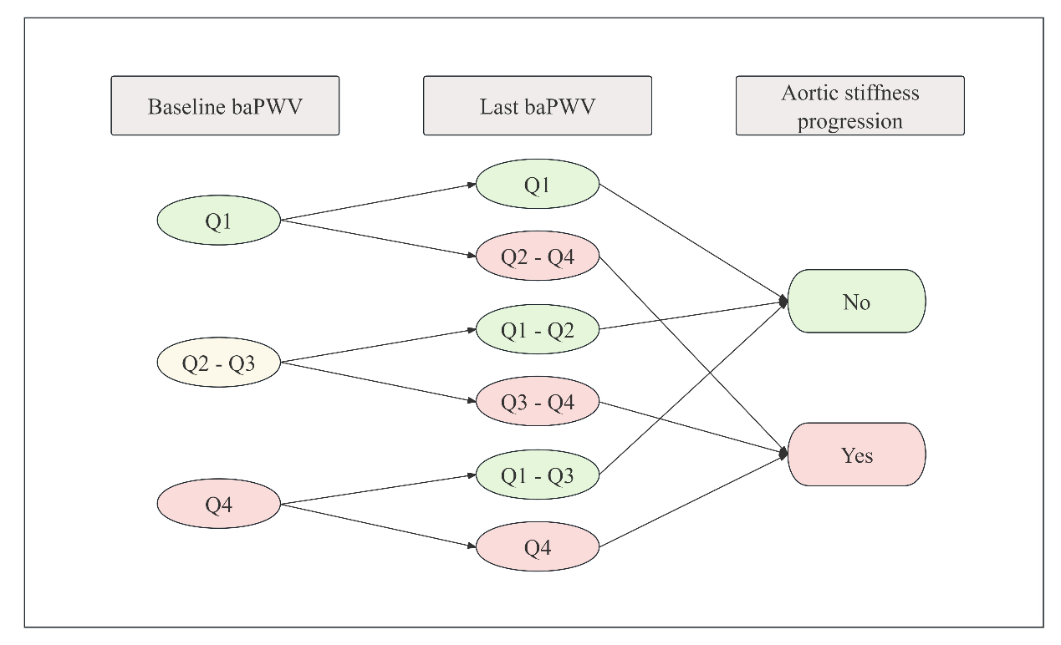
Figure S2: the Definition of Arterial Stiffness Progression Outcomes

Figure S3: Distributions of the number of BP measurements in arterial stiffness progression analysis (n=13,388) and incident diabetic kidney disease analysis (n=11,145)

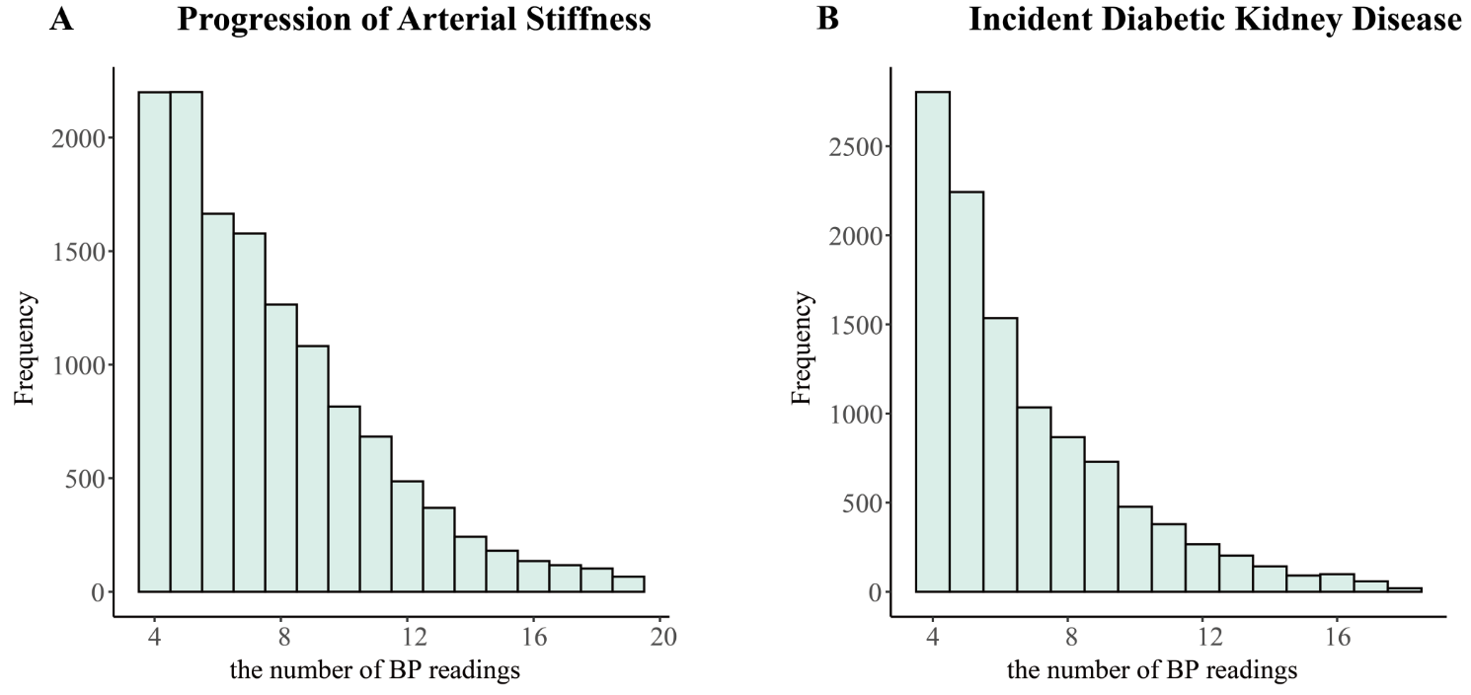

Figure S4: Distributions of cumulative BP load in arterial stiffness progression analysis (n=13,388)

Figure S5: Distributions of cumulative BP load in diabetic kidney disease analysis (n=11,145)

Figure S6. Restricted cubic spline (RCS) curves for the associations of cumulative DBP load with the progression of arterial stiffness (A, B) and diabetic kidney disease (C, D).

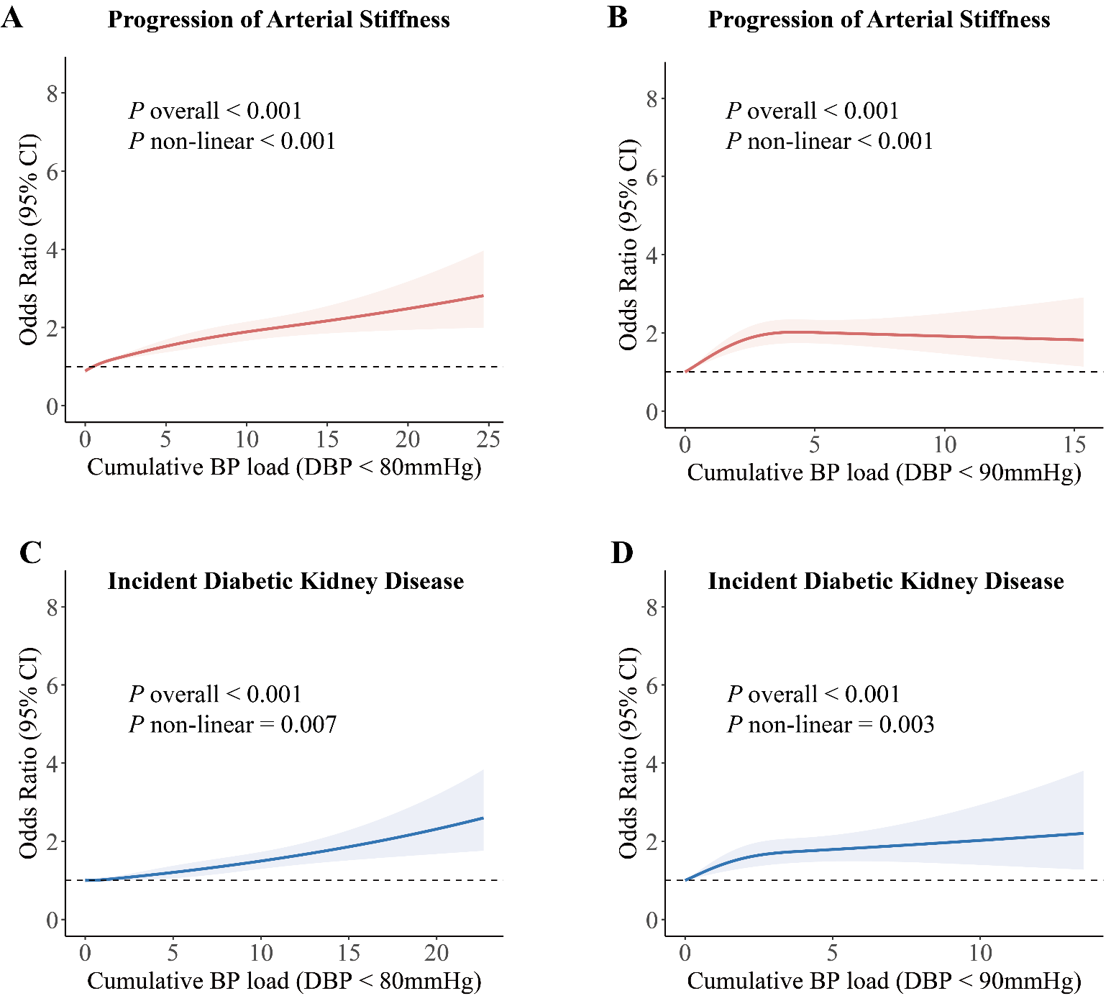

The cumulative DBP load was calculated based on target DBP <80 mmHg and DBP <90 mmHg. All models were adjusted for baseline covariates including age, sex, diabetes duration, DBP, HbA1c, BMI, triglycerides, total cholesterol, high-density lipoprotein cholesterol, low-density lipoprotein cholesterol, history of cardiovascular disease, history of hypertension, and use of antihypertensive medications. The number of BP measurements was also adjusted. Analyses for arterial stiffness progression were additionally adjusted for baseline ba-PWV, while models for incident DKD were adjusted for baseline eGFR. Solid lines represent multivariable-adjusted odds ratios (ORs), and shaded areas indicate 95% confidence intervals (CIs). Knots for the cumulative BP load were placed at the 5th, 35th, 65th, and 95th percentiles. The Wald chi-square test was used to calculate the P values for nonlinearity.

Table S1. Completeness of recording for characteristics of the participants at baseline
 | Progression of  Arterial Stiffness (n=13,388) | Incident Diabetic Kidney Disease (n=11,145)
Age | 13,388 (100) |  | 11,145 (100)
Sex | 13,388 (100) |  | 11,145 (100)
Duration of diabetes | 13,360 (99.79) |  | 11,104 (99.63)
History of CVD | 13,340 (99.64) |  | 11,063 (99.26)
History of hypertension | 13,218 (98.73) |  | 10,995 (98.65)
Education level | 13,355 (99.75) |  | 11,077 (99.39)
Occupation | 13,360 (99.79) |  | 11,092 (99.52)
Annual Household Income | 12,449 (92.99) |  | 10,242 (91.90)
Diet score | 12,504 (93.40) |  | 10,225 (91.75)
Physical activity at goal | 13,279 (99.19) |  | 11,012 (98.81)
Systolic blood pressure | 13,388 (100) |  | 11,145 (100)
Diastolic blood pressure | 13,388 (100) |  | 11,145 (100)
HbA1c | 13,324 (99.52) |  | 11,124 (99.81)
Body mass index | 13,364 (99.82) |  | 11,091 (99.52)
Triglycerides | 13,235 (98.86) |  | 11,110 (99.69)
Total cholesterol | 13,207 (98.65) |  | 11,094 (99.54)
HDL cholesterol | 13,091 (97.78) |  | 11,023 (98.91)
LDL cholesterol | 13,187 (98.50) |  | 11,076 (99.38)
eGFR | 13,207 (98.65) |  | 11,145 (100)
UACR | 12,761 (95.32) |  | 11,145 (100)
ba-PWV measurement | 13,388 (100) |  | 10,934 (98.11)
Antihypertensive agents | 13,061 (97.56) |  | 10,784 (96.76)
Abbreviations: CVD = cardiovascular diseases, HbA1c = glycated hemoglobin, eGFR = estimated glomerular filtration rate, UACR = urine albumin-to-creatinine ratio, ba-PWV = brachial-ankle pulse wave velocity.

Table S2. Criteria for Selecting Risk Factors for the Structural Equation Modeling

Criterion | Description
1. Biological plausibility | Supported by prior studies and pathophysiological evidence
2. Statistical association | Demonstrated association with diabetic complications in previous research
3. Prevalence | Exposure rate ≥10% among study participants
4. Modifiability | Risk factors are clinically modifiable
5. Data availability | Variables were available and reliably measurable in our database
6. Missing data | Proportion of missing values <10% to ensure data integrity

Table S3. Baseline Characteristics of Participants Included vs. Excluded from the Analysis
 |  | Progression of Arterial Stiffness |  |  |  | Incident Diabetic Kidney Disease
 |  | Excluded | Included | P |  | Excluded | Included | P
No. of participants |  | 20,484 | 13,388 |  |  | 22,727 | 11,145
Age, years |  | 54.84 ± 11.32 | 54.83 ± 10.96 | 0.762 |  | 55.10 ± 11.67 | 53.46 ± 10.93 | <0.001
Males, n (%) |  | 11162 (57.79%) | 7555 (56.43%) | 0.015 |  | 13236 (56.35%) | 6655 (59.71%) | <0.001
Duration of diabetes, years |  | 6.93 ± 7.08 | 7.68 ± 7.00 | <0.001 |  | 7.56 ± 7.23 | 6.14 ± 6.51 | <0.001
History of CVD, % |  | 2683 (14.23%) | 1825 (13.68%) | 0.166 |  | 3393 (14.78%) | 1277 (11.54%) | <0.001
History of hypertension, % |  | 8137 (43.34%) | 5869 (44.40%) | 0.065 |  | 10714 (46.93%) | 3851 (35.03%) | <0.001
Systolic blood pressure, mmHg |  | 132.44 ± 18.35 | 132.05 ± 18.96 | 0.080 |  | 133.77 ± 19.19 | 128.49 ± 16.68 | <0.001
Diastolic blood pressure, mmHg |  | 78.29 ± 11.54 | 76.67 ± 11.45 | <0.001 |  | 78.18 ± 11.87 | 76.35 ± 10.66 | <0.001
HbA1c, % |  | 8.51 ± 1.93 | 8.37 ± 2.05 | <0.001 |  | 8.75 ± 2.19 | 8.25 ± 2.05 | <0.001
Body mass index, kg/m² |  | 26.10 ± 3.85 | 26.03 ± 3.69 | 0.102 |  | 26.28 ± 3.93 | 25.54 ± 3.56 | <0.001
Triglycerides, mmol/L |  | 2.23 ± 2.33 | 2.13 ± 2.20 | <0.001 |  | 2.28 ± 2.45 | 2.02 ± 1.95 | <0.001
Total cholesterol, mmol/L |  | 4.96 ± 1.32 | 4.94 ± 1.29 | 0.426 |  | 5.00 ± 1.36 | 4.87 ± 1.21 | <0.001
HDL cholesterol, mmol/L |  | 1.17 ± 0.33 | 1.23 ± 0.34 | <0.001 |  | 1.19 ± 0.34 | 1.21 ± 0.33 | <0.001
LDL cholesterol, mmol/L |  | 2.99 ± 0.99 | 2.92 ± 1.00 | <0.001 |  | 2.98 ± 1.01 | 2.94 ± 0.96 | 0.006

Continuous variables are presented as mean ± standard deviation (SD) or median (interquartile range), while categorical variables are summarized as counts and percentages. Group differences were assessed using Student's t-test, Wilcoxon rank-sum test, or chi-square test.
Abbreviations: CVD = cardiovascular diseases, HbA1c = glycated hemoglobin.

Table S4. Standardized path coefficients with bias-corrected bootstrap confidence intervals for the structural equation model in the arterial stiffness progression analysis (n = 13,388)

RMSEA = 0.037 (SD = 0.007); CFI = 0.998 (SD = 0.001); TLI = 0.929 (SD = 0.025).
Abbreviations: HbA1c = glycated hemoglobin.

Table S5. Standardized path coefficients with bias-corrected bootstrap confidence intervals for the structural equation model in Incident diabetic kidney disease analysis (n = 11,145)
RMSEA = 0.031 (SD = 0.005), CFI = 0.996 (SD = 0.001) indicated a good fit, and TLI = 0.937 (SD = 0.021)
Abbreviations: HbA1c = glycated hemoglobin.

Table S6. Associations of cumulative BP load with progression of arterial stiffness in patients without CVD (n = 11,515)
 |  | OR (95% CI) | P
Cumulative SBP load
Target: SBP<120mmHg |  | 1.76 (1.67 - 1.87) | <0.001
Target: SBP<130mmHg |  | 1.60 (1.52 - 1.69) | <0.001
Target: SBP<140mmHg |  | 1.43 (1.35 - 1.51) | <0.001
Cumulative DBP load
Target: DBP<80mmHg |  | 1.45 (1.38 - 1.52) | <0.001
Target: DBP<90mmHg |  | 1.20 (1.15 - 1.25) | <0.001
The odds ratios (OR) and 95% confidence intervals (CI) were adjusted for baseline covariates including age, sex, diabetes duration, blood pressure, HbA1c, BMI, triglycerides, total cholesterol, high-density lipoprotein cholesterol, low-density lipoprotein cholesterol, history of hypertension, and use of antihypertensive medications. In addition, the number of BP measurements and baseline ba-PWV were also included.
Abbreviations: SBP = systolic blood pressure, DBP = diastolic blood pressure.

Table S7. Prognostic value of cumulative BP load compared with traditional risk factors in patients without CVD (n = 11,515)
 | Akaike Information Criterion |  | C-Statistic  (95% CI) |  | Continuous Net Reclassification Improvement
Base SBP model |  | 14,531 |  | 0.713 (0.704 - 0.722) |  | Reference
Base SBP model + cumulative SBP load
Target: SBP<120mmHg |  | 14,097 |  | 0.736 (0.727 - 0.745) |  | 35.2% (31.6% - 38.8%)
Target: SBP<130mmHg |  | 14,210 |  | 0.731 (0.722 - 0.740) |  | 26.6% (23.0% - 30.2%)
Target: SBP<140mmHg |  | 14,337 |  | 0.725 (0.716 - 0.734) |  | 15.4% (11.8% - 19.0%)
Base DBP model |  | 14,533 |  | 0.713 (0.704 - 0.723) |  | Reference
Base DBP model + cumulative DBP load
Target: DBP<80mmHg |  | 14,326 |  | 0.726 (0.717 - 0.735) |  | 30.6% (27.1% - 34.2%)
Target: DBP<90mmHg |  | 14,466 |  | 0.717 (0.708 - 0.727) |  | 22.7% (19.2% - 26.2%)
*Base SBP model contained baseline SBP and other traditional risk factors, including age, sex, diabetes duration, HbA1c, body mass index, triglycerides, total cholesterol, high-density lipoprotein cholesterol, low-density lipoprotein cholesterol, history of hypertension, and use of antihypertensive medications.
*Base DBP model contained baseline DBP and other traditional risk factors, including age, sex, diabetes duration, HbA1c, body mass index, triglycerides, total cholesterol, high-density lipoprotein cholesterol, low-density lipoprotein cholesterol, history of hypertension, and use of antihypertensive medications.
In addition to the common baseline covariates included in the models, baseline ba-PWV was additionally included in the model for arterial stiffness progression, and baseline eGFR was included in the model for incident DKD.
Abbreviations: SBP = systolic blood pressure, DBP = diastolic blood pressure.
Table S8. Associations of cumulative BP load with the progression of arterial stiffness (n = 5,869) and DKD (n = 3,851) in patients with a history of hypertension
 |  | OR (95% CI) | P
Progression of Arterial Stiffness
Cumulative SBP load
Target: SBP<120mmHg |  | 1.63 (1.52 - 1.75) | <0.001
Target: SBP<130mmHg |  | 1.54 (1.44 - 1.65) | <0.001
Target: SBP<140mmHg |  | 1.41 (1.33 - 1.50) | <0.001
Cumulative DBP load
Target: DBP<80mmHg |  | 1.52 (1.41 - 1.63) | <0.001
Target: DBP<90mmHg |  | 1.23 (1.14 - 1.32) | <0.001
Incident Diabetic Kidney Disease
Cumulative SBP load
Target: SBP<120mmHg |  | 1.30 (1.20 - 1.41) | <0.001
Target: SBP<130mmHg |  | 1.27 (1.19 - 1.36) | <0.001
Target: SBP<140mmHg |  | 1.24 (1.16 - 1.31) | <0.001
Cumulative DBP load
Target: DBP<80mmHg |  | 1.22 (1.13 - 1.31) | <0.001
Target: DBP<90mmHg |  | 1.15 (1.08 - 1.22) | <0.001
The odds ratios (OR) and 95% confidence intervals (CI) were adjusted for baseline covariates including age, sex, diabetes duration, blood pressure, HbA1c, BMI, triglycerides, total cholesterol, high-density lipoprotein cholesterol, low-density lipoprotein cholesterol, history of CVD, and use of antihypertensive medications. In addition, the number of BP measurements was included. Analyses for arterial stiffness progression were additionally adjusted for baseline ba-PWV, while models for incident DKD were adjusted for baseline eGFR.

Table S9. Prognostic value of cumulative BP load compared with traditional risk factors in patients with a history of hypertension
 | Akaike Information Criterion | C-Statistic  (95% CI) | Continuous Net Reclassification Improvement
Progression of Arterial Stiffness
Base SBP model | 7,638 | 0.661 (0.647 - 0.675) | Reference
Base SBP model + cumulative SBP load
Target: SBP<120mmHg | 7,444 | 0.689 (0.675 - 0.702) | 33.0% (27.9% - 38.1%)
Target: SBP<130mmHg | 7,456 | 0.688 (0.675 - 0.702) | 30.7% (25.7% - 35.7%)
Target: SBP<140mmHg | 7,500 | 0.683 (0.670 - 0.697) | 22.8% (17.9% - 27.8%)
Base DBP model | 7,632 | 0.662 (0.648 - 0.676) | Reference
Base DBP model + cumulative DBP load
Target: DBP<80mmHg | 7,549 | 0.675 (0.661 - 0.689) | 27.0% (22.0% - 32.0%)
Target: DBP<90mmHg | 7,596 | 0.666 (0.652 - 0.680) | 23.5% (18.6% - 28.4%)
Incident Diabetic Kidney Disease
Base SBP model | 4,747 | 0.624 (0.605 - 0.643) | Reference
Base SBP model + cumulative SBP load | 4,688
Target: SBP<120mmHg | 4,754 | 0.639 (0.620 - 0.657) | 18.8% (12.2% - 25.5%)
Target: SBP<130mmHg | 4,694 | 0.639 (0.620 - 0.658) | 17.7% (11.1% - 24.3%)
Target: SBP<140mmHg | 4,689 | 0.638 (0.619 - 0.657) | 11.2% (4.7% - 17.7%)
Base DBP model | 4,754 | 0.617 (0.598 - 0.636) | Reference
Base DBP model + cumulative DBP load
Target: DBP<80mmHg | 4,725 | 0.628 (0.609 - 0.647) | 19.1% (12.7% - 25.6%)
Target: DBP<90mmHg | 4,733 | 0.625 (0.606 - 0.644) | 16.4% (9.8% - 23.0%)
*Base SBP model contained baseline SBP and other traditional risk factors, including age, sex, diabetes duration, HbA1c, body mass index, triglycerides, total cholesterol, high-density lipoprotein cholesterol, low-density lipoprotein cholesterol, history of cardiovascular disease, and use of antihypertensive medications.
*Base DBP model contained baseline DBP and other traditional risk factors, including age, sex, diabetes duration, HbA1c, body mass index, triglycerides, total cholesterol, high-density lipoprotein cholesterol, low-density lipoprotein cholesterol, history of cardiovascular disease, and use of antihypertensive medications.
In addition to the common baseline covariates included in the models, baseline ba-PWV was additionally included in the model for arterial stiffness progression, and baseline eGFR was included in the model for incident DKD.
Abbreviations: SBP = systolic blood pressure, DBP = diastolic blood pressure.

Table S10. Associations of cumulative BP load with the progression of arterial stiffness (n = 7,349) and DKD (n = 7,144) in patients without a history of hypertension
 |  | OR (95% CI) | P
Progression of Arterial Stiffness
Cumulative SBP load
Target: SBP<120mmHg |  | 1.87 (1.73 - 2.03) | <0.001
Target: SBP<130mmHg |  | 1.68 (1.54 - 1.82) | <0.001
Target: SBP<140mmHg |  | 1.50 (1.37 - 1.64) | <0.001
Cumulative DBP load
Target: DBP<80mmHg |  | 1.52 (1.41 - 1.63) | <0.001
Target: DBP<90mmHg |  | 1.23 (1.14 - 1.32) | <0.001
Incident Diabetic Kidney Disease
Cumulative SBP load
Target: SBP<120mmHg |  | 1.30 (1.20 - 1.41) | <0.001
Target: SBP<130mmHg |  | 1.30 (1.20 - 1.40) | <0.001
Target: SBP<140mmHg |  | 1.26 (1.16 - 1.36) | <0.001
Cumulative DBP load
Target: DBP<80mmHg |  | 1.23 (1.15 - 1.32) | <0.001
Target: DBP<90mmHg |  | 1.13 (1.06 - 1.21) | <0.001
The odds ratios (OR) and 95% confidence intervals (CI) were adjusted for baseline covariates including age, sex, diabetes duration, blood pressure, HbA1c, BMI, triglycerides, total cholesterol, high-density lipoprotein cholesterol, low-density lipoprotein cholesterol, and history of CVD. In addition, the number of BP measurements was included. Analyses for arterial stiffness progression were additionally adjusted for baseline ba-PWV, while models for incident DKD were adjusted for baseline eGFR.

Table S11. Prognostic value of cumulative BP load compared with traditional risk factors in patients without a history of hypertension
 | Akaike Information Criterion | C-Statistic  (95% CI) | Continuous Net Reclassification Improvement
Progression of Arterial Stiffness
Base SBP model | 9,027 | 0.706 (0.695 - 0.718) | Reference
Base SBP model + cumulative SBP load
Target: SBP<120mmHg | 8,732 | 0.737 (0.726 - 0.748) | 38.2% (33.7% - 42.8%)
Target: SBP<130mmHg | 8,837 | 0.727 (0.715 - 0.739) | 29.5% (24.9% - 34.0%)
Target: SBP<140mmHg | 8,927 | 0.718 (0.706 - 0.730) | 15.3% (10.9% - 19.7%)
Base DBP model | 9,039 | 0.705 (0.693 - 0.717) | Reference
Base DBP model + cumulative DBP load
Target: DBP<80mmHg | 8,902 | 0.720 (0.708 - 0.731) | 31.8% (27.3% - 36.3%)
Target: DBP<90mmHg | 9,004 | 0.709 (0.698 - 0.721) | 23.7% (19.3% - 28.1%)
Incident Diabetic Kidney Disease
Base SBP model | 7,338 | 0.598 (0.583 - 0.614) | Reference
Base SBP model + cumulative SBP load
Target: SBP<120mmHg | 7,295 | 0.611 (0.595 - 0.627) | 14.0% (8.4% - 19.5%)
Target: SBP<130mmHg | 7,295 | 0.609 (0.594 - 0.625) | 11.5% (6.0% - 17.0%)
Target: SBP<140mmHg | 7,306 | 0.607 (0.591 - 0.623) | 6.5% (1.1% - 12.0%)
Base DBP model | 7,350 | 0.594 (0.578 - 0.610) | Reference
Base DBP model + cumulative DBP load
Target: DBP<80mmHg | 7,316 | 0.603 (0.588 - 0.619) | 11.8% (6.3% - 17.3%)
Target: DBP<90mmHg | 7,336 | 0.599 (0.583 - 0.615) | 7.9% (2.5% - 13.2%)
*Base SBP model contained baseline SBP and other traditional risk factors, including age, sex, diabetes duration, HbA1c, body mass index, triglycerides, total cholesterol, high-density lipoprotein cholesterol, low-density lipoprotein cholesterol, and history of cardiovascular disease.
*Base DBP model contained baseline DBP and other traditional risk factors, including age, sex, diabetes duration, HbA1c, body mass index, triglycerides, total cholesterol, high-density lipoprotein cholesterol, low-density lipoprotein cholesterol, and history of cardiovascular disease.
In addition to the common covariates included in the models, baseline ba-PWV was additionally included in the model for arterial stiffness progression, and baseline eGFR was included in the model for incident DKD.
Abbreviations: SBP = systolic blood pressure, DBP = diastolic blood pressure.

Table S12. Associations of BP TITRE and BP variability with progression of arterial stiffness and diabetic kidney disease
Progression of Arterial Stiffness |  | OR (95% CI) |  | P
SBP TITRE
Target: SBP<120mmHg |  | 0.66 (0.63 - 0.69) |  | <0.001
Target: SBP<130mmHg |  | 0.63 (0.60 - 0.66) |  | <0.001
Target: SBP<140mmHg |  | 0.67 (0.64 - 0.70) |  | <0.001
SBP variability
SBP SD |  | 1.14 (1.10 - 1.19) |  | <0.001
SBP ARV |  | 1.14 (1.10 - 1.19) |  | <0.001
DBP TITRE
Target: DBP<80mmHg |  | 0.65 (0.62 - 0.69) |  | <0.001
Target: DBP<90mmHg |  | 0.78 (0.75 - 0.82) |  | <0.001
DBP variability
DBP SD |  | 1.02 (0.99 - 1.06) |  | 0.239
DBP ARV |  | 1.03 (0.99 - 1.07) |  | 0.120
Incident Diabetic Kidney Disease |  | OR (95% CI) |  | P
SBP TITRE
Target: SBP<120mmHg |  | 0.89 (0.85 - 0.94) |  | <0.001
Target: SBP<130mmHg |  | 0.83 (0.78 - 0.87) |  | <0.001
Target: SBP<140mmHg |  | 0.81 (0.77 - 0.85) |  | <0.001
SBP variability
SBP SD |  | 1.11 (1.07 - 1.16) |  | <0.001
SBP ARV |  | 1.10 (1.06 - 1.15) |  | <0.001
DBP TITRE
Target: DBP<80mmHg |  | 0.87 (0.82 - 0.92) |  | <0.001
Target: DBP<90mmHg |  | 0.86 (0.82 - 0.90) |  | <0.001
DBP variability
DBP SD |  | 1.09 (1.05 - 1.14) |  | <0.001
DBP ARV |  | 1.08 (1.03 - 1.12) |  | 0.001
The odds ratios (OR) and 95% confidence intervals (CI) were adjusted for baseline covariates including age, sex, diabetes duration, blood pressure, HbA1c, BMI, triglycerides, total cholesterol, high-density lipoprotein cholesterol, low-density lipoprotein cholesterol, history of cardiovascular disease, history of hypertension, and use of antihypertensive medications. In addition, the number of BP measurements was included. Analyses for arterial stiffness progression were additionally adjusted for baseline ba-PWV, while models for incident DKD were adjusted for baseline eGFR.

Table S13. Prognostic Value of BP TITRE and BP Variability Compared with Traditional Risk Factors
 | Akaike Information Criterion | C-Statistic  (95% CI) | Continuous Net Reclassification Improvement
Progression of Arterial Stiffness
Base SBP model | 16,889 | 0.699 (0.690 - 0.708) | Reference
Base model + SBP TITRE
Target: SBP<120mmHg | 16,569 | 0.716 (0.707 - 0.725) | 25.5% (22.1% - 28.8%)
Target: SBP<130mmHg | 16,555 | 0.717 (0.708 - 0.726) | 27.1% (23.8% - 30.4%)
Target: SBP<140mmHg | 16,528 | 0.718 (0.710 - 0.727) | 35.5% (32.1% - 38.8%)
Base model + SBP variability
SBP SD | 16,832 | 0.702 (0.693 - 0.711) | 11.6% (8.3% - 15.0%)
SBP ARV | 16,843 | 0.701 (0.692 - 0.710) | 10.9% (7.6% - 14.3%)
Base DBP model | 16,896 | 0.698 (0.690 - 0.707) | Reference
Base model + DBP TITRE
Target: DBP<90mmHg | 16,769 | 0.705 (0.696 - 0.714) | 25.9% (22.6% – 29.2%)
Target: DBP<80mmHg | 16,623 | 0.713 (0.704 - 0.722) | 25.2% (22.0% – 28.5%)
Base model + DBP variability
DBP SD | 16,895 | 0.698 (0.690 - 0.707) | 3.2% (0.6% - 6.5%)
DBP ARV | 16,896 | 0.698 (0.690 - 0.707) | 3.5% (0.1% - 6.8%)
Incident Diabetic Kidney Disease
Base SBP model | 12,076 | 0.653 (0.642 - 0.665) | Reference
Base model + SBP TITRE
Target: SBP<120mmHg | 12,051 | 0.657 (0.646 - 0.669) | 11.9% (7.7% - 16.1%)
Target: SBP<130mmHg | 12,026 | 0.659 (0.648 - 0.670) | 10.7% (6.5% - 14.8%)
Target: SBP<140mmHg | 12,010 | 0.660 (0.649 - 0.672) | 15.1% (11.5% - 20.0%)
Base model + SBP variability
SBP SD | 12,064 | 0.655 (0.644 - 0.667) | 0.6% (-3.6% - 4.9%)
SBP ARV | 12,061 | 0.655 (0.644 - 0.667) | 7.7% (3.4% - 11.9%)
Base DBP model | 12,290 | 0.624 (0.612 - 0.636) | Reference
Base model + DBP TITRE
Target: DBP<80mmHg | 12,259 | 0.628 (0.616 - 0.640) | 7.5% (3.3% - 11.7%)
Target: DBP<90mmHg | 12,247 | 0.630 (0.618 - 0.642) | 11.4% (7.3% - 15.5%)
Base model + DBP variability
DBP SD | 12,278 | 0.626 (0.614 - 0.638) | 5.8% (1.5% - 10.0%)
DBP ARV | 12,277 | 0.626 (0.614 - 0.638) | 9.1% (4.9% - 13.3%)
*Base SBP model contained baseline SBP and other traditional risk factors, including age, sex, diabetes duration, HbA1c, body mass index, triglycerides, total cholesterol, high-density lipoprotein cholesterol, low-density lipoprotein cholesterol, history of cardiovascular disease, history of hypertension, and use of antihypertensive medications.
*Base DBP model contained baseline DBP and other traditional risk factors, including age, sex, diabetes duration, HbA1c, body mass index, triglycerides, total cholesterol, high-density lipoprotein cholesterol, low-density lipoprotein cholesterol, history of cardiovascular disease, history of hypertension, and use of antihypertensive medications.
In addition to the common covariates included in the models, baseline ba-PWV was additionally included in the model for arterial stiffness progression, and baseline eGFR was included in the model for incident DKD.
Abbreviations: SBP = systolic blood pressure, DBP = diastolic blood pressure.

Table S14. Associations of cumulative BP load with the progression of arterial stiffness (n = 2,012) and DKD (n = 1,968) in patients with four fixed BP measurements
 |  | OR (95% CI) | P
Progression of Arterial Stiffness
Cumulative SBP load
Target: SBP<120mmHg |  | 1.49 (1.30 - 1.72) | <0.001
Target: SBP<130mmHg |  | 1.44 (1.25 - 1.67) | <0.001
Target: SBP<140mmHg |  | 1.37 (1.18 - 1.61) | <0.001
Cumulative DBP load
Target: DBP<80mmHg |  | 1.09 (0.97 - 1.23) | 0.162
Target: DBP<90mmHg |  | 1.02 (0.91 - 1.13) | 0.772
Incident Diabetic Kidney Disease
Cumulative SBP load
Target: SBP<120mmHg |  | 1.36 (1.18 - 1.56) | <0.001
Target: SBP<130mmHg |  | 1.33 (1.17 - 1.50) | <0.001
Target: SBP<140mmHg |  | 1.29 (1.16 - 1.44) | <0.001
Cumulative DBP load
Target: DBP<80mmHg |  | 1.17 (1.04 - 1.33) | 0.011
Target: DBP<90mmHg |  | 1.07 (0.95 - 1.19) | 0.225
BP measurements were recorded at baseline, 6 (±1 month), 12 (±1 month), and 18 months (±1 month). The odds ratios (OR) and 95% confidence intervals (CI) were adjusted for baseline covariates including age, sex, diabetes duration, blood pressure, HbA1c, BMI, triglycerides, total cholesterol, high-density lipoprotein cholesterol, low-density lipoprotein cholesterol, history of cardiovascular disease, history of hypertension, and use of antihypertensive medications. Analyses for arterial stiffness progression were additionally adjusted for baseline ba-PWV, while models for incident DKD were adjusted for baseline eGFR.

Table S15. Prognostic value of cumulative BP load compared with traditional risk factors in patients with four fixed BP measurements
 | Akaike Information Criterion | C-Statistic  (95% CI) | Continuous Net Reclassification Improvement
Progression of Arterial Stiffness
Base SBP model | 2,504 | 0.718 (0.696 - 0.740) | Reference
Base SBP model + cumulative SBP load
Target: SBP<120mmHg | 2,474 | 0.730 (0.708 - 0.752) | 24.2% (15.5% - 32.8%)
Target: SBP<130mmHg | 2,481 | 0.728 (0.706 - 0.750) | 21.0% (12.4% - 29.6%)
Target: SBP<140mmHg | 2,489 | 0.726 (0.704 - 0.748) | 8.7% (0.3% - 17.2%)
Base DBP model | 2,533 | 0.709 (0.686 - 0.731) | Reference
Base DBP model + cumulative DBP load
Target: DBP<80mmHg | 2,531 | 0.711 (0.688 - 0.733) | 18.7% (14.6% - 22.7%)
Target: DBP<90mmHg | 2,531 | 0.710 (0.687 - 0.732) | 13.2% (4.6% - 21.8%)
Incident Diabetic Kidney Disease
Base SBP model | 2,137 | 0.644 (0.616 - 0.672) | Reference
Base SBP model + cumulative SBP load
Target: SBP<120mmHg | 2,120 | 0.656 (0.627 - 0.684) | 16.4% (6.2% - 26.6%)
Target: SBP<130mmHg | 2,119 | 0.655 (0.626 - 0.683) | 14.1% (9.5% - 22.3%)
Target: SBP<140mmHg | 2,118 | 0.653 (0.625 - 0.682) | 10.1% (4.4% - 17.5%)
Base DBP model | 2,139 | 0.640 (0.612 - 0.668) | Reference
Base DBP model + cumulative DBP load
Target: DBP<80mmHg | 2,135 | 0.644 (0.616 - 0.672) | 13.9% (6.8% - 19.7%)
Target: DBP<90mmHg | 2,139 | 0.641 (0.612 - 0.669) | 12.8% (3.0% - 22.7%)
BP measurements were recorded at baseline, 6 (±1 month), 12 (±1 month), and 18 months (±1 month).
*Base SBP model contained baseline SBP and other traditional risk factors, including age, sex, diabetes duration, HbA1c, body mass index, triglycerides, total cholesterol, high-density lipoprotein cholesterol, low-density lipoprotein cholesterol, and history of cardiovascular disease.
*Base DBP model contained baseline DBP and other traditional risk factors, including age, sex, diabetes duration, HbA1c, body mass index, triglycerides, total cholesterol, high-density lipoprotein cholesterol, low-density lipoprotein cholesterol, and history of cardiovascular disease.
In addition to the common covariates included in the models, baseline ba-PWV was additionally included in the model for arterial stiffness progression, and baseline eGFR was included in the model for incident DKD.
Abbreviations: SBP = systolic blood pressure, DBP = diastolic blood pressure.

Table S16. Associations of cumulative BP load with the progression of arterial stiffness (n = 2,243) and DKD (n = 2,037) in patients whose BP was measured using the OMRON HBP-9031C device
 |  | OR (95% CI) | P
Progression of Arterial Stiffness
Cumulative SBP load
Target: SBP<120mmHg |  | 1.63 (1.41 - 1.88) | <0.001
Target: SBP<130mmHg |  | 1.52 (1.30 - 1.79) | <0.001
Target: SBP<140mmHg |  | 1.43 (1.20 - 1.72) | <0.001
Cumulative DBP load
Target: DBP<80mmHg |  | 1.32 (1.18 - 1.47) | <0.001
Target: DBP<90mmHg |  | 1.12 (1.02 - 1.24) | 0.002
Incident Diabetic Kidney Disease
Cumulative SBP load
Target: SBP<120mmHg |  | 1.24 (1.08 - 1.43) | 0.003
Target: SBP<130mmHg |  | 1.16 (1.01 - 1.34) | 0.034
Target: SBP<140mmHg |  | 1.09 (0.95 - 1.25) | 0.226
Cumulative DBP load
Target: DBP<80mmHg |  | 1.12 (0.98 - 1.26) | 0.081
Target: DBP<90mmHg |  | 1.06 (0.94 - 1.17) | 0.311
The odds ratios (OR) and 95% confidence intervals (CI) were adjusted for baseline covariates including age, sex, diabetes duration, blood pressure, HbA1c, BMI, triglycerides, total cholesterol, high-density lipoprotein cholesterol, low-density lipoprotein cholesterol, history of cardiovascular disease, history of hypertension, and use of antihypertensive medications. In addition, the number of BP measurements was included. Analyses for arterial stiffness progression were additionally adjusted for baseline ba-PWV, while models for incident DKD were adjusted for baseline eGFR.

Table S17. Prognostic value of cumulative BP load compared with traditional risk factors in patients whose BP was measured using the OMRON HBP-9031C device
 | Akaike Information Criterion | C-Statistic  (95% CI) | Continuous Net Reclassification Improvement
Progression of Arterial Stiffness
Base SBP model | 2,948 | 0.715 (0.695 - 0.736) | Reference
Base SBP model + cumulative SBP load
Target: SBP<120mmHg | 2,902 | 0.730 (0.709 - 0.750) | 29.7% (21.8% - 37.7%)
Target: SBP<130mmHg | 2,921 | 0.725 (0.704 - 0.745) | 16.4% (12.4% - 24.3%)
Target: SBP<140mmHg | 2,933 | 0.721 (0.701 - 0.742) | 6.5% (0.2% - 13.2%)
Base DBP model | 2,948 | 0.716 (0.696 - 0.737) | Reference
Base DBP model + cumulative DBP load
Target: DBP<80mmHg | 2,923 | 0.724 (0.703 - 0.744) | 22.7% (14.9% - 30.5%)
Target: DBP<90mmHg | 2,943 | 0.718 (0.698 - 0.739) | 20.7% (12.9% - 28.4%)
Incident Diabetic Kidney Disease
Base SBP model | 1,980 | 0.658 (0.627 - 0.688) | Reference
Base SBP model + cumulative SBP load
Target: SBP<120mmHg | 1,972 | 0.665 (0.635 - 0.695) | 15.9% (5.2% - 26.6%)
Target: SBP<130mmHg | 1,977 | 0.661 (0.631 - 0.692) | 13.3% (7.6% - 19.6%)
Target: SBP<140mmHg | 1,979 | 0.659 (0.628 - 0.689) | 7.2% (1.3% - 14.0%)
Base DBP model | 1,986 | 0.653 (0.622 - 0.684) | Reference
Base DBP model + cumulative DBP load
Target: DBP<80mmHg | 1,984 | 0.656 (0.625 - 0.686) | 13.6% (3.0% - 24.1%)
Target: DBP<90mmHg | 1,985 | 0.654 (0.623 - 0.685) | 6.7% (0.4% - 13.7%)
*Base SBP model contained baseline SBP and other traditional risk factors, including age, sex, diabetes duration, HbA1c, body mass index, triglycerides, total cholesterol, high-density lipoprotein cholesterol, low-density lipoprotein cholesterol, and history of cardiovascular disease.
*Base DBP model contained baseline DBP and other traditional risk factors, including age, sex, diabetes duration, HbA1c, body mass index, triglycerides, total cholesterol, high-density lipoprotein cholesterol, low-density lipoprotein cholesterol, and history of cardiovascular disease.
In addition to the common covariates included in the models, baseline ba-PWV was additionally included in the model for arterial stiffness progression, and baseline eGFR was included in the model for incident DKD.
Abbreviations: SBP = systolic blood pressure, DBP = diastolic blood pressure.

Table S18. STROBE Statement—Checklist of items that should be included in reports of cohort studies

 | Item No | Recommendation | Page No
Title and abstract | 1 | (a) Indicate the study’s design with a commonly used term in the title or the abstract | 1, 3-4
Title and abstract | 1 | (b) Provide in the abstract an informative and balanced summary of what was done and what was found
Introduction
Background/rationale | 2 | Explain the scientific background and rationale for the investigation being reported | 5-6
Objectives | 3 | State specific objectives, including any prespecified hypotheses | 6
Methods
Study design | 4 | Present key elements of study design early in the paper | 7
Setting | 5 | Describe the setting, locations, and relevant dates, including periods of recruitment, exposure, follow-up, and data collection | 7
Participants | 6 | (a) Give the eligibility criteria, and the sources and methods of selection of participants. Describe methods of follow-up
Participants | 6 | (b) For matched studies, give matching criteria and number of exposed and unexposed | 7
Variables | 7 | Clearly define all outcomes, exposures, predictors, potential confounders, and effect modifiers. Give diagnostic criteria, if applicable | 8-9
Data sources/ measurement | 8* | For each variable of interest, give sources of data and details of methods of assessment (measurement). Describe comparability of assessment methods if there is more than one group | 8-9  Supplementary Methods
Bias | 9 | Describe any efforts to address potential sources of bias | 10-14
Study size | 10 | Explain how the study size was arrived at | 13
Quantitative variables | 11 | Explain how quantitative variables were handled in the analyses. If applicable, describe which groupings were chosen and why | 10
Statistical methods | 12 | (a) Describe all statistical methods, including those used to control for confounding
Statistical methods | 12 | (b) Describe any methods used to examine subgroups and interactions | 10-13
Statistical methods | 12 | (c) Explain how missing data were addressed
Statistical methods | 12 | (d) If applicable, explain how loss to follow-up was addressed
Statistical methods | 12 | (e) Describe any sensitivity analyses
Results
Participants | 13* | (a) Report numbers of individuals at each stage of study—eg numbers potentially eligible, examined for eligibility, confirmed eligible, included in the study, completing follow-up, and analysed | 14
Participants | 13* | (b) Give reasons for non-participation at each stage
Participants | 13* | (c) Consider use of a flow diagram
Descriptive data | 14* | (a) Give characteristics of study participants (eg demographic, clinical, social) and information on exposures and potential confounders | 14
Descriptive data | 14* | (b) Indicate number of participants with missing data for each variable of interest
Descriptive data | 14* | (c) Summarise follow-up time (eg, average and total amount)
Outcome data | 15* | Report numbers of outcome events or summary measures over time | 14

Main results | 16 | (a) Give unadjusted estimates and, if applicable, confounder-adjusted estimates and their precision (eg, 95% confidence interval). Make clear which confounders were adjusted for and why they were included | 14-18
Main results | 16 | (b) Report category boundaries when continuous variables were categorized
Main results | 16 | (c) If relevant, consider translating estimates of relative risk into absolute risk for a meaningful time period
Other analyses | 17 | Report other analyses done—eg analyses of subgroups and interactions, and sensitivity analyses | 18-19
Discussion
Key results | 18 | Summarise key results with reference to study objectives | 19
Limitations | 19 | Discuss limitations of the study, taking into account sources of potential bias or imprecision. Discuss both direction and magnitude of any potential bias | 23
Interpretation | 20 | Give a cautious overall interpretation of results considering objectives, limitations, multiplicity of analyses, results from similar studies, and other relevant evidence | 22
Generalisability | 21 | Discuss the generalisability (external validity) of the study results | 24
Other information
Funding | 22 | Give the source of funding and the role of the funders for the present study and, if applicable, for the original study on which the present article is based | 26

*Give information separately for exposed and unexposed groups.

Note: An Explanation and Elaboration article discusses each checklist item and gives methodological background and published examples of transparent reporting. The STROBE checklist is best used in conjunction with this article (freely available on the Web sites of PLoS Medicine at http://www.plosmedicine.org/, Annals of Internal Medicine at http://www.annals.org/, and Epidemiology at http://www.epidem.com/). Information on the STROBE Initiative is available at http://www.strobe-statement.org.

Reference

1. Bi Y, Jiang Y, He J, Xu Y, Wang L, Xu M, Zhang M, Li Y, Wang T, Dai M et al: Status of cardiovascular health in Chinese adults. J Am Coll Cardiol 2015, 65(10):1013-1025.
2. Colberg SR, Sigal RJ, Yardley JE, Riddell MC, Dunstan DW, Dempsey PC, Horton ES, Castorino K, Tate DF: Physical Activity/Exercise and Diabetes: A Position Statement of the American Diabetes Association. Diabetes Care 2016, 39(11):2065-2079.

