Supplemental data
Supplemental S1: Missing data

Variable | Number of missing | Percent of missing
Age | 0 | 0
Sex | 0 | 0
Weight | 0 | 0
Height | 0 | 0
Waist circumference | 0 | 0
Smoking | 0 | 0
CVD history | 0 | 0
Stable angina | 0 | 0
Acute coronary syndrome | 0 | 0
Stroke or transient ischaemic attack | 0 | 0
Surgery of the supra-aortic trunks | 0 | 0
Coronary artery bypass grafting | 0 | 0
Heart rhythm disorder | 0 | 0
Hospitalization for heart failure | 0 | 0
Bariatric_surgery | 2 | 0.1
Systolic | 2 | 0.1
Diastolic | 2 | 0.1
GLP1 analogue | 9 | 0.6
SGLT2 inhibitor | 9 | 0.6
Metformin | 9 | 0.6
Retinopathy | 9 | 0.6
Type of insulin therapy | 10 | 0.7
Pancreas or islet transplantation | 10 | 0.7
Total insulin dose | 14 | 0.9
Family history of type 2 diabetes | 15 | 1.0
History of foot amputation | 21 | 1.4
Michigan Neuropathy Score | 35 | 2.4
Signs of autonomic neuropathy | 35 | 2.4
HbA1c | 37 | 2.5
History of first-degree diabetes | 38 | 2.6
Family history of CVD | 67 | 4.5
Creatininemia | 131 | 8.8
Glomerular filtration rate | 131 | 8.8
Triglycerides | 162 | 10.9
HDL cholesterol | 163 | 11.0
LDLcholesterol | 170 | 11.5
Social vulnerability score | 227 | 15.3
Maximum weight | 273 | 18.4
Angiotensin-converting enzyme inhibitors | 284 | 19.2
Angiotensin receptor blockers | 284 | 19.2
Statins | 284 | 19.2
Albuminuria | 451 | 30.4
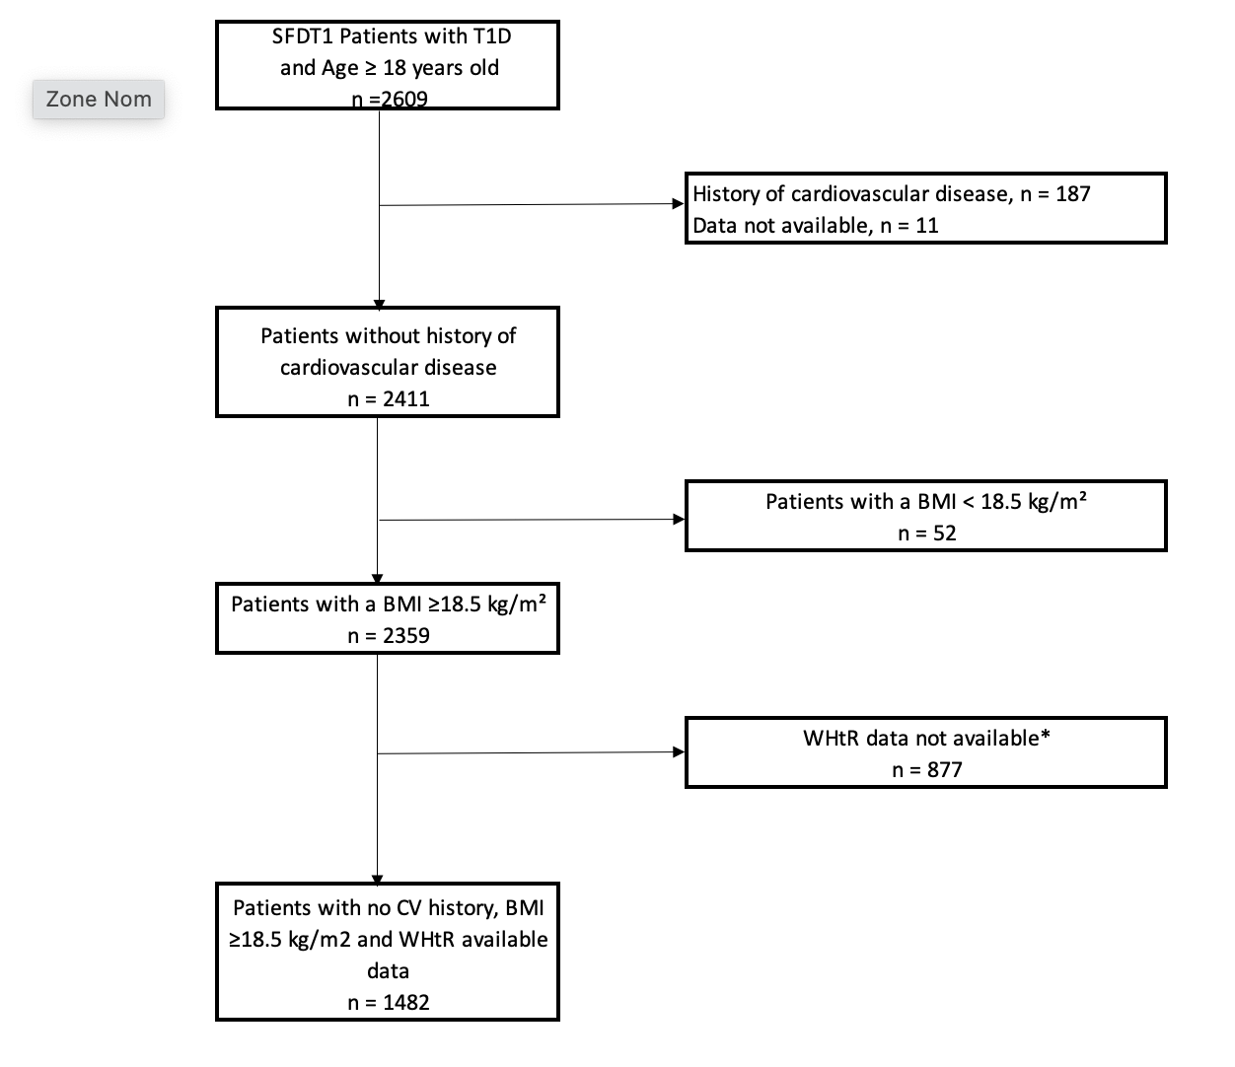

Supplemental data S2: Flowchart
*The reasons for missing waist circumference were not reported in patient files.

Supplemental data S3: Distribution of the cardiovascular risk in the SFDT1 cohort by body mass index class and waist/height ratio, according to sex. The percentage of the population in each of the score categories is shown on the graphs. A: distribution by BMI in male patients, B: distribution by BMI in female patients, C: distribution by waist/height ratio in male patients, D: distribution by waist/height in female patients, The differences between the groups A (BMI in men), C (waist/height ratio in men) and D (waist/height ratio in women) are significant (p value < 0.001, Chi-squared test). The difference between the groups B (BMI in women) is not significant (p value = 0.309, Chi-squared test).

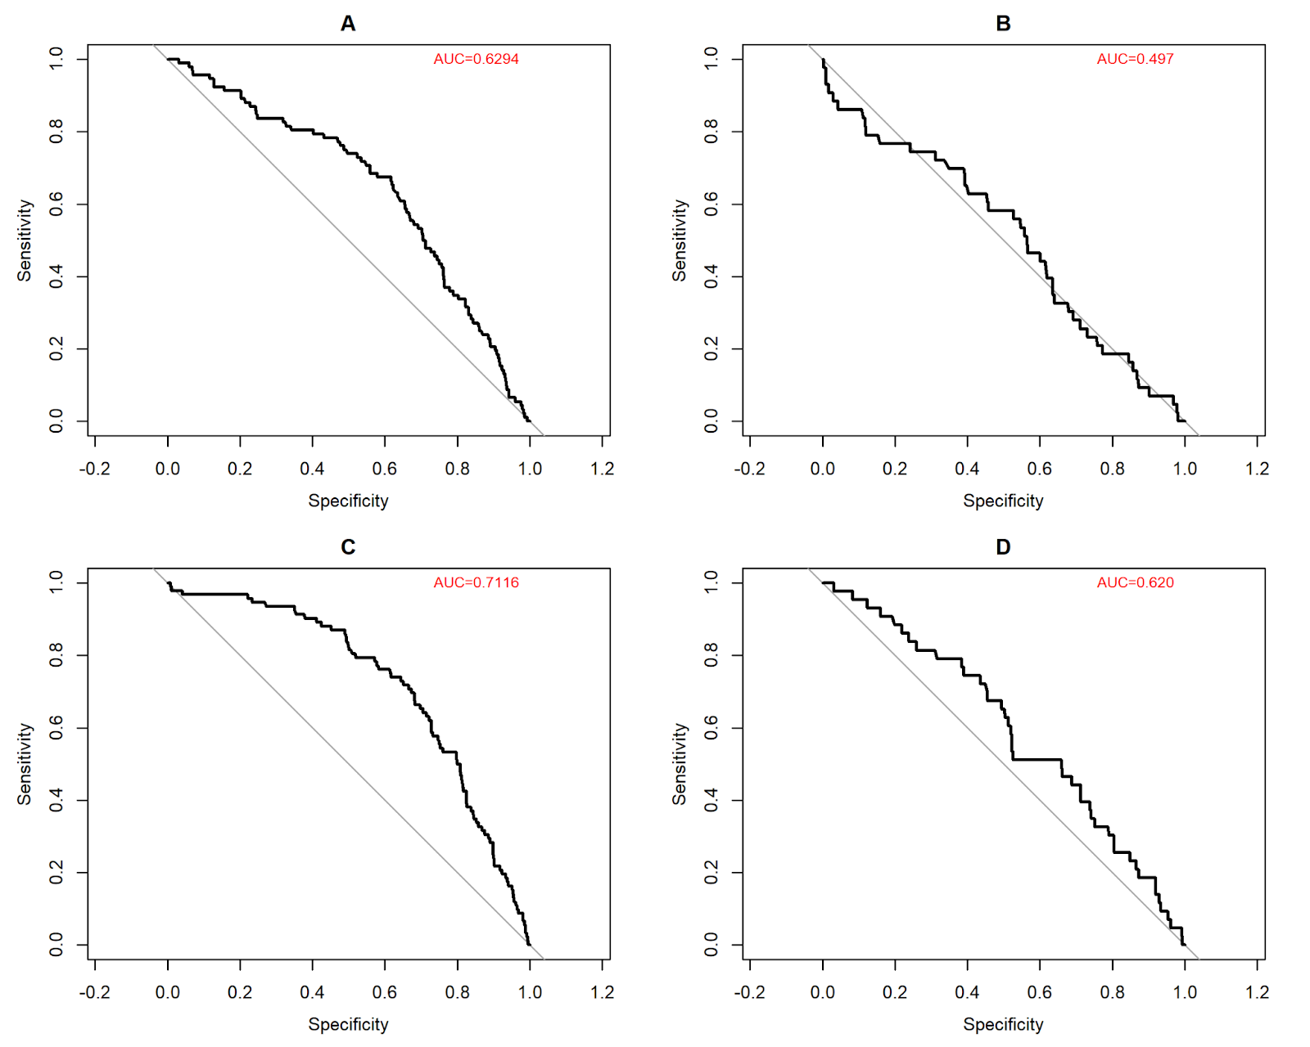

Supplemental data S4: ROC curves of the prediction of 10-year cardiovascular risk by BMI or WHtR ratio. A.Prediction by BMI in men: Cutoff men 24.8kg/m² (sensitivity 0.69; specificity 0.53), B. Prediction by BMI in women, C. Prediction by WHtR in men: Cutoff men 0.51 (sensitivity 0.8; specificity 0.51), D. Prediction by WHtR women: Cutoff women 0.506 (sensitivity 0.68; specificity 0.5), WHtR = Waist/Height Ratio

Supplemental data S5: Association between high cardiovascular risk and Waist/height ratio in younger and older women. A: older women (age ≥50 years) (n=168, EDF = 1.0; Chi squared= 0.2; p-value =0.694), B: younger women (age<50 years) (n=552, EDF = 1.0; Chi squared= 1.0; p-value =0.321). WHtR: Waist/Height ratio. The model was adjusted for diabetes treatment, insulin dose and social deprivation. The blue line represents the median WHtR ratio.

