Supplementary Table 1. Baseline demographic characteristics of the 2 propensity score matched groups by statin therapy.

Variable | No statins  N = 4,533 | Statins  N = 4,533 | Difference (95% CI)
Age (years) | 65 (12) | 66 (12) | -0.09 (-0.13, -0.05)
Sex |  |  | 0.02 (-0.02, 0.06)
M | 2,525 (56%) | 2,577 (57%)
F | 2,008 (44%) | 1,956 (43%)
BMI (kg/m²) | 26.7 (4.5) | 26.8 (4.3) | -0.02 (-0.06, 0.02)
Fasting plasma glucose (mg/dl) | 96 (17) | 97 (18) | -0.09 (-0.13, -0.05)
Serum Creatinine (mg/dl) | 0.88 (0.22) | 0.90 (0.24) | -0.07 (-0.11, -0.03)
Hypertension (%) | 2,902 (64%) | 2,976 (66%) | 0.02 (-0.04,0.01)
Follow-Up (months) | 90 (69) | 89 (68) | 0.02 (-0.02, 0.06)
LDL cholesterol (mg/dl) | 115 (28) | 114 (36) | -0.02 (-0.04, 0.07)
Triglycerides (mg/dl) | 104 (41) | 119 (45) | -0.35 (-0.40, -0.29)

Supplementary Figure 1. Hazard of incident T2D during the follow up by statin therapy in the propensity score matched groups.
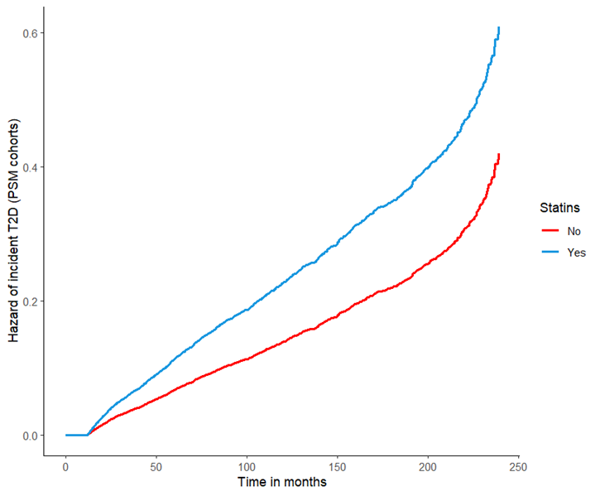

Supplementary Figure 2. Hazard of incident T2D during the follow up by the presence of arterial hypertension and/or statin therapy or the absence of both in the propensity score matched groups.
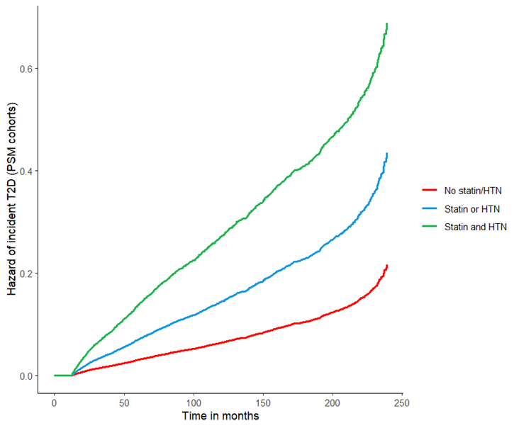

Supplementary Figure 3. Adjusted hazard of CVE during the follow up by statin therapy in the propensity score matched groups.
