Glyoxalase-1 overexpression attenuates arterial wall stiffening in diabetic mice
Supplementary digital content 1
Margarita G. Pencheva, Eline Berends, Koen W.F. van der Laan, Alessandro Giudici, Petra Niessen, Jean L.J.M. Scheijen, Philippe Vangrieken, Peter Leenders, Tammo Delhaas, Florian Caiment, Martina Kutmon, Fabiola M. Trujillo, Kristiaan Wouters, Sébastien Foulquier, Bart Spronck#, Koen D. Reesink#, Casper G. Schalkwijk*, #

# Authors contributed equally.
* Corresponding author.

Address for correspondence
Casper G. Schalkwijk
Dept. of Internal Medicine
Cardiovascular Research Institute Maastricht (CARIM)
Maastricht University
Universiteitssingel 50
6229ER, Maastricht
The Netherlands
c.schalkwijk@maastrichtuniversity.nl

Supplementary methods

Two-photon laser scanning microscopy image analysis
The following method was done in accordance to chapter 6 of van der Laan (2024).

Adjustments to nucleus quantification image processing procedure
Due to misalignment of optical elements, the laser focus spot of the laser scanning microscope was larger and less symmetrical along the optical axis during two-photon laser-scanning microscopy (TPLSM) experiments, as compared to optimal conditions. This resulted in nuclei appearing enlarged, particularly along the optical axis, as well as blurred, and titled with respect to the optical axis. Consequently, the previously reported nucleus quantification method was incapable of processing the TPLSM image stacks containing these nuclei (van der Laan et al., 2021). Specifically, the Vesselness-filtering step of the image analysis methodology produced structures of clumped nuclei that were too large for further processing. In order to process the TPLSM image stacks gathered under these suboptimal conditions, several changes were made to the nucleus quantification image analysis methodology, as described below.

Adjustments to the preprocessing step
In the preprocessing step, the XY pages in nuclei image stack were processed individually, rather than being smoothed through 3D convolution. This is to prevent further enlarging along the Z-axis of the already enlarged segmented nuclei that occurs with smoothing using 3D convolution. The inconsistent intensity of nuclei in the XY plane was previously reduced using the, now omitted, 3D convolution. Instead, to reduce the intensity variation in nuclei, images displaying the local variance in the XY pages were constructed. These local variance images were combined to construct a 3D image stack. The local variance images were constructed in four steps. 1) smoothing the XY pages by convolution using a gaussian kernel constructed using standard deviation of 0.3 µm. 2) Determining local averages in the smoothed XY pages by convolution using a gaussian kernel constructed using a standard deviation of 0.6 µm. 3) Subtracting the smoothed XY page from the local average image to determine differences from local means. And lastly, 4) determining the local variance image from the differences from the local averages by convolution using a gaussian kernel constructed using a 1.2 µm standard deviation.

Adjustments to the vesselness filtering step
Despite the construction of local variance image stacks reducing the intensity variations inside nuclei, the remaining intensity variations were prolific enough that the orientations determined by the vesselness filtering step often followed the orientations along which the intensity variation was minimal, rather than the local orientation of the segmented structure. Therefore, orientations determined by the vesselness filtering step were no longer used in further analyses and instead local orientations of segmented nucleus structures were determined in a later step.
Nucleus structures segmented from the local variance image stacks by the vesselness filtering step were still sufficiently large to prevent further analysis. A pre-splitting step was implemented prior to nucleus splitting to reduce the size of the clumped nuclei structures. This pre-splitting step does not fully split clumped structures into individual nuclei but instead splits large structures into smaller structures consisting of either singular or multiple nuclei. This is achieved by eroding the outer voxel layer of the structure using a 3x3x3 kernel in which the corners are set to zero. As eroding sufficiently thin parts of a large structure results in multiple smaller structures, the number of structures may increase after eroding an outer voxel layer. Therefore, the number and size of structures resulting from the erosion is determined. If any of the resulting structures were above a threshold of 3000 voxels then they were eroded again. This process was repeated until none the resulting structures present after erosion were above the size threshold. These resulting structures were then individually dilated using the same kernel as for eroding. This creates a new outer layers of voxels around the structure. Any voxels that were previously eroded that overlap with this outer layer and that currently don’t belong a structure are added to the structure that was dilated. This process is repeated until all voxels that were eroded were assigned to one of the structures resulting from the erosion process. This process cuts the initial oversized structures into multiple smaller structures along its thinnest points, typically where to nuclei are touching each other, until the resulting structures are all below the above mentioned size threshold.
Local structure orientations of pre-split structures were calculated by determining the orientation along which the variation in the distance to the centreline of the structure was minimized. The structure centreline was determined by first determining for each voxel in the structure the distance to the structure’s edge. This was determined by first determining all the voxels directly neighbouring the structure by dilating the structure using a 3x3x3 kernel of ones and selecting only the voxels that were added to the structure. Then, by iteratively dilating from these voxels using a 3x3x3 kernel, the distance to the edge of the structure for voxels inside the structure was determined by the number of dilations required to reach each voxel. To account for the uneven voxel dimensions, and whether structure voxels were reached by dilating to a direct neighbour or to a diagonal neighbour, each dilation iteration was broken up on several steps. These started with the dilations that spanned the shortest distance in µm, i.e. direct neighbours in the XY plane, and ended with the dilations corresponding with the longest distance in µm, i.e. a diagonal to a neighbouring XY plane. Then, the structure centreline was determined by finding the voxels that either contained a local maximum in a 3x3x3 neighbourhood, or only had one other voxel with a longer distance to the edge in a 3x3x3 neighbourhood.
Similar to determining the distance from voxels to the edge of the structure, the distance to the centreline of the structure for each voxel was determined by iteratively dilating from the centreline until the structure was recreated and determining the number of dilations required to reach each voxel. As for determining the distance to the edge the structure, the dilation iterations were broken up into steps to account for the uneven voxel dimensions and dilating diagonally.
Local structure orientations were calculated using a structured tensor analysis method (Jeppesen et al., 2021). Briefly, This method constructs a 3x3 covariance matrix using local variances calculated using the distance-to-centreline determined for each voxel in the structure is input. Local structure orientations were then determined by the eigenvector of the covariance matrixes corresponding with the smallest absolute eigenvalue. For this method, first order derivatives along the x, y, and z dimensions were determined with a kernels constructed using standard deviation of 0.5 µm and covariance matrix elements were determined with a kernel constructed using standard deviation of 1 µm.

Adjustments to the nucleus splitting step
The previously reported method for determining whether a structure consisted of two or more nuclei, or a single nucleus during the nucleus splitting step proved insufficient (van der Laan et al., 2021). As judged visually, this method frequently split structures consisting of single nuclei into multiple nuclei. In addition, some structures consisting of many nuclei, more than ten, occasionally were not split. Instead, the elements of the eigenvector corresponding with the smallest absolute eigenvalue of the random walk Laplacian matrix were used to determine if a structure needed to be split. If a structure should to be split into multiple nuclei, as judged visually, then many of these eigenvector elements are smaller than 0.001. If a structure consists of a single nucleus, as judged visually, only few of these eigenvector elements are smaller than 0.001. Structures were deemed to consist of a single nucleus if less than 10% of these eigenvector components were smaller than 0.001.
When splitting large structures, typically consisting of 10 or more nuclei, into multiple nuclei using, it would occasionally split the structure into only two nuclei when using the previously reported method (van der Laan et al., 2021). Previously, voxels whose assigned eigenvector elements contained small amplitudes were given a silhouette value of -1 when determining the number of clusters following k-means clustering. To prevent this, voxels who’s assigned eigenvector elements had an amplitude smaller than 0.001 were excluded from the k-means clustering step during spectral clustering, whilst still being given a silhouette value of -1 when determining the number of nuclei, a structure needs to be split in.
Single nuclei resulting from the previously reported nucleus splitting methodology cores did not necessarily consist of a single structure but could consist of multiple disconnected segments(van der Laan et al., 2021). To prevent this, after a structure was split into individual nuclei, nuclei consisting of multiple segments were reduced to their largest segment. The voxels removed from nuclei were reassigned by iteratively dilating the nuclei using a 3x3x3 kernel consisting of ones and assigning voxels to overlapping nuclei following each dilation iteration until all voxels were assigned to nuclei.

Supplementary tables
Table S1. Multiple reaction monitoring settings.
Compound | Parent ion  (m/z) | Daughter ion  (m/z) | Cone  (V) | Collision energy (eV)
LYS  ¹³C₆-LYS  CEL  ²H₄-CEL  CML  ²H₂-CML  MG-H1  ²H₃-MG-H1 | 147.2  153.2  219.1  223.1  205.1  207.1  229.15  232.15 | 84.2  89.2  130.25  134.25  130.25  130.25  166  169 | 10  10  10  10  10  10  10  10 | 15  15  10  10  10  10  10  10
LYS, lysine; CEL, Nε-(1-carboxyethyl)lysine; MG-H, MGO-derived compound hydroimidazolone 1
Table S2: In vivo parameters
Variable | Control | Diabetes | GLO1/Diabetes | ANOVA (p-value)
 | n = 12 | n = 12 | n = 12
In vivo systolic pressure [mmHg] | 104 ± 2.64 | 110 ± 4.08 | 106 ± 8.77 | 0.443
In vivo diastolic pressure [mmHg] | 78 ± 2.29 | 82 ± 3.89 | 79 ± 2.54 | 0.576
In vivo heart rate [bpm] | 554 ± 8.36 | 531 ± 13.29 | 555 ± 6.72 | 0.157
In vivo cfPWV [m/s] | 2.55 ± 0.11 | 2.60 ± 0.14 | 2.56 ± 0.09 | 0.961

cfPWV, carotid-femoral pulse wave velocity; ANOVA, analysis of variance

Table S3: Receptor for advanced glycation end-products (RAGE) gene (Ager) expression.
Group comparison | Log2 (Fold Change) | Adjusted p-value
GLO1/Diabetes vs. Control | -0.117 | 0.862
GLO1/Diabetes vs. Diabetes | -0.227 | 0.898
Diabetes vs. Control | 0.109 | 0.833

Table S4: Constituent-based quasi-linear viscoelastic model parameters utilised to calculate biomechanical variables of control (n=9), diabetes (n=10) and GLO1/Diabetes mice in the following study.
Sample # | Group | Elastin |  |  |  |  |  | Collagen |  |  |  |  |  |  | Fit error
Sample # | Group | µ [MPa] | λ_{θ,e}  [-] | λ_{z,e}  [-] | ν_{e}  [-] | τ_{2,e} [s] | $k_{1}^{1-4}$ [MPa] | $k_{2}^{1}$  [-] | $k_{2}^{2}$  [-] | $k_{2}^{3,4}$  [-] | α^{3,4}  [°] | λ_{c}  [-] | ν_{c}  [-] | τ_{2,c}  [-] | $$R_{D}^{2}$$  [-] | $$R_{S}^{2}$$  [-]
1 | Control | 0.027 | 1.872 | 1.699 | 0.000 | 100 | 0.036 | 3.658 | 6.736 | 14.768 | 39.981 | 1.146 | 0.037 | 100 | 0.991 | 0.994
2 | Control | 0.027 | 1.890 | 1.607 | 0.000 | 100 | 0.035 | 6.243 | 8.925 | 20.033 | 39.018 | 1.132 | 0.053 | 100 | 0.995 | 0.995
11 | Control | 0.026 | 1.798 | 1.712 | 0.000 | 100 | 0.021 | 3.305 | 5.115 | 9.422 | 40.285 | 1.193 | 0.033 | 100 | 0.992 | 0.994
12 | Control | 0.029 | 1.752 | 1.633 | 0.005 | 100 | 0.018 | 5.720 | 7.683 | 15.309 | 40.067 | 1.160 | 0.043 | 100 | 0.995 | 0.997
13 | Control | 0.024 | 1.858 | 1.707 | 0.000 | 100 | 0.034 | 4.287 | 6.012 | 12.078 | 38.331 | 1.162 | 0.055 | 100 | 1.000 | 0.996
27 | Control | 0.030 | 1.776 | 1.655 | 0.000 | 100 | 0.052 | 4.759 | 9.178 | 21.566 | 41.757 | 1.111 | 0.047 | 100 | 1.000 | 0.996
34 | Control | 0.025 | 1.900 | 1.725 | 0.000 | 100 | 0.044 | 4.116 | 7.847 | 16.121 | 41.654 | 1.134 | 0.043 | 100 | 0.991 | 0.996
35 | Control | 0.023 | 1.943 | 1.699 | 0.000 | 100 | 0.040 | 2.503 | 5.326 | 11.082 | 40.714 | 1.154 | 0.043 | 100 | 0.990 | 0.994
36 | Control | 0.025 | 1.789 | 1.692 | 0.000 | 100 | 0.017 | 4.804 | 6.409 | 12.303 | 39.769 | 1.173 | 0.039 | 100 | 1.000 | 0.996
5 | Diabetes | 0.025 | 1.881 | 1.759 | 0.000 | 100 | 0.024 | 3.432 | 4.605 | 8.180 | 39.414 | 1.201 | 0.024 | 100 | 1.000 | 0.993
7 | Diabetes | 0.032 | 1.952 | 1.810 | 0.014 | 100 | 0.032 | 2.818 | 8.489 | 13.517 | 44.513 | 1.161 | 0.024 | 100 | 1.000 | 0.995
18 | Diabetes | 0.038 | 1.757 | 1.665 | 0.016 | 100 | 0.012 | 3.574 | 6.270 | 10.002 | 41.442 | 1.211 | 0.033 | 100 | 1.000 | 0.996
19 | Diabetes | 0.022 | 1.908 | 1.775 | 0.000 | 100 | 0.029 | 3.857 | 6.787 | 12.626 | 39.356 | 1.164 | 0.029 | 100 | 0.968 | 0.993
20 | Diabetes | 0.021 | 2.017 | 1.760 | 0.000 | 100 | 0.036 | 5.143 | 4.286 | 14.658 | 41.075 | 1.139 | 0.032 | 100 | 0.993 | 0.995
31 | Diabetes | 0.025 | 1.869 | 1.829 | 0.000 | 100 | 0.025 | 3.553 | 5.785 | 10.498 | 37.993 | 1.178 | 0.026 | 100 | 0.972 | 0.995
43 | Diabetes | 0.024 | 1.922 | 1.749 | 0.009 | 100 | 0.021 | 1.720 | 5.563 | 7.615 | 43.837 | 1.208 | 0.043 | 100 | 0.985 | 0.994
44 | Diabetes | 0.016 | 2.160 | 1.773 | 0.000 | 100 | 0.040 | 1.482 | 5.221 | 8.535 | 42.731 | 1.174 | 0.046 | 100 | 0.976 | 0.994
46 | Diabetes | 0.027 | 1.938 | 1.672 | 0.000 | 100 | 0.047 | 6.480 | 6.124 | 20.540 | 47.492 | 1.112 | 0.040 | 100 | 0.992 | 0.997
47 | Diabetes | 0.034 | 1.631 | 1.592 | 0.000 | 100 | 0.032 | 3.964 | 4.702 | 9.465 | 39.924 | 1.163 | 0.045 | 100 | 0.996 | 0.997
10 | GLO1/  Diabetes | 0.025 | 2.047 | 1.846 | 0.000 | 100 | 0.052 | 4.664 | 7.827 | 15.637 | 40.422 | 1.138 | 0.029 | 100 | 0.988 | 0.995
15 | GLO1/  Diabetes | 0.023 | 2.019 | 1.862 | 0.000 | 100 | 0.042 | 3.292 | 5.106 | 11.030 | 39.889 | 1.162 | 0.039 | 100 | 1.000 | 0.996
16 | GLO1/  Diabetes | 0.033 | 1.768 | 1.818 | 0.000 | 100 | 0.028 | 3.642 | 6.480 | 11.803 | 40.199 | 1.175 | 0.037 | 100 | 0.993 | 0.997
22 | GLO1/  Diabetes | 0.024 | 1.895 | 1.575 | 0.000 | 100 | 0.031 | 6.359 | 10.179 | 19.539 | 40.502 | 1.131 | 0.043 | 100 | 0.994 | 0.997
23 | GLO1/  Diabetes | 0.026 | 1.914 | 1.754 | 0.000 | 100 | 0.045 | 5.039 | 8.423 | 21.705 | 39.717 | 1.122 | 0.045 | 100 | 0.989 | 0.993
24 | GLO1/  Diabetes | 0.041 | 1.673 | 1.561 | 0.017 | 100 | 0.000 | 2.007 | 2.367 | 3.292 | 41.161 | 1.457 | 0.020 | 100 | 0.996 | 0.996
38 | GLO1/  Diabetes | 0.023 | 1.901 | 1.920 | 0.000 | 100 | 0.028 | 3.232 | 8.148 | 14.598 | 43.436 | 1.155 | 0.036 | 100 | 0.991 | 0.997
39 | GLO1/  Diabetes | 0.022 | 1.956 | 1.705 | 0.000 | 100 | 0.026 | 3.298 | 9.301 | 15.766 | 43.098 | 1.146 | 0.034 | 100 | 0.993 | 0.997
40 | GLO1/  Diabetes | 0.027 | 1.879 | 1.558 | 0.000 | 100 | 0.023 | 5.997 | 5.156 | 13.125 | 38.291 | 1.148 | 0.040 | 100 | 0.996 | 0.997
41 | GLO1/  Diabetes | 0.020 | 1.955 | 1.710 | 0.000 | 100 | 0.029 | 2.916 | 4.473 | 9.800 | 41.035 | 1.172 | 0.046 | 100 | 0.989 | 0.991

µ: elastin stiffness-like parameter; λ_{θ,e}: elastin circumferential deposition stretch; λ_{z,e}: elastin axial deposition stretch; ν_{e}: elastin viscous gain; τ_{2,e}; elastin time constant 2; $k_{1}^{1-4}$: collagen stiffness-like parameter; $k_{2}^{1}$: axial collagen non-linearity parameter; $k_{2}^{2}$: circumferential collagen non-linearity parameter; $k_{2}^{3,4}$: diagonal collagen non-linearity parameter; α^{3,4}: diagonal collagen fibre angle; λ_{c}: collagen deposition stretch in the fibre direction; ν_{c}: collagen viscous gain; τ_{2,c}; elastin time constant 2; $R_{D}^{2}$: coefficient of determination for fitting of the dynamic biomechanical data and $R_{S}^{2}$: coefficient of determination for the fitting of the quasi-static biomechanical data.
Table S5: Geometrical and biomechanical variables (static and dynamic/ viscous and elastic model parameters) for control, diabetes and GLO1/diabetes groups based on averaged group-specific in vivo pressure.
Variable | Control | Diabetes | GLO1/Diabetes | ANOVA (p-value)
 | n = 9 | n = 10 | n = 10
Unloaded thickness [µm] | 147.60 ± 4.66 | 146.10 ± 5.31 | 149.30 ± 4.24 | 0.894
Unloaded inner diameter [µm] | 613.20 ± 8.89 | 611.10 ± 10.76 | 607.50 ± 11.66 | 0.930
In vivo axial stretch [-] | 1.66 ± 0.01 | 1.71 ± 0.02 | 1.70 ± 0.04 | 0.381
Systolic pressure [mmHg] | 104 | 110 | 106 | 0.443
Diastolic pressure [mmHg] | 78 | 82 | 79 | 0.576
Geart rate [bpm] | 554 | 531 | 555 | 0.157
Loaded thickness (static) [µm] | 51.58 ± 1.31 | 47.69 ± 1.34 | 49.51 ± 2.00 | 0.252
Loaded inner diameter (static) [µm] | 1260.00 ± 12.86 | 1298.00 ± 16.83 | 1291.00 ± 13.70 | 0.188
Circumferential stress (static) [MPa] | 0.17 ± 0.00** | 0.20 ± 0.01 | 0.19 ± 0.01 | 0.014
Circumferential stress (dynamic) [MPa] | 0.17 ± 0.00** | 0.20 ± 0.01 | 0.18 ± 0.01 | 0.012
Axial stress (static) [MPa] | 0.18 ± 0.01 | 0.20 ± 0.01 | 0.19 ± 0.01 | 0.256
Axial stress (dynamic) [MPa] | 0.18 ± 0.01 | 0.20 ± 0.01 | 0.19 ± 0.01 | 0.258
Circumferential stiffness (static) [MPa] | 1.39 ± 0.04** | 1.86 ± 0.13 | 1.61 ± 0.09 | 0.009
Circumferential stiffness (dynamic) [MPa] | 1.51 ± 0.05 | 2.00 ± 0.14 | 1.73 ± 0.10 | 0.010
Circumferential stiffness ratio (dynamic/static) [-] | 1.09 ± 0.01 | 1.08 ± 0.01 | 1.07 ± 0.01 | 0.384
Axial stiffness (static) [MPa] | 2.03 ± 0.08 | 2.20 ± 0.12 | 2.18 ± 0.15 | 0.579
Axial-circumferential stiffness (static) [MPa] | 0.90 ± 0.03 | 1.08 ± 0.7 | 1.03 ± 0.06 | 0.075
Axial-circumferential stiffness (dynamic) [MPa] | 1.03 ± 0.03 | 1.21 ± 0.07 | 1.15 ± 0.07 | 0.163
Stored elastic energy (static) [kPa] | 11.23 ± 0.31 | 10.79 ± 0.41 | 11.77 ± 0.71 | 0.404
Dissipated energy [kPa] | 0.07 ± 0.00 | 0.06 ± 0.00 | 0.07 ± 0.01 | 0.312
Loss factor [-] | 0.03 ± 0.00 | 0.03 ± 0.00 | 0.03 ± 0.00 | 0.300
PWV (static) [m/s] | 4.15 ± 0.07** | 4.89 ± 0.16$ | 4.38 ± 0.14 | 0.002
PWV (dynamic) [m/s] | 4.98 ± 0.07* | 5.66 ± 0.19$ | 5.13 ± 0.16 | 0.009
PWV ratio (dynamic/static)  [-] | 1.20 ± 0.01* | 1.16 ± 0.01 | 1.17 ± 0.01 | 0.034
Distensibility (static) [1/MPa] | 55.60 ± 1.75** | 41.01 ± 2.61 | 51.48 ± 4.25 | 0.009
Distensibility (dynamic) [1/MPa] | 38.62 ± 1.12* | 30.59 ± 1.96 | 37.30 ± 2.96 | 0.035
Compliance (static) [mm²/MPa] | 58.08 ± 1.70 | 46.70 ± 2.48 | 56.92 ± 4.89 | 0.048
Compliance (dynamic) [mm²/MPa] | 13.35 ± 0.45 | 11.37 ± 0.63 | 13.60 ± 1.20 | 0.134
Elastin circ. load bearing (static) [%] | 66.10 ± 0.96** | 59.49 ± 1.56$ | 64.62 ± 1.22 | 0.003
Elastin circ. load bearing (dynamic) [%] | 65.96 ± 0.95** | 59.42 ± 1.55$ | 64.53 ± 1.21 | 0.003
Collagen circ. load bearing (static) [%] | 33.90 ± 0.96** | 40.51 ± 1.56$ | 35.38 ± 1.22 | 0.003
Collagen circ. load bearing (dynamic) [%] | 34.04 ± 0.95** | 40.58 ± 1.55 | 35.47 ± 1.21 | 0.003
Elastin axial load bearing (static) [%] | 55.43 ± 1.26 | 52.07 ± 1.81 | 55.00 ± 1.49 | 0.269
Elastin axial load bearing (dynamic) [%] | 55.27 ± 1.26 | 51.99 ± 1.81 | 54.88 ± 1.50 | 0.282
Collagen axial load bearing (static) [%] | 44.57 ± 1.26 | 47.93 ± 1.81 | 45.00 ± 1.49 | 0.259
Collagen axial load bearing (dynamic) [%] | 44.73 ± 1.26 | 48.01 ± 1.81 | 45.12 ± 1.60 | 0.282
Elastin stored energy (static) [%] | 76.13 ± 1.11** | 68.84 ± 1.81$ | 74.79 ± 1.33 | 0.004
Elastin dissipated energy [%] | -0.25 ± 0.19 | 0.22 ± 0.41 | 0.62 ± 1.11 | 0.701
Collagen stored energy (static) [%] | 23.87 ± 1.11** | 31.16 ± 1.81$ | 25.21 ± 1.34 | 0.004
Collagen dissipated energy [%] | 100.30 ± 0.19 | 99.78 ± 0.41 | 99.38 ± 1.11 | 0.701

Unloaded parameters were determined at unloaded length, while the rest were calculated at in vivo-like length. PWV, pulse wave velocity; Circ., circumferential. Data are presented as mean ± standard error. Groups were compared using one-way analysis of variance followed by Tukey post-hoc testing and p-values < 0.05 are in bold. Asterix*: p<0.05 Diabetes vs. control; Asterix#: p<0.05 GLO1/Diabetes vs. control; Asterix$: p<0.05 GLO1/Diabetes vs. Diabetes.

Table S6: Geometrical and biomechanical variables (static and dynamic) for control, diabetes and GLO1/diabetes groups based on mean group 106/80 mmHg pressure.
Variable | Control | Diabetes | GLO1/Diabetes | ANOVA (p-value)
 | n = 9 | n = 10 | n = 10
Unloaded thickness [µm] | 147.60 ± 4.66 | 146.10 ± 5.31 | 149.30 ± 4.24 | 0.894
Unloaded inner diameter [µm] | 613.20 ± 8.89 | 611.10 ± 10.76 | 607.50 ± 11.66 | 0.930
In vivo axial stretch [-] | 1.66 ± 0.01 | 1.71 ± 0.02 | 1.70 ± 0.04 | 0.381
Systolic pressure [mmHg] | 106 | 106 | 106 | -
Diastolic pressure [mmHg] | 80 | 80 | 80 | -
Heart rate [bpm] | 547 | 547 | 547 | -
Loaded thickness (static) [µm] | 51.41 ± 1.30 | 47.98 ± 1.35 | 49.51 ± 2.00 | 0.339
Loaded inner diameter (static) [µm] | 1265.00 ± 12.93 | 1290.00 ± 16.91 | 1291.00 ± 13.70 | 0.399
Circumferential stress (static) [MPa] | 0.17 ± 0.00 | 0.19 ± 0.01 | 0.19 ± 0.01 | 0.216
Circumferential stress (dynamic) [MPa] | 0.17 ± 0.00 | 0.19 ± 0.01 | 0.18 ± 0.01 | 0.206
Axial stress (static) [MPa] | 1.18 ± 0.01 | 0.19 ± 0.01 | 0.19 ± 0.01 | 0.573
Axial stress (dynamic) [MPa] | 0.18 ± 0.01 | 0.19 ± 0.01 | 0.19 ± 0.01 | 0.573
Circumferential stiffness (static) [MPa] | 1.47 ± 0.04 | 1.67 ± 0.12 | 1.61 ± 0.09 | 0.286
Circumferential stiffness (dynamic) [MPa] | 1.60 ± 0.05 | 1.80 ± 0.13 | 1.73 ± 0.10 | 0.382
Circumferential stiffness ratio (dynamic/static) [-] | 1.09 ± 0.01 | 1.07 ± 0.01 | 1.08 ± 0.01 | 0.167
Axial stiffness (static) [MPa] | 2.10 ± 0.08 | 2.07 ± 0.11 | 2.18 ± 0.15 | 0.790
Axial-circumferential stiffness (static) [MPa] | 0.95 ± 0.03 | 0.98 ± 0.06 | 1.03 ± 0.06 | 0.688
Axial-circumferential stiffness (dynamic) [MPa] | 1.10 ± 0.04 | 1.10 ± 0.07 | 1.15 ± 0.07 | 0.781
Stored elastic energy (static) [kPa] | 10.61 ± 0.29 | 10.72 ± 0.43 | 11.14 ± 0.67 | 0.735
Dissipated energy [kPa] | 0.07 ± 0.00 | 0.06 ± 0.00 | 0.07 ± 0.00 | 0.402
Loss factor [-] | 0.03 ± 0.00 | 0.03 ± 0.00 | 0.03 ± 0.00 | 0.110
PWV (static) [m/s] | 4.37 ± 0.06 | 4.62 ± 0.15 | 4.46 ± 0.14 | 0.429
PWV (dynamic) [m/s] | 5.24 ± 0.07 | 5.34 ± 0.19 | 5.21 ± 0.16 | 0.809
PWV ratio (dynamic/static)  [-] | 1.20 ± 0.01* | 1.16 ± 0.01 | 1.17 ± 0.01 | 0.036
Distensibility (static) [1/MPa] | 50.10 ± 1.46 | 46.12 ± 3.09 | 49.60 ± 4.04 | 0.622
Distensibility (dynamic) [1/MPa] | 34.92 ± 0.96 | 34.46 ± 2.33 | 36.13 ± 2.81 | 0.860
Compliance (static) [mm²/MPa] | 53.60 ± 1.56 | 51.51 ± 2.87 | 55.51 ± 4.77 | 0.707
Compliance (dynamic) [mm²/MPa] | 38.68 ± 1.31 | 39.49 ± 2.28 | 41.74 ± 3.63 | 0.704
Elastin circ. load bearing (static) [%] | 64.94 ± 0.94 | 61.59 ± 1.61 | 64.62 ± 1.22 | 0.154
Elastin circ. load bearing (dynamic) [%] | 64.81 ± 0.94 | 61.52 ± 1.60 | 64.53 ± 1.21 | 0.156
Collagen circ. load bearing (static) [%] | 35.06 ± 0.94 | 38.41 ± 1.61 | 35.38 ± 1.22 | 0.154
Collagen circ. load bearing (dynamic) [%] | 35.19 ± 0.94 | 38.48 ± 1.60 | 35.47 ± 1.21 | 0.156
Elastin axial load bearing (static) [%] | 54.56 ± 1.25 | 53.54 ± 1.85 | 55.00 ± 1.49 | 0.794
Elastin axial load bearing (dynamic) [%] | 54.42 ± 1.26 | 53.46 ± 1.85 | 54.89 ± 1.50 | 0.804
Collagen axial load bearing (static) [%] | 45.44 ± 1.25 | 46.46 ± 1.85 | 45.00 ± 1.50 | 0.794
Collagen axial load bearing (dynamic) [%] | 45.58 ± 1.26 | 46.54 ± 1.85 | 45.11 ± 1.50 | 0.804
Elastin stored energy (static) [%] | 74.60 ± 1.10 | 70.76 ± 1.84 | 74.29 ± 1.33 | 0.143
Elastin dissipated energy [%] | 0.13 ± 0.10 | 0.65 ± 0.38 | 1.03 ± 1.03 | 0.637
Collagen stored energy (static) [%] | 25.40 ± 1.10 | 29.24 ± 1.84 | 25.71 ± 1.33 | 0.143
Collagen dissipated energy [%] | 99.87 ± 0.10 | 99.35 ± 0.38 | 98.98 ± 1.03 | 0.460

Unloaded parameters were determined at unloaded length, while the rest were calculated at in vivo-like length. PWV, pulse wave velocity; Circ., circumferential. Data are presented as mean ± standard error. Groups were compared using one-way analysis of variance followed by Tukey post-hoc testing and p-values < 0.05 are in bold. Asterix*: p<0.05 Diabetes vs. control; Asterix#: p<0.05 GLO1/Diabetes vs. control; Asterix$: p<0.05 GlO1/Diabetes vs. Diabetes.

Table S7: Geometrical and biomechanical variables (static and dynamic) for control, diabetes and GLO1/diabetes groups based on 120/80 mmHg pressure.
Variable | Control | Diabetes | GLO1/Diabetes | ANOVA (p-value)
 | n = 9 | n = 10 | n = 10
Unloaded thickness [µm] | 147.60 ± 4.66 | 146.10 ± 5.31 | 149.30 ± 4.24 | 0.894
Unloaded inner diameter [µm] | 613.20 ± 8.89 | 611.10 ± 10.76 | 607.50 ± 11.66 | 0.930
In vivo axial stretch [-] | 1.66 ± 0.01 | 1.71 ± 0.02 | 1.70 ± 0.04 | 0.381
Systolic pressure [mmHg] | 120 | 120 | 120 | -
Diastolic pressure [mmHg] | 80 | 80 | 80 | -
Heart rate [bpm] | 600 | 600 | 600 | -
Loaded thickness (static) [µm] | 50.46 ± 1.23 | 47.10 ± 1.30 | 48.60 ± 1.94 | 0.336
Loaded inner diameter (static) [µm] | 1291.00 ± 13.41 | 1315.00 ± 16.70 | 1317.00 ± 14.76 | 0.424
Circumferential stress (static) [MPa] | 0.21 ± 0.01 | 0.22 ± 0.01 | 0.22 ± 0.01 | 0.214
Circumferential stress (dynamic) [MPa] | 0.20 ± 0.01 | 0.22 ± 0.01 | 0.22 ± 0.01 | 0.203
Axial stress (static) [MPa] | 0.20 ± 0.01 | 0.21 ± 0.01 | 0.21 ± 0.01 | 0.634
Axial stress (dynamic) [MPa] | 0.20 ± 0.01 | 0.21 ± 0.01 | 0.21 ± 0.01 | 0.628
Circumferential stiffness (static) [MPa] | 2.07 ± 0.06 | 2.33 ± 0.15 | 2.30 ± 0.12 | 0.310
Circumferential stiffness (dynamic) [MPa] | 2.25 ± 0.06 | 2.49 ± 0.16 | 2.42 ± 0.13 | 0.420
Circumferential stiffness ratio (dynamic/static) [-] | 1.09 ± 0.01 | 1.07 ± 0.01 | 1.07 ± 0.01 | 0.139
Axial stiffness (static) [MPa] | 2.10 ± 0.08 | 2.07 ± 0.11 | 2.18 ± 0.15 | 0.790
Axial-circumferential stiffness (static) [MPa] | 0.95 ± 0.03 | 0.98 ± 0.06 | 1.03 ± 0.06 | 0.688
Axial-circumferential stiffness (dynamic) [MPa] | 1.10 ± 0.04 | 1.10 ± 0.07 | 1.15 ± 0.07 | 0.781
Stored elastic energy (static) [kPa] | 10.61 ± 0,29 | 10.72 ± 0.43 | 11.14 ± 0.67 | 0.736
Dissipated energy [kPa] | 0.07 ± 0.00 | 0.06 ± 0.00 | 0.07 ± 0.00 | 0.402
Loss factor [-] | 0.03 ± 0.00 | 0.03 ± 0.00 | 0.03 ± 0,.00 | 0.110
PWV (static) [m/s] | 4.79 ± 0.07 | 5.03 ± 0.17 | 4.89 ± 0.15 | 0.483
PWV (dynamic) [m/s] | 5.89 ± 0.08 | 5.94 ± 0.19 | 5.85 ± 0.166 | 0.921
PWV ratio (dynamic/static)  [-] | 1.23 ± 0.01* | 1.18 ± 0.18 | 1.20 ± 0.01 | 0.030
Distensibility (static) [1/MPa] | 41.68 ± 1.12 | 38.71 ± 2.47 | 41.20 ± 3.22 | 0.669
Distensibility (dynamic) [1/MPa] | 27.59 ± 0.74 | 27.80 ± 1.76 | 28.60 ± 2.01 | 0.901
Compliance (static) [mm²/MPa] | 44.62 ± 1.31 | 43.25 ± 2.25 | 46.09 ± 3.79 | 0.757
Compliance (dynamic) [mm²/MPa] | 9.90 ± 0.36 | 10.28 ± 0.55 | 10.68 ± 0.87 | 0.698
Elastin circ. load bearing (static) [%] | 57.81 ± 0.84 | 54.80 ± 1.45 | 57.50 ± 1.11 | 0.158
Elastin circ. load bearing (dynamic) [%] | 57.69 ± 0.84 | 54.72 ± 1.44 | 57.41 ± 1.11 | 0.161
Collagen circ. load bearing (static) [%] | 42.19 ± 0.844 | 45.20 ± 1.45 | 42.50 ± 1.11 | 0.158
Collagen circ. load bearing (dynamic) [%] | 42.31 ± 0.84 | 45.28 ± 1.44 | 42.59 ± 1.11 | 0.161
Elastin axial load bearing (static) [%] | 49.26 ± 1.20 | 48.78 ± 1.72 | 49.70 ± 1.47 | 0.909
Elastin axial load bearing (dynamic) [%] | 49.09 ± 1.20 | 48.68 ± 1.72 | 49.56 ± 1.48 | 0.914
Collagen axial load bearing (static) [%] | 50.74 ± 1.20 | 51.22 ± 1.72 | 50.30 ± 1.47 | 0.909
Collagen axial load bearing (dynamic) [%] | 50.91 ± 1.20 | 51.32 ± 1.72 | 50.44 ± 1.48 | 0.914
Elastin stored energy (static) [%] | 71.19 ± 1.09 | 67.42 ± 1.81 | 70.89 ± 1.34 | 0.147
Elastin dissipated energy [%] | -0.27 ± 0.13 | 0.20 ± 0.37 | 0.41 ± 0.84 | 0.688
Collagen stored energy (static) [%] | 28.81 ± 1.09 | 32.58 ± 1.81 | 29.11 ± 1.34 | 0.147
Collagen dissipated energy [%] | 100.30 ± 0.13 | 99.80 ± 0.37 | 99.59 ± 0.84 | 0.688

Unloaded parameters were determined at unloaded length, while the rest were calculated at in vivo-like length. PWV, pulse wave velocity; Circ., circumferential. Data are presented as mean ± standard error. Groups were compared using one-way analysis of variance followed by Tukey post-hoc testing and p-values < 0.05 are in bold. Asterix*: p<0.05 Diabetes vs. control; Asterix#: p<0.05 GLO1/Diabetes vs. control; Asterix$: p<0.05 GlO1/Diabetes vs. Diabetes.

Supplementary figures

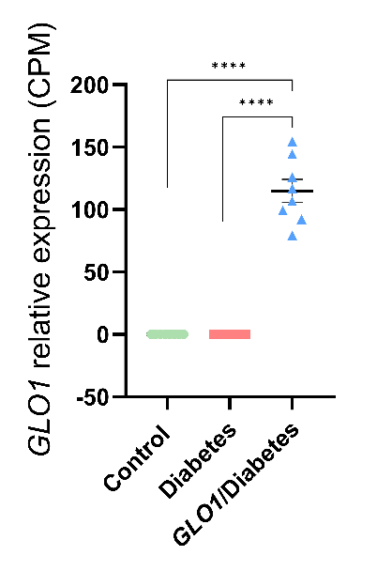

Figure S1: Glyoxalase-1 is overexpressed in the GLO1/Diabetes group compared to the Control and Diabetes groups.

Relative expression of the human GLO1 gene is expressed as counts per million (CPM). Data presented as mean ± standard error. Group differences were assessed using one-way analysis of variance.

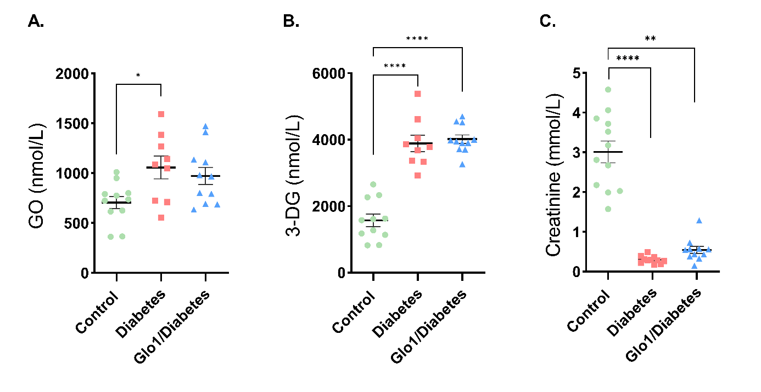
Figure S2: Plasma glyoxal (GO) and 3-deoxyglucosome (3-DG) were increased in diabetes, while urine creatinine was decreased. GO (A) and 3-DG (B) were measured in plasma (n=11; A and B), while creatinine levels were measured in urine (n=11; C). Data presented as mean ± standard error. Group differences were assessed using one-way analysis of variance.
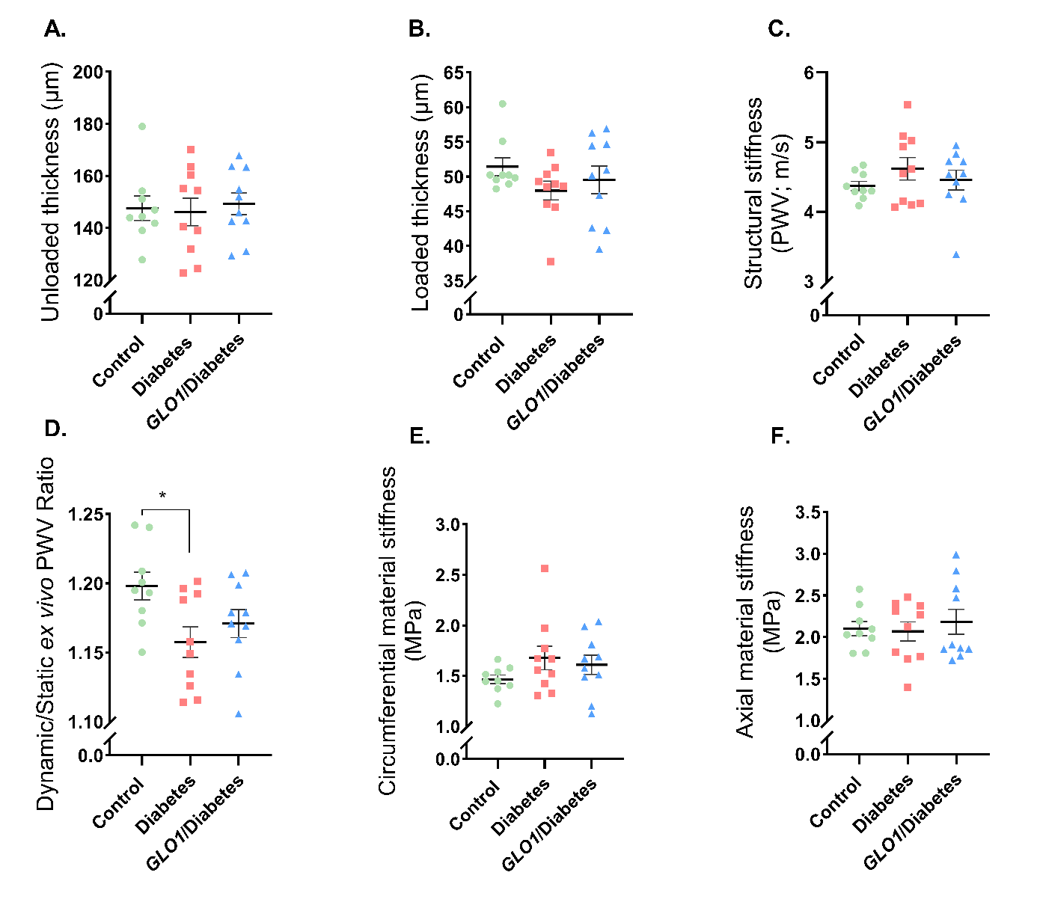
Supplementary Figure S3: When calculated at the same, overall average in vivo pressure of 106/80 mmHg, structural arterial stiffness was not affected by diabetes and glyoxalase-1 overexpression (GLO1)
Following passive biaxial testing of the thoracic descending aorta, ex vivo unloaded thickness (µm) was determined from vessel ring cross sections (n=10; A). The ex vivo modelled parameters, loaded thickness (µm; B), static PWV (m/s; C), static circumferential material stiffness (MPa; E), static axial stiffness (MPa; F) were calculated (n=10) based on the average in vivo systolic blood pressure for all groups. Data presented as mean ± standard error. Group differences were assessed using one-way analysis of variance.
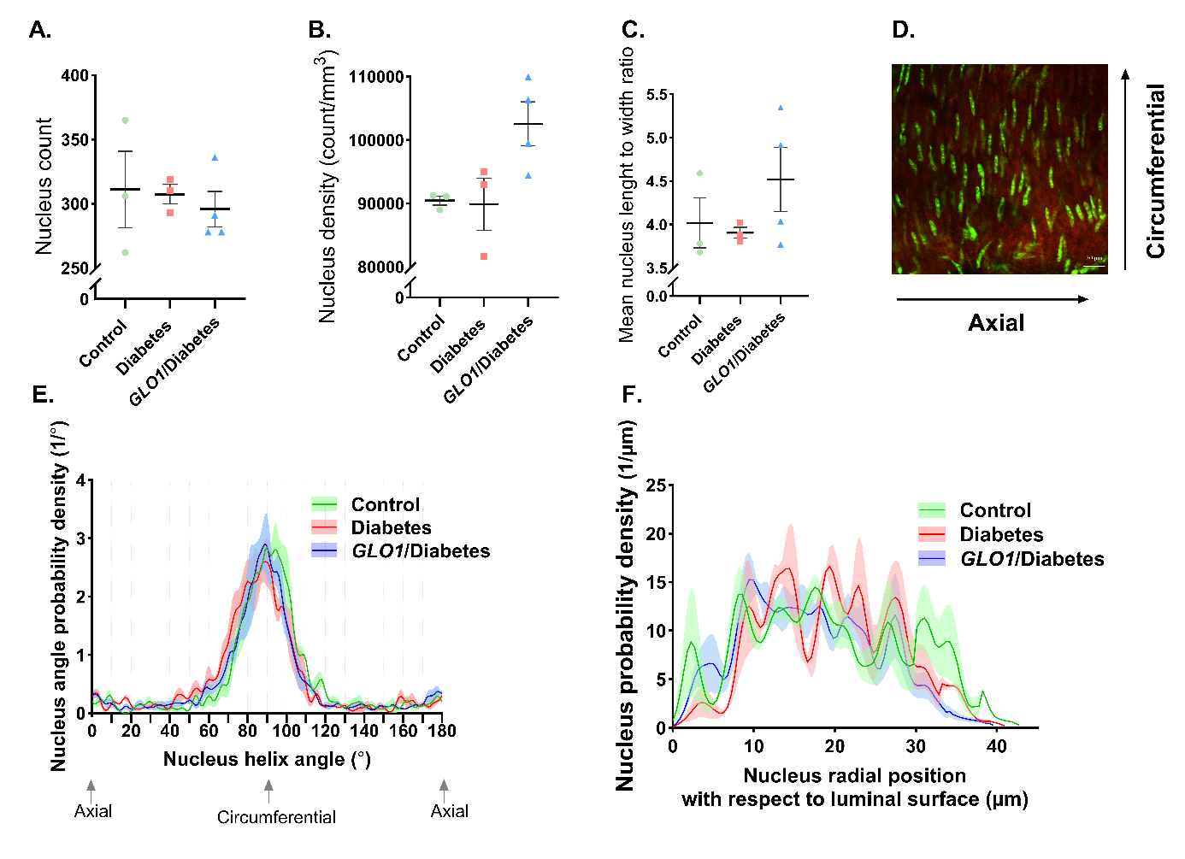
Supplementary Figure S4: Type 1 diabetes and glyoxalase-1 (GLO1) overexpression did not affect cell density, orientation and distribution across the arterial layers
Following descending thoracic aorta passive biaxial testing, to access nucleus count (A), nucleus density (B), mean nucleus length to width ratio (as an indicator of phenotype; C), nucleus angle orientation (°) and nucleus radial position (µm) with respect to the lumen (as an indicator of nucleus distribution; F) of pressurized thoracic descending aorta was determined via 3D image stacks obtained from two-photon fluorescent microscopy (n=4; D). Data presented as mean ± standard error.
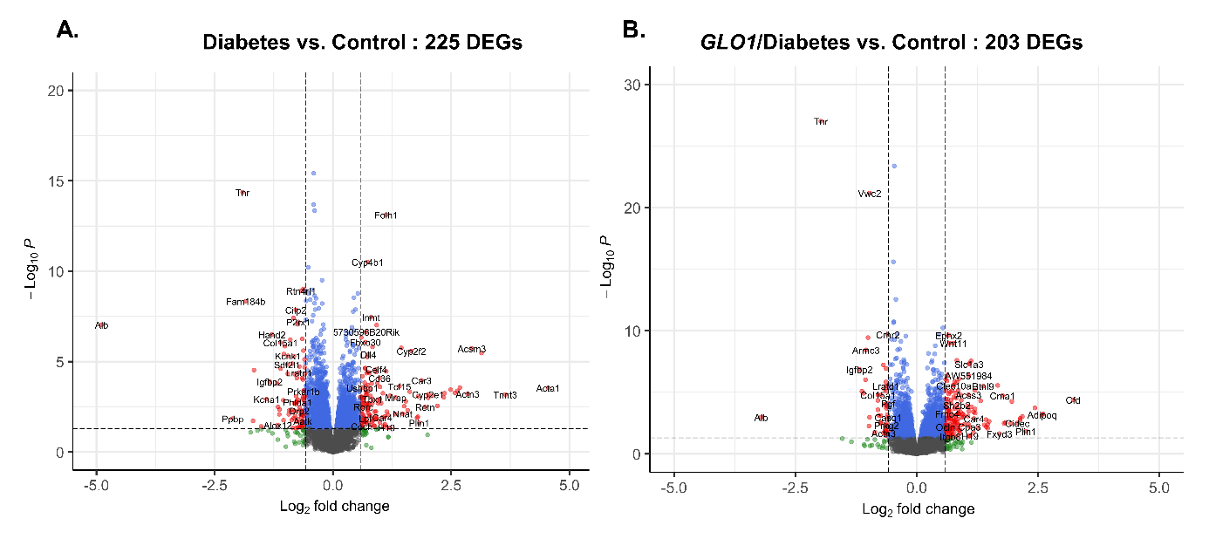
Supplementary Figure S5:
Volcano plots showing 225 differentially expressed genes (DEGs) in Diabetes vs. Control (A) and 203 DEGs in GLO1/Diabetes vs. Control. DEGs are genes that meet a threshold of p.adj < 0.05 and |log₂FC| > 0.58.
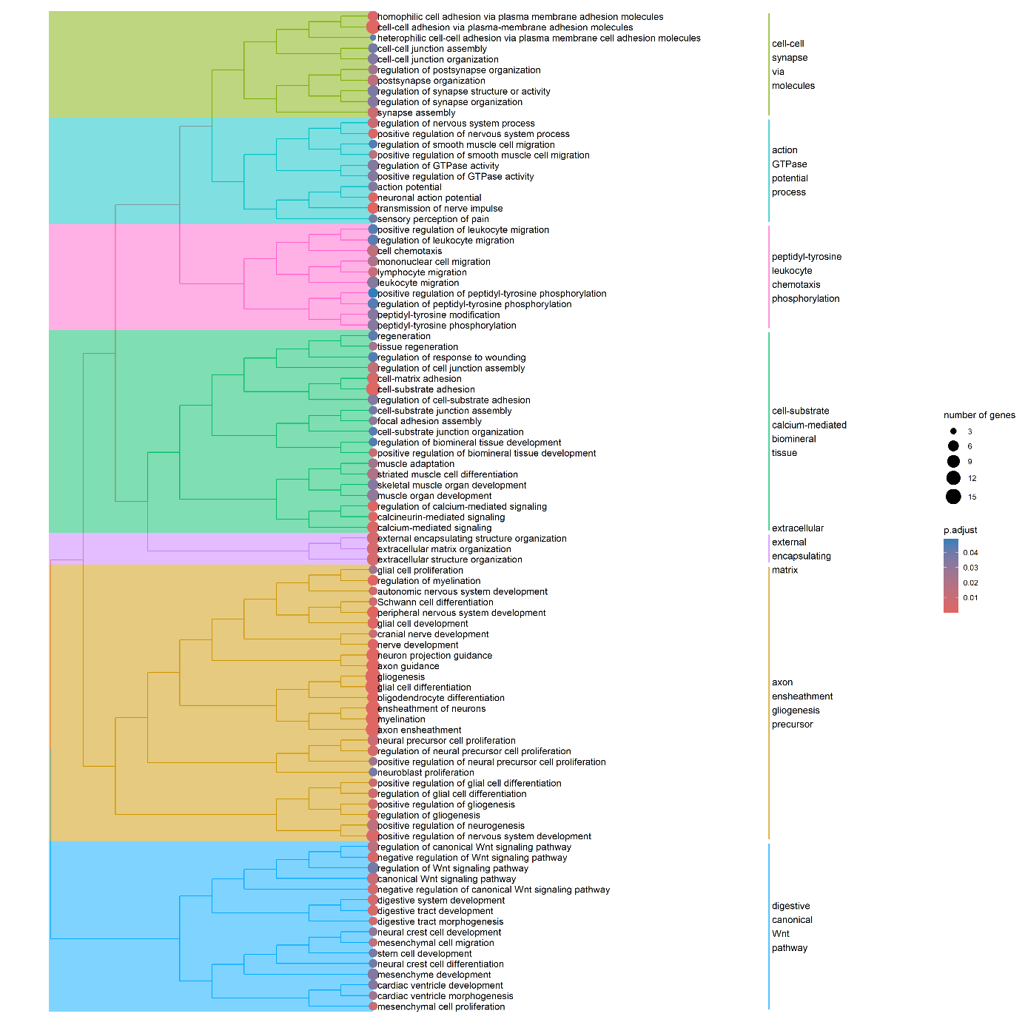
Supplementary Figure S6:
GO biological processes depicting pathways significantly affected between GLO1/Diabetes and diabetes.
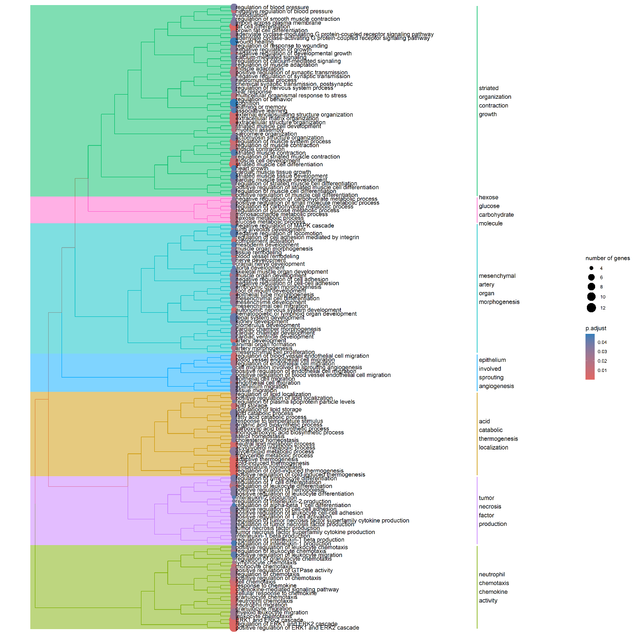
Supplementary Figure S7:
GO biological processes depicting pathways significantly affected between Control and diabetes.
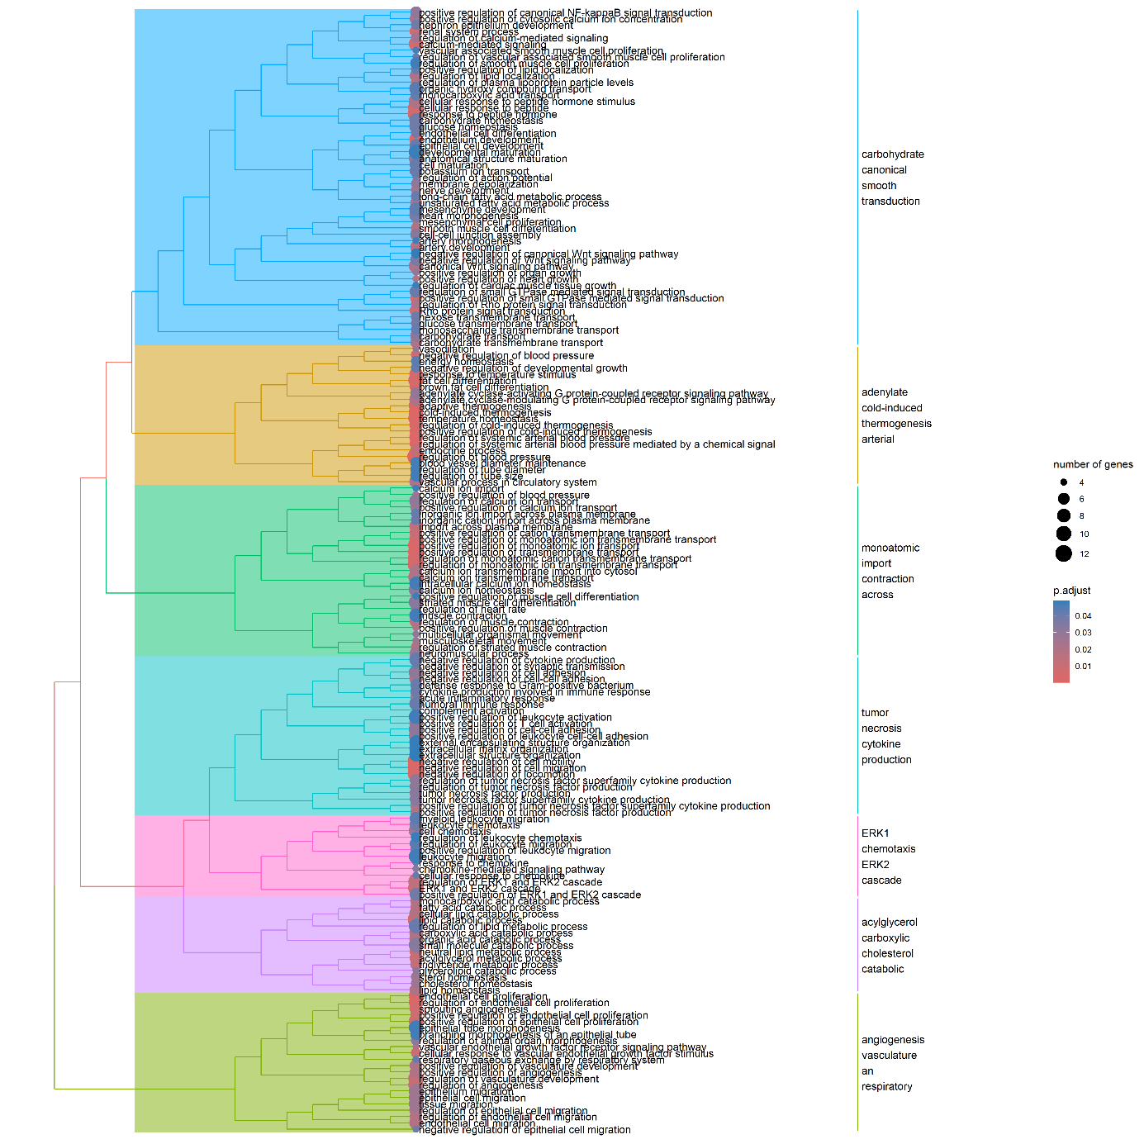
Supplementary Figure S8:
GO biological processes depicting pathways significantly affected between GLO1/Diabetes and Control.
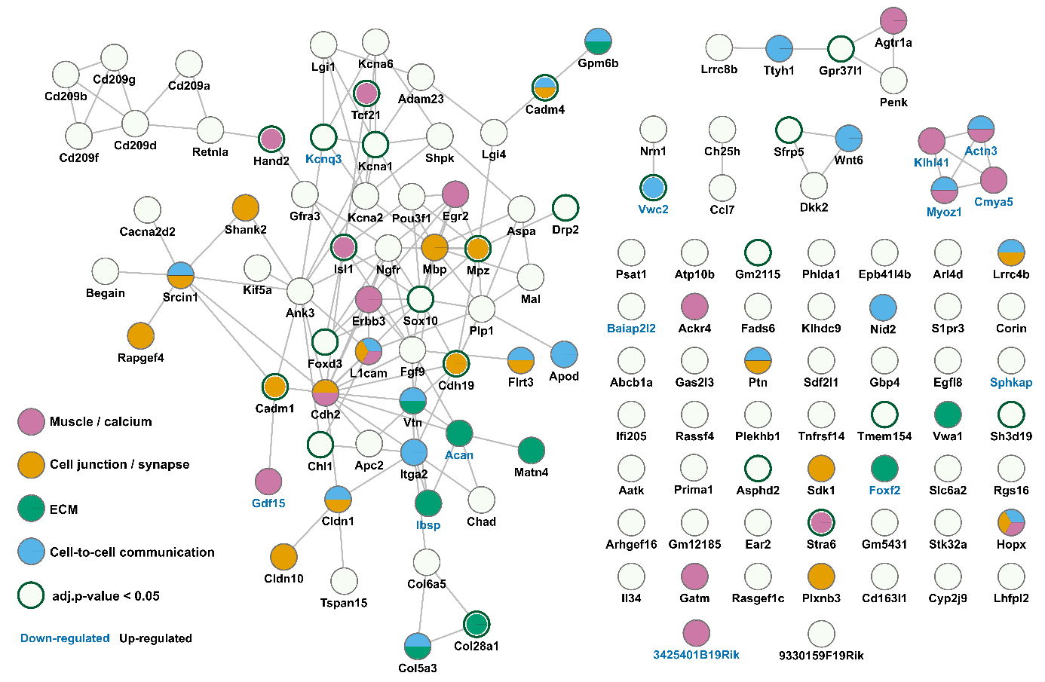
Supplementary Figure S9: Protein-protein interaction network for the DEGs impacted in GLO1/Diabetes vs. Diabetes within the subset of clusters of interest.
Each node represents one of the 137 DEGs and the edges connecting the nodes represent known interactions between these genes. The colour filling corresponds to one of the four GO biological processes pathways clusters: extracellular matrix organisation (teal green), cell junction and synapse organisation pathways (orange), cell to cell communication and tissue regeneration (blue), muscle differentiation, development, and calcium signalling regulation (pink) and genes not present in either of these four clusters but still belonging to the 137 DEGs (white). Nodes with green borders represent genes that are strongly expressed with adjusted p<0.05. Down-regulated genes have their name in blue font colour, while up-regulated in black font colour.

Author contributions
Margarita G. Pencheva optimised and performed the isolation and preparation of all tissue used in this study; optimised and performed the ex vivo passive thoracic arterial stiffness measurements and analysis; optimised and performed two-photon collagen/elastin and DNA/elastin measurements; optimised and performed the RNA isolation of the abdominal aortic tissue prior to RNA sequencing; assisted in model induction procedure (STZ injections) and blood and plasma collection; performed and analysed tail-cuff systolic and diastolic blood pressure measurements; executed data extraction and analysis from carotid-femoral PWV pulse signal recordings; designed the methodology pipeline; developed the theory, planned and managed the gathering of all the data. Led brainstorming for the interpretation and putting the story together
Eline Berends provided access to animal model; supervised the successful disease model development; performed blood and plasma collection; handled the animals. Played a vital role for the animal ethical approval and animal welfare of the present study.
Koen.W.F. van der Laan supervised the optimisation of the ex vivo passive arterial stiffness measurements and collagen/elastin, and DNA/elastin two-photon measurements; developed MATLAB scripts and performed diameter tracking of ex vivo passive arterial stiffness, which served as basis of all other consequential analysis; developed custom made MATLAB scripts and performed all two-photon image analysis; aided in brainstorming for the interpretation.
Alessandro Giudici developed custom-made MATLAB scripts for constituent-based viscoelastic computation model of the arterial wall; supervised the correct continuous analysis of the arterial stiffness data; aided in brainstorming for the interpretation.
Petra Niessen assisted in the optimisation and execution of RNA isolation of abdominal aortic tissue; assisted in RNA sequencing data sorting and analysis.
Jean L.J.M. Scheijen developed, optimised and performed the UHPLC-MS/MS and UPLC-fluorescent analysis of MGO, AGEs, Hydroxyproline and Pentosidine.
Peter Leenders collected the carotid-femoral PWV signals.
Tammo Delhaas aided in brainstorming for the interpretation and putting the story together.
Florian Caiment performed quality control, filtering and normalisation of raw RNA sequencing data and the subsequent raw data analysis; performed data clustering analysis. He was assisted by Fabiola M. Trujillo. Philippe Vangrieken aided in the RNAseq protocol and did additional analysis.
Martina Summer-Kutmon performed differentially expressed gene (DEGs) over-representation analysis, biological processes of the DEGs, tree plot clustering analysis, protein-protein interaction network analysis and produced all the associated figures.
Sébastien Foulquier supervised Eline Berends and developed animal model. Played a vital role for the animal ethical approval and animal welfare of the present study.
Kristiaan Wouters played a vital role in experimental design and secured the ethical approval for the animal study.

Supervisors:
Bart Spronck and Koen Reesink supervised biomedical engineering aspect of the study. Bart provided input on the practical aspect of arterial stiffness measurement; aided in brainstorming for the interpretation and putting the story together; and Koen guided the formation of collaborations; aided in brainstorming for the interpretation and putting the story together.
Casper Schalkwijk is the PI and supervised the study.

