Supplementary Material
Triglyceride-glucose-related indices and risk of cardiovascular disease and mortality in individuals with cardiovascular-kidney-metabolic (CKM) syndrome stages 0-3: a prospective cohort study of 282,920 participants in the UK Biobank
Kun Liu^{1†}, Jinling Hu^{2†}, Yueqing Huang³, Dingliu He^{4*}, Jing Zhang^{2*}
¹Department of Anesthesiology, Shengjing Hospital of China Medical University, Shenyang, China.
²Department of Ultrasound, Shengjing Hospital of China Medical University, Shenyang, China.
³Departments of General Medicine, The Affiliated Suzhou Hospital of Nanjing Medical University, Suzhou Municipal Hospital, Nanjing Medical University, Suzhou 215001, Jiangsu, China.
⁴Department of Clinical Nutrition, Yancheng Clinical College of Xuzhou Medical University, The First People’s Hospital of Yancheng, Yancheng 224001, Jiangsu, China.
†These authors contributed equally: Kun Liu and Jinling Hu.
*Correspond to:
Dingliu He, E-mail: hedingliu@163.com.
Department of Clinical Nutrition, Yancheng Clinical College of Xuzhou Medical University, The First People’s Hospital of Yancheng, Yancheng 224001, Jiangsu, China.
Jing Zhang, E-mail: zzjj198702@163.com.
Shengjing Hospital of China Medical University, No. 36, Sanhao Street, Heping District, Shenyang City, China, 110004.

Table S1. Detailed definition of cardiovascular-kidney-metabolic syndrome
Table S2. Measures of covariates at baseline in the UK Biobank
Table S3 Measurement of healthy diet score used in the UK Biobank
Table S4. Baseline characteristics of study population according to the quartiles of TyG index
Table S5. Sensitivity analysis for the association of TyG-related indices with all-cause and cardiovascular mortality in individuals with CKM stages 0-4
Table S6. Comparison of the current study with previous studies on similar topics
Figure S1. Subgroup analysis stratified by age (<60 vs ≥60 years) for the associations between TyG-related indices and cardiovascular disease incidence and mortality in individuals with cardiovascular-kidney-metabolic syndrome stages 0-3
Figure S2. Subgroup analysis stratified by sex (female vs male) for the associations between TyG-related indices and cardiovascular disease incidence and mortality in individuals with cardiovascular-kidney-metabolic syndrome stages 0-3
Figure S3. Subgroup analysis stratified by stage (stage 0 vs stage 1 vs stage 2 vs stage 3) for the associations between TyG-related indices and cardiovascular disease incidence and mortality in individuals with cardiovascular-kidney-metabolic syndrome stages 0-3
Figure S4. Subgroup analysis stratified by diabetic status (diabetes vs no diabetes) for the associations between TyG-related indices and cardiovascular disease incidence and mortality in individuals with cardiovascular-kidney-metabolic syndrome stages 0-3
Figure S5. Subgroup analysis stratified by adiposity status (adiposity vs no adiposity) for the associations between TyG-related indices and cardiovascular disease incidence and mortality in individuals with cardiovascular-kidney-metabolic syndrome stages 0-3
Figure S6. Subgroup analysis stratified by hypertension status (hypertension vs no hypertension) for the associations between TyG-related indices and cardiovascular disease incidence and mortality in individuals with cardiovascular-kidney-metabolic syndrome stages 0-3
Figure S7. Subgroup analysis stratified by kidney function status (eGFR: <60, 60-89, ≥90 ml/min/1.73m²) for the associations between TyG-related indices and cardiovascular disease incidence and mortality in individuals with cardiovascular-kidney-metabolic syndrome stages 0-3
Figure S8. Subgroup analysis stratified by ethnicity (Whites vs non-Whites) for the associations between TyG-related indices and cardiovascular disease incidence and mortality in individuals with cardiovascular-kidney-metabolic syndrome stages 0-3
Figure S9. Sensitivity analysis for the associations between TyG-related indices and cardiovascular disease incidence in individuals with cardiovascular-kidney-metabolic syndrome stages 0-3: excluding participants who developed outcome within the first 2 years of follow-up
Figure S10. Sensitivity analysis for the associations between TyG-related indices and all-cause and cardiovascular mortality in individuals with cardiovascular-kidney-metabolic syndrome stages 0-3: excluding participants who developed outcome within the first 2 years of follow-up
Figure S11. Sensitivity analysis for the associations between TyG-related indices and cardiovascular disease incidence in individuals with cardiovascular-kidney-metabolic syndrome stages 0-3: imputing covariates with missing values using multiple imputation approach
Figure S12. Sensitivity analysis for the associations between TyG-related indices and all-cause and cardiovascular mortality in individuals with cardiovascular-kidney-metabolic syndrome stages 0-3: imputing covariates with missing values using multiple imputation approach.
Figure S13. Sensitivity analysis for the associations between TyG-related indices and cardiovascular diseases and mortality in individuals with cardiovascular-kidney-metabolic syndrome stages 0-3: using competing risk models to control competing risk of death from other causes
Figure S14. Sensitivity analysis for the associations between TyG-related indices and cardiovascular disease incidence in individuals with cardiovascular-kidney-metabolic syndrome stages 0-3: additionally adjusting for the impact of medication use, including antihypertensive, lipid-lowering, and glucose-lowering medications.
Figure S15. Sensitivity analysis for the associations between TyG-related indices and mortality in individuals with cardiovascular-kidney-metabolic syndrome stages 0-3: adjusting for the impact of medication use, including antihypertensive, lipid-lowering, and glucose-lowering medications
Figure S16. Additional analysis for the associations between the TG/HDL ratio and cardiovascular diseases and mortality in individuals with cardiovascular-kidney-metabolic syndrome stages 0-3

Table S1. Detailed definition of cardiovascular-kidney-metabolic syndrome
Stages | Definition
Stage 0 | Stage 0 is defined as the absence of risk factors for cardiovascular-kidney-metabolic (CKM) syndrome, including normal body mass index (BMI), waist circumference (WC), blood glucose, systolic blood pressure (SBP), diastolic blood pressure (DBP), lipid levels, renal function, and no evidence of cardiovascular disease (CVD).
Stage 1 | Stage 1 was characterized by the existence of at least one of the following metabolic dysfunctions: (1) BMI ≥25 kg/m²; (2) WC ≥88/102 cm in women/men; (3) prediabetes: 5.7%≤ glycated hemoglobin (HbA1c) ≤6.4%.
Stage 2 | Stage 2 is defined as the presence of moderate to high-risk chronic kidney disease (CKD) and the existence of one or more of the following metabolic risk factors: (1) hypertension; (2) diabetes; (3) triglycerides (TG) ≥ 135 mg/dL; (4) diagnosis of metabolic syndrome.  The moderate to high-risk CKD was defined as an estimated Glomerular Filtration Rate (eGFR) between 30 and 60 mL/min/1.73 m², and eGFR was calculated using the CKD-EPI 2021 creatinine-based equation proposed by the Chronic Kidney Epidemiology Collaboration.  Hypertension was defied as a self-reported history of hypertension, and/or SBP ≥130 mmHg, and/or DBP ≥80 mmHg, and/or the intake of anti-hypertensive medications.  Diabetes was defined as HbA1c ≥6.4%, and/or a diagnostic history of diabetes before baseline, and/or the intake of glucose-lowering medications.  Metabolic syndrome is defined as meeting at least three of the following criteria: (1) increased WC; (2) reduced high-density lipoprotein cholesterol (HDL-C < 40 mg/dL in men or < 50 mg/dL in women); (3) high TG (TG > 150 mg/dL); (4) elevated BP (SBP ≥ 130 mmHg or DBP ≥ 80 mmHg); or (5) prediabetes.
Stage 3 | Stage 3 involves individuals with subclinical CVD or advanced-stage CKD.  Participants with subclinical CVD was defined as a high predicted CVD risk based on the Systematic Coronary Risk Evaluation 2 (SCORE2) model.  Participants with advanced-stage CKD include those with an eGFR < 30 mL/min/1.73 m².

Table S2. Measures of covariates at baseline in the UK Biobank
Variable | Filed ID | Question or description | Categories from raw data | Categories for the current study
Ethnicity | 21000 | Ethnic background | White;  Mixed;  Asian or Asian British;  Black or Black British;  Chinese;  Other ethnic group. | 0 = White;  1 = Non-White
Education | 6138 | Qualifications | College or University degree;  A levels/AS levels or equivalent;  O levels/GCSEs or equivalent;  CSEs or equivalent;  NVQ or HND or HNC or equivalent;  Other professional qualifications eg: nursing, teaching. | 0 = College or university degree;  1 = Others.
Family income | 738 | Average total household income before tax (unit: £) | Less than 18,000;  18,000 to 30,999;  31,000 to 51,999;  52,000 to 100,000;  Greater than 100,000; | 1 = <18,000;  2 = 18,000 to 51,999;  3 = ≥52,000.
Employment | 6142 | Current employment status | In paid employment or self-employed;  Retired;  Looking after home and/or family;  Unable to work because of sickness or disability;  Unemployed;  Doing unpaid or voluntary work;  Full or part-time student;  None of the above. | 0 = Employed (including those paid employment or self-employed, retired, doing unpaid or voluntary work, or being full or part time students);  1 = Unemployed.
Townsend deprivation index | 22189 | Townsend deprivation index at recruitment | Continuous. | A higher value indicates greater deprivation.
Smoking | 20116 | The current/past smoking status of the participant. | Never;  Past;  Current. | 0 = Never smoker;  1 = Ever smoker;  2= Current smoker.
Alcohol consumption | 1558 | About how often do you drink alcohol? | Never;  Special occasions only;  One to three times a month;  Once or twice a week;  Three or four times a week;  Daily or almost daily. | 1 = Never drinking;  2 = Special occasions only;  3 = One to three time a month;  4 = Oner or twice a week;  5 = Three or four times a week;  6 = Daily or almost daily.
Adequate physical activity | 884,894,904,914 | Number of days/week of moderate/vigorous physical activity 10+ minutes?  Duration of moderate/vigorous activity? | Continuous. | Total amount of weekly moderate and vigorous physical activity was calculated by multiplying the number of days per week and the duration per day, respectively. Adequate physical activity was defined as vigorous physical activity ≥75 min/week, or moderate physical activity ≥150min/week, or equivalent combination.  0 = Adequate; 1 = Unadequate.
Sleep duration | 1160 | About how many hours sleep do you get in every 24 hours? (please include naps)? | Continuous. | 0 = <7 hours/day;  1 = 7-8 hours/day;  2= >8 hours/day.
Diet score | See Table S3

Table S3 Measurement of healthy diet score used in the UK Biobank
Diet component | Intake goal | Field IDs | Amount per serving
Fruit | ≥3 servings/day | 1309 (pieces fresh fruit/day)  1319 (pieces dried fruit/day) | 1309 – 1 piece  1319 – 5 pieces
Vegetable | ≥3 servings/day | 1289 (tablespoons cooked vegetables/day)  1299 (salad/raw vegetables/day) | 3 heaped tablespoons
Whole grains | ≥3 servings/day | 1438, 1448 (whole meal/wholegrain bread slices/week)  1458, 1468 (bran/oat/muesli cereal bowls/week) | 1438/1448 – 1 slice/day  1458/1468 – 1 bowl/day
Fish | ≥2 servings/week | 1329 (oily fish/week)  1339 (non-oily fish/week) | Once/week
Refined grains | ≤2 servings/day | 1438, 1448 (white, brown, other bread slices/week)  1458, 1468 (biscuit, other cereals/week) | 1438/1448 – 1 slice/day  1458/1468 – 1 bowl/day
Processed meats | ≤1 serving/week | 1349 (processed meat/week or daily)  3680 (age when last ate meat) | 1349 – 1 piece/day  3680 – 0 pieces/day if indicated having never eaten meat
Unprocessed meats | ≤2 servings/week | 1359 (poultry/week or day)  1369 (beef/week or day)  1379 (lamb or mutton/week or day)  1389 (pork/week or day)  3680 (age when last ate meat) | 1359-1389 – once/week  3680 – 0 pieces/day if indicated having never eaten meat
Field IDs and serving sizes used per diet component in UK Biobank with available data from the general baseline questionnaire. If participants achieved the intake goal, they were considered to have an adequate intake of the diet component.
Scoring criteria for healthy dietary component recommendations: 1: If intake goal met; 0: If intake goal not met (Range: 0-7).

Table S4. Baseline characteristics of study population according to the quartiles of TyG index
 | TyG index
 | Q1 | Q2 | Q3 | Q4 | P value
N | 70730 | 70730 | 70730 | 70730
Age (year) | 53.0 (46.0, 60.0) | 57.0 (50.0, 63.0) | 58.0 (51.0, 63.0) | 58.0 (51.0, 63.0) | <0.001
Sex |  |  |  |  | <0.001
Female | 47975 (67.8%) | 41070 (58.1%) | 34623 (49.0%) | 26887 (38.0%)
Male | 22755 (32.2%) | 29660 (41.9%) | 36107 (51.0%) | 43843 (62.0%)
Ethnicity |  |  |  |  | <0.001
White | 63552 (89.9%) | 64555 (91.3%) | 65007 (91.9%) | 65079 (92.0%)
Non-white | 7178 (10.1%) | 6175 (8.7%) | 5723 (8.1%) | 5651 (8.0%)
Employed status |  |  |  |  | <0.001
Employed | 66033 (93.4%) | 66415 (93.9%) | 66688 (94.3%) | 65963 (93.3%)
Not employed | 4697 (6.6%) | 4315 (6.1%) | 4042 (5.7%) | 4767 (6.7%)
Educational level |  |  |  |  | <0.001
University or college | 30266 (42.8%) | 26818 (37.9%) | 24723 (35.0%) | 22876 (32.3%)
Others | 40464 (57.2%) | 43912 (62.1%) | 46007 (65.0%) | 47854 (67.7%)
Townsend deprivation index | -2.2 (-3.7, 0.2) | -2.3 (-3.7, 0.1) | -2.3 (-3.7, 0.1) | -2.2 (-3.6, 0.4) | <0.001
Family income |  |  |  |  | <0.001
≤ €18000 | 11177 (15.8%) | 13873 (19.6%) | 15336 (21.7%) | 16624 (23.5%)
€18000 to €51999 | 35842 (50.7%) | 37231 (52.6%) | 37648 (53.2%) | 37466 (53.0%)
≥ €52000 | 23711 (33.5%) | 19626 (27.7%) | 17746 (25.1%) | 16640 (23.5%)
Physical activity |  |  |  |  | <0.001
MVPA ≥150 min/week | 11427 (16.2%) | 12747 (18.0%) | 13531 (19.1%) | 14892 (21.1%)
MVPA <150 min/week | 59303 (83.8%) | 57983 (82.0%) | 57199 (80.9%) | 55838 (78.9%)
Smoking status |  |  |  |  | <0.001
Never smoking | 43657 (61.7%) | 41374 (58.5%) | 38641 (54.6%) | 35946 (50.8%)
Ever smoking | 21519 (30.4%) | 23127 (32.7%) | 24998 (35.3%) | 26194 (37.0%)
Current smoking | 5554 (7.9%) | 6229 (8.8%) | 7091 (10.0%) | 8590 (12.1%)
Alcoholic drinking |  |  |  |  | <0.001
Never | 10596 (15.0%) | 11310 (16.0%) | 11948 (16.9%) | 12749 (18.0%)
1-3 times/month | 7569 (10.7%) | 7716 (10.9%) | 7781 (11.0%) | 8047 (11.4%)
1-2 times/week | 18595 (26.3%) | 18509 (26.2%) | 18495 (26.1%) | 18378 (26.0%)
3-4 times/week | 18592 (26.3%) | 17835 (25.2%) | 17347 (24.5%) | 16571 (23.4%)
Daily or almost daily | 15378 (21.7%) | 15360 (21.7%) | 15159 (21.4%) | 14985 (21.2%)
Sleep duration |  |  |  |  | <0.001
<7 hour/day | 16063 (22.7%) | 16447 (23.3%) | 16536 (23.4%) | 17182 (24.3%)
7-8 hours/day | 50941 (72.0%) | 49786 (70.4%) | 49267 (69.7%) | 47888 (67.7%)
>8 hours/day | 3726 (5.3%) | 4497 (6.4%) | 4927 (7.0%) | 5660 (8.0%)
Diet quality | 4.0 (3.0, 4.0) | 3.0 (3.0, 4.0) | 3.0 (2.0, 4.0) | 3.0 (2.0, 4.0) | <0.001
SBP (mmHg) | 130.5 (119.0, 143.0) | 136.0 (124.5, 148.5) | 138.0 (127.0, 151.0) | 140.5 (130.0, 153.0) | <0.001
DBP (mmHg) | 79.0 (73.0, 86.0) | 82.0 (75.5, 88.5) | 83.0 (77.0, 90.0) | 84.5 (78.0, 91.5) | <0.001
HbA1c, mmol/mol | 34.0 (31.7, 36.0) | 34.9 (32.5, 36.9) | 35.5 (33.1, 37.5) | 35.9 (33.7, 39.0) | <0.001
TC, mmol/L | 3.2 (2.7, 3.7) | 3.5 (3.0, 4.1) | 3.7 (3.2, 4.3) | 3.9 (3.3, 4.5) | <0.001
LDL-C, mmol/L | 5.3 (4.7, 6.0) | 5.7 (5.0, 6.3) | 5.9 (5.2, 6.6) | 6.1 (5.3, 6.9) | <0.001
CKM stage
0 | 16516 (23.4) | 6839 (9.7) | 707 (1.0) | 13 (0.001)
1 | 7743 (10.9) | 6009 (8.5) | 846 (1.2) | 11 (0.001)
2 | 24392 (34.5) | 22323 (31.6) | 23445 (33.1) | 15236 (21.5)
3 | 22079 (31.2) | 35559 (50.3) | 45732 (64.7) | 55470 (78.4)
TyG index | 8.1 (7.9, 8.2) | 8.5 (8.4, 8.6) | 8.8 (8.8, 8.9) | 9.3 (9.2, 9.6) | <0.001
TyG-BMI index | 196.3 (178.6, 216.9) | 221.0 (201.4, 244.6) | 240.2 (219.2, 266.1) | 268.5 (244.2, 298.2) | <0.001
TyG-WC index | 645.7 (585.5, 718.6) | 738.9 (667.1, 810.6) | 809.7 (738.7, 880.1) | 905.6 (831.3, 985.0) | <0.001
TyG-WHtR index | 3.9 (3.5, 4.2) | 4.4 (4.0, 4.8) | 4.8 (4.4, 5.2) | 5.3 (4.9, 5.7) | <0.001
Data are presented as mean (SD) or median (interquartile range) for continue variables and n (%) for categorical variables.
Abbreviation: CVD, cardiovascular disease; MVPA, moderate-to-vigorous intensity physical activity; SBP, systolic blood pressure; DBP, diastolic blood pressure; HbA1c, glycated hemoglobin; TC, total cholesterol; LDL-C, low intensity density cholesterol; TyG, triglyceride-glucose index; BMI, body mass index; WC, waist circumference; WHtR, weight-to-height ratio; CKM, Cardiovascular-Kidney-Metabolic.

Table S5. Sensitivity analysis for the association of TyG-related indices with all-cause and cardiovascular mortality in individuals with CKM stages 0-4.
Exposure | All-cause mortality | Cardiovascular mortality
TyG index
Per 1-SD increment | 1.02 (1.01-1.03) | 1.03 (1.00-1.06)
Q1 | Reference | Reference
Q2 | 0.98 (0.94-1.02) | 0.95 (0.86-1.04)
Q3 | 0.97 (0.93-1.01) | 0.93 (0.85-1.02)
Q4 | 1.03 (0.99-1.07) | 1.01 (0.92-1.10)
TyG-BMI index
Per 1-SD increment | 1.07 (1.06-1.09) | 1.18 (1.14-1.21)
Q1 | Reference | Reference
Q2 | 0.94 (0.90-0.97) | 1.09 (0.99-1.21)
Q3 | 0.93 (0.89-0.97) | 1.07 (0.97-1.18)
Q4 | 1.08 (1.04-1.13) | 1.37 (1.25-1.51)
TyG-WC index
Per 1-SD increment | 1.13 (1.11-1.14) | 1.23 (1.19-1.27)
Q1 | Reference | Reference
Q2 | 1.01 (0.96-1.06) | 1.08 (0.96-1.21)
Q3 | 1.02 (0.97-1.07) | 1.19 (1.06-1.33)
Q4 | 1.23 (1.17-1.29) | 1.51 (1.35-1.69)
TyG-WHtR index
Per 1-SD increment | 1.11 (1.10-1.13) | 1.21 (1.18-1.25)
Q1 | Reference | Reference
Q2 | 0.97 (0.93-1.02) | 1.08 (0.97-1.21)
Q3 | 1.01 (0.96-1.05) | 1.18 (1.06-1.32)
Q4 | 1.17 (1.12-1.22) | 1.44 (1.29-1.60)
Sensitivity analyses were performed by including individuals with CKM stage 4, which was defined as the presence of clinical cardiovascular disease in addition to adiposity, other CKM risk factors, or CKD.
Data were presented as hazard ratio (95% confidence interval).
Models were adjusted for age, sex, ethnicity, employed status, Townsend deprivation index, educational level, family income, smoking status, alcohol drinking, sleep duration, physical activity, diet quality, systolic/diastolic blood pressure, glycated hemoglobin, total cholesterol, low-density lipoprotein cholesterol, and baseline status of cardiovascular disease.
Abbreviation: TyG, triglyceride-glucose index; BMI, body mass index; WC, waist circumference; WHtR, weight-to-height ratio; CKM, Cardiovascular-Kidney-Metabolic; CKD, chronic kidney disease.

Table S6. Comparison of the current study with previous studies on similar topics
Study | Study population | Sample size | Follow-up duration | Exposures | Outcomes | Limitations
Hong et al., 2025 (CHARLS) | CKM syndrome stage 0-3 (China) | 7,364 | 2011-2020 | TyG, TyG-BMI, TyG-WC, and TyG-WHtR | Overall CVD incidence | Small sample sizes, self-reported outcome events, and short follow-up
Li et al., 2024 (CHARLS) | CKM syndrome stage 0-3 (China) | 7,376 | 2011-2018 | TyG-BMI | Overall CVD incidence | Small sample sizes, self-reported outcome events, and short follow-up
Zhang et al., 2025  (NHANES) | CKM syndrome stage 0-3 (US) | 6,383 | 2009-2018 | TyG, TyG-BMI, TyG-WC, and TyG-WHtR | All-cause  and cardiovascular mortality | Small sample sizes, self-reported outcome events, and short follow-up
Current Study  (UK Biobank) | CKM syndrome stage 0-3 (UK) | 282,920 | 2006-2022 | TyG, TyG-BMI, TyG-WC, and TyG-WHtR | Overall CVD, CHD, and stroke incidence, and all-cause and cardiovascular mortality | The predominantly White study population and the “healthy volunteer” effect

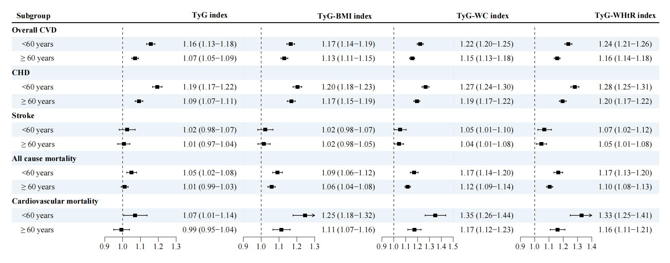

Figure S1. Subgroup analysis stratified by age (<60 vs ≥60 years) for the associations between TyG-related indices and cardiovascular disease incidence and mortality in individuals with cardiovascular-kidney-metabolic syndrome stages 0-3
Data were presented as hazard ratio and 95% confidence interval. Models were adjusted for sex, ethnicity, employed status, Townsend deprivation index, educational level, family income, smoking status, alcohol drinking, sleep duration, physical activity, diet quality, systolic/diastolic blood pressure, glycated hemoglobin, total cholesterol, and low-density lipoprotein cholesterol.
Abbreviations: CVD, cardiovascular disease; CHD, coronary heart disease; TyG, triglyceride-glucose index; BMI, body mass index; WC, waist circumference; WHtR, weight-to-height ratio.
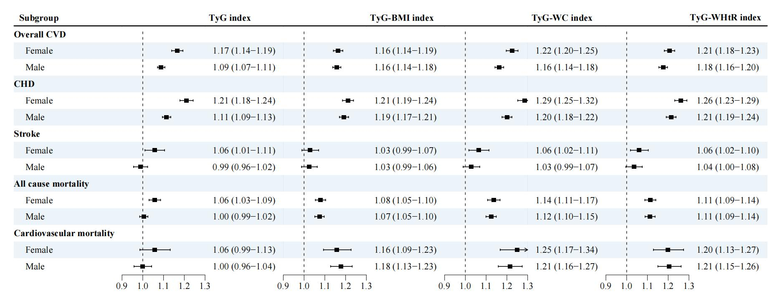

Figure S2. Subgroup analysis stratified by sex (female vs male) for the associations between TyG-related indices and cardiovascular disease incidence and mortality in individuals with cardiovascular-kidney-metabolic syndrome stages 0-3
Data were presented as hazard ratio and 95% confidence interval. Models were adjusted for age, ethnicity, employed status, Townsend deprivation index, educational level, family income, smoking status, alcohol drinking, sleep duration, physical activity, diet quality, systolic/diastolic blood pressure, glycated hemoglobin, total cholesterol, and low-density lipoprotein cholesterol.
Abbreviations: CVD, cardiovascular disease; CHD, coronary heart disease; TyG, triglyceride-glucose index; BMI, body mass index; WC, waist circumference; WHtR, weight-to-height ratio.

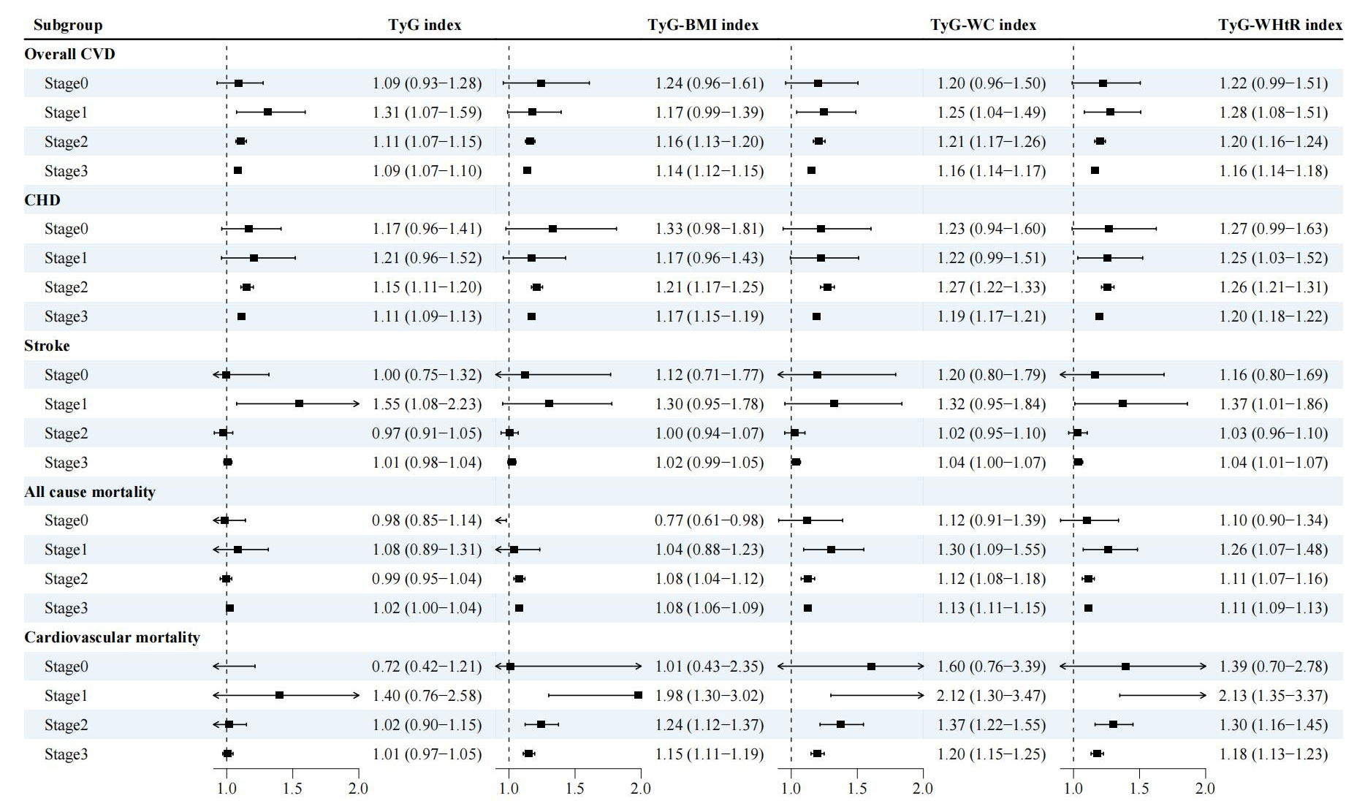

Figure S3. Subgroup analysis stratified by stage (stage 0 vs stage 1 vs stage 2 vs stage 3) for the associations between TyG-related indices and cardiovascular disease incidence and mortality in individuals with cardiovascular-kidney-metabolic syndrome stages 0-3
Data were presented as hazard ratio and 95% confidence interval. Models were adjusted for age, sex, ethnicity, employed status, Townsend deprivation index, educational level, family income, smoking status, alcohol drinking, sleep duration, physical activity, diet quality, systolic/diastolic blood pressure, glycated hemoglobin, total cholesterol, and low-density lipoprotein cholesterol.
Abbreviations: CVD, cardiovascular disease; CHD, coronary heart disease; TyG, triglyceride-glucose index; BMI, body mass index; WC, waist circumference; WHtR, weight-to-height ratio.

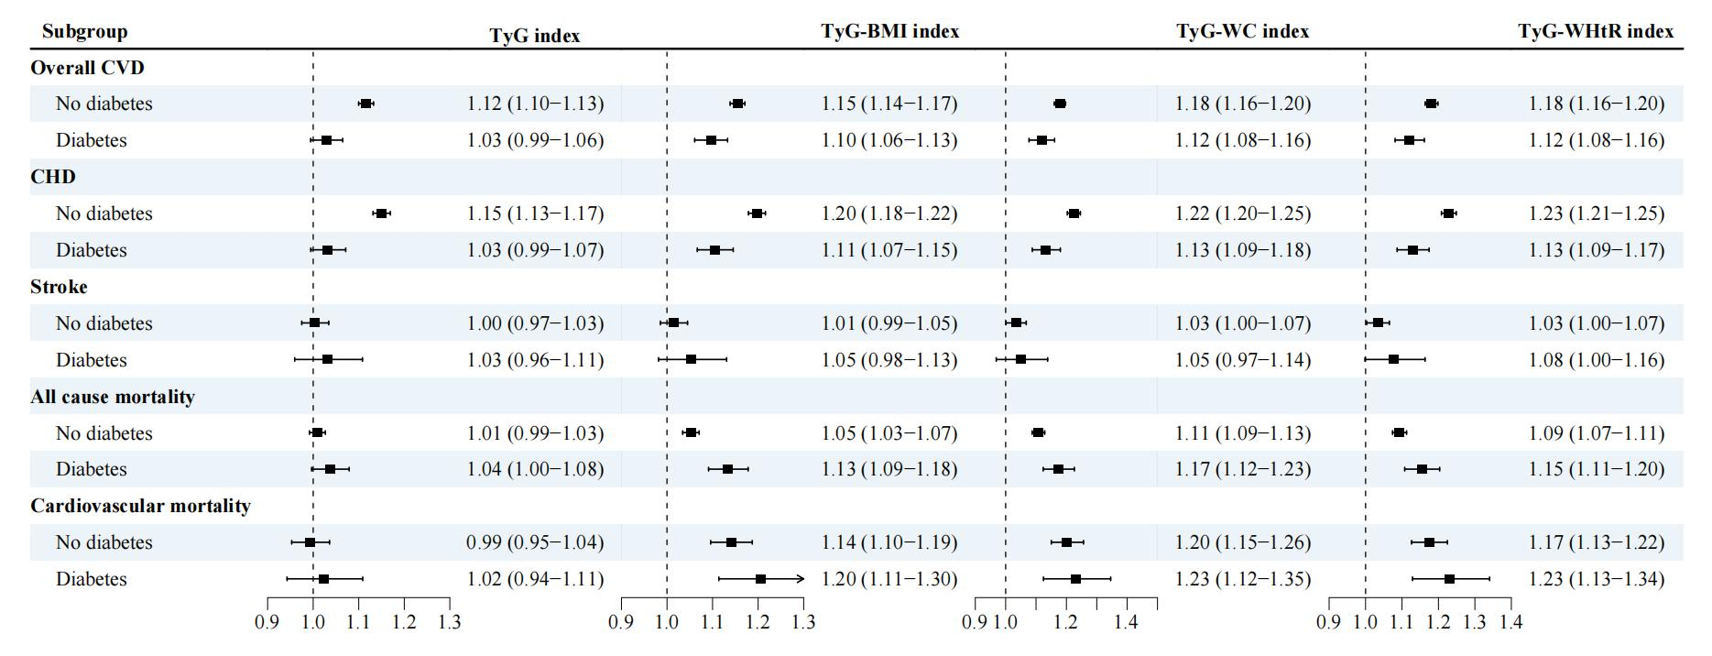

Figure S4. Subgroup analysis stratified by diabetic status (diabetes vs no diabetes) for the associations between TyG-related indices and cardiovascular disease incidence and mortality in individuals with cardiovascular-kidney-metabolic syndrome stages 0-3
Data were presented as hazard ratio and 95% confidence interval. Models were adjusted for age, sex, ethnicity, employed status, Townsend deprivation index, educational level, family income, smoking status, alcohol drinking, sleep duration, physical activity, diet quality, systolic/diastolic blood pressure, glycated hemoglobin, total cholesterol, and low-density lipoprotein cholesterol.
Abbreviations: CVD, cardiovascular disease; CHD, coronary heart disease; TyG, triglyceride-glucose index; BMI, body mass index; WC, waist circumference; WHtR, weight-to-height ratio.
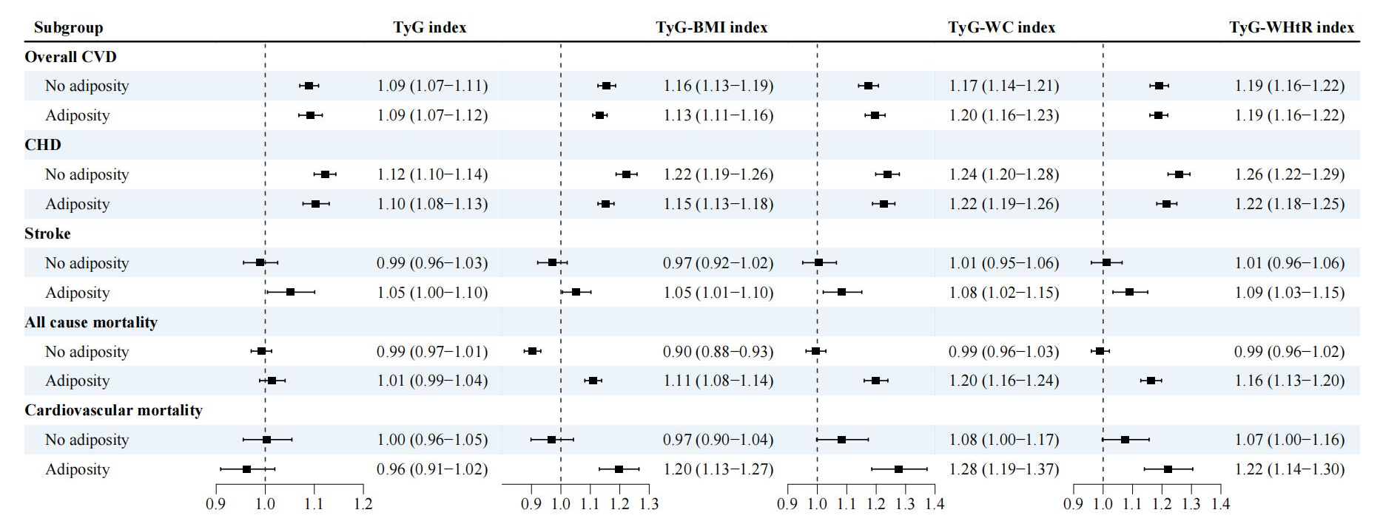

Figure S5. Subgroup analysis stratified by adiposity status (adiposity vs no adiposity) for the associations between TyG-related indices and cardiovascular disease incidence and mortality in individuals with cardiovascular-kidney-metabolic syndrome stages 0-3
Data were presented as hazard ratio and 95% confidence interval. Models were adjusted for age, sex, ethnicity, employed status, Townsend deprivation index, educational level, family income, smoking status, alcohol drinking, sleep duration, physical activity, diet quality, systolic/diastolic blood pressure, glycated hemoglobin, total cholesterol, and low-density lipoprotein cholesterol.
Abbreviations: CVD, cardiovascular disease; CHD, coronary heart disease; TyG, triglyceride-glucose index; BMI, body mass index; WC, waist circumference; WHtR, weight-to-height ratio.

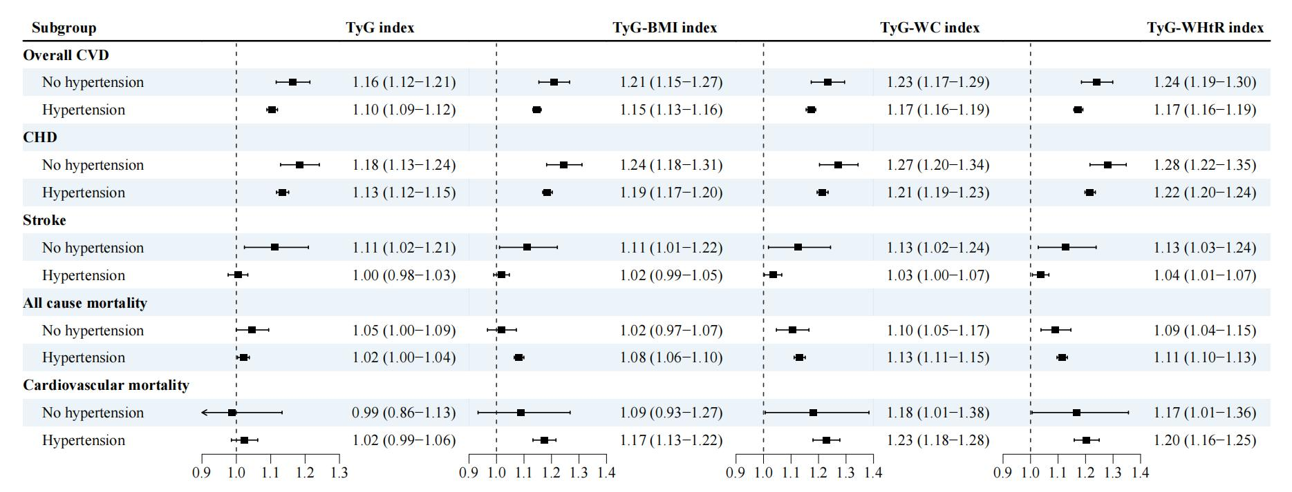

Figure S6. Subgroup analysis stratified by hypertension status (hypertension vs no hypertension) for the associations between TyG-related indices and cardiovascular disease incidence and mortality in individuals with cardiovascular-kidney-metabolic syndrome stages 0-3
Data were presented as hazard ratio and 95% confidence interval. Models were adjusted for age, sex, ethnicity, employed status, Townsend deprivation index, educational level, family income, smoking status, alcohol drinking, sleep duration, physical activity, diet quality, systolic/diastolic blood pressure, glycated hemoglobin, total cholesterol, and low-density lipoprotein cholesterol.
Abbreviations: CVD, cardiovascular disease; CHD, coronary heart disease; TyG, triglyceride-glucose index; BMI, body mass index; WC, waist circumference; WHtR, weight-to-height ratio.
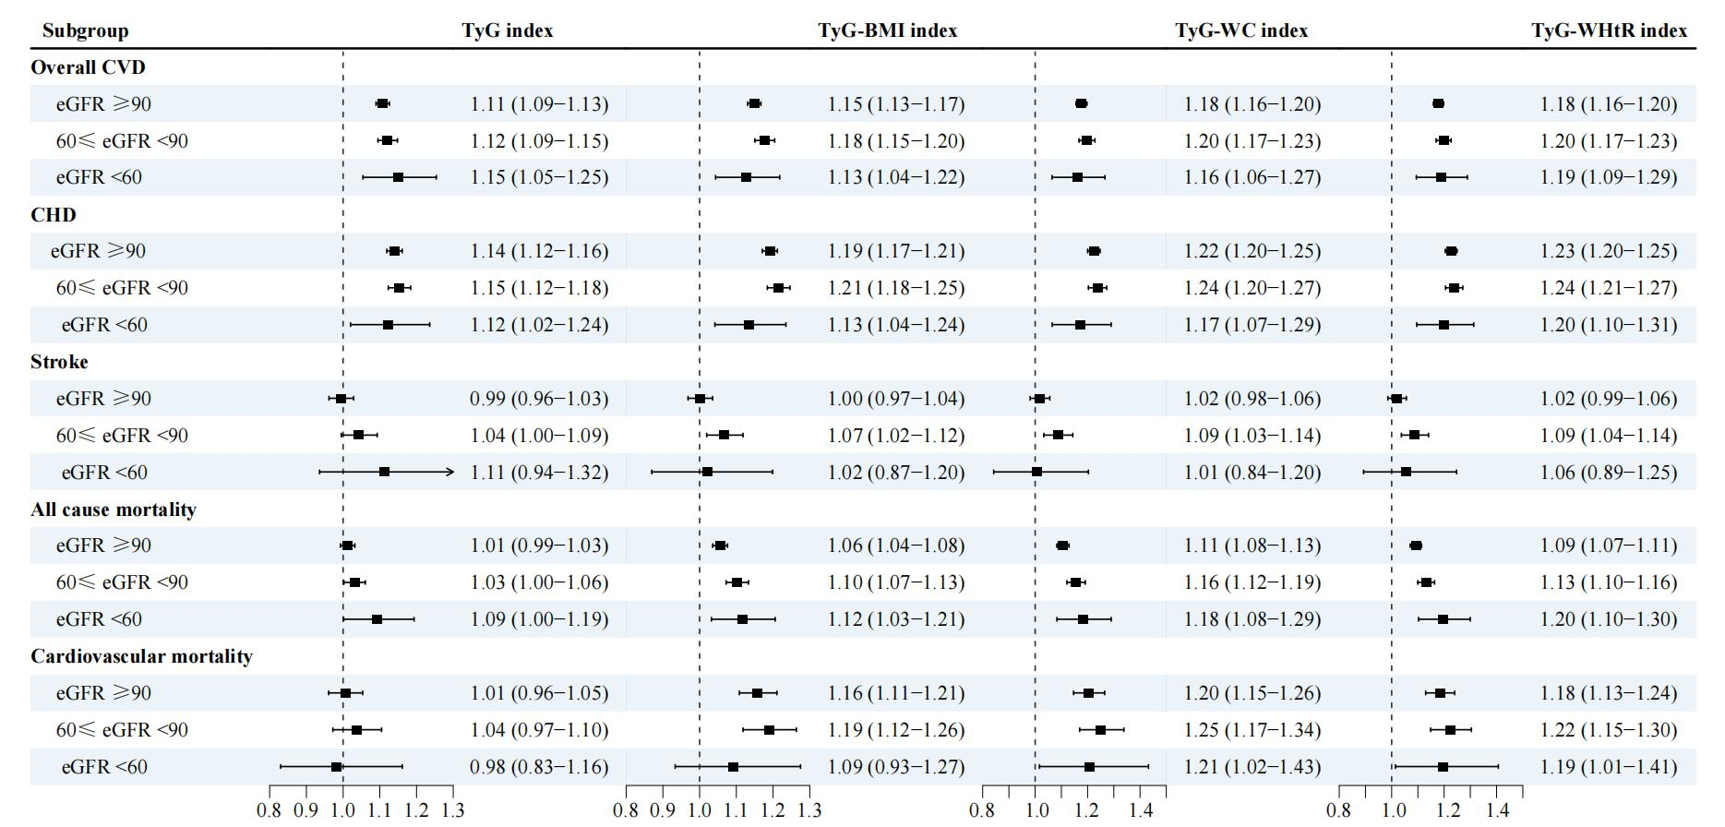

Figure S7. Subgroup analysis stratified by kidney function status (eGFR: <60, 60-89, ≥90 ml/min/1.73m²) for the associations between TyG-related indices and cardiovascular disease incidence and mortality in individuals with cardiovascular-kidney-metabolic syndrome stages 0-3
Data were presented as hazard ratio and 95% confidence interval. Models were adjusted for age, sex, ethnicity, employed status, Townsend deprivation index, educational level, family income, smoking status, alcohol drinking, sleep duration, physical activity, diet quality, systolic/diastolic blood pressure, glycated hemoglobin, total cholesterol, and low-density lipoprotein cholesterol.
Abbreviations: CVD, cardiovascular disease; CHD, coronary heart disease; TyG, triglyceride-glucose index; BMI, body mass index; WC, waist circumference; WHtR, weight-to-height ratio; eGFR, estimated Glomerular Filtration Rate.

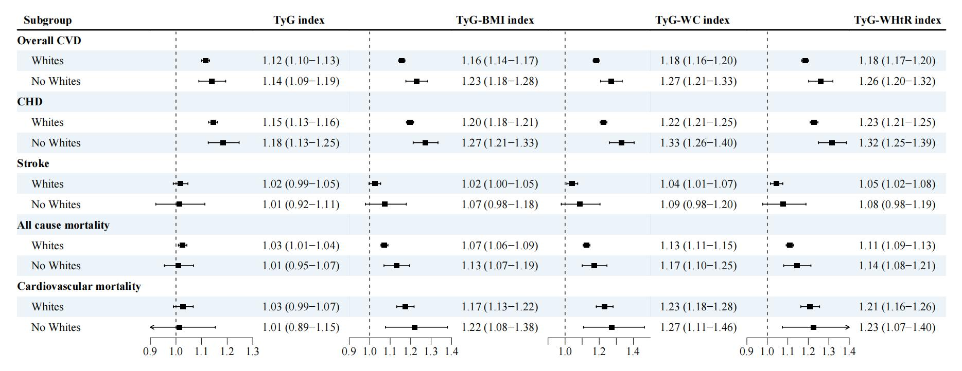

Figure S8. Subgroup analysis stratified by ethnicity (Whites vs non-Whites) for the associations between TyG-related indices and cardiovascular disease incidence and mortality in individuals with cardiovascular-kidney-metabolic syndrome stages 0-3
Data were presented as hazard ratio and 95% confidence interval. Models were adjusted for age, sex, employed status, Townsend deprivation index, educational level, family income, smoking status, alcohol drinking, sleep duration, physical activity, diet quality, systolic/diastolic blood pressure, glycated hemoglobin, total cholesterol, and low-density lipoprotein cholesterol.
Abbreviations: CVD, cardiovascular disease; CHD, coronary heart disease; TyG, triglyceride-glucose index; BMI, body mass index; WC, waist circumference; WHtR, weight-to-height ratio.

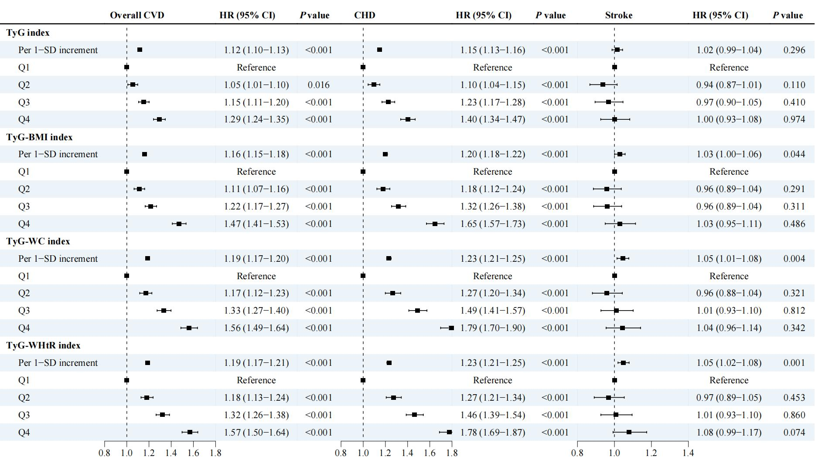

Figure S9. Sensitivity analysis for the associations between TyG-related indices and cardiovascular disease incidence in individuals with cardiovascular-kidney-metabolic syndrome stages 0-3: excluding participants who developed outcome within the first 2 years of follow-up
Models were adjusted for age, sex, ethnicity, employed status, Townsend deprivation index, educational level, family income, smoking status, alcohol drinking, sleep duration, physical activity, diet quality, systolic/diastolic blood pressure, glycated hemoglobin, total cholesterol, and low-density lipoprotein cholesterol.
Abbreviations: CVD, cardiovascular disease; CHD, coronary heart disease; TyG, triglyceride-glucose index; BMI, body mass index; WC, waist circumference; WHtR, weight-to-height ratio, SD, standard deviation; HR, hazard ratio; CI, confidence interval.

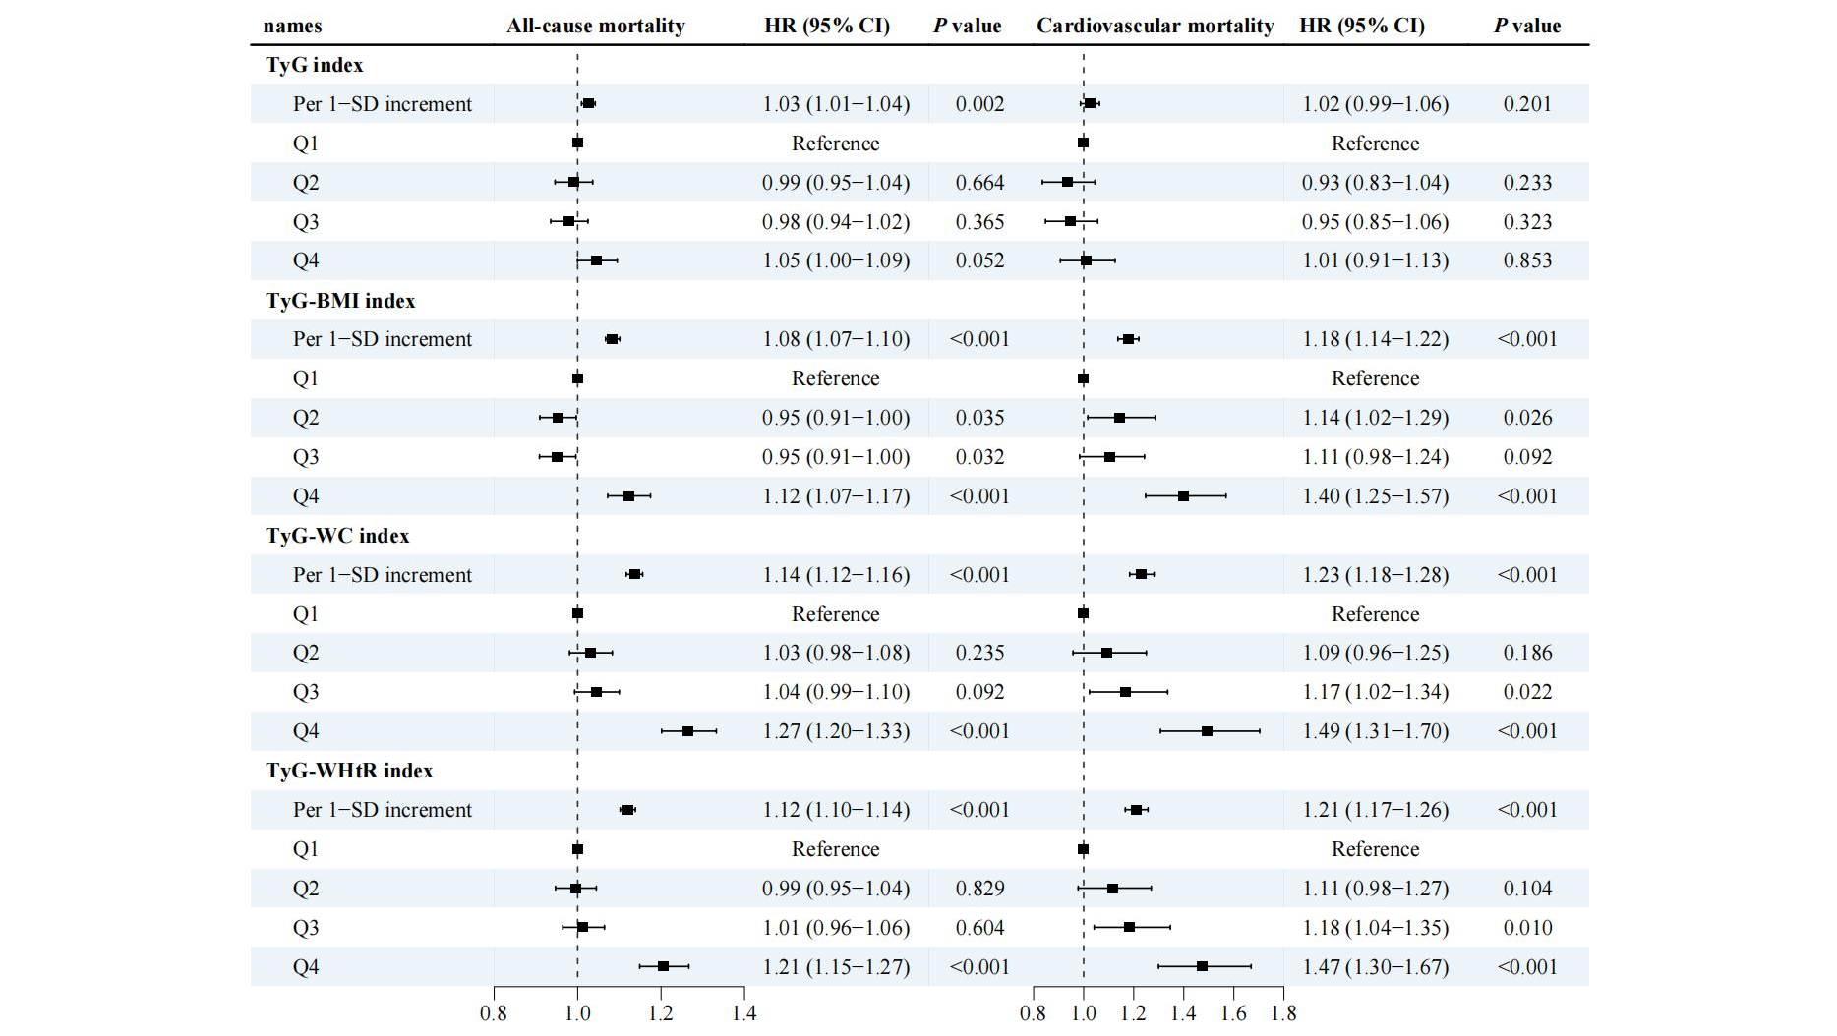

Figure S10. Sensitivity analysis for the associations between TyG-related indices and all-cause and cardiovascular mortality in individuals with cardiovascular-kidney-metabolic syndrome stages 0-3: excluding participants who developed outcome within the first 2 years of follow-up
Models were adjusted for age, sex, ethnicity, employed status, Townsend deprivation index, educational level, family income, smoking status, alcohol drinking, sleep duration, physical activity, diet quality, systolic/diastolic blood pressure, glycated hemoglobin, total cholesterol, and low-density lipoprotein cholesterol.
Abbreviations: CVD, cardiovascular disease; CHD, coronary heart disease; TyG, triglyceride-glucose index; BMI, body mass index; WC, waist circumference; WHtR, weight-to-height ratio, SD, standard deviation; HR, hazard ratio; CI, confidence interval.

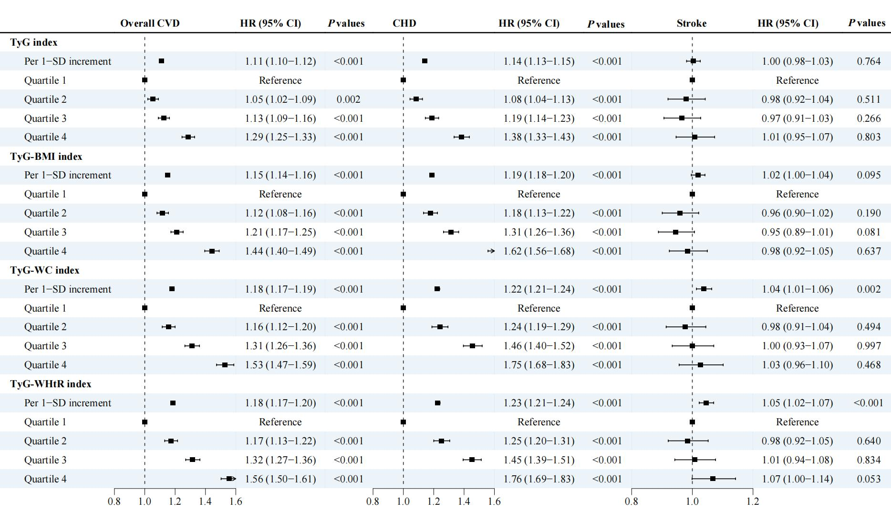

Figure S11. Sensitivity analysis for the associations between TyG-related indices and cardiovascular disease incidence in individuals with cardiovascular-kidney-metabolic syndrome stages 0-3: imputing covariates with missing values using multiple imputation approach
Models were adjusted for age, sex, ethnicity, employed status, Townsend deprivation index, educational level, family income, smoking status, alcohol drinking, sleep duration, physical activity, diet quality, systolic/diastolic blood pressure, glycated hemoglobin, total cholesterol, and low-density lipoprotein cholesterol.
Abbreviations: CVD, cardiovascular disease; CHD, coronary heart disease; TyG, triglyceride-glucose index; BMI, body mass index; WC, waist circumference; WHtR, weight-to-height ratio, SD, standard deviation; HR, hazard ratio; CI, confidence interval.
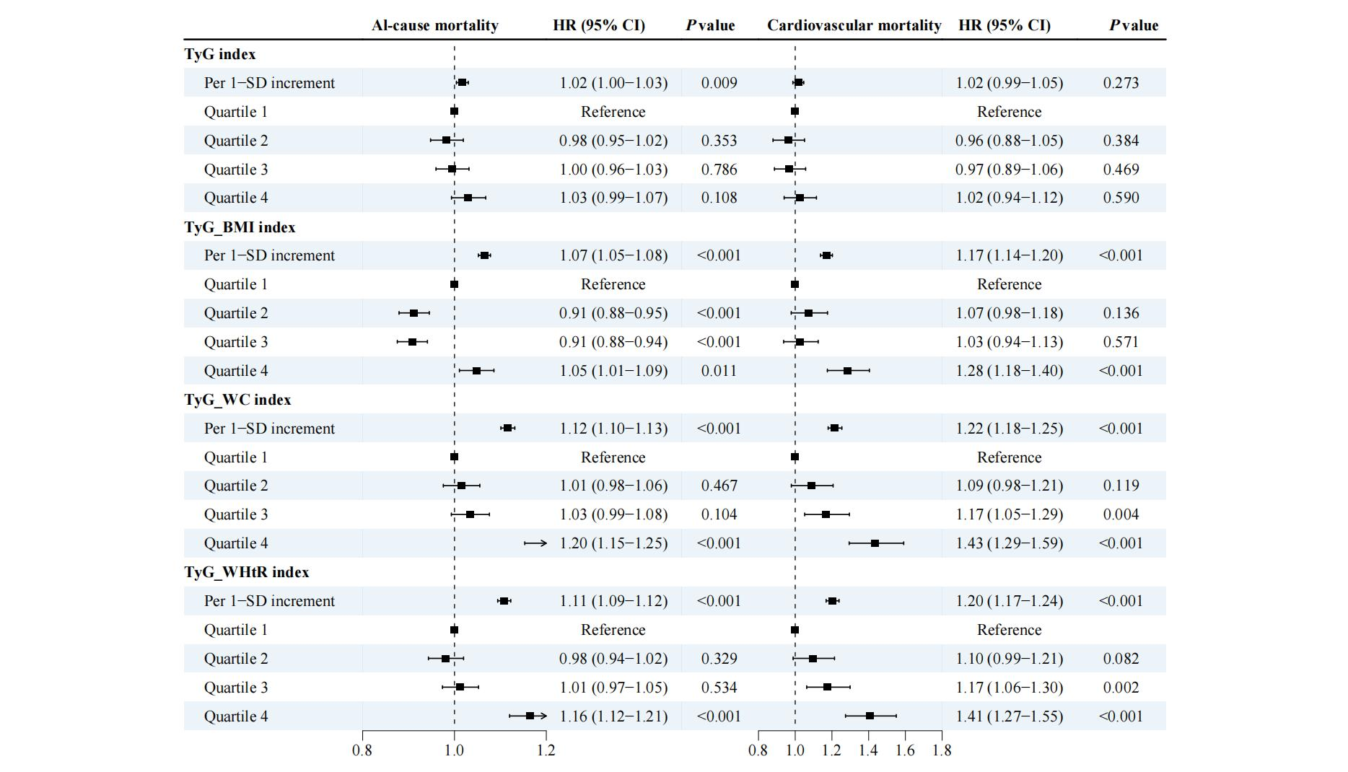
Figure S12. Sensitivity analysis for the associations between TyG-related indices and all-cause and cardiovascular mortality in individuals with cardiovascular-kidney-metabolic syndrome stages 0-3: imputing covariates with missing values using multiple imputation approach.
Models were adjusted for age, sex, ethnicity, employed status, Townsend deprivation index, educational level, family income, smoking status, alcohol drinking, sleep duration, physical activity, diet quality, systolic/diastolic blood pressure, glycated hemoglobin, total cholesterol, and low-density lipoprotein cholesterol.
Abbreviations: TyG, triglyceride-glucose index; BMI, body mass index; WC, waist circumference; WHtR, weight-to-height ratio, SD, standard deviation; HR, hazard ratio; CI, confidence interval.

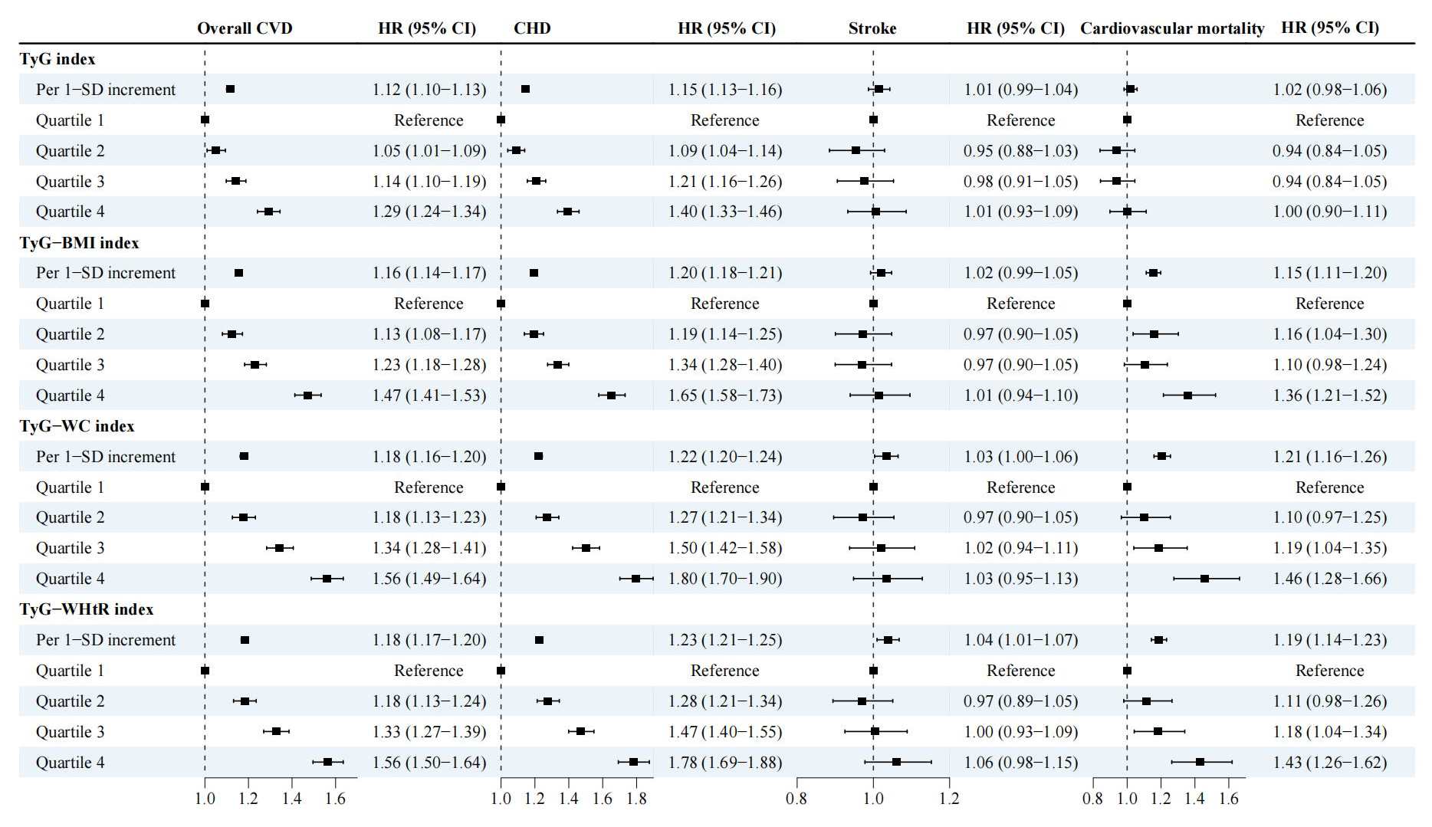

Figure S13. Sensitivity analysis for the associations between TyG-related indices and cardiovascular diseases and mortality in individuals with cardiovascular-kidney-metabolic syndrome stages 0-3: using competing risk models to control competing risk of death from other causes
Models were adjusted for age, sex, ethnicity, employed status, Townsend deprivation index, educational level, family income, smoking status, alcohol drinking, sleep duration, physical activity, diet quality, systolic/diastolic blood pressure, glycated hemoglobin, total cholesterol, and low-density lipoprotein cholesterol.
Abbreviations: CVD, cardiovascular disease; CHD, coronary heart disease; TyG, triglyceride-glucose index; BMI, body mass index; WC, waist circumference; WHtR, weight-to-height ratio, SD, standard deviation; HR, hazard ratio; CI, confidence interval.
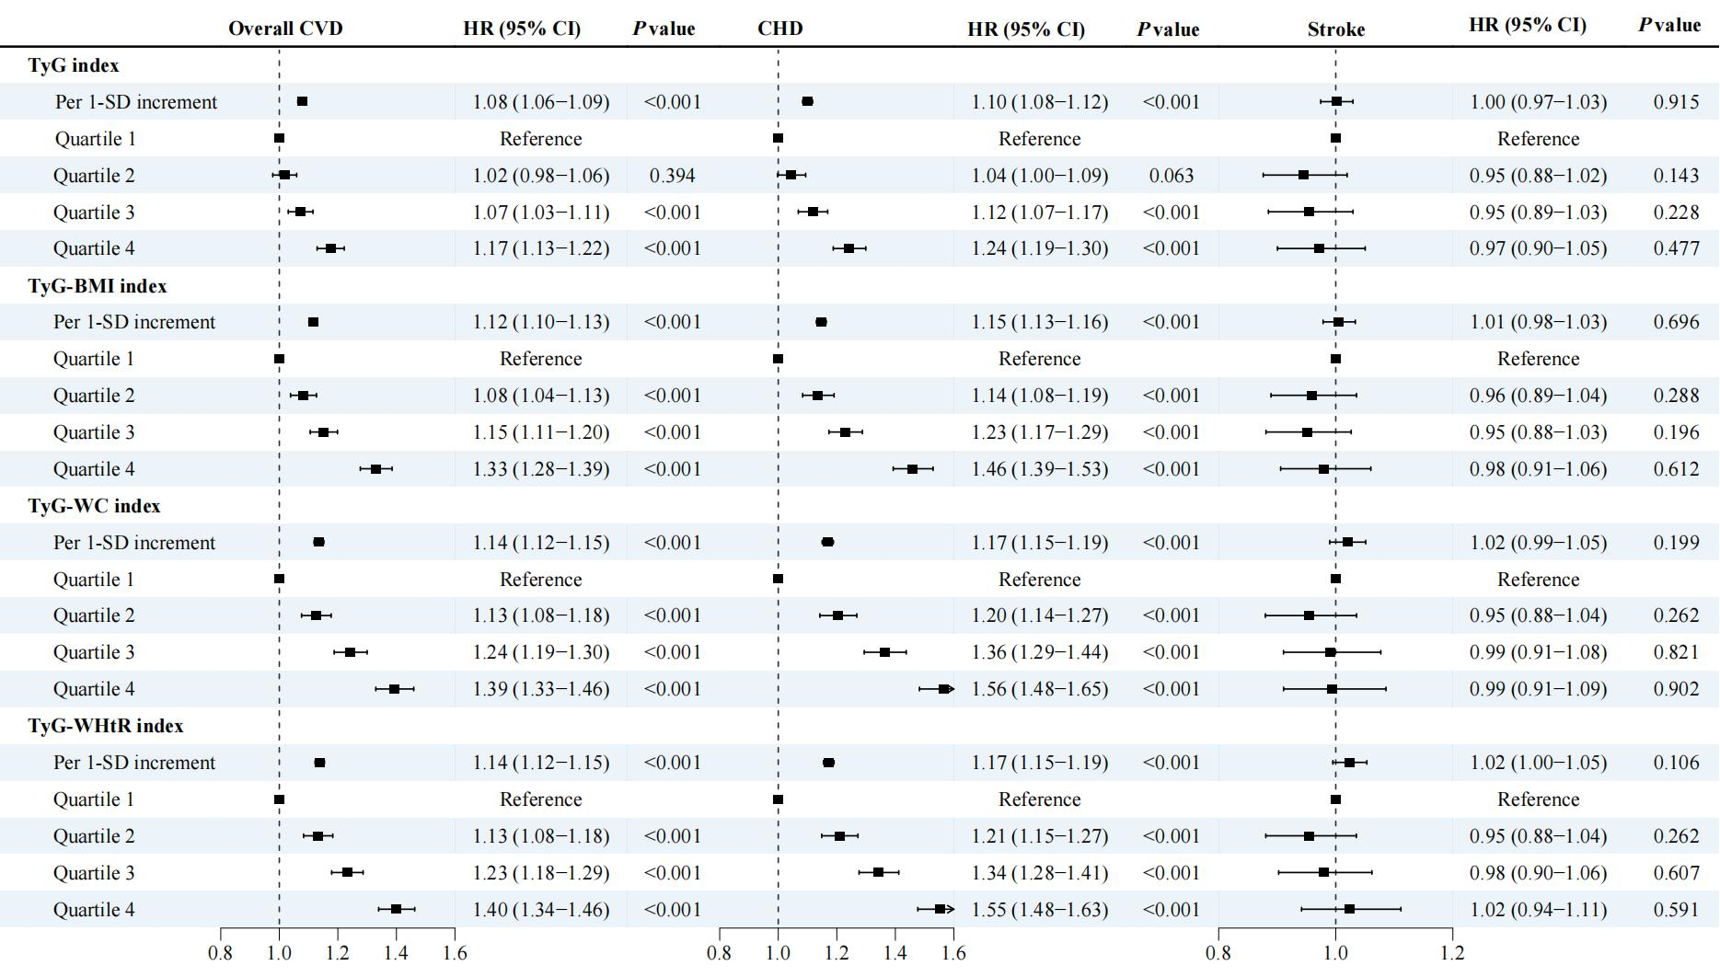

Figure S14. Sensitivity analysis for the associations between TyG-related indices and cardiovascular disease incidence in individuals with cardiovascular-kidney-metabolic syndrome stages 0-3: additionally adjusting for the impact of medication use, including antihypertensive, lipid-lowering, and glucose-lowering medications.
Models were adjusted for age, sex, ethnicity, employed status, Townsend deprivation index, educational level, family income, smoking status, alcohol drinking, sleep duration, physical activity, diet quality, systolic/diastolic blood pressure, glycated hemoglobin, total cholesterol, low-density lipoprotein cholesterol, and antihypertensive, lipid-lowering, and glucose-lowering medications.
Abbreviations: CVD, cardiovascular disease; CHD, coronary heart disease; TyG, triglyceride-glucose index; BMI, body mass index; WC, waist circumference; WHtR, weight-to-height ratio, SD, standard deviation; HR, hazard ratio; CI, confidence interval.
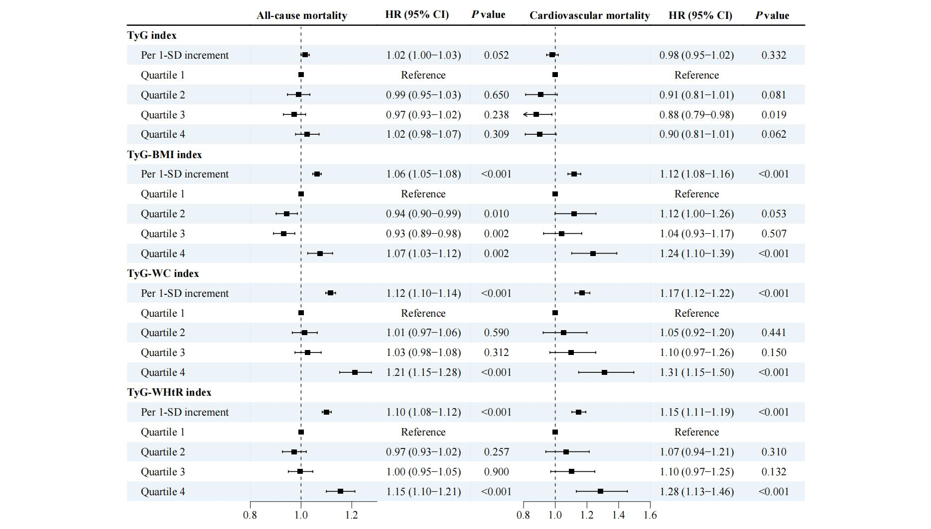

Figure S15. Sensitivity analysis for the associations between TyG-related indices and mortality in individuals with cardiovascular-kidney-metabolic syndrome stages 0-3: adjusting for the impact of medication use, including antihypertensive, lipid-lowering, and glucose-lowering medications.
Models were adjusted for age, sex, ethnicity, employed status, Townsend deprivation index, educational level, family income, smoking status, alcohol drinking, sleep duration, physical activity, diet quality, systolic/diastolic blood pressure, glycated hemoglobin, total cholesterol, low-density lipoprotein cholesterol, and antihypertensive, lipid-lowering, and glucose-lowering medications.
Abbreviations: TyG, triglyceride-glucose index; BMI, body mass index; WC, waist circumference; WHtR, weight-to-height ratio, SD, standard deviation; HR, hazard ratio; CI, confidence interval.

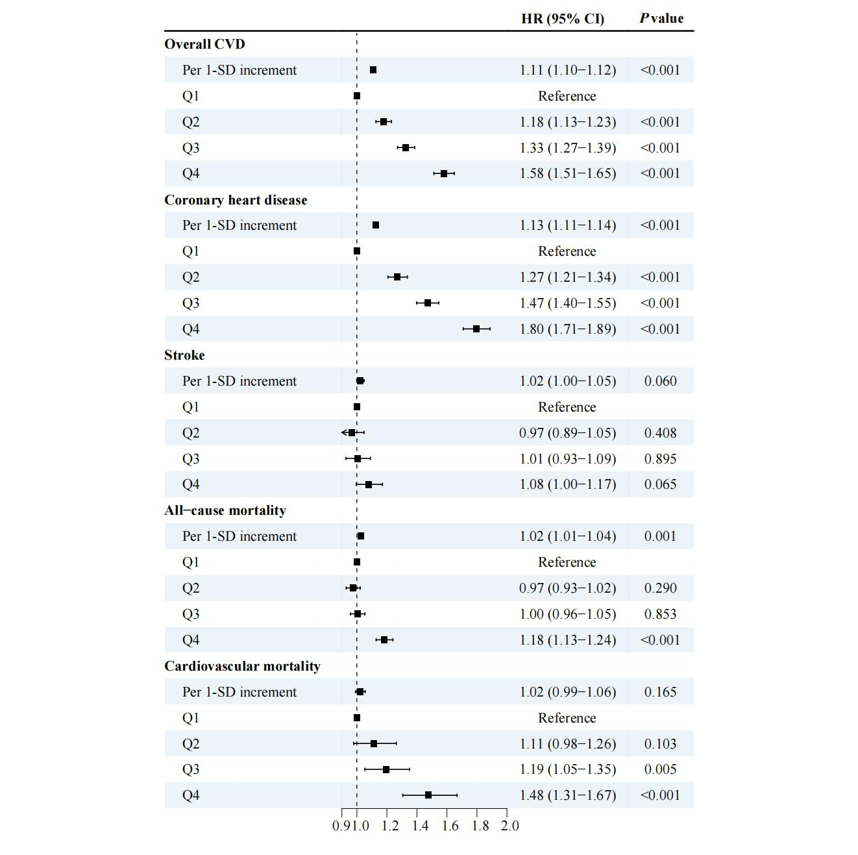

Figure S16. Additional analysis for the associations between the TG/HDL ratio and cardiovascular diseases and mortality in individuals with cardiovascular-kidney-metabolic syndrome stages 0-3.
Models were adjusted for age, sex, ethnicity, employed status, Townsend deprivation index, educational level, family income, smoking status, alcohol drinking, sleep duration, physical activity, diet quality, systolic/diastolic blood pressure, glycated hemoglobin, total cholesterol, and low-density lipoprotein cholesterol.
Abbreviations: TG, triglyceride; HDL, high-density lipoprotein cholesterol; SD, standard deviation; HR, hazard ratio; CI, confidence interval.

