Abbreviations
CTI C-reactive protein-triglyceride-glucose index
CKM cardiovascular–kidney–metabolic
CHARLS China Health and Retirement Longitudinal Study
CVD Cardiovascular disease
CKD chronic kidney disease
AHA American Heart Association
SBP: Systolic blood pressure
DBP: Diastolic blood pressure
BMI: body mass index
CRP: C-reactive protein
TG: total cholesterol
Fglu: fast blood glucose
HbA1c: Hemoglobin A1c
TyG: triglyceride-glucose
Cr: serum creatinine
eGFR estimated glomerular filtration ratio
TC: total cholesterol
LDL: low density lipoprotein cholesterol
Hb, glycated hemoglobin
DM diabetes
NGR normal glucose regulation
PRE-DM pre-diabetes
HR Hazard ratios
95%CI 95% confidence interval
AUC Area under the curve
RCS Restricted cubic spline

Figure S1. Kaplan-Meier survival curves showing the CVD-free survival rates and all-cause mortality for the different CTI classification groups (Q1, Q2 and Q3). (A) Cardiovascular disease (B) All-cause mortality
Figure S2. Sex stratified Kaplan-Meier curves for cardiovascular disease-free survival and all-cause mortality-free survival in CKM syndrome. (A) Sex stratification in CVD-free survival (B) Sex stratification in all-cause mortality-free survival
Figure S3. Stage-stratified Kaplan-Meier curves for cardiovascular disease-free survival and all-cause mortality-free survival in CKM syndrome. (A) Stage stratification in CVD-free survival (B) Stage stratification in all-cause mortality-free survival.
Figure S4. Subgroup analysis of HRs (95% CIs) for CVD incidence of CTI
Figure S5. Subgroup analysis of HRs (95% CIs) for all-cause mortality of CTI
Figure S6. Time-dependent ROC curves of the TyG, CTI, and CRP indices for predicting CVD onset and all-cause mortality onset. (A) Cardiovascular disease (B) All-cause mortality. ROC receiver operating characteristic curve.
Figure S7. RSC with 4 knots showing the connection between CTI, CVD incidence and all-cause death events. (A-C) cardiovascular disease. (D-F) All-cause mortality.

TableS1. Distribution of variables with missing data
TableS2. Methods for evaluating CKM stages
TableS3. Specific definitions of various diseases
Table S4. Baseline characteristics of the study population with and without CVD
Table S5. Baseline characteristics of the study population with and without all-cause death.
Table S6. Multivariable Cox regression analysis of CTI association with CVD incidence and all-cause mortality in individuals with CKM syndrome (stages 0–3): after excluding participants who died within 2 years of baseline
Table S7 The association between TyG and CRP standardized values (CRP-SD) and CVD incidence
Table S8. Threshold effect analysis of CTI on CVD incidence using a two-piecewise linear regression model
Table S9. Threshold effect analysis of CTI on all-cause mortality using a two-piecewise linear regression model
Table S10. Multivariable Cox regression analysis of CTI association with CVD incidence and all-cause mortality in individuals with CKM syndrome (stages 0–3): A multiple imputation approach for missing data
Table S11. Multivariate logistic regression of the relationship between CTI and CVD incidence and all-cause mortality risk among individuals with CKM syndrome stages 0-3
Table S12. Association between CTI and CVD stratified by sex, age, drink status, smoke status, marital status, educational status, hypertension, dyslipidemia, diabetes, glycemic statuses and CKM stages.
Table S13. Association between CTI and all-cause mortality stratified by sex, age, drink status, smoke status, marital status, educational status, hypertension, dyslipidemia, diabetes, glycemic statuses and CKM stages.
Table S14. Association between the CTI and CVD incidence according to age, sex, glycemic statuses
Table S15. Renal Function Across CKM Stages in baseline character

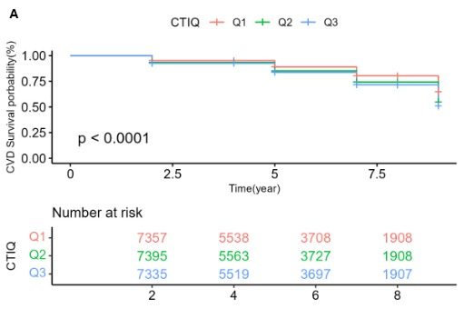
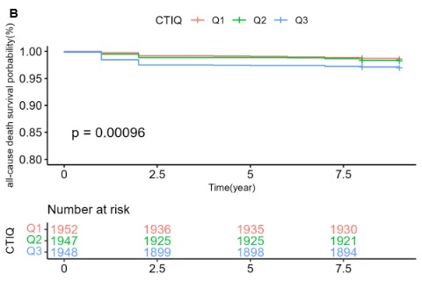

Figure S1. Kaplan-Meier survival curves showing the CVD-free survival rates and all-cause mortality for the different CTI classification groups (Q1, Q2 and Q3). (A) Cardiovascular disease (B) All-cause mortality
CTI: C-reactive protein-triglyceride-glucose index; CVD: cardiovascular disease

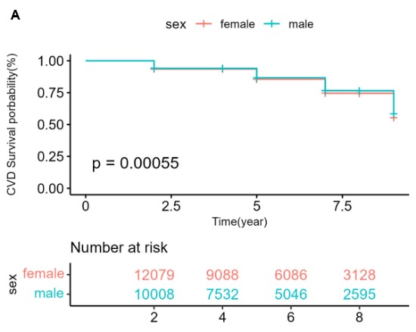
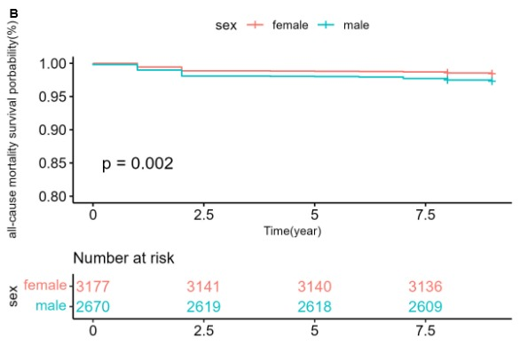
Figure S2. Sex stratified Kaplan-Meier curves for cardiovascular disease-free survival and all-cause mortality-free survival in CKM syndrome. (A) Sex stratification in CVD-free survival (B) Sex stratification in all-cause mortality-free survival
CTI: C-reactive protein-triglyceride-glucose index; CVD: cardiovascular disease; CKM cardiovascular–kidney–metabolic

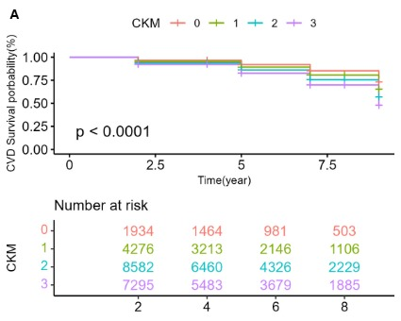
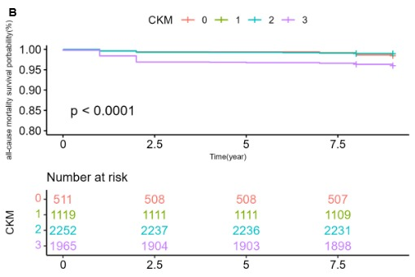
Figure S3. Stage-stratified Kaplan-Meier curves for cardiovascular disease-free survival and all-cause mortality-free survival in CKM syndrome. (A) Stage stratification in CVD-free survival (B) Stage stratification in all-cause mortality-free survival.
CTI: C-reactive protein-triglyceride-glucose index; CVD: cardiovascular disease; CKM cardiovascular–kidney–metabolic

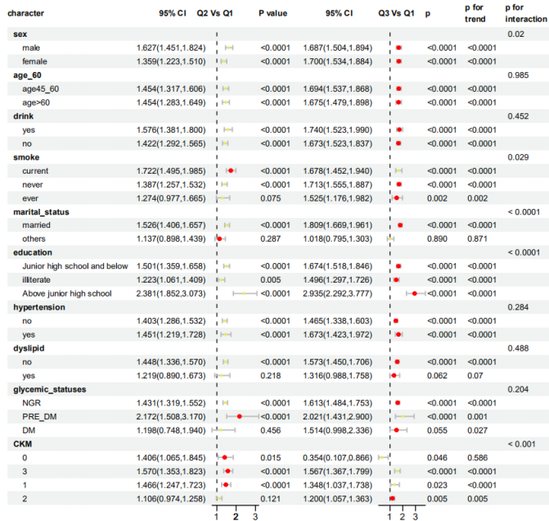
Figure S4. Subgroup analysis of HRs (95% CIs) for CVD incidence of CTI
CTI: C-reactive protein-triglyceride-glucose index; CVD: cardiovascular disease; HR Hazard Ratio, CI Confidence Interval;
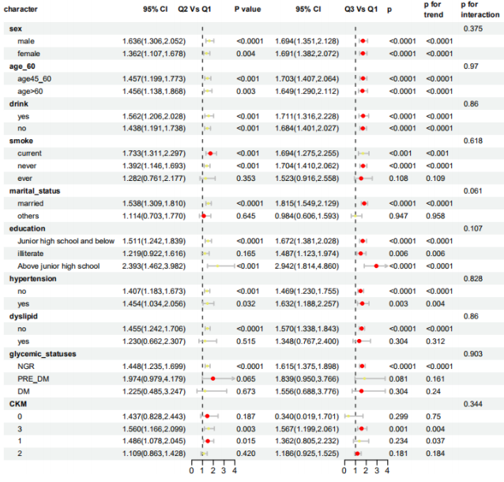
Figure S5. Subgroup analysis of HRs (95% CIs) for all-cause mortality incidence of CTI
CTI: C-reactive protein-triglyceride-glucose index; CVD: cardiovascular disease; HR Hazard Ratio, CI Confidence Interval
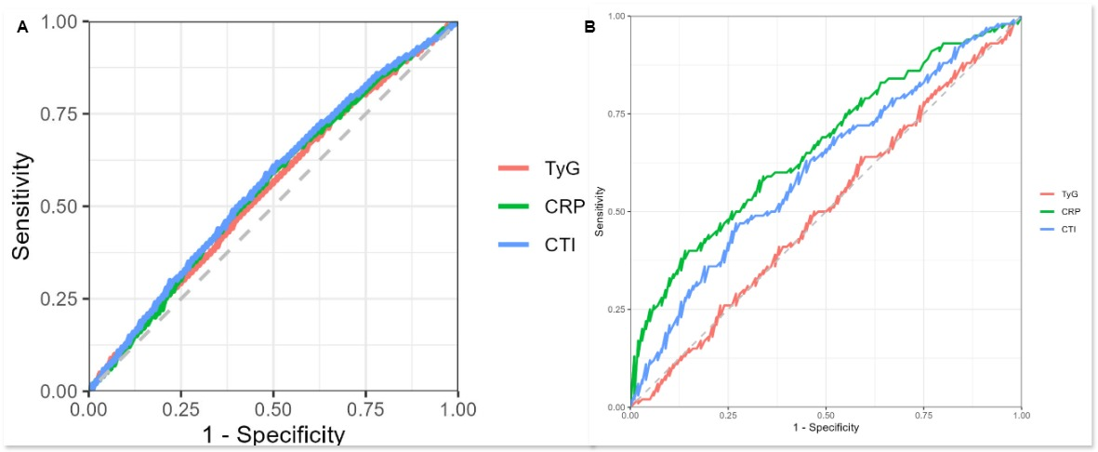
Figure S6. Time-dependent ROC curves of the TyG, CTI, and CRP indices for predicting CVD onset and all-cause mortality onset. (A) Cardiovascular disease (B) All-cause mortality. ROC receiver operating characteristic curve.
ROC; receiver operating characteristics; TyG: triglyceride-glucose; CTI: C-reactive protein-triglyceride-glucose index; CVD: cardiovascular disease
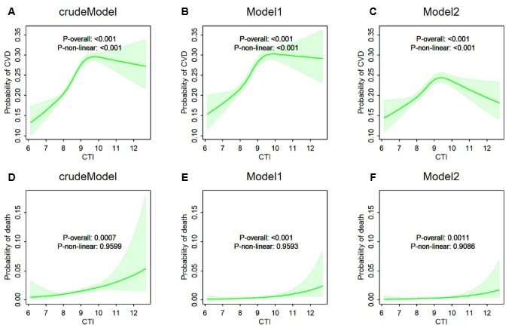
Figure S7. RSC with 4 knots showing the connection between CTI, CVD incidence and all-cause death events. (A-C) cardiovascular disease. (D-F) All-cause mortality. Crude model: unadjusted for covariates; Model 1: Adjust for: age, gender, smoke, drink, marital status, education; Model 2: Adjusted for: age, gender, smoke, drink, marital status, education, BMI, eGFR, hypertension, dyslipidemia, diabetes, Hypertension treatment, Diabetes treatment, dyslipidemia treatment.
TableS1.Distribution of variables with missing data
 |  | CVD incidence |  | morality
Variables |  | Number of Missing Proporation |  | Number of Missing | Proportion
Educational level |  | 7 | 0.09% | 7 |  | 0.09%
Smoke status |  | 1 | 0.01% | 1 |  | 0.01%
Drink status |  | 1 | 0.01% | 1 |  | 0.01%
Hypertension |  | 50 | 0.65% | 52 |  | 0.65%
Dyslipidemia |  | 171 | 2.23% | 183 |  | 2.25%
DM |  | 79 | 1.03% | 81 |  | 0.09%
BMI |  | 953 | 12.43% | 1024 |  | 12.58%
SBP |  | 892 | 11.63% | 955 |  | 11.73%
DBP |  | 892 | 11.63% | 955 |  | 11.73%
TyG |  | 841 | 10.97% | 904 |  | 11.10%
CRP |  | 105 | 1.37% | 111 |  | 1.36%
Fglu |  | 841 | 10.97% | 841 |  | 10.97%
Hb |  | 72 | 0.94% | 76 |  | 0.93%
Cr |  | 121 | 1.58% | 127 |  | 1.56%
eGFR |  | 121 | 1.58% | 127 |  | 1.56%
TC |  | 110 | 1.43% | 115 |  | 1.41%
LDL |  | 118 | 1.54% | 125 |  | 1.54%
TG |  | 110 | 1.43% | 115 |  | 1.41%
CTI |  | 841 | 10.97% | 904 |  | 11.10%
NGR |  | 143 | 1.86% | 153 |  | 1.88%
PRE-DM |  | 838 | 10.93% | 900 |  | 11.06%
BMI: body mass index; SBP: Systolic blood pressure; DBP: Diastolic blood pressure; Fglu: fast blood glucose; LDL: low density lipoprotein cholesterol; TG: total cholesterol; TC: total cholesterol; Cr: serum creatinine; eGFR estimated glomerular filtration ratio; TyG: triglyceride-glucose; CRP: C-reactive protein; DM: diabetes; NGR: normal glucose regulation; PRE-DM; pre-diabetes
TableS2. Methods for evaluating CKM stages 0-3
CKM stages | Threshold for CKM conditions
Stages 0 | All criteria are met：  - BMI< 23 kg/m2  - Waist circumference <80/90 cm in female/male  - Fasting blood glucose < 100 mg/dL and HbA1c < 5.7% and without self-reported diagnosis of diabetes, use of insulin, or oral hypoglycemic agents.  - SBP <130 mm Hg and DBP <80 mm Hg without self-reported diagnosis of hypertension or use of antihypertensive medications.  - HDL-C <50/40 mg/dL in female/male  - TG < 150 mg/dL  - eGFR ≥ 60 ml/min/1.73m2 and without self-reported diagnosis of CKD  - No Subclinical CVD and clinical CVD
Stages 1 | Any of the three criteria is met:  - Overweight/obesity  - Abdominal obesity  - Prediabetes  All criteria are met：  （1）SBP <130 mmHg and DBP <80 mmHg without self-reported diagnosis of hypertension or use of antihypertensive medications.  （2）HDL-C <50/40 mg/dL in female/male  （3）TG < 150 mg/dL  （4）eGFR ≥ 60 ml/min/1.73m2 and without self-reported diagnosis of CKD  （5）No Subclinical CVD and clinical CVD
Stages 2 | Any of the five criteria is met:  - Hypertriglyceridemia  - Hypertension  - Diabetes  - metabolic syndrome  - eGFR：30-60 ml/min/1.73m2 and/or with self-reported diagnosis of CKD  All criteria are met：  - No Subclinical CVD and clinical CVD
Stages 3 | Any of the two criteria is met:  - eGFR<30 ml/min/1.73m2  - Subclinical CVD  Any of the eight criteria is met:  - Overweight/obesity  - Abdominal obesity  - Prediabetes  - Hypertriglyceridemia  - Hypertension  - diabetes  - metabolic syndrome  - eGFR：30-60 ml/min/1.73m2 and/or with self-reported diagnosis of CKD  The criterion is met：  - No clinical CVD

TableS3. Specific definitions of various diseases
Prediabetes | Fasting blood glucose ≥ 100-124 mg/dL or HbA1c ≥ 5.7%-6.4% and  without self-reported diagnosis of diabetes, use of insulin, or oral  hypoglycemic agents
Diabetes | Fasting blood glucose ≥ 125 mg/dL or HbA1c ≥ 6.5% or self-reported diagnosis of diabetes, use of insulin, or oral hypoglycemic agents
Hypertension | SBP ≥130 mm Hg or DBP ≥80 mm Hg or self-reported diagnosis of hypertension or use of antihypertensive medications
chronic kidney disease | Any of the two criteria is met：  - Self-reported history of chronic kidney disease  - eGFR < 60 ml/min/1.73m2
Hypertriglyceridemia | Triglycerides ≥ 135 mg/dL
metabolic syndrome | Meet any three or more of the five  ① Waist circumference ≥ 80/90 cm in female/male.  ②HDL cholesterol ≥50/40 mg/dL in female/male.  ③ Triglycerides ≥150 mg/dL.  ④ Elevated blood pressure (SBP ≥130 mm Hg or DBP ≥80 mm Hg and/or use of antihypertensive medications)  ⑤ Fasting blood glucose ≥100 mg/dL

Table S4. Baseline characteristics of the study population with and without CVD
variable | Total  (n=5723) | no  (n=4302) | yes  (n=1421) | p value
Age, years | 57.00(51.00,63.00) | 56.00(50.00,63.00) | 59.00(53.00,65.00) | <0.0001
Sex, male, n (%) |  |  |  | 0.07
female | 3128(54.66) | 2321(53.95) | 807(56.79)
male | 2595(45.34) | 1981(46.05) | 614(43.21)
Smoke status, n (%) |  |  |  | <0.0001
current | 1729(30.21) | 1338(31.10) | 391(27.52)
ever | 424(7.41) | 285(6.62) | 139(9.78)
never | 3570(62.38) | 2679(62.27) | 891(62.70)
Drink status, n (%) |  |  |  | 0.03
no | 3757(65.65) | 2789(64.83) | 968(68.12)
yes | 1966(34.35) | 1513(35.17) | 453(31.88)
Marital status, n (%) |  |  |  | 0.74
married | 5174(90.41) | 3893(90.49) | 1281(90.15)
others | 549(9.59) | 409(9.51) | 140(9.85)
Educational level, n (%) |  |  |  | 0.53
Above junior high school | 575(10.05) | 426(9.90) | 149(10.49)
illiterate | 1609(28.11) | 1198(27.85) | 411(28.92)
Junior high school and below | 3539(61.84) | 2678(62.25) | 861(60.59)
BMI, kg/m² | 23.53 ± 3.75 | 23.31 ± 3.63 | 24.19 ± 4.04 | <0.0001
SBP, mmHg | 128.81 ± 20.43 | 127.51 ± 19.99 | 132.74 ± 21.25 | <0.0001
DBP, mmHg | 75.42 ± 11.87 | 74.83 ± 11.68 | 77.22 ± 12.27 | <0.0001
Fglu, mg/dL | 102.06(94.41,111.60) | 101.70(94.14,111.06) | 102.96(95.22,113.04) | <0.0001
Hb, mg/dL | 5.26 ± 0.76 | 5.22 ± 0.69 | 5.36 ± 0.93 | <0.0001
LDL, mg/dL | 117.86 ± 34.43 | 116.84 ± 34.08 | 120.93 ± 35.32 | <0.001
TG, mg/dL | 101.78(73.46,148.68) | 100.00(71.68,146.91) | 107.97(79.65,155.76) | <0.01
TC, mg/dL | 194.70 ± 37.52 | 193.65 ± 37.42 | 197.90 ± 37.68 | <0.001
Cr, mg/dL | 0.77 ± 0.18 | 0.77 ± 0.18 | 0.77 ± 0.18 | 0.67
GFR,ml/min·1.73m² | 122.51 ± 29.17 | 123.02 ± 28.96 | 120.96 ± 29.78 | 0.02
TyG | 8.64 ± 0.64 | 8.62 ± 0.64 | 8.73 ± 0.64 | <0.0001
CRP | 0.96(0.53,1.96) | 0.90(0.51,1.87) | 1.15(0.59,2.20) | 0.18
Hypertension, n (%) |  |  |  | <0.0001
no | 4530(79.15) | 3556(82.66) | 974(68.54)
yes | 1193(20.85) | 746(17.34) | 447(31.46)
Dyslipidemia, n (%) |  |  |  | <0.0001
no | 5307(92.73) | 4077(94.77) | 1230(86.56)
yes | 416(7.27) | 225(5.23) | 191(13.44)
Diabetes, n (%) |  |  |  | <0.0001
no | 5472(95.61) | 4145(96.35) | 1327(93.38)
yes | 251(4.39) | 157(3.65) | 94(6.62)
Hypertension treatment, n (%) |  |  |  | <0.0001
no | 4846(84.68) | 3758(87.35) | 1088(76.57)
yes | 877(15.32) | 544(12.65) | 333(23.43)
Diabetes treatment, n (%) |  |  |  | <0.0001
no | 5568(97.29) | 4211(97.88) | 1357(95.50)
yes | 155(2.71) | 91(2.12) | 64(4.50)
Dyslipidemia treatment, n (%) |  |  |  | <0.0001
no | 5493(95.98) | 4182(97.21) | 1311(92.26)
yes | 230(4.02) | 120(2.79) | 110(7.74)
CKM |  |  |  | <0.0001
0 | 503(8.79) | 431(10.02) | 72(5.07)
1 | 1106(19.33) | 895(20.80) | 211(14.85)
2 | 2229(38.95) | 1680(39.05) | 549(38.63)
3 | 1885(32.94) | 1296(30.13) | 589(41.45)
NGR, mg/dL |  |  |  | <0.0001
no | 631(11.03) | 426(9.90) | 205(14.43)
yes | 5092(88.97) | 3876(90.10) | 1216(85.57)
PRE-DM, mg/dL |  |  |  | 0.01
no | 5323(93.01) | 4023(93.51) | 1300(91.48)
yes | 400(6.99) | 279(6.49) | 121(8.52)
Continuous variables are expressed as Mean ± SD or Median (IQR), categorical variables are expressed as number (percent) Abbreviation CTI: C-reactive protein-triglyceride-glucose index; BMI: body mass index; SBP: Systolic blood pressure; DBP: Diastolic blood pressure; Fglu: fast blood glucose; Hb, glycated hemoglobin; LDL: low density lipoprotein cholesterol; TG: total cholesterol; TC: total cholesterol; Cr: serum creatinine; eGFR estimated glomerular filtration ratio; TyG: triglyceride-glucose; CRP: C-reactive protein; DM: diabetes; NGR: normal glucose regulation; PRE-DM; pre-diabetes; CKM: cardiovascular–kidney–metabolic

Table S5. Baseline characteristics of the study population with and without all-cause death.
variable | Total  (n=5847) | no  (n=5726) | yes  (n=121) | P value
Age, years | 57.00(51.00,64.00) | 57.00(51.00,63.00) | 70.00(62.00,76.00) | <0.0001
Sex, male, n (%) |  |  |  | <0.01
female | 3177(54.34) | 3128(54.63) | 49(40.50)
male | 2670(45.66) | 2598(45.37) | 72(59.50)
Smoke status, n (%) |  |  |  | <0.0001
current | 1782(30.48) | 1730(30.21) | 52(42.98)
ever | 443(7.58) | 425(7.42) | 18(14.88)
never | 3622(61.95) | 3571(62.36) | 51(42.15)
Drink status, n (%) |  |  |  | 0.34
no | 3845(65.76) | 3760(65.67) | 85(70.25)
yes | 2002(34.24) | 1966(34.33) | 36(29.75)
Marital status, n (%) |  |  |  | <0.0001
married | 5260(89.96) | 5177(90.41) | 83(68.60)
others | 587(10.04) | 549(9.59) | 38(31.40)
Educational level, n (%) |  |  |  | <0.0001
Above junior high school | 578(9.89) | 575(10.04) | 3(2.48)
illiterate | 1671(28.58) | 1610(28.12) | 61(50.41)
Junior high school and below | 3598(61.54) | 3541(61.84) | 57(47.11)
BMI, kg/m² | 23.50 ± 3.77 | 23.53 ± 3.75 | 21.90 ± 4.40 | <0.0001
SBP, mmHg | 128.98 ± 20.56 | 128.82 ± 20.44 | 136.47 ± 24.77 | <0.001
DBP, mmHg | 75.40 ± 11.88 | 75.43 ± 11.87 | 74.35 ± 12.30 | 0.34
Fglu, mg/dL | 102.06(94.32,111.78) | 102.06(94.50,111.60) | 103.32(93.42,115.92) | 0.17
Hb, mg/dL | 5.26 ± 0.75 | 5.26 ± 0.76 | 5.29 ± 0.71 | 0.62
LDL, mg/dL | 117.78 ± 34.47 | 117.86 ± 34.43 | 113.79 ± 36.62 | 0.23
TG, mg/dL | 101.78(73.46,148.68) | 101.78(73.46,148.68) | 96.46(75.22,133.63) | 0.23
TC, mg/dL | 194.61 ± 37.59 | 194.71 ± 37.51 | 189.88 ± 40.80 | 0.20
Cr, mg/dL | 0.77 ± 0.19 | 0.77 ± 0.18 | 0.85 ± 0.49 | 0.06
eGFR,ml/min·1.73m² | 122.23 ± 29.34 | 122.50 ± 29.17 | 117.55 ± 31.84 | <0.01
TyG | 8.64 ± 0.64 | 8.64 ± 0.64 | 8.64 ± 0.64 | 0.98
CRP | 0.97(0.53,2.00) | 0.96(0.53,1.96) | 1.76(0.84,6.24) | <0.001
Hypertension, n (%) |  |  |  | <0.0001
no | 4608(78.81) | 4531(79.13) | 77(63.64)
yes | 1239(21.19) | 1195(20.87) | 44(36.36)
Dyslipidemia, n (%) |  |  |  | 0.81
no | 5421(92.71) | 5310(92.73) | 111(91.74)
yes | 426(7.29) | 416(7.27) | 10(8.26)
Diabetes, n (%) |  |  |  | 0.94
no | 5590(95.60) | 5475(95.62) | 115(95.04)
yes | 257(4.40) | 251(4.38) | 6(4.96)
Hypertension treatment, n (%) |  |  |  | <0.001
no | 4934(84.39) | 4847(84.65) | 87(71.90)
yes | 913(15.61) | 879(15.35) | 34(28.10)
Diabetes treatment, n (%) |  |  |  | 0.22
no | 5686(97.25) | 5571(97.29) | 115(95.04)
yes | 161(2.75) | 155(2.71) | 6(4.96)
Dyslipidemia treatment, n (%) |  |  |  | 1.00
no | 5612(95.98) | 5496(95.98) | 116(95.87)
yes | 235(4.02) | 230(4.02) | 5(4.13)
CKM |  |  |  | <0.0001
0 | 511(8.74) | 503(8.78) | 8(6.61)
1 | 1119(19.14) | 1107(19.33) | 12(9.92)
2 | 2252(38.52) | 2229(38.93) | 23(19.01)
3 | 1965(33.61) | 1887(32.95) | 78(64.46)
NGR, mg/dL |  |  |  | 0.54
no | 647(11.07) | 631(11.02) | 16(13.22)
yes | 5200(88.93) | 5095(88.98) | 105(86.78)
PRE-DM, mg/dL |  |  |  | 0.71
no | 5437(92.99) | 5326(93.01) | 111(91.74)
yes | 410(7.01) | 400(6.99) | 10(8.26)
Continuous variables are expressed as Mean ± SD or Median (IQR), categorical variables are expressed as number (percent) Abbreviation CTI: C-reactive protein-triglyceride-glucose index; BMI: body mass index; SBP: Systolic blood pressure; DBP: Diastolic blood pressure; Fglu: fast blood glucose; Hb, glycated hemoglobin; LDL: low density lipoprotein cholesterol; TG: total cholesterol; TC: total cholesterol; Cr: serum creatinine; eGFR estimated glomerular filtration ratio; TyG: triglyceride-glucose; CRP: C-reactive protein; DM: diabetes; NGR: normal glucose regulation; PRE-DM; pre-diabetes; CKM: cardiovascular–kidney–metabolic

Table S6 Multivariable Cox regression analysis of CTI association with CVD incidence and all-cause mortality in individuals with CKM syndrome (stages 0–3): after excluding participants who died within 2 years of baseline
CTI | Crude model |  | Model 1 |  | Model 2
 | 95%CI | P | 95%CI | P | 95%CI | P
CVD incidence
Q1 | ref |  | ref |  | ref
Q2 | 1.38(1.28,1.49) | <0.0001 | 1.33(1.23,1.44) | <0.0001 | 1.26(1.16,1.36) | <0.0001
Q3 | 1.54(1.43,1.67) | <0.0001 | 1.47(1.36,1.59) | <0.0001 | 1.27(1.17,1.38) | <0.0001
All-cause mortality
continuous | 1.4(1.26,1.54) | <0.0001 | 1.48(1.33,1.65) | <0.0001 | 1.44(1.29,1.61) | <0.0001
categories
Q1 | ref |  | ref |  | ref
Q2 | 1.12(0.58,2.16) | 0.73 | 1.1(0.57,2.13) | 0.77 | 0.92(0.47, 1.81) | 0.81
Q3 | 0.9(0.45,1.80) | 0.76 | 0.94(0.47, 1.90) | 0.87 | 0.73(0.34, 1.54) | 0.41
p for trend |  | 0.77 |  | 0.88 |  | 0.41

HR Hazard Ratio, CI Confidence Interval
crude model: no covariates were adjusted.
model 1: age, sex, smoke status, drink status, marital status, educational level.
model 2: age, sex, smoke status, drink status, marital status, educational level, BMI, eGFR, hypertension, dyslipidemia, diabetes, Hypertension treatment, Diabetes treatment, dyslipidemia treatment
CTI: C-reactive protein-triglyceride-glucose index; CVD: cardiovascular disease; CKM: cardiovascular–kidney–metabolic
Table S7 The association between TyG and CRP standardized values (CRP-SD) and CVD incidence.
character | Crude model |  | Model 1 |  | Model 2
character | 95%CI | P | 95%CI | P | 95%CI | P
TyG
Q1 | ref |  | ref |  | ref
Q2 | 1.33(1.24,1.42) | <0.0001 | 1.3(1.22,1.39) | <0.0001 | 1.25(1.17,1.34) | <0.0001
Q3 | 1.35(1.26,1.44) | <0.0001 | 1.32(1.24,1.42) | <0.0001 | 1.14(1.07,1.23) | <0.001
CRP-SD
Q1 | ref |  | ref |  | ref
Q2 | 1.21(1.13,1.29) | <0.0001 | 1.15(1.07,1.23) | <0.0001 | 1.1(1.03,1.18) | 0.01
Q3 | 1.43(1.34,1.52) | <0.0001 | 1.34(1.25,1.43) | <0.0001 | 1.22(1.14,1.30) | <0.0001
HR Hazard Ratio, CI Confidence Interval
crude model: no covariates were adjusted.
model 1: age, sex, smoke status, drink status, marital status, educational level.
model 2: age, sex, smoke status, drink status, marital status, educational level, hypertension, dyslipidemia, diabetes, Hypertension treatment, Diabetes treatment, dyslipidemia treatment
CVD: cardiovascular disease; TyG: triglyceride-glucose; CRP: C-reactive protein.

Table S8. Threshold effect analysis of CTI on CVD incidence using a two-piecewise linear regression model
variable | Crude Model | Model 1 | Model 2
standard cox regression | 1.224(1.196,1.252) <0.0001 | 1.205(1.177,1.233) <0.0001 | 1.075(1.048,1.102) <0.0001
Log-likelihood value | -97954.132 | -97732.613 | -96706.72
two-piecewise linear regression | IP = 8.602 | IP = 8.602 | IP = 8.602
Log-likelihood value | -97932.426 | -97719.51 | -96693.731
CTI < IP | 1.386(1.276,1.505) <0.0001 | 1.308(1.204,1.420) <0.0001 | 1.153(1.060,1.254) <0.001
CTI ≥ IP | 1.097(1.052,1.144) <0.0001 | 1.1(1.055,1.147) <0.0001 | 0.997(0.954,1.042) 0.890
p for Log-likelihood ratio | <0.0001 | <0.0001 | <0.0001
HR Hazard Ratio, CI Confidence Interval
crude model: no covariates were adjusted.
model 1: age, sex, smoke status, drink status, marital status, educational level.
model 2: age, sex, smoke status, drink status, marital status, educational level, BMI, eGFR, hypertension, dyslipidemia, diabetes, Hypertension treatment, Diabetes treatment, dyslipidemia treatment
CTI: C-reactive protein-triglyceride-glucose index; CVD: cardiovascular disease;
Table S9. Threshold effect analysis of CTI on all-cause mortality using a two-piecewise linear regression model
variable | Crude model | Model 1 | Model 2
standard cox regression | 1.486(1.235,1.788) <0.0001 | 1.597(1.316,1.938) <0.0001 | 1.674(1.357,2.065) <0.0001
Log-likelihood value | -1263.501 | -1148.646 | -1121.79
two-piecewise linear regression | IP = 8.606 | IP = 8.606 | IP = 8.606
Log-likelihood value | -1263.434 | -1148.592 | -1121.602
CTI < IP | 1.443(0.674,3.092) 0.345 | 1.412(0.659,3.026) 0.375 | 1.245(0.578,2.681) 0.576
CTI ≥ IP | 1.427(1.056,1.930) 0.021 | 1.667(1.220, 2.279) 0.001 | 1.779(1.276, 2.479) <0.001
p for Log-likelihood ratio | 0.935 | 0.947 | 0.829
HR Hazard Ratio, CI Confidence Interval
crude model: no covariates were adjusted.
model 1: age, sex, smoke status, drink status, marital status, educational level.
model 2: age, sex, smoke status, drink status, marital status, educational level, BMI, eGFR, hypertension, dyslipidemia, diabetes, Hypertension treatment, Diabetes treatment, dyslipidemia treatment
CTI: C-reactive protein-triglyceride-glucose index; CVD: cardiovascular disease.

Table S10. Multivariable Cox regression analysis of CTI association with CVD incidence and all-cause mortality in individuals with CKM syndrome (stages 0–3): A multiple imputation approach for missing data
CTI | Crude model |  | Model 1 |  | Model 2
 | 95%CI | P | 95%CI | P | 95%CI | P
CVD incidence
Q1 | ref |  | ref |  | ref
Q2 | 1.45(1.37,1.53) | <0.0001 | 1.38(1.31,1.47) | <0.0001 | 1.24(1.17,1.32) | <0.001
Q3 | 1.68(1.59,1.78) | <0.0001 | 1.6(1.51,1.70) | <0.0001 | 1.22(1.14,1.30) | <0.0001
All-cause mortality
continuous | 1.4(1.26,1.54) | <0.0001 | 1.48(1.33,1.65) | <0.0001 | 1.44(1.29,1.61) | <0.0001
categories
Q1 | ref |  | ref |  | ref
Q2 | 1.32(1.03,1.69) | 0.03 | 1.31(1.03,1.68) | 0.03 | 1.28(1.00,1.64) | 0.05
Q3 | 1.9(1.51,2.39) | <0.0001 | 2(1.59,2.53) | <0.0001 | 1.9(1.50,2.41) | <0.0001
p for trend |  | <0.0001 |  | <0.0001 |  | <0.0001

HR Hazard Ratio, CI Confidence Interval
crude model: no covariates were adjusted.
model 1: age, sex, smoke status, drink status, marital status, educational level.
model 2: age, sex, smoke status, drink status, marital status, educational level, BMI, eGFR, hypertension, dyslipidemia, diabetes, Hypertension treatment, Diabetes treatment, dyslipidemia treatment
CTI: C-reactive protein-triglyceride-glucose index; CVD: cardiovascular disease; CKM: cardiovascular–kidney–metabolic

Table S11. Multivariate logistic regression of the relationship between CTI and CVD incidence and all-cause mortality risk among individuals with CKM syndrome stages 0-3
CTI | Crude model |  | Model 1 |  | Model 2
CTI | 95%CI | P | 95%CI | P | 95%CI | P
CVD incidence
Q1 | ref |  | ref |  | ref
Q2 | 1.48(1.37,1.60) | <0.0001 | 1.41(1.30,1.52) | <0.0001 | 1.32(1.22,1.43) | <0.0001
Q3 | 1.71(1.58,1.84) | <0.0001 | 1.62(1.50,1.75) | <0.0001 | 1.35(1.24,1.46) | <0.0001
All-cause mortality
continuous | 1.49(1.23,1.79) | <0.0001 | 1.59(1.30, 1.95) | <0.0001 | 1.66(1.33, 2.07) | <0.0001
categories
Q1 | ref |  | ref |  | ref
Q2 | 1.24(0.78,1.97) | 0.36 | 1.17(0.73, 1.87) | 0.52 | 1.13(0.70, 1.83) | 0.61
Q3 | 1.96(1.28,2.99) | 0.002 | 1.99(1.28, 3.10) | 0.002 | 2.06(1.30, 3.28) | 0.002
p for trend |  | 0.001 |  | 0.001 |  | 0.001

HR Hazard Ratio, CI Confidence Interval
crude model: no covariates were adjusted.
model 1: age, sex, smoke status, drink status, marital status, educational level.
model 2: age, sex, smoke status, drink status, marital status, educational level, BMI, eGFR, hypertension, dyslipidemia, diabetes, Hypertension treatment, Diabetes treatment, dyslipidemia treatment
CTI: C-reactive protein-triglyceride-glucose index; CVD: cardiovascular disease; CKM: cardiovascular–kidney–metabolic

Table S12. Association between CTI and CVD stratified by sex, age, drink status, smoke status, marital status, educational status, hypertension, dyslipidemia, diabetes, glycemic statuses and CKM stages.
character | Q1 | Q2 | p | Q3 | p | p for trend | p for interaction
Sex |  |  |  |  |  |  | 0.02
male | ref | 1.627(1.451,1.824) | <0.0001 | 1.687(1.504,1.894) | <0.0001 | <0.0001
female | ref | 1.359(1.223,1.510) | <0.0001 | 1.700(1.534,1.884) | <0.0001 | <0.0001
Age |  |  |  |  |  |  | 0.985
age45-60 | ref | 1.454(1.317,1.606) | <0.0001 | 1.694(1.537,1.868) | <0.0001 | <0.0001
age>60 | ref | 1.454(1.283,1.649) | <0.0001 | 1.675(1.479,1.898) | <0.0001 | <0.0001
Drink status |  |  |  |  |  |  | 0.452
yes | ref | 1.576(1.381,1.800) | <0.0001 | 1.740(1.523,1.990) | <0.0001 | <0.0001
no | ref | 1.422(1.292,1.565) | <0.0001 | 1.673(1.523,1.837) | <0.0001 | <0.0001
Smoke status |  |  |  |  |  |  | 0.029
current | ref | 1.722(1.495,1.985) | <0.0001 | 1.678(1.452,1.940) | <0.0001 | <0.0001
never | ref | 1.387(1.257,1.532) | <0.0001 | 1.713(1.555,1.887) | <0.0001 | <0.0001
ever | ref | 1.274(0.977,1.665) | 0.075 | 1.525(1.176,1.982) | 0.002 | 0.002
Marital status |  |  |  |  |  |  | < 0.0001
married | ref | 1.526(1.406,1.657) | <0.0001 | 1.809(1.669,1.961) | <0.0001 | <0.0001
others | ref | 1.137(0.898,1.439) | 0.287 | 1.018(0.795,1.303) | 0.890 | 0.871
Educational status |  |  |  |  |  |  | < 0.0001
Junior high school and below | ref | 1.501(1.359,1.658) | <0.0001 | 1.674(1.518,1.846) | <0.0001 | <0.0001
illiterate | ref | 1.223(1.061,1.409) | 0.005 | 1.496(1.297,1.726) | <0.0001 | <0.0001
Above junior high school | ref | 2.381(1.852,3.073) | <0.0001 | 2.935(2.292,3.777) | <0.0001 | <0.0001
Hypertension |  |  |  |  |  |  | 0.284
no | ref | 1.403(1.286,1.532) | <0.0001 | 1.465(1.338,1.603) | <0.0001 | <0.0001
yes | ref | 1.451(1.219,1.728) | <0.0001 | 1.673(1.423,1.972) | <0.0001 | <0.0001
Dyslipidemia |  |  |  |  |  |  | 0.488
no | ref | 1.448(1.336,1.570) | <0.0001 | 1.573(1.450,1.706) | <0.0001 | <0.0001
yes | ref | 1.219(0.890,1.673) | 0.218 | 1.316(0.988,1.758) | 0.062 | 0.07
Glycemic statuses |  |  |  |  |  |  | 0.211
NGR | ref | 1.437(1.326,1.558) | <0.0001 | 1.612(1.485,1.750) | <0.0001 | <0.0001
PRE_DM | ref | 2.172(1.508,3.170) | <0.0001 | 2.021(1.431,2.900) | <0.0001 | 0.001
DM | ref | 1.198(0.748,1.940) | 0.456 | 1.514(0.998,2.336) | 0.055 | 0.027
CKM |  |  |  |  |  |  | < 0.001
0 | ref | 1.406(1.065,1.845) | 0.015 | 0.354(0.107,0.866) | 0.046 | 0.586
1 | ref | 1.466(1.247,1.723) | <0.0001 | 1.348(1.037,1.738) | 0.023 | <0.0001
2 | ref | 1.106(0.974,1.258) | 0.121 | 1.200(1.057,1.363) | 0.005 | 0.005
3 | ref | 1.570(1.353,1.823) | <0.0001 | 1.567(1.367,1.799) | <0.0001 | <0.0001
Continuous variables are expressed as Mean ± SD or Median (IQR), categorical variables are expressed as number (percent)
Abbreviation :BMI: body mass index; SBP: Systolic blood pressure; DBP: Diastolic blood pressure; Fglu: fast blood glucose; Hb, glycated hemoglobin; LDL: low density lipoprotein cholesterol; TG: total cholesterol; TC: total cholesterol; Cr: serum creatinine; TyG: triglyceride-glucose; CRP: C-reactive protein; DM: diabetes; NGR: normal glucose regulation; PRE-DM; pre-diabetes; CKM: cardiovascular–kidney–metabolic

Table S13. Association between CTI and all-cause mortality stratified by sex, age, drink status, smoke status, marital status, educational status, hypertension, dyslipidemia, diabetes, glycemic statuses and CKM stages.
character | 95% CI | p | p for interaction
Sex |  |  | 0.783
male | 1.538(1.191,1.967) | <0.001
female | 1.628(1.179,2.222) | 0.003
Age |  |  | 0.658
age45-60 | 1.671(1.097,2.483) | 0.013
age>60 | 1.501(1.180,1.899) | <0.001
Drink status |  |  | 0.072
yes | 1.196(0.818,1.701) | 0.337
no | 1.774(1.391,2.250) | <0.0001
Smoke status |  |  | 0.774
current | 1.691(1.249,2.265) | <0.001
never | 1.450(1.055,1.964) | 0.019
ever | 1.505(0.883,2.494) | 0.120
Marital status |  |  | 0.727
married | 1.651(1.303,2.077) | <0.0001
others | 1.520(1.007,2.271) | 0.042
Educational status |  |  | 0.755
Junior high school and below | 1.656(1.239,2.190) | <0.001
illiterate | 1.468(1.095,1.945) | 0.009
Above junior high school | 2.059(0.587,6.059) | 0.210
Hypertension |  |  | 0.87
no | 1.487(1.143,1.912) | 0.002
yes | 1.435(1.023,1.994) | 0.034
Dyslipidemia |  |  | 0.887
no | 1.580(1.274,1.947) | <0.0001
yes | 1.505(0.772,2.815) | 0.212
Glycemic statuses |  |  | 0.788
NGR | 1.559(1.240,1.948) | <0.001
PRE_DM | 1.527(0.725,3.141) | 0.252
DM | 2.038(0.965,4.330) | 0.058
CKM |  |  | < 0.001
0 | 8.225(2.568,27.964) | <0.001
1 | 2.441(0.937,5.944) | 0.057
2 | 0.631(0.344,1.135) | 0.131
3 | 1.299(1.018,1.648) | 0.033
HR Hazard Ratio, CI Confidence Interval
crude model: no covariates were adjusted.
model 1: age, sex, smoke status, drink status, marital status, educational level.
model 2: age, sex, smoke status, drink status, marital status, educational level, BMI, eGFR, hypertension, dyslipidemia, diabetes, Hypertension treatment, Diabetes treatment, dyslipidemia treatment
CTI: C-reactive protein-triglyceride-glucose index; CVD: cardiovascular disease; CKM: cardiovascular–kidney–metabolic; DM: diabetes; NGR: normal glucose regulation; PRE-DM; pre-diabetes.

Table S14 Association between the CTI and CVD incidence according to age, sex, glycemic statuses
character | Crude model |  | Model 1 |  | Model 2
character | 95%CI | P | 95%CI | P | 95%CI | P
Age
age45-60
Q1 | ref |  | ref |  | ref
Q2 | 1.45(1.32,1.61) | <0.0001 | 1.45(1.31,1.60) | <0.0001 | 1.34(1.22,1.49) | <0.0001
Q3 | 1.69(1.54,1.87) | <0.0001 | 1.67(1.52,1.85) | <0.0001 | 1.39(1.25,1.54) | <0.0001
age>60
Q1 | ref |  | ref |  | ref
Q2 | 1.45(1.28,1.65) | <0.0001 | 1.42(1.25,1.61) | <0.0001 | 1.37(1.20,1.55) | <0.0001
Q3 | 1.68(1.48,1.90) | <0.0001 | 1.62(1.43,1.84) | <0.0001 | 1.41(1.23,1.60) | <0.0001
Sex
male

Q1 | ref |  | ref |  | ref
Q2 | 1.63(1.45,1.82) | <0.0001 | 1.6(1.43,1.80) | <0.0001 | 1.53(1.36,1.72) | <0.0001
Q3 | 1.69(1.50,1.89) | <0.0001 | 1.68(1.50,1.89) | <0.0001 | 1.42(1.25,1.60) | <0.0001
Female

Q1 | ref |  | ref |  | ref
Q2 | 1.36(1.22,1.51) | <0.0001 | 1.36(1.23,1.51) | <0.0001 | 1.27(1.14,1.41) | <0.0001
Q3 | 1.7(1.53,1.88) | <0.0001 | 1.68(1.52,1.87) | <0.0001 | 1.4(1.26,1.56) | <0.0001
Glycemic statuses
NGR
Q1 | ref |  | ref |  | ref
Q2 | 1.43(1.32,1.55) | <0.0001 | 1.42(1.31,1.54) | <0.0001 | 1.34(1.23,1.45) | <0.0001
Q3 | 1.61(1.48,1.75) | <0.0001 | 1.6(1.47,1.74) | <0.0001 | 1.38(1.27,1.51) | <0.0001
PRE-DM
Q1 | ref |  | ref |  | ref
Q2 | 2.17(1.50,3.15) | <0.0001 | 2.1(1.43,3.06) | <0.001 | 2(1.36,2.94) | <0.001
Q3 | 2.02(1.42,2.88) | <0.0001 | 2.09(1.45,3.01) | <0.0001 | 1.71(1.18,2.49) | 0.005
DM
Q1 | ref |  | ref |  | ref
Q2 | 1.2(0.74,1.93) | 0.46 | 1.24(0.76,2.04) | 0.39 | 1.25(0.75,2.08) | 0.40
Q3 | 1.51(0.99,2.31) | 0.06 | 1.56(1.01,2.42) | 0.04 | 1.53(0.97,2.40) | 0.07
HR Hazard Ratio, CI Confidence Interval
crude model: no covariates were adjusted.
model 1: age, sex, smoke status, drink status, marital status, educational level.
model 2: age, sex, smoke status, drink status, marital status, educational level, BMI, eGFR, hypertension, dyslipidemia, diabetes, Hypertension treatment, Diabetes treatment, dyslipidemia treatment
CTI: C-reactive protein-triglyceride-glucose index; CVD: cardiovascular disease; DM: diabetes; NGR: normal glucose regulation; PRE-DM; pre-diabetes
Table S15: Renal Function Across CKM Stages in baseline character
variable | Total  (n=5723) | CKM=0  (n=503) | CKM=1  (n=1106) | CKM=2  (n=2229) | CKM=3  (n=1885) | P value
eGFR, ml/min·1.73m² | 122.51 ± 29.17 | 126.34 ± 25.42 | 127.67 ± 28.04 | 123.09 ± 27.93 | 117.77 ± 31.41 | <0.0001

