Trace Elements and Risk of Diabetes-Related Vascular Complications: Results from the EPIC-Potsdam Cohort Study
Supplementary Material
Supplementary Table 1 Hazard ratios (95% CIs) for diabetes-related vascular complications according to TE concentrations, stratified by sex
Supplementary Table 2. Unadjusted and FDR-adjusted p-values from the associations between TEs and diabetes-related vascular complications
Supplementary Table 3. Unadjusted and FDR-adjusted p-values from the associations between TEs and diabetes-related vascular complications, sex-stratified
Supplementary Table 4. Hazard ratios (95% CIs) for diabetes-related vascular complications according to TE concentrations, excluding participants developed complications within 2 years of diabetes diagnosis
Supplementary Table 5. Posterior Inclusion Probabilities (PIP) of TEs derived by the BKMR Model
Supplementary Table 6. Hazard ratios (95% CIs) and interaction analysis results for the association between Zn and total vascular complications, stratified by menopausal status
Supplementary Figure 1. Age and sex adjusted Spearman correlation plot of TEs, n = 627
Supplementary Figure 2. Restricted cubic spline regression plots for diabetes-related total vascular complications risk according to TE concentrations
Supplementary Figure 3. Restricted cubic spline regression plots for diabetes-related macrovascular complications risk according to TE concentrations
Supplementary Figure 4. Restricted cubic spline regression plots for diabetes-related microvascular complications risk according to TE concentrations
Supplementary Figure 5. Associations between TEs and diabetes-related total vascular complications estimated by BKMR method.
Supplementary Figure 6. Associations between TEs and diabetes-related macrovascular complications estimated by BKMR method.
Supplementary Figure 7. Associations between TEs and diabetes-related microvascular complications estimated by BKMR method.

Supplementary Table 1. Hazard ratios (95% CIs) for diabetes-related vascular complications according to TE concentrations, by sex
 | Total Complications |  |  | Macrovascular Complications |  |  | Microvascular Complications
 | Men | Women |  | Men | Women |  | Men | Women
N cases/ Total N | 157/341 | 104/286 |  | 45/341 | 24/286 |  | 121/339 | 91/285
 | HR (95% CI) per 1 SD | HR (95% CI) per 1 SD | P-int | HR (95% CI) per 1 SD | HR (95% CI) per 1 SD | P-int | HR (95% CI) per 1 SD | HR (95% CI) per 1 SD | P-int
Cu | 1.23 (0.97-1.57) | 1.04 (0.80-1.35) | 0.31 | 1.46 (0.94-2.26) | 1.57 (0.88-2.82) | 0.93 | 1.29 (0.99-1.68) | 0.88 (0.66-1.18) | 0.15
Fe | 0.95 (0.78-1.16) | 1.20 (0.99-1.46) | 0.09 | 1.07 (0.74-1.56) | 1.10 (0.51-2.36) | 0.92 | 0.89 (0.72-1.11) | 1.19 (0.96-1.48) | 0.13
I | 1.06 (0.89-1.28) | 1.21 (0.97-1.51) | 0.61 | 1.21 (0.86-1.71) | 1.23 (0.84-1.80) | 0.70 | 1.06 (0.86-1.30) | 1.16 (0.91-1.48) | 0.47
Mn | 0.98 (0.85-1.14) | 1.17 (0.94-1.45) | 0.13 | 1.21 (0.89-1.65) | 1.13 (0.60-2.12) | 0.96 | 0.92 (0.78-1.10) | 1.11 (0.87-1.43) | 0.10
Se | 0.98 (0.82-1.17) | 1.22 (0.97-1.52) | 0.11 | 1.05 (0.79-1.41) | 1.16 (0.81-1.67) | 0.48 | 0.94 (0.76-1.16) | 1.19 (0.94-1.51) | 0.12
Zn | 0.97 (0.81-1.15) | 1.35 (1.06-1.73) | 0.08 | 1.33 (1.00-1.77) | 1.05 (0.63-1.75) | 0.39 | 0.86 (0.71-1.04) | 1.52 (1.15-2.02) | 0.01
SelenoP | 1.00 (0.84-1.18) | 1.05 (0.84-1.33) | 0.61 | 1.02 (0.77-1.35) | 0.83 (0.56-1.24) | 0.74 | 1.00 (0.81-1.22) | 1.10 (0.87-1.40) | 0.41
Free Zn | 0.80 (0.66-0.98) | 1.07 (0.85-1.34) | 0.14 | 1.16 (0.88-1.54) | 0.67 (0.43-1.04) | 0.09 | 0.69 (0.53-0.91) | 1.22 (0.94-1.57) | 0.04
Se/Cu | 0.84 (0.68-1.04) | 1.12 (0.89-1.39) | 0.04 | 0.78 (0.53-1.16) | 0.88 (0.55-1.42) | 0.76 | 0.78 (0.61-0.99) | 1.22 (0.96-1.55) | 0.02
Cu/Zn | 1.25 (1.00-1.56) | 0.83 (0.65-1.05) | 0.04 | 0.96 (0.68-1.37) | 1.41 (0.82-2.42) | 0.22 | 1.54 (1.17-2.02) | 0.69 (0.54-0.88) | < 0.01
TE (continuous) were log-transformed and Z-standardized (mean = 0, SD = 1). Adjusted for age at diabetes diagnosis, sex, duration between recruitment and diabetes diagnosis, educational attainment, BMI, waist circumference, smoking status, physical activity, alcohol intake, vitamin and mineral supplement use, prevalent hypertension, prevalent dyslipidemia and Mediterranean diet score. SelenoP; Selenoprotein P, P-int; P for interaction.
Supplementary Table 2. Unadjusted and FDR-adjusted p-values from the associations between TEs and diabetes-related vascular complications
 | Total Complications |  | Macrovascular Complications |  |  | Microvascular Complications
 | Raw p-value | FDR adjusted p-value |  | Raw p-value | FDR adjusted p-value | Raw p-value | FDR adjusted p-value
Cu | 0.658 | 0.896 |  | 0.163 | 0.470 | 0.936 | 0.974
Fe | 0.555 | 0.778 |  | 0.715 | 0.973 | 0.735 | 0.842
I | 0.021 | 0.075 |  | 0.541 | 0.973 | 0.020 | 0.092
Mn | 0.735 | 0.916 |  | 0.274 | 0.775 | 0.714 | 0.830
Se | 0.351 | 0.557 |  | 0.300 | 0.818 | 0.644 | 0.773
Zn | 0.127 | 0.241 |  | 0.056 | 0.280 | 0.611 | 0.742
SelenoP | 0.660 | 0.896 |  | 0.908 | 0.973 | 0.471 | 0.679
Free Zn | 0.397 | 0.576 |  | 0.855 | 0.973 | 0.161 | 0.464
Se/Cu | 0.693 | 0.916 |  | 0.719 | 0.973 | 0.674 | 0.796
Cu/Zn | 0.384 | 0.570 |  | 0.715 | 0.973 | 0.656 | 0.781
TE (continuous) were log-transformed and Z-standardized (mean = 0, SD = 1).
Adjusted for age at diabetes diagnosis, sex, duration between recruitment and diabetes diagnosis, educational attainment, BMI, waist circumference, smoking status, physical activity, alcohol intake, vitamin and mineral supplement use, prevalent hypertension, prevalent dyslipidemia and Mediterranean diet score. SelenoP; Selenoprotein P

Supplementary Table 3. Unadjusted and FDR-adjusted p-values from the associations between TEs and diabetes-related vascular complications, sex-stratified
 | Total Complications |  |  |  | Macrovascular Complications |  |  |  | Microvascular Complications
 | Men |  | Women |  | Men |  | Women |  | Men |  | Women
 | Raw p-value | FDR Adjusted p-value | Raw p-value | FDR Adjusted p-value | Raw p-value | FDR Adjusted p-value | Raw p-value | FDR Adjusted p-value | Raw p-value | FDR Adjusted p-value | Raw p-value | FDR Adjusted p-value
Cu | 0.090 | 0.256 | 0.776 | 0.911 | 0.090 | 0.300 | 0.129 | 0.291 | 0.062 | 0.280 | 0.387 | 0.630
Fe | 0.601 | 0.782 | 0.069 | 0.193 | 0.723 | 0.865 | 0.804 | 0.915 | 0.300 | 0.668 | 0.112 | 0.215
I | 0.510 | 0.764 | 0.086 | 0.208 | 0.265 | 0.611 | 0.281 | 0.463 | 0.590 | 0.779 | 0.227 | 0.378
Mn | 0.813 | 0.894 | 0.166 | 0.347 | 0.214 | 0.545 | 0.703 | 0.825 | 0.366 | 0.668 | 0.401 | 0.631
Se | 0.817 | 0.894 | 0.086 | 0.208 | 0.726 | 0.865 | 0.409 | 0.577 | 0.566 | 0.762 | 0.143 | 0.263
Zn | 0.688 | 0.820 | 0.017 | 0.100 | 0.049 | 0.295 | 0.855 | 0.932 | 0.112 | 0.348 | 0.003 | 0.019
SelenoP | 0.963 | 0.963 | 0.656 | 0.861 | 0.882 | 0.888 | 0.371 | 0.551 | 0.969 | 0.992 | 0.419 | 0.645
Free Zn | 0.030 | 0.105 | 0.562 | 0.795 | 0.297 | 0.611 | 0.074 | 0.199 | 0.007 | 0.045 | 0.132 | 0.246
Se/Cu | 0.106 | 0.275 | 0.331 | 0.533 | 0.220 | 0.550 | 0.603 | 0.728 | 0.037 | 0.216 | 0.098 | 0.199
Cu/Zn | 0.053 | 0.177 | 0.120 | 0.267 | 0.832 | 0.865 | 0.211 | 0.434 | 0.002 | 0.013 | 0.003 | 0.019
TE (continuous) were log-transformed and Z-standardized (mean = 0, SD = 1).
Adjusted for age at diabetes diagnosis, sex, duration between recruitment and diabetes diagnosis, educational attainment, BMI, waist circumference, smoking status, physical activity, alcohol intake, vitamin and mineral supplement use, prevalent hypertension, prevalent dyslipidemia and Mediterranean diet score. SelenoP; Selenoprotein P

Supplementary Table 4. Hazard ratios (95% CIs) for diabetes-related vascular complications according to TE concentrations, excluding participants developed complications within 2 years of diabetes diagnosis
 |  | Total Complications |  | Macrovascular Complications |  |  | Microvascular Complications
N cases/ Total N | 246/608 |  |  |  | 59/608 |  | 205/606
 |  | HR (95% CI) per 1 SD | FDR adjusted P-value |  | HR (95% CI) per 1 SD | FDR adjusted P-value | HR (95% CI) per 1 SD | FDR adjusted P-value
Cu |  | 1.04 (0.88-1.23) | 0.922 |  | 1.23 (0.92-1.64) | 0.468 | 1.01 (0.82-1.24) | 0.938
Fe |  | 1.06 (0.92-1.23) | 0.543 |  | 1.04 (0.78-1.39) | 0.841 | 1.01 (0.87-1.17) | 0.931
I |  | 1.14 (1.00-1.30) | 0.131 |  | 1.04 (0.79-1.37) | 0.841 | 1.17 (1.02-1.36) | 0.110
Mn |  | 0.99 (0.87-1.12) | 0.960 |  | 1.03 (0.78-1.34) | 0.873 | 0.98 (0.85-1.13) | 0.902
Se |  | 1.11 (0.96-1.29) | 0.319 |  | 1.29 (1.04-1.60) | 0.150 | 1.04 (0.89-1.23) | 0.843
Zn |  | 1.13 (0.98-1.30) | 0.242 |  | 1.30 (0.97-1.73) | 0.380 | 1.09 (0.92-1.29) | 0.494
SelenoP |  | 1.08 (0.95-1.24) | 0.371 |  | 1.12 (0.88-1.42) | 0.841 | 1.10 (0.94-1.27) | 0.393
Free Zn |  | 0.97 (0.84-1.11) | 0.888 |  | 1.04 (0.81-1.34) | 0.841 | 0.92 (0.79-1.08) | 0.528
Se/Cu |  | 1.07 (0.91-1.25) | 0.571 |  | 1.09 (0.81-1.45) | 0.841 | 1.03 (0.86-1.25) | 0.873
Cu/Zn |  | 0.92 (0.78-1.09) | 0.494 |  | 0.96 (0.70-1.33) | 0.873 | 0.93 (0.76-1.14) | 0.710
^{ᵻ}TE (continuous) were log-transformed and Z-standardized (mean = 0, SD = 1).
Adjusted for age at diabetes diagnosis, sex, duration between recruitment and diabetes diagnosis, educational attainment, BMI, waist circumference, smoking status, physical activity, alcohol intake, vitamin and mineral supplement use, prevalent hypertension, prevalent dyslipidemia and Mediterranean diet score. SelenoP; Selenoprotein P

Supplementary Table 5. Posterior Inclusion Probabilities (PIP) of TEs derived by the BKMR Model
 | Total Complications | Macrovascular Complications | Microvascular Complications
 | PIP | PIP | PIP
Cu | 0.375 | 0.390 | 0.324
Fe | 0.293 | 0.293 | 0.266
I | 0.620 | 0.373 | 0.646
Mn | 0.173 | 0.231 | 0.175
Se | 0.348 | 0.352 | 0.245
Zn | 0.333 | 0.524 | 0.303

Supplementary Table 6. Hazard ratios (95% CIs) and interaction analysis results for the association between Zn and total vascular complications, stratified by menopausal status
 | Pre-Menopause |  |  | Post-Menopause
 | N cases/Total | HR (95% CI) per 1 SD | P-value | N cases/Total | HR (95% CI) per 1 SD | P-value | P-interaction
Zn | 48/125 | 1.52 (1.03-2.25) | 0.04 | 56/161 | 1.15 (0.86-1.53) | 0.36 | 0.40
Zn was log-transformed and Z-standardized (mean = 0, SD = 1).
Adjusted for age at diabetes diagnosis, sex, duration between recruitment and diabetes diagnosis, educational attainment, BMI, waist circumference, smoking status, physical activity, alcohol intake, vitamin and mineral supplement use, prevalent hypertension, prevalent dyslipidemia and Mediterranean diet score. P-interaction: P-value of the interaction test between Zn and Menopausal status.

Supplementary Figure 1 Age and sex adjusted Spearman correlation plot of TEs, n = 627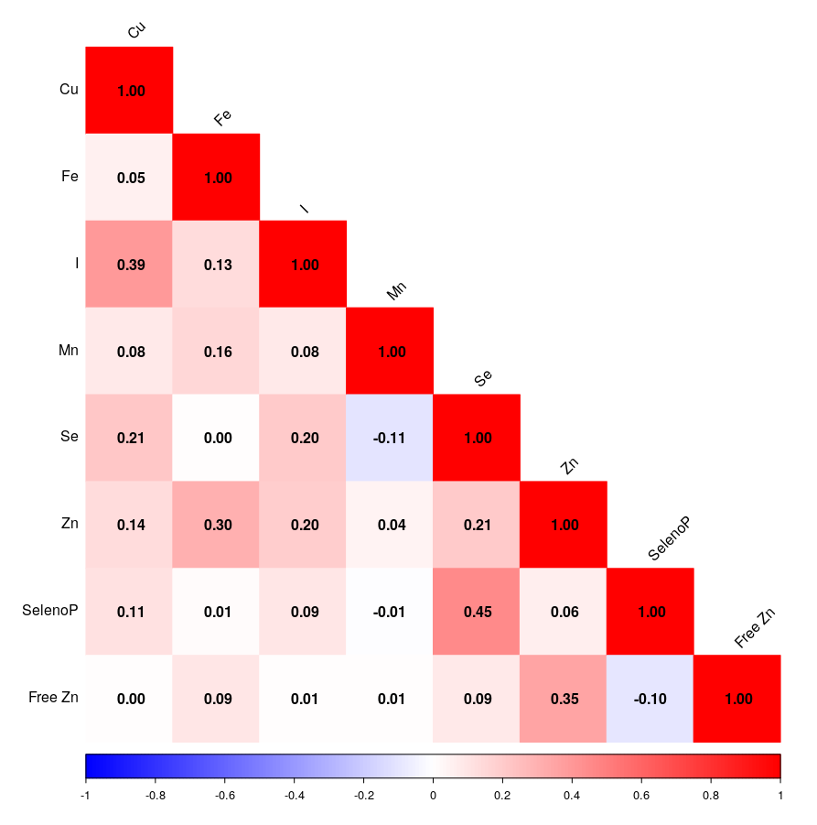
Supplementary Figure 2 Multivariable adjusted hazard ratios for diabetes-related total vascular complications risk according to TE concentrations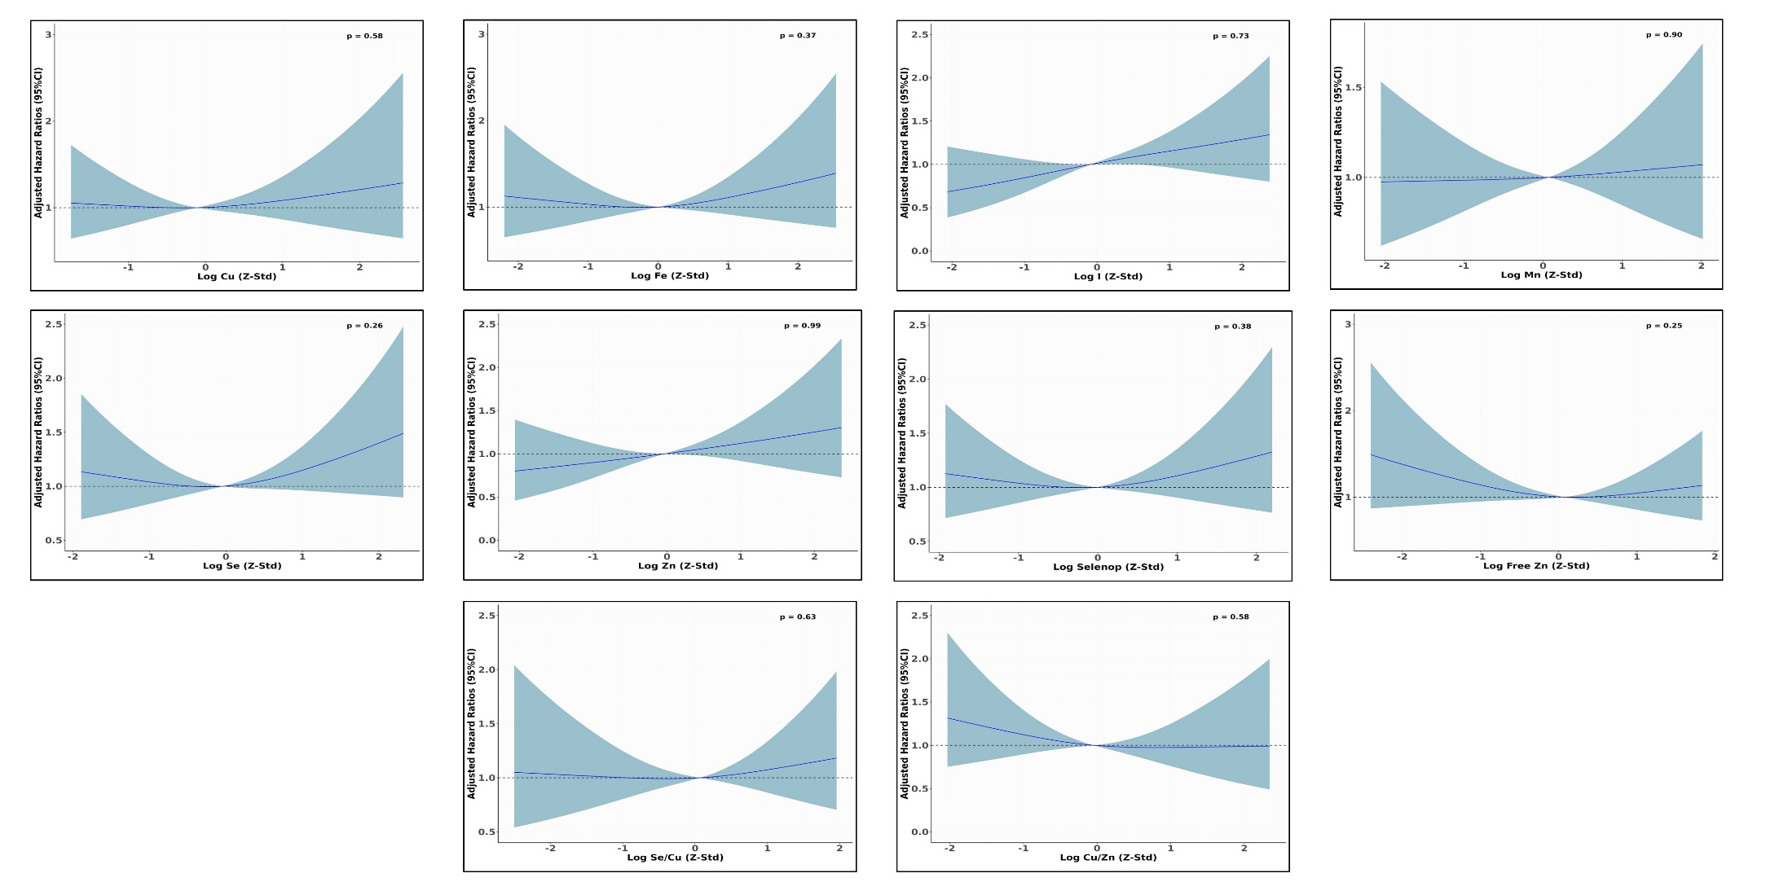Multivariable adjusted hazard ratios for diabetes related total vascular complications risk according to TE concentrations. Models were adjusted for age at diabetes diagnosis, sex, educational attainment, BMI, waist circumference, smoking status, physical activity, alcohol intake, vitamin and mineral supplement use, prevalent hypertension, anti-hypertensive medication, lipid-lowering medication and Mediterranean Diet Score. TEs were log transformed and Z standardized (Mean = 0, SD =1). Knot placement was 10th, 50th, and 90th percentile. P values represent the test for nonlinearity results.
Supplementary Figure 3 Multivariable adjusted hazard ratios for diabetes-related macrovascular complications risk according to TE concentrations 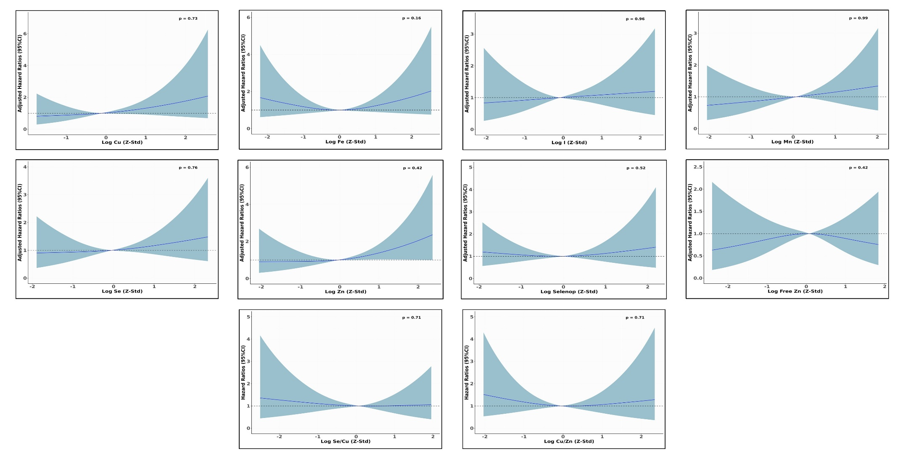
Multivariable adjusted hazard ratios for diabetes related macrovascular complications risk according to TE concentrations. Models were adjusted for age at diabetes diagnosis, sex, educational attainment, BMI, waist circumference, smoking status, physical activity, alcohol intake, vitamin and mineral supplement use, prevalent hypertension, anti-hypertensive medication, lipid-lowering medication and Mediterranean Diet Score. TEs were log transformed and Z standardized (Mean = 0, SD =1). Knot placement was 10th, 50th, and 90th percentile. P values represent the test for nonlinearity results.
Supplementary Figure 4 Multivariable adjusted hazard ratios for diabetes-related microvascular complications risk according to TE concentrations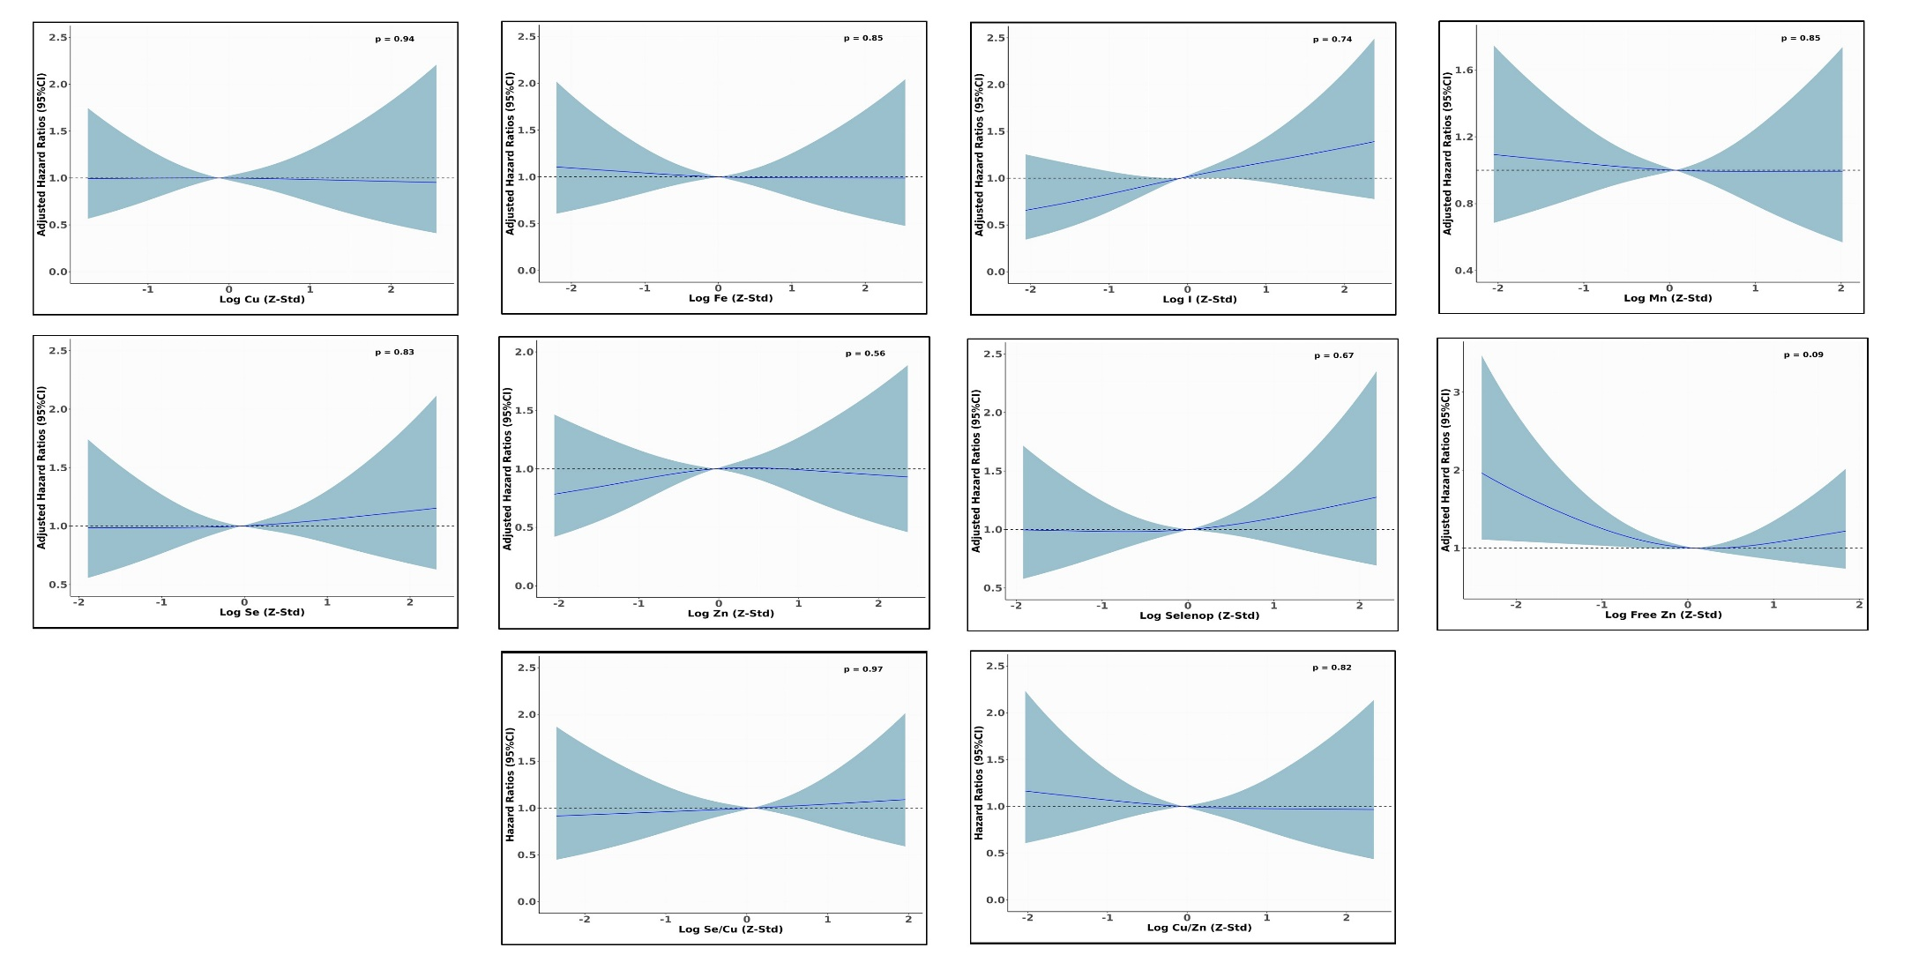
Multivariable adjusted hazard ratios for diabetes related microvascular complications risk according to TE concentrations. Models were adjusted for age at diabetes diagnosis, sex, educational attainment, BMI, waist circumference, smoking status, physical activity, alcohol intake, vitamin and mineral supplement use, prevalent hypertension, anti-hypertensive medication, lipid-lowering medication and Mediterranean Diet Score. TEs were log transformed and Z standardized (Mean = 0, SD =1). Knot placement was 10th, 50th, and 90th percentile. P values represent the test for nonlinearity results.
Supplementary Figure 5. Associations between TEs and diabetes-related total vascular complications estimated by BKMR method.
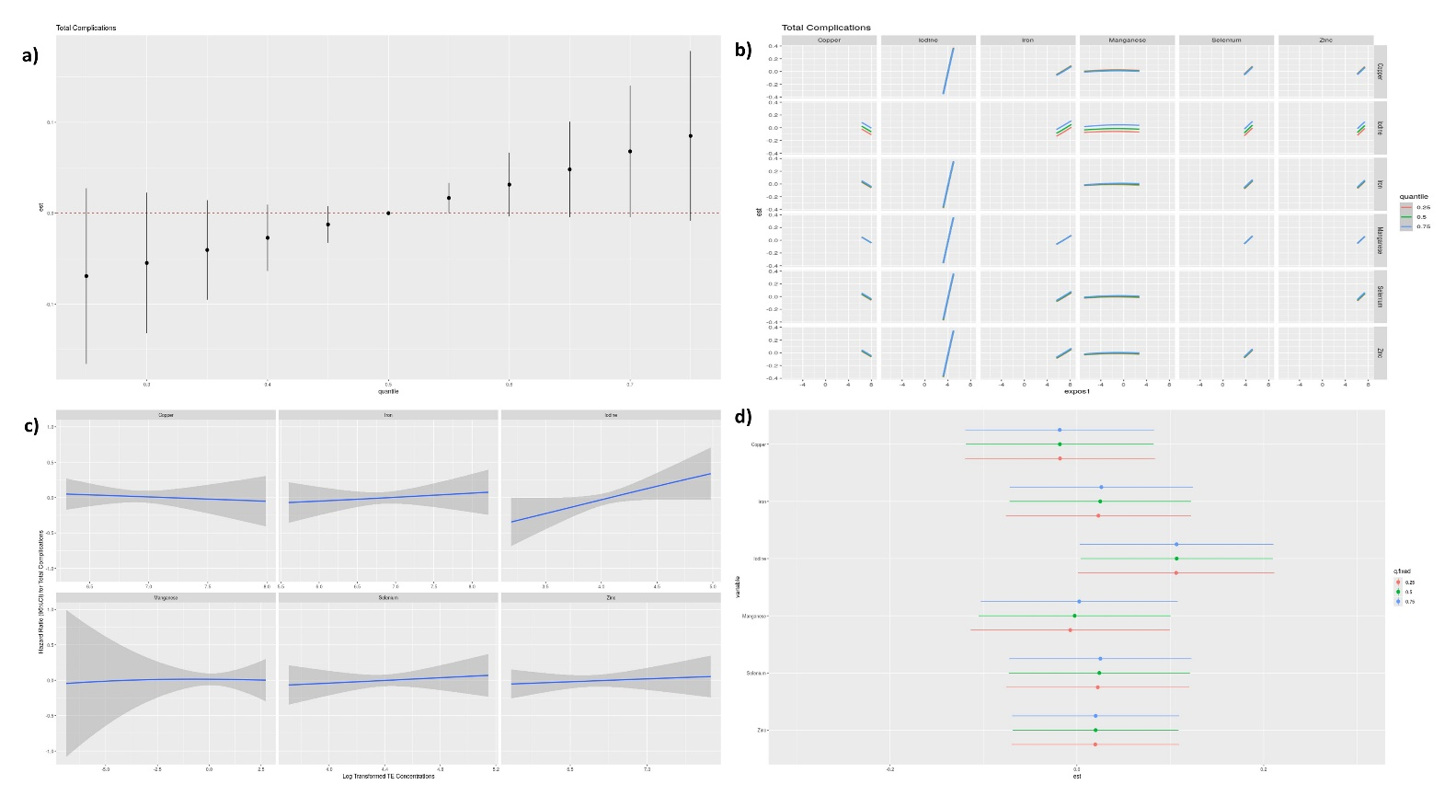
Models were adjusted for age at diabetes diagnosis, sex, duration between recruitment and diabetes diagnosis, educational attainment, BMI, waist circumference, smoking status, physical activity, alcohol intake, vitamin and mineral supplement use, prevalent hypertension, prevalent dyslipidemia and Mediterranean diet score. a) Joint effects of TE mixture with diabetes-related total vascular complications risk at increasing percentiles compared to medians b) Bivariate exposure-response functions for each TE among six TE at varying levels (10th, 50th, 90th) of another TE, when other TEs are set at their median c) Univariate exposure-response function between individual TE with the risk of diabetes-related total vascular complications with other TEs fixed at the corresponding 50th percentiles d) Single-exposure effect of individual TE for an IQR increase on the risk of diabetes-related total vascular complications when other metals are fixed at their 25th, 50th, or 75th percentiles
Supplementary Figure 6. Associations between TEs and diabetes-related macrovascular complications estimated by BKMR method.
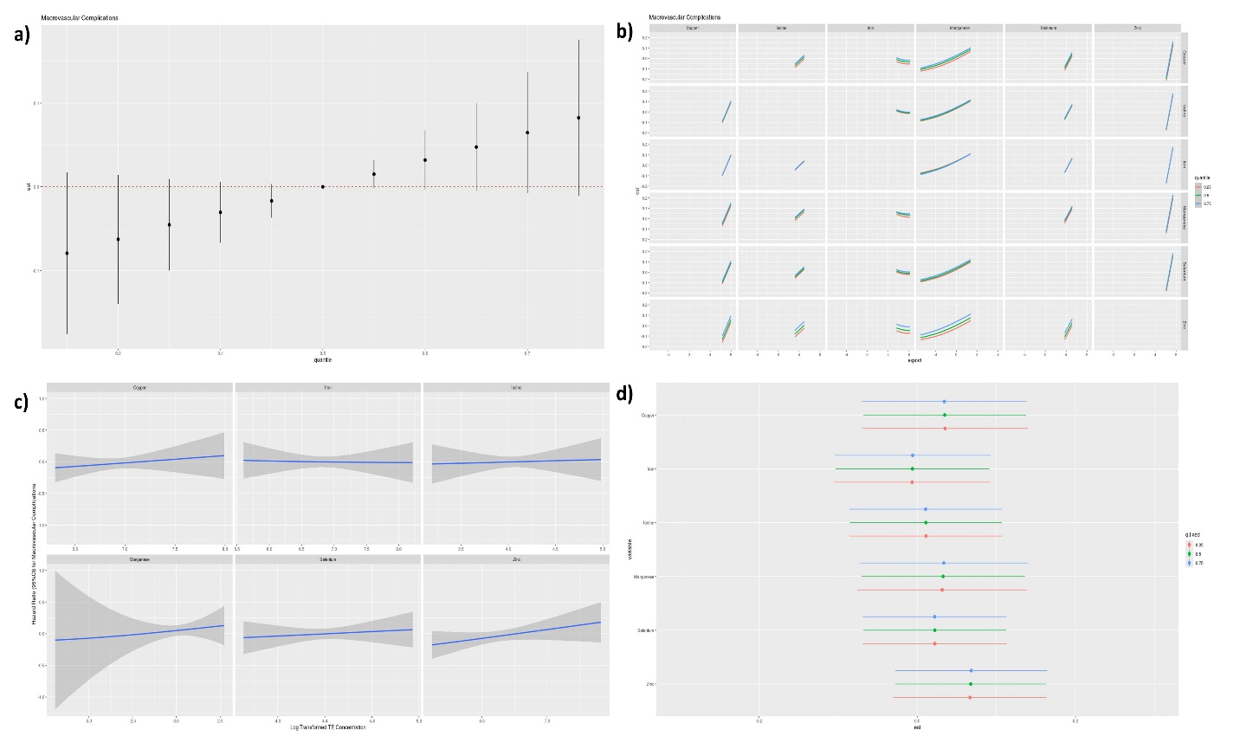
Models were adjusted for age at diabetes diagnosis, sex, duration between recruitment and diabetes diagnosis, educational attainment, BMI, waist circumference, smoking status, physical activity, alcohol intake, vitamin and mineral supplement use, prevalent hypertension, prevalent dyslipidemia and Mediterranean diet score. a) Joint effects of TE mixture with diabetes-related macrovascular complications risk at increasing percentiles compared to medians b) Bivariate exposure-response functions for each TE among six TE at varying levels (10th, 50th, 90th) of another TE, when other TEs are set at their median c) Univariate exposure-response function between individual TE with the risk of diabetes-related macrovascular complications with other TEs fixed at the corresponding 50th percentiles d) Single-exposure effect of individual TE for an IQR increase on the risk of diabetes-related macrovascular complications when other metals are fixed at their 25th, 50th, or 75th percentiles
Supplementary Figure 7. Associations between TEs and diabetes-related microvascular complications estimated by BKMR method.
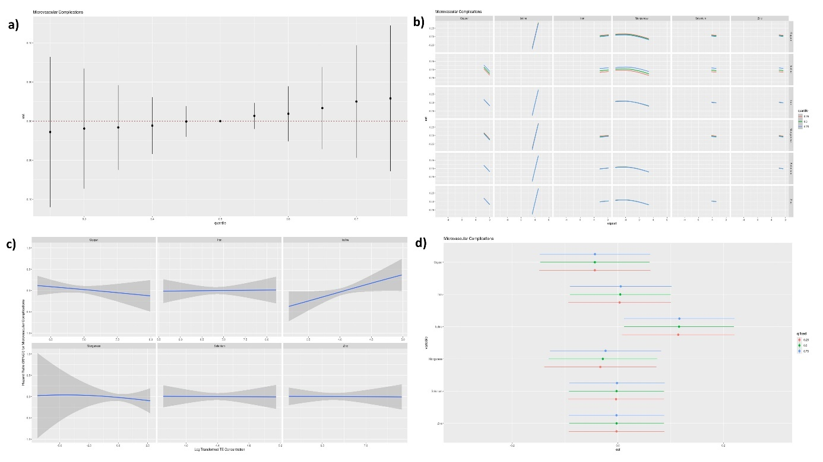
Models were adjusted for age at diabetes diagnosis, sex, duration between recruitment and diabetes diagnosis, educational attainment, BMI, waist circumference, smoking status, physical activity, alcohol intake, vitamin and mineral supplement use, prevalent hypertension, prevalent dyslipidemia and Mediterranean diet score. a) Joint effects of TE mixture with diabetes-related microvascular complications risk at increasing percentiles compared to medians b) Bivariate exposure-response functions for each TE among six TE at varying levels (10th, 50th, 90th) of another TE, when other TEs are set at their median c) Univariate exposure-response function between individual TE with the risk of diabetes-related microvascular complications with other TEs fixed at the corresponding 50th percentiles d) Single-exposure effect of individual TE for an IQR increase on the risk of diabetes-related microvascular complications when other metals are fixed at their 25th, 50th, or 75th percentiles

