Supplementary Table 1. Baseline clinical characteristics of patients according the DM and CMD
 | Non-DM and non-CMD | DM and non-CMD | Non-DM and CMD | DM and CMD | P value
Male | 177 (72.8%) | 86 (59.3%) | 28 (87.5%) | 15 (46.9%) | <0.001
Height, cm | 162.0 [157.0;168.0] | 165.0 [158.0;170.0] | 167.8 [163.5;171.0] | 159.0[155.0;165.5] | <0.001
Weight, kg | 59.2 ± 9.8 | 62.4 ± 10.0 | 66.0 ± 11.5 | 57.4 ± 12.4 | <0.001
Age, years | 73.0 [67.0;79.0] | 71.0 [65.0;75.0] | 76.5 [66.5;81.5] | 70.0 [66.0;74.0] | 0.007
ACS | 162 (66.7%) | 87 (60.0%) | 25 (78.1%) | 21(65.6%) | 0.229
FPG | 5.2 [ 4.6; 6.0] | 6.8 [ 5.7; 9.2] | 5.3 [ 4.7; 6.1] | 5.8 [ 5.1; 7.1] | <0.001
ABG | 7.2 [ 6.4; 8.5] | 10.2 [ 7.5;13.9] | 6.6 [ 6.0; 7.4] | 11.4 [ 8.5;13.0] | <0.001
HBA1c | 5.9 [ 5.6; 6.2] | 7.5 [ 6.8; 8.6] | 5.9 [ 5.7; 6.2] | 7.5 [ 6.6; 8.1] | <0.001
GA1 | 4.9 [ 4.4; 5.3] | 7.2 [ 6.0; 8.4] | 5.3 [ 4.7; 5.6] | 7.8 [ 6.2; 8.6] | <0.001
GA2 | 36.6 ± 4.1 | 38.0 ± 4.9 | 37.9 ± 2.9 | 36.4 ± 4.6 | 0.191
Dyslipidemia | 67 (27.6%) | 33 (22.8%) | 6 (18.8%) | 6(18.8%) | 0.461
CRF | 10 (4.1%) | 21 (14.5%) | 4 (12.5%) | 7 (21.9%) | <0.001
Smoking | 86 (35.4%) | 45 (31.0%) | 11 (34.4%) | 9 (28.1%) | 0.750
Previous PCI | 116 (47.7%) | 63 (43.4%) | 18 (56.2%) | 13 (40.6%) | 0.501
Previous MI | 41 (16.9%) | 27 (18.6%) | 6 (18.8%) | 4 (12.5%) | 0.856
Previous stroke | 17 (7.0%) | 24 (16.6%) | 1 (3.1%) | 4 (12.5%) | 0.011
LVEF | 62.0 [56.3;68.2] | 63.7 [52.5;68.5] | 61.0 [55.4;68.2] | 59.8 [47.1;65.8] | 0.333
Asprin | 238 (97.9%) | 142 (97.9%) | 32 (100.0%) | 30 (93.8%) | 0.365
Clopidogrel | 116 (47.7%) | 66 (45.5%) | 12 (37.5%) | 16 (50.0%) | 0.704
Ticagrelor | 125 (51.4%) | 76 (52.4%) | 20 (62.5%) | 15 (46.9%) | 0.619
DAPT | 233 (95.9%) | 142 (97.9%) | 32 (100.0%) | 30 (93.8%) | 0.370
Statin | 234 (96.3%) | 142 (97.9%) | 32 (100.0%) | 30 (93.8%) | 0.409
Beta blocker | 164 (67.5%) | 93 (64.1%) | 15 (46.9%) | 22 (68.8%) | 0.137
ACEI/ARB/ARNI | 155 (63.8%) | 105 (72.4%) | 19 (59.4%) | 20 (62.5%) | 0.262
CCB | 62 (25.5%) | 61 (42.1%) | 14 (43.8%) | 12 (37.5%) | 0.004
DM treatment |  |  |  |  | <0.001
0 | 242 (99.6%) | 1 (0.7%) | 32 (100.0%) | 1 (3.1%)
1 | 0 (0.0%) | 11 (7.6%) | 0 (0.0%) | 3 (9.4%)
2 | 0 (0.0%) | 75 (51.7%) | 0 (0.0%) | 17 (53.1%)
3 | 1 (0.4%) | 58 (40.0%) | 0 (0.0%) | 11 (34.4%)
MVD | 201 (82.7%) | 123 (84.8%) | 26 (81.2%) | 28 (87.5%) | <0.001
IVUS-use | 151 (62.1%) | 89 (61.4%) | 26 (81.2%) | 21 (65.6%) | 0.180
Values are mean ± SD, n (%), or median (Q1; Q3). ACS, acute coronary syndromes; FPG, fasting blood glucose; HbA1c, hemoglobin A1c; CRF, chronic renal failure; LVEF, left ventricular ejection fraction; DAPT, dual anti-platelet therapy; ACEI, angiotensin-converting enzyme inhibitors; ARB, angiotensin receptor blockers; CCB, calcium channel blockers; DM, diabetes mellitus; CMD, coronary microvascular dysfunction; MVD, multivessel disease; IVUS, intravascular ultrasound; PCI, percutaneous coronary intervention; MI, myocardial infarction; GA, glycated albumin; ABG, admission blood glucose.

Supplementary Table 2. univariate cox regression of clinical risk factors
variable | Univariate HR | P value
Age | 1.02 (0.99 -1.05) | 0.23
BMI | 1.03(1.03-1.04) | <0.01
Male | 1.93 (1.15 -3.25) | 0.01
ACS | 1.16 (0.66-2.03) | 0.60
DM | 1.94(1.15-3.27) | 0.01
Smoking | 0.36(0.18-0.73) | <0.01
Pre-PCI | 1.00 (0.60-1.69) | 0.99
Pre-stroke | 1.95(0.98-3.85) | 0.06
LVEF | 0.97(0.95-0.99) | <0.01
DM-treatment | 1.26(1.02-1.54) | 0.03
Dyslipidemia | 1.11(0.61-2.00) | 0.73
TIMI frame count | 0.97(0.87-1.08) | 0.60
blush score | 1.39(0.42-1.25) | 0.25
CK-MB | 1.00(1.00-1.01) | 0.51
Troponin | 0.98(0.93-1.04) | 0.49
Target Vessel | 1.17 (0.81 -1.68) | 0.41
Long diffuse coronary lesion | 0.83(0.36-1.94) | 0.67
Burr number | 1.63(1.09-2.45) | 0.02
Initial burr size | 0.18(0.03-1.01) | 0.05
RA-time | 1.00(1.00-1.00) | 0.30
RA-max-speed | 0.79(0.67-0.92) | <0.01
Post-PCI angio-IMR | 1.07(1.03-1.11) | <0.01
Total stent number | 1.06(0.78-1.43) | 0.73
BMI, body mass index; TIMI, thrombolysis in myocardial infarction; CK-MB, creatine kinase MB isoenzyme

Supplementary Table 3. The characteristics of patients with type 2 diabetes
variable | Over all | Non-CMD | CMD | P value
Microvascular complication | 31 (17.4%) | 25 (17.1%) | 6 (18.8%) | 1.0
Diabetes duration | 10.0 [ 5.0;15.0] | 10.0 [ 5.0;15.0] | 9.0 [ 5.0;17.0] | 0.716
Diabetes severity
HbA1c>6.5 | 47 (26.4%) | 43 (29.5%) | 4 (12.5%) | 0.08
FPG level |  |  |  | 0.138
FPG≤7.0 | 96 (53.9%) | 73 (50.0%) | 23 (71.9%)
7.0< FPG ≤8.4 | 35 (19.7%) | 30 (20.5%) | 5 (15.6%)
8.4 <FPG ≤11.1 | 22 (12.4%) | 20 (13.7%) | 2 (6.2%)
FPG>11.1 | 25 (14.0%) | 23 (15.8%) | 2 (6.2%)
Microvascular complication: DM retinopathy, DM Nephropathy, DM neuropathy.

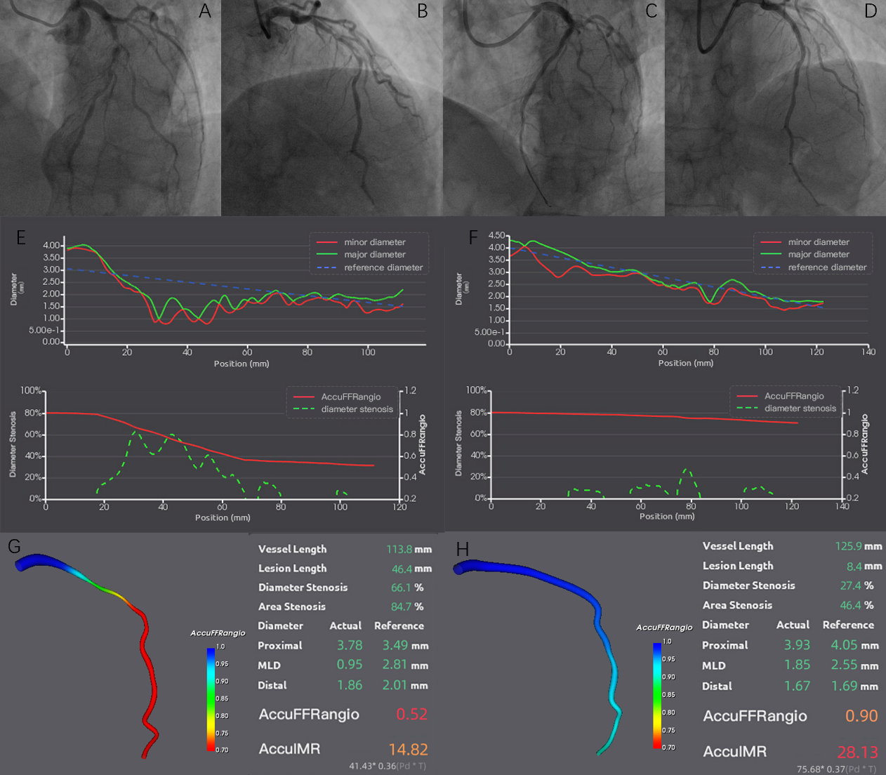
Supplementary figure S1. Calculate angio-IMR of left anterior descending with sever calcification. (A-D) The angiography of pre- and post-PCI, (E and F) lumen diameter and computed angio-IMR, (G and H) the result of computed angiography–based fractional flow reserve and angio-IMR. AccuFFRangio: angiography-derived fractional flow reserve coronary angiography– based fractional flow reserve; AccuIMR: angiography–derived index of microcirculatory resistance coronary angiography–based index of microcirculatory resistance; Angio-IMR, angiography-derived index of microcirculatory resistance.

Supplementary figure S2. Kaplan-Meier survival curves for clinical events in RA patients by CMD (post-PCI angio-IMR≥25). The endpoint was the target vessel failure (TVF, composed of cardiac death, target vessel myocardial infarction, target vessel revascularization). RA, rotational atherectomy; CMD, coronary microvascular dysfunction

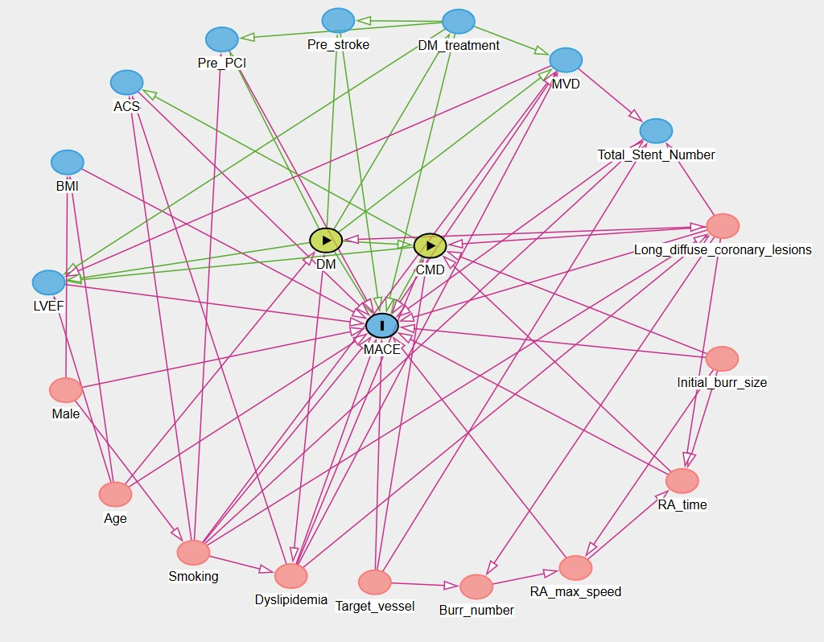
Supplementary figure S3. A directed acyclic graph represents the association between covariates and exposure and outcome. Nodes are connected by arrows, which are unidirectional and indicate the direction of a causal effect between two nodes. DM and CMD were designated as exposure variables, while MACE was defined as the outcome variable. Red circles represent ancestors of exposure and outcome; blue circles represent ancestors of outcome. Green lines represent causal paths and fuchsia lines represent biasing paths. These were considered confounders. The minimal sufficient adjustment sets for estimating the total effect of DM and CMD on MACE include the residual confounders of age, dyslipidemia, smoking, target vessel, RA time, initial burr size and long diffuse coronary lesions. DM, diabetes mellitus; CMD, coronary microvascular dysfunction; MACE, major adverse cardiac event; ACS, acute coronary syndromes; LVEF, left ventricular ejection fraction; MVD, multivessel disease.

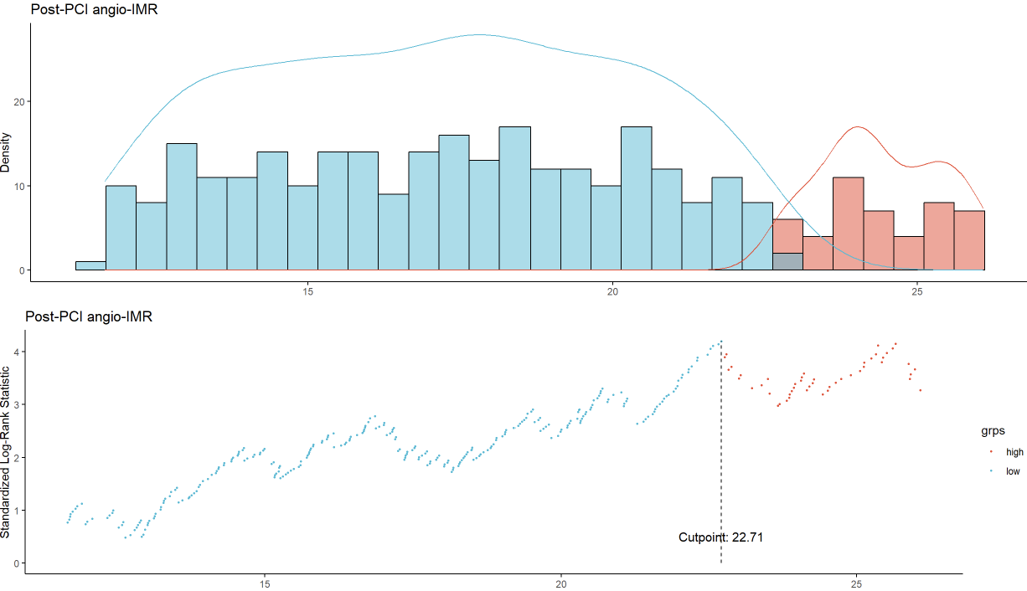
Supplementary figure S4. Maximally selected log-rank statistics. Post-PCI angio-IMR, post percutaneous coronary intervention angiography–based index of microcirculatory resistance.

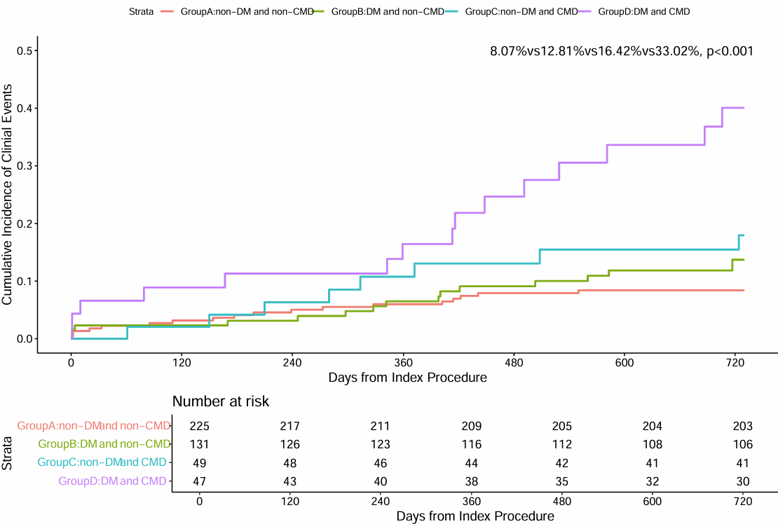
Supplementary figure S5. Comparison of clinical events at 24-month according to the DM and CMD (post-PCI angio-IMR≥23). DM, diabetes mellitus; CMD, coronary microvascular dysfunction; PCI, percutaneous coronary intervention.

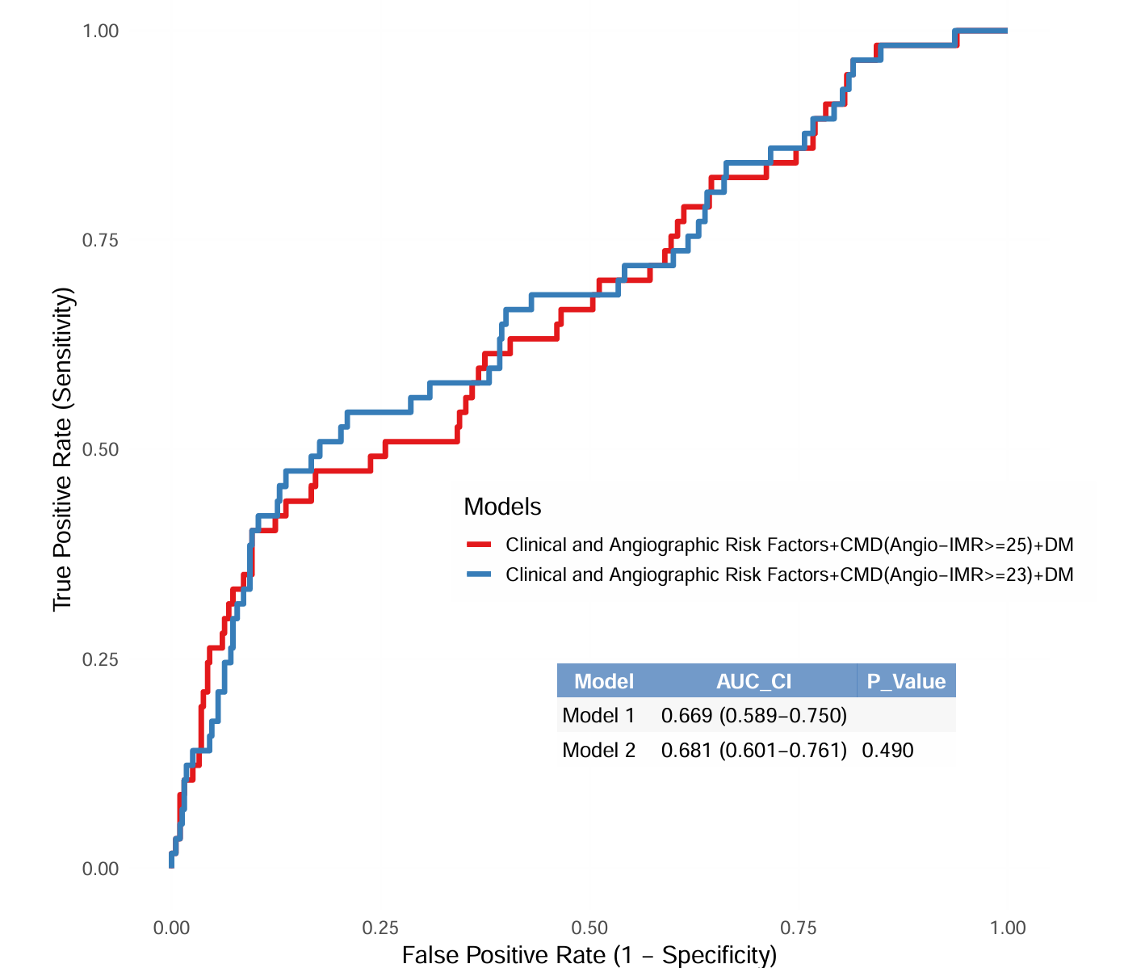

Supplementary figure S6. Incremental Prognostic Value of Angio-IMR Combined with Clinical and Angiographic Factors. The receiver-operating characteristic curve comparison between the 2 models. Model 1: DM, Age, Male, starting burr size, RA time, Vessel, ACS, and CMD (post-PCI angio-IMR≥25); Model 2: DM, Age, Male, starting burr size, RA time, Vessel, ACS, and CMD (post-PCI angio-IMR≥23)

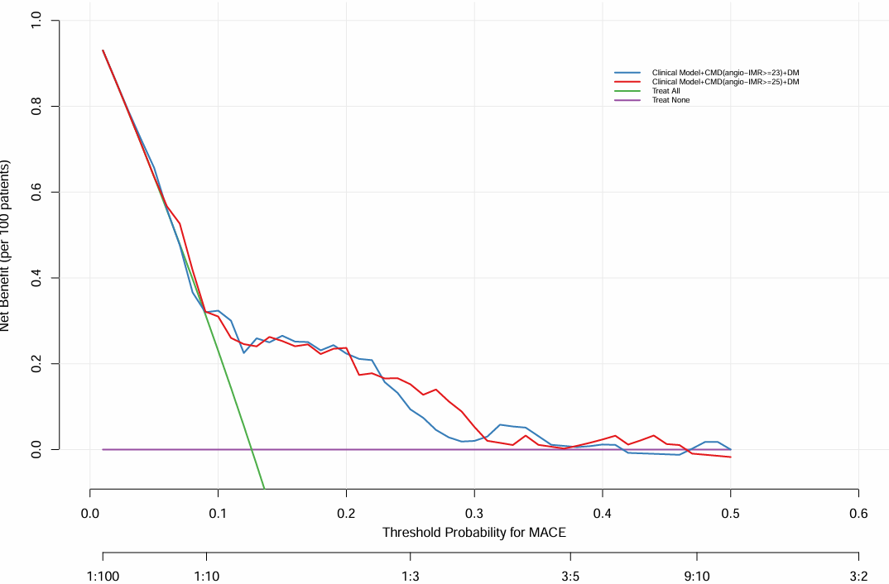
Supplementary figure S7. Comparative analysis of the clinical usefulness of the CMD (angio-IMR ≥ 25) and CMD (angio-IMR ≥ 23) is warranted for the purpose of predicting prognosis via decision curve analysis. Clinical model: DM, male, age, initial burr size, RA time, target vessel, ACS, dyslipidemia, long diffuse coronary lesion.
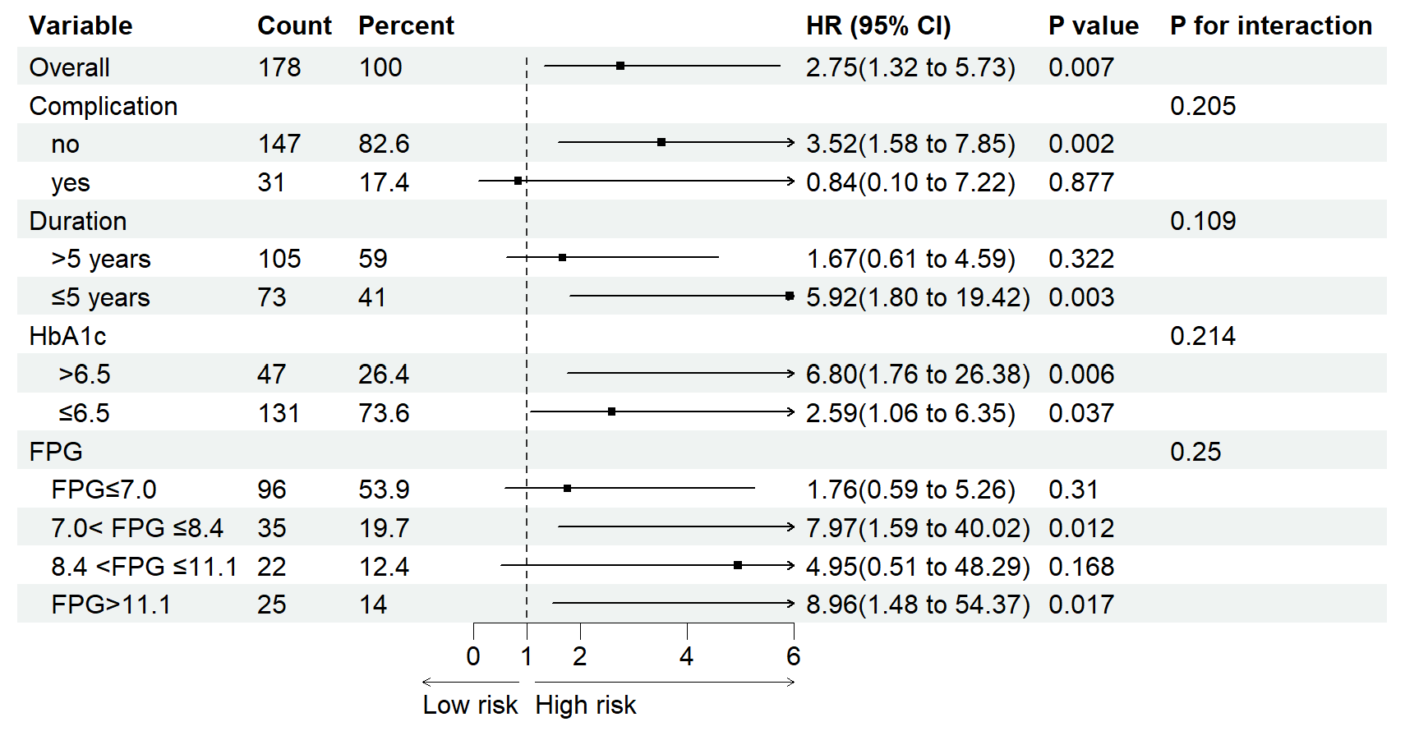
Supplementary figure S8. Subgroup analyses of type 2 diabetes mellitus. Complication: DM retinopathy, DM Nephropathy, DM neuropathy. FPG, fasting blood glucose; HbA1c, hemoglobin A1c;

