Supplementary Materials

Supplementary Table S1. Search strategy for PubMed

#1 | (((((Triglyceride glucose index[Title/Abstract]) OR (Triglyceride glucose[Title/Abstract])) OR (Triglyceride-glucose index[Title/Abstract])) OR (Triglyceride-glucose[Title/Abstract])) OR (TyG[Title/Abstract])) OR (TyG index[Title/Abstract])
#2 | "Coronary Disease"[MeSH ]
#3 | (Coronary Diseases[Title/Abstract] OR Diseases, Coronary[Title/Abstract] OR Coronary Heart Disease[Title/Abstract] OR Coronary Heart Diseases[Title/Abstract] OR Disease, Coronary Heart[Title/Abstract] OR Diseases, Coronary Heart[Title/Abstract] OR Heart Disease, Coronary[Title/Abstract] OR Heart Diseases, Coronary[Title/Abstract] OR Coronary artery disease (CAD[Title/Abstract]) OR Coronary heart disease (CHD[Title/Abstract]) OR Ischemic heart disease[Title/Abstract] OR Coronary disease[Title/Abstract] OR Coronary artery disease risk[Title/Abstract] OR Coronary vascular disease[Title/Abstract] OR Coronary occlusion[Title/Abstract] OR Coronary insufficiency[Title/Abstract])
#4=#2 OR #3
#5 | "Acute Coronary Syndrome"[Mesh]
#6 | (Acute Coronary Syndromes[Title/Abstract] OR Coronary Syndrome, Acute[Title/Abstract] OR Coronary Syndromes, Acute[Title/Abstract] OR Syndrome, Acute Coronary[Title/Abstract] OR Syndromes, Acute Coronary[Title/Abstract] OR Acute coronary syndrome (ACS[Title/Abstract]) OR Acute coronary event[Title/Abstract] OR Acute myocardial infarction (AMI[Title/Abstract]) OR Unstable angina[Title/Abstract] OR ST-elevation myocardial infarction (STEMI[Title/Abstract]) OR Non-ST elevation myocardial infarction (NSTEMI[Title/Abstract]) OR Myocardial infarction (MI[Title/Abstract]) OR Acute ischemic heart disease[Title/Abstract] OR Acute myocardial ischemia[Title/Abstract])
#7=#5 OR #6
#8 | "Myocardial Infarction"[Mesh]
#9 | (Infarction, Myocardial[Title/Abstract] OR Infarctions, Myocardial[Title/Abstract] OR Myocardial Infarctions[Title/Abstract] OR Heart Attack[Title/Abstract] OR Heart Attacks[Title/Abstract] OR Myocardial Infarct[Title/Abstract] OR Infarct, Myocardial[Title/Abstract] OR Infarcts, Myocardial[Title/Abstract] OR Myocardial Infarcts[Title/Abstract] OR Cardiovascular Stroke[Title/Abstract] OR Cardiovascular Strokes[Title/Abstract] OR Stroke, Cardiovascular[Title/Abstract] OR Strokes, Cardiovascular[Title/Abstract] OR Myocardial infarction (MI[Title/Abstract]) OR Heart attack[Title/Abstract] OR Acute myocardial infarction (AMI[Title/Abstract]) OR ST-elevation myocardial infarction (STEMI[Title/Abstract]) OR Non-ST elevation myocardial infarction (NSTEMI[Title/Abstract]) OR Ischemic myocardial injury[Title/Abstract] OR Cardiac infarction[Title/Abstract] OR Coronary artery occlusion[Title/Abstract] OR Myocardial ischemia[Title/Abstract] OR Heart muscle infarction[Title/Abstract])
#10=#8 OR #9
#11=#4 OR #7 OR #10
#12=#1 AND #11

Supplementary Table S2. Characteristics of the included studies

First author  Publication year | Source of participants  Age | MACE/subject  Duration of follow-up（months） | Exposure categories | Adjustment for  potential confounding factors
Chen 2024 [10] | Third People’s Hospital of Chengdu  (66.61 ± 11.42) | 167/986  30.72 | Per 1-unit increase (Diabetes)  1.627 (1.0072,2.6281)  Per 1-unit increase (Non-diabetes)  2.1344 (1.3876,3.2784) | age, male, smoker, previous MI, previous CABG, BMI, AMI, LVEF, left main disease, multi-vessel disease, HbA1c, hs-CRP, statin, insulin  age, body mass index, diastolic blood pressure, high-density lipoprotein cholesterol, glycosylated haemoglobin, sex, current smoking, daily drinking, presence of peripheral artery disease, chronic kidney disease, cardiac failure, previous myocardial infarction, past percutaneous coronary intervention, use of insulin and/or oral antidiabetic agents at discharge, coronary artery disease severity, presence of lesions > 20 mm long, use of drug-coated balloon, and complete revascularization
Wang 2020  [30] | Tianjin Chest Hospital  (66.3 ± 6.8) | 289/2,531  36 | T1 vs T3 (Diabetes)  1.537 (1.138,2.076) | age, male, smoker, previous MI, previous CABG, BMI, AMI, LVEF, left main disease, multi-vessel disease, HbA1c, hs-CRP, statin, insulin
Ma 2020  [28] | Beijing Anzhen Hospital, Capital Medical University  (61 ± 10) | 188/776  30 | T1 vs T3 (Diabetes)  2.15 (1.44,3.22)  Per 1-unit increase (Diabetes)  1.5 (1.15,1.97) | age, male, smoker, previous MI, previous CABG, BMI, AMI, LVEF, left main disease, multi-vessel disease, HbA1c, hs-CRP, statin, insulin  age, body mass index, diastolic blood pressure, high-density lipoprotein cholesterol, glycosylated haemoglobin, sex, current smoking, daily drinking, presence of peripheral artery disease, chronic kidney disease, cardiac failure, previous myocardial infarction, past percutaneous coronary intervention, use of insulin and/or oral antidiabetic agents at discharge, coronary artery disease severity, presence of lesions > 20 mm long, use of drug-coated balloon, and complete revascularization
Xiong 2022  [32] | Third People’s Hospital of Chengdu  (68.02 ± 10.75) | 99/633  18.83 | ≤ 9.04 vs > 9.04(Diabetes)  1.7501 (1.2239,2.5025) | NA
Zhao 2020（a）  [35] | Beijing Anzhen Hospital, Capital Medical University  (60.9 ± 8.3 ) | 180/798  36 | < 9.18VS≥ 9.18(Diabetes)  4.062 (2.732,6.04)  Per 1-unit increase (Diabetes)  3.208 (2.4,4.289) | age, sex (female), BMI, SBP, DBP, smoking, drinking, duration of diabetes, dyslipidemia, prior MI, PCI, stroke ， PVD，SYNTAX score, LM treatment, DCB use, complete revascularization ， number of stents，DAPT at discharge, DAPT interruption in 12 months, statins at discharge, statins interruption in 12 months, oral hypoglycemic agents (metformin, alpha-glucosidase inhibitor, sulfonylurea, dipeptidyl peptidase 4 inhibitor) at discharge and insulin at discharge
Wang 2024  [11] | Improving Cardiovascular Care in China-ACS  (64) | 2,759 /101,113  30 | ≤ 9.161 VS > 10.013(Diabetes)  1.305 (1.185,1.436)  ≤9.161VS>10.013(Non-diabetes)  1.299 (1.215,1.39) | sex, age, cerebrovascular disease, previous MI, smoking status, statins, previous hypertension, history of valve surgery, peripheral vascular disease,HbA1C, diabetes, chronic obstructive pulmonary disease, oral aspirin or not, oral clopidogrel or not, history of angina, creatinine, Left ventricular ejection fraction, subcutaneous insulin or not
Zhang 2021(a)  [44] | Cardiovascular Center of Beijing Friendship Hospital  (65) | 435/1,655  35.6 | <8.33 VS ≥8.33(Non-diabetes)  1.14 (0.9,1.44) | NA
Liu 2023  [15] | Fuwai Central China Cardiovascular Hospital  ( 60.5 ± 9.4 ) | 154/1,467  12 | Per 1-unit increase (Diabetes)  1.2 (0.92,1.56)  Per 1-unit increase (Non-diabetes)  1.64 (1.13,2.37) | age, gender, current smoking, BMI, diabetes, established CVDs (including MI, stroke, HF), stains, antiplatelet drugs, fibrates drugs, antidiabetic agents, SBP, DBP, UA, eGFR, TC, LDL-C
Tao 2023  [12] | China-Japan Friendship Hospital  (62) | 542/1,353  20.4 | T1 vs T3(Diabetes)  2.172 (1.571,3.002)  T1 vs T3(Non-diabetes)  2.345 (1.757,3.13) | Adjusted for age, gender, BMI, SBP, DBP, diabetes, hypertension, familial CVDs, smoking and drinking history, TC, LDL-C, HCY, Hs-CRP, number of coronary lesions and stent implantation
Wu 2022  [16] | Qilu Hospital of Shandong University  ( 44.48 ± 6.30) | 101/526  68 | Per 1-unit increase (Diabetes)  1.55 (0.88,2.72)  Per 1-unit increase (Non-diabetes)  1.45 (1.03,2.05) | age, gender, BMI, LVEF, admission for MI, multivessel disease, GS, current smoking, current drinking, FH-CAD, hypertension, hyperlipidemia, TC, LDL-C, HDL-C, eGFR, UA, antiplatelet drugs, statins, beta-blockers, ACEI/ARB and hypoglycemic drugs
Jiao 2022  [13] | Cardiology Department of Chinese People’s Liberation Army  (81.87 ± 2.14) | 277/662  63 | Per 1-unit increase (Diabetes)  1.48 (1.04,2.1)  Per 1-unit increase (Non-diabetes)  1.25 (0.9,1.74) | age, gender, BMI, SBP, DBP, LVEF, Gensini score, hypertension, hyperlipidemia, previous MI, previous stroke, CKD, current smoking, TC, LDL-C, HDL-C, eGFR, UA, aspirin, clopidogrel, statin, β-blocker, ACEI/ARB, LM lesion
Xie 2023  [17] | Coronary Revascularization in Patients On Dialysis in China-Retrospective Registry  (61.8±10.5) | 214/959  12 | Per 1-unit increase (Diabetes)  1.22 (0.97,1.54)  Per 1-unit increase (Non-diabetes)  1.48 (1.08,2.04) | NA
Yang 2023  [33] | The First Affiliated Hospital of Anhui Medical University  (64.50 ± 10.36 ) | 53/331  44 | Per 1-unit increase (Diabetes)  1.32 (0.88,1.98)  Per 1-unit increase (Non-diabetes)  1.9 (1.33,2.71) | NA
Dong 2023  [24] | Beijing Anzhen Hospital  (64.5 ± 8.0) | 350/1,158  42 | Per 1-unit increase (Diabetes)  1.47 (1,2.16)  Per 1-unit increase (Non-diabetes)  1.19 (0.8,1.79) | age, male, BMI, SBP, current smoking, family history of CAD, hypertension, dyslipidemia, prior MI, prior PCI, prior stroke, PAD, HF, CKD, clinical diagnosis, Hb, hs-CRP, eGFR, TC, LDL-C, HDL-C, HbA1c, LVEF, DAPT, ACEI/ARB, ARNI, antidiabetic agents, statins at discharge, LM disease, multivessel disease, CTO, thrombotic disease, in-stent restenosis, target vessel selection, PTCA, number of stents, interval time from CABG to PCI, PCI success
Sun 2023  [39] | Beijing Anzhen Hospital  (60.3 ± 11.0) | 703/2,055  24 | <8.54 vs ≥ 9.41(Diabetes)  2.25 (1.42,3.59)  <8.54 VS ≥ 9.41(Non-diabetes)  2.94 (1.2,2.45)  Per 1-unit increase (Diabetes)  1.61 (1.28,2.01)  Per 1-unit increase (Non-diabetes)  1.33 (1.08,1.63) | age, sex, heart rate, body mass index, NYHA class, prior PCI, platelet, albumin, TC, LDL-C, HDL-C, potassium, uric acid, LVEF, ARB, thiazide diuretics, spironolactone, sacubitril/valsartan, diffuse lesion, SYNTAX score, LM disease, in-stent restenosis, target vessel (LM), complete revascularization
Sun 2025  [48] | three tertiary public hospitals: Shandong Provincial Hospital, The Second Hospital of Shandong University, and Qilu Hospital of Shandong University  (62.87 ± 8.13 ) | 336/1,472  85 | T1 VS T3(Diabetes)  2.195 (1.244,3.871)  T1 VS T3(Non-diabetes)  1.859 (1.276,2.708) | Age, Sex, LVEF, Current smoking, Hypertension, Diabetes mellitus, Left main disease, Duration of surgery, Number of grafts, eGFR, UA, LDL-C, Current drinking, Previous MI, Previous stroke, Family history-CAD, OPCABG, Use of arterial grafts and Antiplatelet drugs
Tao 2024  [29] | China-Japan Friendship Hospital  (65) | 321/1,034  13.3 | Per 1-unit increase (Diabetes)  1.267 (1.042 ,1.539) | gender, age, BMI, HR, OMI, dyslipidemia, hypertension, FCVDs, echocardiography and PAD features
Wang 2023  [31] | China-Japan Friendship Hospital  (65.6 ± 10.6 ) | 985 /5,046  32 | < 8.52 VS > 9.97(Diabetes)  1.45 (1.09,1.92)  Per 1-unit increase (Diabetes)  1.18 (1.05,1.32) | NT-proBNP, age, sex, BMI, diagnosis of AMI, history of hypertension, history of dyslipidemia, history of myocardial infarction, history of arrhythmia, SBP, LVEF, eGFR, hs-CRP, LDL-C, smoking status, and in-hospital treatments (PCI, antiplatelet therapy, β-blocker, ACEI or ARB, and statins
Zhao 2024  [42] | Dongfang Hospital of Beijing University of Chinese Medicine  (71.71 ± 9.36) | 281/ 596  31 | Per 1-unit increase (Diabetes)  1.89 (1.34,2.66)  Per 1-unit increase (Non-diabetes)  3.52(2.1,5.9) | age, male sex, BMI, systolic blood pressure, diastolic blood pressure, smoking，hypertension, dyslipidemia, prior CVDs, prior PCI, prior stroke ， a family history of CVDs，TC, LDL-C, HDL-C, and HbA1c，the use of antiplatelet medication, angiotensin-converting enzyme inhibitor/angiotensin receptor blocker (ACEI/ARB), calcium channel blocker (CCB), β-Blocker, antidiabetic agents, statins, antidepressants, and benzodiazepines
Guo 2022  [37] | Beijing Anzhen Hospital, Capital Medical University  (58.87 ± 10.27) | 233/2,030  30 | ＜8.83 VS ≥8.83(Diabetes)  3.526 (2.618,4.749) | age, gender (reference to male), BMI, SBP, DBP, smoking status, history of hypertension and hyperlipemia, levels of LDL-C, HDL-C, Cr, SUA, eGFR, brain natriuretic peptide (BNP), and CRP
Yang 2021  [40] | Fuwai Hospital, Chinese National Center  (57.20 ± 10.22 ) | 386 / 5,489  29 | Per 1-unit increase (Non-diabetes)  0.77 (0.52,1.16) | NA
Zhang 2023  [41] | the First Affiliated Hospital of Xi’an Jiaotong University  (60.50 ± 10.19) | 437/1,650  47 | Per 1-unit increase (Non-diabetes)  1.493 (1.23,1.812) | NA
Shao 2022  [46] | Beijing Anzhen Hospital, Capital Medical University, Beijing, China  (60.0 ± 10.4) | 345/1,694  31 | Per 1-unit increase (Diabetes)  1.902 (1.42,2.547)  Per 1-unit increase (Non-diabetes)  1.63 (1.179,2.254) | sex, BMI, current smoking, hypertension, dyslipidemia, past myocardial infarction, past percutaneous coronary intervention, chronic kidney disease, admission diagnosis with different types of ACS, GRACE risk score, hs-CRP, SYNTAX score, complete revascularization, and discharged with aspirin, angiotensin converting enzyme inhibitors/angiotensin II receptor blockers and beta-blockers
Qiu 2024  [43] | Shengli Clinical Medical College of Fujian Medical University  (69) | 111/320  34.37 | Per 1-unit increase (Diabetes)  2.518 (1.349,4.701)  Per 1-unit increase (Non-diabetes)  4.346 (2.704,7.122) | NA
Zhang 2020  [47] | the Cardiovascular Center of Beijing Friendship Hospital Database (CBD) Bank  (61.1 ± 11.9) | 858/3,181  33.3 | <8.88 VS ≥8.88 (Diabetes)  1.18 (0.93,1.5)  <8.88 VS ≥8.88 (Non-diabetes)  1.13 (0.93,1.37) | age, gender, diabetes mellitus, hypertension, previous AMI, hemoglobin, albumin, eGFR, TGs, LVEF and multi-vessel/LM. The dashed vertical line represents the hazard ratio for the overall study population
Zhang 2021(b)  [34] | the Cardiovascular Center of Beijing Friendship Hospital Database (CBD) Bank(65.4 ± 12.0) | 735/1,932  26.8 | ≤ 8.91 VS ≥ 9.54(Diabetes)  2.32 (1.92,2.8) | age, BMI, history of stroke and PCI, antiplatelet agent used before admission, WBC, hemoglobin, albumin, eGFR, LVEF, angiography findings (LM/three-disease and proximal LAD), in-hospital treatment(PCI/CABG, antiplatelet agent, ACEI/ARB, beta-blocker, statins) and hypoglycemic agents(Metformin, Alpha-glucosidase inhibitor, DPP-4i and insulin)
Zhao 2020(b)  [45] | Beijing Anzhen Hospital(59.7±9.3 ) | 316/1,510  48 | ＜ 8.72 VS ≥ 8.72(Non-diabetes)  2.087 (1.6,2.722)  Per 1-unit increase (Non-diabetes)  2.433 (1.853,3.196) | age, gender, BMI, smoking history, hypertension, dyslipidemia, previous history of MI, PCI, stroke, PAD,diagnosis, TC, HDL-C, eGFR, HbA1c, LVEF,LM disease, three-vessel disease, chronic total occlusion, diffuse lesion, in-stent restenosis, SYNTAX score, treatment of LM, LCX, RCA, DES implantation, DCB application, complete revascularization, and number of stents,DAPT at admission, statins at admission, and ACEI/ARB at discharge
Chen 2022  [36] | Beijing Anzhen Hospital( 62.9 ± 8.0 ) | 176/1,578  24 | TI VS T3(Diabetes)  2.133 (1.347,3.377)  Per 1-unit increase (Diabetes)  1.954 (1.508,2.533) | age (continuous), sex, BMI (continuous), current smoking, hypertension, previous MI, previous stroke, past PCI, cardiac failure, CKD, preoperative LVEF, insulin dependence, LDL-C (continuous), HDL-C (continuous), diagnosis, extent of CAD, left main disease, complete revascularization and use of IABP
Khalaji 2024  [22] | Tehran Heart Center  (62.8 ± 11.1) | NA/13,542  12.6 | Per 1-unit increase (Diabetes)  1.063 (0.745,1.517) | age, sex, left ventricular ejection fraction, hypertension, body mass index, waist circumference, LDL-C, HDL-C, creatinine, hemoglobin, family history of CAD, cigarette smoking, opium, type of ACS (STEMI, NSTEMI, or UA), and past medical histories of congestive heart failure, valvular heart disease, cerebrovascular disease, CPR, previous CABG, previous PCI, atrial fibrillation, STEMI, NSTEMI, UA, and SA
Yu 2024  [38] | Sir Run Run Shaw Hospital, affiliated with Zhejiang University School of Medicine  (64.44 ± 10.15) | 352/2,306  26.1 | T1 VS T3(Diabetes)  1.765 (1.054,2.953)  T1 VS T3(Non-diabetes)  1.544 (1.07,2.257)  Per 1-unit increase (Diabetes)  2.558 (1.326,4.935)  Per 1-unit increase (Non-diabetes)  2.768 (1.884,4.076) | age, gender (male or female), baseline BMI, smoke (never, former, and current), drink (never, former, and current), hypertension (yes or no), and diabetes (yes or no), prior AMI (yes or no), baseline LDL-C, multivessel lesion (yes or no), LVEF, and medications (administration of ACEI/ARB, antidiabetic agents, antihypertensive agents, and β-receptor blocker) (yes or no)
Li 2025  [25] | Beijing Anzhen Hospital of Capital Medical University  (62) | 73/546  39 | Per 1-unit increase (Diabetes)  1.51 (1,2.29)  Per 1-unit increase (Non-diabetes)  1.54 (1.04,2.29) | NA
Chen 2023  [23] | Third People’s Hospital of Chengdu  ( 68.02 ± 10.75) | 64/633  18.83 | < 8.85 VS ≥ 9.28(Diabetes)  1.4345 (1.1458,1.7959) | NA
Li 2022  [26] | Beijing Anzhen Hospital, Capital Medical University(58.2 ± 10.49) | 73/652  22.8 | ≤ 8.65 VS > 9.26(Diabetes)  2.11 (0.74,5.98)  ≤8.65 VS > 9.26(Non-diabetes)  2.35 (1.06,5.2) | age, sex, BMI, current smoker, hypertension, dyslipidemia, previous PCI, previous CABG, AMI, FBG, TC, LDL-C, using of statin, ezetimibe, or antidiabetic medication, successful CTO PCI
Lin 2024  [27] | Fuwai Hospital  (60.29 ± 9.27 ) | 328/9,996  37.2 | <8.895 VS ≥9.400 (Diabetes)  1.55 (1.09,2.2)  Per 1-unit increase (Diabetes)  1.93 (1.43,2.6) | age, male sex, BMI, ACS presentation, family history of CAD, previous MI, previous revascularization, hypertension, previous stroke, PAD, current smoker, LVEF, serum creatinine, TC, HDL-C, LDL-C, hsCRP, SYNTAX score, CTO lesion, aspirin use, statins use and insulin use
Yang 2025  [49] | The Medical Information Mart for Intensive Care  (66) | 368/1,410  12 | 6.60–8.67 VS 9.54–12.29(Diabetes)  1.605 (1.203,2.141)  6.60–8.67VS9.54–12.29(Non-diabetes)  1.647 (1.265,2.145) | age, sex, BMI, heart failure, diabetes, renal disease, chronic pulmonary disease, peripheral vascular disease, cerebrovascular disease, renal disease, WBC, BUN, creatinine, serum anion gap, sodium, potassium, HDL, LDL
Shen 2023  [50] | hospitalized in the Department of Cardiology in Chinese PLA General Hospital(81.58 ± 1.93) | 86 /231  49 | T1 VS T3(Diabetes)  2.04 (1.09,3.81) | age, sex, BMI, SBP, DBP, LVEF, Gensini score, hypertension, hyperlipidemia, previous MI, previous stroke, CKD, current smoking, TC, LDL-C, HDL-C, eGFR, UA, aspirin, clopidogrel, statin, β-blocker, ACEI/ARB, LM lesion, multivessel lesion and treatment
HR: Hazard Ratio, N/A: Not Available,CAD: coronary artery disease, BMI: body mass index, PCI: percutaneous coronary intervention, Fib: fibrinogen, AMI: acute myocardial infarction, LVEF: left ventricular ejection fraction, MI: myocardial infarction, CABG: coronary artery bypass graft, HbA1c: Hemoglobin A1c, hs-CRP: high-sensitivity C-reactive protein, SBP: systolic blood pressure, DBP: diastolic blood pressure, PVD: peripheral vascular disease, LM: left main artery, DCB use: drug-coated balloon, DAPT: dual antiplatelet therapy, CVD: cardiovascular diseases, HF: heart failure,UA: uric acid, eGFR: estimated glomerular filtration rate,LDL-C: low density lipoprotein cholesterol, TC: total cholesterol, HDL-C: high-density lipoprotein-cholesterol, HCY: homocysteine, GS: Gensini score, FH-CAD: family history of coronary artery disease, ACEI: angiotensin-converting enzyme inhibitors, ARB: angiotensin receptor blockers, CKD: chronic kidney disease,: PAD: peripheral artery disease, ARNI: angiotensin receptor-neprilysin inhibitor, CTO: chronic total occlusion, PTCA: percutaneous transluminal coronary angioplasty, NYHA: New York Heart Association, ARB: angiotensin receptor blocker, OMI: old myocardial infarction, FCVDs: familial cardiovascular diseases, NT-proBNP: N-terminal pro-B-type natriuretic peptide, Cr: creatinine, DPP-4i:dipeptidyl peptidase-4 inhibitor, LCX: left circumflex artery, RCA: right coronary artery, DES: drug-eluting stent.

Supplementary Table S3. Newcastle–Ottawa Scale (NOS) for Study Quality Evaluation

First author  Publication year | Selection (0–4) | Comparability (0–2) | Outcome (0–3) | Total Score (0–9)
Chen 2024 [10] | ★★★ | ★★ | ★★★ |  | 8
Wang 2020  [30] | ★★ | ★★ | ★★★ |  | 7
Ma 2020  [28] | ★★★★ | ★★ | ★★ |  | 8
Xiong 2022  [32] | ★★★★ | ★ | ★★★ |  | 8
Zhao 2020（a）  [35] | ★★★ | ★★ | ★★★ |  | 8
Wang 2024  [11] | ★★★ | ★★ | ★★★ |  | 8
Zhang 2021(a)  [44] | ★★★ | ★ | ★★★ |  | 7
Liu 2023  [15] | ★★★ | ★★ | ★★★ |  | 8
Tao 2023  [12] | ★★★★ | ★★ | ★★★ |  | 9
Wu 2022  [16] | ★★★ | ★★ | ★★ |  | 7
Jiao 2022  [13] | ★★★★ | ★★ | ★★ |  | 8
Xie 2023  [17] | ★★★ | ★ | ★★★ |  | 7
Yang 2023  [33] | ★★★★ | ★ | ★★ |  | 7
Dong 2023  [24] | ★★★★ | ★★ | ★★ |  | 8
Sun 2023  [39] | ★★★★ | ★★ | ★★★ |  | 9
Sun 2025  [48] | ★★★★ | ★★ | ★★★ |  | 9
Tao 2024  [29] | ★★★ | ★★ | ★★ |  | 7
Wang 2023  [31] | ★★★ | ★★ | ★★★ |  | 8
Zhao 2024  [42] | ★★★ | ★★ | ★★★ |  | 8
Guo 2022  [37] | ★★★ | ★★ | ★★ |  | 7
Yang 2021  [40] | ★★★ | ★ | ★★★ |  | 7
Zhang 2023  [41] | ★★★ | ★ | ★★★ |  | 7
Shao 2022  [46] | ★★★ | ★★ | ★★★ |  | 8
Qiu 2024  [43] | ★★★ | ★ | ★★★ |  | 7
Zhang 2020  [47] | ★★★★ | ★★ | ★★ |  | 8
Zhang 2021(b)  [34] | ★★★★ | ★★ | ★★ |  | 8
Zhao 2020(b)  [45] | ★★★ | ★★ | ★★★ |  | 8
Chen 2022  [36] | ★★★ | ★★ | ★★★ |  | 8
Khalaji 2024  [22] | ★★ | ★★ | ★★ |  | 6
Yu 2024  [38] | ★★★★ | ★★ | ★★★ |  | 9
Li 2025  [25] | ★★★ | ★ | ★★★ |  | 7
Chen 2023  [23] | ★★★★ | ★ | ★★★ |  | 8
Li 2022  [26] | ★★★★ | ★★ | ★★ |  | 8
Lin 2024  [27] | ★★★★ | ★★ | ★★★ |  | 9
Yang 2025  [49] | ★★★ | ★★ | ★★ |  | 7
Shen 2023  [50] | ★★★ | ★★ | ★★ |  | 7

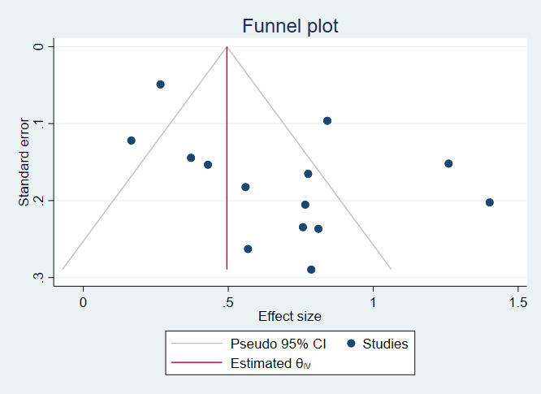

Supplementary Fig S1. Funnel Plot of the association between the TyG Index (Categorical) and MACEs in coronary heart disease patients patients with diabetes

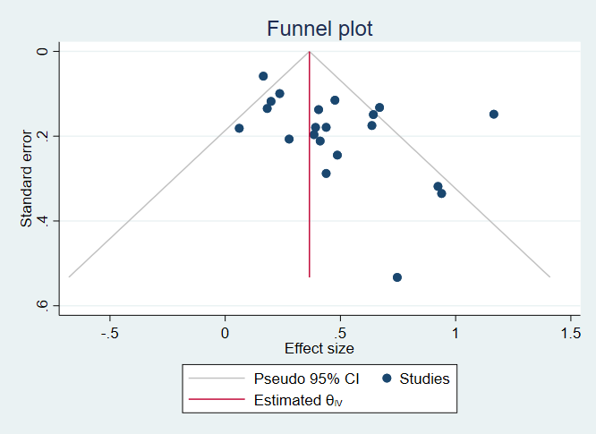

Supplementary Fig S2. Funnel Plot of the association between the TyG Index (Continuous) and MACEs in coronary heart disease patients patients with diabetes

Supplementary Fig S3. Funnel plot of the association between the TyG index (categorical) and MACEs in non-diabetic coronary heart disease patients patients

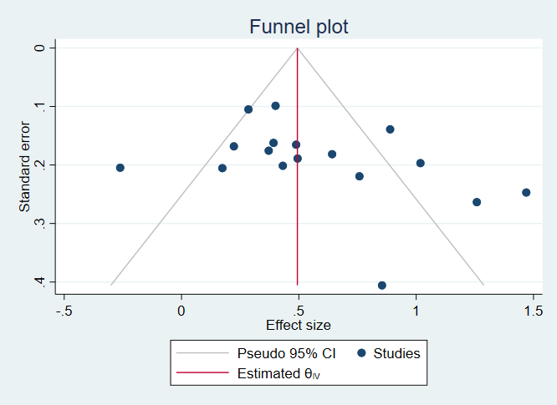

Supplementary Fig S4. Funnel plot of the association between the TyG index (continuous) and MACEs in non-diabetic coronary heart disease patients patients

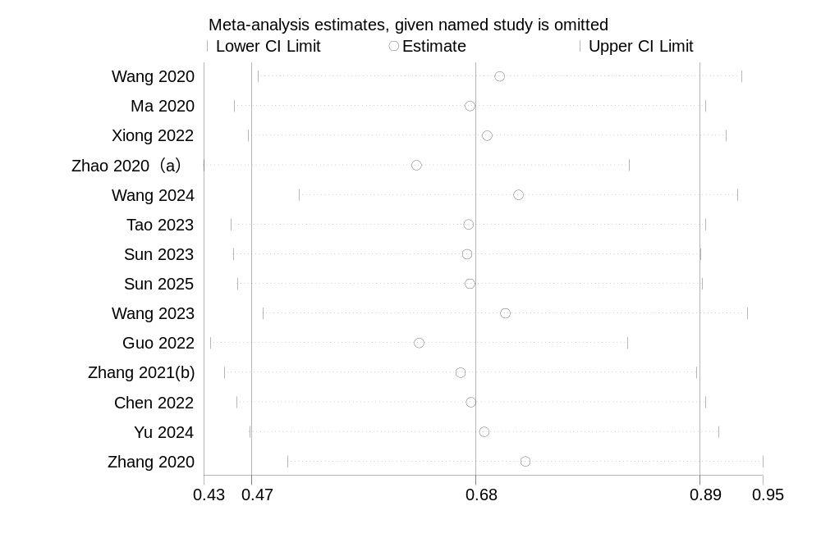
Supplementary Fig S5. Sensitivity analysis plot of the association between the TyG index (categorical) and MACEs in coronary heart disease patients patients with diabetes

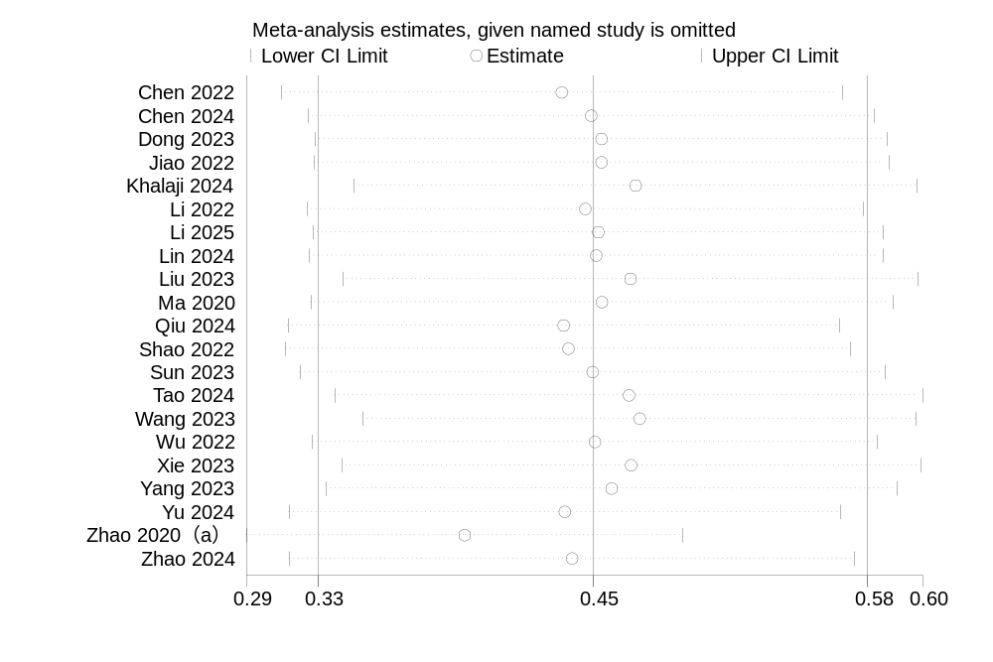
Supplementary Fig S6. Sensitivity analysis plot of the association between the TyG index (continuous) and MACEs in coronary heart disease patients with diabetes

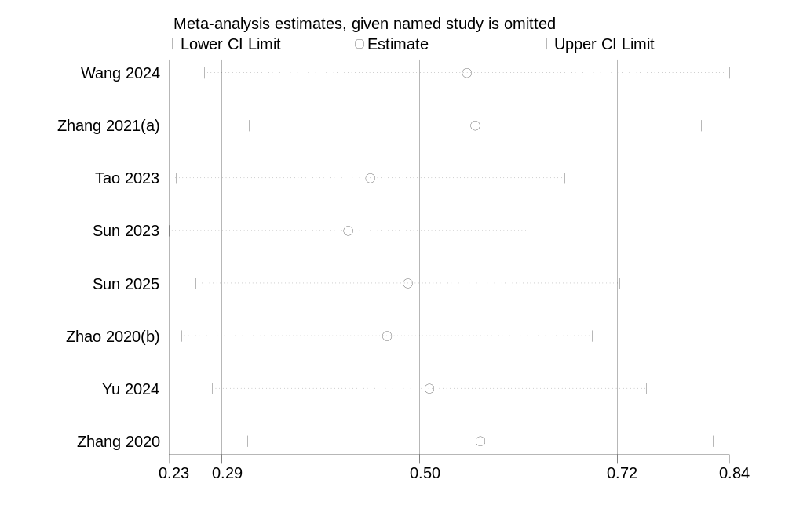

Supplementary Fig S7. Sensitivity analysis plot of the association between the TyG index (categorical) and MACEs in non-diabetic coronary heart disease patients patients

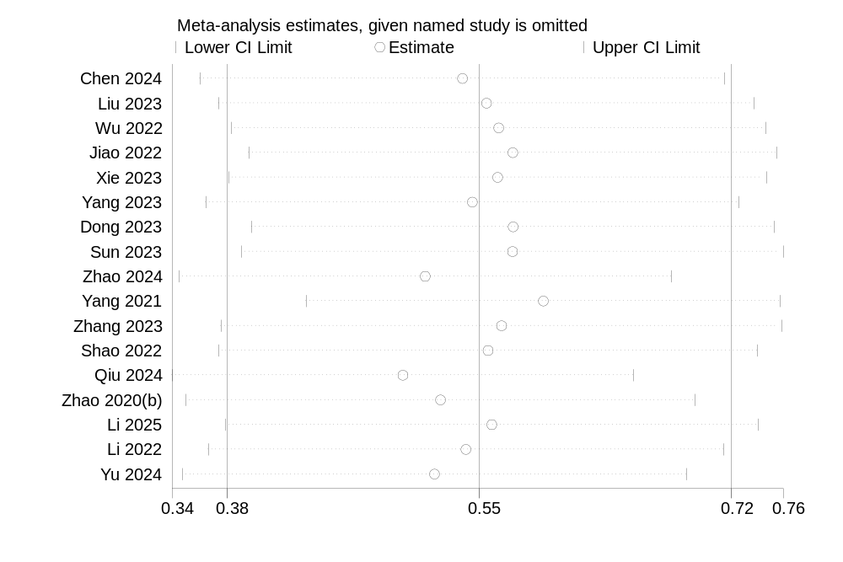

Supplementary Fig S8. Sensitivity analysis plot of the association between the TyG index (continuous) and MACEs in non-diabetic coronary heart disease patients patients

Supplementary Table S4. Subgroup analysis of the association between the TyG index (continuous) and MACEs in coronary heart disease patients patients with diabetes
Subgrouped by |  | HR (95% CI) | I² | Pª | P^{b} | P^{c} | P^{d}
Sample Size | ≥1000 | 1.46 (1.26,1.69) | 67.9 | ＜0.01 | ＜0.01 | 0.26 | 0.45
 | ＜1000 | 1.70(1.38, 2.09) | 68.3 | ＜0.01 | ＜0.01 | 0.26 | 0.45
ACS | YES | 1.68 (1.31,2.15) | 85.60 | ＜0.01 | ＜0.01 | 0.40 | 0.58
 | NO | 1.89 (1.34,2.66) | 14.60 | ＜0.01 | 0.30 | 0.40 | 0.58
PCI | YES | 3.21 (2.40,4.29) | 77.20 | ＜0.01 | 0.045 | 0.25 | 0.67
 | NO | 1.44 (1.28,1.62) | 46.70 | ＜0.01 | 0.03 | 0.25 | 0.67
Follow-up Duration（months） | ≥30 | 1.66 (1.38, 2.00) | 76.2 | ＜0.01 | ＜0.01 | 0.28 | 0.65
 | ＜30 | 1.43 (1.20, 1.69) | 60.3 | ＜0.01 | 0.01 | 0.28 | 0.65
Study quality | High quality | 1.30 (1.19,1.41) | 13.30 | ＜0.01 | 0.31 | ＜0.01 | 0.02
 | Medium quality | 1.92 (1.59,2.31) | 59.40 | ＜0.01 | 0.01 | ＜0.01 | 0.02
Mean age | ≥65 | 1.46 (1.21,1.75) | 61.60 | ＜0.01 | 0.02 | 0.62 | 0.95
 | ＜65 | 1.60 (1.31,1.87) | 68.30 | ＜0.01 | ＜0.01 | 0.62 | 0.95
Pª: p value for the pooled effect estimate; P^{b}: p value for heterogeneity; P^{c}: P value from univariable meta-regression; P^{d}: P value from multivariable meta-regression; ACS: acute coronary syndrome; PCI: percutaneous coronary intervention.

Supplementary Table S5. Subgroup analysis of the association between the TyG index (categorical) and MACEs in non-diabetic coronary heart disease patients patients
Subgrouped by |  | HR (95% CI) | I² | Pª | P^{b} | P^{c} | P^{d}
Sample Size | ≥1000 | 1.65 (1.33,2.05) | 86.5 | ＜0.01 | ＜0.01 | NA | NA
 | ＜1000 | NA | NA | NA | NA | NA | NA
ACS | YES | 1.54 (1.19,1.98) | 88.50 | ＜0.01 | ＜0.01 | 0.48 | 0.866
 | NO | 1.93 (1.51,2.48) | 36.10 | ＜0.01 | 0.21 | 0.48 | 0.866
PCI | YES | 1.45 (1.17,1.80) | 51 | ＜0.01 | 0.045 | 0.62 | 0.72
 | NO | 1.77 (1.21,1.57) | 90.40 | ＜0.01 | ＜0.01 | 0.62 | 0.72
Follow-up Duration（months） | ≥30 | 1.40 (1.16, 1.70) | 78.70 | ＜0.01 | ＜0.01 | 0.09 | 0.44
 | ＜30 | 2.21 (1.57, 3.12) | 67.50 | ＜0.01 | 0.046 | 0.09 | 0.44
Study quality | High quality | 1.34 (1.15,1.56) | 52.40 | ＜0.01 | 0.10 | 0.18 | 0.39
 | Medium quality | 1.99 (1.31,3.01) | 88.50 | ＜0.01 | ＜0.01 | 0.18 | 0.39
Mean age | ≥65 | 1.14 (0.90,1.44) | NA | NA | NA | NA | NA
 | ＜65 | 1.76 (1.37,2.25) | 87.90 | ＜0.01 | ＜0.01 | NA | NA

Supplementary Table S6. Subgroup analysis of the association between the TyG index (continuous) and MACEs in non-diabetic coronary heart disease patients patients
Subgrouped by |  | HR (95% CI) | I² | Pª | P^{b} | P^{c} | P^{d}
Sample Size | ≥1000 | 1.56 (1.23,1.97) | 80.00 | ＜0.01 | ＜0.01 | 0.26 | 0.82
 | ＜1000 | 1.95 (1.51,2.93) | 72.00 | ＜0.01 | ＜0.01 | 0.26 | 0.82
ACS | YES | 1.97 (1.33,2.93) | 83.90 | ＜0.01 | ＜0.01 | 0.39 | 0.31
 | NO | 1.61 (1.36,1.90) | 65.40 | ＜0.01 | ＜0.01 | 0.39 | 0.31
PCI | YES | 1.86 (1.43,2.42) | 72.50 | ＜0.01 | ＜0.01 | 0.58 | 0.39
 | NO | 1.67 (1.32,2.11) | 79.10 | ＜0.01 | ＜0.01 | 0.58 | 0.39
Follow-up Duration（months） | ≥30 | 1.85 (1.51, 2.27) | 74.40 | ＜0.01 | ＜0.01 | 0.38 | 0.91
 | ＜30 | 1.53 (1.12, 2.11) | 78.1 | ＜0.01 | ＜0.01 | 0.38 | 0.91
Study quality | High quality | 1.34 (1.15,1.56) | 68.70 | ＜0.01 | ＜0.01 | 0.08 | 0.06
 | Medium quality | 1.99 (1.31,3.01) | 79.1 | ＜0.01 | ＜0.01 | 0.08 | 0.06
Mean age | ≥65 | 1.48 (1.38,4.45) | 86.4 | ＜0.01 | ＜0.01 | 0.08 | 0.20
 | ＜65 | 1.59 (1.35,1.86) | 68.0 | ＜0.01 | ＜0.01 | 0.08 | 0.20

