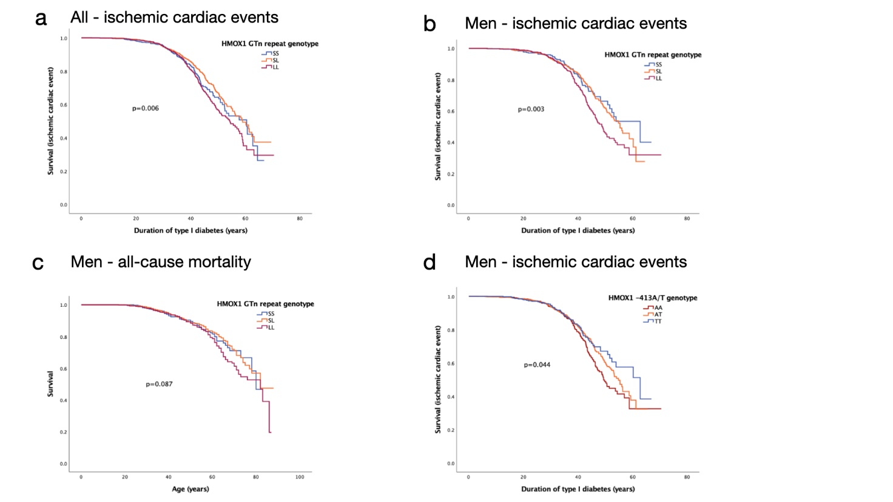
Additional file 1. Kaplan–Meier curves for ischemic cardiac events and mortality according to HMOX1 GTn repeat (SS, SL and LL separated) and -413A/T genotype. Curves for a) ischemic cardiac events in all individuals, b) ischemic cardiac events in men, c) all-cause mortality in men, d) Kaplan–Meier analysis for ischemic cardiac events stratified by HMOX1 -413A/T SNP genotype in men, AA, AT and TT separated.

Additional file 2. Clinical and biochemical characteristics of study participants included in serum HO-1 level analysis, men vs women.
 | Men | Women | p value
HS-CRP (mg/l)  (values > 10 excluded) | 1.82±1.75  n=366 | 2.44±2.13  n=400 | <0.001
HbA1C (mmol/mol) | 63.47±14.66  n=406 | 67.68±14.98  n=444 | <0.001
Total cholesterol (mmol/l) | 4.68±0.95  n=408 | 4.77±0.85  n=449 | 0.130
LDL-cholesterol (mmol/l) | 2.89±0.86  n=340 | 2.77±0.77  n=402 | 0.059
HDL-cholesterol (mmol/l) | 1.30±0.34  n=408 | 1.57±0.40  n=449 | <0.001
HDL2-C (mmol/l) | 0.49±0.26  n=391 | 0.69±0.29  n=439 | <0.001
HDL3-C (mmol/l) | 0.82±0.21  n=391 | 0.89±0.22  n=439 | <0.001
Triglycerides (mmol/l) | 1.00 (0.79-1.40)  n=408 | 0.86 (0.67-1.19)  n=449 | <0.001
APOA1 (mg/dl) | 129.39±19.94  n=395 | 146.90±25.22  n=442 | <0.001
APOB (mg/dl) | 83.44±23.93  n=395 | 78.98±20.85  n=442 | 0.004
Insulin dose (IU/kg) | 0.68±0.29  n=404 | 0.63±0.24  n=449 | 0.008
eGFR | 97.41±31.33  n=410 | 93.97±27.37  n=449 | 0.086
BMI (kg/m2) | 25.45±3.60  n=404 | 24.98±3.99  n=449 | 0.073
WHR | 0.071±0.0036  n=393 | 0.062±0.0029  n=441 | <0.001
SBP (mmHg) | 141.47±19.42  n=400 | 133.44±18.57  n=448 | <0.001
DBP (mmHg) | 77.96±9.34  n=400 | 76.49±9.09  n=448 | 0.021
PP (mmhg) | 63.51±17.09  n=400 | 56.95±17.07  n=448 | <0.001
BAI (%) | 23.38±3.31  n=393 | 28.78±4.72  n=441 | <0.001
Ischemic cardiac event (%) | 6.9  n=406 | 6.0  n=449 | 0.599
Stroke (%) | 4.2  n=406 | 1.1  n=450 | 0.005
Peripheral artery disease (%) | 6.4  n=406 | 4.9  n=447 | 0.348
Severe diabetic retinopathy (%) | 33.8  n=405 | 26.5  n=449 | 0.020
Diabetic kidney disease (%) | 23.3  n=407 | 13.7  n=446 | <0.001
Hypertension (%) | 44.6  n=406 | 36.7  n=450 | 0.018
ACE inhibitors (%) | 25.3  n=400 | 18.0  n=450 | 0.010
AT1R blockers (%) | 13.0  n=399 | 11.1  n=450 | 0.390
Beta blockers (%) | 19.0  n=400 | 14.4  n=450 | 0.075
Calcium channel blockers (%) | 16.3  n=398 | 8.2  n=450 | <0.001
Any AHT medication (%) | 43.4  n=401 | 35.8  n=450 | 0.023
NSAIDs (low-dose ASA) (%) | 26.1  n=402 | 21.3  n=450 | 0.100
Lipid-lowering medication (%) | 27.2  n=401 | 18.5  n=449 | 0.002

Data are means± SD, percentages or median (IQR). WHR waist-hip ratio; SBP systolic blood pressure; DBP diastolic blood pressure; PP pulse pressure; BAI body adiposity index. ACE angiotensin-converting enzyme; AT1R angiotensin II type 1 receptor; AHT antihypertensive; NSAID non-steroidal anti-inflammatory drug; ASA acetylsalicylic acid

