SUPPLEMENTARY MATERIALS
Figure legends
Fig. S1 EFV between the four coronary artery disease phenotypes.
Fig. S1A violin shows the difference of EFV between four groups, Kruskal wills test between four groups and corrected pairwise Wilcox test. Fig. S1B shows the increasing trend of EFV from Group1 to Group4. EFV=Epicardial Fat Volume, CAD=coronary artery disease, CI=95% Confidence Interval. Group1 to Group4 were defined as non-obstructive CAD without ischemia, ischemia with non-obstructive CAD, obstructive CAD without ischemia and obstructive CAD with ischemia.
Fig. S2 Association of EFV/EFVi with CAD phenotypes and optimal cutoff values in unordered multinomial logistic regression model
Both EFV and EFVi were correlated with obstructive CAD without ischemia and obstructive CAD with ischemia but only EFVi was correlated with INOCA. Covariates adjusted for age, sex, BMI, logCACS, N^{b}, LVEF. Optimal cutoff value of EFV/EFVi for CAD phenotypes, determined by pROC maximum Youden index refenced by non-obstructive CAD without ischemia in unordered multinomial logistic regression model. ^{b}N was defined as number of traditional cardiovascular risk factors, such as smoking, hypertension, diabetes and hyperlipidemia. Bold p value indicates <0.05.
CAD=coronary artery disease, CACS=Coronary artery calcium score, logCACS=log transformed CACS, LVEF=Left ventricular ejection fraction, EFV=Epicardial fat volume, EFVi=Epicardial fat volume index.
Fig. S3 Receiver operating characteristic curve of clinical model and additive model to differentiate CAD phenotypes in overall populations.
Clinical model included age, sex, BMI, hypertension, diabetes, hyperlipidemia and smoke. Class1=non-obstructive CAD without ischemia, Class2=non-obstructive CAD with ischemia/INOCA, Class3=obstructive CAD without ischemia, Class4=obstructive CAD with ischemia. Both EFV and EFVi were binary forms in the additive models (cutoff value for EFV was 152.25 and EFVi was 96.68). Unordered multinomial logistic regression models were used to build these models.
AUC=Area under ROC curve, macro-AUC=macro-average-AUC, micro-AUC=micro-average-AUC, ROC= Receiver operating characteristic curve, EFVi=Epicardial fat volume index, EFV=Epicardial fat volume, CAD=coronary artery disease.
Table S1–S5

Supplementary method
Unordered multinomial logistic regression models were used to construct the model of differentiating coronary artery disease (CAD) phenotypes which non-obstructive CAD without ischemia were set as the referenced group. Clinical model was constructed by age, sex, BMI, hypertension, diabetes, hyperlipidemia and smoke. Then EFVi or EFV were added into clinical model. Both EFV and EFVi were dichotomous variable which cutoff value for EFV and EFVi were determined by univariate ordered logistic regression model with the minimal p value. Multiclass ROC curves were constructed by OvR rules (One-vs-Rest)^{[1]}. The AUC (Area under ROC curve) was compared between additive models and clinical models by Delong test^{[2]}. Multi-corrections were not done for exploratory analysis when compared between additive model and clinical model of Delong p value. Net reclassification improvement (NRI) was used to find the incremental value of EFV/EFVi for CAD phenotypes over traditional cardiovascular risk factors^{[3]}. And bootstrap resampling method by 1000 times was used to calculate the 95% confidence interval of NRI.

Supplementary references:
1. Multiclass receiver operating characteristic (ROC). https://scikit-learn.org/stable/auto_examples/model_selection/plot_roc.html#multiclass-receiver-operating-characteristic-roc. Accessed July 2025.
2. DeLong ER, DeLong DM, Clarke-Pearson DL. Comparing the areas under two or more correlated receiver operating characteristic curves: A nonparametric approach. Biometrics. 1988;44(3):837-45.
3. Pencina MJ, D'Agostino RB, D'Agostino RB, Vasan RS. Evaluating the added predictive ability of a new marker: From area under the ROC curve to reclassification and beyond. Statistics in Medicine. 2008;27(2):157-72; discussion 207-12.

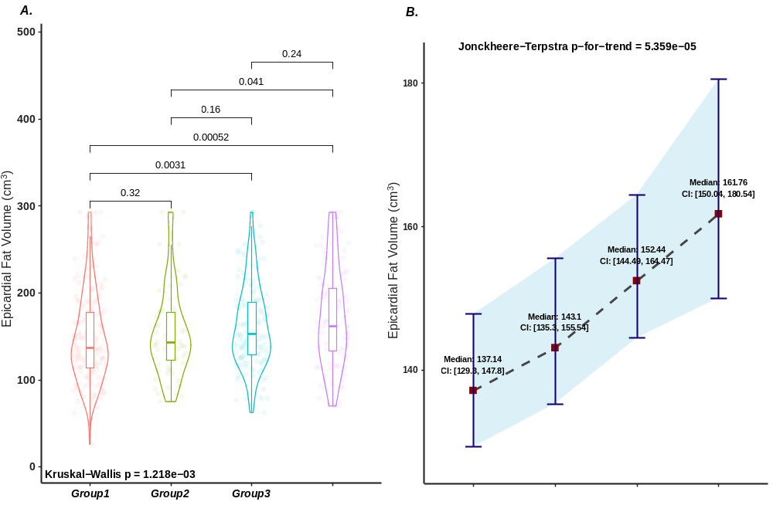
Fig. S1 (EMF) EFV between the four coronary artery disease phenotypes.
Fig. S1A violin showed the difference of EFV between four groups, Kruskal wills test between four groups and corrected pairwise Wilcox test. Fig. S1B showed the increasing trend of EFV from Group1 to Group4. EFV=Epicardial Fat Volume, CAD=coronary artery disease, CI=95% Confidence Interval. Group1 to Group4 were defined as non-obstructive CAD without ischemia, ischemia with non-obstructive CAD, obstructive CAD without ischemia and obstructive CAD with ischemia.

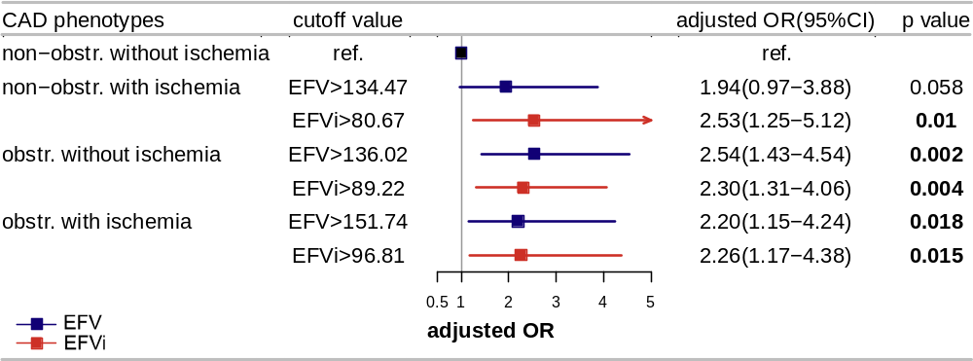
Fig. S2 (EMF) Association of EFV/EFVi with CAD phenotypes and optimal cutoff values in unordered multinomial logistic regression model.
Both EFV and EFVi were correlated with obstructive CAD without ischemia and obstructive CAD with ischemia but only EFVi was correlated with INOCA.
Covariates adjusted for age, sex, BMI, logCACS, N^{b}, LVEF.
Optimal cutoff value of EFV/EFVi for CAD phenotypes, determined by pROC maximum Youden index refenced by non-obstructive CAD without ischemia in unordered multinomial logistic regression model.
^{b}N was defined as number of traditional cardiovascular risk factors, such as smoking, hypertension, diabetes and hyperlipidemia. Bold p value indicates <0.05.
CAD=coronary artery disease, CACS=Coronary artery calcium score, logCACS=log transformed CACS, LVEF=Left ventricular ejection fraction, EFV=Epicardial fat volume, EFVi=Epicardial fat volume index, SD=standard deviations.

Fig. S3 (PNG, 1358kb *300ppi) Receiver operating characteristic curve of clinical model and additive model to differentiate CAD phenotypes in overall populations.
Clinical model included age, sex, BMI, hypertension, diabetes, hyperlipidemia and smoke. Class1=non-obstructive CAD without ischemia, Class2=non-obstructive CAD with ischemia/INOCA, Class3=obstructive CAD without ischemia, Class4=obstructive CAD with ischemia. Both EFV and EFVi were binary forms in the additive models (cutoff value for EFV was 152.25 and EFVi was 96.68). Unordered multinomial logistic regression models were used to build these models.
AUC=Area under ROC curve, ROC= Receiver operating characteristic curve, EFVi=Epicardial fat volume index, EFV=Epicardial fat volume, CAD=coronary artery disease.
Table S1 Hematology and Cardiac function in the study population
Characteristic | Group1 | Group2 | Group3 | Group4 | p  value* | p for  trend
Characteristic | nonobstr.CAD  without ischemia | nonobstr.CAD  with ischemia | obstr.CAD  without ischemia | obstr.CAD  with ischemia | p  value* | p for  trend
Hematology
HB, g/L | 134.96±13.60 | 136.54±16.37 | 137.40±14.24 | 137.80±13.35 | 0.324 | 0.053
WBC, ×10⁹/L | 5.85 (4.80-7.20) | 5.57 (5.01-6.29) | 6.18 (5.40-7.09) | 6.16 (4.88-7.03) | 0.037 | 0.117
NEU, ×10⁹/L | 3.71 (2.86-4.49) | 3.36 (2.72-4.35) | 3.88 (3.25-4.71) | 3.88 (3.04-4.60) | 0.018 | 0.052
LYM, ×10⁹/L | 1.66 (1.34-2.05) | 1.72 (1.25-1.93) | 1.59 (1.34-2.06) | 1.61 (1.23-2.20) | 0.833 | 0.997
FBG, mmol/L | 5.37 (4.90-6.50) | 5.25 (4.78-6.40) | 5.43 (4.89-6.56) | 5.56 (4.90-6.86) | 0.346 | 0.214
creatinine, µmol/L | 67.00  (57.00-77.00) | 65.00  (55.20-75.00) | 69.00  (61.00-79.00) | 71.00  (61.00-80.25) | 0.024 | 0.006
BUN, mmol/L | 5.00 (4.07-6.08) | 5.09 (4.21-6.19) | 5.03 (4.04-5.72) | 4.85 (4.19-5.87) | 0.781 | 0.663
TG, mmol/L | 1.67 (1.20-2.38) | 1.43 (1.14-2.49) | 1.59 (1.04-2.18) | 1.56 (1.18-2.04) | 0.344 | 0.123
TC, mmol/L | 4.17 (3.58-4.73) | 4.20 (3.58-4.54) | 3.84 (3.18-4.47) | 3.92 (3.24-4.61) | 0.023 | 0.009
LDL, mmol/L | 2.20 (1.77-2.63) | 2.10 (1.72-2.73) | 1.96 (1.62-2.67) | 2.08 (1.73-2.79) | 0.461 | 0.38
HDL, mmol/L | 1.08 (0.95-1.25) | 1.13 (0.90-1.35) | 1.03 (0.90-1.13) | 1.07 (0.94-1.24) | 0.006 | 0.073
TnI/hsTnI, | 0.0025 | 0.0036 | 0.003 | 0.0036 | 0.004 | 0.009
ng/mL | (0.0010-0.0044) | (0.0021-0.0069) | (0.0015-0.0052) | (0.0019-0.0061) | 0.004 | 0.009
CRP, mg/L | 4.00 (3.20-5.10) | 3.60 (2.90-5.00) | 3.60 (2.90-5.00) | 4.00 (3.20-4.85) | 0.507 | 0.372
FIB, g/L | 2.47 (2.20-2.83) | 2.52 (2.16-2.82) | 2.55 (2.29-2.88) | 2.77 (2.34-3.10) | 0.008 | <0.001
Echocardiography parameters
LVEDd, mm | 48.00  (46.40-51.00) | 48.00  (46.00-50.80) | 48.00  (46.00-50.20) | 48.00  (46.00-50.00) | 0.981 | 0.727
LVESd, mm | 31.60  (30.00-33.80) | 32.00  (30.00-34.00) | 32.00  (30.00-33.20) | 32.00  (30.00-33.25) | 0.588 | 0.688
LVEF, % | 63.00  (62.00-65.00) | 62.40  (61.00-64.00) | 63.00  (61.00-64.00) | 63.00  (61.00-65.00) | 0.408 | 0.314
*p value is difference between four groups by Kruskal wills test or one-way ANOVA test. p for trend is trend from Group1 to Group4 by Jonckheere-Terpstra test. Bold p value indicates <0.05.
Abbreviations: nonobstr.=Non-obstructive, obstr.=Obstructive, HB=hemoglobin, WBC=White blood cell count, NEU=Neutrophil, LYM=Lymphocyte, FBG=Fasting blood glucose, BUN=Blood urea nitrogen, TG=Triglycerides, TC=Total cholesterol, HDL=High density lipoprotein, LDL=Low density lipoprotein, TnI/hsTnI=Troponin I/high sensitivity Troponin I, CRP=C-reactive protein, FIB=Fibrinogen, LVEDd=Left ventricular end diastolic dimension, LVESd= Left ventricular end systolic dimension, LVEF=Left ventricular ejection fraction.

Table S2 Association of EFV with CAD phenotypes
 | univariable |  | multivariable model 1 |  | multivariable model 2
 | OR(95%CI)* | p value* | OR(95%CI)* | p value* | OR(95%CI)* | p value*
age, per 1 year | 1.02(1.01-1.04) | 0.007 | 0.99(0.97-1.01) | 0.402 | 0.99(0.97-1.01) | 0.427
sex, male | 2.00(1.44-2.77) | <0.001 | 1.40(0.95-2.08) | 0.091 | 1.39(0.94-2.07) | 0.101
sex, male: Group 1 vs. 2,3,4 | NA | NA | 1.53(0.97-2.42) | 0.07 | 1.51(0.95-2.39) | 0.079
sex, male: Group 1,2 vs. 3,4 | NA | NA | 1.77(1.13-2.78) | 0.013 | 1.73(1.10-2.72) | 0.017
sex, male: Group 1,2,3 vs. 4 | NA | NA | 0.94(0.55-1.60) | 0.82 | 0.93(0.55-1.58) | 0.789
BMI, per 1 kg/m² | 1.03(0.98-1.08) | 0.224 | 1.01(0.95-1.07) | 0.725 | 1.02(0.97-1.08) | 0.437
hypertension | 1.52(1.10-2.11) | 0.011 | 0.97(0.68-1.40) | 0.872 | 0.98(0.68-1.41) | 0.919
hypertension: Group 1 vs. 2,3,4 | 1.27(0.87-1.87) | 0.214 | 0.81(0.54-1.23) | 0.319 | 0.83(0.55-1.25) | 0.363
hypertension: Group 1,2 vs. 3,4 | 1.32(0.92-1.90) | 0.132 | 0.78(0.52-1.18) | 0.243 | 0.80(0.53-1.20) | 0.271
hypertension: Group 1,2,3 vs. 4 | 2.43(1.50-3.93) | <0.001 | 1.58(0.96-2.61) | 0.073 | 1.58(0.96-2.60) | 0.071
diabetes | 1.98(1.37-2.87) | <0.001 | 1.42(0.95-2.11) | 0.087 | 1.41(0.95-2.10) | 0.088
hyperlipidemia | 0.94(0.68-1.30) | 0.719 | 0.99(0.70-1.40) | 0.938 | 1.00(0.70-1.41) | 0.978
smoke | 1.60(1.11-2.29) | 0.011 | 1.28(0.84-1.97) | 0.250 | 1.32(0.86-2.02) | 0.206
smoke: Group 1 vs. 2,3,4 | NA | NA | 0.98(0.59-1.64) | 0.948 | 1.00(0.60-1.67) | 0.995
smoke: Group 1,2 vs. 3,4 | NA | NA | 0.91(0.56-1.49) | 0.711 | 0.93(0.57-1.51) | 0.758
smoke: Group 1,2,3 vs. 4 | NA | NA | 2.04(1.19-3.50) | 0.009 | 2.06(1.20-3.53) | 0.009
logCACS, per 1 logAU | 1.47(1.37-1.58) | <0.001 | 1.46(1.36-1.57) | <0.001 | 1.47(1.36-1.58) | <0.001
logCACS: Group 1 vs. 2,3,4 | 1.44(1.31-1.57) | <0.001 | 1.38(1.26-1.50) | <0.001 | 1.37(1.26-1.49) | <0.001
logCACS: Group 1,2 vs. 3,4 | 1.59(1.46-1.73) | <0.001 | 1.51(1.39-1.64) | <0.001 | 1.50(1.38-1.64) | <0.001
logCACS: Group 1,2,3 vs. 4 | 1.41(1.29-1.53) | <0.001 | 1.38(1.27-1.51) | <0.001 | 1.38(1.27-1.51) | <0.001
LVEF, per 1% | 0.95(0.90-1.00) | 0.072 | 1.00(0.94-1.06) | 0.982 | 1.00(0.94-1.06) | 0.957
EFV (per SD unit change) | 1.40(1.19-1.66) | <0.001 | 1.25(1.01-1.54) | 0.044 | NA | NA
EFV (EFV>152.25‡) | 1.86(1.35-2.57) | <0.001 | NA | NA | 1.49(1.02-2.10) | 0.041
*Ordered multinomial logistic regression was used to calculate OR and Wald p value.
Covariates violated Parallel Brant test was marked, and indicated that OR and p value were calculated by proportional odds models. Then partial proportional odds models were substituted in the next three decomposed covariates.
‡Cutoff value was determined by univariate ordered multinomial logistic regression between EFV and CAD phenotypes with the minimum p value.
Multivariable model 1 and model 2 were adjusted for age, sex, BMI, hypertension, diabetes, hyperlipidemia, smoke, logCACS and LVEF. Bold p value indicates <0.05.
EFV=Epicardial fat volume, CAD=Coronary artery disease, CACS= Coronary artery calcium score, logCACS=log transformed CACS, LVEF=Left ventricular ejection fraction, NA=Not applicable, vs=versus, SD=standard deviation.
Group1 to Group4 was defined in Table1. Group1,2,3 was defined as Group1 and Group2 and Group3, other terms were similar to the example.

Table S3 Unordered multinomial logistic regression model of EFV and EFVi for CAD Phenotypes
 | crude |  | adjusted*
 | OR (95%CI) | p value | OR (95%CI) | p value
EFV (Per SD unit change)
non-obstructive CAD without ischemia | ref. | ref. | ref. | ref.
ischemia with non-obstructive CAD | 1.16(0.86-1.56) | 0.335 | 1.08(0.74-1.57) | 0.696
obstructive CAD without ischemia | 1.35(1.07-1.70) | 0.012 | 1.39(1.01-1.92) | 0.046
obstructive CAD with ischemia | 1.60(1.25-2.05) | <0.001 | 1.43(1.01-2.04) | 0.046
EFVi (Per SD unit change)
non-obstructive CAD without ischemia | ref. | ref. | ref. | ref.
ischemia with non-obstructive CAD | 1.14(0.85-1.53) | 0.378 | 1.13(0.79-1.61) | 0.494
obstructive CAD without ischemia | 1.31(1.04-1.65) | 0.023 | 1.40(1.03-1.90) | 0.031
obstructive CAD with ischemia | 1.52(1.19-1.94) | <0.001 | 1.48(1.01-2.07) | 0.023
*Adjusted for age, sex, BMI, logCACS, N^{b}, LVEF.
Use unordered multinomial logistic regression analysis to calculate OR and Wald p value, referenced group was non-obstructive CAD without ischemia.
^{b}N was defined as number of traditional cardiovascular risk factors, such as smoking, hypertension, diabetes and hyperlipidemia. Bold p value indicates <0.05.
CAD=coronary artery disease, CACS=Coronary artery calcium score, logCACS=log transformed CACS, LVEF=Left ventricular ejection fraction, EFV=Epicardial fat volume, EFVi=Epicardial fat volume index, SD=standard deviations.

Table S4 Optimal cutoff value of EFV and EFVi for CAD Phenotypes
 | crude |  |  | adjusted*
 | cutoff value | OR (95%CI) | p value | OR (95%CI) | p value
EFV
non-obstructive CAD without ischemia | ref. | ref. | ref. | ref. | ref.
ischemia with non-obstructive CAD | EFV>134.47 | 1.75(0.97-3.15) | 0.062 | 1.94(0.97-3.88) | 0.058
obstructive CAD without ischemia | EFV>136.02 | 2.28(1.44-3.63) | <0.001 | 2.54(1.43-4.54) | 0.002
obstructive CAD with ischemia | EFV>151.74 | 2.47(1.51-4.05) | <0.001 | 2.20(1.15-4.24) | 0.018
EFVi
non-obstructive CAD without ischemia | ref. | ref. | ref. | ref. | ref.
ischemia with non-obstructive CAD | EFVi>80.67 | 1.90(1.06-3.40) | 0.031 | 2.53(1.25-5.12) | 0.010
obstructive CAD without ischemia | EFVi>89.22 | 2.03(1.29-3.19) | 0.002 | 2.30(1.31-4.06) | 0.004
obstructive CAD with ischemia | EFVi>96.81 | 2.41(1.46-3.98) | <0.001 | 2.26(1.17-4.38) | 0.015
*Adjusted for age, sex, BMI, logCACS, N^{b}, LVEF.
Optimal cutoff value of EFV/EFVi for CAD phenotypes, determined by pROC maximum Youden index refenced by non-obstructive CAD without ischemia in unordered multinomial logistic regression model.
^{b}N was defined as number of traditional cardiovascular risk factors, such as smoking, hypertension, diabetes and hyperlipidemia. Bold p value indicates <0.05.
CAD=coronary artery disease, CACS=Coronary artery calcium score, logCACS=log transformed CACS, LVEF=Left ventricular ejection fraction, EFV=Epicardial fat volume, EFVi=Epicardial fat volume index.

Table S5 Incremental value of EFV/EFVi for differentiating CAD phenotypes over traditional cardiovascular risk factors by Delong test of AUC
 | AUC(95%CI)
 | clinical model | clinical model+EFVi | clinical model+EFV
In overall populations
non-obstr. without ischemia | 0.646(0.595-0.697) | 0.651(0.600-0.701) | 0.651(0.601-0.702)
non-obstr. with ischemia | 0.598(0.526-0.671) | 0.600(0.529-0.671) | 0.599(0.527-0.672)
obstr. without ischemia | 0.654(0.602-0.707) | 0.655(0.603-0.708) | 0.658(0.605-0.710)
obstr. with ischemia | 0.661(0.605-0.716) | 0.663(0.607-0.720) | 0.662(0.606-0.718)
macro-AUC | 0.640(0.603-0.673) | 0.642(0.599-0.675) | 0.643(0.608-0.676)
micro-AUC | 0.684(0.657-0.711) | 0.686(0.659-0.713) | 0.686(0.659-0.713)
In diabetes subgroup
non-obstr. without ischemia | 0.665(0.548-0.781) | 0.708(0.601-0.815) | 0.696(0.585-0.807)
non-obstr. with ischemia | 0.733(0.578-0.887) | 0.750(0.606-0.894) | 0.725(0.573-0.877)
obstr. without ischemia | 0.680(0.582-0.779) | 0.687(0.591-0.784) | 0.685(0.587-0.783)
obstr. with ischemia | 0.737(0.647-0.828) | 0.790(0.705-0.875) | 0.775(0.689-0.861)
macro-AUC | 0.704(0.632-0.769) | 0.734(0.667-0.790) | 0.720(0.639-0.782)
micro-AUC | 0.748(0.700-0.797) | 0.772(0.726-0.818)‡ | 0.763(0.716-0.811)
Clinical model included age, sex, BMI, hypertension, diabetes, hyperlipidemia and smoke (Clinical model included age, sex, BMI, hypertension, hyperlipidemia and smoke in diabetes subgroup). Both EFV and EFVi were binary forms (cutoff value for EFV was 152.25 and EFVi was 96.68). For specific phenotypes comparison and integrated comparison which micro-AUC were compared: ‡p<0.1, *p<0.05, **p<0.01, ***p<0.001 for significant marker, comparison between additive model and clinical model by Delong test. Macro-AUC did not participate in the comparison.
AUC=Area under ROC curve, macro-AUC=macro-average-AUC, micro-AUC=micro-average-AUC, ROC= Receiver operating characteristic curve, CAD=coronary artery disease, EFVi=Epicardial fat volume index, EFV=Epicardial fat volume.

