Supplementary Tables

Supplemental Table 1. Correlation of adiponectin and leptin with metabolic and clinical parameters
 | Adiponectin |  | Leptin
Variable | r | p-value | r | p-value
HbA1c | -0.3352 | 0.0021 | -0.1214 | 0.2772
FPG | -0.0084 | 0.9403 | 0.1075 | 0.3364
C-peptide | 0.0237 | 0.8324 | 0.4142 | 0.0001
Body weight | -0.2202 | 0.0469 | 0.1057 | 0.3446
Weight loss (%) | -0.2724 | 0.0133 | 0.1454 | 0.1926
BMI | -0.1589 | 0.1539 | 0.1461 | 0.1903
Total Cholesterol | 0.1925 | 0.0832 | 0.1859 | 0.0945
LDL Cholesterol | 0.0957 | 0.3924 | 0.0291 | 0.7949
HDL Cholesterol | 0.2698 | 0.0142 | 0.2310 | 0.0368
Blood Urea Nitrogen | 0.2019 | 0.0689 | 0.2465 | 0.0256
Creatine | -0.1150 | 0.3038 | -0.0010 | 0.9931
eGFR | 0.0999 | 0.3719 | -0.0327 | 0.7704
Triglyceride | -0.2716 | 0.0136 | 0.1018 | 0.3627
Systolic blood pressure | -0.0642 | 0.5668 | 0.0855 | 0.4448
Diastolic blood pressure | -0.1474 | 0.1864 | 0.0648 | 0.5633
HOMA-IR | 0.1392 | 0.2122 | 0.3248 | 0.0029
HOMA-beta | 0.0905 | 0.4189 | 0.3029 | 0.0057
Insulin | 0.0932 | 0.4047 | 0.3564 | 0.0010
Ketone | -0.02504 | 0.8233 | -0.38637 | 0.0003
UACR | -0.0015 | 0.9896 | 0.1133 | 0.3108
UGCR | -0.1846 | 0.0969 | -0.2750 | 0.0124
Spearman correlation analysis was used to assess the associations (r) between adiponectin, leptin, and metabolic parameters, with p-values indicating statistical significance.
BMI, body mass index; DBP, diastolic blood pressure; eGFR, estimated glomerular filtration rate; FPG, fasting plasma glucose; HbA1c, glycated hemoglobin; HDL-C, high-density lipoprotein cholesterol; LDL-C, low-density lipoprotein cholesterol; SBP, systolic blood pressure; UACR, urine albumin-to-creatinine ratio; UGCR; urine glucose-to-creatinine ratio.

Supplemental Figure S1. Patient disposition.

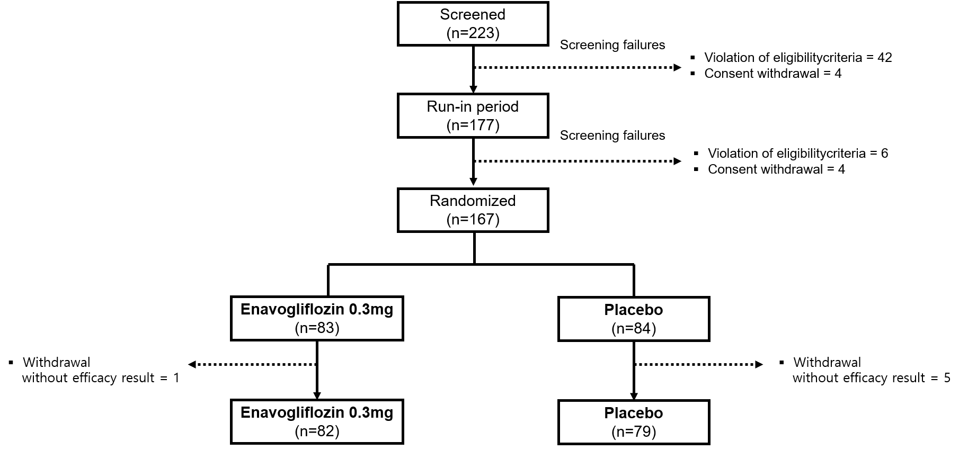
The full analysis set (FAS) comprises all patients who were exposed to at least one dose of the randomised study drug and had at least one HbA1c result after randomisation; patients without a post-randomization HbA1c results were excluded from the FAS

Supplemental Figure S2. Scatter plots of log-transformed changes in each parameter from baseline to week 24 and log-transformed changes in leptin levels.
