Supplementary Online Content

Mingjie Chen, et al. Association between Triglyceride Glucose Index-A Body Shape Index and all-cause and cardiovascular disease mortality among individuals with cardiovascular-kidney-metabolic syndrome stage 0–3

Table S1 Definitions of CKM Syndrome Stages

Table S2 The definition of the HEI-2015 score

Table S3 The definition of SDoH

Table S4 The definition of the other covariates

Table S5 Sensitivity analysis: Associations between TyG-ABSI and mortality in CKM syndrome stage 0-3 after excluding participants who died within two years (n=17, 967).

Table S6 Sensitivity analysis: Associations between TyG-ABSI and mortality in CKM syndrome stages 0–3 after excluding participants who died within five years (n=17, 544).

Table S7 Sensitivity analysis: Associations between TyG-ABSI and mortality in CKM syndrome stages 0–3 after excluding participants with advanced CKD (n=17,516).

Table S8 Sensitivity analysis: Associations between TyG-ABSI and mortality in CKM syndrome stages 0–3 after excluding participants with cancer (n=16,754).

Table S9 Sensitivity analysis: Associations between TyG-ABSI and mortality in CKM syndrome stage 0-3 after excluding patients receiving lipid-lowering drugs or hypoglycemic therapy (n=14944).

Table S10 Sensitivity analysis: Associations between TyG-ABSI and mortality in CKM syndrome stages 0–3, additionally adjusted for use of GLP-1 receptor agonists (n=13,452).

Table S11 Sensitivity analysis: Associations between TyG-ABSI and mortality in CKM syndrome stages 0–3, additionally adjusted for family history of hypertension or stroke before age 50 (n=4,484).

Table S12 Sensitivity analysis: Associations between TyG-ABSI and mortality in CKM syndrome stages 0–3, additionally adjusted for family history of myocardial infarction or angina before age 50 (n=13,152).

Table S13 Sensitivity analysis: Associations between TyG-ABSI and mortality in CKM syndrome stages 0–3, additionally adjusted for depressive symptoms and sleep duration (n=12,548).

Table S14 Sensitivity analysis: Associations between TyG-ABSI and mortality in CKM syndrome stages 0–3, additionally adjusted for SDoH (n=14,969).

Table S15 Sensitivity analysis: Associations between TyG-ABSI and mortality in CKM syndrome stage 0-3 after excluding covariate-missing data (n=14139)

Table S16 Finn-Grey Model for TyG-ABSI and Mortality in CKM syndrome.

Table S17 The baseline characteristics stratified by TyG-ABSI index from the CHARLS 2011 dataset.

Table S18 Associations between the TyG-ABSI index and mortality in CKM syndrome stages 0–3: Data from CHARLS 2011

Table S19 The confidence intervals and Area Under the Curve (AUC) values for all-cause mortality

Table S20 The confidence Intervals and Area Under the Curve (AUC) Values for CVD mortality

Table S21 C-Index values of TyG-associated indicators for all-cause mortality

Table S22 C-Index values of TyG-associated indicators for CVD mortality

Table S23 Mediation analysis of ePWV and SIRI.

Table S24 Incremental Value of TyG-ABSI in Mortality Prediction

Table S25 Multivariable cox regression of the associations between TyG-ABSI and mortality in CKM syndrome stage 0-3

Fig. S1 Flow chart for eligible participants from CHARLS 2011

Fig. S2 Kaplan‒Meier analysis for mortality according to TyG-ABSI

Fig. S3 Restricted cubic spline curve for the association between TyG-ABSI and all-cause mortality: Data from CHARLS 2011

Fig. S4 Time-dependent Receiver Operating Characteristic analysis of TyG-ABSI in predicting all-cause mortality: data from CHARLS 2011

Fig. S5 DCA of TyG Index for Mortality Prediction in CKM Patients

Table S1 Definitions of CKM Syndrome Stages
Stages | Definition
Stage 0: No CKM risk factors | Individuals who meet all of the following criteria: 1. Not overweight or obese (BMI < 25 kg/m2, or < 23 kg/m2 for individuals of Asian descent; waist circumference < 88/102 cm for women/men, or < 80/90 cm for Asian women/men). 2. Absence of metabolic risk factors such as hypertension, hypertriglyceridemia (<135 mg/dL), metabolic syndrome, prediabetes, diabetes, or chronic kidney disease (CKD).
Stage 1: Excess adiposity or dysfunctional metabolism | Individuals with a BMI ≥ 25 kg/m2 (or ≥ 23 kg/m2 for those of Asian descent), or a waist circumference ≥ 88/102 cm for women/men (or ≥ 80/90 cm for Asian women/men), and/or prediabetes, but without additional metabolic risk factors or CKD.
Stage 2: Presence of metabolic risk factors and CKD | Individuals who exhibit at least one metabolic risk factor such as hypertriglyceridemia (≥135 mg/dL), hypertension, metabolic syndrome, diabetes, or have been diagnosed with CKD.
Stage 3: Subclinical Cardiovascular Disease (CVD) in CKM | Individuals with CKD who are at very high risk, or those with a predicted 10-year CVD risk of 20% or higher, based on the PREVENT model (Predict Risk of Cardiovascular Disease EVENTs).
Stage 4: Clinical CVD in CKM | Individuals who have been diagnosed with clinical CVD, including coronary heart disease, myocardial infarction, stroke, or peripheral artery disease.
CKM, cardiovascular-kidney-metabolic; CKD, chronic kidney disease; CVD, cardiovascular disease.

Table S2 Healthy Eating Index-2015 (HEI-2015) Components, Maximum Scores, and Scoring Standards
Component | Max_Score | Standard_Max | Standard_Min
Adequacy
Total Fruits | 5 | ≥ 0.8 cup eq/1000 kcal | 0 cup eq/1000 kcal
Whole Fruits | 5 | ≥ 0.4 cup eq/1000 kcal | 0 cup eq/1000 kcal
Total Vegetables | 5 | ≥ 1.1 cup eq/1000 kcal | 0 cup eq/1000 kcal
Greens and Beans | 5 | ≥ 0.2 cup eq/1000 kcal | 0 cup eq/1000 kcal
Whole Grains | 10 | ≥ 1.5 oz eq/1000 kcal | 0 oz eq/1000 kcal
Dairy | 10 | ≥ 1.3 cup eq/1000 kcal | 0 cup eq/1000 kcal
Total Protein Foods | 5 | ≥ 2.5 oz eq/1000 kcal | 0 oz eq/1000 kcal
Seafood & Plant Proteins | 5 | ≥ 0.8 oz eq/1000 kcal | 0 oz eq/1000 kcal
Fatty Acids | 10 | (PUFA+MUFA)/SFA ≥ 2.5 | (PUFA+MUFA)/SFA ≤ 1.2
Moderation
Refined Grains | 10 | ≤ 1.8 oz eq/1000 kcal | ≥ 4.3 oz eq/1000 kcal
Sodium | 10 | ≤ 1.1 g/1000 kcal | ≥ 2.0 g/1000 kcal
Added Sugars | 10 | ≤ 6.5% energy | ≥ 26% energy
Saturated Fats | 10 | ≤ 8% energy | ≥ 16% energy
Abbreviations: HEI-2015, Healthy Eating Index-2015; PUFA, polyunsaturated fatty acids; MUFA, monounsaturated fatty acids; SFA, saturated fatty acids; cup eq, cup equivalent; oz eq, ounce equivalent; kcal, kilocalories.

Table S3 Detailed explanations of SDoH-related questions and their definitions
SDoH_Variables | Category_Score | Question_and_Definition
Education level | High school graduate or above (0); Less than high school (1) | Participants were asked about the highest grade or level of school completed. Response categories included: less than 9th grade education, 9-11th grade education (includes 12th grade and no diploma), High school graduate/GED, some college or associates (AA) degree, and college graduate or higher.
Employment status | Employed, student, or retired (0); Unemployed (1) | Participants were asked about their work activity in the past week and, if not working, the primary reason for not working.
Family income-to-poverty ratio | ≥ 3 (0); < 3 (1) | Participants were asked about their family income and size, and the poverty/income ratio was calculated as the ratio of family income to the poverty threshold.
Food security | Full security (0); Marginal, low, or very low security (1) | Participants responded to the following questions: 1) whether they were concerned food would run out before they had money to buy more; 2) if the food they bought didn’t last and they couldn’t afford more; 3) if they could not afford balanced meals; 4) if they had to cut meal sizes or skip meals due to lack of money for food; 5) if they had cut or skipped meals, how often this occurred; 6) if they ate less than they felt they should because of limited food funds; 7) if they were hungry but didn’t eat due to affordability issues; 8) if they lost weight due to insufficient money for food; 9) if they went without food for a full day because of financial constraints; 10) if they didn’t eat for a whole day, how often this occurred. Food security levels were classified: full food security (no affirmative responses), marginal food security (1-2 affirmative responses), low food security (3-5 affirmative responses), and very low food security (6-10 affirmative responses).
Type of health insurance | Private (0); Government or none (1) | Participants were asked if they have health insurance or another type of healthcare plan. They were then asked to specify whether they are covered by private insurance or by various types of government insurance, including Medicare, Medi-Gap, Medicaid, SCHIP, military healthcare, Indian Health Service, state-sponsored health plans, or other government insurance.
Regular healthcare access | At least one regular healthcare facility (0); None or emergency room (1) | Participants were asked if they have a usual place they go when sick or need health advice. Those who answered 'yes' or 'there is more than one place' were classified as having routine healthcare.
Home ownership | Own home (0); Rent home or other arrangement (1) | Participants were asked whether the home they live in is owned, being bought, rented, or occupied through another arrangement. A person was considered to own the home even if they are still paying off a mortgage.
Marital status | Married or living with a partner (0); Not married nor living with a partner (1) | Participants were asked about their marital status, with options including married, widowed, divorced, separated, never married, or living with a partner.

Table S4 The definition of the other covariates.

Diabetes Mellitus
1) medical diagnosis of diabetes as recorded by the patient’s healthcare provider or current use of insulin or diabetic pills.
2) glycohemoglobin A1c (HbA1c) level higher than 6.5%.
3) fasting blood glucose level equal to or above 7.0 mmol/L.
4) random blood glucose levels equal to or above 11.1 mmol/L.

Hypertension
1) average systolic blood pressure ≥140 mmHg or average diastolic blood pressure ≥90 mmHg by the mean value of at least three times of measurement.
2) or use of anti-hypertensive medications.
3) or self-reported diagnosis of hypertension.

Cardiovascular diseases (CVDs)
congestive heart failure, coronary heart disease, heart attack, angina, or stroke.

Table S5 Sensitivity analysis: Associations between TyG-ABSI and mortality in CKM syndrome stage 0-3 after excluding participants who died within two years (n=17, 967)
Characteristic | Model1 |  | Model2 |  | Model3
 | HR(95%CI) | P-value | HR(95%CI) | P-value | HR(95%CI) | P-value
All-cause mortality
Continuous TyG-ABSI | 1.908 (1.773, 2.054) | <0.001 | 1.477 (1.368, 1.595) | <0.001 | 1.175 (1.049, 1.317) | 0.005
Quartile TyG-ABSI
Q1 | Ref. |  | Ref. |  | Ref.
Q2 | 2.072 (1.598, 2.686) |  | 1.562 (1.186, 2.056) |  | 1.363 (1.016, 1.829)
Q3 | 3.627 (2.816, 4.671) |  | 2.065 (1.552, 2.747) |  | 1.673 (1.205, 2.324)
Q4 | 6.654 (5.231, 8.465) |  | 2.820 (2.128, 3.738) |  | 1.739 (1.222, 2.474)
P for trend |  | <0.001 |  | <0.001 |  | 0.002
CVD mortality
Continuous TyG-ABSI | 2.039 (1.840, 2.259) | <0.001 | 1.572 (1.376, 1.795) | <0.001 | 1.264 (1.057, 1.511) | 0.010
Quartile TyG-ABSI
Q1 | Ref. |  | Ref. |  | Ref.
Q2 | 3.248 (1.980, 5.327) |  | 2.353 (1.413, 3.917) |  | 2.092 (1.181, 3.705)
Q3 | 6.475 (4.027, 10.411) |  | 3.520 (2.146, 5.773) |  | 2.944 (1.659, 5.226)
Q4 | 12.055 (7.865, 18.478) |  | 4.739 (2.893, 7.762) |  | 2.965 (1.641, 5.359)
P for trend |  | <0.001 |  | <0.001 |  | <0.001
Model 1: crude model.
Model 2 adjusted for age, sex, and ethnicity.
Model 3 adjusted for Model 2 plus educational level, marital status, PIR, smoking status, alcohol consumption, HEI-2015, PA, HDL, LDL, HbA1c, eGFR, uACR, uric acid, CKD, liver disease, cancer, hypertension, DM, antihypertensive drug, hypoglycemic therapy, lipid-lowering drug, and CKM syndrome.
Abbreviations: CKM Syndrome: cardiovascular-kidney-metabolic syndrome. CVD: cardiovascular disease. HR: hazard ratio. CI: confidence interval. TyG: triglyceride-glucose. ABSI: a body shape index. uACR: urinary albumin/creatinine ratio. PA: physical activity. CKD: chronic kidney disease. eGFR: estimated glomerular filtration rate. HbA1c: glycosylated hemoglobin. HEI-2015: healthy eating index-2015. PIR: poverty income ratio. DM: diabetes mellitus. HDL: high-density lipoprotein. LDL: low-density lipoprotein.

Table S6 Sensitivity analysis: Associations between TyG-ABSI and mortality in CKM syndrome stages 0–3 after excluding participants who died within five years (n=17,544).
Characteristic | Model1 |  | Model2 |  | Model3
 | HR(95%CI) | P-value | HR(95%CI) | P-value | HR(95%CI) | P-value
All-cause mortality
Continuous TyG-ABSI | 1.933 (1.778, 2.102) | <0.001 | 1.495 (1.372, 1.629) | <0.001 | 1.268 (1.135, 1.417) | <0.001
Quartile TyG-ABSI
Q1 | Ref. |  | Ref. |  | Ref.
Q2 | 2.205 (1.599, 3.040) |  | 1.707 (1.224, 2.379) |  | 1.582 (1.118, 2.238)
Q3 | 4.237 (3.048, 5.891) |  | 2.482 (1.728, 3.566) |  | 2.104 (1.413, 3.132)
Q4 | 7.473 (5.571, 10.023) |  | 3.191 (2.287, 4.454) |  | 2.233 (1.520, 3.280)
P for trend |  | <0.001 |  | <0.001 |  | <0.001
CVD mortality
Continuous TyG-ABSI | 1.965 (1.754, 2.201) | <0.001 | 1.486 (1.268, 1.742) | <0.001 | 1.237 (1.006, 1.522) | 0.044
Quartile TyG-ABSI
Q1 | Ref. |  | Ref. |  | Ref.
Q2 | 2.641 (1.521, 4.584) |  | 1.960 (1.122, 3.425) |  | 1.786 (1.003, 3.182)
Q3 | 5.118 (2.927, 8.948) |  | 2.835 (1.572, 5.111) |  | 2.371 (1.258, 4.468)
Q4 | 9.461 (6.044, 14.812) |  | 3.711 (2.160, 6.376) |  | 2.492 (1.326, 4.683)
P for trend |  | <0.001 |  | <0.001 |  | 0.010
Model 1: crude model.
Model 2 adjusted for age, sex, and ethnicity.
Model 3 adjusted for Model 2 plus educational level, marital status, PIR, smoking status, alcohol consumption, HEI-2015, PA, HDL, LDL, HbA1c, eGFR, uACR, uric acid, CKD, liver disease, cancer, hypertension, DM, antihypertensive drug, hypoglycemic therapy, lipid-lowering drug, and CKM syndrome.
Abbreviations: CKM Syndrome: cardiovascular-kidney-metabolic syndrome. CVD: cardiovascular disease. HR: hazard ratio. CI: confidence interval. TyG: triglyceride-glucose. ABSI: a body shape index. uACR: urinary albumin/creatinine ratio. PA: physical activity. CKD: chronic kidney disease. eGFR: estimated glomerular filtration rate. HbA1c: glycosylated hemoglobin. HEI-2015: healthy eating index-2015. PIR: poverty income ratio. DM: diabetes mellitus. HDL: high-density lipoprotein. LDL: low-density lipoprotein.

Table S7 Sensitivity analysis: Associations between TyG-ABSI and mortality in CKM syndrome stages 0–3 after excluding participants with advanced CKD (n=17,516).
Characteristic | Model1 |  | Model2 |  | Model3
 | HR(95%CI) | P-value | HR(95%CI) | P-value | HR(95%CI) | P-value
All-cause mortality
Continuous TyG-ABSI | 1.882 (1.748, 2.026) | <0.001 | 1.480 (1.371, 1.597) | <0.001 | 1.222 (1.093, 1.368) | <0.001
Quartile TyG-ABSI
Q1 | Ref. |  | Ref. |  | Ref.
Q2 | 2.254 (1.733, 2.933) |  | 1.743 (1.322, 2.299) |  | 1.524 (1.126, 2.063)
Q3 | 3.583 (2.760, 4.652) |  | 2.187 (1.633, 2.931) |  | 1.821 (1.303, 2.544)
Q4 | 6.631 (5.158, 8.526) |  | 3.066 (2.300, 4.089) |  | 2.077 (1.440, 2.994)
P for trend |  | <0.001 |  | <0.001 |  | <0.001
CVD mortality
Continuous TyG-ABSI | 2.079 (1.861, 2.321) | <0.001 | 1.657 (1.432, 1.918) | <0.001 | 1.410 (1.150, 1.729) | <0.001
Quartile TyG-ABSI
Q1 | Ref. |  | Ref. |  | Ref.
Q2 | 3.073 (1.865, 5.063) |  | 2.303 (1.386, 3.828) |  | 2.033 (1.159, 3.568)
Q3 | 5.918 (3.603, 9.721) |  | 3.459 (2.036, 5.878) |  | 2.966 (1.631, 5.396)
Q4 | 11.511 (7.429, 17.836) |  | 4.976 (2.963, 8.355) |  | 3.423 (1.864, 6.286)
P for trend |  | <0.001 |  | <0.001 |  | <0.001
Model 1: crude model.
Model 2 adjusted for age, sex, and ethnicity.
Model 3 adjusted for Model 2 plus educational level, marital status, PIR, smoking status, alcohol consumption, HEI-2015, PA, HDL, LDL, HbA1c, eGFR, uACR, uric acid, liver disease, cancer, hypertension, DM, antihypertensive drug, hypoglycemic therapy, lipid-lowering drug, CKM syndrome, depressive symptoms, and sleep duration.
Abbreviations: CKM Syndrome: cardiovascular-kidney-metabolic syndrome. CVD: cardiovascular disease. HR: hazard ratio. CI: confidence interval. TyG: triglyceride-glucose. ABSI: a body shape index. uACR: urinary albumin/creatinine ratio. PA: physical activity. CKD: chronic kidney disease. eGFR: estimated glomerular filtration rate. HbA1c: glycosylated hemoglobin. HEI-2015: healthy eating index-2015. PIR: poverty income ratio. DM: diabetes mellitus. HDL: high-density lipoprotein. LDL: low-density lipoprotein.

Table S8 Sensitivity analysis: Associations between TyG-ABSI and mortality in CKM syndrome stages 0–3 after excluding participants with cancer (n=16,754).
Characteristic | Model1 |  | Model2 |  | Model3
 | HR(95%CI) | P-value | HR(95%CI) | P-value | HR(95%CI) | P-value
All-cause mortality
Continuous TyG-ABSI | 1.929 (1.785, 2.084) | <0.001 | 1.559 (1.443, 1.683) | <0.001 | 1.226 (1.097, 1.371) | <0.001
Quartile TyG-ABSI
Q1 | Ref. |  | Ref. |  | Ref.
Q2 | 2.104 (1.580, 2.802) |  | 1.689 (1.257, 2.271) |  | 1.475 (1.075, 2.023)
Q3 | 3.391 (2.536, 4.534) |  | 2.158 (1.559, 2.985) |  | 1.714 (1.182, 2.484)
Q4 | 6.815 (5.192, 8.944) |  | 3.322 (2.442, 4.519) |  | 2.060 (1.408, 3.016)
P for trend |  | <0.001 |  | <0.001 |  | <0.001
CVD mortality
Continuous TyG-ABSI | 2.066 (1.866, 2.287) | <0.001 | 1.640 (1.433, 1.877) | <0.001 | 1.305 (1.074, 1.585) | 0.007
Quartile TyG-ABSI
Q1 | Ref. |  | Ref. |  | Ref.
Q2 | 2.654 (1.620, 4.349) |  | 2.051 (1.248, 3.370) |  | 1.736 (1.040, 2.896)
Q3 | 5.492 (3.387, 8.906) |  | 3.283 (1.967, 5.478) |  | 2.529 (1.465, 4.365)
Q4 | 11.331 (7.494, 17.132) |  | 4.990 (3.055, 8.152) |  | 3.023 (1.767, 5.173)
P for trend |  | <0.001 |  | <0.001 |  | <0.001
Model 1: crude model.
Model 2 adjusted for age, sex, and ethnicity.
Model 3 adjusted for Model 2 plus educational level, marital status, PIR, smoking status, alcohol consumption, HEI-2015, PA, HDL, LDL, HbA1c, eGFR, uACR, uric acid, CKD, liver disease, hypertension, DM, antihypertensive drug, hypoglycemic therapy, lipid-lowering drug, and CKM syndrome.
Abbreviations: CKM Syndrome: cardiovascular-kidney-metabolic syndrome. CVD: cardiovascular disease. HR: hazard ratio. CI: confidence interval. TyG: triglyceride-glucose. ABSI: a body shape index. uACR: urinary albumin/creatinine ratio. PA: physical activity. CKD: chronic kidney disease. eGFR: estimated glomerular filtration rate. HbA1c: glycosylated hemoglobin. HEI-2015: healthy eating index-2015. PIR: poverty income ratio. DM: diabetes mellitus. HDL: high-density lipoprotein. LDL: low-density lipoprotein.

Table S9 Sensitivity analysis: Associations between TyG-ABSI and mortality in CKM syndrome stage 0-3 after excluding patients receiving lipid-lowering drugs or hypoglycemic therapy (n=14944)
Characteristic | Model1 |  | Model2 |  | Model3
 | HR(95%CI) | P-value | HR(95%CI) | P-value | HR(95%CI) | P-value
All-cause mortality
Continuous TyG-ABSI | 1.916 (1.750, 2.096) | <0.001 | 1.515 (1.388, 1.655) | <0.001 | 1.217 (1.072, 1.382) | 0.002
Quartile TyG-ABSI
Q1 | Ref. |  | Ref. |  | Ref.
Q2 | 2.116 (1.621, 2.760) |  | 1.653 (1.244, 2.195) |  | 1.462 (1.070, 1.997)
Q3 | 3.352 (2.554, 4.399) |  | 2.085 (1.522, 2.856) |  | 1.665 (1.161, 2.388)
Q4 | 6.268 (4.847, 8.105) |  | 2.973 (2.197, 4.021) |  | 1.904 (1.296, 2.796)
P for trend |  | <0.001 |  | <0.001 |  | <0.001
CVD mortality
Continuous TyG-ABSI | 2.086 (1.828, 2.382) | <0.001 | 1.681 (1.422, 1.987) | <0.001 | 1.410 (1.140, 1.745) | 0.002
Quartile TyG-ABSI
Q1 | Ref. |  | Ref. |  | Ref.
Q2 | 3.348 (1.954, 5.734) |  | 2.548 (1.483, 4.378) |  | 2.469 (1.348, 4.520)
Q3 | 4.994 (2.906, 8.583) |  | 2.998 (1.678, 5.357) |  | 2.660 (1.331, 5.317)
Q4 | 10.997 (6.881, 17.575) |  | 4.938 (2.874, 8.485) |  | 3.635 (1.959, 6.744)
P for trend |  | <0.001 |  | <0.001 |  | <0.001
Model 1: crude model. Model 2 adjusted for age, sex, and ethnicity.
Model 3 adjusted for Model 2 plus educational level, marital status, PIR, smoking status, alcohol consumption, HEI-2015, PA, HDL, LDL, HbA1c, eGFR, uACR, uric acid, CKD, liver disease, cancer, hypertension, DM, antihypertensive drug, hypoglycemic therapy, lipid-lowering drug, and CKM syndrome.
Abbreviations: CKM Syndrome: cardiovascular-kidney-metabolic syndrome. CVD: cardiovascular disease. HR: hazard ratio. CI: confidence interval. TyG: triglyceride-glucose. ABSI: a body shape index. uACR: urinary albumin/creatinine ratio. PA: physical activity. CKD: chronic kidney disease. eGFR: estimated glomerular filtration rate. HbA1c: glycosylated hemoglobin. HEI-2015: healthy eating index-2015. PIR: poverty income ratio. DM: diabetes mellitus. HDL: high-density lipoprotein. LDL: low-density lipoprotein.

Table S10 Sensitivity analysis: Associations between TyG-ABSI and mortality in CKM syndrome stages 0–3, additionally adjusted for use of GLP-1 receptor agonists (n=13,452).
Characteristic | Model1 |  | Model2 |  | Model3
 | HR(95%CI) | P-value | HR(95%CI) | P-value | HR(95%CI) | P-value
All-cause mortality
Continuous TyG-ABSI | 1.906 (1.752, 2.073) | <0.001 | 1.490 (1.344, 1.651) | <0.001 | 1.175 (1.009, 1.369) | 0.038
Quartile TyG-ABSI
Q1 | Ref. |  | Ref. |  | Ref.
Q2 | 2.162 (1.510, 3.096) |  | 1.649 (1.123, 2.421) |  | 1.481 (0.972, 2.255)
Q3 | 3.879 (2.739, 5.493) |  | 2.288 (1.538, 3.404) |  | 1.802 (1.133, 2.865)
Q4 | 6.684 (4.722, 9.459) |  | 3.111 (2.062, 4.696) |  | 1.951 (1.147, 3.320)
P for trend |  | <0.001 |  | <0.001 |  | 0.010
CVD mortality
Continuous TyG-ABSI | 2.137 (1.865, 2.448) | <0.001 | 1.641 (1.371, 1.965) | <0.001 | 1.324 (1.020, 1.718) | 0.035
Quartile TyG-ABSI
Q1 | Ref. |  | Ref. |  | Ref.
Q2 | 4.021 (2.131, 7.585) |  | 2.906 (1.548, 5.453) |  | 2.536 (1.276, 5.040)
Q3 | 12.102 (6.498, 22.539) |  | 6.672 (3.476, 12.806) |  | 5.016 (2.451, 10.264)
Q4 | 18.549 (10.728, 32.071) |  | 7.801 (4.063, 14.976) |  | 4.827 (2.226, 10.468)
P for trend |  | <0.001 |  | <0.001 |  | 0.002
Model 1: crude model.
Model 2 adjusted for age, sex, and ethnicity.
Model 3 adjusted for Model 2 plus educational level, marital status, PIR, smoking status, alcohol consumption, HEI-2015, PA, HDL, LDL, HbA1c, eGFR, uACR, uric acid, CKD, liver disease, cancer, hypertension, DM, antihypertensive drug, hypoglycemic therapy, lipid-lowering drug, CKM syndrome, and use of GLP-1 receptor agonists.
Abbreviations: CKM Syndrome: cardiovascular-kidney-metabolic syndrome. CVD: cardiovascular disease. HR: hazard ratio. CI: confidence interval. TyG: triglyceride-glucose. ABSI: a body shape index. uACR: urinary albumin/creatinine ratio. PA: physical activity. CKD: chronic kidney disease. eGFR: estimated glomerular filtration rate. HbA1c: glycosylated hemoglobin. HEI-2015: healthy eating index-2015. PIR: poverty income ratio. DM: diabetes mellitus. HDL: high-density lipoprotein. LDL: low-density lipoprotein.

Table S11 Sensitivity analysis: Associations between TyG-ABSI and mortality in CKM syndrome stages 0–3, additionally adjusted for family history of hypertension or stroke before age 50 (n=4,484).
Characteristic | Model1 |  | Model2 |  | Model3
 | HR(95%CI) | P-value | HR(95%CI) | P-value | HR(95%CI) | P-value
All-cause mortality
Continuous TyG-ABSI | 1.945 (1.733, 2.182) | <0.001 | 1.536 (1.409, 1.674) | <0.001 | 1.361 (1.192, 1.554) | <0.001
Quartile TyG-ABSI
Q1 | Ref. |  | Ref. |  | Ref.
Q2 | 2.194 (1.539, 3.129) |  | 1.684 (1.171, 2.421) |  | 1.527 (1.057, 2.207)
Q3 | 3.719 (2.647, 5.223) |  | 2.162 (1.522, 3.070) |  | 1.930 (1.296, 2.874)
Q4 | 7.941 (5.959, 10.582) |  | 3.248 (2.383, 4.427) |  | 2.403 (1.699, 3.400)
P for trend |  | <0.001 |  | <0.001 |  | <0.001
CVD mortality
Continuous TyG-ABSI | 2.063 (1.778, 2.394) | <0.001 | 1.687 (1.399, 2.034) | <0.001 | 1.526 (1.189, 1.957) | <0.001
Quartile TyG-ABSI
Q1 | Ref. |  | Ref. |  | Ref.
Q2 | 2.879 (1.377, 6.018) |  | 2.233 (1.041, 4.789) |  | 2.297 (0.959, 5.504)
Q3 | 3.692 (1.863, 7.320) |  | 2.175 (1.073, 4.409) |  | 2.371 (0.955, 5.888)
Q4 | 10.993 (5.809, 20.802) |  | 4.571 (2.212, 9.448) |  | 3.859 (1.668, 8.928)
P for trend |  | <0.001 |  | <0.001 |  | <0.001
Model 1: crude model.
Model 2 adjusted for age, sex, and ethnicity.
Model 3 adjusted for Model 2 plus educational level, marital status, PIR, smoking status, alcohol consumption, HEI-2015, PA, HDL, LDL, HbA1c, eGFR, uACR, uric acid, CKD, liver disease, cancer, hypertension, DM, antihypertensive drug, hypoglycemic therapy, lipid-lowering drug, CKM syndrome, and family history of hypertension/stroke.
Abbreviations: CKM Syndrome: cardiovascular-kidney-metabolic syndrome. CVD: cardiovascular disease. HR: hazard ratio. CI: confidence interval. TyG: triglyceride-glucose. ABSI: a body shape index. uACR: urinary albumin/creatinine ratio. PA: physical activity. CKD: chronic kidney disease. eGFR: estimated glomerular filtration rate. HbA1c: glycosylated hemoglobin. HEI-2015: healthy eating index-2015. PIR: poverty income ratio. DM: diabetes mellitus. HDL: high-density lipoprotein. LDL: low-density lipoprotein.

Table S12 Sensitivity analysis: Associations between TyG-ABSI and mortality in CKM syndrome stages 0–3, additionally adjusted for family history of myocardial infarction or angina before age 50 (n=13,152).
Characteristic | Model1 |  | Model2 |  | Model3
 | HR(95%CI) | P-value | HR(95%CI) | P-value | HR(95%CI) | P-value
All-cause mortality
Continuous TyG-ABSI | 1.932 (1.774, 2.105) | <0.001 | 1.517 (1.369, 1.682) | <0.001 | 1.239 (1.064, 1.444) | 0.006
Quartile TyG-ABSI
Q1 | Ref. |  | Ref. |  | Ref.
Q2 | 2.116 (1.474, 3.037) |  | 1.624 (1.102, 2.394) |  | 1.548 (1.025, 2.338)
Q3 | 3.737 (2.625, 5.319) |  | 2.238 (1.497, 3.346) |  | 1.946 (1.228, 3.086)
Q4 | 6.603 (4.640, 9.397) |  | 3.122 (2.058, 4.736) |  | 2.228 (1.323, 3.750)
P for trend |  | <0.001 |  | <0.001 |  | 0.001
CVD mortality
Continuous TyG-ABSI | 2.204 (1.915, 2.536) | <0.001 | 1.691 (1.410, 2.028) | <0.001 | 1.416 (1.069, 1.875) | 0.015
Quartile TyG-ABSI
Q1 | Ref. |  | Ref. |  | Ref.
Q2 | 3.862 (1.986, 7.507) |  | 2.762 (1.413, 5.400) |  | 2.501 (1.257, 4.978)
Q3 | 11.672 (6.139, 22.193) |  | 6.369 (3.294, 12.312) |  | 5.269 (2.706, 10.259)
Q4 | 19.057 (10.635, 34.149) |  | 7.934 (4.033, 15.608) |  | 5.553 (2.605, 11.839)
P for trend |  | <0.001 |  | <0.001 |  | <0.001
Model 1: crude model.
Model 2 adjusted for age, sex, and ethnicity.
Model 3 adjusted for Model 2 plus educational level, marital status, PIR, smoking status, alcohol consumption, HEI-2015, PA, HDL, LDL, HbA1c, eGFR, uACR, uric acid, CKD, liver disease, cancer, hypertension, DM, antihypertensive drug, hypoglycemic therapy, lipid-lowering drug, CKM syndrome, and family history of myocardial infarction/angina.
Abbreviations: CKM Syndrome: cardiovascular-kidney-metabolic syndrome. CVD: cardiovascular disease. HR: hazard ratio. CI: confidence interval. TyG: triglyceride-glucose. ABSI: a body shape index. uACR: urinary albumin/creatinine ratio. PA: physical activity. CKD: chronic kidney disease. eGFR: estimated glomerular filtration rate. HbA1c: glycosylated hemoglobin. HEI-2015: healthy eating index-2015. PIR: poverty income ratio. DM: diabetes mellitus. HDL: high-density lipoprotein. LDL: low-density lipoprotein.

Table S13 Sensitivity analysis: Associations between TyG-ABSI and mortality in CKM syndrome stages 0–3, additionally adjusted for depressive symptoms and sleep duration (n=12,548).
Characteristic | Model1 |  | Model2 |  | Model3
 | HR(95%CI) | P-value | HR(95%CI) | P-value | HR(95%CI) | P-value
All-cause mortality
Continuous TyG-ABSI | 1.917 (1.758, 2.091) | <0.001 | 1.511 (1.358, 1.680) | <0.001 | 1.215 (1.041, 1.418) | 0.014
Quartile TyG-ABSI
Q1 | Ref. |  | Ref. |  | Ref.
Q2 | 2.454 (1.701, 3.542) |  | 1.895 (1.278, 2.808) |  | 1.709 (1.120, 2.609)
Q3 | 4.149 (2.851, 6.040) |  | 2.470 (1.619, 3.767) |  | 1.997 (1.222, 3.262)
Q4 | 7.322 (5.064, 10.588) |  | 3.487 (2.257, 5.389) |  | 2.283 (1.314, 3.965)
P for trend |  | <0.001 |  | <0.001 |  | 0.003
CVD mortality
Continuous TyG-ABSI | 2.137 (1.860, 2.456) | <0.001 | 1.661 (1.380, 1.998) | <0.001 | 1.374 (1.046, 1.804) | 0.023
Quartile TyG-ABSI
Q1 | Ref. |  | Ref. |  | Ref.
Q2 | 4.616 (2.257, 9.440) |  | 3.427 (1.690, 6.950) |  | 3.074 (1.437, 6.576)
Q3 | 13.728 (6.998, 26.929) |  | 7.763 (3.913, 15.403) |  | 5.965 (2.868, 12.405)
Q4 | 21.061 (11.554, 38.391) |  | 9.319 (4.667, 18.606) |  | 5.984 (2.674, 13.389)
P for trend |  | <0.001 |  | <0.001 |  | 0.001
Model 1: crude model.
Model 2 adjusted for age, sex, and ethnicity.
Model 3 adjusted for Model 2 plus educational level, marital status, PIR, smoking status, alcohol consumption, HEI-2015, PA, HDL, LDL, HbA1c, eGFR, uACR, uric acid, CKD, liver disease, cancer, hypertension, DM, antihypertensive drug, hypoglycemic therapy, lipid-lowering drug, CKM syndrome, depressive symptoms, and sleep duration.
Abbreviations: CKM Syndrome: cardiovascular-kidney-metabolic syndrome. CVD: cardiovascular disease. HR: hazard ratio. CI: confidence interval. TyG: triglyceride-glucose. ABSI: a body shape index. uACR: urinary albumin/creatinine ratio. PA: physical activity. CKD: chronic kidney disease. eGFR: estimated glomerular filtration rate. HbA1c: glycosylated hemoglobin. HEI-2015: healthy eating index-2015. PIR: poverty income ratio. DM: diabetes mellitus. HDL: high-density lipoprotein. LDL: low-density lipoprotein.

Table S14 Sensitivity analysis: Associations between TyG-ABSI and mortality in CKM syndrome stages 0–3, additionally adjusted for SDoH (n=14,969).
Characteristic | Model1 |  | Model2 |  | Model3
 | HR(95%CI) | P-value | HR(95%CI) | P-value | HR(95%CI) | P-value
All-cause mortality
Continuous TyG-ABSI | 1.928 (1.790, 2.077) | <0.001 | 1.506 (1.383, 1.640) | <0.001 | 1.192 (1.050, 1.354) | 0.007
Quartile TyG-ABSI
Q1 | Ref. |  | Ref. |  | Ref.
Q2 | 1.999 (1.454, 2.748) |  | 1.552 (1.108, 2.175) |  | 1.431 (0.988, 2.073)
Q3 | 3.642 (2.734, 4.852) |  | 2.133 (1.533, 2.969) |  | 1.819 (1.248, 2.651)
Q4 | 6.766 (5.091, 8.994) |  | 3.042 (2.170, 4.264) |  | 1.971 (1.293, 3.003)
P for trend |  | <0.001 |  | <0.001 |  | <0.001
CVD mortality
Continuous TyG-ABSI | 2.166 (1.948, 2.409) | <0.001 | 1.704 (1.451, 2.001) | <0.001 | 1.458 (1.161, 1.831) | 0.001
Quartile TyG-ABSI
Q1 | Ref. |  | Ref. |  | Ref.
Q2 | 3.370 (1.762, 6.444) |  | 2.509 (1.293, 4.871) |  | 2.351 (1.158, 4.773)
Q3 | 8.389 (4.516, 15.587) |  | 4.668 (2.423, 8.991) |  | 4.108 (2.017, 8.365)
Q4 | 15.676 (8.628, 28.482) |  | 6.545 (3.336, 12.839) |  | 4.700 (2.237, 9.874)
P for trend |  | <0.001 |  | <0.001 |  | <0.001
Model 1: crude model.
Model 2 adjusted for age, sex, and ethnicity.
Model 3 adjusted for Model 2 plus SDoH, smoking status, alcohol consumption, HEI-2015, PA, HDL, LDL, HbA1c, eGFR, uACR, uric acid, CKD, liver disease, cancer, hypertension, DM, antihypertensive drug, hypoglycemic therapy, lipid-lowering drug, CKM syndrome, depressive symptoms, and sleep duration.
Abbreviations: CKM Syndrome: cardiovascular-kidney-metabolic syndrome. CVD: cardiovascular disease. HR: hazard ratio. CI: confidence interval. TyG: triglyceride-glucose. ABSI: a body shape index. uACR: urinary albumin/creatinine ratio. PA: physical activity. CKD: chronic kidney disease. eGFR: estimated glomerular filtration rate. HbA1c: glycosylated hemoglobin. HEI-2015: healthy eating index-2015. PIR: poverty income ratio. DM: diabetes mellitus. HDL: high-density lipoprotein. LDL: low-density lipoprotein. SDoH: social determinants of health.

Table S15 Sensitivity analysis: Associations between TyG-ABSI and mortality in CKM syndrome stage 0-3 after excluding covariate-missing data (n=14139)
Characteristic | Model1 |  | Model2 |  | Model3
 | HR(95%CI) | P-value | HR(95%CI) | P-value | HR(95%CI) | P-value
All-cause mortality
Continuous TyG-ABSI | 2.310 (2.114, 2.524) | <0.001 | 1.619 (1.468, 1.785) | <0.001 | 1.302 (1.135, 1.493) | <0.001
Quartile TyG-ABSI
Q1 | Ref. |  | Ref. |  | Ref.
Q2 | 2.496 (1.874, 3.325) |  | 1.905 (1.403, 2.585) |  | 1.764 (1.261, 2.468)
Q3 | 4.249 (3.238, 5.576) |  | 2.535 (1.863, 3.449) |  | 2.201 (1.558, 3.109)
Q4 | 8.211 (6.318, 10.672) |  | 3.546 (2.610, 4.817) |  | 2.499 (1.713, 3.646)
P for trend |  | <0.001 |  | <0.001 |  | <0.001
CVD mortality
Continuous TyG-ABSI | 2.665 (2.302, 3.086) | <0.001 | 1.790 (1.484, 2.159) | <0.001 | 1.409 (1.113, 1.783) | 0.004
Quartile TyG-ABSI
Q1 | Ref. |  | Ref. |  | Ref.
Q2 | 3.296 (1.801, 6.032) |  | 2.374 (1.285, 4.385) |  | 2.095 (1.081, 4.060)
Q3 | 7.346 (4.229, 12.762) |  | 4.029 (2.249, 7.220) |  | 3.316 (1.729, 6.361)
Q4 | 15.112 (9.084, 25.140) |  | 5.751 (3.196, 10.350) |  | 3.750 (1.923, 7.315)
P for trend |  | <0.001 |  | <0.001 |  | <0.001
Model 1: crude model.
Model 2 adjusted for age, sex, and ethnicity.
Model 3 adjusted for Model 2 plus educational level, marital status, PIR, smoking status, alcohol consumption, HEI-2015, PA, HDL, LDL, HbA1c, eGFR, uACR, uric acid, CKD, liver disease, cancer, hypertension, DM, antihypertensive drug, hypoglycemic therapy, lipid-lowering drug, and CKM syndrome.
Abbreviations: CKM Syndrome: cardiovascular-kidney-metabolic syndrome. CVD: cardiovascular disease. HR: hazard ratio. CI: confidence interval. TyG: triglyceride-glucose. ABSI: a body shape index. uACR: urinary albumin/creatinine ratio. PA: physical activity. CKD: chronic kidney disease. eGFR: estimated glomerular filtration rate. HbA1c: glycosylated hemoglobin. HEI-2015: healthy eating index-2015. PIR: poverty income ratio. DM: diabetes mellitus. HDL: high-density lipoprotein. LDL: low-density lipoprotein.

Table S16 Finn-Grey Model for TyG-ABSI and Mortality in CKM syndrome.
Characteristic | Model1 |  | Model2 |  | Model3
 | HR(95%CI) | P-value | HR(95%CI) | P-value | HR(95%CI) | P-value
Continuous TyG-ABSI | 1.760 (1.649, 1.879) | <0.001 | 1.378 (1.262, 1.504) | <0.001 | 1.209 (1.074, 1.362) | 0.002
Quartile TyG-ABSI
Q1 | Ref. |  | Ref. |  | Ref.
Q2 | 2.570 (1.719, 3.843) | <0.001 | 1.689 (1.122, 2.542) | 0.012 | 1.444 (0.954, 2.185) | 0.082
Q3 | 4.848 (3.335, 7.048) | <0.001 | 2.377 (1.607, 3.517) | <0.001 | 1.840 (1.231, 2.749) | 0.003
Q4 | 7.663 (5.336, 11.006) | <0.001 | 2.841 (1.916, 4.212) | <0.001 | 1.896 (1.241, 2.896) | 0.003
P for trend |  | <0.001 |  | <0.001 |  | 0.003
Model 1: crude model.
Model 2 adjusted for age, sex, and ethnicity.
Model 3 adjusted for Model 2 plus SDoH, smoking status, alcohol consumption, HEI-2015, PA, HDL, LDL, HbA1c, eGFR, uACR, uric acid, CKD, liver disease, cancer, hypertension, DM, antihypertensive drug, hypoglycemic therapy, lipid-lowering drug, CKM syndrome, depressive symptoms, and sleep duration.
Abbreviations: CKM Syndrome: cardiovascular-kidney-metabolic syndrome. CVD: cardiovascular disease. HR: hazard ratio. CI: confidence interval. TyG: triglyceride-glucose. ABSI: a body shape index. uACR: urinary albumin/creatinine ratio. PA: physical activity. CKD: chronic kidney disease. eGFR: estimated glomerular filtration rate. HbA1c: glycosylated hemoglobin. HEI-2015: healthy eating index-2015. PIR: poverty income ratio. DM: diabetes mellitus. HDL: high-density lipoprotein. LDL: low-density lipoprotein. SDoH: social determinants of health.

Table S17 The baseline characteristics stratified by TyG-ABSI index from the CHARLS 2011 dataset.
Characteristic | Overall, N = 5695 | Q1, N = 1424 | Q2, N = 1424 | Q3, N = 1423 | Q4, N = 1424 | P-valueª | P-adjust^{b}
Age, years | 58.055 ± 8.605 | 55.762 ± 8.066 | 57.565 ± 8.305 | 58.443 ± 8.491 | 60.450 ± 8.878 | <0.001 | <0.001
Age, n(%) |  |  |  |  |  | <0.001 | <0.001
<60 | 3,415 (59.965%) | 997 (70.014%) | 884 (62.079%) | 838 (58.890%) | 696 (48.876%)
>=60 | 2,280 (40.035%) | 427 (29.986%) | 540 (37.921%) | 585 (41.110%) | 728 (51.124%)
Gender, n(%) |  |  |  |  |  | <0.001 | <0.001
Female | 3,071 (53.924%) | 671 (47.121%) | 698 (49.017%) | 805 (56.571%) | 897 (62.992%)
Male | 2,624 (46.076%) | 753 (52.879%) | 726 (50.983%) | 618 (43.429%) | 527 (37.008%)
Education Level, n(%) |  |  |  |  |  | <0.001 | <0.001
Below primary | 2,643 (46.409%) | 592 (41.573%) | 638 (44.803%) | 651 (45.748%) | 762 (53.511%)
Primary schools | 1,276 (22.406%) | 328 (23.034%) | 312 (21.910%) | 330 (23.190%) | 306 (21.489%)
Middel school | 1,204 (21.141%) | 330 (23.174%) | 306 (21.489%) | 319 (22.417%) | 249 (17.486%)
High school and above | 572 (10.044%) | 174 (12.219%) | 168 (11.798%) | 123 (8.644%) | 107 (7.514%)
Marital status, n(%) |  |  |  |  |  | 0.098 | >0.999
Married | 5,129 (90.061%) | 1,292 (90.730%) | 1,279 (89.817%) | 1,297 (91.145%) | 1,261 (88.553%)
Other | 566 (9.939%) | 132 (9.270%) | 145 (10.183%) | 126 (8.855%) | 163 (11.447%)
Living place, n(%) |  |  |  |  |  | 0.001 | 0.035
Rural | 3,791 (66.567%) | 1,004 (70.506%) | 940 (66.011%) | 940 (66.058%) | 907 (63.694%)
Urban | 1,904 (33.433%) | 420 (29.494%) | 484 (33.989%) | 483 (33.942%) | 517 (36.306%)
Smoking status, n(%) |  |  |  |  |  | <0.001 | <0.001
Never smoker | 3,501 (61.475%) | 814 (57.163%) | 822 (57.725%) | 910 (63.949%) | 955 (67.065%)
Former smoker | 432 (7.586%) | 100 (7.022%) | 119 (8.357%) | 108 (7.590%) | 105 (7.374%)
Current smoker | 1,762 (30.939%) | 510 (35.815%) | 483 (33.919%) | 405 (28.461%) | 364 (25.562%)
Alcohol Comsumption, n(%) |  |  |  |  |  | 0.130 | >0.999
No | 4,904 (86.111%) | 1,227 (86.166%) | 1,202 (84.410%) | 1,230 (86.437%) | 1,245 (87.430%)
Yes | 791 (13.889%) | 197 (13.834%) | 222 (15.590%) | 193 (13.563%) | 179 (12.570%)
Sleep duration, hours | 6.402 ± 1.849 | 6.458 ± 1.741 | 6.383 ± 1.836 | 6.371 ± 1.893 | 6.397 ± 1.922 | 0.603 | >0.999
Social engagement, n(%) |  |  |  |  |  | 0.025 | 0.637
No | 4,597 (80.720%) | 1,156 (81.180%) | 1,180 (82.865%) | 1,116 (78.426%) | 1,145 (80.407%)
Yes | 1,098 (19.280%) | 268 (18.820%) | 244 (17.135%) | 307 (21.574%) | 279 (19.593%)
Depressive symptom, n(%) |  |  |  |  |  | 0.390 | >0.999
No | 3,717 (65.268%) | 950 (66.713%) | 939 (65.941%) | 914 (64.230%) | 914 (64.185%)
Yes | 1,978 (34.732%) | 474 (33.287%) | 485 (34.059%) | 509 (35.770%) | 510 (35.815%)
HDL-C, mg/dl | 51.775 ± 15.070 | 58.827 ± 14.953 | 54.100 ± 14.278 | 49.874 ± 13.271 | 44.299 ± 13.807 | <0.001 | <0.001
LDL-C, mg/dl | 117.603 ± 34.470 | 111.189 ± 30.121 | 118.508 ± 32.896 | 122.648 ± 33.002 | 118.071 ± 40.112 | <0.001 | <0.001
HbA1C, % | 5.256 ± 0.750 | 5.091 ± 0.501 | 5.129 ± 0.451 | 5.239 ± 0.612 | 5.565 ± 1.134 | <0.001 | <0.001
eGFR, ml/min/1.73m² | 96.912 ± 13.360 | 99.480 ± 12.426 | 98.026 ± 12.167 | 96.187 ± 13.402 | 93.952 ± 14.666 | <0.001 | <0.001
Uric Acid, mg/dl | 4.390 ± 1.208 | 4.250 ± 1.131 | 4.301 ± 1.173 | 4.415 ± 1.204 | 4.593 ± 1.288 | <0.001 | <0.001
Incident hypertension, n(%) |  |  |  |  |  | <0.001 | <0.001
No | 2,344 (41.159%) | 777 (54.565%) | 613 (43.048%) | 546 (38.370%) | 408 (28.652%)
Incident | 1,275 (22.388%) | 290 (20.365%) | 357 (25.070%) | 319 (22.417%) | 309 (21.699%)
Prevalent | 2,076 (36.453%) | 357 (25.070%) | 454 (31.882%) | 558 (39.213%) | 707 (49.649%)
Incident diabetes, n(%) |  |  |  |  |  | <0.001 | <0.001
No | 4,205 (73.837%) | 1,226 (86.096%) | 1,145 (80.407%) | 1,036 (72.804%) | 798 (56.039%)
Incident | 720 (12.643%) | 131 (9.199%) | 177 (12.430%) | 208 (14.617%) | 204 (14.326%)
Prevalent | 770 (13.521%) | 67 (4.705%) | 102 (7.163%) | 179 (12.579%) | 422 (29.635%)
CKD, n(%) |  |  |  |  |  | 0.456 | >0.999
No | 5,429 (95.329%) | 1,351 (94.874%) | 1,357 (95.295%) | 1,353 (95.081%) | 1,368 (96.067%)
Yes | 266 (4.671%) | 73 (5.126%) | 67 (4.705%) | 70 (4.919%) | 56 (3.933%)
Liver disease, n(%) |  |  |  |  |  | 0.190 | >0.999
No | 5,549 (97.436%) | 1,390 (97.612%) | 1,382 (97.051%) | 1,380 (96.978%) | 1,397 (98.104%)
Yes | 146 (2.564%) | 34 (2.388%) | 42 (2.949%) | 43 (3.022%) | 27 (1.896%)
Cancer, n(%) |  |  |  |  |  | 0.104 | >0.999
No | 5,658 (99.350%) | 1,414 (99.298%) | 1,411 (99.087%) | 1,420 (99.789%) | 1,413 (99.228%)
Yes | 37 (0.650%) | 10 (0.702%) | 13 (0.913%) | 3 (0.211%) | 11 (0.772%)
Lipid-lowering drug, n(%) |  |  |  |  |  | <0.001 | <0.001
No | 5,497 (96.523%) | 1,393 (97.823%) | 1,397 (98.104%) | 1,375 (96.627%) | 1,332 (93.539%)
Yes | 198 (3.477%) | 31 (2.177%) | 27 (1.896%) | 48 (3.373%) | 92 (6.461%)
Antihypertensive drug, n(%) |  |  |  |  |  | <0.001 | <0.001
No | 4,798 (84.249%) | 1,295 (90.941%) | 1,245 (87.430%) | 1,171 (82.291%) | 1,087 (76.334%)
Yes | 897 (15.751%) | 129 (9.059%) | 179 (12.570%) | 252 (17.709%) | 337 (23.666%)
Hypoglycemic therapy, n(%) |  |  |  |  |  | <0.001 | <0.001
No | 5,526 (97.032%) | 1,404 (98.596%) | 1,407 (98.806%) | 1,382 (97.119%) | 1,333 (93.610%)
Yes | 169 (2.968%) | 20 (1.404%) | 17 (1.194%) | 41 (2.881%) | 91 (6.390%)
CKM Syndrome, n(%) |  |  |  |  |  | <0.001 | <0.001
CKM 0 | 496 (8.709%) | 303 (21.278%) | 118 (8.287%) | 62 (4.357%) | 13 (0.913%)
CKM 1 | 1,095 (19.227%) | 417 (29.284%) | 399 (28.020%) | 216 (15.179%) | 63 (4.424%)
CKM 2 | 2,197 (38.578%) | 440 (30.899%) | 543 (38.132%) | 661 (46.451%) | 553 (38.834%)
CKM 3 | 1,907 (33.486%) | 264 (18.539%) | 364 (25.562%) | 484 (34.013%) | 795 (55.829%)
All-cause mortality, n(%) |  |  |  |  |  | 0.002 | 0.054
No | 5,580 (97.981%) | 1,406 (98.736%) | 1,395 (97.963%) | 1,400 (98.384%) | 1,379 (96.840%)
Yes | 115 (2.019%) | 18 (1.264%) | 29 (2.037%) | 23 (1.616%) | 45 (3.160%)
Continuous variables were presented as means±standard deviation; categorical variables were presented as percentages and unweighted frequencies.
ªP values were obtained from survey-weighted linear regression. ^{b}Bonferroni corrections were applied for comparisons among multiple groups.
Abbreviations: CKM Syndrome: cardiovascular-kidney-metabolic syndrome. HR: hazard ratio. CI: confidence interval. TyG: triglyceride-glucose. ABSI: a body shape index. CKD: chronic kidney disease. eGFR: estimated glomerular filtration rate. HbA1c: glycosylated hemoglobin. DM: diabetes mellitus. HDL: high-density lipoprotein. LDL: low-density lipoprotein.
Continuous variables were presented as weighted means±standard deviation; categorical variables were presented as weighted percentages and unweighted frequencies.
ªP values were obtained from survey-weighted linear regression. ^{b}Bonferroni corrections were applied for comparisons among multiple groups.
Abbreviations: CKM Syndrome: cardiovascular-kidney-metabolic syndrome. HR: hazard ratio. CI: confidence interval. TyG: triglyceride-glucose. ABSI: a body shape index. CKD: chronic kidney disease. eGFR: estimated glomerular filtration rate. HbA1c: glycosylated hemoglobin. DM: diabetes mellitus. HDL: high-density lipoprotein. LDL: low-density lipoprotein.

Table S18 Associations between the TyG-ABSI index and mortality in CKM syndrome stages 0–3: Data from CHARLS 2011
Characteristic | Model 1 |  | Model 2 |  | Model 3
 | HR(95%CI) | P-value | HR(95%CI) | P-value | HR(95%CI) | P-value
All-cause mortality
Continuous TyG-ABSI | 1.371 (1.119, 1.679) | 0.002 | 1.312 (1.067, 1.615) | 0.010 | 1.375 (1.045, 1.811) | 0.023
Quartile TyG-ABSI
Q1 | Ref. |  | Ref. |  | Ref.
Q2 | 1.501 (0.872, 2.582) | 0.143 | 1.317 (0.764, 2.269) | 0.322 | 1.437 (0.788, 2.619) | 0.237
Q3 | 1.430 (0.825, 2.479) | 0.203 | 1.358 (0.780, 2.364) | 0.280 | 1.518 (0.805, 2.859) | 0.197
Q4 | 2.378 (1.433, 3.945) | <0.001 | 2.064 (1.228, 3.471) | 0.006 | 2.492 (1.325, 4.688) | 0.005
P for trend |  | 0.001 |  | 0.006 |  | 0.005
Model 1: crude model. Model 2 adjusted for age, sex, marital status, educational level and living place.
Model 3 adjusted for Model 2 plus smoking status, alcohol consumption, sleep dutation, social activities, HDL, LDL, HbA1c, eGFR, uric acid, CKD, liver disease, cancer, incident hypertension, incident diabetes, depression symptoms, antihypertensive drug, hypoglycemic therapy, lipid-lowering drug, and CKM syndrome.
Abbreviations: CKM Syndrome: cardiovascular-kidney-metabolic syndrome. CVD: cardiovascular disease. HR: hazard ratio. CI: confidence interval. TyG: triglyceride-glucose. ABSI: a body shape index. uACR: urinary albumin/creatinine ratio. CKD: chronic kidney disease. eGFR: estimated glomerular filtration rate. HbA1c: glycosylated hemoglobin. HDL: high-density lipoprotein. LDL: low-density lipoprotein.

Table S19 The confidence intervals and Area Under the Curve (AUC) values for all-cause mortality
 | AUC at 5 years |  |  |  | AUC at 10 years |  |  |  | AUC at 15 years
Variable | AUC | CI_Lower | CI_Upper |  | AUC | CI_Lower | CI_Upper |  | AUC | CI_Lower | CI_Upper
TyG-ABSI | 0.688 | 0.673 | 0.710 |  | 0.695 | 0.688 | 0.706 |  | 0.708 | 0.696 | 0.705
TyG | 0.574 | 0.563 | 0.582 |  | 0.582 | 0.567 | 0.590 |  | 0.601 | 0.585 | 0.609
TyG-BMI | 0.488 | 0.480 | 0.507 |  | 0.490 | 0.484 | 0.501 |  | 0.506 | 0.501 | 0.520
TyG-WC | 0.571 | 0.565 | 0.580 |  | 0.570 | 0.559 | 0.578 |  | 0.593 | 0.592 | 0.605
TyG-WHtR | 0.579 | 0.562 | 0.588 |  | 0.585 | 0.580 | 0.600 |  | 0.601 | 0.590 | 0.626
TyG-WWI | 0.658 | 0.643 | 0.669 |  | 0.670 | 0.657 | 0.682 |  | 0.684 | 0.681 | 0.700
Abbreviations: ROC: receiver operating characteristic, AUC: area under the curve, TyG: triglyceride–glucose index, ABSI: a body shape index, BMI: body mass index, WWI: weight-adjusted waist index, WHtR: waist-to-height ratio, WC: waist circumference. CI: condidence interval. CI_Lower: confidence interval lower limit. CI_Upper: confidence interval upper limit.

Table S20 The confidence Intervals and Area Under the Curve (AUC) Values for CVD mortality
 | AUC at 5 years |  |  |  | AUC at 10 years |  |  |  | AUC at 15 years
Variable | AUC | CI_Lower | CI_Upper |  | AUC | CI_Lower | CI_Upper |  | AUC | CI_Lower | CI_Upper
TyG-ABSI | 0.739 | 0.701 | 0.770 |  | 0.714 | 0.701 | 0.734 |  | 0.696 | 0.684 | 0.702
TyG | 0.617 | 0.607 | 0.646 |  | 0.600 | 0.591 | 0.618 |  | 0.590 | 0.581 | 0.601
TyG-BMI | 0.504 | 0.492 | 0.522 |  | 0.510 | 0.490 | 0.512 |  | 0.529 | 0.528 | 0.552
TyG-WC | 0.601 | 0.585 | 0.625 |  | 0.594 | 0.585 | 0.615 |  | 0.617 | 0.590 | 0.622
TyG-WHtR | 0.618 | 0.592 | 0.652 |  | 0.613 | 0.583 | 0.628 |  | 0.617 | 0.603 | 0.628
TyG-WWI | 0.713 | 0.672 | 0.751 |  | 0.697 | 0.676 | 0.709 |  | 0.684 | 0.654 | 0.691
Abbreviations: ROC: receiver operating characteristic, AUC: area under the curve, TyG: triglyceride–glucose index, ABSI: a body shape index, BMI: body mass index, WWI: weight-adjusted waist index, WHtR: waist-to-height ratio, WC: waist circumference. CI: condidence interval. CI_Lower: confidence interval lower limit. CI_Upper: confidence interval upper limit. CVD: cardiovascular disease.

Table S21 C-Index values of TyG-associated indicators for all-cause mortality
Time(years) | TyG-ABSI | TyG | TyG-BMI | TyG-WC | TyG-WHtR | TyG-WWI
1 | 0.708 | 0.596 | 0.457 | 0.537 | 0.551 | 0.658
2 | 0.683 | 0.58 | 0.476 | 0.552 | 0.559 | 0.645
3 | 0.669 | 0.567 | 0.488 | 0.558 | 0.568 | 0.641
4 | 0.682 | 0.571 | 0.489 | 0.566 | 0.577 | 0.653
5 | 0.685 | 0.574 | 0.489 | 0.57 | 0.578 | 0.655
6 | 0.693 | 0.58 | 0.488 | 0.571 | 0.58 | 0.663
7 | 0.689 | 0.575 | 0.488 | 0.567 | 0.58 | 0.662
8 | 0.684 | 0.569 | 0.49 | 0.567 | 0.58 | 0.659
9 | 0.686 | 0.574 | 0.491 | 0.568 | 0.581 | 0.662
10 | 0.686 | 0.577 | 0.492 | 0.57 | 0.582 | 0.662
11 | 0.688 | 0.581 | 0.492 | 0.57 | 0.583 | 0.664
12 | 0.686 | 0.582 | 0.494 | 0.57 | 0.584 | 0.664
13 | 0.686 | 0.583 | 0.498 | 0.574 | 0.587 | 0.665
14 | 0.687 | 0.584 | 0.503 | 0.578 | 0.59 | 0.666
15 | 0.69 | 0.588 | 0.507 | 0.582 | 0.594 | 0.669
16 | 0.689 | 0.59 | 0.512 | 0.584 | 0.597 | 0.67
17 | 0.692 | 0.596 | 0.518 | 0.589 | 0.601 | 0.673
18 | 0.691 | 0.599 | 0.522 | 0.592 | 0.603 | 0.673
19 | 0.688 | 0.6 | 0.527 | 0.594 | 0.606 | 0.673
20 | 0.683 | 0.599 | 0.535 | 0.597 | 0.611 | 0.673

Abbrevaitions: C-index: concordance index, TyG: triglyceride–glucose, ABSI: a body shape index, BMI: body mass index, WWI: weight - adjusted waist index, WHtR: waist-to-height ratio, WC: waist circumference.

Table S22 C-index values of TyG-associated indicators for CVD mortality
Time(years) | TyG-ABSI | TyG | TyG-BMI | TyG-WC | TyG-WHtR | TyG-WWI
1 | 0.732 | 0.635 | 0.452 | 0.562 | 0.537 | 0.642
2 | 0.731 | 0.637 | 0.534 | 0.622 | 0.622 | 0.693
3 | 0.706 | 0.604 | 0.528 | 0.602 | 0.615 | 0.683
4 | 0.723 | 0.597 | 0.51 | 0.595 | 0.616 | 0.699
5 | 0.737 | 0.615 | 0.504 | 0.597 | 0.617 | 0.711
6 | 0.727 | 0.604 | 0.497 | 0.588 | 0.607 | 0.701
7 | 0.723 | 0.596 | 0.506 | 0.595 | 0.612 | 0.701
8 | 0.707 | 0.584 | 0.502 | 0.584 | 0.606 | 0.692
9 | 0.714 | 0.59 | 0.506 | 0.591 | 0.61 | 0.696
10 | 0.712 | 0.597 | 0.515 | 0.595 | 0.616 | 0.697
11 | 0.714 | 0.597 | 0.518 | 0.599 | 0.62 | 0.701
12 | 0.703 | 0.587 | 0.522 | 0.598 | 0.619 | 0.694
13 | 0.702 | 0.59 | 0.523 | 0.6 | 0.617 | 0.69
14 | 0.69 | 0.578 | 0.525 | 0.599 | 0.614 | 0.68
15 | 0.688 | 0.58 | 0.529 | 0.6 | 0.614 | 0.677
16 | 0.69 | 0.585 | 0.537 | 0.606 | 0.62 | 0.681
17 | 0.699 | 0.604 | 0.545 | 0.614 | 0.626 | 0.688
18 | 0.693 | 0.605 | 0.557 | 0.621 | 0.631 | 0.685
19 | 0.688 | 0.604 | 0.556 | 0.613 | 0.628 | 0.682
20 | 0.687 | 0.608 | 0.566 | 0.621 | 0.632 | 0.682

Abbrevaitions: C-index: concordance index, TyG: triglyceride–glucose, ABSI: a body shape index, BMI: body mass index, WWI: weight - adjusted waist index, WHtR: waist-to-height ratio, WC: waist circumference. CVD: cardiovascular disease.

Table S23 Mediation analysis of ePWV and SIRI.
Outcome | Total effect  HR (95% CI) | Indirect effect  HR (95% CI) | Direct effect  HR (95% CI) | Proportion mediated (%) | P-value | E-value
ePWV
All-cause mortality | 1.676 (1.469, 1.908) | 1.089 (1.078, 1.100) | 1.538 (1.353, 1.744) | 16.6% (13.1, 22) | <0.001 | 2.211
CVD mortality | 1.711 (1.344, 2.190) | 1.093 (1.077, 1.109) | 1.566 (1.237, 1.988) | 16.5% (11.6, 29.0) | <0.001 | 2.257
SIRI
All cause mortality | 1.162 (1.107, 1.222) | 1.006 (1.003, 1.008) | 1.155 (1.102, 1.212) | 3.7% (2.3, 5.8) | <0.001 | 1.458
CVD mortality | 1.151 (1.052, 1.252) | 1.005 (1.002, 1.009) | 1.144 (1.048, 1.243) | 3.7% (1.8, 9.1) | <0.001 | 1.437
Models for ePWV were adjusted for sex, ethnicity, educational level, marital status, PIR, smoking status, alcohol consumption, HEI-2015, PA, HDL, LDL, HbA1c, eGFR, uACR, uric acid, CKD, liver disease, cancer, hypertension, DM, antihypertensive drug, hypoglycemic therapy, lipid-lowering drug, and CKM syndrome. Age was excluded because it is part of the ePWV calculation formula.
Models for SIRI were adjusted for age, sex, ethnicity, educational level, marital status, PIR, smoking status, alcohol consumption, HEI-2015, PA, HDL, LDL, HbA1c, eGFR, uACR, uric acid, CKD, liver disease, cancer, hypertension, DM, antihypertensive drug, hypoglycemic therapy, lipid-lowering drug, and CKM syndrome.
Abbrevaitions: HR: hazard ratio. CI: confidence interval. CVD: cardiovascular disease. TyG: triglyceride-glucose. ABSI: a body shape index. uACR: urinary albumin/creatinine ratio. PA: physical activity. CKD: chronic kidney disease. eGFR: estimated glomerular filtration rate. HbA1c: glycosylated hemoglobin. HEI-2015: healthy eating index-2015. PIR: poverty income ratio. DM: diabetes mellitus. HDL: high-density lipoprotein. LDL: low-density lipoprotein. ePWV: estimated Pulse Wave Velocity. SIRI: Systemic Inflammation Response Index.

Table S24 Incremental Value of TyG-ABSI in Mortality Prediction
Event | NRI (95% CI) | NRI P value | IDI (95% CI) | IDI P value
Allcause mortality
Basic model 1 | Ref | - | Ref | -
Basic model 1 +TyG-ABSI | 0.223 (0.197-0.240) | <0.001 | 0.011 (0.001-0.013) | 0.001
Basic model 2 | Ref | - | Ref | -
Basic model 2 +TyG-ABSI | 0.236 (0.174-0.284) | <0.001 | 0.009 (0.001-0.012) | 0.002
CVD mortality
Basic model 1 | Ref | - | Ref | -
Basic model 1 +TyG-ABSI | 0.273 (0.146-0.285) | <0.001 | 0.006 (0.001-0.007) | <0.001
Basic model 2 | Ref | - | Ref | -
Basic model 2 +TyG-ABSI | 0.320 (0.256-0.410) | <0.001 | 0.006 (0.000-0.012) | 0.043
Basic Model 1: This model includes variables from the Framingham risk score, which typically incorporates age group, sex, total cholesterol, HDL cholesterol, smoking, blood pressure systolic, DM, and antihypertensive drug use. Basic Model 2: This model includes variables from the ASCVD Cohort Equation (PCE), which typically incorporates age group, sex, race, total cholesterol, HDL cholesterol, smoking, blood pressure systolic, DM, and antihypertensive drug use.
Abbreviations: NRI: Net Reclassification Improvement, IDI: Integrated Discrimination Improvement, PCE: Pooled Cohort Equations (ASCVD Cohort Equation)
CKM Syndrome: cardiovascular-kidney-metabolic syndrome. CVD: cardiovascular disease. HR: hazard ratio. CI: confidence interval. TyG: triglyceride-glucose. ABSI: a body shape index. DM: diabetes mellitus. HDL: high-density lipoprotein.

Table S25 Multivariable cox regression of the associations between TyG-ABSI and mortality in CKM syndrome stage 0-3
Varaibles | All-cause mortality |  | CVD mortality
 | HR(95%CI) | P-value | HR(95%CI) | P-value
TyG-ABSI | 1.226(1.104, 1.361) | <0.001 | 1.377(1.149, 1.651) | <0.001
Age
<60 | Ref. |  | Ref.
>=60 | 3.983(3.235, 4.905) | <0.001 | 4.148(2.654, 6.485) | <0.001
Gender
Female | Ref. |  | Ref.
Male | 1.906(1.640, 2.217) | <0.001 | 2.502(1.916, 3.267) | <0.001
Race
Mexican American | Ref. |  | Ref.
Other Hispanic | 1.149(0.821, 1.608) | 0.418 | 1.090(0.536, 2.214) | 0.813
Non-Hispanic White | 1.912(1.516, 2.413) | <0.001 | 1.495(0.976, 2.291) | 0.065
Non-Hispanic Black | 1.868(1.439, 2.425) | <0.001 | 1.845(1.154, 2.950) | 0.010
Other/Multiracial | 1.498(1.078, 2.083) | 0.016 | 1.624(0.862, 3.061) | 0.134
PIR
<1.3 | Ref. |  | Ref.
1.3-3..5 | 0.770(0.665, 0.891) | <0.001 | 0.794(0.597, 1.056) | 0.113
>=3.5 | 0.643(0.523, 0.790) | <0.001 | 0.573(0.405, 0.812) | 0.002
Education Level
Less Than 9th Grade | Ref. |  | Ref.
9-11th Grade | 0.954(0.797, 1.142) | 0.608 | 1.052(0.679, 1.632) | 0.819
High School Grad/GED | 0.881(0.716, 1.084) | 0.230 | 1.136(0.782, 1.650) | 0.504
Some College/AA degree | 0.897(0.725, 1.108) | 0.312 | 0.985(0.614, 1.579) | 0.949
College Graduate or above | 0.729(0.572, 0.929) | 0.011 | 0.949(0.604, 1.491) | 0.821
Marital status
Married/Living with a partner | Ref. |  | Ref.
Never Married | 0.965(0.748, 1.245) | 0.784 | 1.117(0.681, 1.832) | 0.661
Widowed/Divorced/Separated | 1.438(1.241, 1.666) | <0.001 | 1.510(1.175, 1.941) | 0.001
Smoking status
Never smoker | Ref. |  | Ref.
Former smoker | 1.256(1.093, 1.444) | 0.001 | 0.954(0.723, 1.260) | 0.741
Current smoker | 1.755(1.463, 2.105) | <0.001 | 1.158(0.811, 1.654) | 0.418
Alcohol Comsumption
Never | Ref. |  | Ref.
Former | 1.169(0.969, 1.412) | 0.104 | 1.065(0.747, 1.518) | 0.729
Mild | 0.738(0.600, 0.908) | 0.004 | 0.754(0.512, 1.109) | 0.152
Moderate | 0.807(0.628, 1.037) | 0.093 | 0.904(0.544, 1.502) | 0.697
Heavy | 0.797(0.637, 0.998) | 0.048 | 0.616(0.362, 1.049) | 0.075
HEI-2015 | 1.001(0.997, 1.005) | 0.633 | 1.001(0.992, 1.010) | 0.764
PA
No | Ref. |  | Ref.
Yes | 0.798(0.704, 0.906) | <0.001 | 0.697(0.536, 0.906) | 0.007
Hypertension
No | Ref. |  | Ref.
Yes | 1.203(1.017, 1.423) | 0.031 | 1.401(0.993, 1.975) | 0.055
DM
No | Ref. |  | Ref.
Yes | 1.041(0.835, 1.298) | 0.721 | 0.964(0.606, 1.535) | 0.878
CKD
Low risk | Ref. |  | Ref.
Moderate risk | 1.869(1.557, 2.243) | <0.001 | 2.121(1.530, 2.939) | <0.001
High risk | 1.499(1.161, 1.935) | 0.002 | 1.578(1.019, 2.442) | 0.041
Very high risk | 1.632(1.066, 2.497) | 0.024 | 1.459(0.865, 2.460) | 0.156
uACR | 1.000(1.000, 1.000) | <0.001 | 1.000(1.000, 1.000) | <0.001
eGFR | 0.995(0.990, 0.999) | 0.013 | 0.995(0.988, 1.002) | 0.185
Liver disease
No | Ref. |  | Ref.
Yes | 1.540(1.047, 2.267) | 0.028 | 0.843(0.402, 1.765) | 0.650
Cancer
No | Ref. |  | Ref.
Yes | 1.421(1.209, 1.669) | <0.001 | 0.883(0.659, 1.184) | 0.405
CKM Syndrome
CKM 0 | Ref. |  | Ref.
CKM 1 | 1.610(1.031, 2.516) | 0.036 | 1.437(0.525, 3.936) | 0.480
CKM 2 | 2.047(1.347, 3.111) | <0.001 | 2.101(0.786, 5.614) | 0.139
CKM 3 | 4.215(2.604, 6.821) | <0.001 | 4.974(1.792, 13.812) | 0.002
Uric Acid | 0.930(0.882, 0.981) | 0.007 | 0.992(0.900, 1.094) | 0.873
HDL-C | 1.012(1.007, 1.017) | <0.001 | 1.020(1.013, 1.028) | <0.001
LDL-C | 0.998(0.996, 1.000) | 0.053 | 0.999(0.996, 1.002) | 0.671
HbA1C | 1.002(0.939, 1.070) | 0.950 | 1.008(0.890, 1.143) | 0.898
Lipid-lowering drug
No | Ref. |  | Ref.
Yes | 0.869(0.749, 1.009) | 0.065 | 1.135(0.833, 1.547) | 0.421
Antihypertensive drug
No | Ref. |  | Ref.
Yes | 1.093(0.932, 1.281) | 0.273 | 1.299(0.968, 1.743) | 0.081
Hypoglycemic therapy
No | Ref. |  | Ref.
Yes | 0.914(0.738, 1.132) | 0.411 | 1.035(0.665, 1.611) | 0.879
Abbreviations: CKM Syndrome: cardiovascular-kidney-metabolic syndrome. CVD: cardiovascular disease. HR: hazard ratio. CI: confidence interval. TyG: triglyceride-glucose. ABSI: a body shape index. uACR: urinary albumin/creatinine ratio. PA: physical activity. CKD: chronic kidney disease. eGFR: estimated glomerular filtration rate. HbA1c: glycosylated hemoglobin. HEI-2015: healthy eating index-2015. PIR: poverty income ratio. DM: diabetes mellitus. HDL: high-density lipoprotein. LDL: low-density lipoprotein.

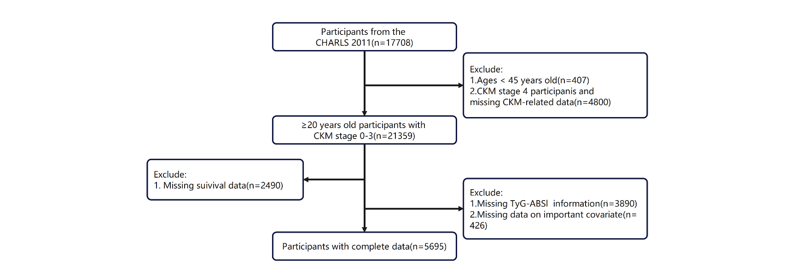

Fig. S1 Flow chart for eligible participants from CHARLS 2011.
Abbreviations: CKM Syndrome: cardiovascular-kidney-metabolic syndrome. TyG: triglyceride-glucose. ABSI: a body shape index. CHARLS: China Health and Retirement Longitudinal Study.

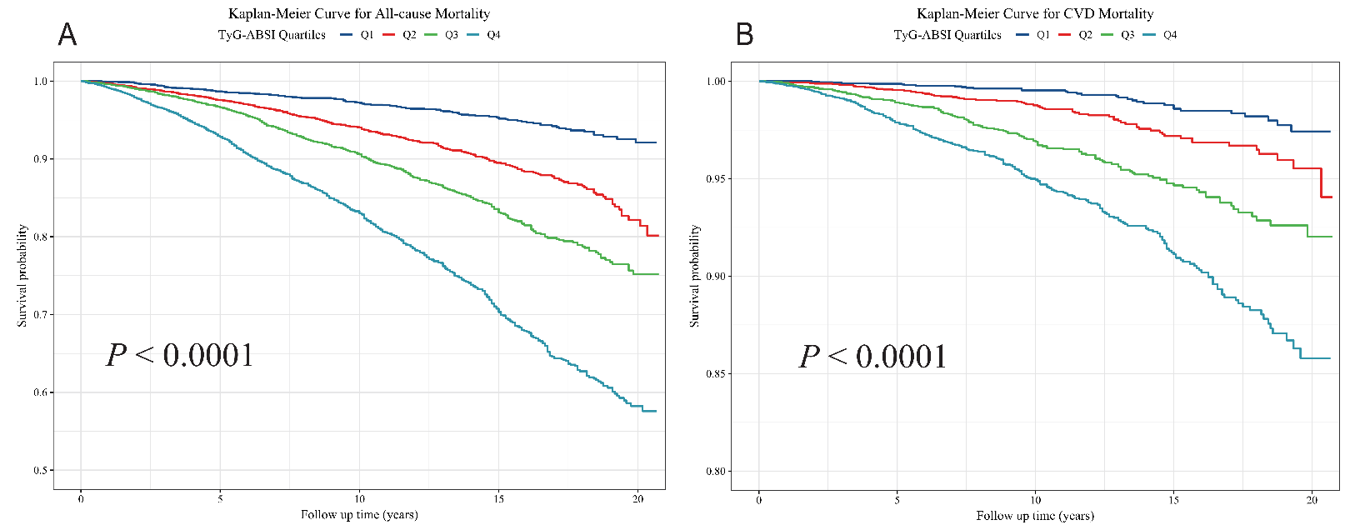
Fig. S2 Kaplan‒Meier analysis for mortality according to TyG-ABSI.
Abbreviations: TyG: triglyceride-glucose. ABSI: a body shape index. Z-score: standard score

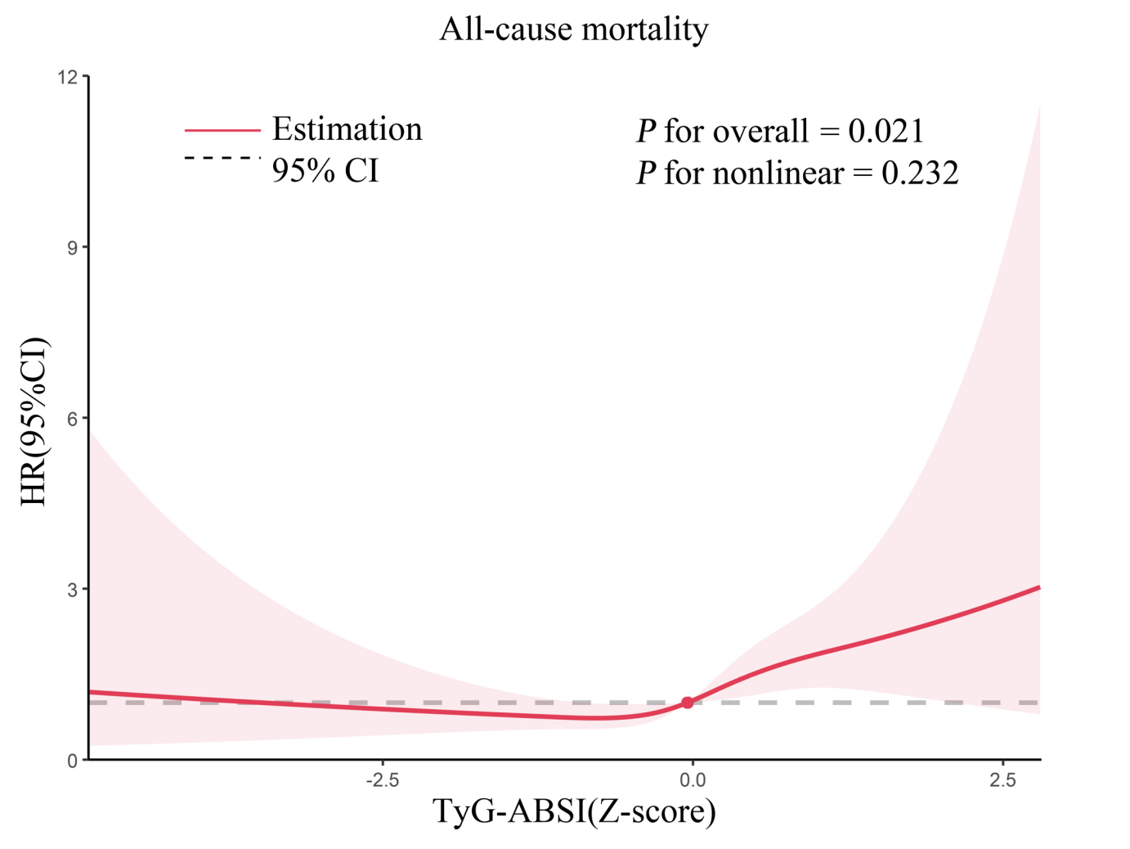
Fig. S3 Restricted cubic spline curve for the association between TyG-ABSI and all-cause mortality: Data from CHARLS 2011
Adjusted for age, sex, marital status, educational level, living place, smoking status, alcohol consumption, HDL, LDL, HbA1c, eGFR, uric acid, CKD, liver disease, cancer, hypertension, DM, antihypertensive drug, hypoglycemic therapy, lipid-lowering drug, and CKM syndrome.
Abbreviations: CKM Syndrome: cardiovascular-kidney-metabolic syndrome. CVD: cardiovascular disease. HR: hazard ratio. CI: confidence interval. TyG: triglyceride-glucose. ABSI: a body shape index. uACR: urinary albumin/creatinine ratio. CKD: chronic kidney disease. eGFR: estimated glomerular filtration rate. HbA1c: glycosylated hemoglobin. DM: diabetes mellitus. HDL: high-density lipoprotein. LDL: low-density lipoprotein.
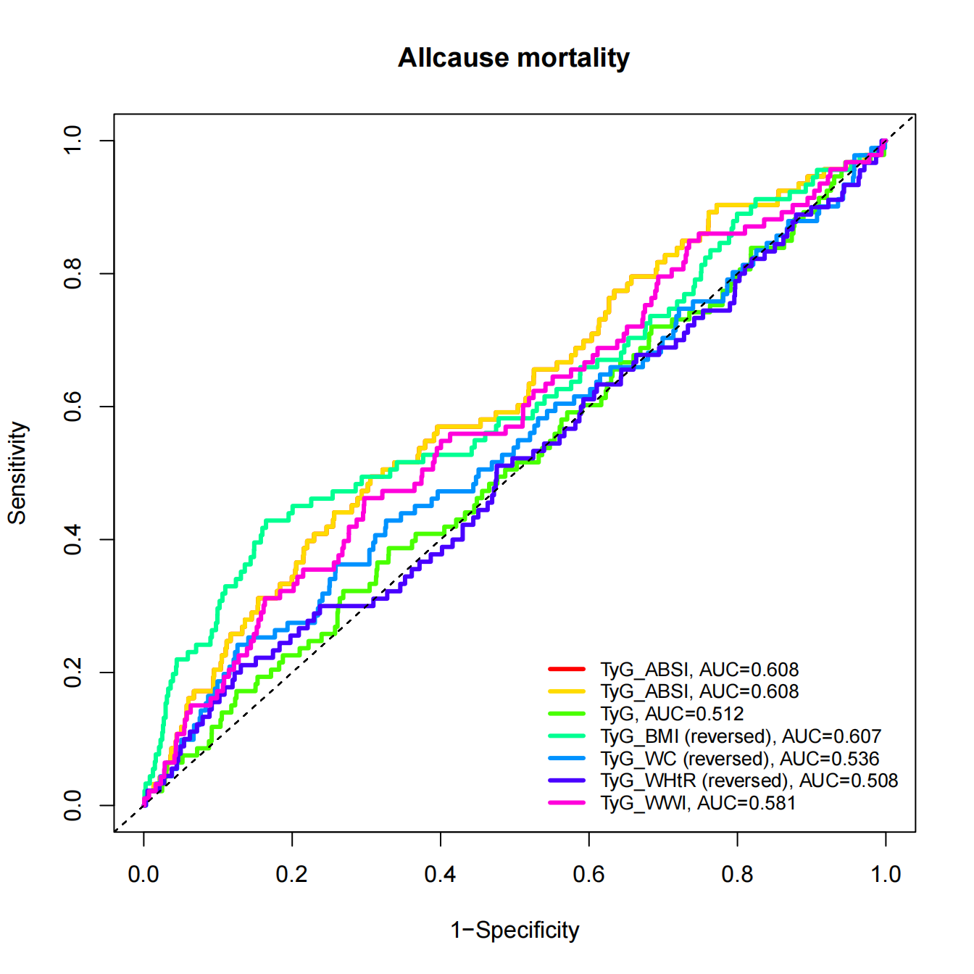
Fig. S4 Time-dependent Receiver Operating Characteristic analysis of TyG-ABSI in predicting all-cause mortality: data from CHARLS 2011
Adjusted for age, sex, marital status, educational level, living place, smoking status, alcohol consumption, HDL, LDL, HbA1c, eGFR, uric acid, CKD, liver disease, cancer, hypertension, DM, antihypertensive drug, hypoglycemic therapy, lipid-lowering drug, and CKM syndrome.
Abbreviations: ROC: receiver operating characteristic, AUC: area under the curve, TyG: triglyceride–glucose, ABSI: a body shape index, BMI: body mass index, WWI: weight-adjusted waist index, WHtR: waist-to-height ratio, WC: waist circumference. CKM Syndrome: cardiovascular-kidney-metabolic syndrome. CVD: cardiovascular disease. HR: hazard ratio. CI: confidence interval. CKD: chronic kidney disease. eGFR: estimated glomerular filtration rate. HbA1c: glycosylated hemoglobin. DM: diabetes mellitus. HDL: high-density lipoprotein. LDL: low-density lipoprotein.

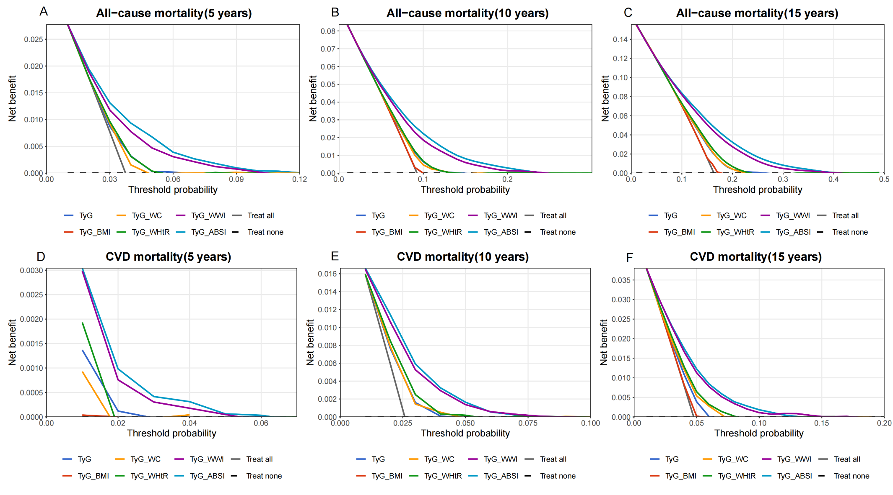

Fig. S5 DCA of TyG Index for Mortality Prediction in CKM Patients
Panels A-C illustrate decision curve analyses (DCAs) for 5-, 10-, and 15-year all-cause mortality, respectively. Panels D-F display DCAs for 5-, 10-, and 15-year cardiovascular disease (CVD) mortality, respectively.
Abbreviations: DCA, decision curve analysis; CVD, cardiovascular disease.

