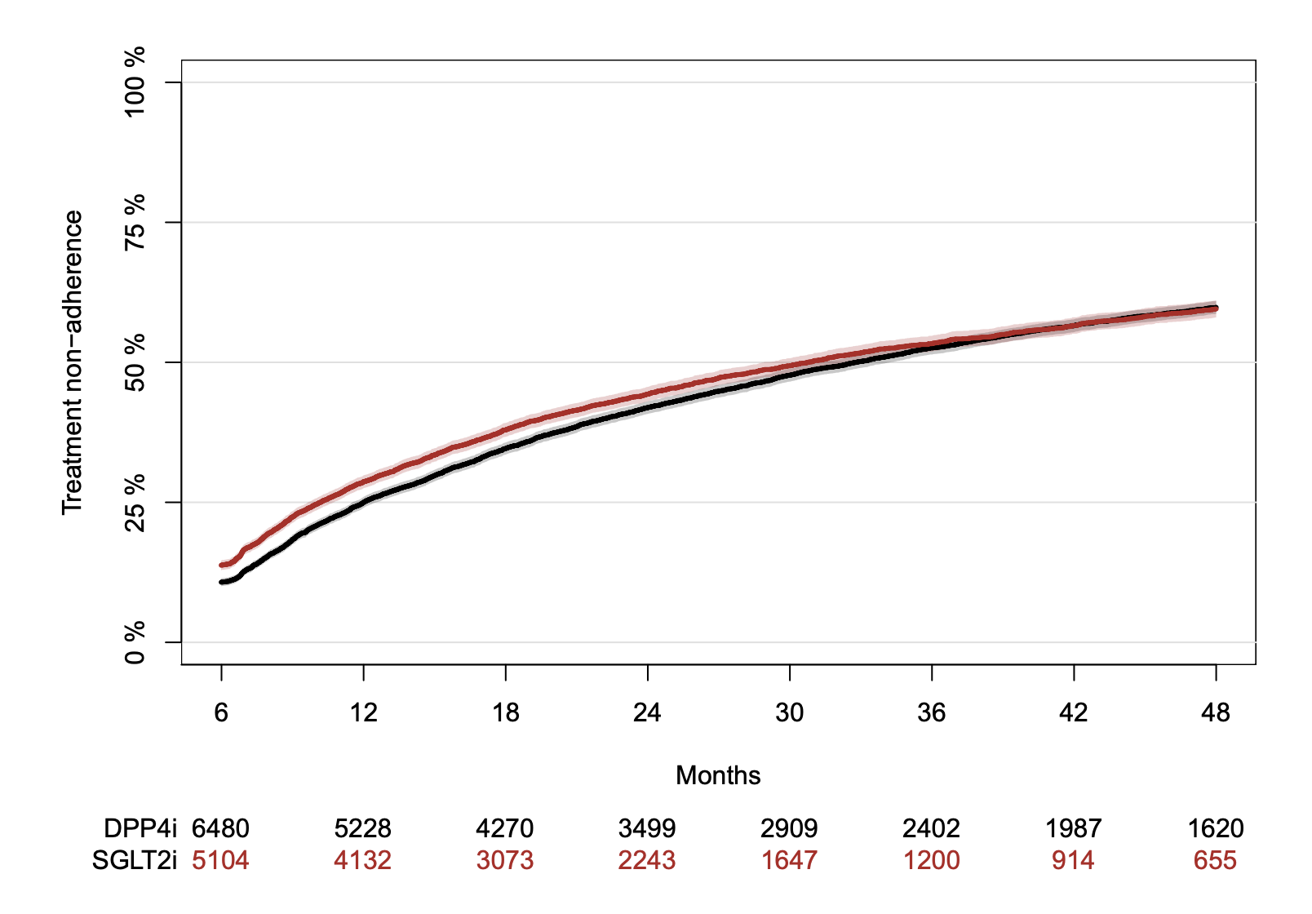
Supplementary figure 1. Treatment non-adherence: Cumulative risk of more than 180 days between prescription redemption by groups of initial prescription of SGL2i or DPP4i.

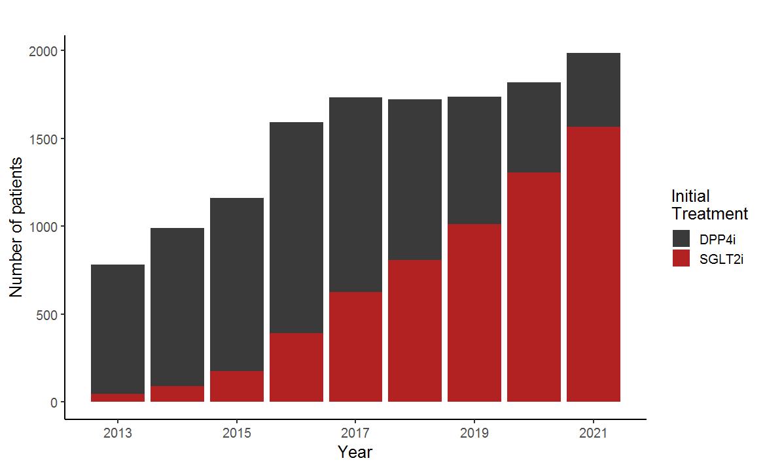
Supplementary figure 2. Distribution of new users of SGLT2i and DPP4i by year from 2013 to 2021.

Time period (months) | Average Treatment Effect (percentage point, with 95% CI) | P-value
6 | 1.03 (0.44, 1.64) | 0.001
12 | 1.95 (1.11, 2.78) | <0.001
18 | 2.23 (1.15, 3.31) | <0.001
24 | 2.31 (0.91, 3.71) | 0.002
30 | 2.89 (1.21, 4.51) | 0.001
36 | 2.78 (0.93, 4.63) | 0.005
42 | 3.05 (0.71, 5.39) | 0.013
48 | 2.62 (-0.29, 4.96) | 0.029
Supplementary table 1: Average treatment effects (ATE) on MACE across all time periods. Positive ATE values indicate the benefit of SGLT2i over DPP4i. Effects are expressed as absolute percentage point differences in risk.

