Supple Figures

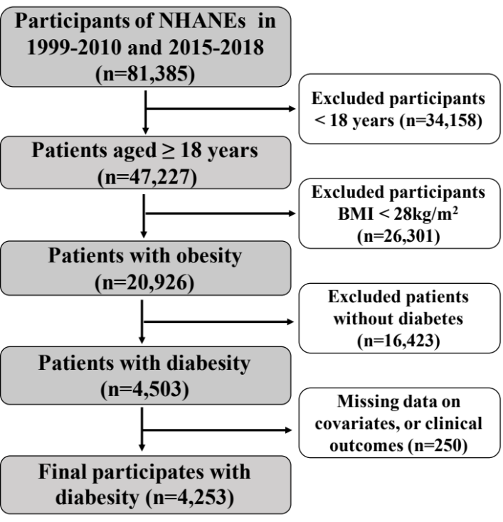
Supple Figure 1 Flow chart of participants selection. NHANES, National Health and Nutrition Examination Survey.

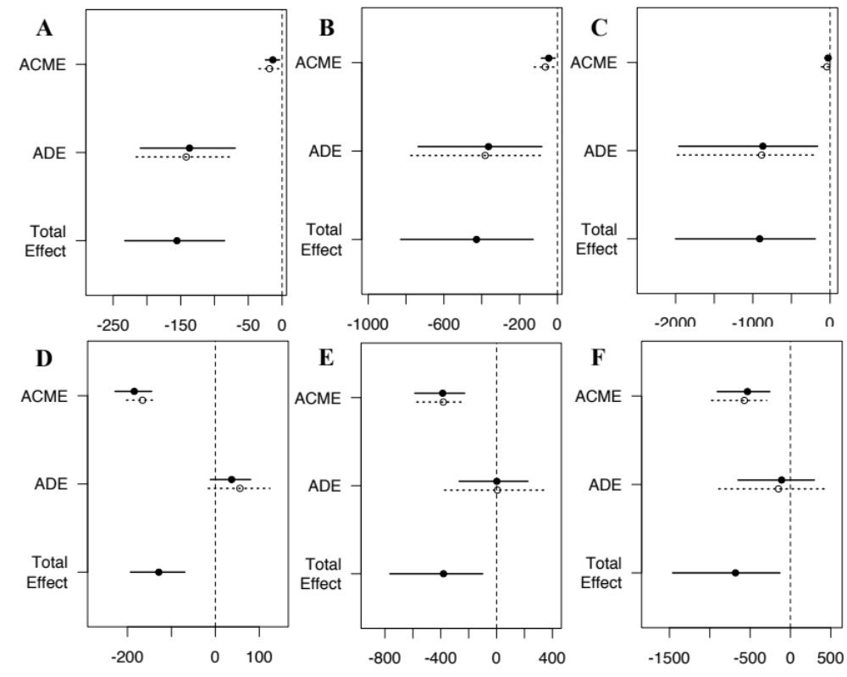
Supple Figure 2 The mediating effect of accelerated biological aging on the association between SHR and mortality. A~C: The mediating effect of kdmAgeAccel on the association between SHR and all-cause (A), CVD (B), and cancer mortality (C); D~F: The mediating effect of phenoAgeAccel on the association between SHR and all-cause (D), CVD (E), and cancer mortality (F). CVD, cardiovascular disease. Analysis were adjusted for age, sex, race, and marital status, smoking status, alcohol status, coronary heart disease, stroke, cancer or malignancy, serum uric acid, TG, TC, and serum creat.

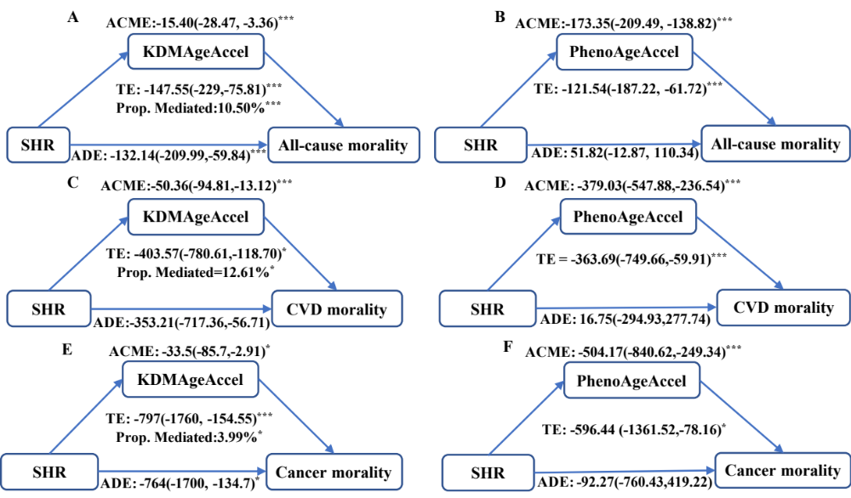
Supple Figure 3 Sensitivity analysis results of the mediating effect of the accelerated biological aging in the population excluding participants over 80 years old. ADE: average direct effect, ACEM: average causal mediation effect, TE: total effect. CVD, cardiovascular disease. Analysis were adjusted for age, sex, race, and marital status, smoking status, alcohol status, coronary heart disease, stroke, cancer or malignancy, serum uric acid, TG, TC, and serum creat. *P<0.05, **P<0.01, ***P<0.001.

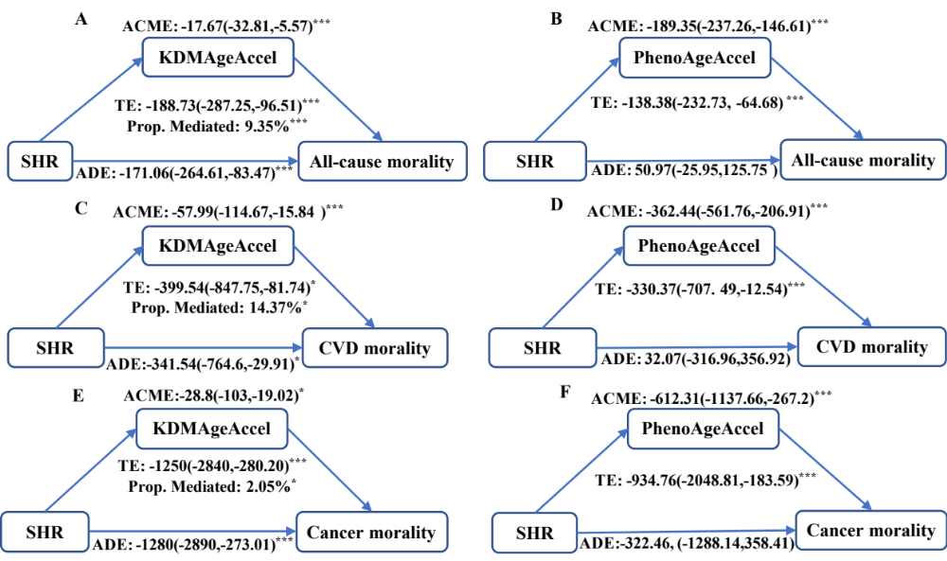
Supple Figure 4 Sensitivity analysis results of the mediating effect of the accelerated aging in the population with a follow-up period of more than 12 months. ADE: average direct effect, ACEM: average causal mediation effect, TE: total effect. CVD, cardiovascular disease. Analysis were adjusted for age, sex, race, and marital status, smoking status, alcohol status, coronary heart disease, stroke, cancer or malignancy, serum uric acid, TG, TC, and serum creat. *P<0.05, **P<0.01, ***P<0.001.

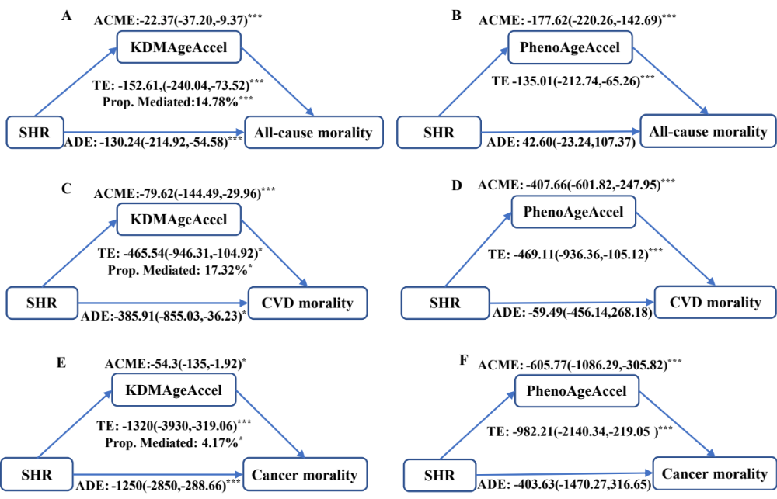
Supple Figure 5 Sensitivity analysis results of the mediating effect of the accelerated aging in the population excluding participants who had values that fell within the 1% extremes of the SHR range. ADE: average direct effect, ACEM: average causal mediation effect, TE: total effect. CVD, cardiovascular disease. Analysis were adjusted for age, sex, race, and marital status, smoking status, alcohol status, coronary heart disease, stroke, cancer or malignancy, serum uric acid, TG, TC, and serum creat. *P<0.05, **P<0.01, ***P<0.001.

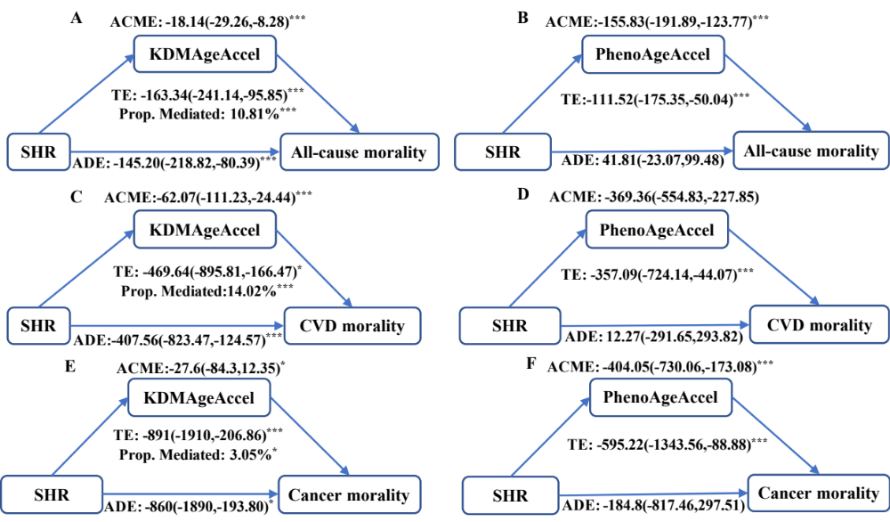
Supple Figure 6 Sensitivity analysis results of the mediating effect of the accelerated aging in the population excluding participants who had values that fell within the 1% extremes of the SHR range. ADE: average direct effect, ACEM: average causal mediation effect, TE: total effect. CVD, cardiovascular disease. Analysis were adjusted for age, sex, race, and marital status, smoking status, alcohol status, coronary heart disease, stroke, cancer or malignancy, serum uric acid, TG, TC, and serum creat. *P<0.05, **P<0.01, ***P<0.001.

Characteristics | Overall | Tertiles of SHR |  |  | P-value
Characteristics | Overall | T1(<0.79) | T2(0.79-0.99) | T3(>0.99) | P-value
Chronological Age, years | 60(13.62) | 60.29(13.08) | 59.94(13.7) | 59.77(14.07) | 0.534
SBP, mmHg | 132.40(19.9) | 132.3(19.73) | 131.89(19.3) | 133.04(20.67) | 0.301
Serum glucose, mg/dL | 148.74(67.34) | 104.91(28.6) | 137.79(39.1) | 203.87(79.14) | <0.001
HbA1c,% | 7.33(1.67) | 7.27(1.44) | 7.09(1.50) | 7.64(1.99) | <0.001
TC, mg/dl | 189.75(47.00) | 188.13(44.26) | 189.54(45.58) | 191.59(50.9) | 0.132
Albumin, g/dl |  | 4.1(0.35) | 4.08(0.34) | 4.06(0.36) | 0.005
  4.08(0.35)
BUN, mg/dl | 16.45(8.65) | 16.41(8.31) | 15.89(7.65) | 17.07(9.85) | 0.002
Creat, mg/dl | 0.98(0.62) | 0.97(0.56) | 0.94(0.48) | 1.04(0.78) | <0.001
WBC, 1000 cells/uL | 7.77(2.25) | 8.05(2.37) | 7.51(2.1) | 7.75(2.24) | <0.001
LYM, % | 29.79(8.66) | 31.11(9.08) | 30.02(8.13) | 28.24(8.51) | <0.001
MCV, fL | 88.34(5.99) | 87.66(6.13) | 88.35(5.8) | 88.99(5.99) | <0.001
RDW, % | 13.60(1.47) | 13.76(1.48) | 13.57(1.42) | 13.48(1.51) | <0.001
CRP, mg/dl | 0.30(0.83) | 0.3(0.75) | 0.29(0.73) | 0.32(0.69) | 0.603
Alp, U/L | 79.40(29.92) | 78.83(28.62) | 76.84(29.09) | 82.62(31.72) | <0.001
Supple Table 1 Components of biological age in adults with diabesity by three categories of SHR. SBP, systolic blood pressure; HbA1c, glycated hemoglobin; TC, total cholesterol; BUN, blood urea nitrogen; WBC, White blood cell count; LYM, lymphocyte; MCV, mean cell volume; RDW, red cell distribution width; CRP, C-reactive protein; Alp, alkaline phosphatase.

Characteristics | Overall | Tertiles of SHR |  |  | P-value
Characteristics | Overall | T1(<0.79) | T2(0.79-0.99) | T3(>0.99) | P-value
kdm | 35.74(41.23) | 36.03(39.05) | 33.23(38.33) | 38.03(45.86) | 0.021
kdmAgeAccel | -0.006(40.76) | 0.15(38.77) | -2.49(37.75) | 2.39(45.31) | 0.018
phenoage | 56.19(16.48) | 53.9(15.21) | 54.8(15.63) | 59.75(17.71) | <0.001
phenoAgeAccel | 0.001(9.91) | -2.39(9.22) | -1.33(8.16) | 3.8(11.05) | <0.001
Supple Table 2 Biological age levels by SHR tertiles. Significant differences among groups were analyzed by ANOVA.

 | Adjusted HR(95% CI), P-value
All-cause mortality
Total | 1.79(1.42, 2.25), <0.001
Fitting by two-piecewise Cox proportional hazards model
Inflection point | 0.89
SHR < 0.89 | 0.37(0.19, 0.73), 0.004
SHR ≥ 0.89 | 2.22(1.61, 3.06), <0.001
P for Log-likelihood ratio | <0.001
CVD mortality
Total | 1.89(1.22, 2.93), 0.004
Fitting by two-piecewise Cox proportional hazards model
Inflection point | 0.86
SHR <0.86 | 0.24(0.06, 0.96), 0.044
SHR ≥0.86 | 2.01(1.06, 3.80), 0.033
P for Log-likelihood ratio | <0.001
Supple Table 3 Threshold effect analysis of SHR on all-cause mortality and CVD mortality in patients with diabesity. SHR, stress hyperglycemia ratio; CVD, cardiovascular disease. The analysis was adjusted by age, sex, race, marital status, smoking status, alcohol status, coronary heart disease, stroke, cancer or malignancy, serum uric acid, TG, TC, and serum creat.

 | All-cause mortality |  | P-int | CVD mortality |  | P-int | Cancer mortality |  | P-int
 | SHR<0.89 | SHR≥0.89 | P-int | SHR<0.86 | SHR≥0.86 | P-int | SHR<0.88 | SHR≥0.88 | P-int
 | ref | HR(95%CI),P | P-int | ref | HR(95%CI),P | P-int | ref | HR(95%CI),P | P-int
Overall | 1 | 1.36(1.21,1.53),<0.001 |  | 1 | 1.31(1.05,1.65),0.019 |  | 1 | 1.31(1.05,1.65),0.019
Age, years |  |  | 0.094 |  |  | 0.38 |  |  | 0.985
>60 | 1 | 1.36(1.19,1.54),<0.001 |  | 1 | 1.36(1.06,1.75),0.017 |  | 1 | 1.26(0.93,1.71),0.138
≤60 | 1 | 1.36(1.05,1.77),0.02 |  | 1 | 1.19(0.70,2.02),0.513 |  | 1 | 1.31(0.71,2.42),0.395
Gender |  |  | 0.104 |  |  | 0.732 |  |  | 0.776
Male | 1 | 1.22(1.04,1.43),0.014 |  | 1 | 1.27(0.94,1.71),0.115 |  | 1 | 1.22(0.86,1.73),0.256
Female | 1 | 1.50(1.26,1.78),<0.001 |  | 1 | 1.36(0.96,1.92),0.085 |  | 1 | 1.32(0.84,2.05),0.224
Race |  |  | 0.735 |  |  | 0.837 |  |  | 0.539
Non-Hispanic White | 1 | 1.31(1.04,1.66),0.023 |  | 1 | 1.41(0.91,2.18),0.124 |  | 1 | 1.08(0.60,1.87),0.789
Other Race | 1 | 1.37(1.20,1.57),<0.001 |  | 1 | 1.28(0.98,1.67),0.07 |  | 1 | 1.34(0.97,1.84),0.073
BMI, kg/m2 |  |  | 0.195 |  |  | 0.514 |  |  | 0.642
>= 30 | 1 | 1.41(1.24,1.61),<0.001 |  | 1 | 1.36(1.05,1.77),0.02 |  | 1 | 1.24(0.91,1.67),0.169
<30 | 1 | 1.18(0.92,1.50)0.194 |  | 1 | 1.17(0.74,1.86),0.502 |  | 1 | 1.44(0.75,2.75),0.269
HbA1c, % |  |  | 0.912 |  |  | 0.926 |  |  | 0.408
>= 7 | 1 | 1.37(1.16,1.62),<0.001 |  | 1 | 1.29(0.94,1.77),0.121 |  | 1 | 1.45(0.94,2.23),0.091
< 7 | 1 | 1.35(1.15,1.59),<0.001 |  | 1 | 1.32(0.96,1.82),0.09 |  | 1 | 1.19(0.84,1.70),0.33
eGFR, mL/min/1.73 m2 |  |  | 0.372 |  |  | 0.533 |  |  | 0.936
> 60 | 1 | 1.34(1.15,1.55)<0.001 |  | 1 | 1.24(0.93,1.67),0.147 |  | 1 | 1.29(0.92,1.79),0.136
<= 60 | 1 | 1.47(1.22,1.78),<0.001 |  | 1 | 1.40(0.98,2.01),0.063 |  | 1 | 1.26(0.77,2.05),0.353
Education |  |  | 0.96 |  |  | 0.721 |  |  | 0.68
Low level | 1 | 1.36(1.19,1.57),<0.001 |  | 1 | 1.32 (1.01,1.74),0.044 |  | 1 | 1.31 (0.94.1.83),0.109
High level | 1 | 1.38(1.12,1.71),0.003 |  | 1 | 1.23(0.81,1.85),0.328 |  | 1 | 1.13 (0.70.1.83),0.606
Smoking status |  |  | 0.145 |  |  | 0.572 |  |  | 0.556
Yes | 1 | 1.24(1.06,1.44),0.007 |  | 1 | 1.24(0.92,1.68),0.151 |  | 1 | 1.18 (0.83,1.66),0.363
No | 1 | 1.49(1.24,1.79),<0.001 |  | 1 | 1.37(0.97,1.95),0.075 |  | 1 | 1.36 (0.87,2.10),0.175
Alcohol status |  |  | 0.641 |  |  | 0.597 |  |  | 0.507
Yes | 1 | 1.32(1.13,1.54),<0.001 |  | 1 | 1.21(0.90,1.63),0.200 |  | 1 | 1.23 (0.86,1.75),0.258
No | 1 | 1.42(1.17,1.72),<0.001 |  | 1 | 1.34(0.92,1.95),0.132 |  | 1 | 1.51 (0.94,2.42),0.088
Suppl Table 4 Subgroup analysis of the associations between SHR and mortality among diabesity. SHR, stress hyperglycemia ratio; CVD, cardiovascular disease; BMI, body mass index; HbA1c, glycated hemoglobin; eGFR, estimated glomerular filtration rate. The variables were not included in the model when stratified by itself. Educational attainment was categorized as low (high school graduate or less) or high (some college or above). Smoking status was classified as non-smoker (never smoker) or smoker (former/occasional/daily smoker). Drinking status was defined as non-drinker (never drinking) or drinker (former/mild/moderate/heavy drinking).

 | Tertiles |  |  | P trend
 | T1 | T2 | T3 | P trend
SHR
All-cause | 1 | 0.98(0.83,1.15),0.770 | 1.32(1.13,1.55),<0.001 | <0.001
CVD | 1 | 1.12(0.83,1.52),0.467 | 1.40(1.04,1.90),0.028 | <0.001
Cancer | 1 | 1.13(0.78,1.63),0.512 | 1.53(1.07,2.19),0.020 | <0.001
KDMAgeAccel
All-cause | 1 | 1.41(1.15,1.72),0.001 | 2.25(1.79,2.83),<0.001 | <0.001
CVD | 1 | 2.04(1.42,2.92),<0.001 | 4.20(2.79,6.34),<0.001 | <0.001
Cancer | 1 | 1.09(0.69,1.72), 0.713 | 1.80(1.07,3.04),0.027 | <0.001
PhenoAgeAccel
All-cause | 1 | 1.29(1.10,1.51),0.002 | 2.71(2.28,3.23),<0.001 | <0.001
CVD | 1 | 1.11(0.82,1.50),0.515 | 2.43(1.75,3.38),<0.001 | <0.001
Cancer | 1 | 1.02(0.72,1.46),0.904 | 2.13(1.44,3.16),<0.001 | 0.017
Supple Table 5 Sensitivity analysis results of logistic regression in the population excluding participants over 80 years old. SHR tertiles: T1: <0.79; T2: 0.79-0.99; T3: >0.99; kdmAgeAccel tertiles: T1: <-10.52; T2: -10.52~17.42; T3: >17.42; phenoAgeAccel tertiles: T1: <-4.87; T2: 2.77~76.06; T3: >76.06. CVD, cardiovascular disease. Analyses were adjusted for age, sex, race, and marital status, smoking status, alcohol status, coronary heart disease, stroke, cancer or malignancy, serum uric acid, TG, TC, and serum creat.

 | Tertiles |  |  | P trend
 | T1 | T2 | T3 | P trend
SHR
All-cause | 1 | 0.98(0.83,1.15),0.773 | 1.34(1.15,1.58),0.001 | <0.001
CVD | 1 | 1.01(0.74,1.37),0.947 | 1.30(0.96,1.75),0.093 | <0.001
Cancer | 1 | 1.18(0.80,1.73),0.407 | 1.72(1.19,2.49),0.004 | <0.001
KDMAgeAccel
All-cause | 1 | 1.36(1.10,1.67),0.004 | 2.03(1.60,2.57),<0.001 | <0.001
CVD | 1 | 1.64(1.13,2.40),0.010 | 3.59(2.35,5.49),<0.001 | <0.001
Cancer | 1 | 1.10(0.69,1.76),0.697 | 1.44(0.83,2.49),0.195 | <0.001
PhenoAgeAccel
All-cause | 1 | 1.45(1.23,1.70),<0.001 | 2.78(2.32,3.34),<0.001 | <0.001
CVD | 1 | 1.32(0.98,1.79),0.067 | 2.14(1.50,3.04),<0.001 | <0.001
Cancer | 1 | 1.16(0.80,1.68),0.428 | 2.50(1.66,3.76),<0.001 | <0.001
Supple Table 6 Sensitivity analysis results of logistic regression in the population with a follow-up period of more than 12 months. SHR tertiles: T1: <0.79; T2: 0.79-0.99; T3: >0.99; kdmAgeAccel tertiles: T1: <-10.52; T2: -10.52~17.42; T3: >17.42; phenoAgeAccel tertiles: T1: <-4.87; T2: 2.77~76.06; T3: >76.06. CVD, cardiovascular disease. Analyses were adjusted for age, sex, race, and marital status, smoking status, alcohol status, coronary heart disease, stroke, cancer or malignancy, serum uric acid, TG, TC, and serum creat.

 | Tertiles |  |  | P trend
 | T1 | T2 | T3 | P trend
SHR
All-cause | 1 | 1.02(0.88,1.20),0.758 | 1.32(1.14,1.54),<0.001 | <0.001
CVD | 1 | 1.14(0.85,1.52),0.378 | 1.35(1.01,1.80),0.042 | <0.001
Cancer | 1 | 1.26(0.87,1.81),0.218 | 1.67(1.17,2.39),0.004 | <0.001
KDMAgeAccel
All-cause | 1 | 1.35(1.11,1.64),0.003 | 2.01(1.59,2.54),<0.001 | <0.001
CVD | 1 | 1.88(1.32,2.67),<0.001 | 3.96(2.61,6.02),<0.001 | <0.001
Cancer | 1 | 1.03(0.66,1.62),0.898 | 1.53(0.90,2.59),0.116 | <0.001
PhenoAgeAccel
All-cause | 1 | 1.33(1.14,1.56),<0.001 | 2.67(2.24,3.18),<0.001 | <0.001
CVD | 1 | 1.17(0.88,1.56),0.290 | 2.24(1.61,3.13),<0.001 | <0.001
Cancer | 1 | 1.15(0.81,1.63),0.426 | 2.10(1.41,3.14),<0.001 | <0.001
Supple Table 7 Sensitivity analysis results of logistic regression in the population excluding participants who had values that fell within the 1% extremes of the SHR range, KDMAgeAccel and PhenoAgeAccel. SHR tertiles: T1: <0.79; T2: 0.79-0.99; T3: >0.99; kdmAgeAccel tertiles: T1: <-10.52; T2: -10.52~17.42; T3: >17.42; phenoAgeAccel tertiles: T1: <-4.87; T2: 2.77~76.06; T3: >76.06. CVD, cardiovascular disease. Analyses were adjusted for age, sex, race, and marital status, smoking status， alcohol status, coronary heart disease, stroke, cancer or malignancy, serum uric acid, TG, TC, and serum creat.

